Slide 1
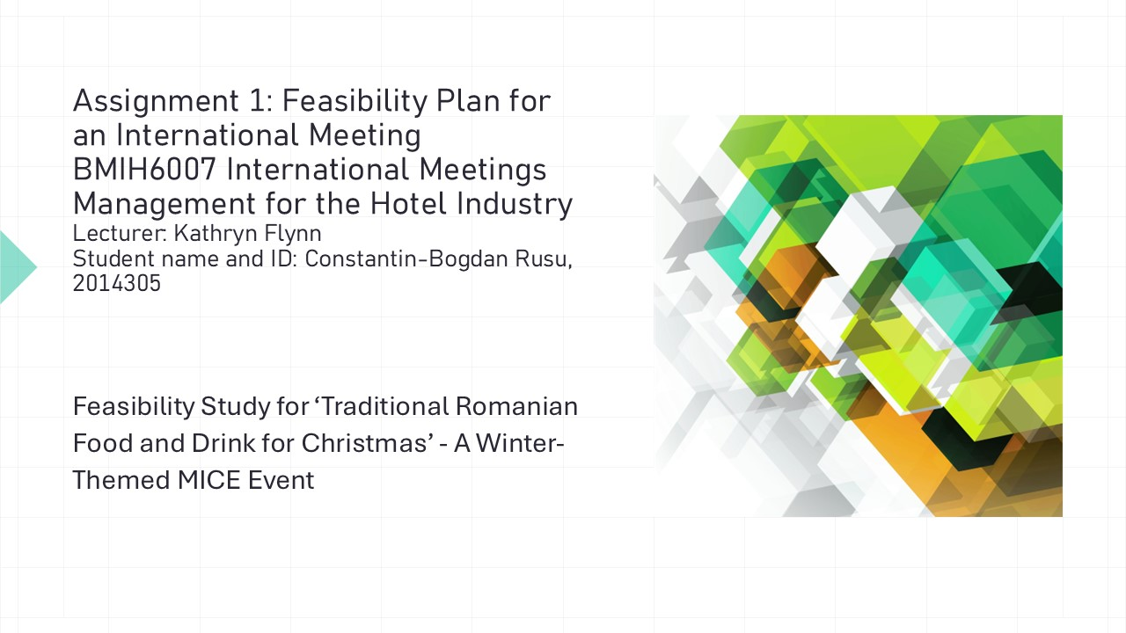
Feasibility Study for ‘Traditional Romanian Food and Drink for Christmas’ - A Winter-Themed MICE Event
Assignment 1: Feasibility Plan for an International Meeting
BMIH6007 International Meetings Management for the Hotel Industry
Lecturer: Kathryn Flynn
Student name and ID: Constantin-Bogdan Rusu, 2014305

Slide 2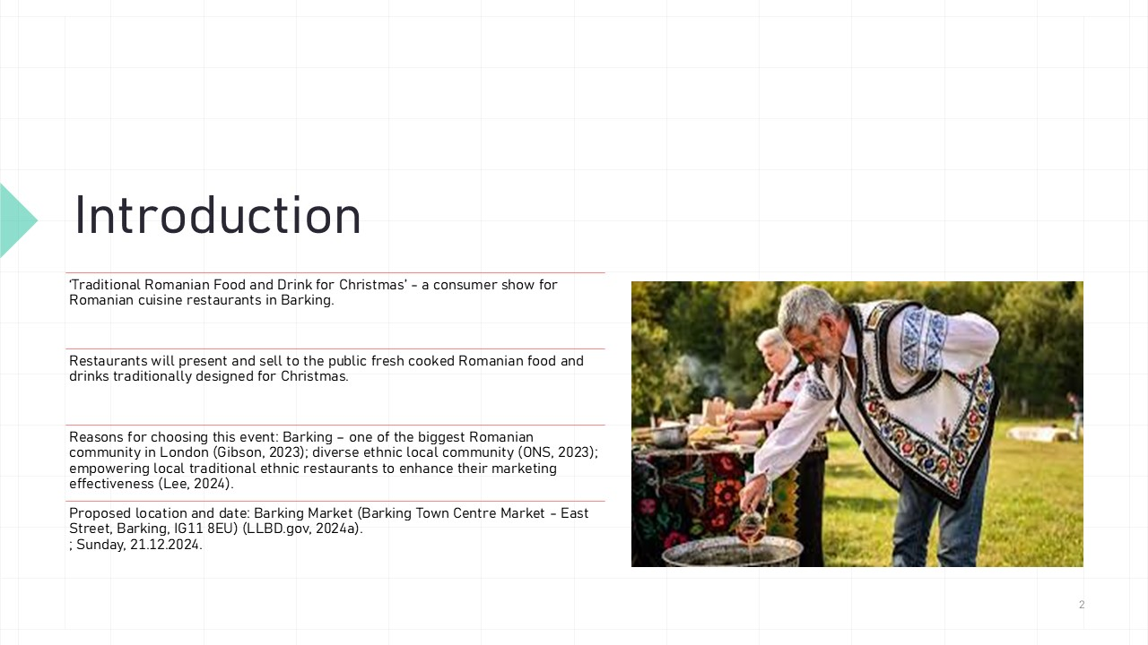
Introduction
The aim of this presentation is to critically justify the feasibility and strategic pre-planning research for a proposed MICE (Meetings, Incentives, Conferences, and Exhibitions) industry event within the hospitality sector, focusing on a seasonal theme of "Winter.“ The presentation aims to show the details of delivering the chosen event, more exactly ‘Traditional Romanian Food and Drink for Christmas’, a consumer show for Romanian cuisine restaurants in Barking.
The objectives of the presentation are:
- To provide a detailed feasibility study for an original event, including background research and situational analysis. ​
- To critically analyse market factors, operational factors, and financial factors related to the event. ​
At this consumer show, restaurants will present and sell to the public fresh cooked Romanian food and drinks traditionally designed for Christmas.
The decision to have this event was made for the following reasons: Barking is home to a largest Romanian community in London (Gibson, 2023); the neighbourhood is home to a diverse ethnic community (ONS, 2023); and it will enable local traditional ethnic restaurants to improve their marketing effectiveness (Lee, 2024).
This event is scheduled to take place on Sunday, December 21st, 2024, at Barking Market, which is in Barking Town Centre Market on East Street in Barking, IG11 8EU (LLBD.gov, 2024a).

Slide 3
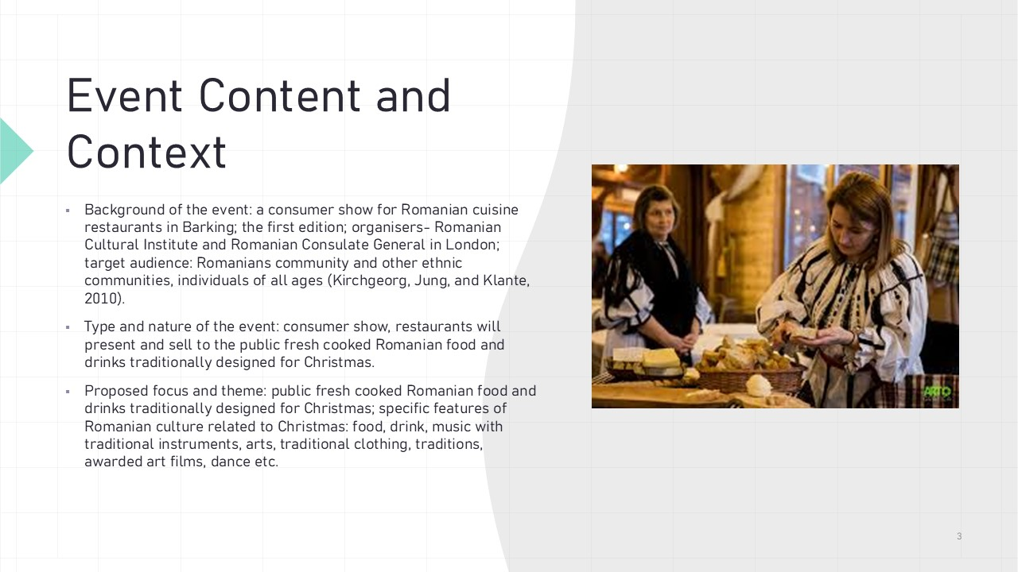
Event Content and Context
Background information about the event: it is a consumer expo for Romanian food restaurants in Barking; it is the first edition; the Romanian Cultural Institute London (RCI London,2024) is the organiser, along with the Romanian Consulate General in London (Londra.MAE.ro, 2024).
The target audience includes individuals of all ages, members of the Romanian community, and members of families of other ethnic communities (Kirchgeorg, Jung, and Klante, 2010).
The type and characteristic of the event is a consumer show, in which restaurants will showcase and sell to the general public freshly cooked Romanian food and drinks that are customarily intended for the holiday season.
The proposed focus and theme is as follows: freshly prepared Romanian food and drinks that are typically designed for Christmas; specific aspects of Romanian culture that are associated to Christmas, including food, drink, music with traditional instruments, arts, costume traditions, awarded art films, dance, and so on.

Slide 4
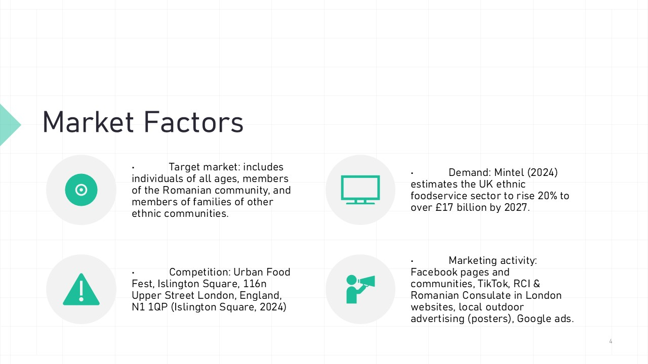
Market Factors
Individuals of all ages, members of the Romanian community, and members of families belonging to other ethnic communities are included in the target market.
According to Mintel (2024), the demand for ethnic foodservice in the United Kingdom is expected to increase by twenty percent, reaching over seventeen billion pounds by the year 2027.
Islington Square, London, England, N1 1QP (Islington Square, 2024) is the location of an event known as the Urban Food Fest, also held on the day of the proposed event.
Marketing strategy includes Facebook pages and communities, TikTok, the websites of the Romanian Consulate in London and Romanian Cultural Institute, local outdoor advertising (such as posters), and Google advertisements.

Slide 5

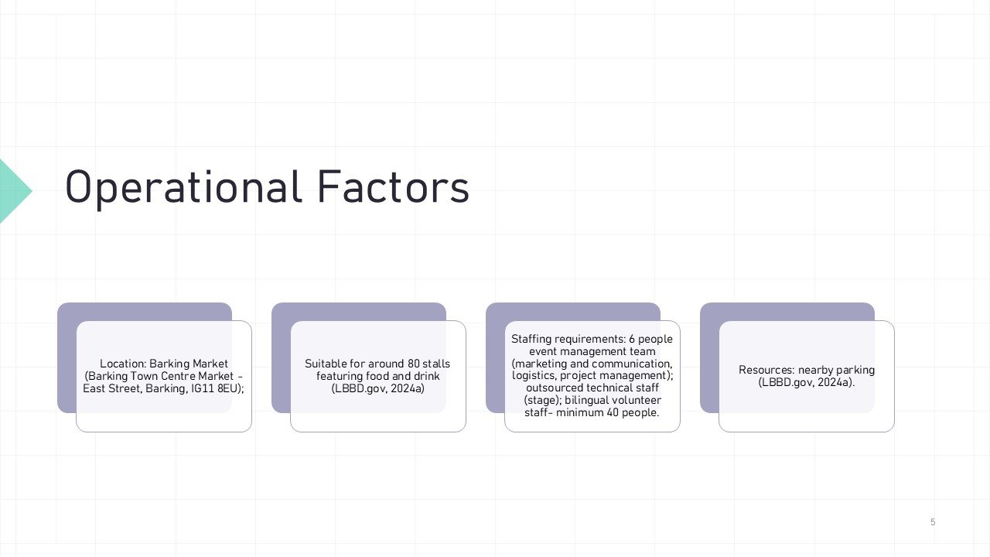
Operational Factors
Location: Barking Market (Barking Town Centre Market - East Street, Barking, IG11 8EU); Capable of accommodating about eighty vendors that offer food and drink (LBBD.gov, 2024a).
Six individuals are required to make up the event management team (which is responsible for marketing and communication, logistics, and project management); technical crew (stage) that is contracted out; and a minimum of forty persons who are multilingual volunteers.
Parking is found in proximity.

Slide 6
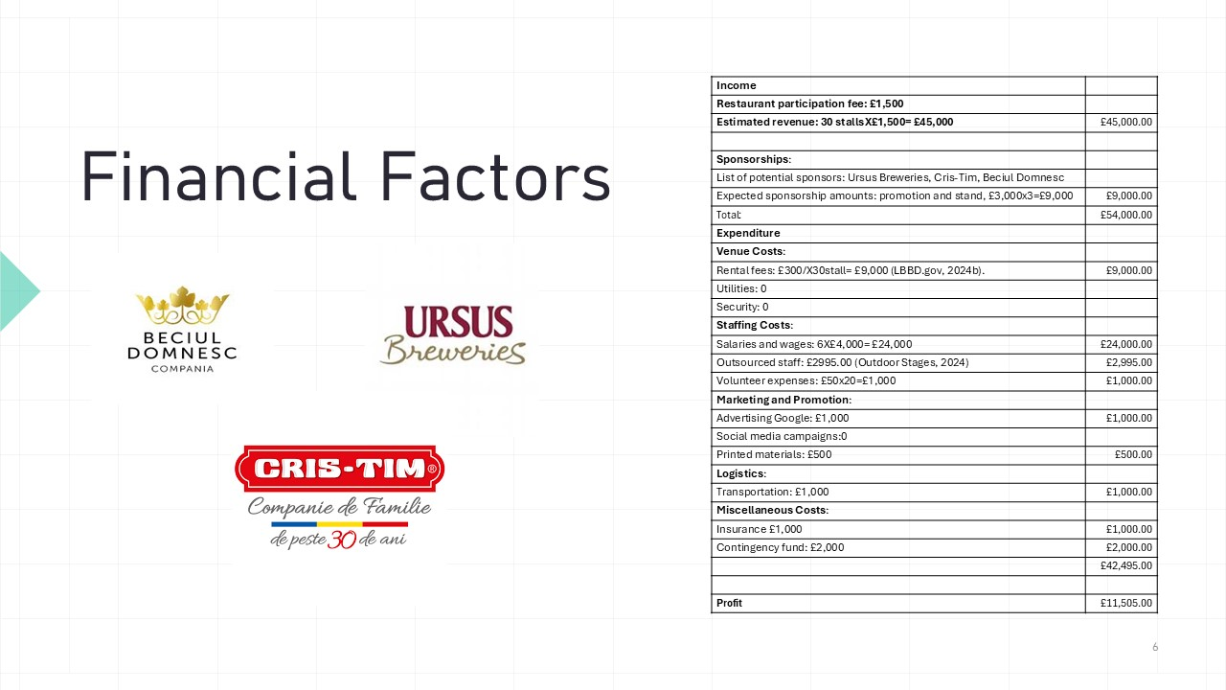
Financial Factors
Income
The participation fee for the restaurant is 1,500 pounds.
Ursus Breweries (2024), Cris-Tim (2024), and Beciul Domnesc (2024) are on the list of potential sponsors for this event.
Expected sponsorship amounts include promotion and stand, which add up to £9,000 (£3,000 multiplied by three).
A total of 54,000 pounds income.
Expenditure includes:
locational fees (LLBD.gov, 2024b)
personnel that is contracted out (Outdoor Stages, 2024)
Advertising within the umbrella of marketing and promotion Google
Materials that are printed
In terms of logistics, transportation fees
Expenses Diverse to Others
Total expenses: £42,495.00
Total estimated profit of 11,505.00 pounds.

Slide 7
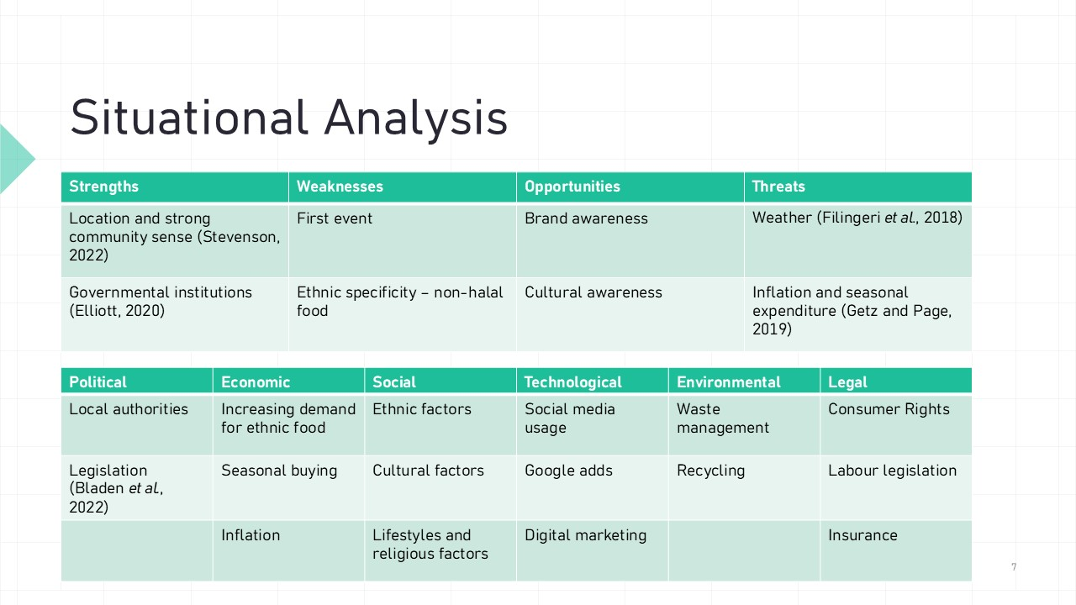
Situational Analysis
SWOT Analysis
Strengths:
- A strong sense of community and a prime location (Stevenson, 2022).
- Governmental institutions are involved in the effort as organisers (Elliott, 2020).
Weaknesses: first-time event, ethnic specificity - non-halal cuisine.
Opportunities: brand awareness for restaurants, and cultural awareness.
Threats: weather (Filingeri et al., 2018), inflation and seasonal expenditure

PESTLE Analysis identified the following factors:
Political: local authorities, legislation (Bladen et al., 2022).
Economic: increasing demand for ethnic food (Mintel, 2024), seasonal buying, inflation
Social factors: ethnicity, culture, lifestyles, religion.
Technological: social media usage, Google ads, digital marketing
Environmental: waste management, recycling
Legal: consumer rights, labour law, insurance etc.

Slide 8

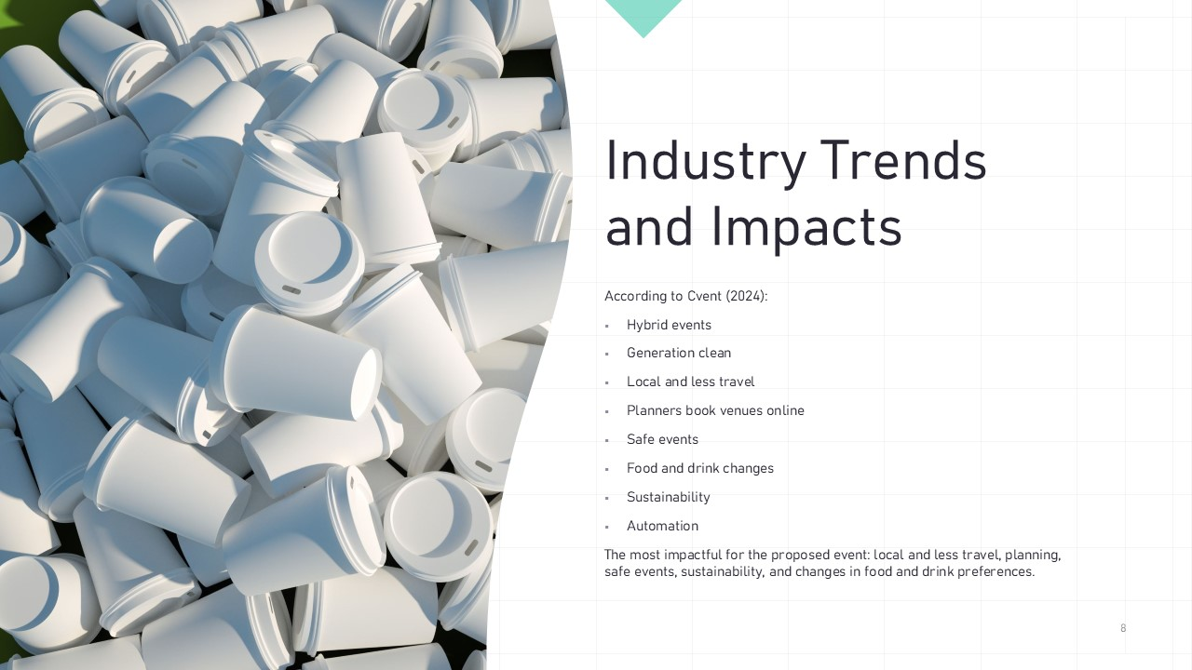
Industry Trends and Impacts
Cvent (2024) identified industry trends such as:
Hybrid events
Generation clean
Local and less travel
Planners reserve venues online.
Safe events
Food and drink alter
Sustainability
Automation
Local and less travel, planning, safe events, sustainability, and food and drink choices are most important for the proposed event.

Slide 9

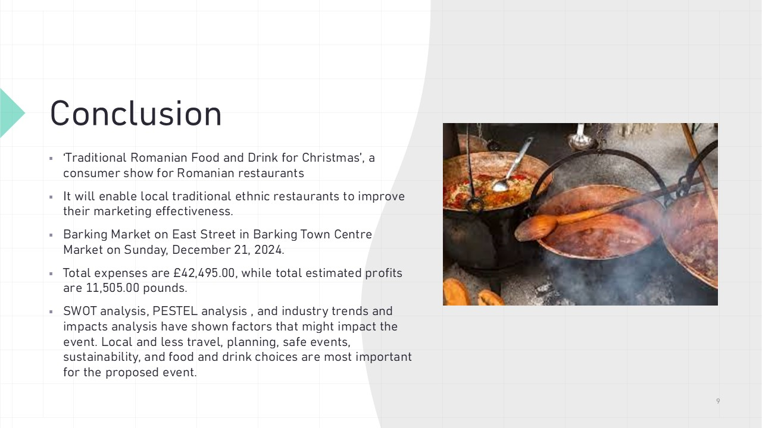

Conclusion
This presentation critically justified the viability and strategic pre-planning research for a proposed hospitality MICE (Meetings, Incentives, Conferences, and Exhibitions) business event with a "Winter" theme. The presentation described how to conduct the chosen event, ‘Traditional Romanian Food and Drink for Christmas’, a consumer show for Romanian restaurants.
Presentation objectives included an assessment for an innovative event, comprising background research and situational analysis, and an evaluation of event-related market, operational, and financial variables. ​
It will enable local traditional ethnic restaurants to improve their marketing effectiveness.
Restaurants will offer fresh Romanian Christmas food and drinks at this consumer exhibition. This event was chosen for these reasons: Barking has the largest Romanian community in London, a diversified ethnic group, and it will help local traditional ethnic restaurants sell better. This event will take place at Barking Market on East Street in Barking Town Centre Market on Sunday, December 21, 2024.
The target audience includes individuals of all ages, members of the Romanian community, and members of families of other ethnic communities.
The proposed focus and theme is as follows: freshly prepared Romanian food and drinks that are typically designed for Christmas; specific aspects of Romanian culture that are associated to Christmas, including food, drink, music with traditional instruments, arts, costume traditions, awarded art films, dance, and so on.
Marketing strategy includes Facebook pages and communities, TikTok, the websites of the Romanian Consulate in London and Romanian Cultural Institute, local outdoor advertising (such as posters), and Google advertisements.
Total expenses are £42,495.00, while total estimated profit is of 11,505.00 pounds.
SWOT analysis, PESTEL analysis , and industry trends and impacts analysis have shown factors that might impact the event. Local and less travel, planning, safe events, sustainability, and food and drink choices are most important for the proposed event.

Slide 10 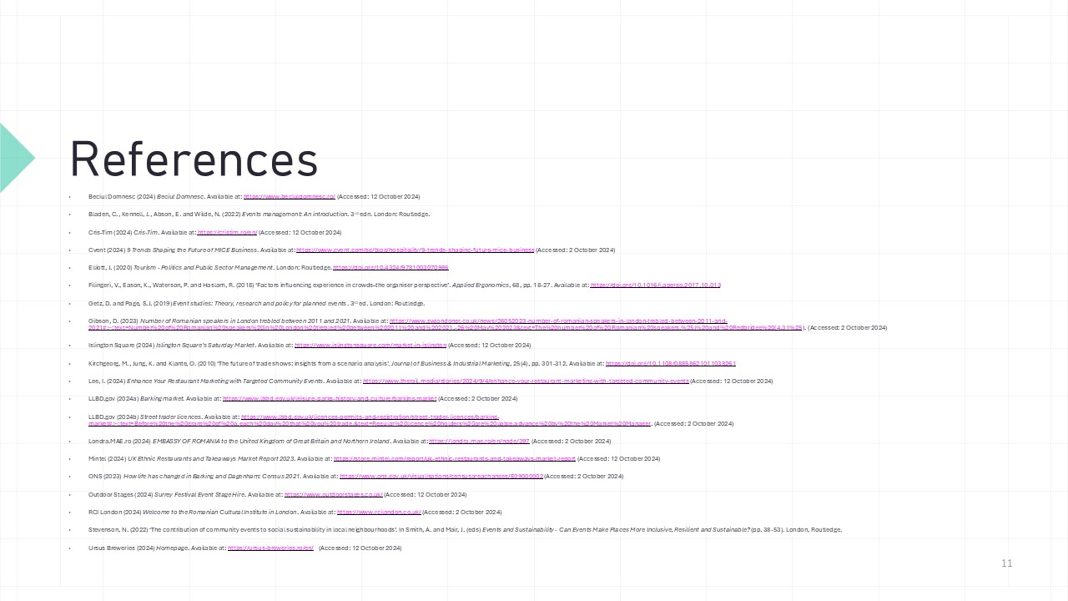
References
Beciul Domnesc (2024) Beciul Domnesc. Available at: https://www.beciuldomnesc.ro/ (Accessed: 12 October 2024)
Bladen, C., Kennell, J., Abson, E. and Wilde, N. (2022) Events management: An introduction. 3rd edn. London: Routledge.
Cris-Tim (2024) Cris-Tim. Available at: https://cristim.ro/en/ (Accessed: 12 October 2024)
Cvent (2024) 9 Trends Shaping the Future of MICE Business. Available at: https://www.cvent.com/sg/blog/hospitality/9-trends-shaping-future-mice-business (Accessed: 2 October 2024)
Elliott, J. (2020) Tourism - Politics and Public Sector Management. London: Routledge. https://doi.org/10.4324/9781003070986
Filingeri, V., Eason, K., Waterson, P. and Haslam, R. (2018) ‘Factors influencing experience in crowds–the organiser perspective’. Applied Ergonomics, 68, pp. 18-27. Available at: https://doi.org/10.1016/j.apergo.2017.10.013
Getz, D. and Page, S.J. (2019) Event studies: Theory, research and policy for planned events. 3rd ed. London: Routledge.
Gibson, D. (2023) Number of Romanian speakers in London trebled between 2011 and 2021. Available at: https://www.swlondoner.co.uk/news/26052023-number-of-romanian-speakers-in-london-trebled-between-2011-and-2021#:~:text=Number%20of%20Romanian%20speakers%20in%20London%20trebled%20between%202011%20and%202021,-26%20May%202023&text=The%20number%20of%20Romanian%20speakers,%25)%20and%20Redbridge%20(4.31%25). (Accessed: 2 October 2024)
Islington Square (2024) Islington Square’s Saturday Market. Available at: https://www.islingtonsquare.com/market-in-islington (Accessed: 12 October 2024)
Kirchgeorg, M., Jung, K. and Klante, O. (2010) ‘The future of trade shows: insights from a scenario analysis’. Journal of Business & Industrial Marketing, 25(4), pp. 301-312. Available at: https://doi.org/10.1108/08858621011038261
Lee, I. (2024) Enhance Your Restaurant Marketing with Targeted Community Events. Available at: https://www.therail.media/stories/2024/9/4/enhance-your-restaurant-marketing-with-targeted-community-events (Accessed: 12 October 2024)
LLBD.gov (2024a) Barking market. Available at: https://www.lbbd.gov.uk/leisure-parks-history-and-culture/barking-market (Accessed: 2 October 2024)
LLBD.gov (2024b) Street trader licences. Available at: https://www.lbbd.gov.uk/licences-permits-and-registration/street-trader-licences/barking-market#:~:text=Before%20the%20grant%20of%20a,each%20day%20that%20you%20trade.&text=Regular%20licence%20holders%20are%20liable,advance%20by%20the%20Market%20Manager. (Accessed: 2 October 2024)
Londra.MAE.ro (2024) EMBASSY OF ROMANIA to the United Kingdom of Great Britain and Northern Ireland. Available at: https://londra.mae.ro/en/node/397 (Accessed: 2 October 2024)
Mintel (2024) UK Ethnic Restaurants and Takeaways Market Report 2023. Available at: https://store.mintel.com/report/uk-ethnic-restaurants-and-takeaways-market-report (Accessed: 12 October 2024)
ONS (2023) How life has changed in Barking and Dagenham: Census 2021. Available at: https://www.ons.gov.uk/visualisations/censusareachanges/E09000002 (Accessed: 2 October 2024)
Outdoor Stages (2024) Surrey Festival Event Stage Hire. Available at: https://www.outdoorstages.co.uk/ (Accessed: 12 October 2024)
RCI London (2024) Welcome to the Romanian Cultural Institute in London. Available at: https://www.rcilondon.co.uk/ (Accessed: 2 October 2024)
Stevenson, N. (2022) ‘The contribution of community events to social sustainability in local neighbourhoods’. In Smith, A. and Mair, J. (eds) Events and Sustainability - Can Events Make Places More Inclusive, Resilient and Sustainable? (pp. 38-53). London, Routledge.
Ursus Breweries (2024) Homepage. Available at: https://ursus-breweries.ro/en/ (Accessed: 12 October 2024)

