

Research Project

Project Title: Research on the design of intelligent systems
for Chinese elderly home care

University : UWTSD
Programme: Professional Doctorate Art & Design
Student name: Qianqian Hu
Student ID number: 1913919
Tutor’s name: Timi O’Neill
Submission date: August 22, 2022
Module code: ADAD7019
Word count: 4235

Table of Contents:

1 Introduction 3
2 Objectives of the study .......... 4
3 Project Investigation 5
4 Collation and analysis of research data 10
5 Intelligent Systems for Aging in the Home 15
Reference List 20

1 Introduction
In today's society, the issue of population ageing is becoming more and more prominent and is receiving attention from all sectors of society. Population ageing refers to a situation where the proportion of young people is decreasing and the proportion of older people is increasing as society moves forward. According to the United Nations demographic standards, a country or region has entered a state of population ageing if more than 10% of its population is over 60 years of age, or if more than 7% of its population is over 65 years of age.
In this context, the issue of support for the elderly is a matter of concern and importance. Unlike the Western concept of old age, the concept of "raising children for old age" has existed since ancient times, and the introduction of family planning in 1982 has led to a situation where a couple now has to support four elderly people and one child at the same time. Children are often unable to balance the demands of work and life, and support for the elderly should be more than just financial and material contributions, but more than spiritual companionship and care.
With the emergence of new technologies such as the Internet of Things and intelligence, the concept of intelligent ageing has become well known and the use of new technologies to improve the quality of life of the elderly has become a new design idea. Through the use of new methods such as sensor technology, RFID technology and embedded system technology related to the Internet of Things, it will change the way of life of the elderly in their homes, making interoperability between people, people and things, and things and things. On the one hand, the elderly can control their smart homes through hands-on operation and achieve self-care in their daily lives through a convenient experience; on the other hand, their children can receive various data information generated from the elderly's home life through intelligent devices, so as to keep abreast of the elderly's home life. In short, the use of new technologies such as the Internet of Things can change our lives to a great extent, and can solve some of the things that could not be solved without new technologies.

2 Objectives of the study
The design study for the elderly in their homes is a way for our designers to use intelligent new technology from the user's perspective to maximise the various needs of the elderly in their home life. For the society as a whole, it helps to help the elderly to improve their home life, enhance the quality of their life, meet their physical and psychological needs, relieve the pressure of their children's support, and solve the social problems brought about by the ageing of the population. For theoretical research, based on new technologies such as the Internet of Things, coupled with analysis of the physiological and psychological aspects of the elderly as a population, and then intersected with multiple disciplines such as product design, attempts are made to describe intelligent system solutions that can meet the needs of the elderly in their homes, to analyse the system architecture and specific functions, and to explore the functional, usability, experiential and emotional needs of intelligent elderly systems.

3 Project Investigation
Research on Current Products and Technologies
Most of the smart home products on the market today are in the form of a combination of hardware and software, with the products themselves existing as smart hardware that can be controlled through a mobile app. Most of these smart home products take a specific user need as the entry point, and combine new technologies to make the functions and operations of the products meet the individual needs of different users, thus maximising the functions of the products. The smart home product categories that exist in the market today mainly include smart home appliances and smart security. Smart home appliances are different from traditional home appliances in that they enable intelligent control of home appliances, saving time and reducing people's physical work, making life more convenient and comfortable. Through research on the existing smart home appliances on the market, we found that there are a wide range of smart home appliances including: control, lighting, entertainment, kitchen appliances and cleaning in five main areas.
The smart home system is an intelligent home mutual communication platform built on the basis of the home network, and on the basis of this platform, the respective functions of smart home products are realised, allowing users to have an intelligent and humanised home life experience. A complete smart home system includes information processing module, communication module, function driver module and external information interface module, in addition to various types of functional smart hardware products. The information processing module is like the brain of the smart home system, which enables the smart hardware that were originally independent of each other to work together and share information, and any smart home system must have a special information processing module. The communication module is like the nerve of the smart home system, enabling the transmission of information through wired (power carrier) or wireless (infrared, Bluetooth) transmission. The function-driven module exists because of the differences in functionality and implementation between brands of smart products, so the status information of various smart products needs to be converted into understandable binary information for transmission via the function-driven module. The external information interface module is the gateway to the external world for the information of the smart home system, which transmits all kinds of information from inside the home to the Internet, thus realising the sharing of resources.
The current smart home products have a good market prospect, but the variety of products does not have a unified industry system, each brand and enterprise's products are self-contained can not well realize the interconnection and interoperability between smart home products, so the current smart home products market is still in the growth stage. In addition, many smart home products are not really "smart" and do not really solve the deep-seated needs of users. Most of the smart home products are still only for the mass consumer groups, and some groups such as the elderly, children and disabled people who need to be provided with special care have not yet been paid attention to. Smart home application technology has been constantly developing and improving, and the various technologies that have been widely used are beginning to bring more convenient experiences to our lives. However, the current market for smart home products is characterised by the phenomenon that one product corresponds to one technology and only solves a single problem, which leads to technical abuse and waste of resources. Therefore, it is important to consider how to optimise the integration of products and technologies, not to cause technology abuse and waste of resources, and to subtract from the user's cumbersome operations.

Determination of the research population and environment
This research is aimed at the elderly population, with the main objective of observing and exploring their needs in the context of ageing in place. In order to have a clear definition of the target user group, the differences between the elderly groups are analysed in the following three aspects: firstly, the differences in the demand for smart elderly products. As the popularity of smart products in urban areas is much higher than in rural areas, the demand for smart elderly products differs between urban and rural elderly groups due to both economic and environmental constraints. Older people have different living habits in their daily lives, and their experience in using some electrical appliances and smart products is also different due to the difference in their personal literacy. Therefore, they have different experiences in the operation of smart products; thirdly, they have different levels of cognition of smart products. As the cognitive level of the elderly is lower than that of the young, and the cognitive level of the elderly with different cognitive abilities is also very different, we need to take into account the degree of operation and acceptance of smart products by different elderly people.
Through a preliminary analysis of the three differences between the elderly group, as well as taking into account the current situation of the popularity of smart homes. The target group for the research on the demand for smart products for the elderly in their homes is now identified as: elderly people with a certain economic base; elderly people with a certain level of education; elderly people with a certain level of self-care ability and a certain level of cognitive ability in the use of smart products. In terms of living conditions, the main choice was an elderly person living alone in one room or an elderly couple. Their children live in another place or they and their children do not live together normally for other reasons.

Content and methodology of the research
The need for smart products for older people can be quickly identified through field research. Physiologically, by asking them one-to-one and observing their behaviour and life paths, etc. Psychologically, it is possible to sense their emotional changes by talking to them and observing their activities. In order to find out what they are satisfied and dissatisfied with in their existing home care life, to understand their expectations for their future intelligent life, and to find the direction of intelligent system design for home care that meets their needs.
Through the research, we understand the following issues.
A. What problems have the elderly encountered in their ageing-in-place life? In what areas are the most prominent problems?
B. What is the experience of the elderly in using intelligent products? What are their expectations of smart products?
C. What are the requirements for the design of intelligent products for the elderly in their homes due to their physiological and psychological peculiarities?
Through this research, we can analyse the problems encountered by the elderly in their ageing-in-place life from their perspective. With this series of questions in mind, the follow-up design study will be targeted so that the problems of their ageing-in-place life can be solved in a practical way.
The two main methods chosen for the research methodology were observation and interview as the main ways of collecting sample data in the preliminary stage. The observation method was used to find out the behavioural patterns of the elderly in their natural state and their most realistic living conditions through field observations. By observing their behaviour, we analyse their behavioural habits and thinking patterns in their home life, and by recording, collating and analysing them, we summarise the physical and psychological problems they encounter in their home life. The interview method, through a natural and calm interview format, builds a bridge of mutual trust for this interview. Through the setting of some questions from the basic personal situation, daily behavioural habits, acceptance and use of smart products, etc., we explore the problems involving the physiological and psychological aspects of the elderly, and look for new ideas for the design of smart products for ageing in place in their answers, so that we can gain a deeper understanding of In this way, it is possible to gain a deeper understanding of the details that are not covered by the observation method.

4 Collation and analysis of research data
Organising the results of the elderly needs research
The research information from household observations and interviews with people in the process of researching the needs of elderly people in their homes is summarised and the results are analysed using user research methods to uncover the deeper needs behind the behaviour and language of the target users. The questions obtained from the research can be divided into three main categories: daily life, telemedicine and remote communication. Some of these are explicit problems directly pointed out by the target users or directly existing in their lives, while others are hidden problems indirectly discovered through observations and interviews.
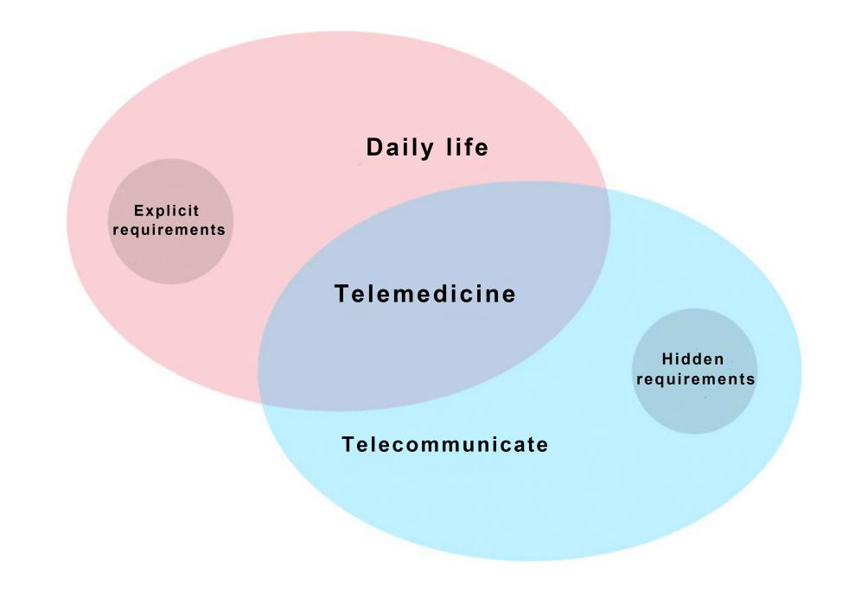
By summarising and analysing the information obtained during the research, we found that the problems of the elderly in their home life can be divided into three main areas: daily life, remote communication and telemedicine.
In terms of daily life, the physical functions of the elderly gradually deteriorate as they age and their quality of life decreases, so they need products that can remind them and help them. As the memory of the elderly grows weaker with age, they are prone to forgetting trivial things in their daily lives, so it is essential to remind and help them in their daily lives. In terms of daily reminders, they include reminders to take medication on time, reminders to use daily household appliances such as boiling water and cooking rice, and reminders on food safety such as shelf life of food. In terms of daily assistance, the main functions include the control of household appliances, the switching on and off of home lighting systems and some time and temperature settings. The elderly, who are not able to protect themselves, are often forgetful and cause disasters, so security and alarm measures for the elderly are also necessary. The main security features include indoor and outdoor surveillance equipment and access control. In terms of alarm measures, the main considerations are water leakage, electricity leakage, gas leakage and fire emergencies.
In terms of remote communication, older people are more vulnerable psychologically and are more likely to feel lonely than other older people, and they need to be cared for and loved by the outside world. Children are the hope and emotional support of the elderly and they need to be cared for by their children, who are often unable to communicate with them due to their busy schedules. This is why it is important to establish a communication channel for them through the use of intelligent devices, so that they can communicate and care for each other remotely and feel the warmth of their families at all times. In addition, many elderly people have a desire to make friends and have a wide range of hobbies and interests, and are eager to lead a colourful life in their old age. By connecting with the community's public service platform and building a community friendship platform for the elderly, we can provide them with information and resources for making friends, leisure and entertainment, so that they can have a
This will enable them to have a more colourful life in their old age.
In terms of telemedicine, as most elderly people still have traditional health concepts, they generally do not go to the hospital for regular medical check-ups and are unable to receive timely treatment for chronic diseases, which makes them much more likely to get chronic diseases. Therefore, it is necessary to use intelligent telemedicine equipment to check the daily physiological indicators of the elderly to reduce the probability of their illness or to inform them of the precautions to be taken for their illnesses. As they grow older, they are also becoming more aware of their health, and it is important that they have access to the right health information for their health conditions. It is also worth considering how to provide emergency assistance in the event of a fall or sudden illness, for example. This is why the use of telemedicine with intelligent means to connect the elderly to the relevant departments of the hospital in their own homes can help to ensure that they have a safe and secure environment.
This is why telemedicine is a smart way of connecting the elderly to the relevant hospital departments, so that they can have a safer life in their old age.

Reflections arising from the research
The research found that older people have clear needs in their home life, but there are still contradictions between these needs and reality. Because their children are not always around to look after them, the elderly may not be able to do the small things that seem to be their responsibility. At the same time, the question of how to get help in the event of an emergency indicates that this group has a greater need than the general population for security in their old age. We need to design them to be able to live independently, but also to be safe. However, most elderly people do not have the habit of having regular medical check-ups and only go to hospital passively when they fall ill, which can lead to aggravation of their condition and delay the best time for treatment. Also, due to living alone, elderly people often do not pay attention to a balanced diet and eat according to their own preferences, which can lead to illness. However, there are also elderly people who are very concerned about their health and will pay attention to their diet, work and rest, and have regular medical check-ups, but they are still not sure about their health condition because of the lack of information or the lack of professional doctors to answer their questions. The lack of communication is the main reason for their isolation and loneliness. The most effective way to alleviate this problem is through the care of their children. The most effective way to alleviate this problem is through the care of their children. Older people want to be connected to the outside world and more communication can reduce their psychological crisis. We are in an era of rapid technological development, where technology is making life more convenient, but the elderly are rarely exposed to smart products and their cognitive abilities are unable to accurately operate the constantly updated smart systems.
The three main needs of the elderly are safety, health and communication, which are the most important aspects of their home life. One of the biggest issues for the elderly is their safety in the home living environment, as this is the primary concern for their life safety. When designing intelligent products for the elderly, we must first try to establish an intelligent system that meets their needs and connects their behavioural activities and daily conditions with their children, communities and hospitals in an intelligent way, so as to fully meet their physical and psychological needs.

5 Intelligent Systems for Aging in the Home
Division of system functions
In terms of home living, the two main categories can be divided into home security and home control. One is home security, which includes both monitoring and alarm. Monitoring is mainly for burglary, or unusual conditions encountered by the elderly at home, while monitoring the indoor and outdoor home environment and security settings for access control. Alarm is mainly for gas leaks, water leaks, electricity leaks, fires, smoke and other disasters caused by the negligence of the elderly or other reasons. The second is home control, which includes both help and reminders. Help is mainly for the elderly in their daily life, such as the daily help of switching on and off, control of home appliances, time setting, etc. Reminders are mainly for daily reminders of events such as taking medication, boiling water, food shelf life, etc. that the elderly often forget due to their declining memory capacity.
With regard to remote control, the two main categories can be divided into telemedicine and telecommunication. One is telemedicine, which includes both medical and health care and emergency assistance. Medical health care mainly focuses on the common and chronic diseases of the elderly to formulate a suitable medical plan for them and provide scientific and reasonable health care knowledge and healthy recipes. Emergency assistance is mainly for elderly people who have fallen at home or need assistance due to some sudden illnesses. The second is remote communication, which includes both child communication and community befriending. The communication between children and the elderly is mainly aimed at remote communication between children and the elderly, as well as allowing children who have been away from home for a long time to be aware of the various developments of the elderly at home and to provide remote care for the elderly. The community befriending programme focuses on recreational activities in the community where the elderly live, and community befriending as a form of social interaction to alleviate the loneliness of the elderly.
In the way of information transmission, various sensor technologies are used to achieve the collection of information and monitoring of the home environment, to complete functions such as burglary, fire prevention, gas leakage prevention, glass breakage alarm and emergency distress. Nowadays, sensors are usually divided into two categories, one is divided by the physical quantity to be measured, and the other is divided by the working principle of the sensor. According to the physical quantity to be measured divided into common sensors are: temperature sensors, humidity sensors, pressure sensors, displacement sensors, flow sensors, liquid level sensors, force sensors, acceleration sensors, torque sensors, etc.. According to the working principle can be divided into: electrical sensors, magnetic sensors, photoelectric sensors, potential-type sensors, charge sensors, semiconductor sensors, resonant sensors, electrochemical sensors, etc. When carrying out specific design practice, the appropriate information transmission method will be selected for application to the product as required.

Description of the system
By dividing the system functions, the intelligent system for the elderly ageing in place is divided into two system types: home based and remote. The description of the intelligent system for elderly people living at home is completed by establishing effective links with third parties such as children, communities and hospitals for problems that may arise in their lives at home.

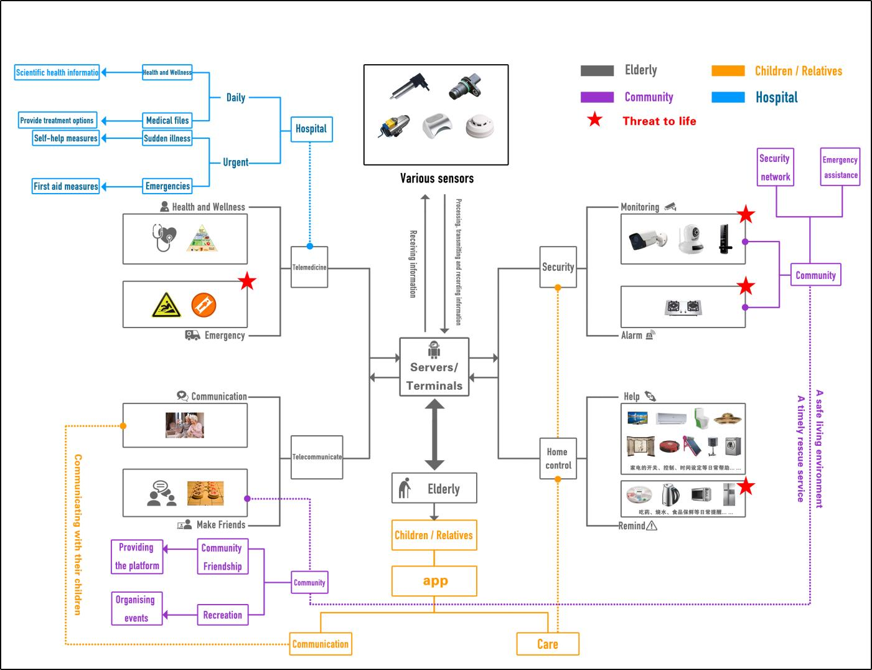
Because of the complex needs that exist for older people in their home living, they are divided into four parts based on the type of need: home security system, telemedicine system, home control system and remote communication system. It is also because all of these systems function to serve the needs of elderly people living at home that they are unified under this larger system. The community and the family, as important vehicles for taking on the needs of the elderly in their homes, need to each take on different tasks and responsibilities. The community is a government-led, policy-guided and legally supervised welfare system, so the main implementer of help from the community is still the government. The government can financially support the operation of non-profit organisations such as community aged care centres, and can also step up publicity efforts to encourage voluntary organisations and volunteers to participate in community services to provide better facilities and door-to-door services for the elderly in their old age. Family is a form of home-based services for the elderly led by relatives and involving children and friends. This process not only allows the elderly to feel cared for by their relatives, but also allows the children and friends to know how the elderly are living so that the family can feel more at ease. In this way, we have established an intelligent system for the elderly in their homes.

Reference List

Christensen, K. et al. (2009) Ageing populations: the challenges ahead, The Lancet (British edition), 374(9696), pp. 1196–1208. DOI: 10.1016/S0140-6736(09)61460-4

Cheng Huan. (2016) Design of intelligent pension System for empty-nesters , Anhui: Anhui Polytechnic University

Du Peng. et al. （2021） Long-term Trends Projection of China’s Population Aging in the New Era, Journal of Renmin University of China

Huang Yi. et al. (2012) Analysis of population aging in China [J]. Chinese Journal of Gerontology, 2012

Li Qingyun.(2015) Research on the design of intelligent home Medical products for the elderly based on Internet of Things, Nanjing University of Science and Technology

Majumder, S. et al. (2017) Smart Homes for Elderly Healthcare-Recent Advances and Research Challenges, Sensors (Basel, Switzerland), 17 (11), pp. 2496. DOI: 10.3390/s17112496

Ni, Q. et al. (2015) The Elderly’s Independent Living in Smart Homes: A Characterization of Activities and Sensing Infrastructure Survey to Facilitate Services

Satpathy, L. (2006) Smart housing: Technology to aid aging in place. New opportunities and challenges, ProQuest Dissertations Publishing.

Sha Yingzi.(2014) Research on intelligent Home Design of urban empty nesters based on Internet of Things, Beijing Jiaotong University

Sun Qichao. (2016) Research on the design and application of smart Home products for the elderly under the combination of medical care service mode, East China University of Science and Technology

Tang Yanwen. (2014) Social Organization and Management of Old-age Care Service , Guilin: Guangxi Normal University Press

Wu L. (2014) Psychological Adjustment Manual for empty-nesters, Hangzhou: Zhejiang Gongshang University Press

Yi Zhou. (2014) Empty Nest: Who Decides My Pension ,Xi 'an: Taibai Literature and Art Publishing House

Zhang Min Sheng.(2015) Urban Empty Nest Research,Beijing: People's Daily Publishing House

Zhang Chen. (2013) Research on the Application of Internet of Things in Security Monitoring System , Tongji University (Software School)

Zhao Yapeng. (2014) Design and research of intelligent home care Interactive System for the elderly living alone in cities , Jiangnan University



