  Component One: Student Journal (learning log) 750 words +/- 10%  Contribution to Overall Module Assessment: 25% | Student No/Name: | 2244870/Mihai Mihalcea
 | Module Title: | Operating Hotel Facilities
 | Module Code: | BMIH 4006
 | Lecturer: | Scott James

Gibbs Model of Reflection

Description
It was my responsibility as a housekeeper to ensure that all guest rooms and common areas were clean and organised. This included dusting, vacuuming, changing sheets, replenishing amenities, and attending to visitor requests. I collaborated with housekeeping to manage inventories and clean them efficiently. As an employee, I helped create a warm and inviting atmosphere, which in turn allowed us to provide our visitors with much better service. Paying close attention to detail was crucial since the hotel is now undergoing renovations and maintenance (Delta Hotels, 2024). Despite the difficulties, keeping the space clean and orderly was essential to minimising visitor complaints. I learned in housekeeping that departmental objectives and the hotel's exceptional hospitality depend on being accurate, precise, collaborative, and strong communicators.

Feelings
A wide spectrum of feelings, from happiness to grief, washed over me during my internship at the Delta Hotel by Marriot Bristol City Centre. I wanted to assist with the hotel's operations since cleanliness affected client satisfaction. The more I delved into the routine tasks of everyday life, the more overwhelmed and dissatisfied I became (Dyrbye et al., 2021). The hotel's constant repairs and refurbishments were so distracting and loud that it was impossible to focus. Guests' complaints about the heat and loudness further added to the already high stress levels. As the guest groups demanded different things, a three-day wedding made it much harder to communicate and stay calm with a lack of housekeepers, but we had to deal with all the mess they made, food even on the hotel lobby floor. Despite these setbacks, I did have certain moments of satisfaction and pride in being a part of a diligent and effective cleaning crew.

Evaluation
I assessed my strengths and areas for improvement throughout my housekeeping internship. My outstanding communication skills and thorough attention to detail allowed me to provide visitors with a clean and enjoyable experience. The frequent remodelling and fast-paced workplace make time management tough. I felt pressured or overwhelmed, which may have harmed my work. I responded to unexpected events and came up with creative answers despite these challenges. Reflecting on my cleaning time revealed my strengths and weaknesses. I want to enhance my time management skills to be productive while juggling several goals. I will also continue to improve my communication skills, which are essential to good service and collaboration. I think reflection and training may help me progress in hospitality (Xu et al., 2022).

Analysis
I discovered how important cleaning is to the Delta Hotel by Marriot Bristol City Centre's business and customers' enjoyment. The department must operate cleanly to help visitors enjoy their stay. The cleaning staff continued to provide exceptional service despite a wedding and renovations. To overcome challenges and meet deadlines, team members needed to communicate and collaborate. Staying positive and focused on customers was crucial (Uslu and Tosun, 2023). This event showed how hotel departments collaborate to satisfy clients. The hotel's restaurant supplied wonderful food, and the engineering team quickly fixed maintenance issues, making customers happier. Moreover, they handle refurbishment well, offering generous refunds and complimentary amenities. They also reimburse taxis and room costs for noise complaints. This experience taught me the significance of continuing education and training in one's job and increased sympathy for the hospitality industry.

Conclusion
I learned a lot about hospitality working at the Delta Hotel by Marriot Bristol City Centre. I've learned that flexibility, detail, and communication are key to organisation. Customers' impressions of the cleaning crew greatly affect their loyalty to the hotel and the number of positive evaluations they provide. The hotel has stressed collaboration and interdependence. Through collaboration with engineering and maintenance, I overcame challenges and ensured a smooth tourist experience. My professional and personal development has improved my communication, scheduling, and problem-solving (Cottrell, 2019). I'm always ready to learn and progress and I'll use any opportunity to further my housekeeping and hospitality profession. The experience and training I have received throughout my internship have prepared me well for a career in the hotel sector.

Action Plan
I strongly suggest various adjustments for the Delta Hotel by Marriott Bristol City Centre housekeeping crew. I want to improve my organisational skills, communication, and detail. I planned to take cleaning best practices courses to improve cleanliness and tourist experience (Raghubalan and Raghubalan, 2016). To improve colleague collaboration, I wish to attend team-building and communication courses. I need to improve my time management to be more productive. To stay current in my industry, I will join relevant online communities, subscribe to relevant periodicals, and attend conferences. I want to use cross-training to discover how the cleaning department influences customers' experiences. In the ever-changing hotel industry, this plan will lead to my development and success. I'm convinced I can succeed in hospitality by studying, increasing my interpersonal and organisational skills, and pursuing cross-functional experience (Williams et al., 2020).

Component Two: Health and Safety Guide
Contribution to Overall Module Assessment: 25%
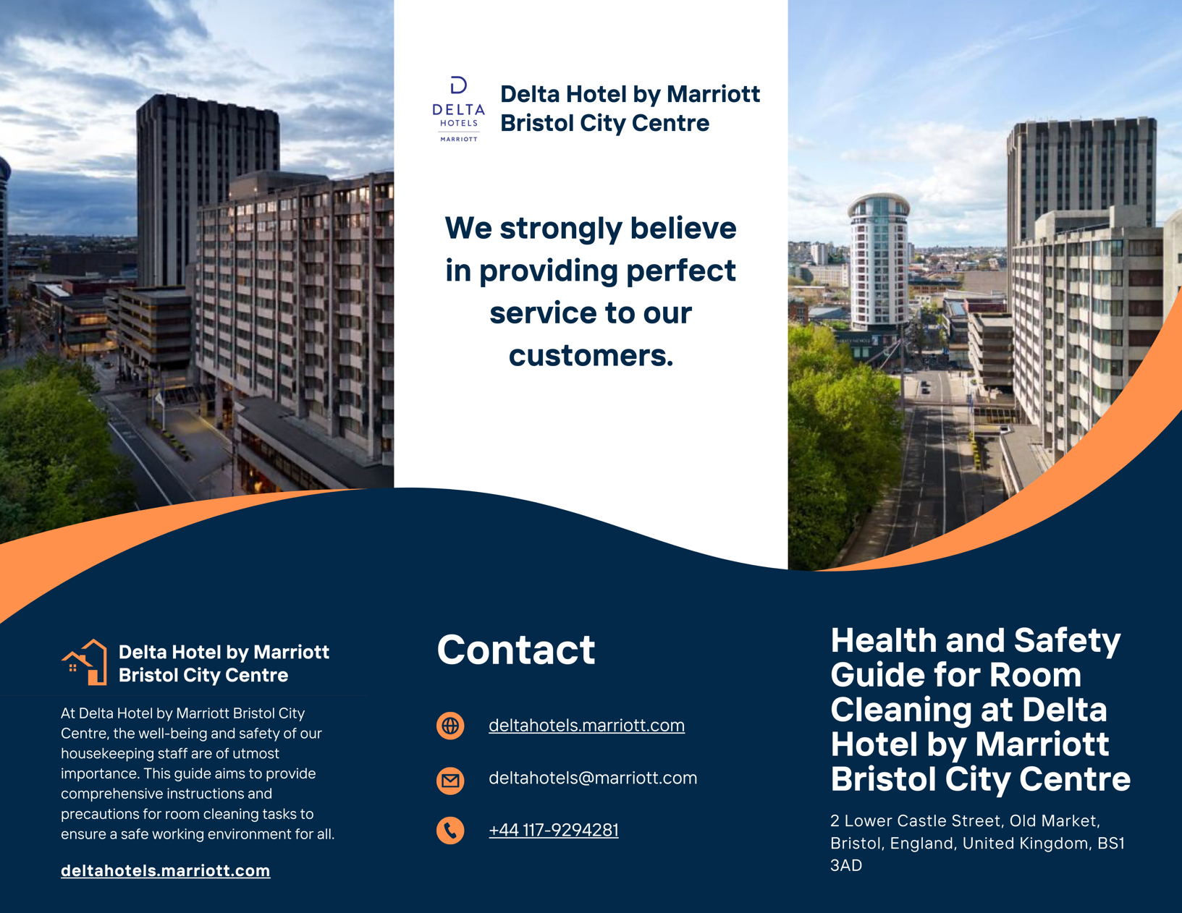
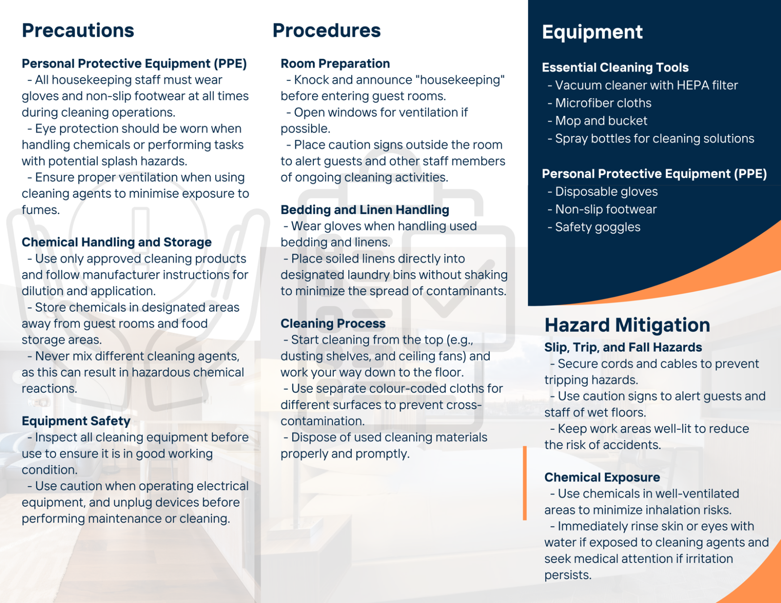

Reference List
Alabi, O.A., Creczynski, T.B. and Adebo, T.C. (2023). Environmental Contamination and Public Health Effects of Household Hazardous Waste. Journal of biomedical research & environmental sciences, 4(9), pp.1323–1340. doi:https://doi.org/10.37871/jbres1801.
Bridger, E. (2018). Employee engagement : A practical introduction. 2nd ed. London: Koganpage.
Cottrell, S. (2019). The Study Skills Handbook. 5th ed. London: Red Globe Press.
Delta Hotels (2024). Hotels & Resorts | Book your Hotel directly with Marriott Bonvoy. [online] Marriott Bonvoy. Available at: https://www.marriott.com/en-gb/default.mi.
Dyrbye, L.N., West, C.P., Kelsey, E.A., Gossard, A.A., Satele, D. and Shanafelt, T. (2021). A national study of personal accomplishment, burnout, and satisfaction with work–life integration among advance practice nurses relative to other workers. Journal of the American Association of Nurse Practitioners, 33(11). doi:https://doi.org/10.1097/jxx.0000000000000517.
Laird, K. and Owen, L. (2020). The role of protective clothing in healthcare and its decontamination. Decontamination in Hospitals and Healthcare, 56(89), pp.209–226. doi:https://doi.org/10.1016/b978-0-08-102565-9.00010-8.
Lovén, K., Gudmundsson, A., Assarsson, E., Kåredal, M., Wierzbicka, A., Dahlqvist, C., Nordander, C., Xu, Y. and Isaxon, C. (2023). Effects of cleaning spray use on eyes, airways, and ergonomic load. BMC Public Health, 23(1). doi:https://doi.org/10.1186/s12889-022-14954-4.
Quick, L. (2020). Managing events : real challenges, real outcomes. London: Sage.
Raghubalan, G. and Raghubalan, S. (2016). Hotel Housekeeping : Operations and Management. 3rd ed. New Delhi, India: Oxford University Press.
Uslu, A. and Tosun, P. (2023). Tourist personality, value co‐creation, and emotional well‐being. International Journal of Consumer Studies, 48(1). doi:https://doi.org/10.1111/ijcs.12995.
Williams, K., Woolliams, M. and Spiro, J. (2020). Reflective Writing. Bloomsbury Publishing.
Xu, J. (Bill), Chung, K.-H.M., Zhang, X. and Tavitiyaman, P. (2022). Fostering Work-integrated Learning in Hospitality and Tourism: An Integration of Leximancer and Students’ Self-reflective Statement Approaches. Journal of China Tourism Research, 18(6), pp.1330–1354. doi:https://doi.org/10.1080/19388160.2022.2047858.

