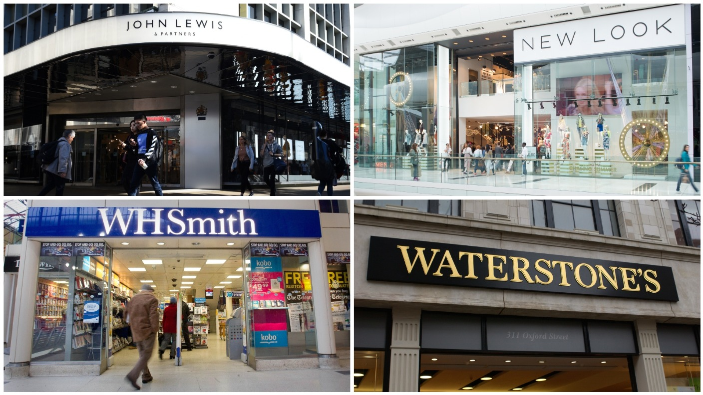  Analysis of External Factors Affecting High Street Retailers in the UK | Employability Skills Module: Problem Solving and Innovation  Module code: BMSW4014  Student: Mrs Barbara Dorota Bak  Student number: 2317808

1. Introduction
The retail sector on High Streets across the United Kingdom has long been a vital part of the national economy. These traditional shopping streets provide not only goods and services but also social spaces that support local communities. However, in recent years, retailers on the High Street have faced significant challenges. Changes in consumer behaviour, rising operational costs, and broader economic uncertainties have all contributed to a challenging trading environment. This report aims to examine the key external factors affecting High Street retailers in the UK, using well-established analytical frameworks such as PESTLE and SWOT. Based on this analysis, the report will conclude with recommendations designed to help retailers adapt and thrive in the face of these ongoing challenges.

2. Analysis of External Factors

2.1 PESTLE Analysis
The PESTLE framework enables a thorough examination of six key external influences on the retail sector: Political, Economic, Social, Technological, Legal, and Environmental factors.
Political
The UK retail sector has been influenced heavily by political changes over recent years, notably the impact of Brexit. The withdrawal from the European Union has created uncertainty in trading relationships, import tariffs, and supply chains. Additionally, ongoing changes in labour laws and tax regulations affect retailer costs and staffing. Government support for the retail industry, especially following the COVID-19 pandemic, has been variable, with limited financial aid and shifting policies, which add to operational difficulties.
Economic
Economic conditions have a direct impact on consumer spending and retail performance. Inflation rates remain high, increasing the cost of living and reducing disposable income for many shoppers. Retailers are also experiencing rising energy prices, higher rental costs for prime High Street locations, and growing wage demands. According to the Retail Insight Network (2025), these factors combine to constrain retail recovery and profitability. Uncertainty around economic growth further complicates business planning for retailers.
Social
Social trends have undergone substantial shifts in recent years. The rise of online shopping has altered consumer expectations for convenience, speed, and product availability. More customers expect multi-channel options, such as click-and-collect or home delivery. There is also a growing demand for sustainable and ethically produced goods. Furthermore, the UK’s ageing population requires retailers to reconsider product ranges and customer service approaches to meet diverse needs.
Technological
Advances in technology present both opportunities and challenges for High Street retailers. Digital point-of-sale systems, customer data analytics, and mobile apps can enhance the shopping experience and improve efficiency. However, adopting these technologies often requires significant investment and new skill sets, which some smaller retailers find difficult to afford or implement. Keeping pace with e-commerce developments is essential to remain competitive.
Legal
The legal environment for retail is evolving rapidly. Regulations concerning consumer rights, data protection (such as GDPR), employment law, and health and safety standards require continuous attention. Compliance costs can be high, and failure to adhere can result in legal penalties or reputational damage. Retailers must stay informed and responsive to these changing rules to operate effectively.
Environmental
Growing environmental awareness influences both consumer behaviour and business practices. Retailers are expected to reduce energy consumption, limit waste, and offer environmentally friendly products. Although implementing green initiatives can involve upfront costs, it can also enhance brand reputation and appeal to increasingly eco-conscious customers. The push towards sustainability is becoming a standard part of retail strategy.

2.2 SWOT Analysis
A SWOT analysis evaluates the internal strengths and weaknesses of retailers alongside the external opportunities and threats they face.
Strengths
- Proximity to local customers enables personal interaction and relationship-building.
- Established physical presence on the High Street supports brand recognition and trust.
- Ability to provide immediate product availability without delivery delays.
- Experienced staff offering personalised customer service.
Weaknesses
- High fixed costs, such as rent and staff wages, which reduce flexibility.
- Limited adoption of modern technologies compared to online competitors.
- Difficulty adapting quickly to changing market trends and consumer preferences.
- Smaller scale of operations, limiting purchasing power and marketing reach.
Opportunities
- Expanding digital sales channels and integrating online-offline experiences.
- Growing consumer interest in local, artisanal, and sustainable products.
- Forming partnerships with online platforms or local businesses to increase visibility.
- Leveraging data analytics to understand customer behaviour and tailor offerings better.
Threats
- Intense competition from large online retailers and out-of-town shopping centres.
- Economic uncertainties affecting consumer confidence and spending habits.
- Increasing regulatory requirements are adding to operational complexity.
- Shifts in consumer habits favouring convenience and digital solutions.

3. Discussion
The retail sector on the UK High Street faces a complex landscape shaped by numerous external pressures. Politically, Brexit has brought ongoing uncertainty, disrupted supply chains, and complicated international trade. Economically, inflation and rising costs limit consumers’ disposable income, directly impacting retail sales. Socially, the shift towards digital shopping and demand for ethical products forces traditional retailers to innovate or risk losing market share.
Technological advancements offer retailers tools to enhance their operations and customer engagement; however, investment barriers persist, particularly for smaller businesses. Legal requirements add another layer of challenge, necessitating constant vigilance and adaptation. Meanwhile, environmental concerns have taken centre stage, with customers increasingly favouring businesses that demonstrate sustainability.
Retailers’ strengths, such as local customer loyalty and immediate product access, remain valuable assets. However, weaknesses such as high overheads and slow digital adoption can weaken competitiveness. Opportunities exist for those willing to invest in technology, adopt sustainable practices, and collaborate with other businesses. Nevertheless, threats from online giants and economic instability require careful strategic management.

4. Recommendations
Based on the analysis, several steps can help High Street retailers improve resilience and seize new opportunities:
- Invest in digital technology and online presence: Developing user-friendly websites, offering online shopping options, and using customer data can enhance sales and customer satisfaction. Combining physical and digital channels (omnichannel retailing) will meet modern consumer expectations.
- Focus on sustainability and local products: Stocking eco-friendly goods and locally sourced products appeals to environmentally aware shoppers and supports community identity. Marketing these values can differentiate retailers from larger chains.
- Build partnerships: Collaborating with other local businesses or integrating with popular online marketplaces can expand reach and share costs. Joint marketing initiatives can also attract more customers to the High Street.
- Enhance customer experience: Train staff to provide personalised service and adapt store layouts to be welcoming and accessible, which will encourage repeat visits.
- Monitor regulatory changes: Staying informed about legal requirements and seeking professional advice where necessary reduces risk and ensures compliance.

5. Conclusion
The UK High Street retail sector is undergoing significant change driven by a combination of political, economic, social, technological, legal, and environmental factors. While challenges are numerous and complex, opportunities exist for retailers that adapt their strategies effectively and remain open to innovation. Embracing technology, prioritising sustainability, and leveraging local strengths can help retailers remain competitive and relevant in the evolving market. Furthermore, by fostering strong relationships with customers and communities, retailers can build loyalty and trust that supports long-term success. By addressing both internal weaknesses and external threats proactively, High Street shops can secure their future in the UK retail landscape and continue to play a vital role in local economies.
References:
CBRE (2025) Retail Market Report 2025. Available at: https://www.cbre.com/insights/figures/retail-market-report-2025 (Accessed: 28 May 2025).
Centre for Retail Research (2024) Retail Forecast 2025–2026. Available at: https://www.retailresearch.org/retail-forecast.html (Accessed: 28 May 2025).
Christie & Co. (2025) Business Outlook 2025 | Retail. Available at: https://www.christie.com/news-resources/business-outlook-2025/retail/ (Accessed: 28 May 2025).
Coresight Research (2024) Retail 2025: UK Retail Predictions. Available at: https://coresight.com/research/retail-2025-uk-retail-predictions/ (Accessed: 28 May 2025).
Deloitte Global (2025) Global Powers of Retailing 2025: Improving effectiveness and unlocking growth in the year ahead. Available at: https://www.deloitte.com/global/en/Industries/retail/research/global-powers-of-retailing.html (Accessed: 28 May 2025).
Deloitte UK (2025) Retail Trends 2025. Available at: https://www.deloitte.com/uk/en/Industries/consumer/perspectives/retail-trends.html (Accessed: 28 May 2025).
Infosys Knowledge Institute (2025) Retail Industry Outlook 2025. Available at: https://www.infosys.com/iki/research/retail-industry-outlook2025.html (Accessed: 28 May 2025).
Mintel (2024) UK Retail Rankings Market Report 2024. Available at: https://store.mintel.com/report/uk-retail-rankings-market-report (Accessed: 28 May 2025).
Retail Economics (2025) Understanding the economic outlook for UK retail to 2025. Available at: https://www.retaileconomics.co.uk/retail-insights-trends/understanding-the-economic-outlook-for-uk-retail-to-2025?slug=presentations (Accessed: 28 May 2025).
Retail Insight Network (2025) Rising costs threaten UK retail recovery in 2025. Available at: https://www.retail-insight-network.com/news/rising-costs-threaten-uk-retail-recovery-in-2025/ (Accessed: 28 May 2025).
RSM UK (2025) Retail industry outlook 2025. Available at: https://www.rsmuk.com/insights/consumer-outlook/retail-industry-outlook (Accessed: 28 May 2025).
The Guardian (2023) Autumn statement will cause higher prices, retailers warn. Available at: https://guardian.pressreader.com/article/282076281622832 (Accessed: 28 May 2025).

Tokio Marine HCC (2025) UK Retail Sector Report 2025. Available at: https://www.tmhcc.com/en/news-and-articles/thought-leadership/uk-retail-sector-report-2025 (Accessed: 28 May 2025).
Verdon, J. (2025) ‘Retail Outlook Positive for 2025, With Spending Expected to Top 3%’, Forbes. Available at: https://www.forbes.com/sites/joanverdon/2025/01/22/retail-outlook-positive-for-2025-with-spending-expected-to-top-3/ (Accessed: 28 May 2025).

