This document will cover the building and implementation of my website. The website created is for musicians planning on travelling around Europe with their instruments on a budget.
Travelling with a Ukulele Website Report.
Understanding how my website was created.
Andrew Cooper (1704746)
Software Engineering
Introduction to Web Development
03/01/18
Contents
Introduction: 1

Introduction:
Within the report the reader will find information concerning the designing and implementation of the website that I created for aspiring travelling musicians. The reader will discover the purpose of the website that has been created as well as who the website is targeted towards. I will also create a site map and other visual aid to illustrate my website and how the pages link to each other. I will show you how I validated both my HTML for my home page and my websites main CSS by using http://validator.w3.org/ and http://jigsaw.w3.org/css-validator/. I will lastly give an evaluation of the website’s accessibility by making regular references to the WCAG 2.0.

Requirements:
The website I created is for people who want to be able to travel but feel they can’t afford to do so. I created the website to give viewers a better understanding of ways in which they could save money when travelling. Within the website I have displayed places in which I feel are good places to travel to should the person want to travel with their ukulele and play music in new places. The target audience for my website are people aged 18 – 28 who want to travel but may not be able to afford a trip around Europe the conventional way. For my website I feel that it is very relevant to the target audience as it gives them useful tips of how to travel while saving money.

Site Map:
Contact Page
contact.html
Where to Travel
whereToTravel.html
What Equipment should I Take? whatEquipment.html
Travelling on a Budget
travelOnBudget.html
Home Page
Index.html

All my pages on my website are linked together which means that no matter what page I am on, I can easily access all of the other pages. I have done this because I feel that it is a much easier way to navigate and is less time consuming for the users of my website.

Wireframe Diagram:
Nav Bar

Body.

Header.
Banner of a Hawaiian sunset.
Footer.
Image of ukulele.

Implementation:
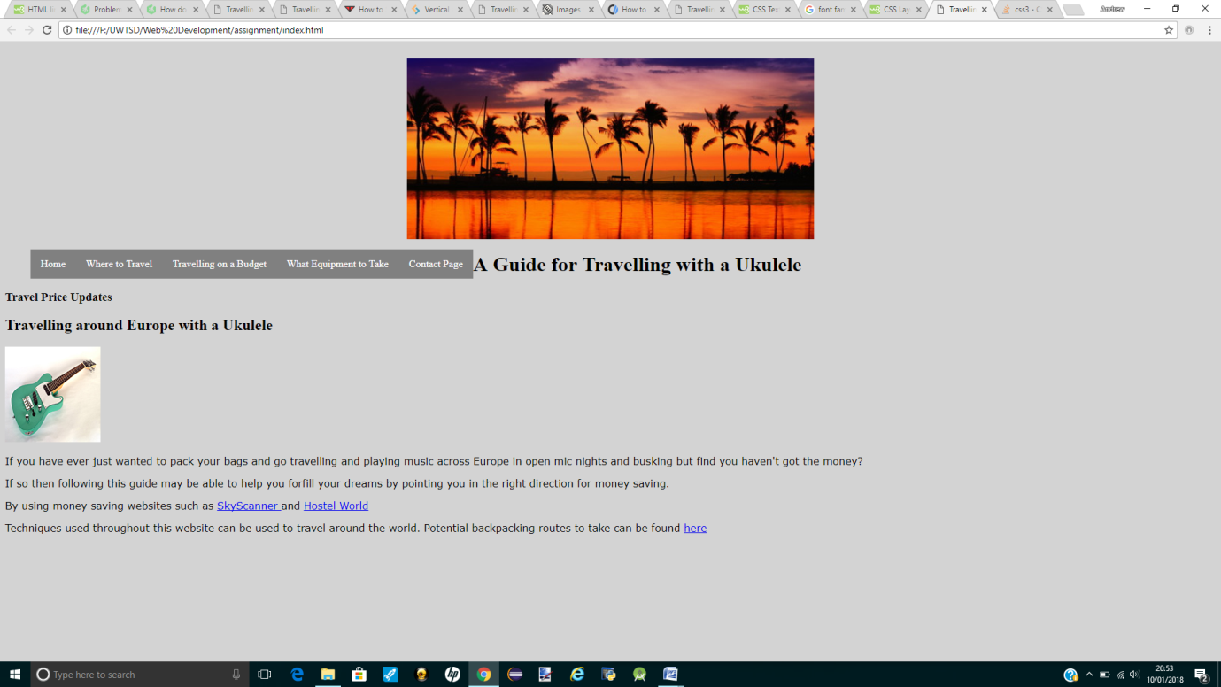

Headings :
I have used appropriate methods of identifying by using the <h1> and <h2> tags to make them standout. I have also changed the fonts of these headings.
Colours of the website:
This is the front page of my website and it's based on pure simplicity. As this is purely a informative website and would have no profitable gain I have created it with a very simplistic design. I have used black and light grey as the text and background as I feel it is easy to read for my users.

Forms:
I have not used any forms in my website as I deemed then unnecessary for my website because of the nature of the information.

Navigation:
I have made my website very effortless to navigate through the pages. Each page is accessible from every page. I have also used hyperlinks within texts to also take users to the required pages. Within my website I have also created both written and image links to lead users to separate websites where they can use their services. To ensure that the user stays on my website I have ensured that the new websites open as in a new tab.

