PROGRAMME: MASTER OF BUSINESS ADMINISTRATION
ASSIGNMENT TITLE: MARKETING ENVIRONMENT ANALYSIS OF BHP
MODULE: MARKETING MANAGEMENT
MODULE CODE: LCMB7024
LECTURER’S NAME: Taonga Kaonga Sobere-Snithers
STUDENT NAME: Jayraj Nathabhai Keshvala
STUDENT ID: 2614288
Word count: 2505

Table of Contents
Task 1: Marketing Environment Analysis 3
1.1 Company overview 3
1.2 Analysis of market environment actors 4
1.2.1 Political, legal, and environmental (PEL) actors influencing BHP’s transition towards lower-carbon products 4
1.2.2 Environmental factors pushing towards transition 10
Task 2: Strategic Growth and Competitive Positioning 13
2.1 Strategic Growth Strategy 13
2.1.1 Applying the Ansoff Matrix 13
2.1.2 Critical evaluation supported by PLC 14
2.1.3 Business unit or portfolio level analysis 16
2.1.4 Risk-adjusted Ansoff evaluation 16
2.2 Competitive Advantage and Positioning 17
2.2.1 Applying Porter’s Generic Strategies 17
2.2.2 Strategic competitor matrix 18
2.3 Brief Strategic Synthesis 19
Task 3: Managerial and Professional Reflection 21
3.1 Rationale for Company Selection 21
3.2 Reflection on Environmental Analysis Decision 21
3.3 Reflection on Strategic Growth Decisions 22
3.4 Limitations and Gaps in the Analysis 23
3.5 Information Required Before Final Recommendation 23
3.6 Professional Learning and Reflection 23
References 24

Task 1: Marketing Environment Analysis

1.1 Company overview
BHP Group Limited is one of the highest-value companies in the global metal and mining sector. The company generated revenue of US$58.76 billion in FY26. EBITDA was US$32.9 billion, and profit was US$13.20 billion in 2026 (Macro trends, 2026). Moreover, the external factors include environmental, political, and legal factors.
This puts pressure on BHP to transition to lower-carbon products to capture market opportunities in green steel and sustainable mining. Also the study help BHP to adopt sustainable initiatives to overcome the pressure.
As suggested by Kotler et al. (2024), most of the primary producers face rising pressure from the institutional investors and the end users to get the transparent roadmaps.
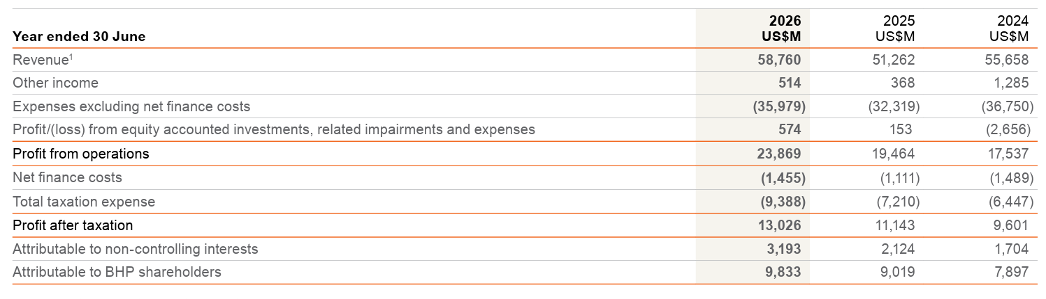
Figure 1: The Financial Performance of BHP
(Source: BHP Annual Report, 2026)
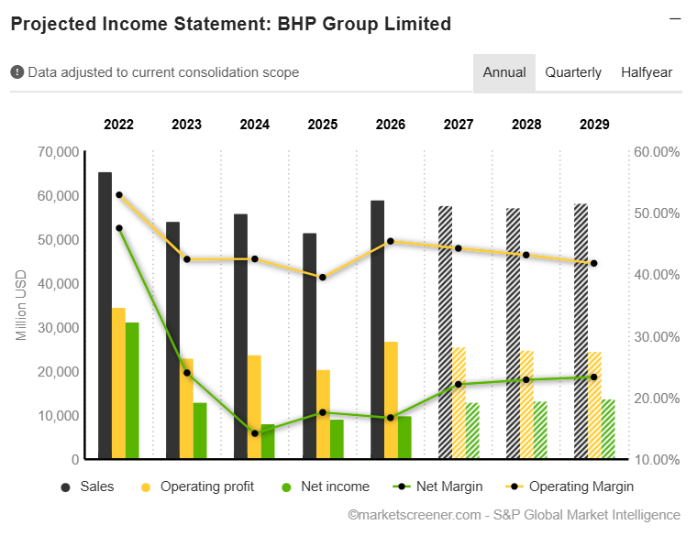
Figure 2: The net revenue of BHP
(Source: Market Screener, 2026)

1.2 Analysis of market environment actors

1.2.1 Political, legal, and environmental (PEL) actors influencing BHP’s transition towards lower-carbon products
Political environmental actor
- Australia’s safeguard mechanism is administered under the National Greenhouse and Energy Reporting (NGER) framework. This is mandatory for the baseline emissions intensity to reduce by 4.9% per year and to emit over 100,000 CO₂e annually.
- This policy directly impacts BHP’s Western Australia Iron Ore (WAIO) and the “Queensland metallurgical coal operations (BMA)” (ICAP, 2026). This mostly covered the net emissions in Australian safeguard facilities reached 132.8 Mt CO₂e in FY25-26 (Clean Energy Regulator Safeguard Data, 2026). The legislative pressure directly exposes BHP to financial penalties (CER, 2026).
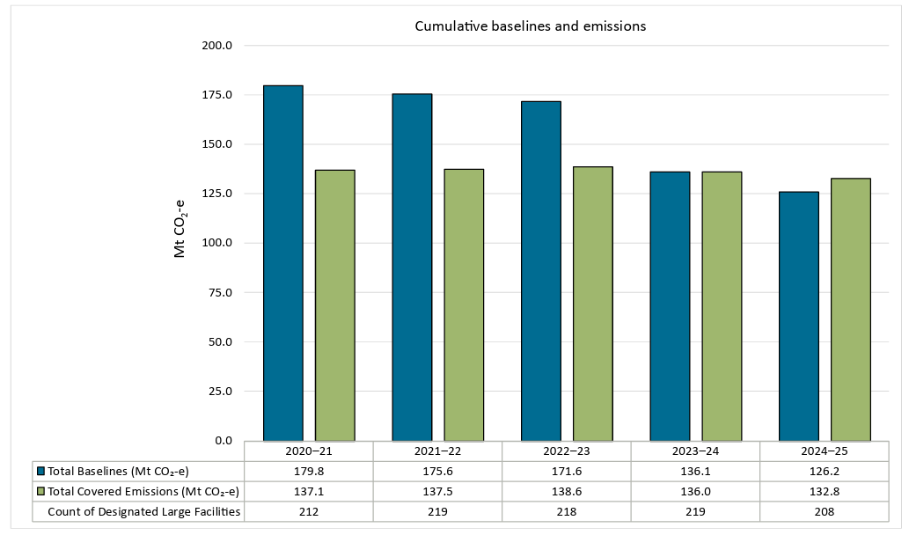
Figure 3: CO₂ emission intensity of BHP operational sites
(Source: Clean Energy Regulator Safeguard Data, 2026)
- Internationally, the political mechanism also includes the European Union’s carbon Border adjustment mechanism (CBAM) and the tariff push by BHP. It helps to reduce direct emissions in their value chains. To overcome this issue, BHP developed a decarbonised partnership with the Asian steelmakers.
- This international political cross-border traffic can create higher risk margin erosion for BHP’s B2B clients (Global Efficiency Intelligence, 2026; BHP Group, 2026).
- The cross boarder carbon equalization tariffs like CBAM enhances the landed costs for carbon-intensive primary commodities.
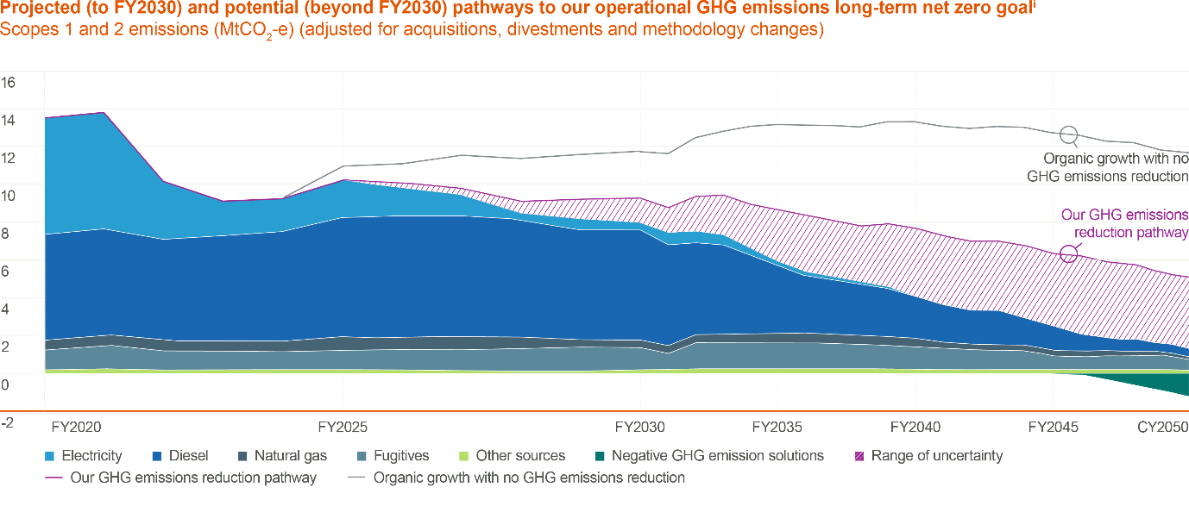
Figure 4: Potential exposure reduction trend over time
(Source: BHP Group, 2026)
- To power domestic assets' sustainability, BHP co-founded renewable infrastructure projects across the Pilbara micro grid.
- This integrates 200 MV of solar power and battery storage to reduce dependence on gas turbines. This green energy transition can ensure a long-term energy process (CER, 2026; BHP Group, 2026).
Legal environmental actor
- Nationally, under the mandatory climate rules forced by the Australian Securities and Investments Commission (ASIC), the “International Sustainability Standards Board (ISSB S1/S2) requirements” are voluntary. BHP needs to publish a detailed annual greenhouse gas report. In 2026, BHP reported 9.4 Mt CO₂e of combined Scope 1 and Scope 2 operational emissions (BHP ESG Data book, 2026).
- Also, 382.5 Mt CO₂e of Scope 3 emissions from steelmaking customer processing (BHP ESG Data book, 2026). This legal transparency forces BHP to track value chain carbon liabilities. It directly influences the ESG rating scores (ASIC, 2026; BHP ESG Data book, 2026). With the help of the legal auditing under ASIC this minimize the corporate greenwashing risks.
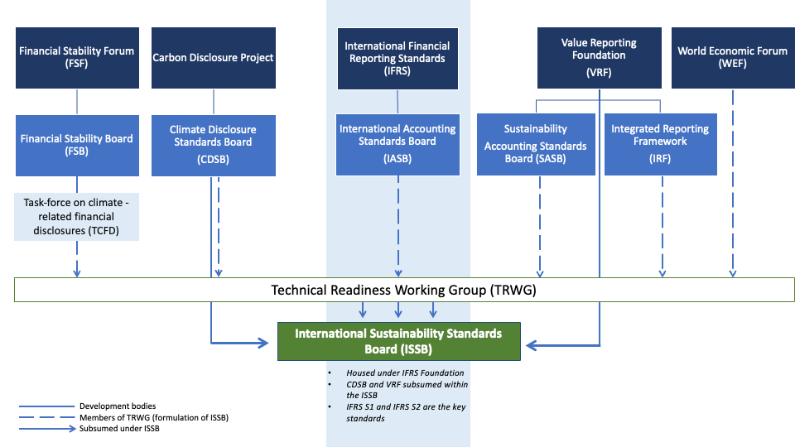
Figure 5: Proper guide to mandatory climate reporting in Australia
(Source: ASIC, 2026)
- Internationally, regulatory pressure creates pressure. In South America, strict water extraction limits the Escondido copper mine. This pressurized BHP to invest over $4 billion in industrial seawater desalination plants. This helps to eliminate the groundwater draw.

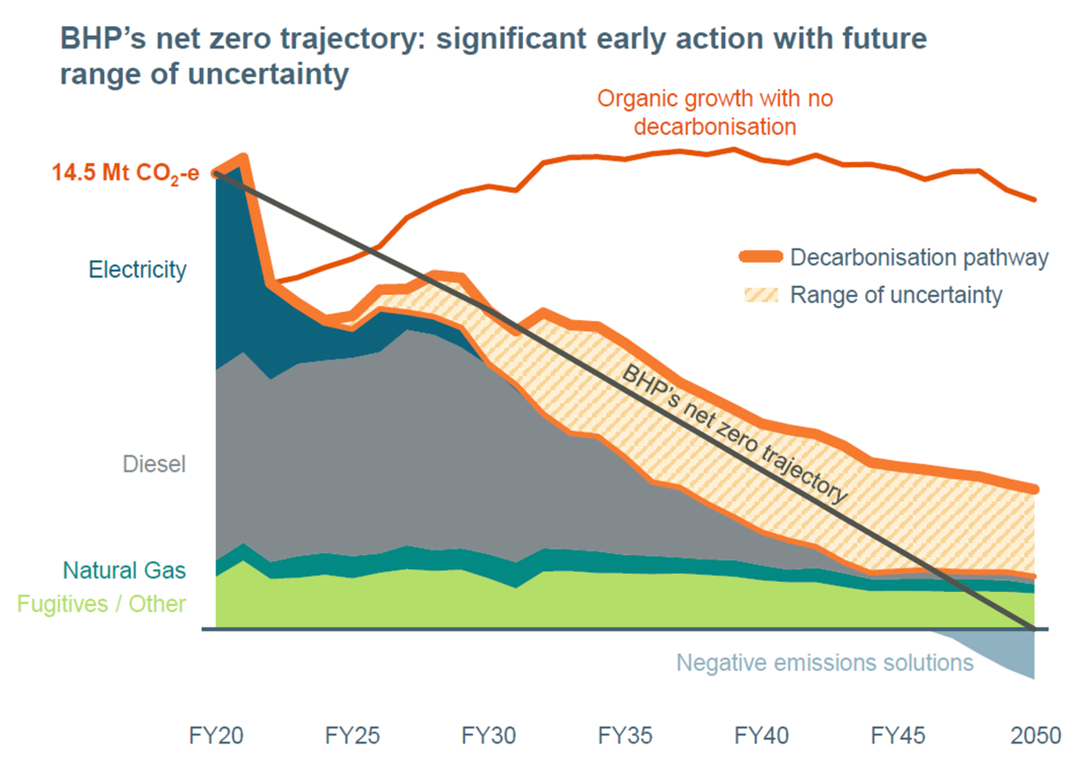
Figure 6: The CO₂ emissions by BHP
(Source: BHP Group, 2026)
Environmental actor
- The environmental factors force BHP to take a sustainable product and operational transformation. The global ore grade degradation mostly extracts the larger rock volumes. As suggested by Stroykov et al. (2026), this determined the energy intensity with the help of the volume.
- BHP’s average iron ore grade across the pits declined from 62% Fe content to 60.8% Fe. This drive the higher energy consumption per tonne. The decline of physical resources forces BHP to use advanced processing and high-grade selection (Fast markets, 2026).
- The downstream B2B automotive customers, such as BMW and Volkswagen, demand sustainable copper and battery nickel supply. This is to fulfil the corporate net-zero commitments and lower Scope 3 footprints.
- The ESG-driven investors' pressure also impacts the capital evaluation process. BHP faced equity price volatility during Q1 of 2026 (PwC, 2026; ICMM, 2026). The automotive OEMs prioritize the main resource suppliers by offering proper carbon traceability. This directly risks the loss of long term contracts (Kotler et al., 2024).
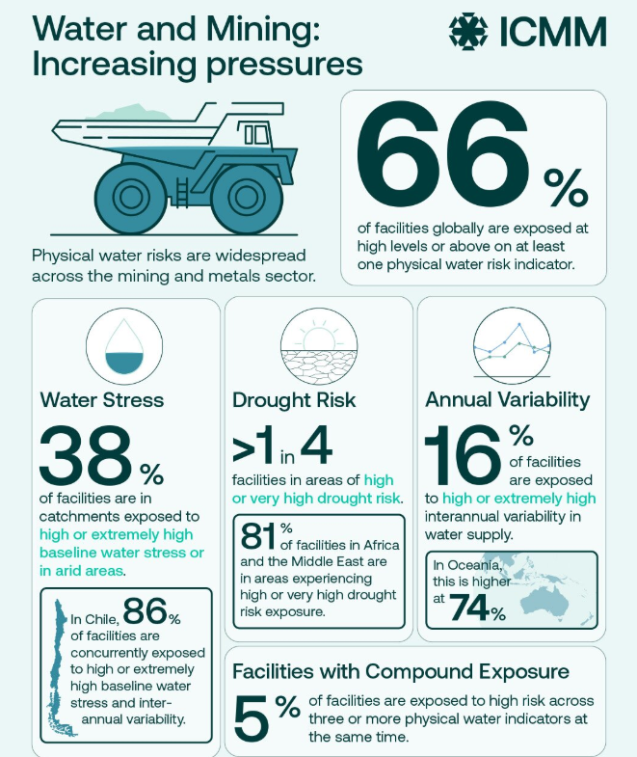
Figure 7: Water and mining increase pressure
(Source: ICMM, 2026)

1.2.2 Environmental factors pushing towards transition
The global mining and metals extraction sector is highly energy-intensive. This accounts for almost 25% of the industrial emissions globally (Global Energy Intelligence, 2026). The change towards decarbonised extraction via battery electric hauling fleets and zero-carbon processing is effective for long-term viability.
Resource scarcity: Resource scarcity is the main environmental driver. Using the high-grade mineral reserves focuses market leaders on developing proper, beneficial technologies. The lower-grade ores offer high-quality lump iron ore, which helps steelmakers to reduce coking coal intensity (Amegboleza and Ülkü, 2025). This structural deficit in the natural high-grade ores connects to BHP investing in the infrastructure to maintain the premium B2B products (Fast markets, 2026).
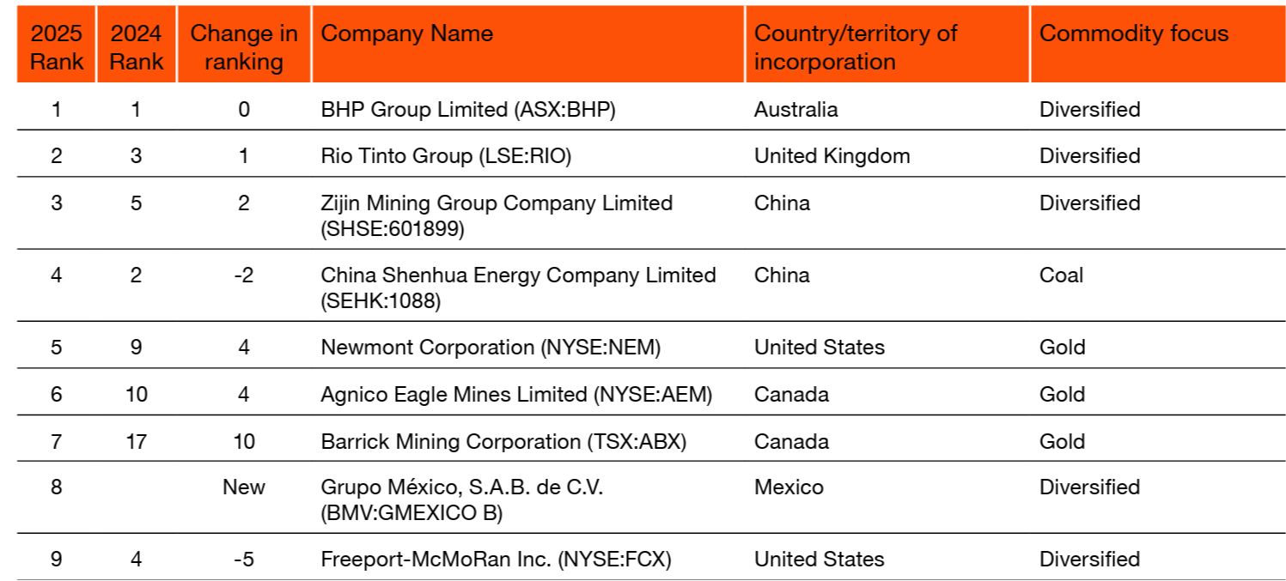
Figure 8: Top 9 mining companies as per resources
(Source: PwC, 2026)
- Opportunity: Beneficiation and scrap integration help BHP to reduce the site processing emission intensity by 15 to 20%. The maximum mineral recovery rates compliance credits under the safeguarding mechanism of Australia (Clean Energy Regulator Safeguard Data, 2026). Generating tradeable safeguard related to credits lowers corporate tax burdens. Along with that, developing overall operational EBITDA margins across Western Australian iron ore sites (CER, 2026).
- Challenge: Higher dependence on the global scrap market and underdeveloped green hydrogen infrastructure can limit large-scale production. The lack of a national green hydrogen supply chain can restrict the commercial-scale deployment of DRI steelmaking.
Environmental pollution: The main extraction activities bear the environmental pollution liabilities. Almost 38% of the global mining facilities operate in regions with tighter baseline water stress. BHP targeted a freshwater consumption reduction to 1.22 m³/t of material processed in 2026. Moreover, the implementation of Zero Liquid Discharge (ZLD) systems and dry stack tailings can protect the regional watersheds. As suggested by Paul (2026), controlling air dust and tailings leakage can mitigate higher ecological degradation. The elimination of the tailing run off and the air pollution protects the regional biodiversity process (Paul, 2026). It needed to secure the proper social license to operate within the local ecosystem process.
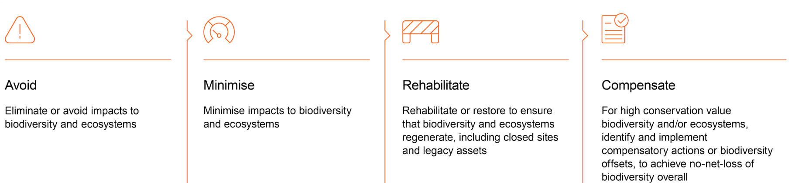
Figure 9: The sustainability initiatives taken by BHP
(Source: BHP Group, 2026)
- Opportunity: The adoption of ZLD can prevent regulatory fines. This also secures the local operational permits. As suggested by Araújo and de Medeiros (2024), it helps with water supply during the drought cycles. Moreover, maintaining operational continuity during severe climate events can protect the corporate revenue of the company (ICMM, 2026). Closed-loop water recycling guarantees stable processing and safeguard the long term production process.
- Challenge: The transition of legacy mining assets to ZLD and dry stacking needs the proper capital expenditure. This compresses the operational margins. The higher capital allocation in the non-revenue-generating waste infrastructure can reduce the short-term cash flow process.

Task 2: Strategic Growth and Competitive Positioning

2.1 Strategic Growth Strategy

2.1.1 Applying the Ansoff Matrix
Strategy vector | Relevance | Core strategic rationale
Product development | High (Primary Vector) | Develop the certified low-carbon commodity variants such as eco-copper with sub-0.5 tCO₂e/t intensity. For the previous B2B industrial clients this can reduce the Scope 3 liabilities ( Hossain et al., 2026)
Market development | Medium–high (Secondary vector) | Develop green copper and potash exploration in the carbon-regulated part. This is mostly in European battery gigafactories and the North American market.
Market penetration | Low–medium (Baseline) | Harvest the cash flow from the WAIO and BMA by managing rising carbon baselines under the safeguard mechanism of Australia.
Diversification | Low (Unfavourable) | Non-mining operational risks and high capital intensity make non-core diversification necessary (Vigil et al., 2025).
Table 1: Ansoff matrix application
(Source: Self-developed; BHP Annual Report, 2026; Zugay, 2023)
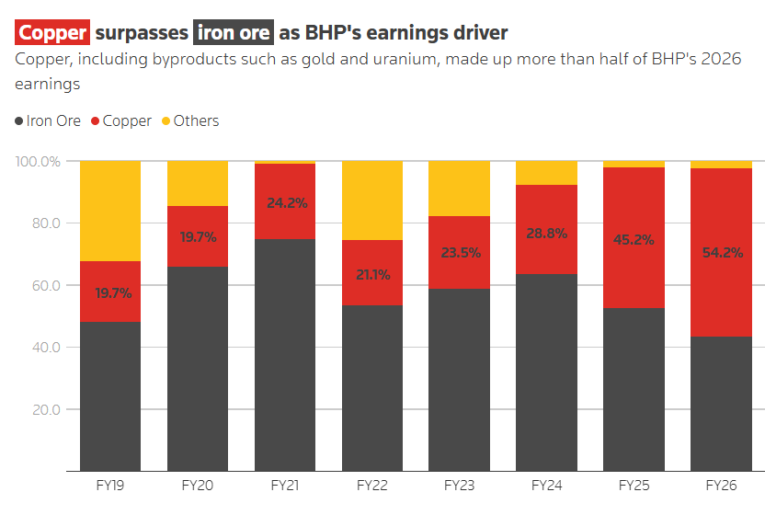
Figure 10: BHP profit tops estimates as copper powers growth
(Source: Reuters, 2026)

2.1.2 Critical evaluation supported by PLC
The main strategic growth venture for BHP is Product Development. The application of the Product Life Cycle (PLC) framework to high-carbon mineral extraction assets. As suggested by Bukhari and Bukhari (2025), the Maturity and Decline stage is due to the legal carbon limits and CBAM import penalties. On the other hand, certified sustainable commodities such as eco copper and high-grade iron ore are in the growth and introduction stage. BHP uses B2B relationships with OEMs such as Tesla and BMW (Reuters, 2026).
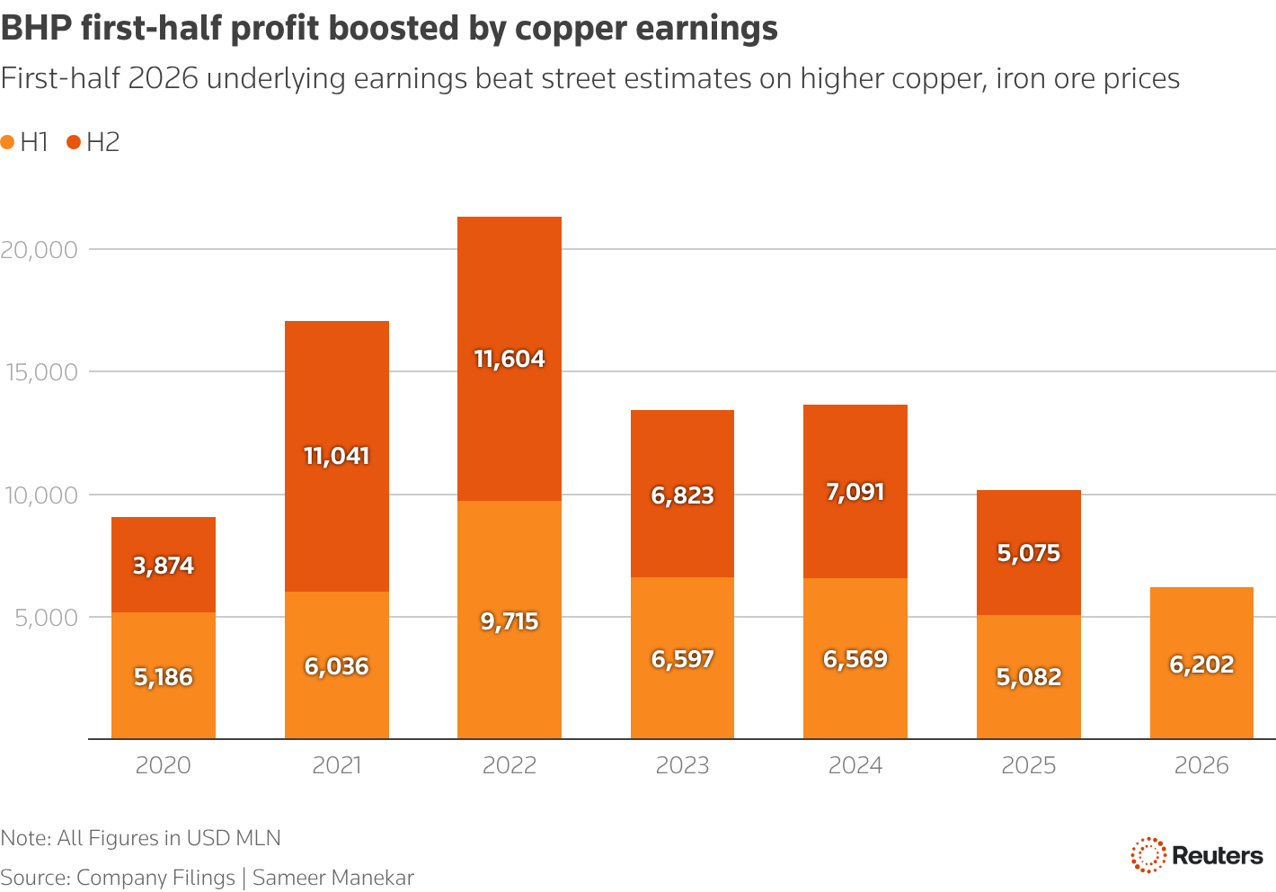
Figure 11: BHP’s first half profit boosted by Copper earnings
(Source: Reuters, 2026)
The growth process is aligned with Porter’s Focused Differentiation strategy. It provides third-party carbon traceability with the help of digital provenance platforms. BHP shows price premiums from B2B customer target the Scope 3 compliance (Insights IAS, 2026).

2.1.3 Business unit or portfolio level analysis
Category | Product line/ Asset | Strategic action
Cash cows | WAIO Iron Ore Operations | Harvest operational cash flows such as $18B+ EBITDA to fund decarbonization technology (BHP Group, 2026).
Stars | Escondida & Copper South Australia | Develop production towards ~2 MtPA; allocate CapEx to capture electrification demand (Reuters, 2026).
Question marks | Green Hydrogen DRI & CCUS Partnerships | Joint venture R&D investments to determine the viability before scaling.
Dogs | Legacy High-Emission Thermal Coal | Phased divestment to eliminate the long-term carbon liabilities.
Table 2: Growth-share strategies of BHP
(Source: BHP Annual Report 2026; PwC Mine 2026 Report)

2.1.4 Risk-adjusted Ansoff evaluation
- Product development risk: Higher CapEx requirements, such as $10.2B in FY26, and technological delays in electrification (ICAP, 2026). This can mitigate the 70% EBITDA margin in copper.
- Strategic verdict: The product development optimizes the risk-return balance process. This helps to get 18.5% of ROCE and generate almost $9.8 billion in free cash flow. It helps to develop portfolio resilience.
- Market development risks: The cross border trade protectionism and CBAM regulations to manage with the joint ventures with Asian Steelmakers.

2.2 Competitive Advantage and Positioning

2.2.1 Applying Porter’s Generic Strategies
BHP is transitioning from cost leadership to focused differentiation across the premium mineral portfolio. BHP further uses the low-cost WAIO asset base to finance the site. Moreover, the investment of $1.8 billion in renewable microgrids delivers and the low carbon commodities (Mining.com.au, 2026). BHP is emerging from the price wars with the high-emission miners and Vale. The premium position is developed by the carbon provenance and supports the EBITDA margins, which are almost 60% in 2026.
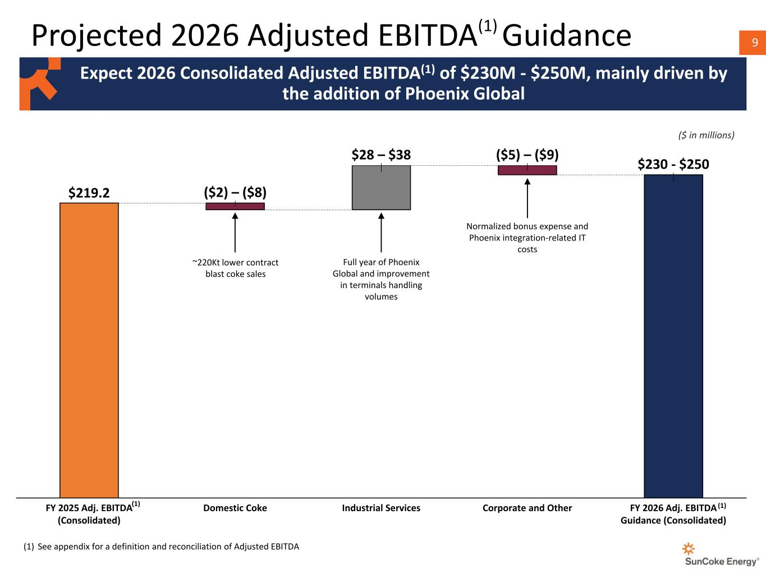
Figure 12: Projected 2026 Adjusted EBITDA of BHP
(Source: BHP Group, 2026)

2.2.2 Strategic competitor matrix
Metric | BHP | Rio Tinto | Fortescue (FMG)
Revenue growth | $58.76 Billion (+9.2%) | $54.10 Billion (+3.1%) | $18.20 Billion (-1.4%)
Underlying EBITDA | $32.90 Billion (~56.0%) | $25.30 Billion (~46.8%) | $8.75 Billion (~48.1%)
CO₂ Intensity Target | -30% by 2030 (Net Zero 2050) | -50% by 2030 (Net Zero 2050) | Real Zero by 2030
Waste generate | ~240 Mt/year total waste & tailings managed | ~210 Mt/year total mineral waste | ~145 Mt/year mineral waste
Air pollution rate | Low-to-medium (PM10: ~0.85 kg/t material processed) | Medium (PM10: ~1.10 kg/t material processed) | Medium (PM10: ~1.25 kg/t material processed)
Energy consumption | ~310 Petajoules (PJ) total energy | ~410 Petajoules (PJ) total energy | ~165 Petajoules (PJ) total energy
Table 3: Competitive market scenario
(Source: BHP Annual Report 2026; Rio Tinto, 2026; Fortescue, 2026)
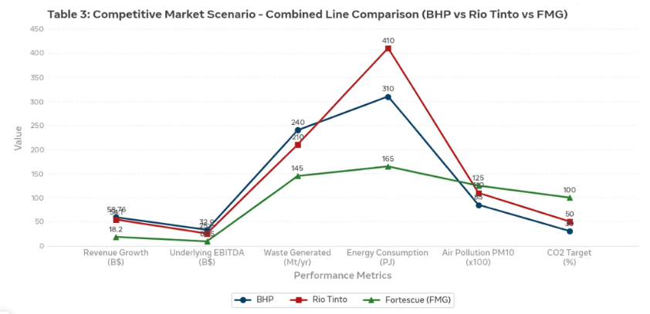
Figure 13: The comparative analysis between BHP, Rio Tinto, and Fortescue
(Source: Self-developed)

2.3 Brief Strategic Synthesis
BHP operates the first-mover green initiatives under the Climate Transition Action Plan. The development of the brand process and driving operations performance, along with regulatory compliance. As suggested by Paul (2026), these systematic professions help to build B2B trust controls and manage climate-related operational risks. This secure long-term co-development partnership will integrate the customer's decarbonization roadmaps.
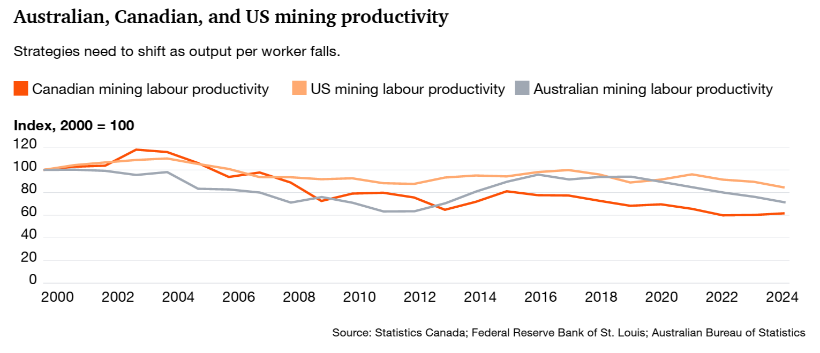
Figure 14: The comparison of mining productivity
(Source: PwC, 2026)

Task 3: Managerial and Professional Reflection

3.1 Rationale for Company Selection
The selection of the BHP Group is effective as it has an effective market scale and a high-impact role on the primary suppliers. The reported revenue of $58.76 billion and an underlying EBITDA of $32.90 billion in FY26 show the strong financial performance (BHP Annual Report 2026). BHP also operates across the energy-intensive primary assets, including iron ore, coal, and copper. The company’s commitment to reducing emissions also provides a proper case to determine the modern marketing environment across the growth strategies.

3.2 Reflection on Environmental Analysis Decision
The selection of political, legal, and environmental markets helped in the structured evaluation of the external environment analysis. With the help of the analysis, I recognise that these three environmental factors are deeply connected. The political factors such as Australia’s Safeguard Mechanism of 4.9% annual baseline reduction, were effective (ASIC, 2026). Similarly, the legal process under NGER and ASIC reporting rules also impacted BHP along with the industry process.
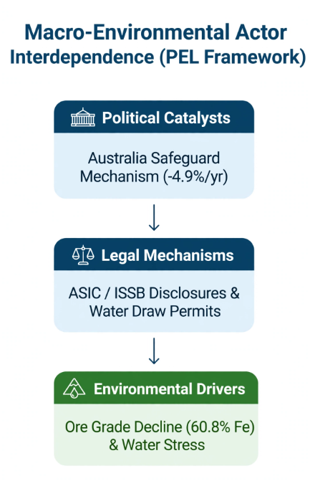
Figure 15: The alignment of macro-environmental actors influencing BHP
(Source: Self-developed)

3.3 Reflection on Strategic Growth Decisions
The use of the growth factors, such as the Ansoff Matrix, showed that product development provides the most effective strategy for BHP. The integrated product lifecycle theory showed that carbon-intensive assets can face declining long-term returns. On the other hand, growth-stage commodities include the term Reuters due to the rising regulatory costs.

3.4 Limitations and Gaps in the Analysis
The main limitation of this report is the dependence on secondary resource sources such as the annual reports, corporate reports, and sustainability reports. The secondary corporate reporting can show potential bias. Most of the reports focus on the positive ESG targets and ignore the operational issues (Vigil et al., 2025). The primary research, such as interviews with the engineers, supply chain managers, and regulatory officers, can provide a more unbiased view of the issues of BHP’s decarbonisation commitment.

3.5 Information Required Before Final Recommendation
Before providing the final recommendations to the senior executive leadership, a professional management consultant is required. This would include:
- B2B contract pricing structured as the verified green price premium negotiation with the tier-1 steel makers. These can include China Baowu and POSCO for the higher-grade iron ore.
- The detailed capital expenditure breakdown and the internal rate of return can help with the battery-electric free fleet conversions in WAIO assets.
- Econometric modelling of the cross-border carbon tariff can change under the EU CBAM regulations.
- The proper supply chain data related to the metal procurement networks are effective. Also, the green Power Purchase Agreement (PPA) is related to the tariff structures.

3.6 Professional Learning and Reflection
Professionally, this assessment developed my capabilities to analyse financial statements. Also, the complex environment performance metrics have been determined. I also developed knowledge of how corporate sustainability initiatives directly protect market access in the B2B market. Personally, I aim to refine my financial modelling and risk adjustment capabilities. I further evaluated the capital allocation decision in this energy industry.

References
Amegboleza, A.A. and Ülkü, M.A., (2025). Sustainable energy transition for the mining industry: A bibliometric analysis of trends and emerging research pathways. Sustainability, 17(5), p.2292. https://www.mdpi.com/2071-1050/17/5/2292
Araújo, O.D.Q.F. and de Medeiros, J.L., (2024). Green steel: technologies enabling decarbonization from mine to steel. Clean Technologies and Environmental Policy, 26(10), pp.3151-3153. https://link.springer.com/content/pdf/10.1007/s10098-024-03050-3.pdf
ASIC, (2026). A director’s guide to mandatory climate reporting. Available at: https://www.aicd.com.au/content/dam/aicd/pdf/tools-resources/director-resources/directors-guide-to-mandatory-climate-reporting-web.pdf [Accessed on: 30/09/2026]
BHP Annual report, (2026). BHP Annual Report 2026. Available at: file:///E:/New%20folder%20(2)/SEPTEMBER/30/260818_bhpannualreport2026%20(1).pdf [Accessed on: 30/09/2026]
BHP Group, (2026). BHP Climate Transition Action Plan & ESG Databook 2026. Available at: https://www.bhp.com/sustainability/climate-change/transition-to-a-net-zero-economy [Accessed on: 20/09/2026]
Bukhari, S.N.Z. and Bukhari, S.A.A., (2025). Customer-Based Islamic Brand Equity (CBIBE) Pyramid. Journal of Climate and Community Development, 4(1), pp.78-90. https://www.joccd.com/index.php/joccd/article/download/67/55
CER, (2026). 2024–25 Safeguard Mechanism Data Insights. Available at: https://cer.gov.au/document/2024-25-safeguard-mechanism-data-insights [Accessed on: 18/09/2026]
Fastmarkets, (2026). Iron ore quality decline meets green steel ambitions. Available at: https://www.fastmarkets.com/insights/iron-ore-quality-decline-meets-green-steel-ambitions/ [Accessed on: 18/09/2026]
Fortescue (2026), Sustainability at Fortescue 2026. Available at: https://fy26sustainability.fortescue.com/en [Accessed on: 16/07/2026]
Global Efficiency Intelligence, (2026). The Impact of Global Carbon Policy Mechanisms on Raw Material Trade. Available at: https://www.globalefficiencyintel.com/research [Accessed on: 21/09/2026]
Hossain, M.M., Lema, A.C., Nahar, S., Rahman, M.J., Edirisinghe, U.C. and Bodle, K., (2026). Corporate Indigenous Stakeholder Engagement in the Sustainability Reporting: Evidence From the Australian Mining Industry. Business strategy and the environment. https://onlinelibrary.wiley.com/doi/pdf/10.1002/bse.71325
ICAP, (2026). Australian Safeguard Mechanism ETS Policy Profile. Available at: https://icapcarbonaction.com/en/ets-pdf-download/128 [Accessed on: 15/09/2026]
ICMM, (2026), Global Mining and Metals Water Dataset. Available at: https://www.icmm.com/global-datasets/water [Accessed on: 16/07/2026]
Insights IAS, (2026). The Global Mining and Metals Water Dataset Report. Available at: https://www.insightsonindia.com/2026/07/25/the-global-mining-and-metals-water-dataset-report/ [Accessed on: 25/07/2026]
Kotler, P., Armstrong, G., Harris, L.C. and He, H., (2024). Principles of Marketing. 19th edn. Harlow: Pearson Education.
Macro trends, (2026), BHP Group Revenue 2012-2026 | BHP. Available at: https://www.macrotrends.net/stocks/charts/BHP/bhp-group/revenue [Accessed on: 16/07/2026]
Market Screener, (2026), BHP Group Limited. Available at: https://www.marketscreener.com/quote/stock/BHP-GROUP-LIMITED-6492795/calendar/ [Accessed on: 16/07/2026]
Mining.com.au, (2026). ICMM reveals water risk has become a material issue for mining. Available at: https://mining.com.au/icmm-reveals-water-risk-has-become-a-material-issue-for-mining/ [Accessed on: 23/07/2026]
Paul, M., (2026). Two-thirds of global mining facilities face significant water risk, ICMM report says. Down To Earth.
PwC, (2026), Mine 2026: Ambition to Action. Available at: https://www.pwc.com/gx/en/industries/energy-utilities-resources/global-mine-2026.pdf [Accessed on: 19/09/2026]
Reuters, (2026), BHP profit beats forecasts as copper tops iron ore earnings on AI-driven demand. Available at: https://www.reuters.com/business/bhp-group-reports-22-growth-first-half-profit-2026-02-16/ [Accessed on: 16/07/2026]
Reuters, (2026), BHP profit tops estimates as copper powers growth, to pay highest dividend in 4 years. Available at: https://www.reuters.com/business/energy/bhp-profit-tops-estimates-copper-powers-growth-highest-dividend-4-years-2026-08-17/ [Accessed on: 16/07/2026]
Rio Tinto, (2026). Sustainability reporting. Available at: https://www.riotinto.com/en/invest/reports/sustainability-report [Accessed on: 16/07/2026]
Stroykov, G., Lebedev, A., Belous, A. and Kolganova, E., (2026). Achieving Sustainable Development Goals Through Hybrid Energy Supply Systems in Mining: The Case of the Varvarinskoye Copper–Gold Deposit. Resources, 15(2), p.25. https://www.mdpi.com/2079-9276/15/2/25
Vigil, D.A., Johnson Jr, R.L. and Tauchnitz, J., (2025). Improved estimation methods for surface coal mine methane emissions for reporting, beneficial use, and emission reduction purposes and relative to Australia's safeguard mechanisms. Journal of Environmental Management, 376, p.124366. https://www.sciencedirect.com/science/article/pii/S0301479725003421
Zugay, B. (2023). Ansoff matrix. SAGE Publications, Inc.. https://sk.sagepub.com/foundations/ansoff-matrix

