ACADEMIC SKILLS AND EMPLOYABILITY B4X 01917 Student: Raluca Urloi Lecturer: Dale Clarke Student Number: 1905716 University of Wales Trinity Saint Davies

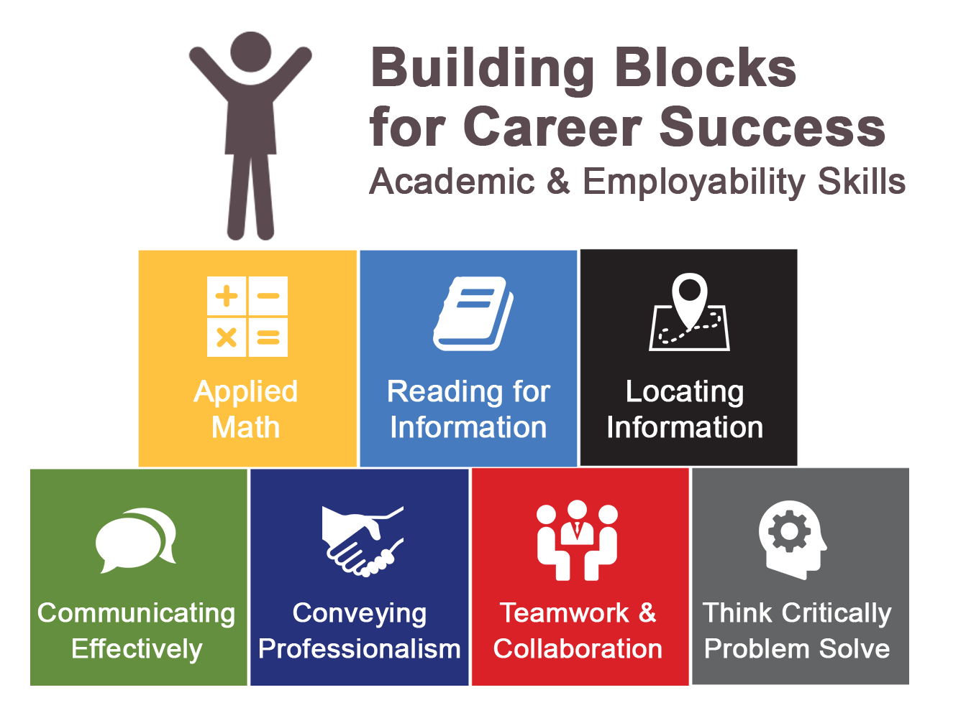

Table of contents
Introduction…………………………………………………Page 3
Current Academic and Employability Skills………………Page 4
SWOT…………………………………………………………Page 4-6
Personal Development Plan …………………………………… Page 6
Conclusion……………………………………………………………Page 7
References ………………………………………………………… Page 8



Introduction In this assignment I have been asked to create a report which, based on SWOT and PDP, analyses my current Academic and employability skills. Also, I have been asked to outline my plan in using the skills to develop a career in the hotel and hospitality industry. In my opinion it is very important that you look and test your skills and abilities especially when you looking after careers in a specific area such as a career in the Hotel Industry which requires you to be able to deal with unexpected situations, guests, deals and many many aspects.
SWOT is an undertaken study and a very powerful toot that describes the strengths, weaknesses, opportunities and the threats for a person that is planning to start a career in a specific job. In addition, I can say that it is not for the ones planning to start a career only, it is even for the ones that are already in charge of a company/ hotel or simply any propriety and want to change some of the services that will probably bring more guests. SWOT helps each person/company to find what goods they have now and what they need to improve what should disappear from their life’s. To help you analyse the SWOT based on your person there are some helpful questions for each section that help you analyse everything in the best possible way.
PDP in its definition is The Personal Development Plan and this is used to contour the start and the development of a business or simply for working on getting a job position. A PDP gives you the opportunity to find the determination and the commitment for the carer you have chosen to start (develop), in addition, next to the SWOT it allows you to find the weak areas and it makes you realize what obstacles you have on your way. The PDP contains five steps that drives you to the perfect result/ plan. Those five steps are: Identify- Meaning that you take your time to analyse what you can do and what you are not. Also, it makes you think about what you have done regarding to your present abilities. Plan- Based on your identifications you will build up an idea about what you could do in the career you want, and you might think about what to begin with. Action- Is the stage that gives you the chance to put in action what you have planned and using the actions and tasks you should accumulate new skills that will help you within the next process. Record- The process throughout which you compare the skills you had before and what else you now have after the action side of the plan Review- The final stage in which you might check what you have done well and how it is helping you to go any further within your career.

Current Academic and employability skills Making a bit of research based on the current academic and employability skills we can see that the employers are looking mostly after people that are able to do many things next to the higher education they have. Considering what Harvey said, most of companies and employers are looking for people that are capable to use their accumulated skills in the work they must do, and they should be mature in using the criticism and feedbacks wisely to increase constantly the level of working. Also, it says that the deliberated communication should facilitate contemporary teamwork and they should make the organisation look better and better trough the made work. (Harvey, et al 1997, cited in Holden and Jameson, 2002).
Therefore, to test my current academic and employability skills I have used SWOT to help me structure what exactly I am good at and what I must improve:
.
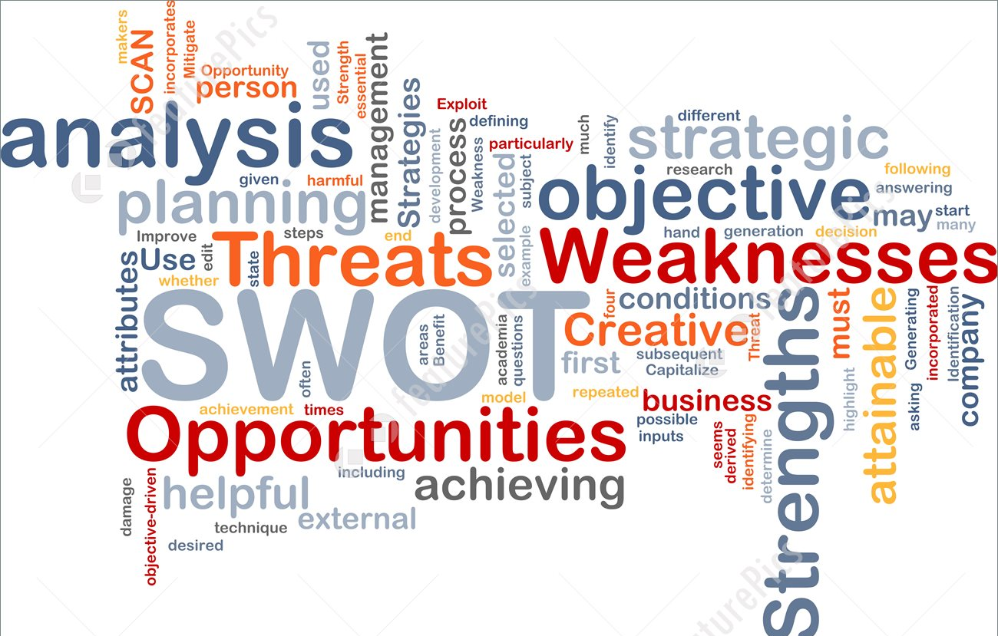 My Strengths are described through: Communication skills- I am openly speaking with people around me about anything and I am not struggling to express exactly my point of view. Also, to make this shill even stronger I can say that I am not shy and that I can speak with any type of person.
IT Skills- I can work with the Microsoft office and I am well at using the browsers wisely to find needed research. Therefore, I can learn how to use different systems that are set on the computer as well
Languages- I can speak fluently Romanian and English and also, I can easily speak Spanish. Calm under stressful moments- I can say that I am surprised about it, but in my opinion it I so important aspect especially when you must deal with different types of guests every single day.
Friendly- Is one of the strengths’ parts of me and this because this skill allows me to share different concepts with people around me and it makes me create relationships within professional boundaries with the people I am working with.
Punctual- I manage to be on time when I have scheduled meetings or activities, job or whatever
Flexibility/ Adaptability- Meaning that I am easily getting adapted to new rules or activity at the workplace or simply in a group.
My Weaknesses: The weaknesses are the gaps in learning of the person testing its SWOT and they usually are keeping you away from achieving the wanted goals. And so, my weaknesses are described through the following:
My knowledge in English language as much writing as speaking- Because English is my 2nd language I can absolutely say that I am not capable to hold a conversation or a speech from the start to the end fluently and right pronounced. I feel like this is the main weakness I have got and this because it stops me from saying my ideas properly and explaining them in the way I would like to. Another reason why this is a minus for me is because knowing that I want to be a high rated manager in hotel industry I need to speak constantly with people around me needing to be able to explain to them how to do things. Also, as a manager I should be able to write reports about people coming for interviews or about the current employer’s work and many many other things that require writing skills as much as possible.
My generosity- It could be a weakness of mine and this because if I am not being a bit strict within the prices or within the services I am giving for nothing then the environment I am working for will not be able to increase its profit and it only will go down or it will be slightly money on money.
Overthinking- In my opinion I overthink too much before taking up the final decisions and this because I have got times when I am struggling to take the best decision thinking that it is not good enough.
My Opportunities
The opportunities in SWOT are defined as being the activities that you decide to do to improve your current position. The opportunities I am taking for myself are base on:
Communicating with people around me at the work place, meaning that I try my best to communicate even if my English is not the most understandable one, I am still trying and by trying and trying I will slowly, but successfully improve my way of expressing in words what I think.
The opportunity of coming at the university- In my opinion this is the most important opportunity I took in my advantage and this regarding to the degree I will have at the end which will give me a powerful chance to get a job in the studied area and this because during the course I will be doing practical sessions as well which when it will come about adding them in the CV it will look good.
Overall, I am trying to take up to myself as much opportunities as possible and this because I am very confident with the idea of touching my goal of being a manager in a popular hotel.
My Threats
The threats are the unwanted things coming against your plans, challenging to do a change in what you have planned, therefore you might be careful at what you are doing an how ready you are to deal with situations that could come up.

My threats are not as many, but anyway they are described through the fact that I am having a job out of university which is killing some of the time in which I could do some more useful things that could help in my career. Another threat is the organisation skills I have not got as developed, which means that I do not know what to start with and how to plan everything.
Personal Development Plan
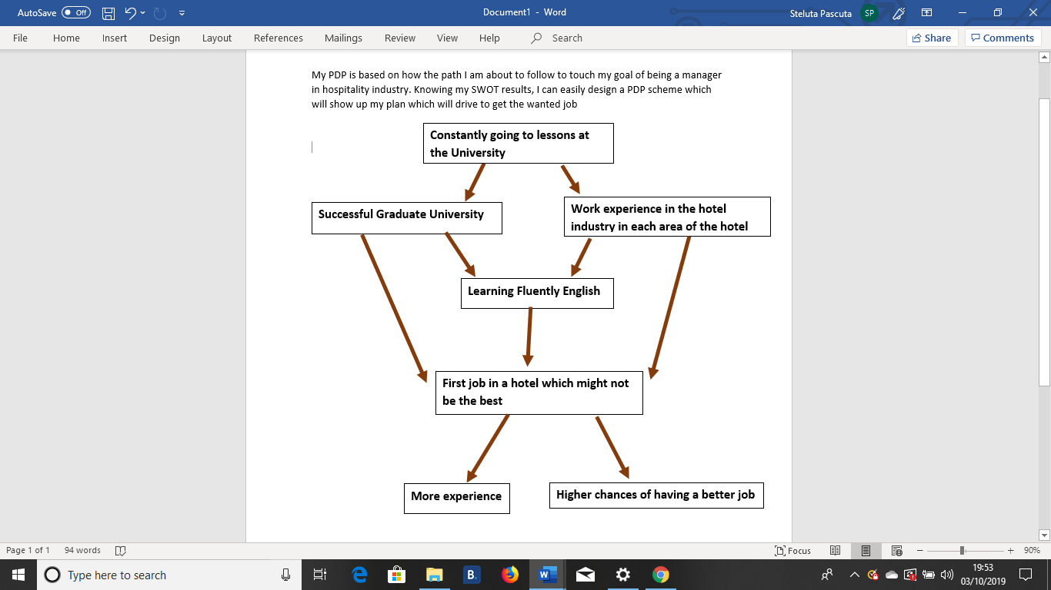

Conclusion
To finish with I want to say that this report has highly helped me to identify the level I am on the chances I have to work in a hospitality environment. Therefore, I can say that SWOT and PDP are very good tools when it comes about testing yourself and noticing what are your sides that needs some improvements and it makes you decide and plan which way to follow.


References
https://pestleanalysis.com/swot-analysis-threats-definition-examples/
chrome-extension://oemmndcbldboiebfnladdacbdfmadadm/https://www.exeter.ac.uk/ambassadors/HESTEM/resources/General/STEMNET%20Employability%20skills%20guide.pdf
https://www.researchgate.net/publication/280169039_Employability_of_Hospitality_Graduates_Student_and_Industry_Perspectives
Harvey, et al 1997, cited in Holden and Jameson, 2002

