Distinctiveness and Regeneration

Assignment 1

Field Report on Blaenavon

Sarah Carr

Student ID - 2107448

Assignment 1 – Task

For this assignment you should prepare a log report of 1000 words on the distinctiveness of one of the following destinations you visited Blaenavon or Newcastle Emlyn.

You will write a report on what made your chosen area distinctly prosperous allowing it to happen, the areas connected to the processes, the workers, the environment, social issues, technology, the local economy, and national economy at the time (industrial revolution).

Blaenavon is a town and community located at the head of the Afon Llwyd valley, Gwent in South Wales. Its historic landscape consists of around “32.9 sq. km, which includes extensive areas of mountain land together with adjacent valleys” (The Blaenavon Partnership, 1999).

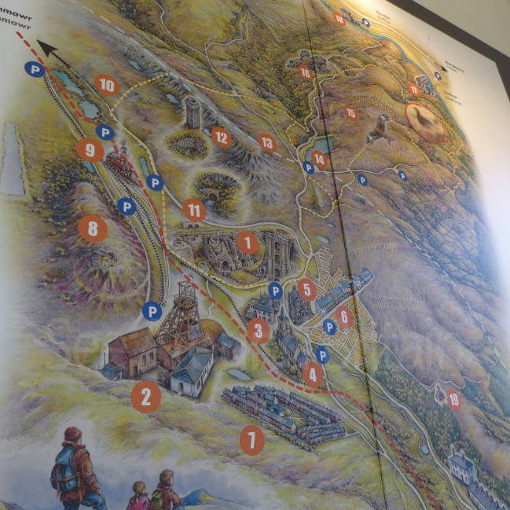
Early Blaenavon was prominently dominated by the economy of agriculture with the population of the area mainly supporting themselves through sheep farming on the fast open areas. However, many people were employed in some form of small-scale industry. There was an awareness of the rich resources in the area long before the creation of Blaenavon Ironworks. In 1565, the Hanbury family who were ironmasters and tinplate manufactures in the nearby town of Pontypool, leased the rights for the use of timber and minerals on the land now known as Blaenavon and Pontypool. Local people were employed by the family to collect the raw materials needed from the area in order to run their charcoal fired furnaces. This was life for the people of the area, it remained the same for many centuries until the arrival of industrialists in the late 1780’s, the area was set for drastic change in a very short period of time.

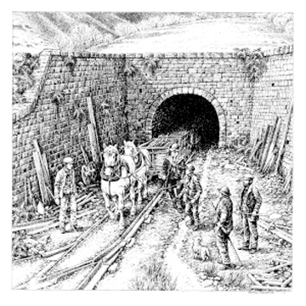
In 1788, Lord Abergavenny leased the lands known as ‘Lord Abergavenny Hills’ to three entrepreneurs Thomas Hill, Thomas Hopkins and Benjamin Pratt from the Midlands area of England. They saw an opportunity to build a major ironworks in the area using the latest technologies in a resource rich setting. Within a year they had built three blast furnaces that were powered by steam and became the second largest ironworks in Wales and one of the biggest in the world. By the end of that century the ironworks at Blaenavon was producing an average of 5,400 tons of iron a year. Due to the success of the business, the Blaenavon Iron Company, created primitive railways to carry raw materials from the mines and quarries to the works and also to sell at nearby markets. Over the next ten years the works continued to grow and by 1812 Blaenavon Ironworks had five furnaces producing 14,000 tons of pig iron a year.

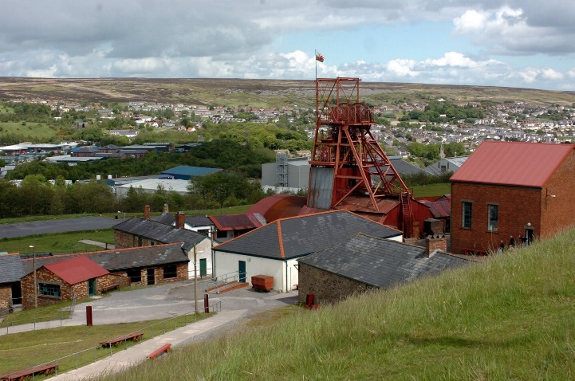
Improvement in transport links was an incredibly important part of Blaenavon’s success. More railway connections where created, not only to deliver raw materials to different areas of the works but also further afield. By 1815, Britain’s longest horse-powered tramway tunnel was built in the village of Pwll Ddu. The Pwll Du tunnel carried materials from Blaenavon through the mountain connecting to Pwll Ddu quarries, Garnddyrys Forge and the Brecknock and Abergavenny Canal. The creation of this tunnel allowed the materials to travel through the mountain rather than around it, which would drastically reduce the time it would take to deliver products. Being connected the canal waterways gave Blaenavon a direct link to the sea at Newport, creating a bigger market for them to sell their products.

As the industry continued to grow the Blaenavon Iron Company had an ever-growing work force. The population of Blaenavon and nearby local villages grew rapidly due to the migration of workers from rural areas of Wales as well as England, Scotland, and Ireland. “By 1851, more Welsh people were employed in the industry than agriculture, giving Wales a claim to be the first-ever industrial nation” (Ellis, 2014). Due to the increase of workers migrating to the area, there became an issue with where all the workers would live. In a move to encourage further migration of workers the Blaenavon Ironworks company built industrial housing next to the works for its workers, they also continued this with housing near the coal mines, quarries and near the land the horse paddocks. However, there became a social segregation between the workers. Due to the houses being built near the different working areas of the site, workers felt segregated from one another. In order to combat this issue, they began creating and building community buildings such as a churches, chapels, workingmen’s clubs, and schools.

The introduction of the main railway networks to the area had a great impact to Blaenavon. There was no longer a need to use the tramways as the new railway system provided a more convenient way to move raw materials and export finished products to the intended destinations. The industrial area continued to grow with the introduction of a sixth furnace added to the ironworks and a steelworks being built at Forgeside. In 1859 also, the Big Pit coal mine was sunk in order for it to supply coal to the steelworks. After all the expense that came with expansion of the business Blaenavon Iron and Coal went into liquidation in 1864.

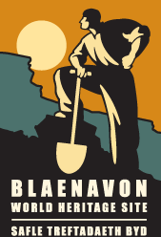
The Blaenavon Iron and Steel Company bought the rights in 1870, they then converted the ironworks at an extremely high cost to begin steel production due to an increasing demand for steel in the Victorian era. With the change came an increasing problem with steel production. A large quantity of iron ores where containing phosphorus which would make steel brittle and unsuitable for use in many structures. Many of the smelting and other techniques used to make steel from pig iron did not remove the phosphorus and it was becoming a problem that many people were trying to solve all over the world. Metallurgist Sidney Thomas believed he found the solution where dephosphorisation would happen causing all the phosphorus to be deposited with the slag and then it would be used as agricultural fertiliser. Percy Carlyle Gilchrist, the chemist at Blaenavon, along with his cousin Sidney Thomas where given permission from the Ironworks owners to conduct experiments using his theory. With the experiments a success and his process which became known as the ‘Thomas or basic process’, had worldwide reaching significance, as previously unusable phosphorus rich iron ores could now be used in the process of making steel.

Blaenavon has changed so much from its humble agricultural beginnings. It has become “one of the finest surviving examples in the world of a landscape created by coal mining and iron making in the late eighteenth and nineteenth centuries. (Glamorgan-Gwent Archaeological Trust, n.d.) The development of these industries was one of the key forces of the Industrial Revolution, with South Wales being one of the leading areas of its importance.

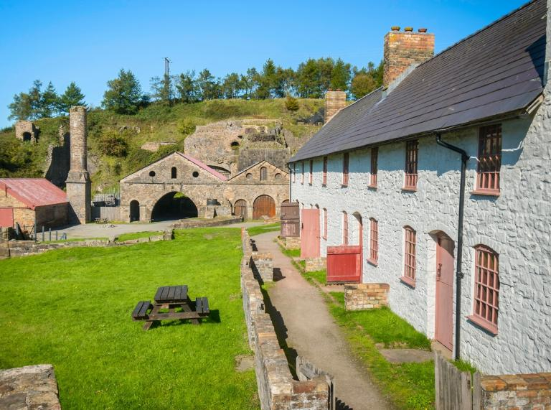
Today the Industrial landscape of Blaenavon has been classed as a World Heritage Site, with the heritage centre being located in the former St Peters Church school, which was founded by Sarah Hopkins in 1816. The Big Pit Coal Mine is now a museum where you will be given a guided tour of the mines by a real miner and told the history of the pit and its workers. The Ironworks has been used on many television programmes including BBC Wales’s Coal House, you can also visit the remains of the blast furnaces and cast houses on the site and gain much information on the history of how the works thrived during an important time of Welsh history.

Word count 1161

References
BBC. (2012, May 8). Counties of Wales - History of Blaenavon Ironworks. Retrieved February 10, 2022, from BBC: https://www.bbc.co.uk/programmes/p00s7dbq
Blaenavon Town Council. (n.d.). Blaenavon Ironworks. Retrieved February 10, 2022, from Blaenavon Town Council: https://www.blaenavontowncouncil.co.uk/blaenavon-ironworks
Ellis, S. (2014, March). Ironmasters of Wales - history forged in the Valley. Retrieved February 09, 2022, from British Heritage: https://britishheritage.com/travel/ironmasters-wales-history-valley
Glamorgan-Gwent Archaeological Trust. (n.d.). Glamorgan-Gwent Archeologial Trust. Retrieved February 9, 2022, from Blaenavon - Historical Processes, Themes and Background: www.ggat.org.uk/cadw/historic_landscape/blaenavon/englidh/Blaenavon_Features.htm#introduction
Matthews, N. A. (2008). The development of Blaenavon town. Retrieved February 9, 2022, from Visit Blaenavon: https://www.visitblaenavon.co.uk/en/Publications/Blaenavon-Story/The-development-of-Blaenavon-Town.pdf
Morris, C. (2011). Blaenavon Ironworks. Retrieved February 10, 2022, from Engineering Timelines: http://engineering-timelines.com/scripts/engineeringItem.asp?id=1395
The Blaenavon Partnership. (1999, October ). Nomination of the Blaenavon Industrial landscape for inclusion on the world heritage list. Retrieved February 9, 2022, from https://www.visitblaenavon.co.uk/en/Publications/WorldHeritageSite/LookingAfterBlaenavon/ManagementPlan.pdf
Torfaen County Borough Council. (2017, August 17). Blaenavon World Hertitage Site. Retrieved February 10, 2022, from You Tube: https://www.bing.com/videos/search?q=blaenavon+iornworks&&view=detail&mid=78997636DB6F1FEE88EB78997636DB6F1FEE88EB&&FORM=VRDGAR&ru=%2Fvideos%2Fsearch%3Fq%3Dblaenavon%2Biornworks%26FORM%3DHDRSC4

Image References

Image one – own image – Map of Blaenavon Industrial landscape taken at Bit Pit Museum

Image two – Pwll Ddu Tunnel – image found at
https://www.visitblaenavon.co.uk/en/Maps/industry-trade.html#IndustryPwllDuTunnel

Image three – Bit Pit Museum – image found at
https://www.walesonline.co.uk/incoming/gallery/big-pit-national-coal-museum-5838803

Image four - Blaenavon World Heritage Site logo – image found at
https://www.visitblaenavon.co.uk/en/Homepage.aspx

Image five – Blaenavon Ironworks – image found at
https://www.visitwales.com/info/travel-trade/fact-sheets/industrial-heritage-south-wales

