11/20/2025
Assessment
Portfolio Report on Contemporary Software Applications for Business


Student Name: SINAN KYAZIM
Student ID: 2513882

Module NaMe: Software solutions for business
Module Code: ACCA 4026
Lecturer: RAJEEV NATH
UNIVERSITY OF WALES TRINITY SAINT DAVID (London Campus)

Table of Contents
TASK 1 - e-Commerce Website Builders/Software Solutions 1
Introduction 1
TASK 2 – Mind-map of Contemporary Software Applications 6
a. Mind-maps in business operations 6
b. Contemporary software applications mind-map 8
TASK 3 – Office Applications for Creating, Storing, Presenting, and Analysing Data 9
a. Software solutions for business operations 9
b. Functions of software applications (Mail merge and XLOOKUP) 13
TASK 4 - Communication and Collaboration applications 21
a. Contemporary Communication (Outlook) and Collaboration (OneDrive) applications 21
b. Testing features of Outlook and OneDrive application 23
References 29

Introduction
Globalization and the increased use of digital devices and the Internet push rapidly into e-commerce. The benefit of the growing orientation towards online commerce for customers is that they have access to and participation in the global economy, can easily and quickly compare prices, and can shop for items and models from different parts of the world. All of this without leaving the comfort of their home. On the other hand, the benefits for businesses include just-in-time production, which boosts their strategic capabilities worldwide. Furthermore, in online commerce, businesses do not require rented premises; access to customers and customer flow multiplies, sales and corporate transactions are automated, and online payment is encouraged, which helps reduce the loss of financial resources [1].

TASK 1 - e-Commerce Website Builders/Software Solutions
Some of the most popular e-commerce software solutions, preferred by small and medium-sized businesses due to their ease of use, are Shopify, Wix eCommerce, and the WooCommerce plugin for WordPress (Fig. 1). Large retailers and international companies often turn to more complex software solutions due to the volume of sales, multiple markets, and complex logistics. Examples of more complex e-commerce platforms are Magento (Adobe Commerce), SAP Commerce Cloud, and Drupal Commerce.


Figure 1. Example: website created by small business owner [4]
Wix eCommerce is often preferred by small and medium retailers because it is a platform offering a visual drag-and-drop editor that does not require in-depth technical knowledge to build an online store. Key features include a catalog of over 900 free customizable templates, integrations with channels such as Facebook, Instagram, and Google Shopping, optimizing 6X more revenue from social media activity. Users can sell physical products, dropshipping, print-on-demand, digital products, and subscriptions. There are options for managing products, payments, and shipping. Features include automatic recovery of abandoned carts, multiple payment gateways, and management of data and image storage.
The benefits of Wix eCommerce include an easy start with AI assistance, a low barrier to entry, integration, and minimal technical resources. One dashboard allows total business control, infrastructure is built for scale with fast page loading, free hosting that handles record traffic, high-volume sales, and up to 750 simultaneous transactions per second, and a high level of security using threat prevention and real-time detection [2].
The limitations of Wix include less flexibility compared to other platforms. Templates are not always fully adaptive and changing them often requires rebuilding the site. Features like true multi-currency checkout or bulk product editing may be limited. Some users consider Wix “easy to start but difficult to scale” when the store becomes large or catalogues become very extensive [3]. A more significant drawback is the vendor lock-in effect; although Wix offers hosting and domain services, it does not allow exporting the site to host it elsewhere.

On the other hand, Magento is preferred by online merchants with large product catalogues, multiple stores, international operations, and a need for integration with ERP/CRM systems. Its main features include UX-inspired designs and a variety of plug-ins, responsive and mobile-optimized tools, multi-language and multi-currency e-commerce plans, integration with Sage, Salesforce, payment portals, and EPOS [5].
The benefits of Magento include high store control, strong flexibility and personalization, the ability to support complex business models and integrations, stability with large catalogues, high sales volumes, and international business. According to research by Adobe/Stax, companies that migrated to Magento 2 (Adobe Commerce) achieved cost savings, higher average order value, and better conversions. The platform also supports integrations with ERP, CRM, POS, and other corporate systems.
Some of the more significant drawbacks of Magento are that it requires an experienced team of developers, high maintenance and hosting costs, and installation and management are more complex and time-consuming. Fees and licenses are calculated based on GMV (Gross Merchandise Value), meaning that as sales increase, the annual fee for the platform also increases. For example, if a store achieves $1 million GMV in a year, the license fee may be approximately $40,000–$60,000 per year (the figure varies depending on the contract and store requirements).
Businesses using Magento include Warners Group Publications PLC and Bauer Media [6] [7].

Figure 2. Warners Group Publications PLC Home page created by Magento
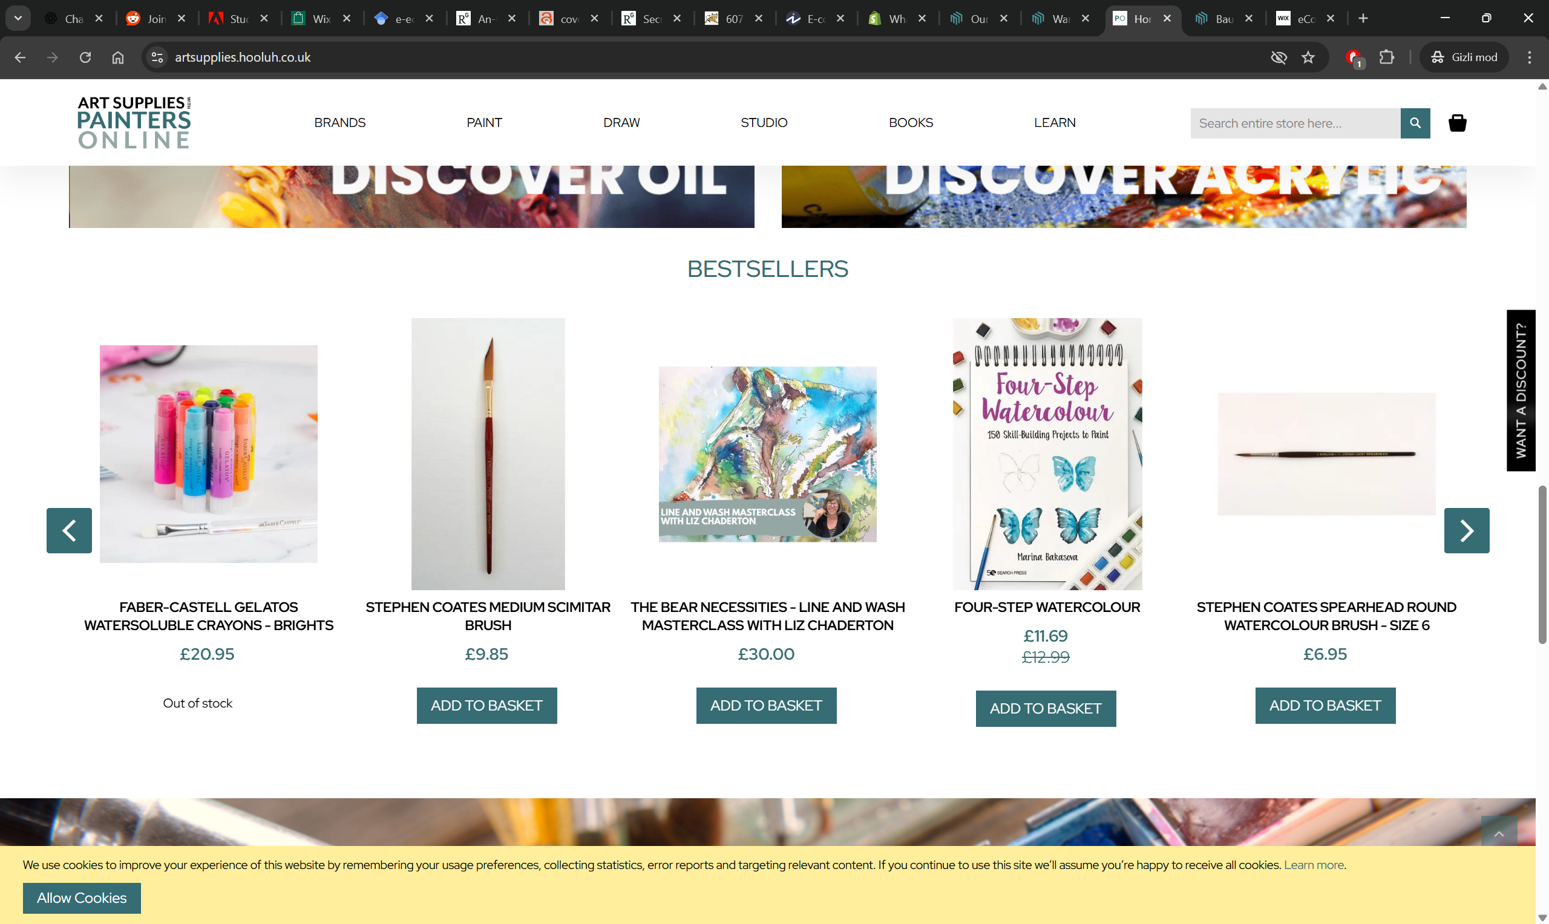
Figure 3. Art Supplies and Painters online website (part of Warners Group Publications PLC) created by Magento
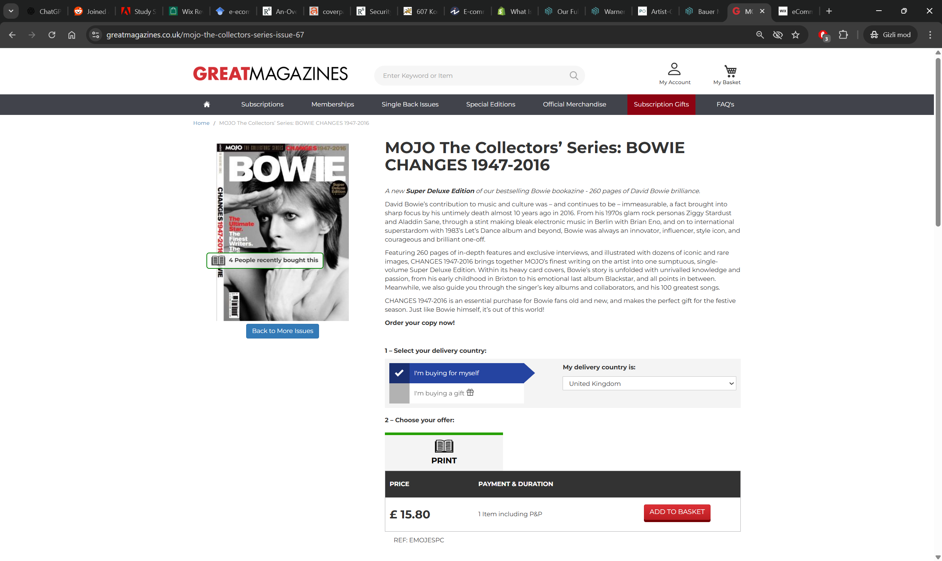
Figure 4. Great Magazines website (Bauer Media) created by Magento

TASK 2 – Mind-map of Contemporary Software Applications

Mind-maps in business operations
The Mind Map is a dynamic and exciting tool to help all thinking and planning become a smarter and faster activity. It is a tool for communication, problem-solving, creative dreaming, teaching, revising, managing time and recalling memories [8].
Mind mapping is a visual technique for organizing ideas and concepts that helps with better understanding and analysing information. The Mind Map is a dynamic and exciting tool for communication, problem-solving, creative thinking, revising, managing time and recalling memories. It consists of a central image or word, around which are branches with key concepts and key words. From each of them will emanate second-level branches and subsequent third-level branches, extending the main idea organically. This is the visual presentation of how the human brain thinks [9].
Mind maps can innovate the way of running a business on a daily basis, allowing really thinking about a situation from every aspect in a way that is brief and save precious time. They facilitate the core business skills – such as making choices, organising your own and other people’s ideas, setting time and amount targets, and especially memory and communication – all the elements that are essential for successful business management.
Mind mapping has multiple benefits for business operations, particularly in organizing thoughts, improving decision-making, and enhancing collaboration. One of the most important benefits is that it improves the clarity of complex ideas. Mind maps help expand and deepen a core idea by breaking it down into smaller concepts that are easy to understand, navigate, and manage as tasks. This is very useful during the strategic planning stage in business, where a mind map visualizes the connections between different business goals and their general relationship to the core idea.
Another significant benefit is that the mind mapping method fosters creativity and innovative thinking within a team. Creating a mind map is more than just a brainstorming session, as it encourages free-flowing thoughts that can spark new perspectives and solutions. Sometimes, through mind mapping, teams generate features or improvements by linking customer needs with innovative solutions that might not have been obvious in traditional brainstorming sessions.
Mind mapping also plays a crucial role in problem-solving. With a mind map, teams can quickly analyze different aspects of the issue and brainstorm solutions, speeding up the resolution process.
The visual nature of mind mapping significantly boosts memory and retention. Most of the time people tend to remember information better when it is presented visually rather than textually, because visual information is easier for processing key concepts which allows employees to retain critical information and improve their overall performance.
Mind maps also improve communication and collaboration within teams which is especially valuable during meetings or collaborative sessions, where a mind map serve as visual aid to guide discussions.
Finally, mind mapping is a valuable tool for project planning and time management. It allows businesses to break down larger projects into smaller, actionable tasks, ensuring that important milestones and deadlines are met.
In conclusion, from enhancing clarity and creativity to improving collaboration and decision-making, mind-mapping enables teams to work more efficiently and solve problems more effectively.

Contemporary software applications mind-map
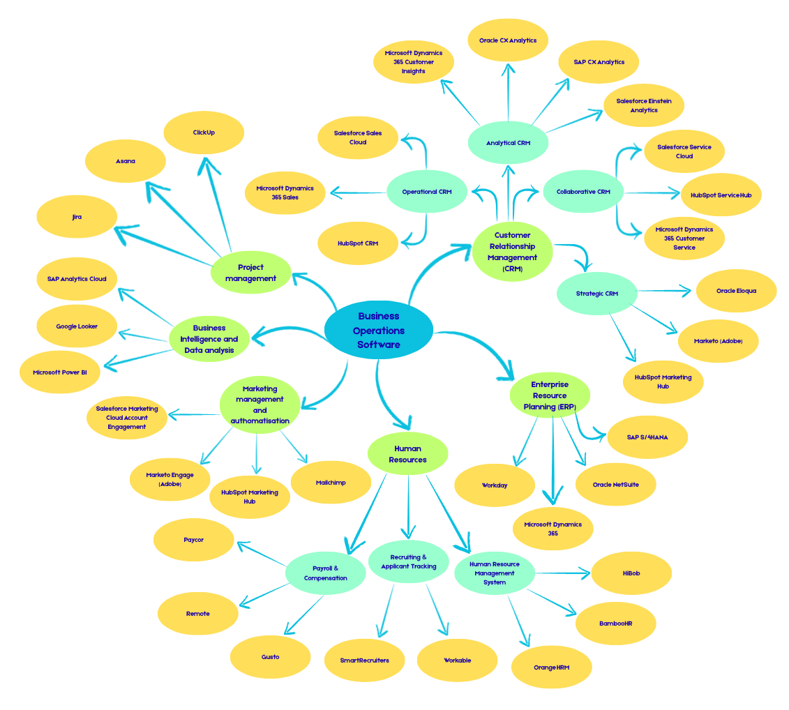
Figure 5. Mind-map of contemporary software applications used in business operations

TASK 3 – Office Applications for Creating, Storing, Presenting, and Analysing Data

Software solutions for business operations
Ms Word, PowerPoint, Excel, and Access are core components of the MS Office suite, covering a wide range of business needs—from text documentation, presentations, and spreadsheet analysis to database management. Each of these tools has strengths that make it suitable for specific tasks and applicable in business processes but also comes with limitations that must be considered during implementation in order to maximize the benefits of their use. When choosing software for office use, businesses must first evaluate the volume of data, the number of users, the need for collaboration, and the potential for future expansion—and based on this, combine the appropriate tools. This thesis will examine the main functions, benefits, and limitations of the most widely used system products launched by Microsoft.
MS Word is a text-processing program that primarily creates, stores, presents, and prints text documents such as reports, proposals, letters, statements, orders, etc. It is one of the most widely used technological tools in the world for business correspondence and business needs [10].
The most essential function of MS Word is the ability to manipulate text within the document—for example: typing, inserting, cutting, copying, and pasting text. More recent versions of the software product also offer a “word and phrase prediction” feature, which allows for even faster writing and makes the program such a valuable tool. In addition, it offers spell-checking as well as basic grammar checking. Newer versions of MS Word also provide suggestions for clearer phrasing, checking online sources for similarities, and assessing the readability of the document.
Another standard feature offered by MS Word is the ability to change the visual appearance of the text content. The program includes a wide range of fonts and offers options for bold, italic, and underlined text as well as font size adjustments to enhance emphasis when needed. Despite the wide selection of available fonts, businesses most often prefer cleaner and more uniform fonts, such as Arial or Times New Roman, because they are easier to read and comprehend, and over time have come to be seen as more professionally appropriate.
MS Word also allows users to add simple tables, charts or numbered lists, illustrations, more complex graphics, and even video clips. For even more convenience, the program offers page layout features—size, margins, spacing, etc.—and additionally includes ready-made built-in templates for the most commonly used types of documents.
The modern digital era in which businesses operate is further supported by MS Word through browser-based and cloud technology that facilitates collaboration among multiple people working on the same document. This function enables editors to track changes, leave comments, assign tasks to other users, and review previous versions of the document. This functionality is invaluable for teams relying on virtual collaboration due to geographically dispersed locations and the lack of direct contact.
As a result of reviewing the main functions of MS Word, the following advantages of the program can be identified: it is universal and flexible, as it is suitable for creating various business documents; integrated, as it allows inserting and using content from other MS Office products, such as tables from MS Excel; and collaborative, as it enables simultaneous editing of content by multiple users.
The main limitations of MS Word are that it is not efficient for complex spreadsheet calculations and requires the use of specialized spreadsheet or BI tools. Additionally, large documents with extensive text, tables, graphics, and charts become heavy and slower, and layout elements may even shift. It is also important to note that the Cloud version of MS Word lacks many of the functionalities offered in the desktop versions.
MS PowerPoint is a software solution designed for creating presentations. According to scientific research, people perceive information more easily when it is presented visually, and MS PowerPoint is a frequently preferred tool in business for visualizing ideas, reports, and strategies [11].
PowerPoint enables the creation of presentations from clean slides, complex pitch decks, and the development of impactful presentations. One of the key features of the program is its support for templates and design ideas customized for organizations so that presentations align with the brand. The multimedia capabilities are perhaps most strongly expressed in MS PowerPoint, as it allows the embedding of images, video, and audio, which makes presentations more engaging. In its more recent versions, the program offers the assistance of Microsoft’s AI tool — Copilot, which suggests and generates an overall presentation layout.MS PowerPoint also provides the possibility for real-time collaboration, similarly to MS Word.
As a result of the reviewed main functions, the advantages of PowerPoint include: the ability to present large amounts of information in a visually convincing and easy-to-digest manner; virtual real-time collaboration; and the time-saving Copilot tool, which helps and facilitates the creation, structuring, and formatting of presentations.
The disadvantages of this software product are that the web version used for virtual collaboration does not support all the functionalities available in the desktop version, which limits the possibilities for creating more complex and high-quality presentations. Furthermore, due to the presence of the AI tool, if users rely on it too heavily, there is a risk of losing individuality and personalization in presentations because of the template-like layouts it generates. Organizing many multimedia elements in a single presentation also carries the risk of making the file too heavy and causing issues with sharing and presenting it.
MS Excel is a key tool characterized by its flexibility and functionality for data analysis, which is beneficial at every stage of a business. According to some authors, if a person is serious about their business intentions, they must understand, measure, and track the numbers that drive their work [12]. In practice, through Excel, businesses can aggregate data, make forecasts, and visualize key financial or operational indicators.
The most essential function of Excel is its support for a wide range of formulas and functions—financial, statistical, text-based, logical, and others—which enable complex calculations and modeling. In addition, Excel supports programming through VBA (Visual Basic for Applications), which allows the automation of routine tasks, the creation of macros, and even the development of user interfaces within spreadsheets. PivotTables are another key mechanism for summarizing and analyzing large datasets in MS Excel. The more recent version of the program also offers modern features such as dynamic arrays, new text functions, improved accessibility, and even the LAMBDA function, which allows users to create their own custom functions. Excel also supports data import and analysis, enabling the creation of tables, filtering, sorting, and data visualization through charts and graphs.
The advantages of MS Excel are that it is universal, meaning it is suitable for everything from basic spreadsheets to complex financial models. For projects and business operations, its flexibility enables teams to create customized templates, budgets, analyses, and reports without the need for specialized software, making Excel a cost-effective choice. Its integration with other Microsoft applications (such as Word, PowerPoint, and Outlook) facilitates data sharing and accountability. The analysis and visualization tools allow business users to understand trends and make informed decisions. Automation reduces the time spent on manual operations, while new features like LAMBDA enhance the power and reusability of logic [13].
The disadvantages of MS Excel are that it may appear overly technical, and complex formulas and macros can be difficult for all team members to maintain and understand. When working with large volumes of data (millions of rows), Excel can become slow or even impractical, especially in versions with older limitations or without additional business intelligence tools. Errors in formulas, poorly structured tables, or inconsistent data can lead to significant risks in calculation accuracy. Excel files may lack robust security features, making them vulnerable to unauthorized access, data breaches, or accidental alterations. Managing versions and collaborating on a single Excel file can be challenging, leading to confusion and potential data conflicts [14].
MS Access is a relational database management system that combines a database engine, a user interface, and development tools locally within a desktop environment.
The main functions of Access include creating tables, queries, forms, and reports through a graphical interface and macros, as well as programming business logic through VBA [15]. The program’s integration capabilities allow it to connect to various data sources: in addition to its own Access files, it can link to Microsoft SQL Server, Excel files, CSV, XML, and more. The reporting tools in Access enable the generation of complex reports, summaries, and printable forms that businesses can use to document and share information based on their data. Automation through macros also speeds up processes and data handling.
The advantages of MS Access are that it is user-friendly — users with limited programming skills can create a database through templates, forms, and macros without difficulty or the need to write much code. The MS Access software is very inexpensive; by using the program, many business processes can be automated and documented relatively quickly and at low cost. Its integration with other Office applications — Excel, Word, and others — enables easy data exchange and reporting. MS Access is both flexible and powerful, as it serves as a central data repository and supports customized interfaces and reports, which significantly reduces business expenses related to maintaining corporate databases.
MS Access, compared to other Microsoft products, has somewhat more disadvantages. One of the most serious drawbacks is that Access databases are limited, and as data volumes and user numbers grow, performance can drop significantly. The program does not support modern web technologies such as APIs, webhooks, or contemporary UI libraries (JavaScript, CSS), which means that multi-user scenarios often require a VPN or remote desktop setup to ensure access — a substantial limitation in modern remote or cloud-based operations. There are also numerous factors that can cause an MS Access database to become corrupted or damaged, including both hardware failures and software-related issues. Without proper safeguards, these databases may become unreliable, especially when developed by non-programmers who may unintentionally exceed their technical expertise [16].
It is also important to note that early MS Access development is often started by an employee who already has other full-time responsibilities. When these individuals become unavailable or leave the organization, the database frequently remains without anyone qualified to maintain or further develop it.

Functions of software applications (Mail merge and XLOOKUP)
In a small computer accessories company called “CompTech,” orders from various customers are processed daily. The company offers a wide range of products, including wireless mice, keyboards, USB-C cables, external hard drives, monitors, and etc. The team uses a spreadsheet to manage orders, calculate the total value of purchases, and maintain communication with customers through personalized emails. This scenario simulates a real business process in which the company must maintain accurate product information and send clear, personalized messages to its clients.
The aim of this exercise is to demonstrate the practical use of the XLOOKUP function to retrieve unit prices, ordered quantities, and total order amounts based on the product name. In addition, the table serves as a data source for Mail Merge, which will be used to automatically generate personalized emails for each customer, including the customer’s name, product purchased, quantity ordered, and total amount due.
In Figure 6, we see the Master table containing information about product orders of CompTech.
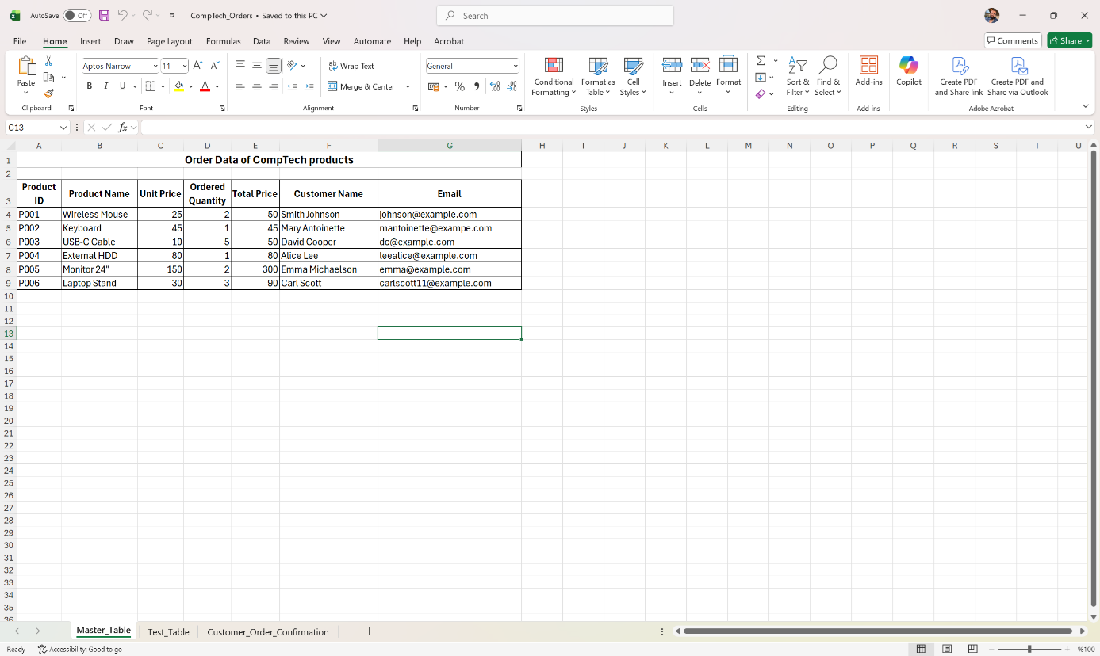
Figure 6. Order Data table
In Figure 7, we see a verification table used to check the unit price, quantity, and total value for the respective products.
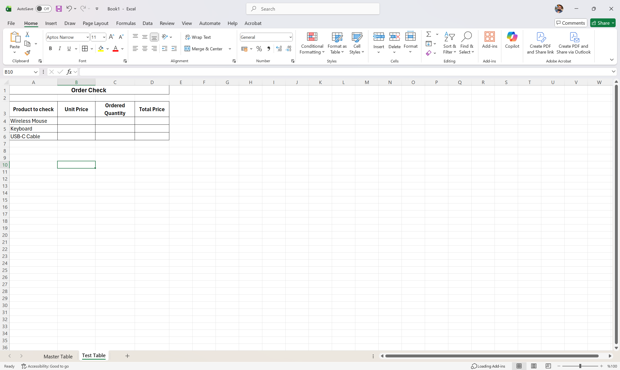
Figure 7. Order Check table
In Figure 8, I demonstrate how I enter the information for the XLOOKUP function in order to extract the required data, and in Figure 9 and 10 we can see the result of applying the function.
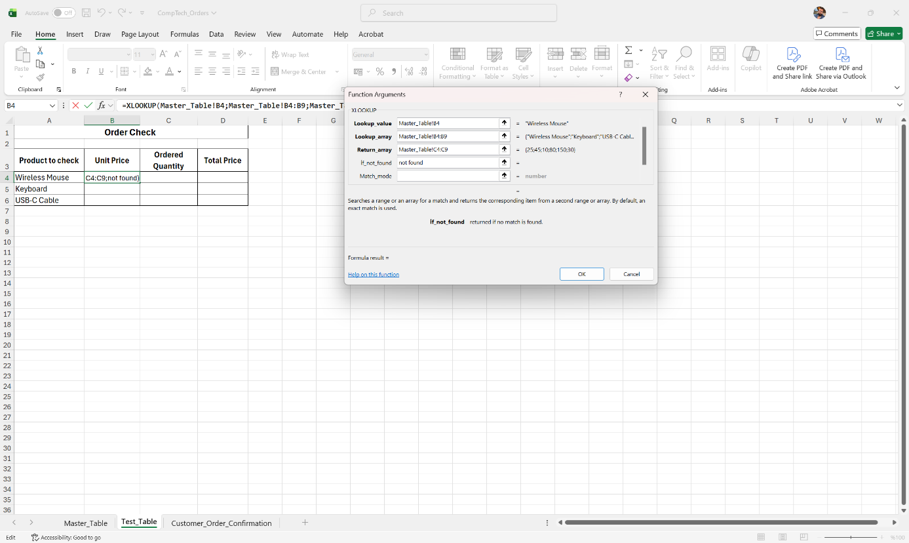
Figure 8. XLOOKUP function arguments based on my example
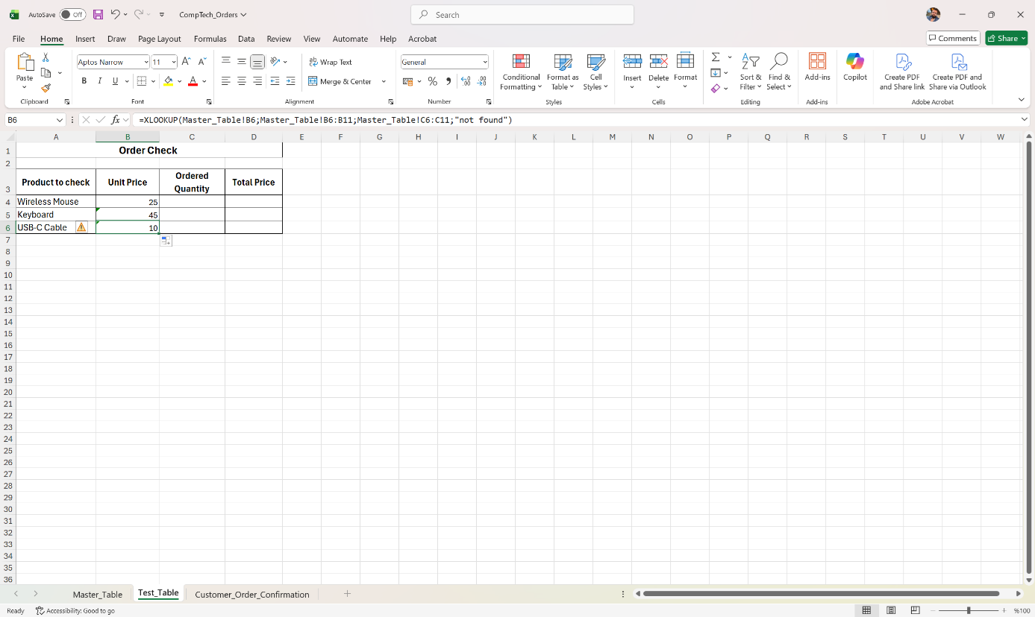
Figure 9. Result of the used function to find Unit Price
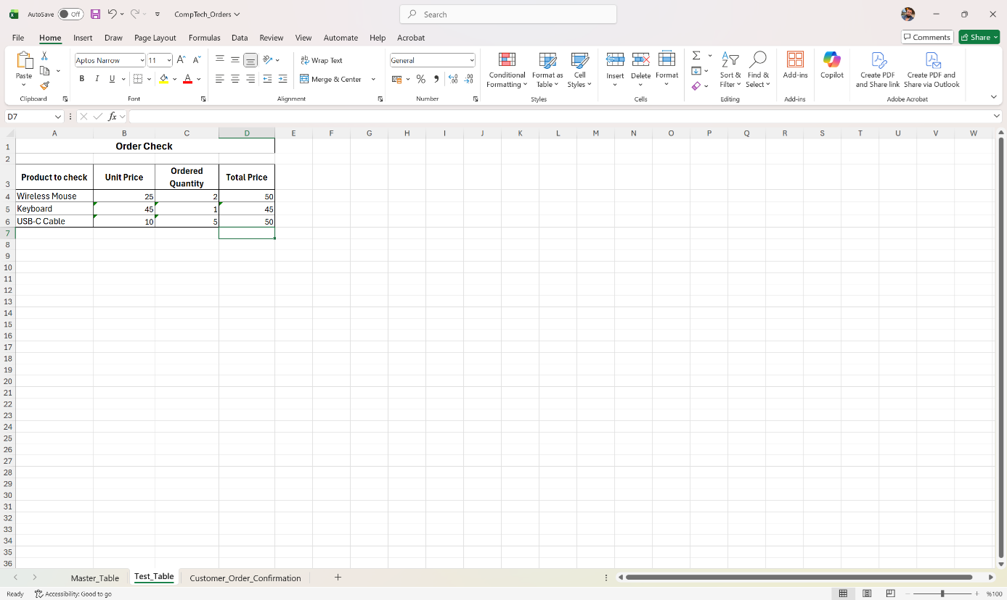
Figure 10. Result of the used function to find Unit Price, Ordered Quantity and Total Price
I return to the main table and change the unit price values for the wireless mouse and the keyboard to test the dynamism and automatic data updating.
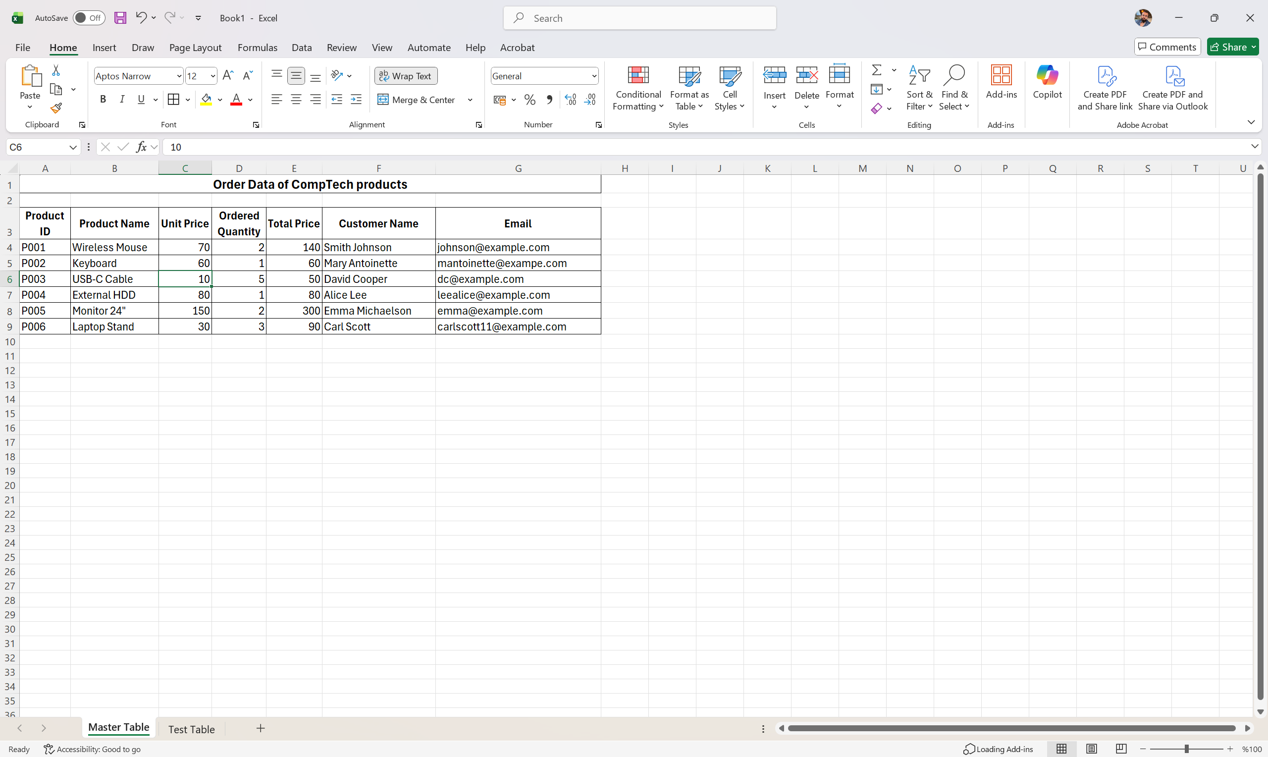
Figure 11. Changing amount of Unit price for Wireless Mouse and Keyboard
In Figure 12, we can see that the values have been automatically updated in the verification table where the XLOOKUP function is applied, which proves that the function is modern, flexible, faster, and more reliable.
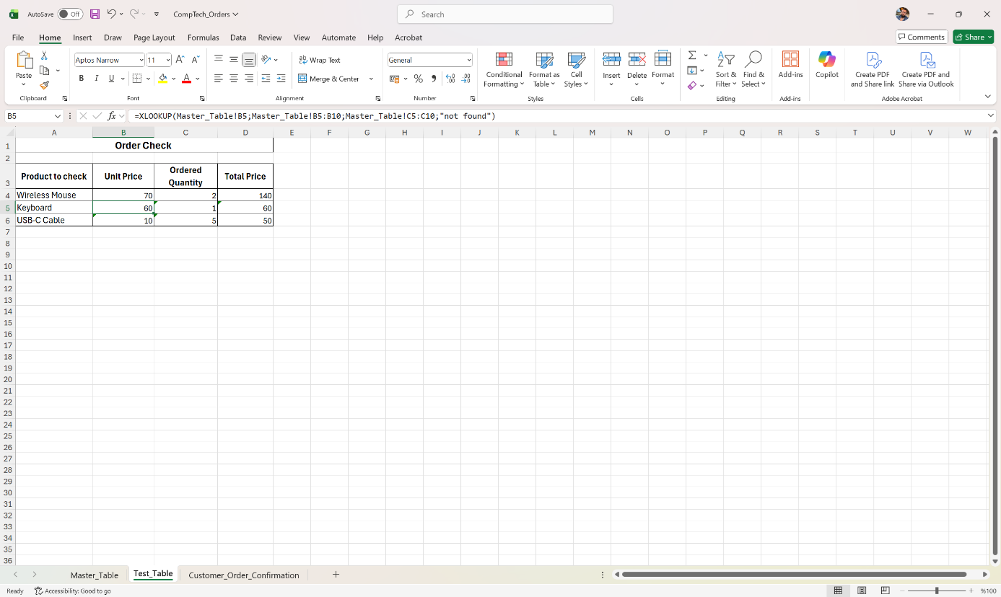
Figure 12. Test of data dynamics and automatic update
My choice of using the XLOOKUP function instead of VLOOKUP is driven by the following advantages of XLOOKUP: it can search in any direction without requiring the table to be rearranged; XLOOKUP can return multiple columns as a result (dynamic array), whereas VLOOKUP can return only one; the formula is simpler and more readable, and even if the structure of the main table changes, the function continues to work correctly, while VLOOKUP breaks immediately.
To demonstrate the second business-related tool, I chose the Mail Merge functionality in Microsoft Word. In this exercise, I used the Mail Merge Table created earlier, which contains customer names, contact information, product names, ordered quantities, and total purchase values. This table serves as the data source.
In Figure 13, we see the Excel sheet that includes all customer order information.
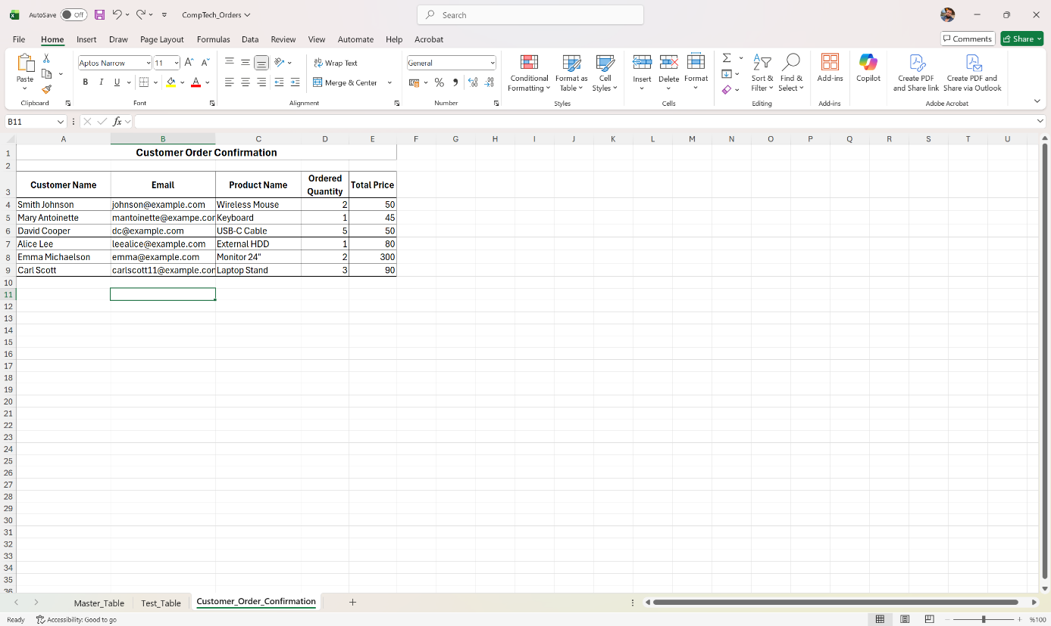
Figure 13. Customer order information

In Figure 14, I selected this file in Word using: Mailings → Select Recipients → Use an Existing List.
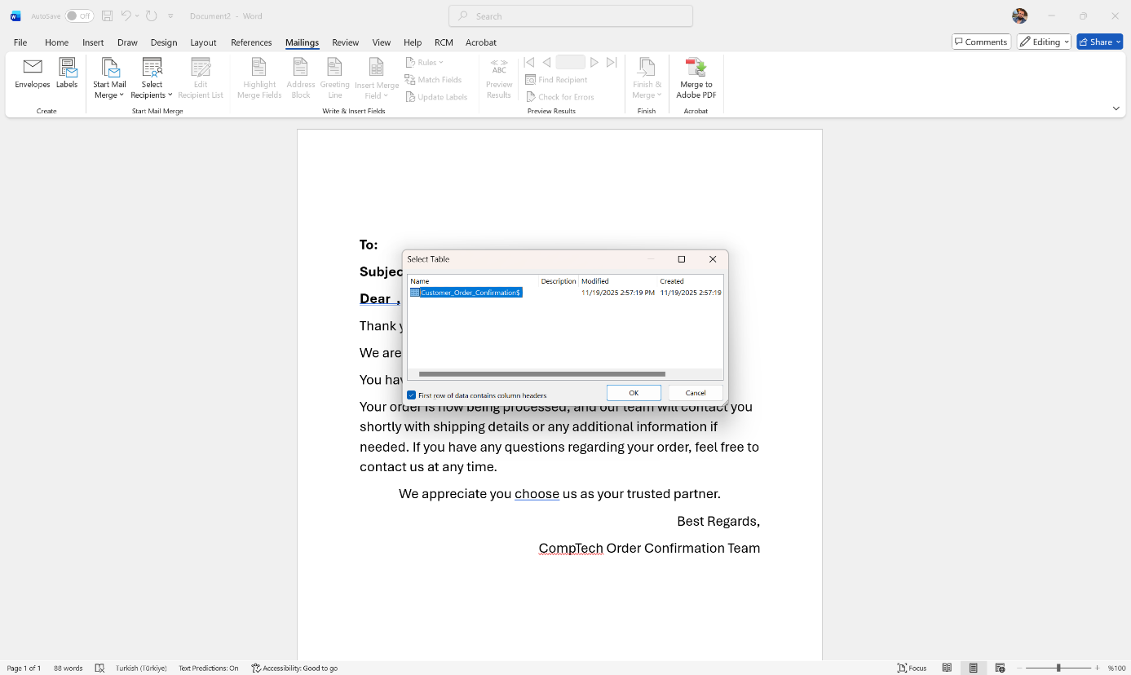
Figure 14. Selection of an existing list for MailMerge
In Figure 15 and 16 , I wrote my email text and inserted the relevant fields into the email template, such as «Customer_Name», «Product_Name», «Ordered_Quantity», and «Total_Price».
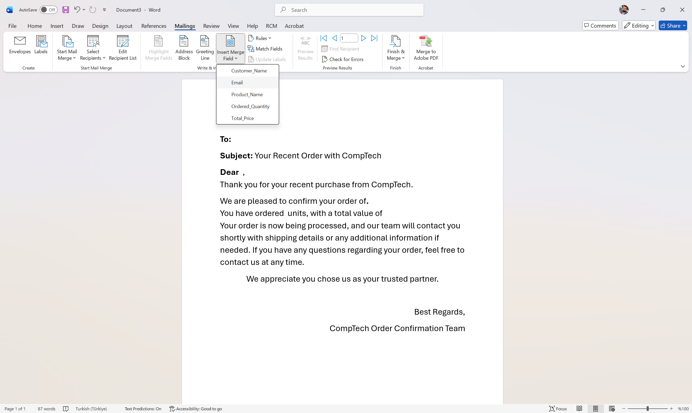
Figure 15. Preparing mail text and inserting merge fields
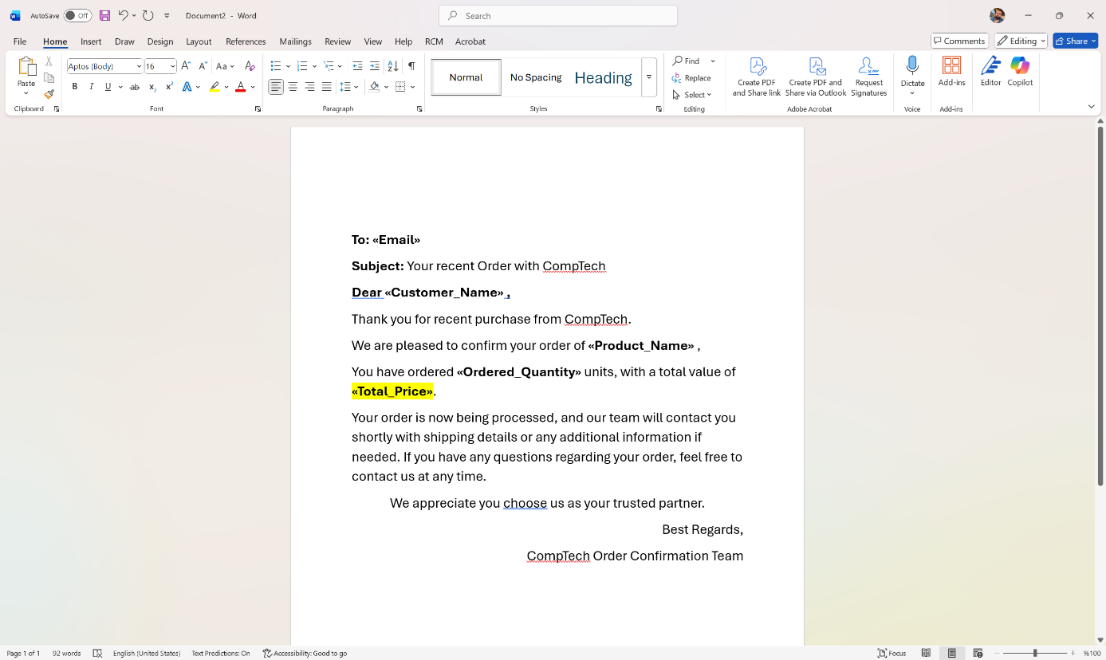
Figure 16. Inserted merge fields view
In Figure 17, using the Preview Results button, we can see how the template transforms into a personalized message for each individual customer.
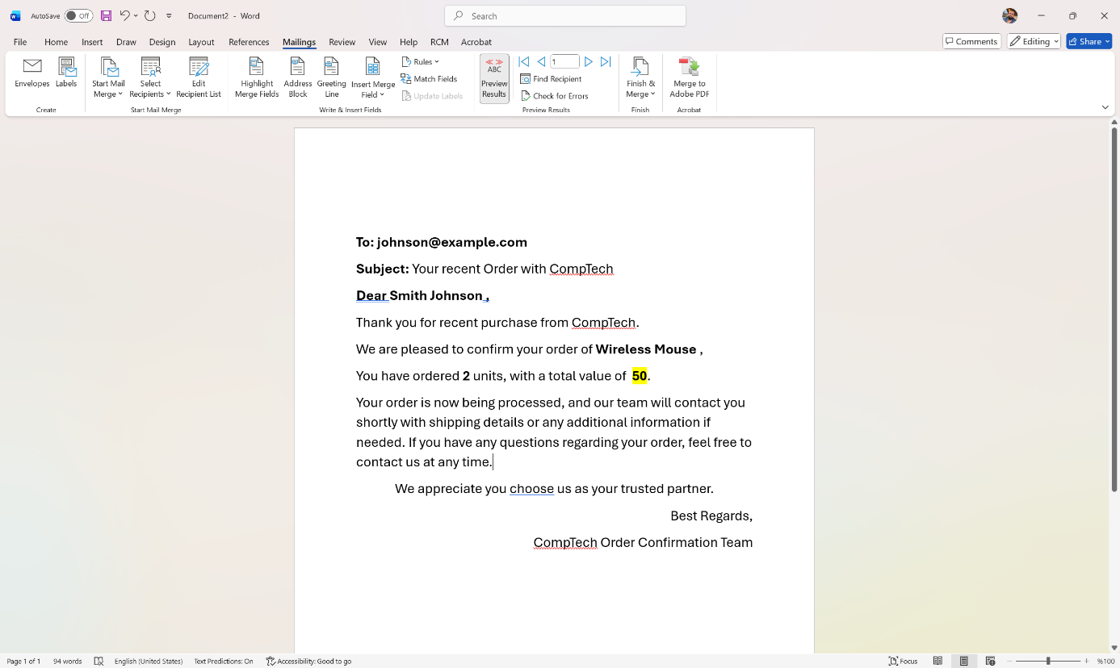
Figure 17. Preview of the prepared mail

Figure 18 shows the final step of the process using Finish & Merge, where the messages can be generated as separate documents or directly sent as email messages.
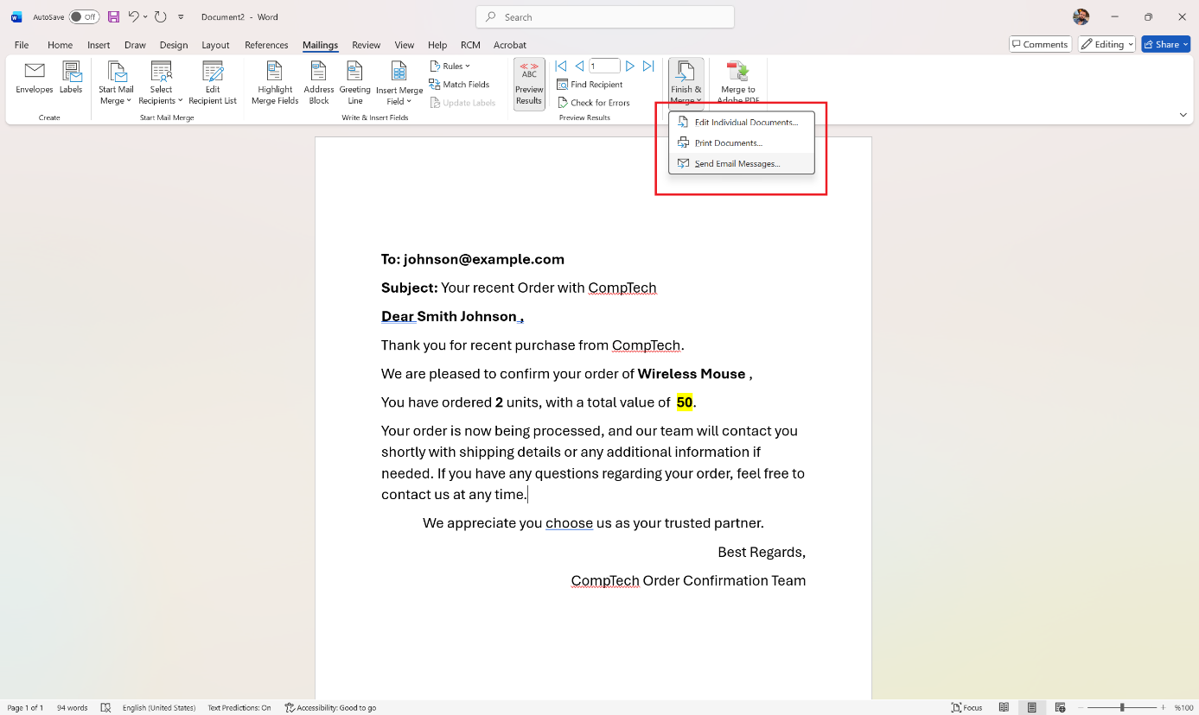
Figure 18. Final steps of MailMerge process

TASK 4 - Communication and Collaboration applications

Contemporary Communication (Outlook) and Collaboration (OneDrive) applications
In modern business, in addition to using software solutions for operational tasks such as MS Office, organizations also require applications that support communication and data storage. Microsoft is a logical choice for businesses because it offers a complete suite of services, including MS Outlook and OneDrive.
MS Outlook is a communication software that provides email, calendar, contacts and task management functionalities. Having all these key features within a single application represents an integrated approach that increases productivity and facilitates employees’ daily work, as they can manage their correspondence, everyday commitments and meetings in one place. The business version of MS Outlook offers a high level of protection, reliable infrastructure and intelligent tools designed to support workflow organization within corporations [17].
Perhaps the most significant advantages of MS Outlook are its user-friendly nature and its strong integration with other Microsoft 365 applications, which are accessible directly from the left side of the interface. This is beneficial because it eliminates the need to download a file locally before attaching it; instead, files can be added directly from OneDrive. This direct connection optimizes work by making it more efficient and reducing the risk of file loss, which is crucial for international teams working through virtual collaboration. The ability to customize the interface is another advantage, allowing users to personalize their Outlook theme. Another notable benefit is the strong support available for the product. Microsoft is widely known for its extensive help ecosystem, which includes a support center, technical support, forums and user community assistance.
Outlook does have some limitations, such as its wide range of features sometimes being overwhelming for users who are used to simpler email services. A more major problem is that Outlook is a Microsoft product and therefore has system requirements tied to specific operating systems. For example, Outlook operates most efficiently on Windows; it also functions on Mac, primarily in a virtualized environment, while Linux users face significantly more restrictions and fewer support options. Integration, listed above as an advantage, can also be a disadvantage in certain cases. For example, if users rely on Google Calendar or similar applications, Outlook does not integrate with them, requiring manual transfer of information or the use of a third-party tool to connect the systems [18].
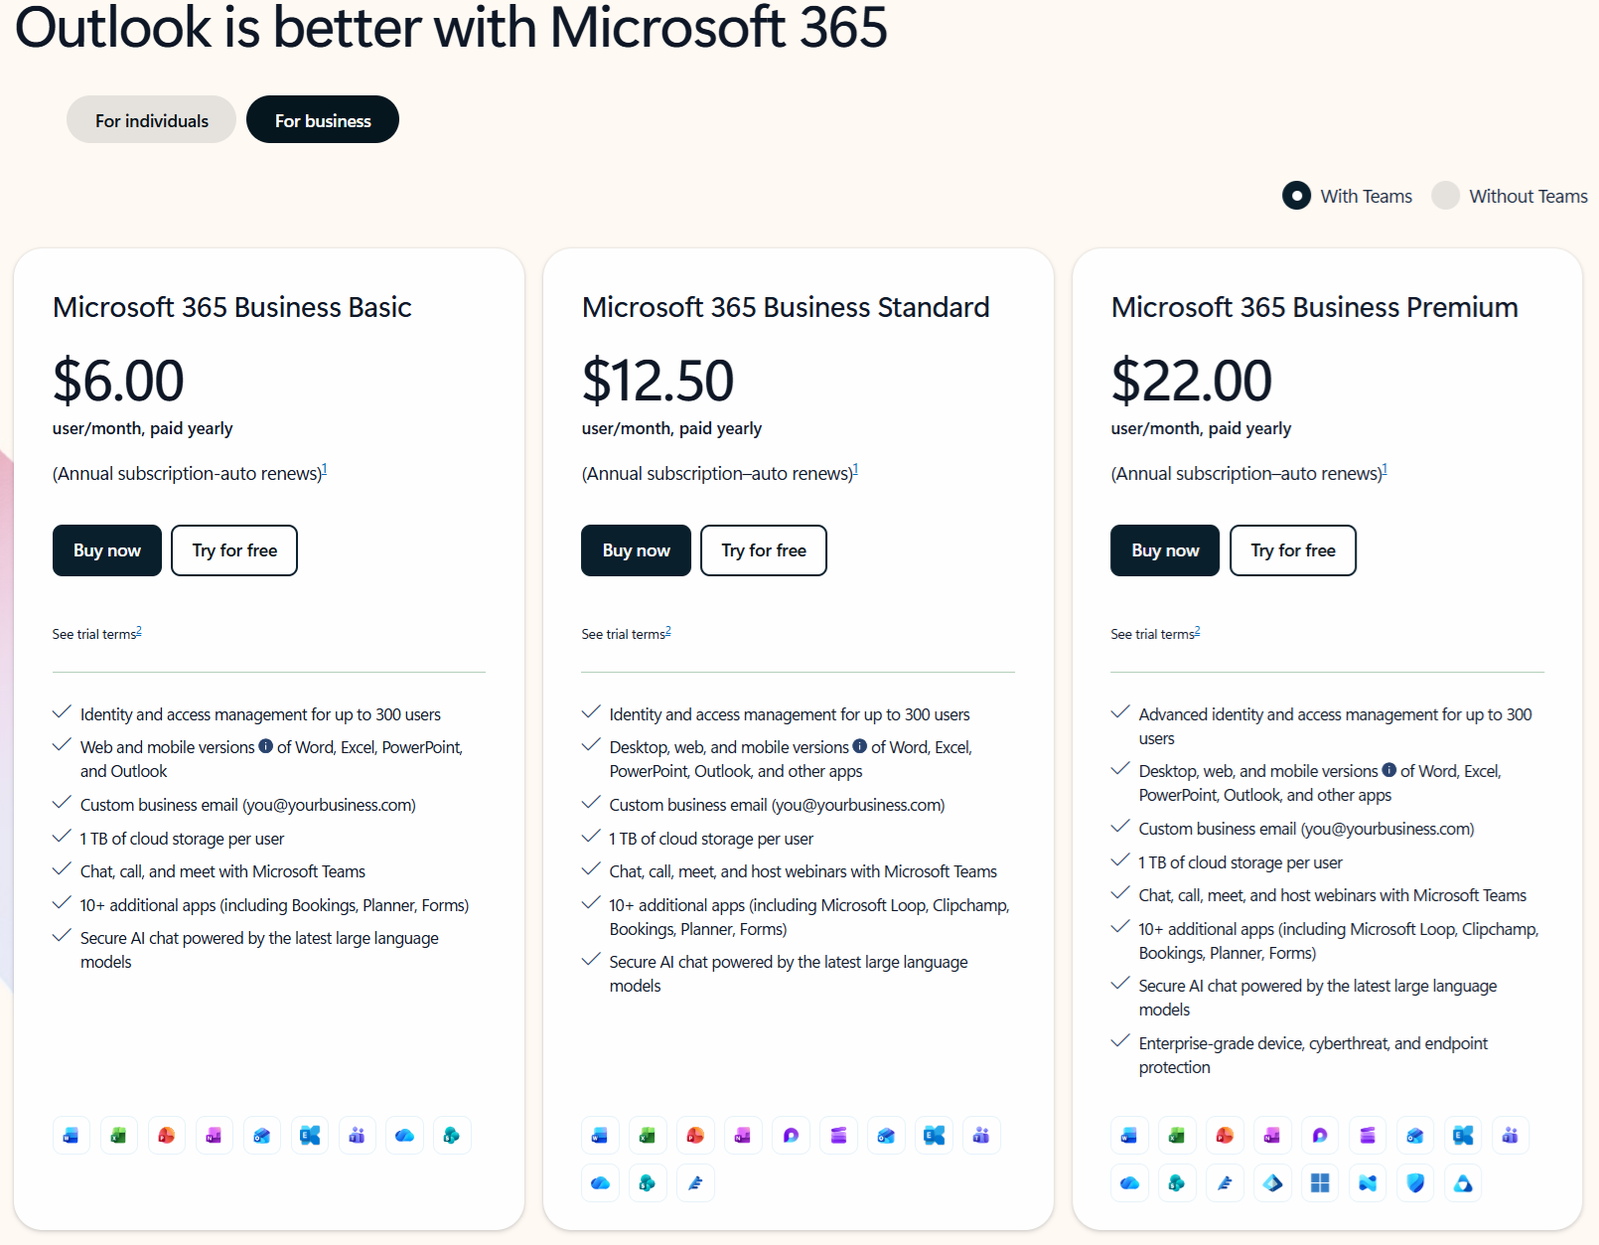
Another important limitation is the cost: Outlook for business is part of the MS Office Package, which is a paid suite of applications costing several hundred pounds per year. For instance, Microsoft 365 Business Premium, which includes all available tools, costs over £200 annually [19].
Figure 19. Microsoft 365 Business Premium price [19]
However, choosing such subscriptions remains logical for businesses, because the strong integration between Outlook and OneDrive is essential for modern business models.
OneDrive is a cloud storage service offered by Microsoft and designed for storing, sharing and collaborating on files. Its core functions include cloud storage and synchronization, enabling users to save files in the cloud and, if working offline, have their work automatically synchronized across devices once connected to the internet. The file-sharing feature allows collaboration with other users, with options to grant view-only or editing permissions. Another key advantage of OneDrive is its security, ensured through file encryption, two-factor authentication and ransomware protection, which allows files to be restored to their previous state in the event of an attack. There are also protected-sharing options, such as expiring links or password-protected access [20].
A downside is that OneDrive is a cloud storage and synchronization tool, not a full system backup solution; it does not back up operating systems or applications. Users must also be cautious with access and sharing policies, as misconfiguration can lead to the exposure of sensitive information. Encryption keys are managed by Microsoft, and organizations wishing to use their own keys face additional costs and technical requirements. Furthermore, the free version has upload limitations (e.g., a 250MB file size limit).
Microsoft 365 and the combined use of Outlook and OneDrive can provide centralized management within business processes. Outlook is a communication solution that facilitates information exchange and schedule planning, while OneDrive enhances its functionality by offering secure file storage and real-time collaboration.

Testing features of Outlook and OneDrive application
In this practical activity, I will demonstrate one common business use of Microsoft Outlook: sending a professional email with an attached file stored in OneDrive. This is a typical workflow in modern organisations, as it allows employees to communicate efficiently while sharing documents securely.
I start by opening Microsoft Outlook and selecting the “New Message” option.
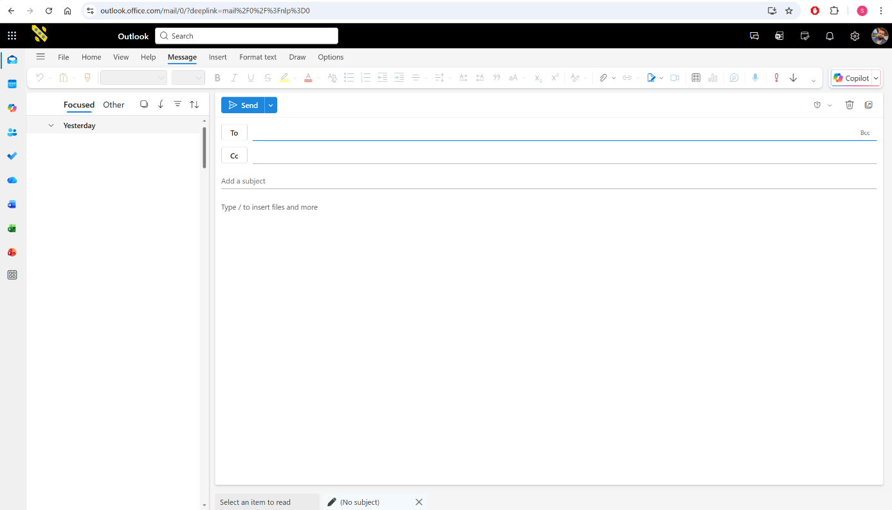
Figure 20. Creating New message in Outlook
I enter the recipient’s email address, subject, and message content. This mirrors how employees communicate daily with colleagues.
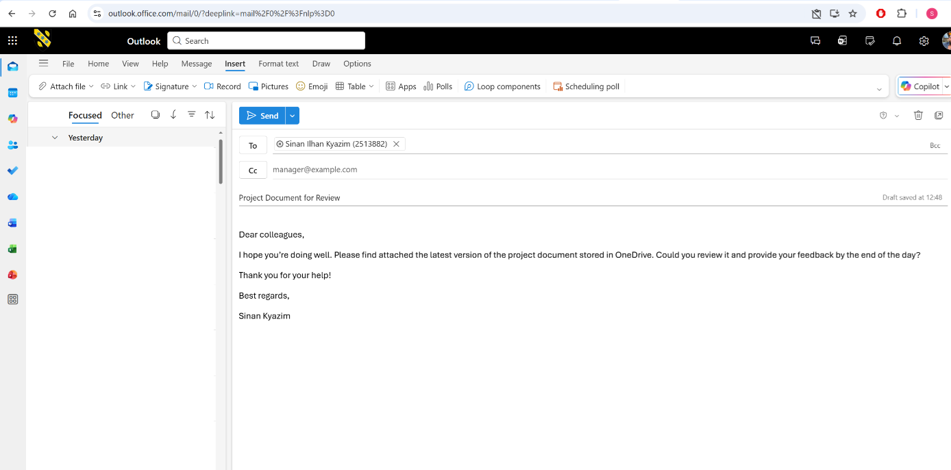
Figure 21. Message content creating
After that, instead of attaching a local file, I select “Attach” → “OneDrive”. This allows me to choose a document already stored online. Using OneDrive attachments is widely used in businesses because it ensures that recipients always have the most updated version of a shared file.
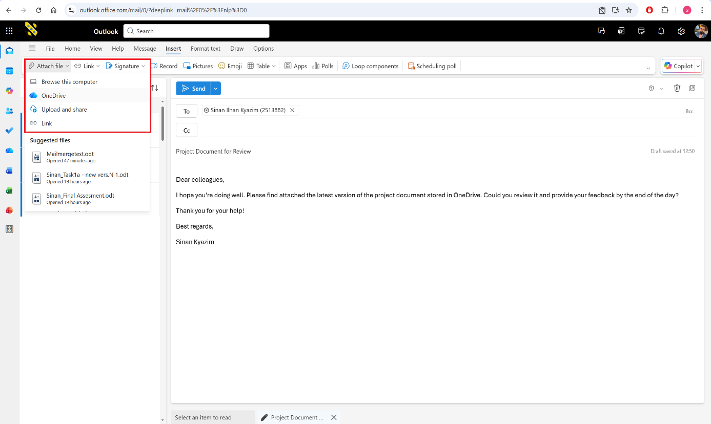
Figure 22. Selecting OneDrive attachment file
Then I choose the required document from my OneDrive folder and confirm the attachment.
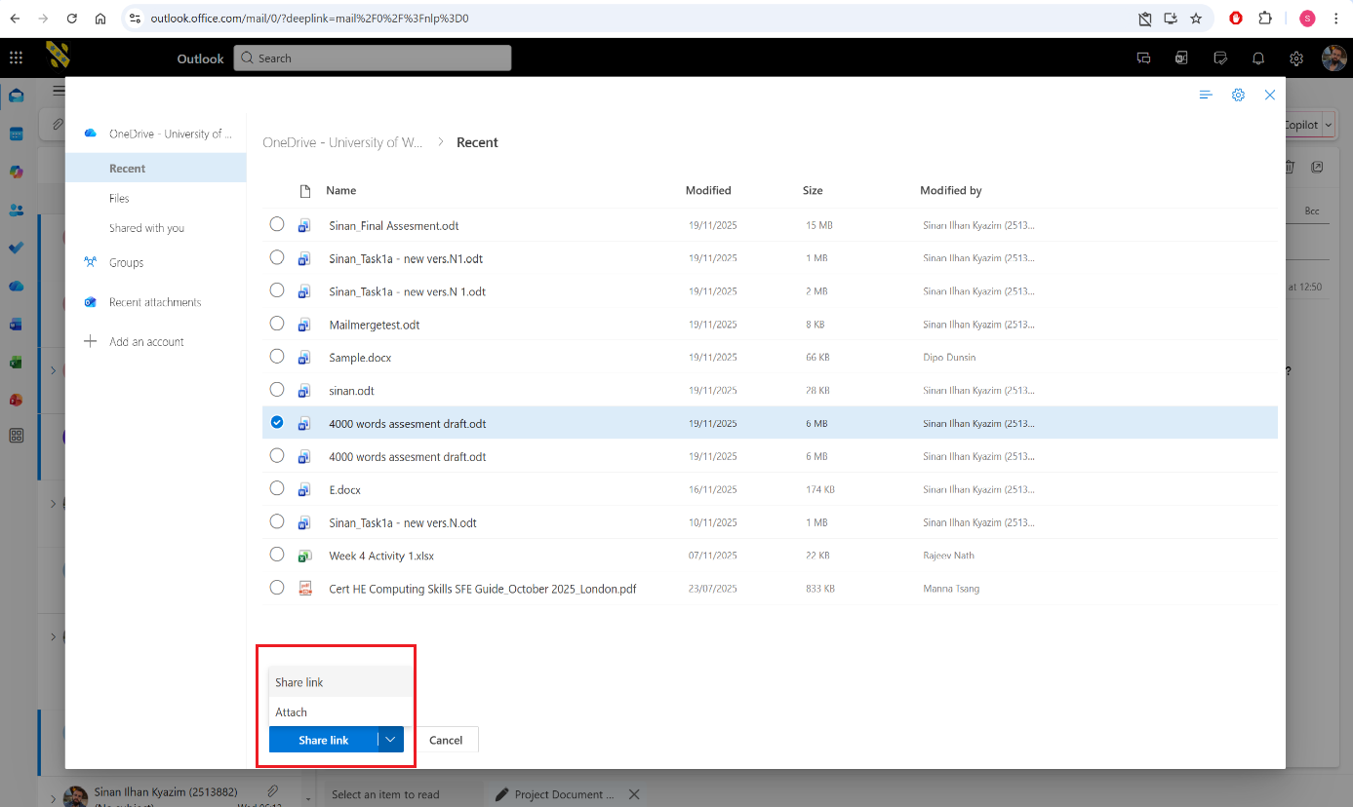
Figure 23. Choosing and attaching the file
Finally, I press “Send”. The email is delivered along with a OneDrive-powered link to the file. This method improves collaboration and avoids duplicate file versions circulating through email.
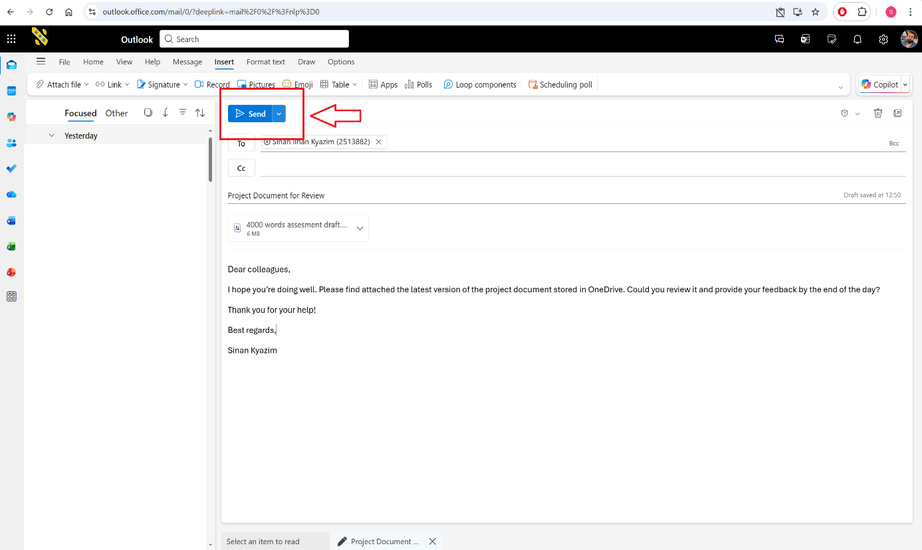
Figure 24. Sending prepared email with attached OneDrive file

For the second part of the task, I demonstrate uploading a file and sharing it with another user, which is a core collaboration process in modern business environments.
I access OneDrive through Outlook, so I can show the integration between two of them.
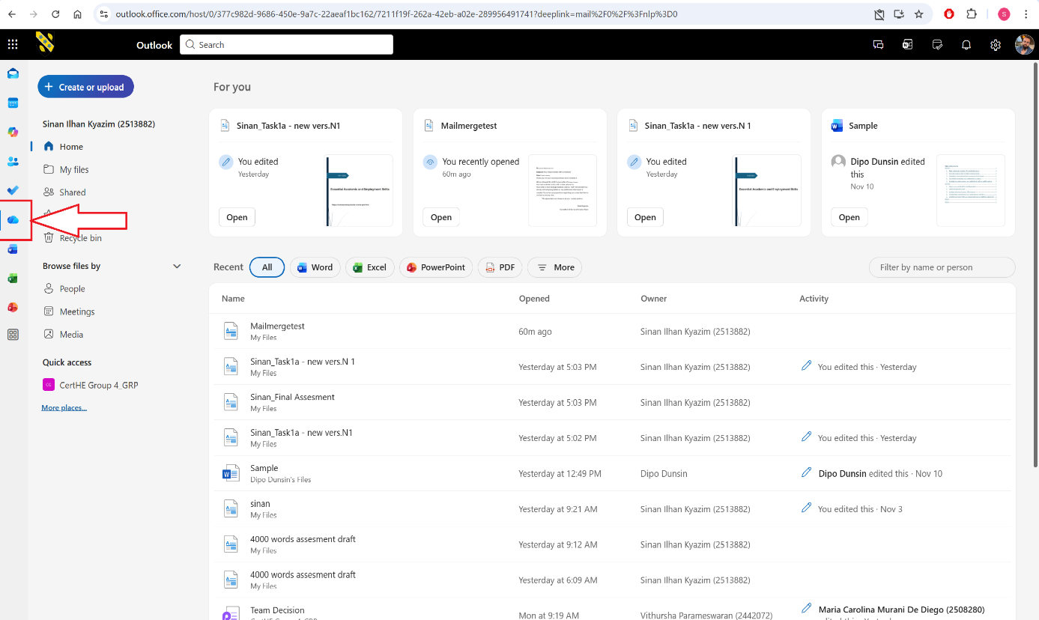
Figure 25. Access to OneDrive at Outlook
To upload a new document, I select “Create or Upload” → “Files upload” and choose a file from my device. Uploading files to OneDrive is essential for centralised storage and for making documents accessible to teams regardless of location.
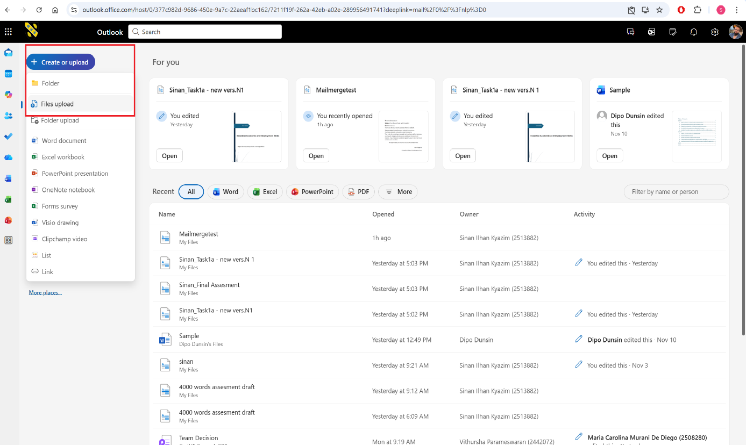
Figure 26. Uploading a new file from my device
Once the file appears in my OneDrive directory, it becomes accessible from any device connected to my Microsoft 365 account and I can find it in “My files”.
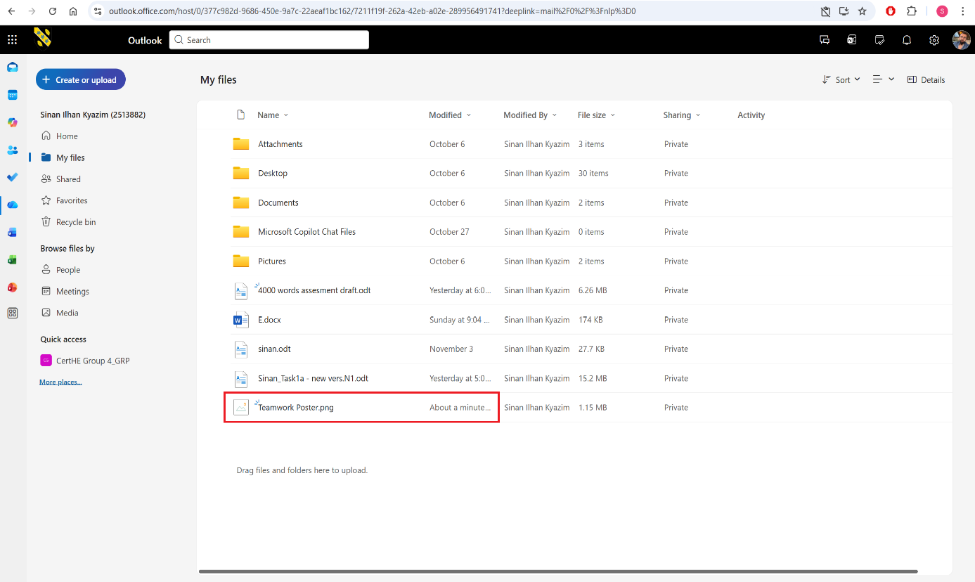
Figure 27. Uploaded new file in “My files” directory
Lastly, I click “Share” on the uploaded file. Organisations heavily use this feature to allow colleagues to collaborate in real time. I choose the appropriate permissions such as “Can view” or “Can edit”, depending on the purpose. Then I generate a sharing link or send the invitation directly to a colleague’s email.
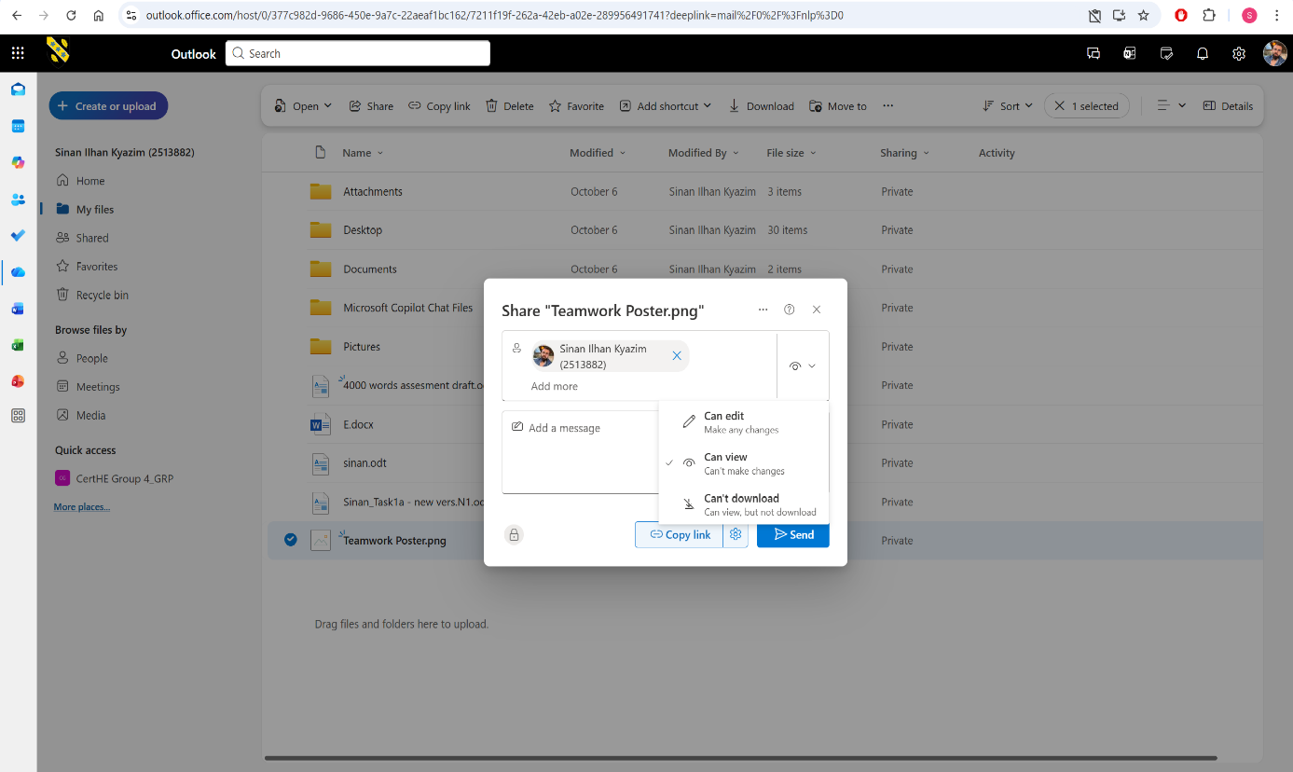
Figure 28. Sharing and giving permission, generating link and sending invitation to a colleague
Both applications demonstrate how Microsoft 365 tools support modern business communication and collaboration.

References

[1] | B. M. ,. S. A. VIPIN JAIN, “An Overview of Electronic Commerce (e-Commerce),” Journal of Contemporary Issues in Business and Government, pp. 665-670, 2021.
[2] | “Wix eCommerce,” [Online]. Available: https://www.wix.com/ecommerce. [Accessed 15 11 2025].
[3] | C. Singleton, “Ecommerce reviews: Wix review,” ecommercetrix, [Online]. Available: https://www.ecommercetrix.com/ecommerce-reviews/wix-review/. [Accessed 15 11 2025].
[4] | “Z Jewelers e-shop,” [Online]. Available: https://www.shopzjewelers.com/. [Accessed 15 11 2025].
[5] | “Magium Commerce,” [Online]. Available: https://www.magium.co.uk/services. [Accessed 15 11 2025].
[6] | “Magium Commerce - Work,” [Online]. Available: https://www.magium.co.uk/work/warners-group-publications. [Accessed 15 11 2025].
[7] | “Magium Commerce - Work,” [Online]. Available: https://www.magium.co.uk/work/bauer-media. [Accessed 15 11 2025].
[8] | T. Buzan, Mind Mapping, BBC Active, 2006.
[9] | C. G. Tony Buzan, Mind Maps for Business, Pearson Education, 2013.
[10] | “Microsoft,” [Online]. Available: https://www.microsoft.com/en/microsoft-365/word?market=af. [Accessed 16 11 2025].
[11] | C. A. &. N. Valanides, “Examining the effects of text-only and text-and-visual instructional materials on the achievement of field-dependent and field-independent learners during problem-solving with modeling software,” Educational Technology Research and Development, vol. 52, no. 1, pp. 23-36, 2004.
[12] | C. Carlberg, Business Analysis with Microsoft Excel, Pearson Education, 2018.
[13] | D. Raymond, “10 Advantages of Managing your Projects with Excel,” Aceproject, [Online]. Available: https://www.aceproject.com/blog/10-pros-advantages-of-managing-your-projects-with-excel-9387815/ [Accessed 16 11 2025].
[14] | A. Mehar, “What are the Advantages and Disadvantages of MS Excel,” AlmaBetter, [Online]. Available: https://www.almabetter.com/bytes/articles/advantages-and-disadvantages-of-ms-excel. [Accessed 16 11 2025].
[15] | “Pros and cons of Microsoft Access,” KeyPress Software Development Group, [Online]. Available: https://keypressgroup.com/article/pros-and-cons-of-microsoft-access/. [Accessed 16 11 2025].
[16] | J. Ebsen, “MS Access: Advantages and Disadvantages,” Arkware, [Online]. Available: https://www.arkware.com/ms-access-advantages-disadvantages/. [Accessed 16 11 2025].
[17] | “Outlook for business,” Microsoft, [Online]. Available: https://www.microsoft.com/en/microsoft-365/outlook/outlook-for-business. [Accessed 18 11 2025].
[18] | Admin, “Pros and Cons of Microsoft Outlook for Business,” LuxHosting, 5 7 2021. [Online]. Available: https://luxhosting.com/blog/pros-and-cons-of-microsoft-outlook. [Accessed 18 11 2025].
[19] | “Grow your business with Microsoft 365,” Microsoft, [Online]. Available: https://www.microsoft.com/en-gb/microsoft-365/business. [Accessed 18 11 2025].
[20] | “How OneDrive safeguards your data in the cloud,” Microsoft, [Online]. Available: https://support.microsoft.com/en-us/office/how-onedrive-safeguards-your-data-in-the-cloud-23c6ea94-3608-48d7-8bf0-80e142edd1e1. [Accessed 18 11 2025].

