BMSP5015
To what extent does brand authenticity influence the purchase intentions of ‘Gen Z’ consumers?
By Alyssia Frampton, 2327857
Word Count: 2156

Contents:
Introduction |  |  | 3
Part 1: Qualitative Research |  |  | 4
1.1 | Methodology |  | 4
1.2 | Data Collection |  | 5
1.3 | Data Analysis |  | 6
1.4 | Findings |  | 7
1.5 | Interpretation |  | 8
Part 2: Quantitative Research |  |  | 9
2.1 |  | Methodology | 9
2.2 |  | Survey Design | 10
2.3 |  | Data Analysis | 11
2.4 |  | Results | 12
2.5 |  | Interpretation | 15
Conclusion |  |  | 16
References |  |  | 17
Appendix |  |  | 18

Introduction:
In contemporary marketing environments, consumers increasingly expect brands to demonstrate authenticity in their behaviour. Brand authenticity is often associated with values such as transparency, honesty, and consistency. Research suggests that authentic brands are perceived as more credible and trustworthy, positively influencing consumer attitudes (Napoli et al., 2014). However, authenticity is also subjective, with consumers developing their own interpretation of genuineness (Abratt et al., 2014). Trust is closely linked to authenticity and is often central to building emotional connection and loyalty, making authenticity an increasingly important strategic focus for organisations aiming to strengthen long-term relationships with consumers.
Generation Z, typically defined as individuals born between 1997 and 2012, are digitally native and highly influenced by brand values, ethics and social responsibility (Francis & Hoefel, 2018). They are more likely than previous generations to assess brands based on alignment with personal values, with social media playing a key role in shaping perceptions through peer validation, influencer content and brand interactions (Rao et al., 2025). This makes authenticity particularly relevant when examining Gen Z consumer behaviour.
This research investigates the extent to which perceived brand authenticity influences purchase intention among Gen Z consumers and explores how authenticity is understood and applied in purchasing decisions. A mixed-method approach was used, combining an online survey to identify overall patterns in attitudes and purchase intentions with interviews to gain deeper unsought into individual perceptions and experiences. Together, these methods provide both broad trends and detailed understanding of how authenticity influences Gen Z consumer behaviour.

Part 1: Qualitative Research
  - Methodology
A qualitative approach, underpinned by an interpretivist philosophy, was adopted to explore how brand authenticity influences the purchase intentions of Generation Z consumers. This approach was appropriate as it recognises that individuals construct subjective meanings of authenticity based on personal experiences, values and social context. Semi-structured interviews were used as the primary data collection method, as they provide a consistent framework of questions while allowing flexibility to explore participant responses in greater depth. This facilitated the collection of detailed insights into opinions, experiences and attitudes in a conversational yet structured format. Three interviews of approximately 15 minutes were conducted within the target group.
Ethical considerations were addressed using UWTSD’s secure data systems to store and manage all research data. Ethical approval forms were completed prior to data collection (appendix A and F) and participation anonymity was maintained throughout to protect identities and encourage honest responses. The interview data was then transcribed and analysed thematically (appendix B and C) to identify key patterns and broader themes.

  - Data Collection
Data for qualitative reasoning was collected through three semi-structured interviews conducted with participants aged 18-25, ensuring alignment with the Gen Z age group. A purposive sampling method was used to select the sample including three participants with mixed educational and experiential backgrounds in relation to marketing. Interviews were conducted remotely using Microsoft Teams, providing a convenient and accessible setting for participants.
A semi-structured interview guide was used to ensure consistency across interviews (appendix B) while allowing flexibility to explore responses in greater depth. Questions focused on perceptions of brand authenticity and its influence on purchase behaviour. Interviews lasted approximately 15 minutes each and were recorded and transcribed for analysis.
A key limitation of this approach is the small sample size, which restricts the generalisability of findings and may not fully represent the diversity of Gen Z consumer perspectives.

  - Data Analysis
Data analysis was conducted using thematic analysis, following the six-step process outlined by Braun and Clarke (2006) and further supported by Naeem et al. (2023). This approach was appropriate as it allows for a structured yet flexible interpretation of qualitative data, enabling key patterns in perceptions of brand authenticity to be identified. Interview recordings were transcribed using Microsoft Teams within the UWTSD’s secure network and reviewed multiple times to ensure familiarisation with the data. Initial coding was then carried out manually, identifying recurring words, phrases and concepts related to authenticity and purchasing behaviour. These codes were subsequently grouped into broader themes, such as honesty, transparency and value alignment (appendix C). This helped reflect patterns across the dataset.
Reflexivity was applied throughout the analysis to acknowledge the researcher’s potential influence on interpretation and to minimise personal bias when identifying and developing themes. This process strengthened the credibility and trustworthiness of the findings by ensuring that interpretations remained grounded in participant responses. Regular re-reading of the transcripts supported consistency and reduced the risk of misinterpretation.

  - Findings
Authenticity Consideration
The first three interview questions explored participants’ understanding and attitudes towards brand authenticity. Interviewee 1 described “genuine…transparency and putting customers and values first,” while interviewee 2 reflected to “a brand that is open and honest…reliable…relatable.” Using Gymshark as an example. Interviewee 3 defined it as “a brand that is trustworthy and honest with its customers,” linking it to ethics and sustainability through Poppi. This shows authenticity is understood individually but shares common themes.
Authenticity was considered as a secondary factor in purchase decisions. Interviewee 1 prioritised price and quality, while interviewees 2 and 3 described it as situational. One noted “…price and quality will always be the top…I’d probably let authenticity be the decider.”(Interviewee 2), while interviewee 3 stated “Price and quality…where quality is the same as authenticity”. This indicates that although authenticity is recognised, its influence depends on context and personal values.
Impact of Social Media
Social media was identified as a key influence in shaping perceptions of authenticity. Interviewee 1 argued “it’s very easy to be fake online,” while interviewee 2 acknowledged that “everything can be faked…but it’s a good way to connect with customers.” Interviewee 3 stated they use social media more than Google for brand discovery and noted that authentic brands “try to connect with people on social media.” A recurring idea was the distinction between organic and paid content, with all participants expressing dislike towards overly promotional content and preferred more natural organic content.
Trust, Shared Values and Emotional Connection
All participants linked authenticity to trust, although to different extents. Interviewee 3 stated “you won’t feel that confidence or loyalty in a non-authentic brand,” highlighting trust as a driver of long-term loyalty. Emotional connection also varied, with interviewees 2 and 3 expressing stronger alignment with brands reflecting shared values such as ethics, sustainability and customer care. An unexpected finding was the importance placed on post-purchase communication and service experiences as part of authenticity, highlighted in particular by interviewee 1.

  - Interpretation
The findings indicate that brand authenticity influences Gen Z purchase intentions indirectly rather than as a primary driver, supporting literature that frames authenticity as subjective and value-based (Abratt et al., 2014 & Napoli et al., 2014). While participants consistently linked authenticity to trust, honesty and connection, practical factors such as price and quality dominated decision-making, suggesting a gap between attitudinal value and actual behaviour. Social media further reinforces this, acting as a key space for constructing authenticity perceptions instead of directly impacting purchases. This implies that authenticity functions more for longevity and loyalty than an immediate sales trigger. Critically, this challenges assumptions that authenticity alone shapes consumer behaviour, highlighting its situational and context-dependent role within Gen Z purchasing decisions.

Part 2: Quantitative Research
2.1 Methodology
This quantitative study, underpinned by a positivist approach, investigates the relationship between perceived brand authenticity and purchase intention among Gen Z consumers. A positivist methodology was appropriate as it emphasises objectivity, ensuring that consumer behaviour is measured through numerical data without researcher bias. This means a clearer identification of generalisable patterns.
A cross-sectional survey design was adopted, enabling data to be collected at a single point in time to provide a snapshot of current attitudes towards brand authenticity. This design was suitable for efficiently capturing trends within a defined population.
Data was collected using an online survey, chosen for its ability to gather standardised responses from a larger sample of 18-25 year olds. A convenience sampling method was used due to accessibility and relevance to the target population. Overall, this approach allowed for structured, comparable data to be analysed effectively.

2.2 Survey Design
The survey was designed as a cross-sectional instrument to capture Gen Z attitudes towards brand authenticity and purchase intention at a single point in time. It consisted of 10 questions using a combination of Likert scale, multiple choice, ranking, yes/no and one short answer question. Likert scale items were used to measure levels of agreement with statements relating to authenticity and purchase likelihood, enabling quantifiable analysis of attitudes. Multiple choice questions captured clear behavioural preferences, while ranking questions assessed the relative importance of factors influencing purchase decisions. Yes/no questions provided straightforward indicators of behaviour, and the short-answer question allowed a limited qualitative elaboration for added context (appendix D).
The structured design ensured comparability of responses while allowing some depth of insight. Ethical considerations included voluntary participation, anonymity, and informed consent, ensuring participants understood the purpose of the study and their right to withdraw at any time.

2.3 Data Analysis
Data analysis was conducted using Microsoft Forms (appendix E) and Microsoft Excel to organise and interpret the quantitative data. Once collected, the dataset was cleaned by removing responses from participants over the age of 25 to ensure alignment with the Gen Z sample criteria. The data was then prepared for analysis by coding responses and categorising them into relevant variables. Descriptive statistical methods were used, including frequencies, percentages and averages, to identify patterns in consumer attitudes towards brand authenticity and purchase intention. These methods enabled clear and structured comparison of responses across the sample.
The use of Excel supported accurate calculation and visual representation of findings. This enhances clarity and interpretation. Objectivity was maintained throughout analysis by focusing on numerical data and avoiding subjective interpretation. Validity was strengthened through clear question design and targeted sampling of the relevant demographic.

2.4 Findings
The quantitative results reveal several clear patterns regarding the perceived importance of brand authenticity, it’s relationship to purchasing behaviour, and the influence of social media of 35 respondents.
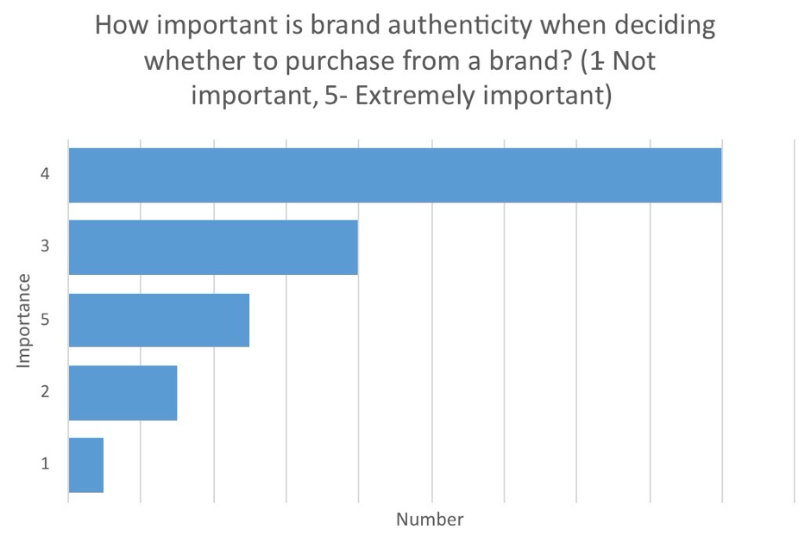
Overall, participants rated brand authenticity as highly important when deciding whether to purchase from a brand. In Figure 1, the modal responses was rated a 4, on a 5 point scale (see Figure 1 for scale). This indicates that most respondents considered authenticity to be a significant factor within purchase intentions. This aligns with attitudinal data in Figure 2, where 17 participants strongly agreed and 17 agreed that they are more likely to purchase from brands that appear genuine and transparent. Only one participants disagreed, showing a strong positive trend towards authenticity influencing purchase likelihood.
(Figure 1)
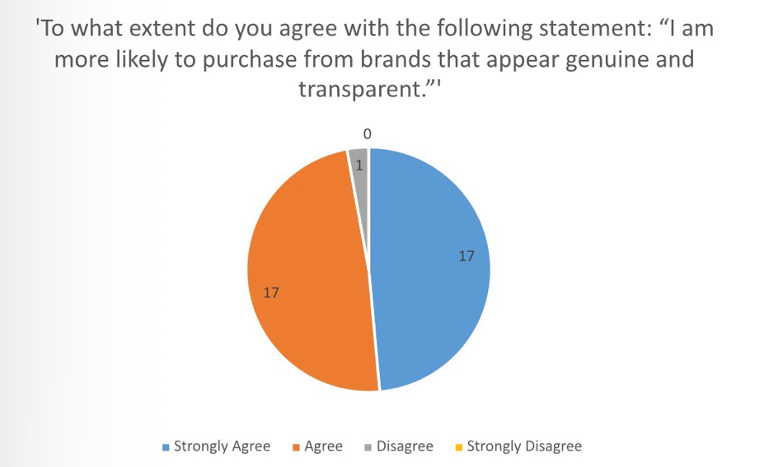
(Figure 2)
Behavioural data further supports this pattern. As shown in Figure 3, 71% reported having purchased from a brand because it felt authentic or relatable.
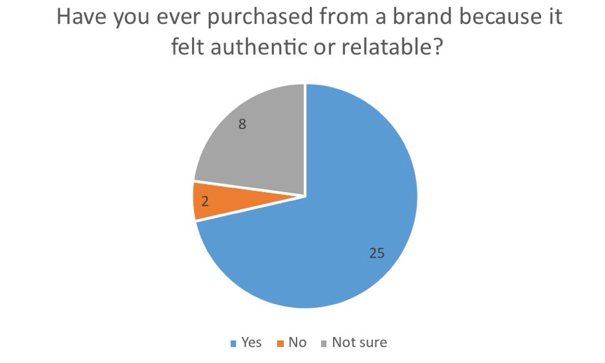
(Figure 3)
However, when authenticity is compared with other purchasing factors, a different trend emerges. Figure 4 shows that price was most frequently ranked as the primary influence (57%), followed by quality (46%). Brand authenticity ranked third (37%), suggesting it is valued but not the dominant factor in decision-making.
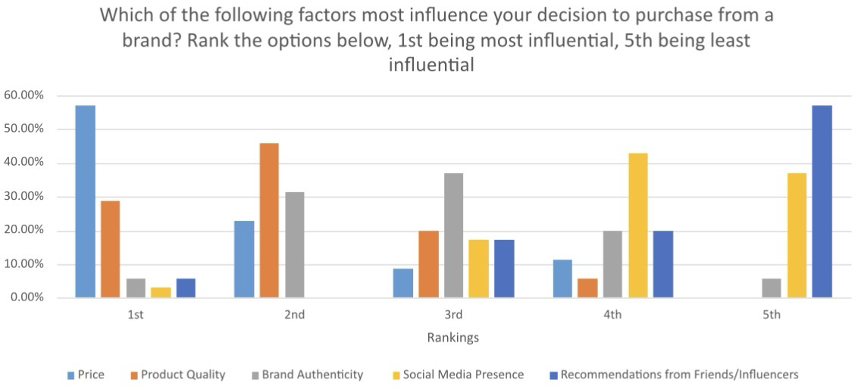
(Figure 4)
Social media-related findings show mixed behavioural patterns. In Figure 5, only 12 participants reported purchasing from brands they follow on social media “very often” or “often” while majority selected “sometimes” or “rarely”. Despite this, Figure 6 shows unanimous agreement (all 35 respondents) with the statement stating they trust brands that communicate honestly, and high agreement with the statement “I prefer brands that show their values on social media”.
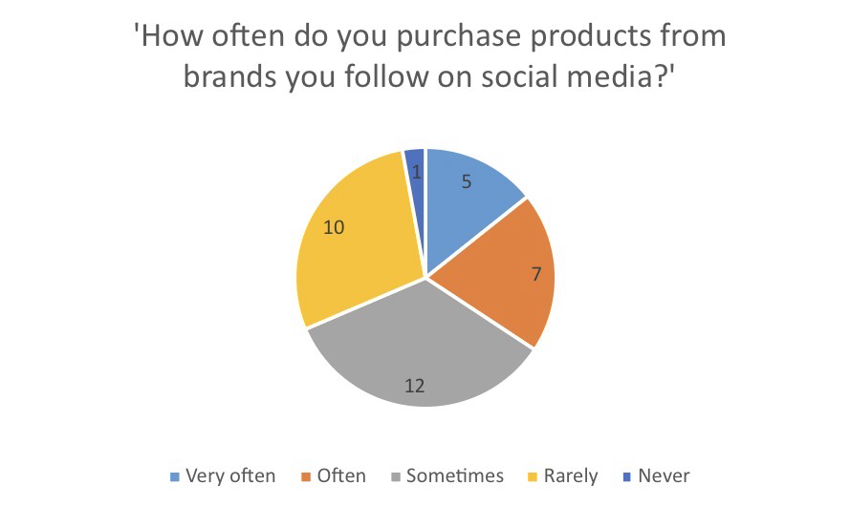
(Figure 5)
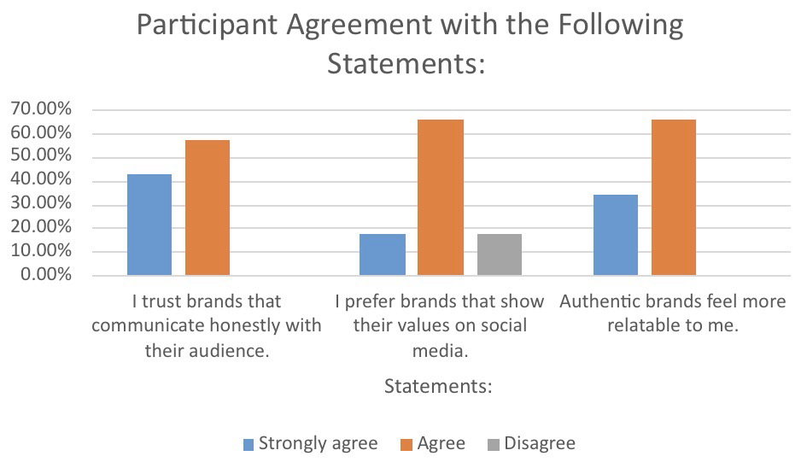
(Figure 6)

These results collectively highlight strong positive attitudes toward authenticity, consistent behavioural evidence and varying levels of influence across different purchasing contexts.

2.5 Interpretations
The results indicate that perceived authenticity plays a meaningful role in shaping Gen Z purchase intentions, supporting literature that links authenticity with trust and positive consumer attitudes (Napoli et al., 2014). High agreement with statements about honesty and value alignment reflects the subjective nature of authenticity outlined by Abratt et al. (2014). However, the prominence of price and quality suggests authenticity functions alongside, rather than above, practical considerations. Social media appears influential for value signalling but less for direct purchasing. As the data is self-reported and based on a smaller sample, generalisability is limited.

Conclusion:
Overall, this research met its aim of examining how perceived brand authenticity influences Gen Z purchase intentions through an ontological perspective that recognises authenticity as socially constructed and individually interpreted. Quantitative findings showed that authenticity contributes to trust and positive attitudes, but price and quality remain primary decision factors, with social media shaping perceptions rather than driving direct purchases. Qualitative findings reinforced this, showing authenticity as a subjective, trust-building concept that supports long-term loyalty rather than immediate behaviour. Integrating both methods demonstrates that authenticity operates as a contextual, secondary influence rather than a dominant driver of consumption. The mixed-method design strengthened depth and comparability, although, limitations include a small sample size, self-reported data and limited generalisability. Future research should expand sample diversity, increase survey scale and further explore the differences within Gen Z subgroups to enhance validity and reliability.

References:
Abratt, R., Portal, S., & Bendixen, M. (2019). The role of brand authenticity in developing brand trust. Journal of Strategic Marketing, 27(8), 714-729. https://doi.org/10.1080/0965254X.2018.1466828
Braun, V., & Clarke, V. (2006). Using thematic analysis in psychology. Qualitative Research in Psychology. 3(2), 77-10. https://doi.org/10.1191/1478088706qp063oa
Francis, T. & Hoefel, F. (2018). ‘True Gen’: Generation Z and its implications for companies. McKinsey & Company, 1-10. https://www.mckinsey.com/~/media/mckinsey/industries/consumer%20packaged%20goods/our%20insights/true%20gen%20generation%20z%20and%20its%20implications%20for%20companies/generation-z-and-its-implication-for-companies.pdf
Naeem, M., Ozuem, W., Ranfagni, S., & Howell, K. (2023). A step-by-step process of thematic analysis to develop a conceptual model in qualitative research. International Journal of Qualitative Methods, 22. https://doi.org/10.1177/16094069231205789
Napoli, J., Dickinson, S. J., Beverland, M. B., & Farrelly, F. (2014). Measuring consumer-based brand authenticity. Journal of Business Research, 67(6), 1090-1098. https://doi.org/10.1016/j.jbusres.2013.06.001
Rao, M., Younas, W., Farooq, M., Hassaan, M., & Zulfiqar, S. (2025). The influence of brand authenticity on consumer behaviour in social media marketing. Dialogue Social Science Review, 3(8), 230-241. https://www.researchgate.net/profile/Waqar-Younas-3/publication/399817167_Dialogue_Social_Science_Review_DSSR_The_Influence_of_Brand_Authenticity_on_Consumer_Buying_Behavior_in_Social_Media_Marketing/links/6969e9f9c906f117f2a5bf11/Dialogue-Social-Science-Review-DSSR-The-Influence-of-Brand-Authenticity-on-Consumer-Buying-Behavior-in-Social-Media-Marketing.pdf

Appendix:
Appendix A- Ethics Form:

APPLICATION FOR ETHICAL APPROVAL

In order for research to result in benefit and minimise risk of harm, it must be conducted ethically.

The University follows the OECD Frascati manual definition of research activity: “creative work undertaken on a systematic basis in order to increase the stock of knowledge, including knowledge of man, culture and society, and the use of this stock of knowledge to devise new applications”. As such this covers activities undertaken by members of staff, postgraduate research students, and both taught postgraduate and undergraduate students working on dissertations/projects.

The individual undertaking the research activity is known as the “principal researcher”.

This form must be completed and approved prior to undertaking any research activity.

SECTION A: About You (Principal Researcher)
1 | Full Name: | Alyssia Frampton
2 | Student Number: | 2327857
3 | Email address: | 2327857@student.uwtsd.ac.uk
4 | Programme of Study: | BMSP5007 Business Inquiry & Research
5 | Supervisor: | Helen Evans

SECTION B: Internal and External Ethical Guidance Materials
 | Please list the core ethical guidance documents that have been referred to during the completion of this form (including any discipline-specific codes of research ethics, location-specific dodes of research ethics, and also any specific ethical guidance relating to the proposed methodology). Please tick to confirm that your research proposal adheres to these codes and guidelines. You may add rows to this table if needed.
1 | UWTSD Research Ethics & Integrity Code of Practice | ☒
2 | UWTSD Research Data Management Policy | ☒

SECTION C: Details of Research Activity
1 | Indicative title: | Business Inquiry and Research Module Assignment 1,  part 1 qualitative research report  part 2 quantitative research report  “To what extent does perceived brand authenticity influence purchase intention among Gen Z consumers?”
2 | Proposed start date: | 12-03-2026 | Proposed end date: | 01-05-2026
Introduction to the Research (maximum 300 words in each section)
Ensure that you write for a Non-Specialist Audience when outlining your response to the three points below:
- Purpose of Research Activity
- Proposed Research Question
- Aims of Research Activity
- Objectives of Research Activity
Demonstrate, briefly, how Existing Research has informed the proposed activity and explain
- What the research activity will add to the body of knowledge
- How it addresses an area of importance.
3 | Purpose of Research Activity  This research activity forms part of the Business Inquiry and Research module assessment. The purpose of the study is to explore how perceived brand authenticity influences purchasing behaviours among Generation Z consumers.  The research will consist of two parts. Part 1 will involve a small-scale qualitative study using semi-structured interviews with three participants to explore in depth how Gen Z consumers interpret brand authenticity and how it affects their perceptions of brands. Part 2 will involve a small-scale quantitative study using an online questionnaire to collect survey data from a wider sample of Gen Z consumers aged between 18 and 25.  The research aims to provide both qualitative insights and quantitative evidence about the role of authenticity in shaping consumer attitudes and purchase intentions. The findings will help develop a better understanding of how authenticity influences marketing effectiveness and consumer decision-making among younger consumers.
4 | Research Question  Part 1 – Qualitative Research Question  How do Generation Z consumers perceive brand authenticity and how does it influence their purchasing decisions?  Part 2 – Quantitative Research Question  To what extent does perceived brand authenticity influence purchase intention among Generation Z consumers aged 18–25?
5 | Aims of Research Activity  Part 1  The aim of this research activity is to explore how Generation Z consumers interpret and evaluate brand authenticity and how these feelings influence their attitudes and purchasing behaviour.  Part 2  The aim of this research activity is to measure the relationship between perceived brand authenticity and purchase intention among Generation Z consumers through the collection of survey data.
6 | Objectives of Research Activity  Part 1  - Conduct three semi-structured interviews with participants aged 18–25.  - Explore participants’ views on authenticity in branding.  - Identify key themes relating to trust, transparency, and authenticity.  - Analyse interview responses using thematic analysis.  Part 2  - Design and distribute an online survey with up to 10 questions.  - Collect responses from 20–40 participants aged 18–25.  - Analyse survey data using descriptive statistics in Excel or MS Forms.  - Interpret the findings to identify patterns in attitudes toward brand authenticity.
Proposed data collection methods (maximum 600 words)
Provide a brief summary of all the methods that may be used in the research activity to collect data, making it clear what specific techniques may be used. If methods other than those listed in this section are deemed appropriate later, additional ethical approval for those methods will be needed. You do not need to justify the methods here, but should instead describe how you intend to collect the data necessary for you to complete your project.
7 | Data will be collected using two primary research methods: semi-structured interviews and an online survey questionnaire.  For the qualitative component of the study, three semi-structured interviews will be conducted with participants aged between 18 and 25. These interviews will last approximately 20 minutes each and will explore participants’ views on brand authenticity, their perceptions of authentic brands, and how authenticity influences their purchasing decisions. The semi-structured format allows the researcher to ask predetermined questions while also allowing flexibility for participants to elaborate on their experiences and opinions. With participant consent, interviews may be audio recorded to ensure accurate transcription and analysis.  For the quantitative component, an online survey questionnaire will be created using a digital platform such as Microsoft Forms. The survey will contain no more than ten questions and will focus on participants’ perceptions of brand authenticity and their likelihood of purchasing from brands they perceive as authentic. The survey will primarily use closed-ended questions, including Likert scale and multiple-choice questions, in order to generate quantitative data that can be analysed statistically.  Participants will be recruited through personal networks and social media platforms and will be invited to voluntarily participate in the study. All participants will be adults aged 18 or above and will provide informed consent before taking part in the research.

SECTION D: Scope of Research Activity
 | Will the research activity include: | YES | NO
1 | Use of a questionnaire or similar research instrument? | ☒ | ☐
2 | Use of interviews? | ☒ | ☐
3 | Use of focus groups? | ☐ | ☒
4 | Use of participant diaries? | ☐ | ☒
5 | Use of video or audio recording? | ☒ | ☐
6 | Use of computer-generated log files? | ☐ | ☒
7 | Participant observation with their knowledge? | ☐ | ☒
8 | Participant observation without their knowledge? | ☐ | ☒
9 | Access to personal or confidential information without the participants’ specific consent? | ☐ | ☒
10 | Administration of any questions, test stimuli, presentation that may be experienced as physically, mentally or emotionally harmful / offensive? | ☐ | ☒
11 | Performance of any acts which may cause embarrassment or affect self-esteem? | ☐ | ☒
12 | Investigation of participants involved in illegal activities? | ☐ | ☒
13 | Use of procedures that involve deception? | ☐ | ☒
14 | Administration of any substance, agent or placebo? | ☐ | ☒
15 | Working with live vertebrate animals? | ☐ | ☒
16 | Procedures that may have a negative impact on the environment? | ☐ | ☒
17 | Other primary data collection methods. Please indicate the type of data collection method(s) below. | ☐ | ☒
 | Details of any other primary data collection method:  (this box should expand as you type) | ☐ | ☒

If you have ticked NO to every question then the research activity is (ethically) low risk and you may skip section E and continue to section F.

If YES to any question, then no research activity should be undertaken until full ethical approval has been obtained.

SECTION E: Intended Participants
 | Who are the intended participants: | YES | NO
1 | Students or staff at the University? | ☒ | ☐
2 | Adults (over the age of 18 and competent to give consent)? | ☒ | ☐
3 | Vulnerable adults? | ☐ | ☒
4 | Children and Young People under the age of 18? (Consent from Parent, Carer or Guardian will be required) | ☐ | ☒
5 | Prisoners? | ☐ | ☒
6 | Young offenders? | ☐ | ☒
7 | Those who could be considered to have a particularly dependent relationship with the investigator or a gatekeeper? | ☐ | ☒
8 | People engaged in illegal activities? | ☐ | ☒
9 | Others. Please indicate the participants below, and specifically any group who may be unable to give consent. | ☐ | ☒
 | Details of any other participant groups: | ☐ | ☒

Participant numbers and source
Provide an estimate of the expected number of participants. How will you identify participants and how will they be recruited?
10 | How many participants are expected? | Approximately 23–43 participants are expected to take part in the study.  - 3 participants will take part in qualitative interviews.  - 20–40 participants will complete the online survey questionnaire.  Participants will be recruited through the researcher’s personal network and social media platforms. Participation will be voluntary and participants will be required to confirm that they are aged between 18 and 25 before completing the survey.
11 | Who will the participants be? | Participants will consist of Generation Z consumers aged between 18 and 25.  This may include university students and young adults who regularly engage with brands and marketing through social media platforms.
12 | How will you identify the participants? | Participants will be identified through personal contacts, university networks and social media platforms such as Instagram, WhatsApp, or LinkedIn. The survey link will be shared online and individuals who meet the age criteria will be invited to participate voluntarily.

 | Information for participants: | YES | NO | N/A
13 | Will you describe the main research procedures to participants in advance, so that they are informed about what to expect? | ☒ | ☐ | ☐
14 | Will you tell participants that their participation is voluntary? | ☒ | ☐ | ☐
15 | Will you obtain written consent for participation? | ☒ | ☐ | ☐
16 | Will you explain to participants that refusal to participate in the research will not affect their treatment or education (if relevant)? | ☒ | ☐ | ☐
17 | If the research is observational, will you ask participants for their consent to being observed? | ☐ | ☐ | ☒
18 | Will you tell participants that they may withdraw from the research at any time and for any reason? | ☒ | ☐ | ☐
19 | With questionnaires, will you give participants the option of omitting questions they do not want to answer? | ☒ | ☐ | ☐
20 | Will you tell participants that their data will be treated with full confidentiality and that, if published, it will not be identifiable as theirs? | ☒ | ☐ | ☐
21 | Will you debrief participants at the end of their participation, in a way appropriate to the type of research undertaken? | ☒ | ☐ | ☐
22 | If NO to any of above questions, please give an explanation

 | Information for participants: | YES | NO | N/A
24 | Will participants be paid? | ☐ | ☒ | ☐
25 | Is specialist electrical or other equipment to be used with participants? | ☐ | ☒ | ☐
26 | Are there any financial or other interests to the investigator or University arising from this study? | ☐ | ☒ | ☐
27 | Will the research activity involve deliberately misleading participants in any way, or the partial or full concealment of the specific study aims? | ☐ | ☒ | ☐
28 | If YES to any question, please provide full details

SECTION F: Anticipated Risks

 | Outline any anticipated risks that may adversely affect any of the participants, the researchers and/or the University, and the steps that will be taken to address them.
1 | Risks to participants  For example: sector-specific health & safety, emotional distress, financial disclosure, physical harm, transfer of personal data, sensitive organisational information. If you have identified in section D that there are no participants then enter N/A and go skip to question 3.
 | Risk to participants:  Participants may experience minor discomfort when discussing their personal opinions about brands or purchasing behaviour. However, the topic is not considered sensitive. | How you will mitigate the risk to participants:  Participants will be informed that they may skip any question they do not wish to answer and may withdraw from the study at any time without providing a reason.
2 | If research activity may include sensitive, embarrassing or upsetting topics (e.g. sexual activity, drug use) or issues likely to disclose information requiring further action (e.g. criminal activity), give details of the procedures to deal with these issues, including any support/advice (e.g. helpline numbers) to be offered to participants. Note that where applicable, consent procedures should make it clear that if something potentially or actually illegal is discovered in the course of a project, it may need to be disclosed to the proper authorities
3 | Risks to the investigator  For example: personal health & safety, physical harm, emotional distress, risk of accusation of harm/impropriety, conflict of interest
 | Risk to the investigator:  The main risk to the investigator is the potential for misunderstandings during interviews or difficulties managing personal data. | How you will mitigate the risk to the investigator:  All interviews will be conducted respectfully and professionally, and all collected data will be stored securely using password-protected systems.
4 | University/institutional risks  For example: adverse publicity, financial loss, data protection
 | Risk to the University:  There is a small risk of reputational damage if participants’ personal data were mishandled. | How you will mitigate the risk to the University:  All data will be anonymised and handled in accordance with the UWTSD Research Ethics & Integrity Code of Practice and the Data Protection Act (2018).
5 | Environmental risks  For example: accidental spillage of pollutants, damage to local ecosystems
 | Risk to the environment:  The study will be conducted online or through virtual communication platforms and therefore environmental risks are minimal. | How you will mitigate the risk to environment:  No materials or procedures will be used that could harm the environment.

SECTION G: Feedback, Consent and Confidentiality

If you have identified in section D that there are no participants then enter skip this section and continue to section H.

1 | Feedback  What de-briefing and feedback will be provided to participants, how will this be done and when?
 | Participants will be informed that they can contact the researcher via email if they wish to receive a summary of the research findings after the study is completed.
2 | Informed consent  Describe the arrangements to inform potential participants, before providing consent, of what is involved in participating. Describe the arrangements for participants to provide full consent before data collection begins. If gaining consent in this way is inappropriate, explain how consent will be obtained and recorded in accordance with prevailing data protection legislation.
Participants will receive an information statement explaining the purpose of the study, what participation involves, and their right to withdraw at any time.
For interviews, participants will provide written or verbal consent before the interview begins.
For the survey, participants will be shown a consent statement at the beginning of the questionnaire explaining that by continuing they are providing informed consent.
3 | Confidentiality / Anonymity  Set out how anonymity of participants and confidentiality will be ensured in any outputs. If anonymity is not being offered, explain why this is the case.
 | All participant responses will remain anonymous. No names or identifying information will be included in the research report. Participants will instead be assigned a unique identifier (e.g., Participant 1, Participant 2). Data will only be used for the purposes of completing this academic assignment.

SECTION H: Data Protection and Storage

 | Does the research activity involve personal data (as defined by the General Data Protection Regulation 2016 “GDPR” and the Data Protection Act 2018 “DPA”)? | YES | NO
1 | “Personal data” means any information relating to an identified or identifiable natural person (‘data subject’). An identifiable natural person is one who can be identified, directly or indirectly, in particular by reference to an identifier such as a name, an identification number, location data, an online identifier or to one or more factors specific to the physical, physiological, genetic, mental, economic, cultural or social identity of that natural person. Any video or audio recordings of participants is considered to be personal data. | ☒ | ☐
 | If YES, provide a description of the data and explain why this data needs to be collected:
2 | Audio recordings from interviews and survey responses may constitute personal data. However, no names or identifying details will be collected unless necessary for consent purposes.
 | Does it involve special category data (as defined by the GDPR)? | YES | NO
3 | “Special category data” means sensitive personal data consisting of information as to the data subjects’ –  (a) racial or ethnic origin,  (b) political opinions,  (c ) religious beliefs or other beliefs of a similar nature,  (d) membership of a trade union (within the meaning of the Trade Union and Labour Relations (Consolidation) Act 1992),  (e) physical or mental health or condition,  (f) sexual life,  (g) genetics,  (h) biometric data (as used for ID purposes), | ☐ | ☒
 | If YES, provide a description of the special category data and explain why this data needs to be collected:
4

 | Will data from the research activity (collected data, drafts of the thesis, or materials for publication) be stored in any of the following ways? | YES | NO
5 | Manual files (i.e. in paper form)? | ☐ | ☒
6 | University computers? | ☐ | ☒
7 | Private company computers? | ☐ | ☒
8 | Home or other personal computers? | ☒ | ☐
9 | Laptop computers/ CDs/ Portable disk-drives/ memory sticks? | ☐ | ☒
10 | “Cloud” storage or websites? | ☒ | ☐
11 | Other – specify: | ☐ | ☐
12 | For all stored data, explain the measures in place to ensure the security of the data collected, data confidentiality, including details of backup procedures, password protection, encryption, anonymisation and pseudonymisation:
 | All data will be stored in password-protected files on the University Office 365 system. Audio recordings will be transcribed and anonymised before analysis. Any files stored on portable devices will be encrypted. All data will be deleted once the research project and assessment have been completed.

 | Data Protection
 | Will the research activity involve any of the following activities: | YES | NO
13 | Electronic transfer of data in any form? | ☐ | ☒
14 | Sharing of data with others at the University outside of the immediate research team? | ☐ | ☒
15 | Sharing of data with other organisations? | ☐ | ☒
16 | Export of data outside the UK or importing of data from outside the UK? | ☐ | ☒
17 | Use of personal addresses, postcodes, faxes, emails or telephone numbers? | ☐ | ☒
18 | Publication of data that might allow identification of individuals? | ☐ | ☒
19 | If YES to any question, please provide full details, explaining how this will be conducted in accordance with the GDPR and Data Protection Act (2018) (and/or any international equivalent):
 | All data will be stored in password-protected files on the University Office 365 system. Audio recordings will be transcribed and anonymised before analysis. Any files stored on portable devices will be encrypted. All data will be deleted once the research project and assessment have been completed.
20 | List all who will have access to the data generated by the research activity:
Principal researcher (Alyssia Frampton)
Module supervisor (required for assessment purposes)
21 | List who will have control of, and act as custodian(s) for, data generated by the research activity:
 | The principal researcher (Alyssia Frampton) will act as the data custodian.
22 | Give details of data storage arrangements, including security measures in place to protect the data, where data will be stored, how long for, and in what form.
 | All data will be stored securely in password-protected cloud storage on the University Office 365 system until the completion of the project, after which it will be deleted.
22 | Confirm that you have read the UWTSD guidance on data management (see https://www.uwtsd.ac.uk/library/research-data-management/) | ☒
23 | Confirm that you are aware that you need to keep all data until after your research has completed or the end of your funding | ☒

SECTION I: Declaration
The information which I have provided is correct and complete to the best of my knowledge. I have attempted to identify any risks and issues related to the research activity and acknowledge my obligations and the rights of the participants.

In submitting this application I hereby confirm that I undertake to ensure that the above named research activity will meet the University’s Research Ethics and Integrity Code of Practice which is published on the website: https://www.uwtsd.ac.uk/research/research-ethics/
 | 1 | Signature of applicant: | Alyssia Frampton | Date:  12/03/2026
2 |  | Director of Studies/Supervisor: |  |  | Date:
3 |  | Signature: |  |  | Date:

FOR INTERNAL USE ONLY:
 | Ethical approval given
1 | Signature of assessor: |  | Date:
2 | Name:
3 | Role:

Appendix B- Interview Transcripts:
Interview 1-
What does the term authentic brand mean to you? A brand that's... A brand that's genuine and real. I suppose a brand that is genuine towards its customers. Okay. Can you think of an example of a brand that feels authentic to you? Nike. Why Nike? 'Cause I like that they sponsor athletes and take their [the athletes] values in account and have to align with them. What characteristics specifically make a brand feel authentic? Honesty, transparency, and real in a way that shows they put customers and values first. Has your understanding of authenticity changed over time? Yeah. Why? Different things matter as you get older. Like what? Brands, money, quality, lifestyle. Okay. As you get older you are more aware of buying quality products that last, not just what the trending thing is to have. For me its more of a case of if it ain’t broke don’t fix it. How important is brand authenticity when you decide whether to buy from a brand? Not really important. No? Why? No because other things should be considered first. There’s no point in buying a random product because you’ve seen it advertised on Facebook. Like what if its its terrible or bad quality? Okay. Has authenticity ever influenced you to buy something? No. Why hasn’t it? It just hasn’t been a deciding factor from what I can remember. Okay. Would you still buy from a brand you liked if it didn't feel authentic? Yes, because I liked the brand or product I would already have some type of loyalty to them. Okay. Do you think authenticity matters more at the first point of purchase or over time? Probably first point of purchase. Why? Because that's what might draw you in in the first place if you’re looking for something new from a new place. Okay. Do social media platforms influence how authentic you think a brand is? Very. How? Some of it's fake and its very easy to be fake online. Are there specific things that brands do online that makes them feel more genuine? Sponsors, charity work. Yeah. Anything else? Not using such obvious ads like on TikTok. Okay. Do influencers affect how authentic a brand seems? Yes. Why? A lot of them are fake reviews and they are very obvious. You can see people on TikTok saying they use a product all the time and its great but they film it in the original packaging and you know its just rubbish. They lead you on to make this product so cool and stuff, and it's not. Okay. How important is consistency across platforms in shaping authenticity? … what do you mean? Do you like brands that you see all the time, or do you like just every now and then? Every now and then. If I see something I like, I'll buy it. Okay. Do you think authenticity affects how much you trust a brand? Sometimes. Why? If it’s a brand I haven’t bought from before I’m more likely to look for signs that it’s trustworthy and genuine. Can you think of a time when a brand lost your trust? I bought some sweets from TikTok shop from a big sweet business and they arrived 3 days late, gone off and damaged. So I won't buy from there again. Okay. Would it have been better if the brand had... contacted you about the delay or sent you a replacement? I don't know. I didn’t want another one. They already lost my trust but I suppose the contact or heads up would have been better. Okay. Um, do you think a brand can recover trust once it's been lost? Sometimes. It depends on the service after theres an issue. Okay. Do you feel more connected to brands that appear authentic? No. Why not? Because I'll buy from anywhere if I like it and the quality is good. Okay. Would you recommend authentic brands to others? No. But would you recommend a product or the quality of a product to a friend? No. Okay. Why? Cause people are different. If I like something, someone else might not like it. Okay. How does authenticity compare to other factors, like price or quality or trends, when deciding what to buy? Well, if it's a trend, it's normally more expensive. Okay. So do price and quality matter more to you than authenticity? Yes. Why? Because brands can say anything online and stuff its more the actions that go with buying from them. Okay. Um, would you pay more for a brand that you believe is authentic? No. Why would you not pay more? Because if you can buy a hoodie for a tenner, why would you pay sixty quid for a hoodie? If it’s the same product basically and quality then authenticity doesn’t really come into it. Okay. Final question. Do trends ever override your decision-making when purchasing? Not anymore. No? When you get older trends just get less important. Okay. Thank you for your time.
Interview 2-
What does the term authentic brand mean to you? Um, I think authentic brand means, um, a brand that is open and honest with its customers, um, a brand that is reliable, and relatable in a sense. Okay. Can you think of an example of a brand that feels authentic to you? Probably um, Gymshark is quite, is quite authentic because they post their consumer's content. They often, like, set trends and, and you feel a part of a community and because you know the videos and pictures they post they're from real people. Okay. What characteristics specifically make a brand feel authentic? I think a brand that is transparent, and genuine, um, but again, also relatable. Has your understanding of authenticity changed over time?I wouldn't say, like, the definition has changed over time, but maybe the importance has changed over time. Like when, you're younger, you don't really think about how relatable a brand is if you're not on social media or you're not seeing brands working with celebrities or sponsors. But as you get older and you can tell this feels a bit more fake, because you kind of understand the difference between real and fake. Okay. How important is brand authenticity when you decide whether to buy from a brand? Um, I wouldn't say it's something, like, that's really important, but I do always think in the back of my mind of, you know, the brands that I've seen on social media that I actually think, "Oh, I really relate to them," or, "I really like their product and, and what their values are and things." I wouldn't say it's, like, really important in terms of, like, price and quality of, what you're actually buying, but I think it's really important for maybe your confidence in your decision or loyalty. Like, if maybe you're stuck between two brands and you think, "Well, actually, I feel confident in this decision because they care about their customers." Okay. Has authenticity ever influenced you to buy something? Um, yes, it has. I saw someone online give a real unsponsored review on a new skincare brand on YouTube and TikTok. So that’s something I bought recently because I trusted the person giving the review especially as it wasn’t paid. Okay. Would you still buy from a brand you liked if it didn't feel authentic? Um, I would, depending on what the product was and what the quality was. Like, if I was in desperate need of something, and I needed it the next day or whatever, then quite often I'll go to, like, Amazon, because of the convenience instead of the actual brand. Do you think authenticity matters more at the first point of purchase or purchase over time? I suppose to me, brand authenticity is more about loyalty. I think its different for everyone but for me, it would be more about if I've had really good treatment, really good customer service, maybe they've given me a personalised coupon to use after I've already bought something with them, then I'm more likely to stick with that brand and be loyal to them. Okay. How do social media platforms influence how authentic you think a brand is? Uh, I think with social media, everything can be faked, so you do take everything with a pinch of salt between what's real and what's not. Like, you see a lot of things that are AI. But overall I think social media, is a good way to connect with your customers. You can, reply to comments and questions instantly. Um, you can DM your customers about customer service, that sort of thing. You can do sort of trends that are going around that aren't promotional, and I think that helps them feel more authentic. Are there specific things brands do online that make them feel more genuine? Definitely, like, when their content isn't all centred around promotion. Like, you can have videos explaining the product, et cetera, how it's made, whatever, but I think just videos that are not even promoting the product at all, just promoting the people behind it maybe, um, make them feel more genuine. Okay. Do influencers affect how authentic a brand seems? I think yes. I think there's different types of influencers, and you kind of know which ones would be paid to say something and which ones wouldn't. I find quite often the most like trustworthy ones are either the more smaller local sort of influencers or the celebrity type influencers. Um, and it's generally like the people who are like the influencers sort of in the middle category that sort of lie and get paid to say like, "This brand is great," or get sponsored by a brand and that makes it seem inauthentic and just like their job almost. How important is consistency across platforms in shaping authenticity? Um, I think it's quite key. Like if you see a brand pop up on your feed sort of every day or every other day, that brand is always gonna be in your mind. Okay. So if you're thinking, "Oh, you know what? I really need a bracelet actually because mine's just broken. Oh, I've seen this brand on social media I'll look at their page,". Do you think authenticity affects how much you trust a brand? Yes, I do.I think especially if you buy from just a brand in general, um, if they're authentic or if they're not, it kind of gives you the, the confidence of, "Yeah, I'm happy with what I've bought. I'm happy with the product. I'm happy with the service. I'm happy with the values that the company have." And actually like, you know, they've delivered on what they've said they would've delivered on. Whereas if you don't trust a brand and they're not really authentic, then it, it does kind of show in, you know, how you receive a product based on delivery or quality or price, that sort of thing. Okay. What actions make a brand seem honest or transparent? I would definitely say like just owning mistakes. Um, it's very easy to be sort of caught out for something in this day and age if you, if you're trying to hide it. Um, so just being like open with your customers about, you know, something that went wrong or something, a product that failed sort of thing. Or maybe, there was a mistake in manufacturing or whatever like that. If you're honest about that before anybody catches you out, then it's less of a, a big deal I suppose. Can you think of a time when a brand lost your trust? Um, not off the top of my head. Um, I suppose... Oh, I'm trying to think. It’s okay. Um, I bought, when I bought Adidas trainers, they were really bad quality. And because they are quite expensive, you expect the quality to be the same as ones that I've bought in the past, but actually the seams and the stitching, they weren't quite right. They have a returns policy, I did return them but there wasn’t really any like follow-up customer service or, anything to make you feel like valued as a customer after that. Okay. Do you think a brand can recover trust once it's been lost? Um, I do think it's possible, yeah. I think you just have to own, own your mistakes, don't you? Like, um, say with those Adidas trainers, if I'd returned them and customer service actually cared, they might said, "You know what? We'll look into the manufacturing, and we'll let you know”. Or they could of helped me find other sort of similar adidas trainers that will be the best quality. Yeah. Do you feel more connected to brands that appear authentic? Um, I suppose you do in a way, don't you? Like some, some brands you really enjoy seeing like posts on social media, or you really enjoy their ad campaigns. Um, so I think it depends on what your conversation is like with your customers. Does this connection make you more likely to buy from them? It honestly depends on the, on the price of the product and the quality for me. Like I follow a lot of like beauty brands, um, on social media, but I wouldn't actually purchase from them because of the price, but I do enjoy seeing like their promotion and, and things like that. Would you recommend authentic brands to others? I would actually, especially if I know that they would be getting the same sort of service or reliability. Okay. How does authenticity compare to other factors like price, quality, or trends when deciding what to buy? Uh, I think price and quality will always be the top, and I do sort of follow some kind of trends, um, particularly like in clothing or, uh, or makeup, that sort of thing. Um, but I wouldn't let the trend be my final decider on what to buy. I'd probably let authenticity be the decider then. What factors matter most to you? Definitely quality. Like, if I am gonna buy something, I want it to, to last or be a reflection of the price. Um, so definitely quality and price are the most important to me. Would you pay more for a brand you believe is authentic? It depends what it is. Say like I wouldn't just go buy a, a lip balm for fifty pounds just because I like the brand. That’s just not practical. But if it, if it was something like trainers or something long-lasting, then I probably would pay for... pay a little bit more. Not much more, but a little bit more for, for the extra sort of loyalty and, confidence. Are there situations where authenticity becomes less important? Yes. I would say that authenticity becomes less important where there's necessity. Um, for like when I buy things that I need for the next day on Amazon, I'm not really thinking about where the products have come from, et cetera. Um, whereas if it's a product I think is just nice and not a necessity then authenticity becomes more important to me. Okay. Do trends ever override authenticity in decision-making? Um, sometimes, but then I think the most authentic brands are the ones that do follow and set the trends.I suppose like an example would be SHEIN, um, they have clothes and things that are based on trends however I wouldn’t call them an authentic brand so. The fact they do well as a company, um, probably says that for some people, like, trends do override authenticity. For me though, authenticity is more important. Okay. How do you balance values with practical considerations, like cost? Um, I would say if it's a necessity, then I'm not really focused on which brand is authentic or where I'm buying it from, as long as I get the product when I need it, um, for the right price and quality, et cetera. Um, but if it's something that's like a luxury good in a way, I would prefer, um, that they were authentic or like a more genuine brand. Okay. Thank you. Thank you for your time today.
Interview 3-
What does the term authentic brand mean to you? Uh, to me it means a brand that is trustworthy and honest with its customers. If they have good customer services, good reviews, um, and they listen to customer feedback. A brand that is authentic will make you feel like your listen to and comforted in a way, I suppose. Can you give an example of a brand that feels authentic to you? Um, probably Poppi. It's a drink brand. I’ve recently looked on their socials and stuff and they're always talking to customers, like asking for new, uh, flavours of drinks to bring out, um, acknowledging reviews and things like that. Okay. What characteristics specifically make a brand feel authentic? …T o me it's a brand that you can trust. Maybe they've got, like, good ethics and they really care about their impact on people and the environment. Has your understanding of authenticity changed over time? I wouldn't s- I'd say no, it hasn't changed. Um, maybe the things that are important to me are different, but I wouldn't say that a brand that sort of hides what they're doing, or ignores mistakes was less damaging than what it is now. Okay. How important is brand authenticity when you decide whether to buy from a brand? I'd say it's quite important to me actually.I like a brand that has good values and good ethics. And that they can prove that what they're doing is truthful. I also think that it’s easy to tell when a brand is being honest and when they're not. So has authenticity ever influenced you to buy something? Yes, definitely, particularly on, like, Instagram. If I'm sort of just scrolling on there and adverts and things come up, if they look like a good product and good quality, I'll look on their page, and I'll look for their values and how they treat their customers, if they reply to customers, if there's, like, any problems that they'd fix with the customers, things like that. Do a brand's values affect how authentic it feels to you? Oh, one hundred percent. I really appreciate brands that show their values and show what's important to them. Like, maybe they're giving to charity, and charity is important to them. I th- I think, like, showing values that way is, is really good. Would you still buy from a brand you liked if it didn't feel authentic? Um, I suppose I would, if I had to. But I'd always consider authenticity if I'm buying something that's expensive and maybe made to last. A handbag for example. If I want to spend so much money on an expensive handbag, I'd want it to be from a brand that's authentic and treats their customers well. I wouldn't want to buy a bag from a brand that wouldn't have good customer service. Do you think authenticity matters more at the first point of purchase or over time? Uh, I think it matters in both, to be honest. I don't think I could choose… I think at the first point of purchase, obviously you need to be showing people, what you stand for and how credible you are. But then again, some people build trust over time. So, like a loyal customer, for example, might, might find that they're more authentic because they get, um, like, personalised emails or early access, like, benefits. How do social media platforms influence how authentic you think a brand is? I think social media is a massive influence. I probably use it more than I use Google, to search things on TikTok and Instagram. Brand pages are really important because you can gather quite a lot. Not every brand is on social media, but I think all the ones that are authentic or are trying to be, are trying to connect with people on social media and I think it does influence how authentic they are. And I think it's quite easy to tell nowadays what, um, what is fake and what is real on social media. Are there specific things brands do online that make them feel more genuine? … I personally like when you know the people behind the brand. Like say there's a small, there's a small business. When you see videos or posts of the team, like appreciation posts. Because a brand is just a brand, but it's the people that run the brand that have the values and are authentic. Okay. Do influencers affect how authentic a brand seems? Yes. You obviously-- you always get the influencers that are purely just promoting a product. But I think it's more genuine when influencers receive PR and they just review it honestly. It definitely feels more trustworthy. So what specifically would you say makes an influencer seem trustworthy? … I would say an influencer that has a, a history of reviewing and recommending good products. Like, people have bought them and have tried them, especially because they have no kind of, commitment to the brand. Okay. How important is consistency across platforms in shaping authenticity? Uh, consistency is important because it's about...how often you're discussing your values and your ethics and not chopping and changing your mind. So yeah, I do think its important. Do you think authenticity affects how much you trust a brand? Yes, a hundred percent I do. Uh, when you... You can trust a brand that's not authentic, but you won't ever feel that confidence or sense of loyalty that you might do in an authentic one. When a company is authentic, they, they're a lot more open about their mistakes, about their values, and about their ethics. Yeah. I do think, au- to me, authenticity does mean that I trust a brand. Okay. What actions make a brand seem honest or transparent? Um, I think connecting with … people definitely on social media. Creating like a conversation almost. I do think that's really important, and I think it does show that they are-- like a brand is listening to what customers want. Also when you know the people behind the brand as well, it is really important. Can you think of a time when a brand lost your trust? Uh, I can't think of one from the-- off the top of my head. But I know that, uh, I definitely don’t trust businesses who treat their employees unfairly and I probably wouldn’t ever buy from that brand again. So does that mean you don’t think a brand can recover trust once it's been lost? Hm, yeah, I do. How? I think it takes a bit of time, but I think being just open and honest, um, about sort of the misalignment, is important. I think it depends what it was, obviously, but I think you...can recover from it eventually. Do you feel more connected to brands that appear authentic? Why or why not? I do, I do feel more connected to brands that appear authentic because I feel like they're more relatable if they connect with my own values. It makes you feel that they aren’t just after your money but that they actually want to build a supportive community almost. Would you say this connection makes you more likely to buy from them? Yes. If I feel like I'm in a good community and I have a good almost like relationship with the brand, then I'm going to be a loyal customer. And I'm gonna support, support their business. Do you feel like certain brands reflect your personality or values? Yeah, a hundred percent I do. I love businesses that give back to charity, that talk about sustainability. Uh, I personally think that businesses should supporting fair treatment of employees and things like that… And they can prove that they support that as well, not just say it. Would you recommend authentic brands to others? Yeah, I would. Definitely, if I've had like a really good experience, then yeah. But then I might also recommend things that weren't based on authenticity as well, depending on what that was like. But overall, yes, I would. How does authenticity compare to other factors like price, quality, or trends when deciding what to buy? Honestly… I think, I think authenticity is, is, is up there. I do-- Price and quality are, are also so important as well because you don't want to buy something that's cheap but costs a lot essentially. You want to be able to get your money's worth. But I think that authentic brands wouldn't, wouldn't be giving out poor quality products. So I think to me, that sort of comes into the factor, like the quality of customer service as well. Um, so I do think price and quality and authenticity, where quality is the same as authenticity or is part of the quality. Which factor matters most to you? Probably quality. I, I don't mind spending a little bit more for something that, for that, something that is good quality and has good customer service. And if I am already loyal to the brand, then to me it doesn't feel like an extra sort of price. So you would pay more for a brand that you believe is authentic? Yeah. Yeah, I would. Okay. Are there situations where authenticity becomes less important? I suppose when, when you do really need something by a deadline. Like, if you're dying for some water, then you're gonna buy the water wherever you are, aren't you? It doesn't really matter where it's come from. Um, but I do try to value authenticity as the best that I can. Do trends ever override authenticity in your decision-making? Most of the time, I think they, they almost go hand in hand. I feel like the most authentic brands are sort of keeping up with the trends. Maybe that’s just for my demographic and what I'm interested in. Um, but no, I'd, I'd say that I still believe that authenticity is, uh, is one of my main factors that I look for. Okay. Final question: How do you personally balance values with p- uh, practical considerations like cost? Cost is always going to be important but, I would... I don't mind paying a little bit more for, for something to be authentic and for a brand to be authentic because essentially you would be getting what you pay for. I wouldn't go crazy with it. Obviously like if I have a limited budget, I'm gonna stick to the budget. But I do like to support authentic brands where I can. Great. That's all. Thank you for your time.

Appendix C- Grouped Quotes for Thematic Analysis:
Interviewee Quotes Grouped: | Meaning/ Interpretation: | Themes Identified:
“[Authenticity is] not really important…other things should be considered first like quality.” (1)  “Price and quality will always be the top.” (2)  “Authenticity is quite important…especially for expensive or long-lasting items.” (3)  “If it’s the same product basically and quality then authenticity doesn’t really come into it.” (1)  “I would pay a little more depending on the product.” (2)  “I’d pay more for something authentic and good quality.” (3) | Authenticity is viewed as a secondary and situational factor, often weighed against price, quality and necessity. It becomes more influential in high-involvement purchases but less relevant in convenience-based decisions. | Authenticity Consideration
“Social media is very influential but easy to fake.” (1)  “Everything online can be faked, but it helps brands to connect with customers.” (2)  “I use social media more than Google to search brands.” (3)  “Influencers can be fake…especially paid promotions.” (1)  “Unpaid or smaller influencers feel more trustworthy.” (2)  “Brand pages and interaction show authenticity.” (3) | Social media is perceived as both a risk and opportunity: it enables engagement and visibility but also creates skepticism due to inauthentic pecorino and influencer marketing. Consumers actively evaluate content credibility. | Impact of Social Media
“[Authenticity is] honesty, transparency, and real in a way that shows they put customers and values first.” (1)  “It’s about being open, reliable and relatable.” (2)  “It means trust, good values and listening to customers.” (3)  “If a brand aligns with my values, I feel more connected.” (3)  “Good customer service and owning mistakes builds trust.” (2)  “Bad experiences lead to loss of trust.” (1) | Authenticity is strongly linked to trust-building, driven by transparency, ethical values, and customer experience. Emotional connection emerges when brand loyalty aligns with personal values, encouraging loyalty and repeat behaviour. | Building Trust through Shared Values and Emotional Connection

Appendix D- Survey Questions:
Brand Authenticity & Purchase Intention (Gen Z) Survey
This is a survey linked to the research question: “To what extent does brand authenticity influence purchase intention among Gen Z consumers?”.
By completing this survey, you agree to take part in a small-scale business research project carried out by a Level 5 student at the University of Wales Trinity Saint David (UWTSD). Your answers will be anonymous, and you will not be asked for your name, contact details, or any sensitive information. Your responses will be used only for this assignment, kept securely, and deleted once this work is marked. If you do not wish to participate, please close the form now.

1.What is your age? Required to answer. Single choice.
18-20
21-23
24-25
26 or above

2.How often do you purchase products from brands you follow on social media? Single choice.
Very often
Often
Sometimes
Rarely
Never

3.How important is brand authenticity when deciding whether to purchase from a brand?
1- Not important
5- Extremely important Rating.
1
2
3
4
5

4.To what extent do you agree with the following statement: Likert.
“I am more likely to purchase from brands that appear genuine and transparent.”
Strongly Agree
Agree
Disagree
Strongly Disagree

5.Which of the following factors most influence your decision to purchase from a brand? Rank the following from most important to least important: Ranking.
Price
Brand authenticity
Social media presence
Product quality
Recommendations from friends/influencers

6.Which of the following best describes an authentic brand to you? (Choose all that apply) Multiple choice.
A brand that is transparent and honest
A brand that shares real values and beliefs
A brand that engages with its audience openly
A brand that shows behind-the-scenes content
I’m not sure

7.Please indicate your agreement with the following statements: Likert.
I trust brands that communicate honestly with their audience.
Strongly Agree
Agree
Disagree
Strongly Disagree
I prefer brands that show their values on social media.
Strongly Agree
Agree
Disagree
Strongly Disagree
Authentic brands feel more relatable to me.
Strongly Agree
Agree
Disagree
Strongly Disagree

8.Have you ever purchased from a brand because it felt authentic or relatable? Single choice.
Yes
No
Not sure

9.How likely are you to recommend an authentic brand to others?
1 - Very unlikely
5 - Very likely Rating.

10.In your opinion, what makes a brand feel authentic? Single line text.
Enter your answer

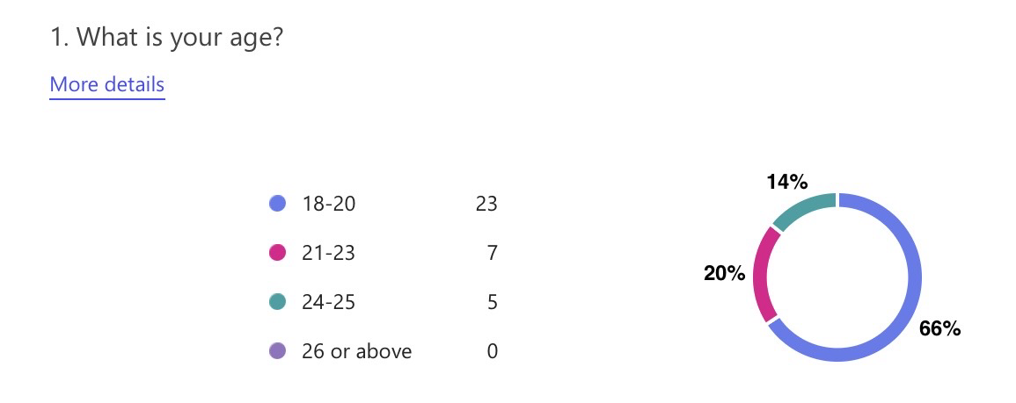
Appendix E- Survey Raw Data:

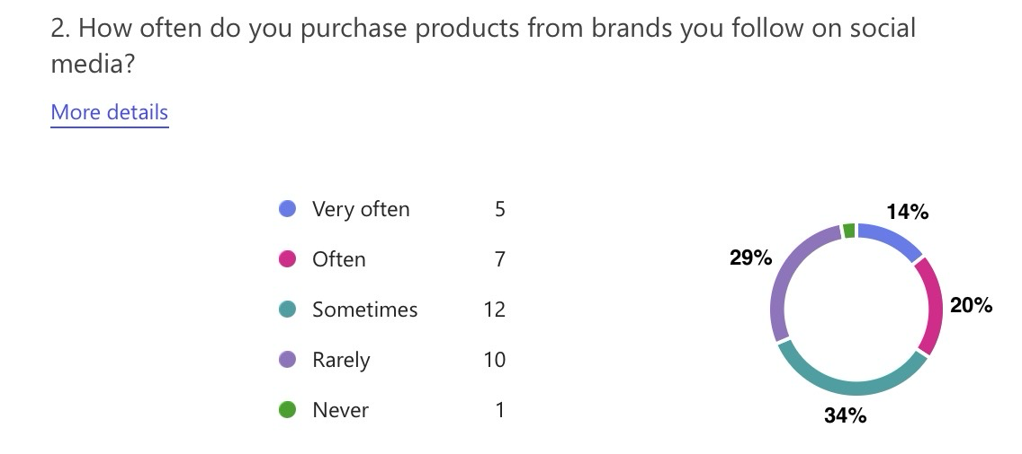

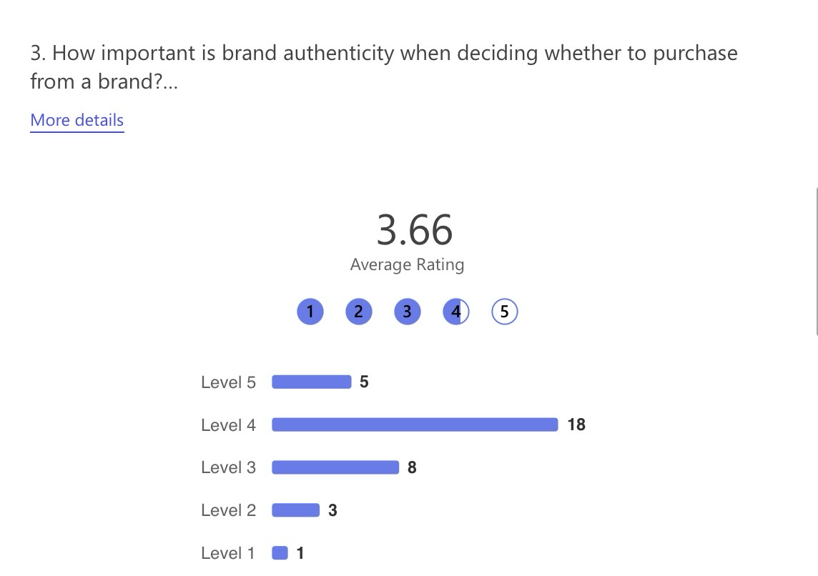
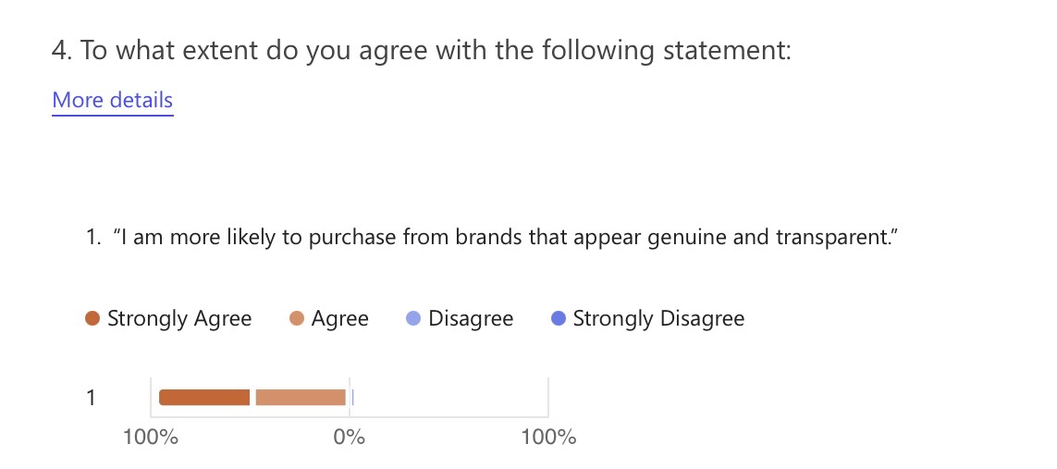

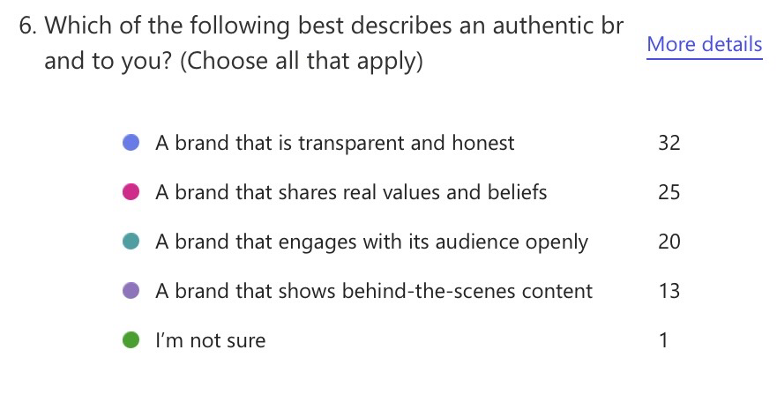
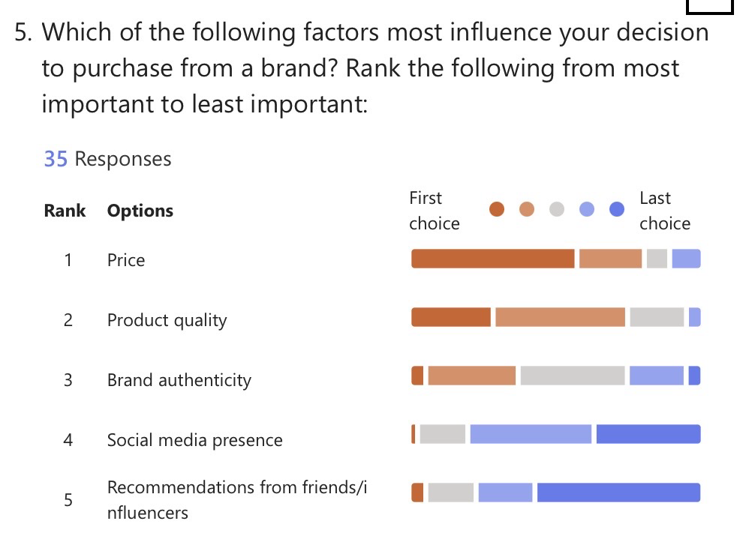

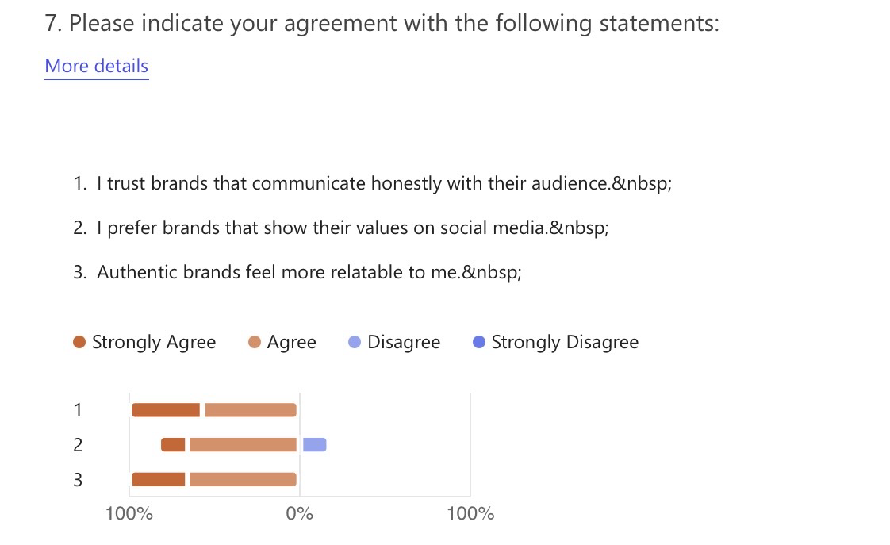

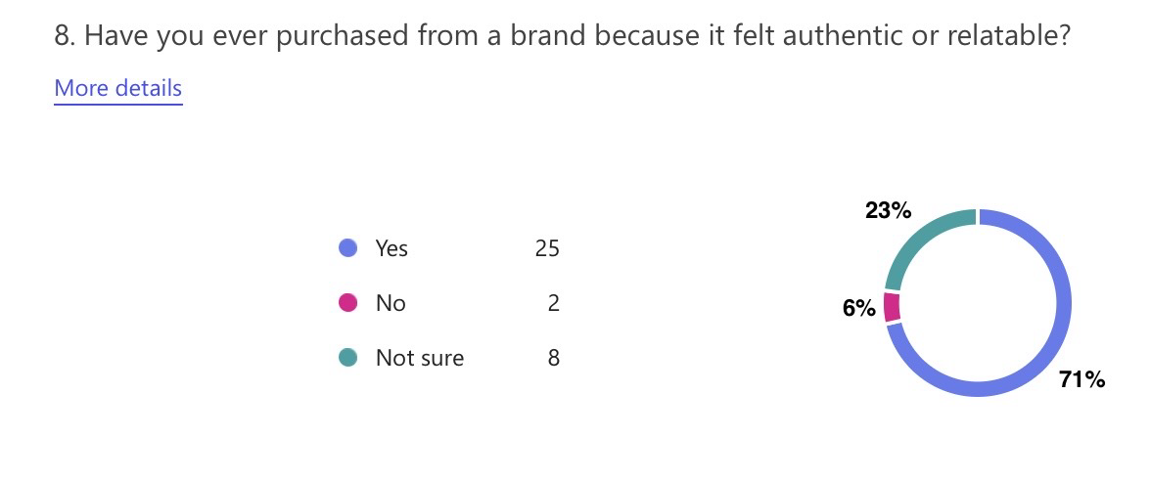

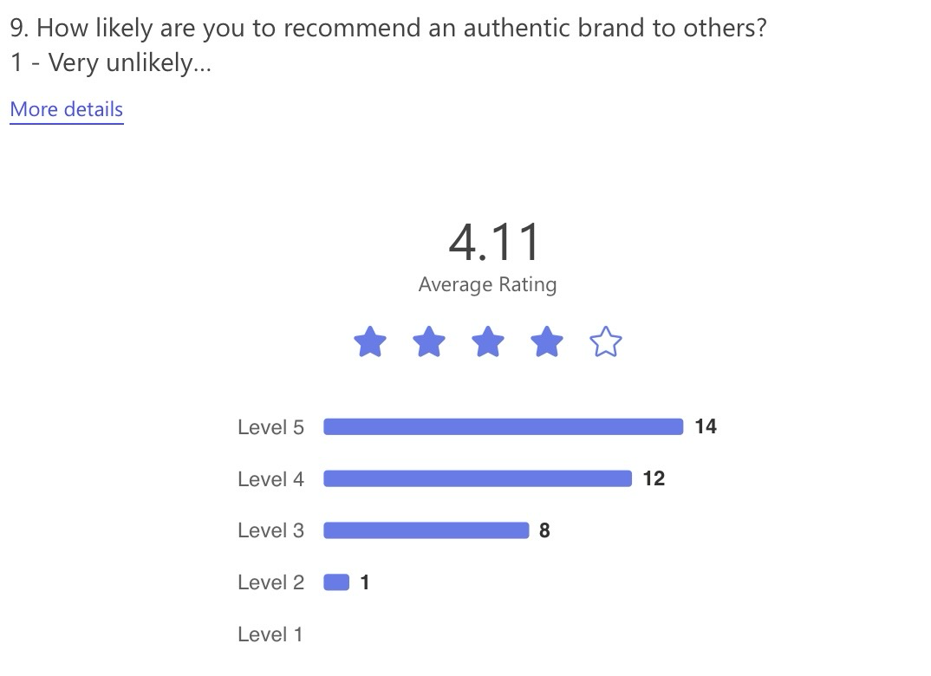
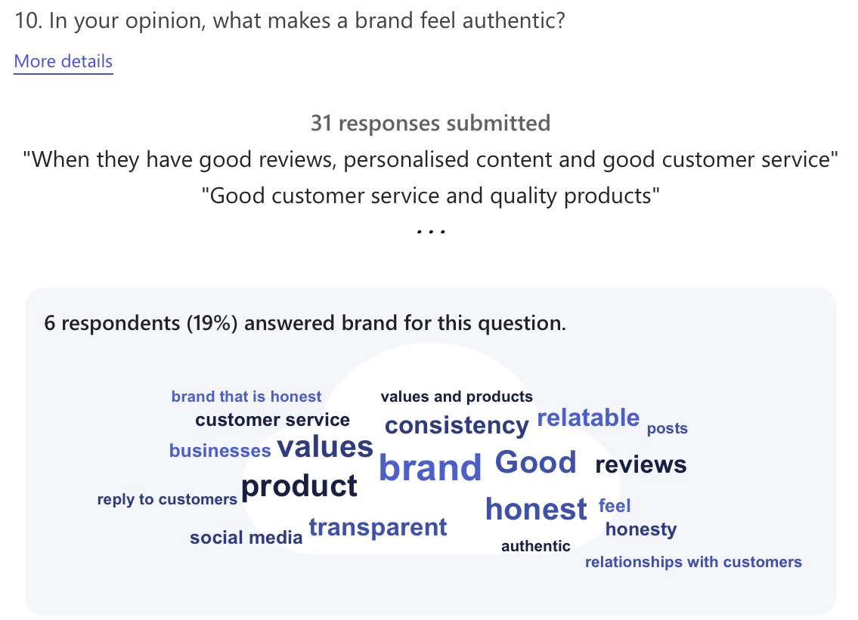

Appendix F- Individual Ethics Forms:


Participant Name Ethan Watts
Interviewer Name Alyssia Frampton (2327857)
Interviewer Programme of Study Business & Management
Research Learning Lecturer Helen Evans , UWTSD

Participation Agreement to be interviewed:

I agree to participate in the research concerning “To what extent does perceived brand authenticity influence purchase intention among Gen Z consumers?”. I understand that the purpose of this study is to examine my experiences of “brand authenticity, what brand authenticity means to me and if it influences my purchases”. I understand that this will involve me in a short 10–15-minute interview.

I understand that this interview will be recorded and transcribed for use only in interviewer’s (Alyssia Frampton) undergraduate research methods course and dissertation at the University of Wales Trinity Saint David.

I understand that my name or any reference to my identity will be kept anonymous in this study and for any subsequent publications I will be asked again for my consent. I understand that use storage of the recordings and transcriptions relating to this interview will be anonymous; not be used for any other purpose than this study and will be subsequently destroyed after the use intended here.

I understand that I may withdraw from the study at any point with all records of my contribution removed without having to provide a reason.

Interviewee Signature: ETHAN WATTS

Interviewer Signature: ALYSSIA FRAMPTON

Date of Interview: 23/04/26

A copy of this agreement should be retained by both interviewer and interviewee.

Participant Name Holly Saunders
Interviewer Name Alyssia Frampton (2327857)
Interviewer Programme of Study Business & Management
Research Learning Lecturer Helen Evans , UWTSD

Participation Agreement to be interviewed:

I agree to participate in the research concerning “To what extent does perceived brand authenticity influence purchase intention among Gen Z consumers?”. I understand that the purpose of this study is to examine my experiences of “brand authenticity, what brand authenticity means to me and if it influences my purchases”. I understand that this will involve me in a short 10–15-minute interview.

I understand that this interview will be recorded and transcribed for use only in interviewer’s (Alyssia Frampton) undergraduate research methods course and dissertation at the University of Wales Trinity Saint David.

I understand that my name or any reference to my identity will be kept anonymous in this study and for any subsequent publications I will be asked again for my consent. I understand that use storage of the recordings and transcriptions relating to this interview will be anonymous; not be used for any other purpose than this study and will be subsequently destroyed after the use intended here.

I understand that I may withdraw from the study at any point with all records of my contribution removed without having to provide a reason.

Interviewee Signature: HOLLY SAUNDERS

Interviewer Signature: ALYSSIA FRAMPTON

Date of Interview: 24/04/2026

A copy of this agreement should be retained by both interviewer and interviewee.

Participant Name Naomi Evans
Interviewer Name Alyssia Frampton (2327857)
Interviewer Programme of Study Business & Management
Research Learning Lecturer Helen Evans , UWTSD

Participation Agreement to be interviewed:

I agree to participate in the research concerning “To what extent does perceived brand authenticity influence purchase intention among Gen Z consumers?”. I understand that the purpose of this study is to examine my experiences of “brand authenticity, what brand authenticity means to me and if it influences my purchases”. I understand that this will involve me in a short 10–15-minute interview.

I understand that this interview will be recorded and transcribed for use only in interviewer’s (Alyssia Frampton) undergraduate research methods course and dissertation at the University of Wales Trinity Saint David.

I understand that my name or any reference to my identity will be kept anonymous in this study and for any subsequent publications I will be asked again for my consent. I understand that use storage of the recordings and transcriptions relating to this interview will be anonymous; not be used for any other purpose than this study and will be subsequently destroyed after the use intended here.

I understand that I may withdraw from the study at any point with all records of my contribution removed without having to provide a reason.

Interviewee Signature: NAOMI EVANS

Interviewer Signature: ALYSSIA FRAMPTON

Date of Interview: 24/04/2026

A copy of this agreement should be retained by both interviewer and interviewee.

