
MODULE: FINANCIAL MANAGEMENT FOR THE HOTEL INDUSTRY
ASSIGNMENT: GRAND HOTEL BUDGET PLANNER
NAME: SYEDA SHAMIA AKTHER
STUDENT ID: 2016558
LECTURER: DALE CLARKE


University of Wales Trinity Saint David

Executive Summary

I have prepared a cash flow forecast for The Grand Hotel as per request from the account’s director. I have prepared a budget planner for the forthcoming year. The planner shows the companies income and expenditures for the forthcoming year. You can see I have analysed the forecast and detailed what the forecast will look like next year detailing all the categories, monthly income/expenditures along with the opening and closing balance. I have also prepared a report for the director detailing the importance of budgeting, my understanding of the main 4 types of budgeting, incremental, activity based, value proposition and zero-based budgeting. I have also touched on how budgeting control can support sustainability with the social, environmental and economic factor.

Table of Contents
Executive Summary 1
1. Introduction 3
2. 500 words Analysis of Grand hotel budget planner 4
3. Task 2 4
3.1 Importance of budgeting 4
3.2 understanding of incremental budgeting 4
3.3 Activity based 4
3.4 Value proposition based 4
3.5 zero based budgeting 4
3.6 How budgeting control can support sustainability 4
4. Conclusion 5
5. Reference List 6
6. Appendix with Excel Budget planner…………………..………………………………………………………………………7

Introduction

This report will analyse The Grand Hotel Budget Forecast. I will analyse and evaluate the financial performance within the Hotel Industry and show the revenue and expenditure for the forthcoming year.

500-words analysis of Grand hotel budget planner
As you can see on the budget planner for the forthcoming year, we have a very positive year as we are in positives all year. Budgeting is the procedure of producing a plan on how to spend your money. (What is Budgeting and Why is it Important? 2022). The Grand Hotel uses the incremental budgeting method. We started in April 2022 out account was in credit by £13500. You can see in the planner we will not be overdrawn any months and will remain in credit which will gain us interests every month. In December and February, we will have the highest expenditures however we have good cash sales for those months too. November and January are the months where the least expenditures will be going out. The budget expenditures have expenses which we will normally not have for other years. For example, the wardrobe expense is because the hotel purchased custom made wardrobes as at cost of £14000 which is due to be paid from May 2022 in 4 instalments. This expenditure is on top of the normal ones and will not be there for the next forecast. Some of the expenditures like wages cannot be avoided as the hotel needs staff. The hotel can reduce expenditures the following year for things like car insurance as the quote annually should be lower than. The mini bar for instance is questionable as the hotel will be making £8900 and will be spending £7000 on it monthly. There isn’t a very good profit there and should be something the hotel should investigate. You can see the planner shows our balance not only for the year but also for the months. The net cashflow will be efficient for the year and we should not expect any problems. Please remember this is a cash flow forecast and its shows the liquidity, so this means, cash inflows and outflows. By the figures I can tell the budget remains steady through-out the year and we don’t expect any problems. Any changes can be seen clearly and easily, and the planner is very easy to read and understand.

Task 2

Importance of budgeting
Budgeting is a financial plan for a set time in the future. It is in fact a ‘plan of action’. It represents the companies’ costs for the forthcoming months or years. The company must know what its aims are before it can arrange a budget. (Slavin,2022). Creating a budgeting plan is an important strategy for the overall success of any business. (Budgeting, 2022). The budget information is very important as this is used to predict excess or shortfall, they are expecting to obtain during the budgeting period. Typically, the importance of a budget for your business is to help enable us to see how much money we have, how much is going out (spend) and how much we need to bring in to meet business expectations.
A typical budget forecast has some simple steps that we must follow.
- Setting realistic Goals. This will enable us to make wise spending choices.
- Identifying income and expenses. So how much for example income we have coming in like sales. And how much expenditures we have going out.
- Construct a budget. We need to balance out our budget to assist everything we need to pay for. Make sure we review our predicted surplus and deficit.
- Make any necessary changes if needed.
- Get the approval and sign it off. (7 steps to a budget made easy, 2022)
One common factor in two recent crises has been the collapse of business’s that thought budgeting was outdated. In the past some managers avoided budgeting as it was time consuming as per Seal et al (2015).
There are four common types of budgeting business’s use which I will be looking at below. Budgeting is important for the business as it shows us our revenues and expenditures clearly.

Understanding of incremental budgeting
Incremental budgeting is a way of making the budget based on the previous budget with changing it based on sales estimates, market demands and new growth etc. (Quassini, 2022). There are obviously advantages and disadvantages of incremental budgeting.
Advantages
- The budget remains steady and if there is any change it is gradual. (Michael, 2007)
- Departments can be monitored on a regular basis.
- This method is simple to operate and very easy to understand.
- The effect of any change can be seen very quickly.

Disadvantages
- There is an assumption that activities and processes of working will continue the same way as previously.
- There are no motivations for developing any new ideas.
- There are no incentives to reduce cost.
- It encourages spending up to the budget figure so that the budget is maintained the following year. (Budgeting Methods – Incremental Budgeting, 2022).

Activity based

Activity based budgeting, also known as ABB is a method that recognizes the activities that run costs in a business and then assigns those costs to those activities. (Activity-Based Budgeting: Financial Modelling Terms Explained, 2022). In a simple way the budget can be prepared in 3 steps
- Determine what the activities are, and their costs involved.
- Estimate the number of items for cost demands.
- Calculate the items costs per activity.

There are two major benefits of ABB (Taban et al. 2021)
- Recognize situations when the plan needs human strengths to provide support and service activities in the business.
- It provides a more precise method of assessing future costs. (Taban et al. 2021)

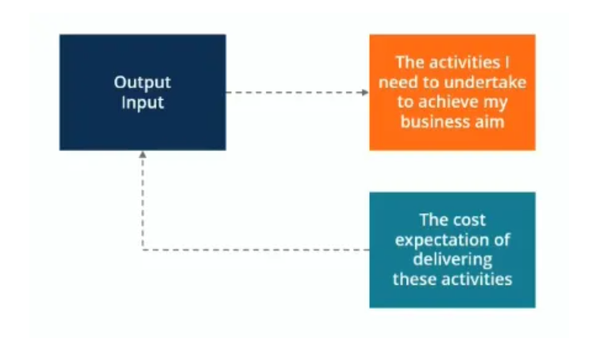(Types of Budgets, 2022)

Value proposition based
Value proposition based also known as VPB and priority-based budgeting basically involves analysing a business’s expenses for a given financial period. It aims to find out where a business should be spending its money and how much value each expense in the business brings in. (Stefenka, 2022). We must empathize on the word ‘value’ here. For an example a company like Apple, what would be the core value. Design is up most important to the company so this likely means design is a key value for the company. (Stefenka, 2022). When preparing for the value proposition-based method, companies must answer 3 important questions
- Why are we spending this amount of money?
- What sort of values does it bring to our company and customers?
- Does the value compensate the costs involved. (4 Top Budgeting methods for Business’s in 2022-Shoeboxed, 2022).

Government organizations prefer this budgeting method as they often encounter financial modernizing throughout the year. (Mitchell, 2014).
Like all the other budgeting value proposition budgeting also has its pros and cons.
Advantages
- Very easy to see where the money is going and helps avoid unnecessary spending.
- Helps you spend money where it is more needed, that brings in more value.
- As you are focusing on high-value areas it helps bring in more revenue.

Disadvantages
- The values might change, regarding social/seasonal and cultural needs, so this means the budget will need reassessing. (Value Proposition Budgeting | Divvy, 2022)

Zero based budgeting

Zero based budgeting originating in the 1970’s by Peter Pyhrr. This sort of budgeting requires that all the activities of a business be subject to a continuing review. It is an attempt to resolve incremental budgeting. (Ibrahim, 2019). The process of zero-based budgeting starts from a ‘zero base’ and every task within a business is analysed for it needs and costs. So, then the budgets are planned around what is needed for the forthcoming period, irrespective of whether each budget is higher or lower than the previous one. (Zero-Based Budgeting: What It Is and How to Use It, 2022). There are some advantages and disadvantages of this sort of budgeting.
Advantages
- Helps a business understand and assess if every department is sufficiently funded.
- Allows the business to focus on the current numbers rather numbers from the previous budgets.
- It helps reduce unnecessary spending.
- Helps communication and engagement within the company/departments as employees are being involved in decision making.

Disadvantages
- Zero based budgeting doesn’t guarantee any savings as you will need to master how you implement it.
- The process and authorisation from managers may be difficult. (British Business Bank, 2022).

3.6 How budgeting control can support sustainability

Sustainability means meeting all our demands without negotiating the ability of the potential generation of meeting their demands. (Mcgill, 2022). In business’s sustainability basically means doing business without negatively impacting the environment, community, or society. The aim of sustainable business is to make a positive effect on at least one of the areas. (What Is Sustainability in Business? | HBS Online, 2022).
Elements of sustainability include:
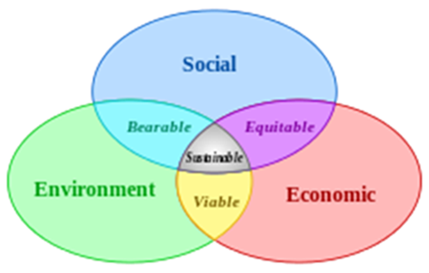(Salameh, 2022)

Budgeting control supports sustainability in the sense socially we know what we are spending and how much we are spending. For an example The Grand Hotel budgeting for wages will be socially sustainable as we know how much we are spending and giving our employees. Budgeting includes employee pensions and bonuses so this will be socially sustainable. Budgeting is also environmentally friendly as it involves employees in the process. The Grand Hotel budgets for petrol and diesel which helps the environment, and we know how much we will be using and not going over consumption. Budgeting is economically sustainable in the sense if we know what we are spending, the forthcoming year, we can plan and spend, we can track our expenditure and make savings for the following year. (Investopedia, 2022).

Conclusion

To conclude we know that budgeting is a very vital part of a business. We need to budget to be aware of our sales and expenditures. There are 4 common ways of budgeting, incremental budgeting, value proposition budgeting, zero based budgeting and activity-based budgeting. The main type of budgeting is incremental budgeting, which is also the traditional way of budgeting, and it gives us a clear insight into the forthcoming year and what we can do to reduce costs. All the types of budgeting have its advantages and disadvantages and we need to weigh out which one is more important for as a company. For instance, a start-up company may use zero-based budgeting whilst an established company may you incremental budgeting. Budgeting can also affect sustainability and its environmental, social, and economic factor. We can see the business’s who budget do contribute and support sustainability.

Reference List
Alexa Michael and Technical Information Service, (2007), `Beyond Budgeting: Topic Gateway Series No.35`, by Chartered Institute of Management Accountants (CIMA), Available:http://www.cimaglobal.com/Documents/ImportedDocuments/cid_tg_beyond_budgeting _oct07.pdf (Accessed 13th October 2022)
AlHussaini, E.H. and Taban M.M, 2021 The Possbility of Applying Activity Based Budgeting in Iraq. Journal of Legal, Ethical and Regulatory Issues, 24, pp. 1-9
British Business Bank. 2022. Available at: https://www.british-business-bank.co.uk/finance-hub/zero-based-budgeting/ (Accessed 18 October 2022).
Business Insights Blog. 2022. What Is Sustainability in Business? | HBS Online. Available at: https://online.hbs.edu/blog/post/what-is-sustainability-in-business (Accessed 16 October 2022).
Causal.app. 2022. Activity-Based Budgeting: Financial Modelling Terms Explained. Available at: https://www.causal.app/define/activity-based-budgeting (Accessed 18 October 2022).
Corporate Finance Institute. 2022. Types of Budgets. Available at: https://corporatefinanceinstitute.com/resources/knowledge/accounting/types-of-budgets-budgeting-methods/ (Accessed 11 October 2022).
Divvy. 2022. Value Proposition Budgeting | Divvy. Available at: https://getdivvy.com/learn/value-proposition-budgeting/ (Accessed 14 October 2022).
Ibrahim. (2019) Designing zero-based budgeting for public organizations. Problems and Perspectives in Management, 17(2), pp. 323-333.
Investopedia. 2022. Zero-Based Budgeting: What It Is and How to Use It. Available at: https://www.investopedia.com/terms/z/zbb.asp (Accessed 18 October 2022).
Marr, B. (2012) Key Performance Indicators 75 Measures ever Managers needs to Know, UK:Pearson
Mcgill.ca. 2022. Available at: https://www.mcgill.ca/sustainability/files/sustainability/what-is-sustainability.pdf (Accessed 16 October 2022).
Mitchell (2014). An Exploratory Study of Priority Based Budgeting: Identification of Public Values and Public Priorities through Citizen Engagement in Government Budgeting Decisions.
My Money Coach. 2022. What is Budgeting and Why is it Important? Available at: https://www.mymoneycoach.ca/budgeting/what-is-a-budget-planning-forecasting (Accessed 10 October 2022).
My Money Coach. 2022. 7 Steps to a Budget Made Easy. Available at: https://www.mymoneycoach.ca/budgeting/7-easy-steps-create-budget-tips (Accessed 11 October 2022).
Practicalbusinessskills.com. 2022. Budgeting. Available at: https://www.practicalbusinessskills.com/getting-started/financial-basics/budgeting (Accessed 10 October 2022).
Quassini, I.,2022. Available at: https://www.researchgate.net/publication/324065329_An_Introduction_to_the_Concept_of_Incremental_Budgeting_and_Beyond_Budgeting (Accessed 12 October 2022).
Salameh, M., 2022. The Triangle of Sustainable Development: The Economy, Energy & the Environment.Energymanagementcentre.eu. Available at: https://www.energymanagementcentre.eu/views-on-energy-news/sustainable-development/ (Accessed 18 October 2022).
Seal (2015) Management accounting (5th ed). McGraw-Hill Education
Shoeboxed Blog. 2022. 4 Top Budgeting Methods for Businesses in 2022 - Shoeboxed. Available at: https://blog.shoeboxed.com/4-most-used-budgeting-methods-for-businesses/11281/ (Accessed 18 October 2022).
Slavin, S., 2022. Social Administration: Managing finances, personnel, and information in human services. Available at: <https://books.google.co.uk/books? (Accessed 09 October 2022).
Stefenka, L., 2022. Available at: <https://relayfi.com/blog/value-proposition-budgeting#what-is-value-proposition-budgeting> (Accessed 15 October 2022).
Tutor2u.net. 2022. Budgeting Methods - Incremental Budgeting. Available at: https://www.tutor2u.net/business/reference/budgeting-methods-incremental-budgeting (Accessed 18 October 2022).
Walsh, C (2010), Key Management Ratios- The 100+ Ratios every Manager needs to Know (4th Edition), Uk: Prentice Hall

4.Appendix Budget Calculations


