HND Manufacturing Systems Engineering Operations

Control & Automation

Stuart Jones

1909136

ACMA5001

Design of an
industrial automatic
control system

Micro Brewery

CONTENTS

Introduction 3

Micro Brewery Explained 5

Control Strategy Proposal 8

Standards 10

References 12

INTRODUCTION

A local Micro-brewery company has approached me with a request to design and implement a control strategy for a new proposed continuous production process.

The new process requires the control strategy be self-regulating, and the design of the control system includes the collection and safe storage of all appropriate production data and process alarms for improvement analysis.

The proposed control system must consider any potential hazards that a food & beverage manufacturing process expects. It must also acknowledge and conform to the cleanliness of the environment.

The food & beverage industry demand certain manipulated variables, consider these and propose a simple control system that satisfies the automatic control prime objective.

It is advised that I take full advantage of the plant pneumatic power supply.

I submit this report detailing my control system proposal, including industrial standards and appropriate diagrams. Also include actuation, controllers, and all necessary instrumentation etc. in your design.

Finally, I explain where a hydraulic power supply system may be beneficial to the plant in general (directly or indirectly involved in the production process).

MICRO BREWERY

First, before I start the control strategy design, let us understand a standard brewery process. Figure 01 outlines a basic flow diagram of a standard brewery production line:

Fig. 01.
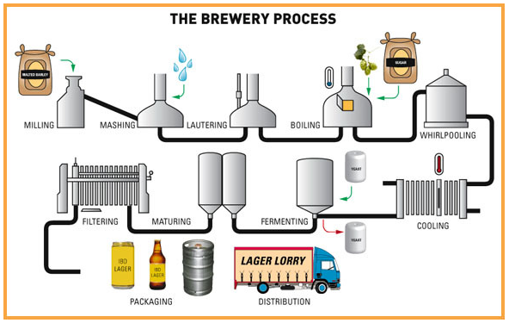
(microbrewery-is-easy, 2021)

Beer is an alcoholic beverage made by the fermentation of sugars derived from a variety of grains. Production methods often differ, but in general terms the brewery production process consists of many individual steps and is actually a somewhat sophisticated and precise process.
The process is a series of steps passing through several phases of Malting/Milling, Mashing, Lautering, Boiling, Fermenting, Conditioning, Filtering, and Packaging. There are many manufacturers out there that customise the process to improve the characteristics of their own final product.

A basic explanation for each phase of the brewing process:

Malting & Milling
Malting is the process of preparing barley grain for use, and the most common grain utilised as a raw ingredient is barley. Barley can be stored for a long period after harvesting, and it is the malted barley that gives Beer its distinctive colour and flavour.
First step is known as ‘steeping’, the barley grain is placed in a vat with water and left to soak for anything up to 40 hours. Next stage is ‘germination’, where the grain is spread out and left for approximately 5 days. The final stage is known as ‘kilning’, the grain goes through a drying kiln, the temperature gradually increasing. The grain is now malt and will be milled or crushed, to break up the kernels, make it easier to extract sugars during the mashing stage.

Mashing
This transforms the starches generated during the malting cycle into fermentable sugars in a big vessel called a Mash Tun or Mesh Kettle. The milled grain and boiling water are combined in this vessel to make a cereal mash. The grain is then processed to get the desired malt consistency, known as wort. The starches released during the malting step are converted into sugars that can be fermented during this process.

Lautering
This is the process of separating the grains from the wort, the liquid that contains the sugar released during mashing. This sugar rich liquid (wort) that was extracted via the bottom of the Mash Tun after the mashing process will be separated from the grains.

Boiling and Hopping
Boiling the wort ensures that it is sterile, removing unwanted bacteria preventing potential infections. During this step of the boiling process, hops are added with the wort in a large tank known as a brew kettle or copper. Hops are utilised to encourage flavour and aroma which balances the sweetness of the malt, and this is where the chemical reaction takes place.

Whirlpooling
Following the boiling process, the Whirlpool is used to separate out the solid particles from the wort. The idea is that by swirling the wort, the turning process pushes the hop debris down into a cone at the very base of the tank, where it can be easily accessed and removed.

Cooling
The wort is removed from the crushed hop debris and, by means of a heat exchanger, it is quickly cooled to a temperature where yeast can be added at the fermenting phase. Water or glycol is used in the heat exchanger, flowing in the opposite direction of the wort, to force the temperature to quickly drop to around 5 degrees Celsius.

Fermenting
The cooled wort is then placed in a fermentation tank, and a type of yeast is chosen and also added (pitched) to the fermentation tank. The fermentation process commences when yeast is added to the wort, and the sugars are converted to alcohol, carbon dioxide, and other various components. It is here that the product can now be called ‘beer’.

Maturing
After fermentation the beer is transferred to a ‘conditioning tank’. Fermented beer has suspended particles, has little taste or scent, and is less stable. Maturing (or conditioning) lowers the concentrations of these unwanted compounds, resulting in a more finalised product where the flavour becomes smoother.

Filtering
Next the beer goes through a Filtration process to stabilise the flavour, removes any surplus yeast to prevent further development, as well as any leftover solids in the beer like hops or grain particles. The filtering procedure also removes haze that results in a clear, bright, and consistent beer.

Packaging
Packaging is the process of putting beer into cans, bottles, or other high-volume containers. One of the most crucial aspects of packaging is keeping oxygen away from the beer.

Distribution
The final product is shipped to various distribution centres or customer depots, etc. usually by heavy goods vehicles.

Figure 02 illustrates the brewery production line as a simple process flow diagram.

Fig. 02
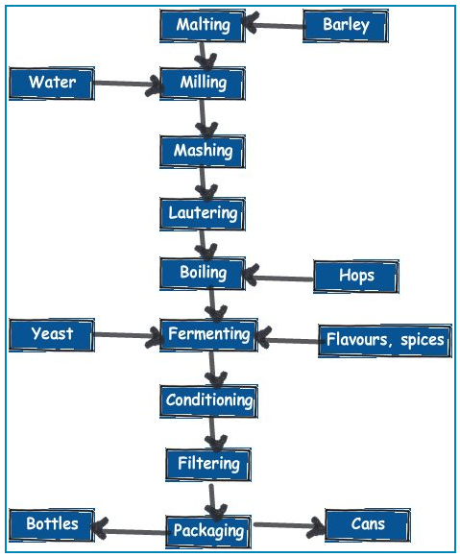
(microbrewery.wordpress.com, 2021)

CONTROL STRATEGY PROPOSAL

I will attempt to create a control system that will make the brewing process as automated as possible. It is imperative to use an intelligent control system with food-grade level-sensors and flow meters.
To simplify my report, I will describe the control system at each stage of the process. In-between each stage I suggest fitting check valves on the stainless steel pipework to control the flow and prevent back flow (hence check valves). All valves will open/close by pneumatic actuators, controlled electronically by signals from a PLC.
Recommendations for a suitable PLC
It is also sensible to have a pressure relief valve fitted to each vat/tun/brew kettle/tank to ensure internal pressures are safely regulated.

Examples of intelligent components I propose to use in my control system:

Temperature Controllers Pressure relief valve
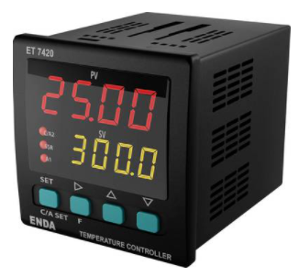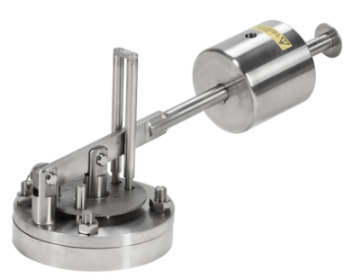
(conrad.com, 2021) (Alfalaval, 2021)

Flow meters Viscosity sensors
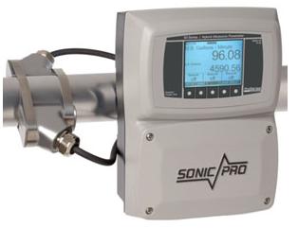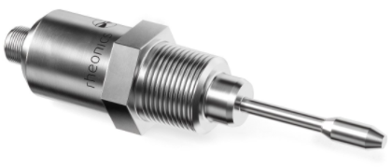
(Xylemanalytics, 2021) (Rheonics, 2021)

HMI PLC Pneumatic Check Valves
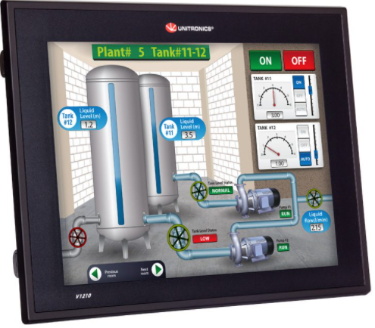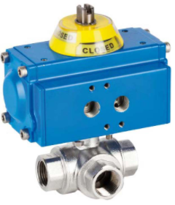
(Unitronics, 2021) (processvalvesonline, 2021)

Malting
The barley grain is supplied in bags; the grain is put into the vat by manual operator intervention. However before that I suggest weighing the bags using a calibrated scale transducer, this transducer will convert the weight into a measurement. This measurement will serve as an input (a measurand) into a pc to calculate the amount of water needed per weight. This system is an ‘open loop’ system, as the weight is the reference value, and the water volume demanded is the controlled variable, see figure 03 below.

Once water volume is calculated, an in-line check valve will open (driven by pneumatic piston) and a pump will deliver water into the vat, a flow meter will measure amount of water entering the vat. Finally, the in-line check valve will close when the flow meter reaches the figure the operator entered. This system is a ‘closed loop’ system, as the water flow meter will feedback to the control valve to close when necessary, see figure 04 below.
As the water and grain is in the vat for 40 hours, a simple count-down device is needed to alert the operator to remove the vat contents when ready.

Fig. 03
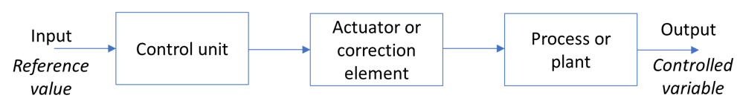

Fig. 04
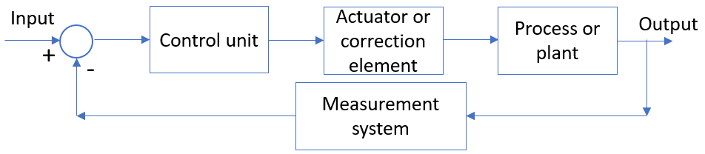

(Goodson, 2021)

Mashing
Milled grain is mixed with boiling water to make a mash. To do this efficiently, we need to control the temperature of the water, speed of motors mixing the mash, and the viscosity of the product. They must work together to achieve the desired wort.
Same as malting, we control the water flow using the same control system. However, in the mass tun I suggest we use a ‘closed loop’ system to constantly regulate and alter the system to achieve greater efficiency. Temperature sensors will be our measurands feeding into the control unit, maintaining temperature to approximately 45-65◦c. Motor speedometers (or maybe an encoder that counts revolutions) can regulate the agitators, and a viscosity sensor can feedback when the grain is mashed.
All of these ‘controlled variables’ will be controlled via a Fieldbus strategy, and will be inputs to the system control unit, thus making regular corrections to the motor speed and temperature to achieve the final product quickly and efficiently.

Lautering
This process of separating grains again uses water, which we will control using pumps, check valves and flow meters. The control system will also monitor and control run-offs here, so it never overflows or runs dry.

Boiling and Hopping
Again temperature control is important here, the heater element will be controlled by a closed loop system, temperature sensors will feedback the brew kettle temperature to the control unit and the heating element will be adjusted. The control of water to the brew kettle will be controlled by pump, checked valves and flow meters, all operating on a closed loop system. The Vision 1210 PLC Controller has the capacity to manage this.
Hoppers will have check valves operated by the PLC to deliver the ingredients to the brew kettle. We will need PH sensors to feedback to the control unit, to trigger actuators to open the hopper valves, these will measure the chemical reaction in the brew kettle and thus control the amount of ingredients added to the brew kettle.

Whirlpooling
The mix is swirled by a device operated by a motor and gearbox. The motor is controlled using an open loop system based on a timer. Here we are simply separating solid particles from the wort. There is no need to control temperatures or motor speed here, once the solid particles are removed, the process can stop and wort is moved to the cooling stage.

Cooling
Before yeast is added, the wort needs to be brought back down to 20-25◦c, a Heat Exchanger is used to achieve this. We will use a pump to push the wort in-between the heat exchanger pipes, which has cold water and glycol running through them in the opposite direction to the wort flow. The water/glycol is controlled by a pump, and water temperature is achieved by a chiller unit which adjusts its temperature based on the feedback from the temperature sensors in the heat exchanger. The heat exchanger target temperature is 5◦c, so the temperature sensors are important measurands in this closed loop system. They will alert the correction element in the closed loop to adjust the chiller unit temperatures.

Fermenting
The cooled wort is transferred to the fermentation tank by pumps via pneumatically controlled check valves. Here the yeast is added from a hopper, which encourages sugar to convert into alcohol and carbon dioxide. PH sensors in the tank will feedback to the closed loop system, once PH levels have been achieved, the control unit triggers the actuators to stop the process. It can now be called beer, which is now pumped to the maturing tank.

Maturing
After the fermentation process, the beer is transferred to a ‘conditioning tank’ for maturing or aging. The beer can be in this tank for several weeks, months, even years. There is no demand for a control system at this stage of the process., perhaps a pressure relief valve at the top of the tank to control pressure.

Filtering
Electric pumps will transfer the matured beer to the filtration process via pipework and check valves. The beer is passed through filters (sheet or pad filters) to remove any large particles from the liquid. It is worth fitting level sensors to the tank so that we can monitor the efficiency of the filters, if they’re blocked then the beer level will drop very slowly. This could feedback to an alarm to notify the operators of the filter blockage.

Packaging
Finally, a conveyor line to fill cans/bottles with the beer. A standard conveyor line process, belts driven by electric motors, proximity sensors, counters, labellers, etc, all linked up to a plc as inputs and outputs to control the conveyor line.

Data storage
Data needs to be saved and stored so that it can be used as inputs, or analysed for efficiencies. I propose using the Vision 1210 PLC Controller, it is a trusted PLC used in Breweries across the world. It has the capacity to support temperature measurement in three tanks, record batch data, and automate their circulation pump, transfer pump, and Boiler tank. This PLC can monitor current temperature and history, and store data during the entire brew process.
(News, PLCs & Industrial PCs, 2014)

Proposed Hydraulic System

We are utilising the plant compressed air system because its cleaner and less expensive than a hydraulic alternative. However, we could make use of hydraulic power system at the end of the process to move the beer kegs.

When full, beer kegs can weigh up to 73kg, we need to somehow lift these onto a lorry for distribution. A hydraulic lifting system would be ideal, a couple of hydraulic cylinders operating a platform to lift kegs up to the level of a HGV trailer would reduce risk of back injury, increase loading times, improve efficiencies, etc.

STANDARDS

Health & Safety

We are operating a plant that has moving parts, stored energy, industrial equipment, etc. All Risk Assessments need to be completed and signed off, as per HSE regulations:

Health & Safety at Work Act 1974.

There are other safe working regulations we need to be aware of when installing a control system operating using pneumatic valves, pipework, pressure vessels, etc. it is imperative that we recognise and conform to the HSE standards for pneumatic systems:

The Pressure Equipment (Safety) Regulations 2016.

We also need to take into consideration the ISO Standard:

ISO 4414:2010 Pneumatic Fluid Power.

Working to these regulations will ensure the plant is operating to a high safe standard.

Thinking about the Environmental expectations, we have to consider how we manage the process water, energy consumption, waste, consumables, and plant emissions to air, and all relevant regulations to the sector.

Food and Drink

As we are handling grain dust, we need to consider the regulation:
Control of Substances Hazardous to Health Regulations 2002: Grain Dust Guidance Note EH66.

We are manufacturing a product for consumption, therefore we need to ensure we construct a process that conforms to appropriate standards. For example, labelling drinks is regulated under regulations:

Weights and Measures Act 1985
Weights and Measures (packaged goods) Regulations 2006

REFERENCES

Alfalaval, 2021. www.alfalaval.com. [Online]
Available at: https://www.alfalaval.com/products/fluid-handling/valves/safety-valves/sb-pressure-relief-valve/
[Accessed 17 October 2021].

conrad.com, 2021. www.conrad.com. [Online]
Available at: https://www.conrad.com/p/enda-et7420-230-pid-temperature-controller-pt100-j-k-t-s-r-2-a-relay-ssr-l-x-w-x-h-101-x-72-x-72-mm-197573
[Accessed 17 October 2021].

Goodson, R., 2021. Control & Automation, Lecture 02a, Bridgend: UWTSD.

microbrewery.wordpress.com, 2021. microbrewery.wordpress.com. [Online]
Available at: https://microbrewery.wordpress.com/tag/brewing-flowchart/
[Accessed 02 October 2021].

microbrewery-is-easy, 2021. microbrewery-is-easy. [Online]
Available at: https://microbrewery-is-easy.tumblr.com/post/96006759168/the-brewery-process-from-milling
[Accessed 02 October 2021].

News, PLCs & Industrial PCs, 2014. www.automationmagazine.co.uk. [Online]
Available at: https://www.automationmagazine.co.uk/brewery-cuts-significant-time-and-costs-with-new-control-system/
[Accessed 17 October 2021].

processvalvesonline, 2021. www.processvalvesonline.com. [Online]
Available at: https://processvalvesonline.com/product-category/process-valves/actuated-valves/pneumatic-actuated-valves/?gclid=CjwKCAjw8KmLBhB8EiwAQbqNoJ9j-A78eixEa3j48wMu-kaPo9rJLSRh-w6qHAUCA98vVQGac-bvUBoCNnIQAvD_BwE
[Accessed 17 October 2021].

Rheonics, 2021. www.rheonics.com. [Online]
Available at: https://rheonics.com/products/inline-viscometer-srv/
[Accessed 17 October 2021].

Unitronics, 2021. www.unitronicsplc.com. [Online]
Available at: https://www.unitronicsplc.com/vision-series-vision1210/
[Accessed 17 October 2021].

Xylemanalytics, 2021. www.xylemanalytics.co.uk. [Online]
Available at: https://www.xylemanalytics.co.uk/global-water-fm500-ultrasonic-flow-meter/
[Accessed 17 October 2021].

