Student name: Mohammad Mifthahul Bari. Student ID: 2407686
Programme: BA(Hons) leadership and management skills in the workplace.
Module code: LCLM 5003. Teacher name: Samson Oladejo
Assignment title: A project portfolio.
Project description: Name: highway reopening of M6 North. Budget: £ 20 million. Schedule: 24 Weeks.

Scope: 1: appraisal of flood damage. 2. Reconstruction of highway. 3. The management of traffic diversion. 4.post project quality assurance. 5. Mejor infrastructure development. 6. Longterm maintenance of the highway.
Part A. Poster of project proposal.

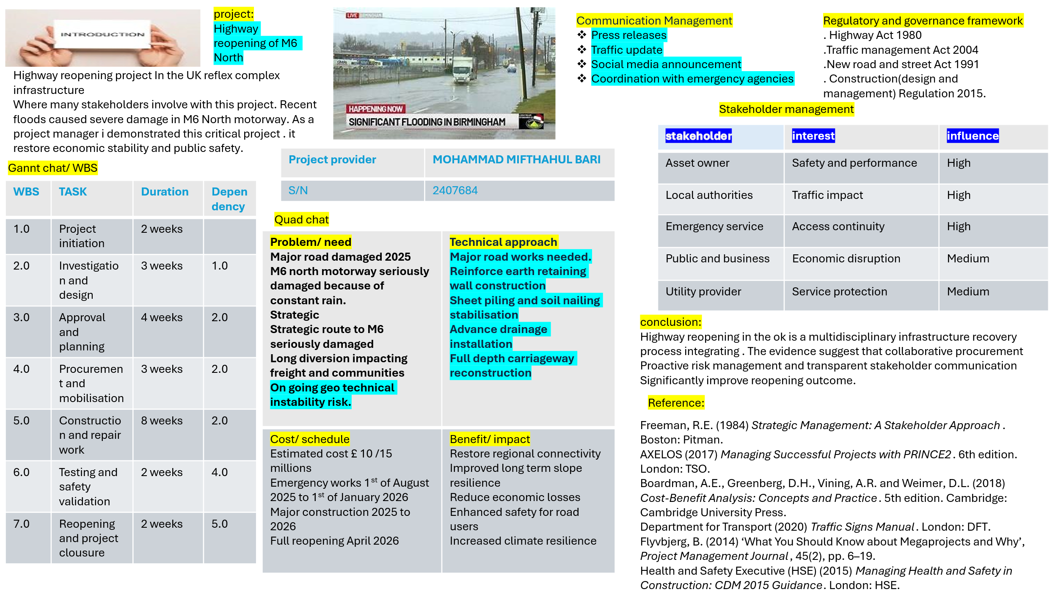

Part B. Reflection of the poster.
I have received positive feedback from my teacher and peers where I have presented following,
- Gannt chat/ WBS involving project initiation, investigation and design, approval and planning, procurement and mobilisation, construction and repair, testing and validation, reopening and closure. Time frame 24 weeks.
- Quad chat involves with, top of the left problem/need, bottom of the left cost and schedule, right top technical approach and right bottom benefit and impact.
- I have explained stakeholders’ management, project name and conclusion with references in the poster.
- I have also included project description and project scope including appraisal of flood damage, reconstruction of highway, the management of traffic diversion, post project quality assurance, major infrastructure development and long-term maintenance of the highway which was instructed by my teacher.

PART C
Project management plan for M6 North reopening after flood damage:

Introduction:
The M6 North is an essential transport rote in the UK, coordinating the movement of good and passengers between North and South of the country. Following serious flood damage, the has been untraversable leading to substantial disruption in regional connectivity. The project management plan (PMP) outlines the extensive approach for the restoration and reopening of these connecting areas. It indicates project management frameworks such as the Project management institute, (PMI) guidelines, PRINCE 2 to ensure effective and proficient implementation.
2.Project overview:
2.1. project purpose:
The purpose of the project is to repair the damage caused by severe flooding in M6 North. The key objective includes road safety, avoid disruption and strengthen infrastructure’s resilience for future disaster.
2.2 project scope:
This project includes,
The appraisal of flood damage to the road, bridges and drainage systems.
The reconstruction of highway including reemerge and repair damaged structures.
The management of traffic diversion during the restore period.
Post construction quality assurance complies with road safety standards.
Long term maintenance of the highway.
Major infrastructure development surrounding the area.

3 Project objectives:
3.1 primary objectives:
1. restoration of road infrastructure; ensure the M6 north is fully restored to operational condition maintaining safety standards and enhancing resilience.
2. minimise disruption: complete the project as soon as possible so that it minimises disruption to road users, local communities and business.
3. prompt completion: ensure the project completed within the set deadline to restore vital transport link.
4. budget adherence: complete the reopening work within the allocated budget without compromising on accuracy.
3.2 secondary objectives:
1.Sustainability: put flood resistant measure in the road design to mitigate future flood risk.
2. stakeholder satisfaction: maintain an appropriate communication and manage stakeholder satisfaction throughout the lifecycle of the project.
4. stakeholder identification and communication:
4.1 key stakeholder:
Stakeholder involvement is essential for ensuring the project aligns with the demands of all engaged parties. Identified stakeholders are,
. highways England: main project owner and funders.
. Local authorities: responsible for leasing with local communities and supporting traffic management measures.
. contractors: engineers and construction firms accountable for dispatching the repairs.
. Emergency services: key responders (ambulance service / NHS) to incident or emergencies during construction.
. commuters: daily users of the M6 who are affected by traffic diversion.
. suppliers: who provide equipment and materials for the project.

4.2 communication plan:
Effective communication is critical for any project. The communication plan based on the PMI communication management knowledge area, which outlines the following methods:
. weekly stakeholders meeting: to provide progress report and identify concern.
. public announcement and media coverage: to inform public and commuters of road closers and diversion.
Project website: a digital platform provides live updates and traffic information.
Emergency communication protocol: execute clear lines of communication for unseen incidents.
5.Project deliverables:
5.1 key deliverables:
1. Damage assessment report: a specific report referring the extent of flood damage.
2. Reconstruction and repair plan: an extensive project plan specifying all repair works, material requirements and schedule.
3. completion of repair: reopening of M6 north to a fully functional street including resurfacing of roads, repairs of bridges and reopening of drainages.
4.reopned highway: the M6 north motorway will be reopening to everyone after passing safety check and inspection.
5. post project review: an assessment of the project performance, involving conformity to schedule, budget and stakeholders’ satisfaction.
6. project methodology:
6.1 approach and framework: this project will apply a professional approach using PMI’S Project Management body of knowledge (PMBOK) framework, PRINCE2 methodology and Agile project management technique where applicable.
. PMBOK: provide a hybrid approach for project inauguration, strategy, enactment, observe and closer. It defines clear goals, scope, time frame and quality assurance.
. PRINCE2 will guide the management and control the project, with a focus on emphasizes on specific rules, responsibilities and authorization procedure.
. Agile will be used in specific areas such as traffic control and responding to unexpected construction challenges, to permit flexibility and resilience.

6.2 Work Breakdown Structure (WBS)
WBS will develop to breakdown the project more manageable. The WBS will help specify the scope, estimating cost, assigning responsibilities and scheduling task. The major work packages include,
- Phase 1. Damage assessment and strategy.
. arial and ground survey.
Initial design proposal.
- Phase2: procurement and set up.
Material procurement
Temporary traffic management set up.
- Phase 3: reconstruction and repair
. structural repair
. resurfacing
. drainage system improvements
- Phase 4: quality assurance and reopening.
Final inspection.
Road reopening.
6.3 project time frame.
Project will follow a critical path method (CPM) time frame which identifies the longest path of dependant task and highlight critical milestone include
Week 1-3 damage assessment and initial design.
Week 4-6 procurement and mobilization.
Week 7-18 repair and reconstruction work.
Week 19-20 Testing, quality assurance and road reopening.
7.Project budget:
7.1 cost break down.
The estimated budget for the project is £ 15/20 millions.
1 material and equipment £9 million.
2. labour cost £4 million
3. consultancy and design fees £ 1 million.
4. traffic management and diversions. £ 1million.
5. contingency fund £ 5 million.
Contingency budget is included to manage sudden incident for example delays caused by adverse weather conditions.
8. risk management plan:
Risk management plan (RMP) is essential part of any project. It will clarify, evaluate and emphasize any potential risk using risk breakdown structure (RBS). The primary risk categories include:
Environmental risk: extreme weather such as flood /cyclone could delay the project.
Mitigation: execute early warning system and arranging contingency plans.
Construction risk: unexpected structural issues or delays in material supply.
Mitigation; regular supplier review and proactive quality control.
Traffic disruption risk: traffic congestion or accident on the road.
Mitigation: translucent communication and efficient traffic management planning.
Political risk: protest or international political unrest / war.
Mitigation; efficient traffic management plan.
Health and safety risk; onsite accident or construction related injury.
Mitigation: strict core principle of health and safety in workplace and continuous audit.
8.1 The project manager will monitor risk continuously throughout the process: regular risk review will be undertaken in stakeholder meeting.
9. Monitoring and evaluation:
9.1 key performance indicator (KPIs)
The performance of the project will be tracked against the following KPIs
- Schedule compliance: percentage of milestone will be completed on time.
- Budget compliance: tracking actual cost against the planned budget.
- Quality standard: pass rate on quality assurance test and inspection.
- Stakeholders’ satisfaction: regular surveys to assesses stakeholder involvement and gratification.
9.2 post project review: upon project completion a post project evaluation will assess the overall success in terms of 1. meeting objectives (time, budget, quality)
2 Stakeholder advise. 3. Take initiative for future project.
10. Conclusion:
This project management plan has given a structured idea and approach of reopening of M6 north motorway of Birmingham. By following adequate project management frameworks, incorporating risk management strategies and ensuring active stakeholder involvement the project aims to reopening the M6 North safely, on time and within the budget. The proposed plan ensures quick recovery, survival of future flood damage, massive value to the local community, road users, stakeholders and government.
Harvard style references.
• PRINCE2 (2017). PRINCE2 Manual: Managing Successful Projects with PRINCE2. 6th ed. TSO (The Stationery Office).
Project Management Institute (PMI), 2017. A Guide to the Project Management Body of Knowledge (PMBOK® Guide). 6th ed. Newton Square, PA: Project Management Institute.
• Kerzner, H., 2017. Project Management: A Systems Approach to Planning, Scheduling, and Controlling. 12th ed. Hoboken, NJ: John Wiley & Sons.
• Schwabe, G., and Muller, M., 2020. The Role of Agile in Project Management: An Empirical Study. International Journal of Project Management, 38(4), pp. 239-253.
• Crawford, L., and Pollack, J., 2004. The Influence of Project Management Methodologies on Project Success. International Journal of Project Management, 22(1), pp. 51-58.
• Flood, A., 2018. Understanding Flood Risk and Mitigation Strategies. 2nd ed. London: Routledge.
•Miller, A., and Roberts, D., 2019. Road Construction and Safety in the UK: Case Studies and Lessons Learned. 1st ed. Oxford: Oxford University Press.
• Highways England, 2020. M6 North Road Closure Information. Highways England.
• Department for Transport, 2021. Highway Infrastructure and Flooding: Annual Report. London: Department for Transport.
Thompson, R., and Bostrom, A., 2021. Managing Construction Projects: Principles and Techniques. 3rd ed. Cambridge: Cambridge University Press.
• Jha, M., 2020. Rebuilding After Natural Disasters: A Comprehensive Guide to Reconstruction. 1st ed. New York: Springer.
•
British Standards Institution (BSI), 2018. BS EN 1991-1-1: Eurocode 1 - Actions on Structures: General Actions. London: British Standards Institution.
• Rasmussen, M., 2019. Sustainable Infrastructure: Resilience to Climate Change and Flooding. 1st ed. London: Wiley.
• Chapman, C., and Ward, S., 2011. Project Risk Management: Processes, Techniques and Insights. 2nd ed. Chichester: Wiley.
• Smith, R., and Perry, M., 2018. Construction Project Management: A Practical Guide to Field Construction Management. 4th ed. New York: McGraw-Hill.
• Tirozzi, S., and Fernandez, J., 2021. Flooding and Road Infrastructure: Assessing the Impact of Extreme Weather Events. Journal of Civil Engineering and Environmental Systems, 38(2), pp. 121-137.
• Cooper, D., and Schindler, P., 2019. Business Research Methods. 13th ed. New York: McGraw-Hill Education.
• Kwak, Y., and Anbari, F. T., 2009. The Effect of Project Management Methodologies on Project Success. International Journal of Project Management, 27(6), pp. 547-556.
• Akinci, B., and Fischer, M., 2017. Impact of Construction Changes on Project Performance. Journal of Construction Engineering and Management, 143(3), pp. 13-22.
• Zhang, L., and Xie, L., 2016. Optimizing Road Resilience: The Future of Transportation and Infrastructure. Journal of Infrastructure Systems, 22(1), pp. 45-56.

