BMSP4005 Distinctiveness and Regeneration

Assignment Two

Lois Elizabeth Rossiter

1909920

The coal industry had large growth from it beginning in the 1880s to the 1930s economic depression, was affected by the second world war and then the closer of the collieries. This history has lead the town of Blaenavon to into need of regeneration to help the declining town. Therefore the investigation need to be undertaken to understand the issues, the solutions already in place and the potential regeneration plans that could lead the town into a successful future mirroring that of its past, if only the correct industries are invested in. (Travers Merrill, 2017).

The coal industry had large growth from it beginning in the 1880s to the 1930s economic depression, was affected by the second world war and then the closer of the collieries. This history has lead the town of Blaenavon to into need of regeneration to help the declining town. Therefore the investigation need to be undertaken to understand the issues, the solutions already in place and the potential regeneration plans that could lead the town into a successful future mirroring that of its past, if only the correct industries are invested in.

“Big Pit is an award-winning national mining museum and one of Wales’s leading tourist attractions, welcoming more than 150,000 visitors each year.” (Blaenavon Town Council , 2020).

Blaenavon, a welsh town that primarily depended on that of its coal industry. The coal industry in Britain has in time faced challenges, including that of the great depression and the second world war. The end of the 20th century saw the coal mines in Britain shut and this saw large numbers of the population who worked in this industry be made redundant. With a change in the employment opportunities in the town, during this time, the town saw their population numbers more than half. So the question reminds how has Blaenavon copped with these challenges, the town population has declined and they have tried some regeneration plans, but with little avail. For the last approximate 50 years endeavours have been made to make modifications to the town in order to help it become once again successful, but these were not successful (Visitblaenavon, 2020).

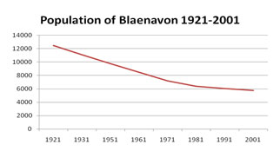
(Visitblaenavon, 2020)

1974 saw the Big Pit become a place of state protection and as later turned into a museum nine years later in 1983. Although there were many ideas into how the town could be regenerated, within the following years, by taking advantage of tourism there was no committed plans created. Blaenavon in the year 2000 became a place of World Heritage status, but this wasn’t a source of financial help. Financial help was later sources and invested into the tourism industry sources of the town, the Big Pit and the iron works were beneficiaries of these funds. This funding also allowed for additional tourism attractions to be devolved and these were the 2008 opening of the Blaenavon World Heritage Centre and the 2001 Blaenavon Cordell and Community Heritage Museum (Visitblaenavon, 2020).

“Officially, Blaenavon’s population peaked was at 12,469 in 1921, according to the census,” “The 2011 census shows the population as 6,055, which was the first census to show an increase for 90 years” (Blaenavon Town Council, 2020)
March 2017 saw a census undertaken and the results were not ones that reflected a successful town or definitely not matching the one previously to the coal mining industry closing. “45.1% of households are classed as ‘in poverty’’ (Torfaen Public Servies Board, 2017, p. 10).
“There is 50% higher proportion of unemployed residents aged 16-24 in Blaenavon (2.1%) compared to Wales (1.4%). Long term unemployed is of a similar higher rate (2.6%) compared to Wales 1.7%)”. (Torfaen Public Servies Board, 2017, p. 17)”. This data would indicate that there is not enough local work or opportunities for this age group. The only source of education in the local facility is that of Blaenavon Primary school. The nearest college is in Pontypool, means of travel could be a problem for local residents.
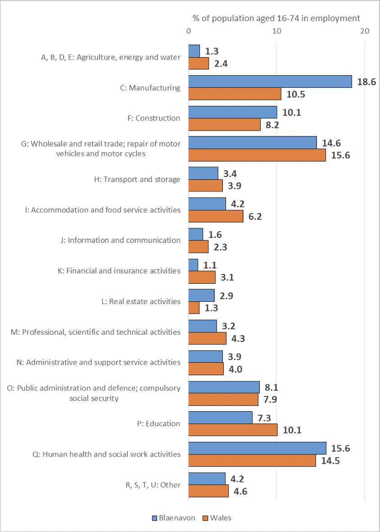 (Torfaen Public Servies Board, 2017, p. 18)
“Gilchrist Thomas Industrial Estate is the main area of employment in the town”. “The majority of businesses on the estate are manufacturing based”. “Units on the estate range in age and size - orginal units from the 1960 and more modern buildings including heritage court.” From this data source it would be suggested that the new main industry is that of the manufacturing, this would be seen to have taken over from the mining industry as the main source of employment (Torfaen Public Servies Board, 2017, p. 16).
18.6% of 16-74 year old residents of Blaenavon in employment work in manufacturing which is nearly twice that of Wales (10.5%). These employment sites are not confined to Blaenavon.”. Again there figures show that this is a manufacturing industry town and the fact that the employment sites are nit necessary local, show that some residents do travel for work opportunities. (Torfaen Public Servies Board, 2017, p. 18).
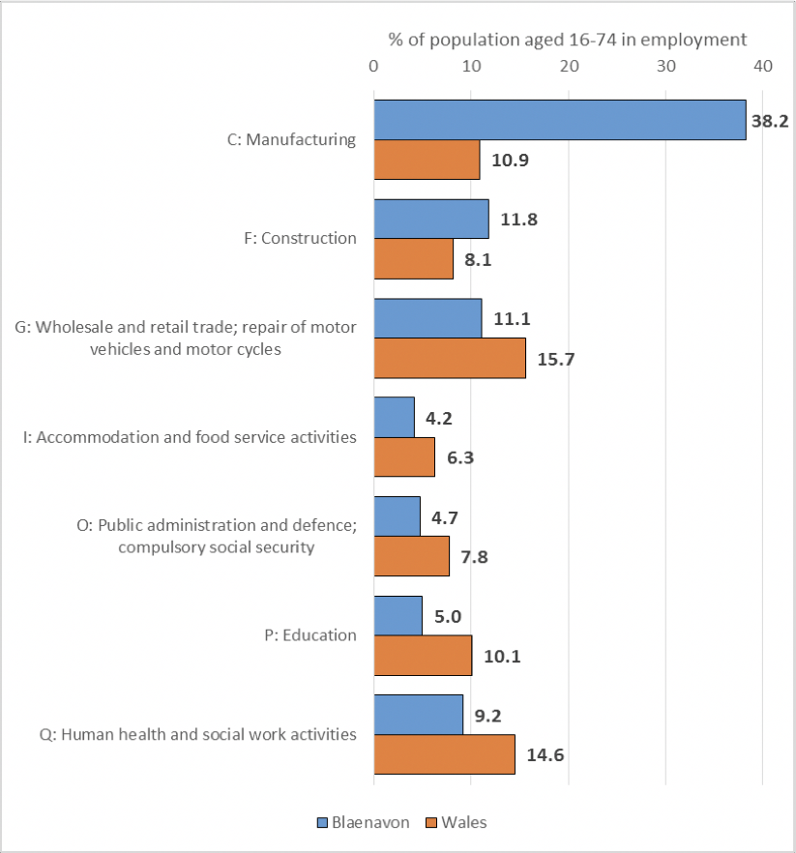
(Torfaen Public Servies Board, 2017, p. 19)
Some of these figures show that the town of Blaenavon has tried to diversified into a manufacturing town and with the added element of tourist attractions. This diversification has been successful and as of 2011 figures four times 18.6% the manufacturing workers compare to the welsh average of 10.9%. “There are approx. 660 people working in manufacturing in Blaenavon, but only 460 residents working in that industry.” (Torfaen Public Servies Board, 2017, p. 19).

Existing assets, structures and economic character /
Local/ regional development strategies

The Town of Blaenavon was benefited by investment into the form of structures, housing etc when the coal mine was operating. These buildings are continuing to be used today, therefore Blaenavon already had part of an infrastructure in place for when the town needed to diversity. “The Blaenavon Company usually built dwellings very close to its ironworks, mines, quarries or transport routes. An urban centre therefore developed only gradually” (Blaenavon Historial Processes, Themes and Background , 2020). Although for the positives there is the negative that some areas of town were not positively affected by this.

“Blaenavon has 46 listed buildings under the heritage category” (Torfaen Public Servicces Board, 2017, p. 15).

The Gilchrist Thomas Industrial Estate has original business units dating from the 1960 and also more modern buildings. This estate is where predominantly most manufacturing and food sector businesses are based. (Torfaen Public Servicces Board, 2017, p. 16).

Blaenavon has successfully kept it heritage buildings in working order and have used them as places for tourists and local people, these include the Blaenavon Workmen’s hall, which is now a digital cinema and social gathering facilities amongst other things. The community Museum and the bigger tourist attractions, such as the big pit.

Blaenavon Active Living Centre is another community place that facilitates the local community with activities. “The Active Living Centre is located on the Blaenavon Community Campus and is part of Blaenavon Heritage VC School. The Leisure Centre is managed by the school and not Torfaen Leisure.” (Blaenavon Active Living Centre, 2020). This is a great initiative by connecting the community to the local primary school.

The town of Blaenavon does have a “Townscape Heritage Programme” and this has a “Conservation Area Appraisal and Management Plan 2017-2022”. This plan looks at lots of different areas including bio-diversity, undesignated assets in the form of listed buildings, historical development and the town centre conservation area in Blaenavon. (Blaenavon Town Centre Conservation Area Appraisal and Management Plan 2017-2022, 2020).
Blaenavon’s local economy including its lack of investment in amenities for its local people could have an impact on the town being able to retain or attract local people to live within the area. The creation of their tourism industry has created a reliance on the intake of people to support and bring money to the area. There will be a proportion of the local economy that is not directly linked to the tourism industry, but still therefore relies on it.

SUSTANABILITY

Ground source heat
“Monitoring carried out in the area by Cardiff University, Geoenvironmental Research Centre through the Seren Project has identified the potential for generating energy from mine water in Blaenavon. Temperature and flow data collected over a 12 month period has been collected from a site in Blaenavon and identifies a potential 350 – 440 kW of heat power. Ground source heating is a low carbon source of energy that can be used for district heating for local homes or businesses.” [24] “Studies have also shown the potential for generating energy using hydro power in Blaenavon.
The installed ‘Dragon’s Teeth’ 25kW
micro-hydro project provides a long-term revenue stream - money which has been ring-fenced for World Heritage Site related work.” (Torfaen Public Servicces Board, 2017, p. 16)
The area of Blaenavon does have areas that have been used for sustainability purposes that bring in potential growth within this sector.
“The Garn Lakes area has seen a remarkable transformation over the past couple of decades. Once covered in spoil tips and old colliery workings, following an extensive land reclamation scheme it is now a beautiful haven for wildlife, walkers and cyclists.
The 40 hectare-site, which has been designated a Local Nature Reserve, features two lakes and grasslands which provides a diverse habitat and breeding grounds for a wide range of wildlife such as Tufted Ducks, Skylarks, Snipes, Redshanks and Little Grebes.
Garn Lakes is a great starting point for walks through the Industrial Landscape, while around the lakes there are many places to enjoy a picnic.’ (blaenavontowncouncil, 2020)

Welsh Government:
“We believe that town centre businesses may need to operate more flexible working hours in order to meet changing customer needs. We therefore recommend that the Welsh Government should update its Technical Advice Note on Planning and Retailing to include guidance for local authorities about imposing conditions on retail development regarding more flexible working hours.” (Committee, 2012). The Welsh Government has acknowledged the need for regeneration and adaption for local areas to create growth and success. One area that is relevant to Blaenavon is that flexibility that could be put in place to help some local businesses adhere to any changes that the local tourism industry may bring to the needs of their business operations.
“We recommend that the Welsh Government should work with local authorities to develop planned and innovative approaches that incentivise property owners to let their vacant town centre properties for living and working uses that would contribute to the vitality of town centres but would not undermine the properties‟ long-term value. (Page 30)” (Committee, 2012). Although not directly linked to the Blaenavon case this flexibility for property owners could be an area that could be brought to the attention if the Welsh Government. The town centre could benefit from acknowledgment of such problems
“We recommend that within the framework of the Local Development Plan, each town should have a comprehensive plan in place, developed by a local partnership of key stakeholders and engaging the community, which contains actions for addressing the issues affecting the viability of the town centre.” (Committee, 2012).
“We recommend that the Welsh Government through Visit Wales should encourage town partnerships to market their unique selling points such as architectural heritage and environmental quality, local produce and local culture, perhaps involving groups of towns within a region so that their different offers can complement each other. This could be part of the town centre plan we recommended above.” (Committee, 2012).

Regeneration ideas

Number 1

The Town of Blaenavon’s tourism industry and therefore attractions attracted 488,200 visitors during the year of 2015. Blaenavon has several visitor attractions including Blaenavon World Heritage Centre, Big Pit: National Coal Museum, Blaenavon Ironworks, Blaenavon Community Heritage & Cordell Museum and Blaenavon Heritage Town (Torfaen Public Servicces Board, 2017, p. 28).
The key element to this regeneration plan is the statistic that of the 488,200 people 475,000 of those were only day visitors (Torfaen Public Servicces Board, 2017, p. 28).
Upon further investigation Blaenavon only has one small hotel. This fact alone is not going to help the industry develop further. A regeneration idea is that creation of an additional hotel or small resort that will encourage tourist to stay in the area, therefore spending more time and being able to visit more attractions. How accessible is the tourism sights to visitors out of area, there could be investigations undertaken to gain statistics to the potential numbers of tourists would be interested in using such facility if available.
This regeneration idea could potentially attract more visitors and/or bring in extra funds for local facilities. Local jobs would also be created and could be used to train local residents.
A negative could be any out of season job variations.

Number 2

“As part of the Blaenavon Housing Needs Survey (2012) respondents were asked about the improvements they would like to see in Blaenavon. The top 5 responses were: Play areas, shops, road improvements, improved Road structures and Parking” (Torfaen Public Servicces Board, 2017, p. 14).
A town that was also had an previous industrial mining background is that of Merthyr Tydfil. The residence of this town were asked their opinion on what their regeneration plan for the area would be, in 2011. A list of areas that need regeneration and changes that they felt were needed was created, in 2012 Merthyr Tydfil County Council won funding from several sources that raised over £25 million. The funding was used to create new road systems, improve railway access, a car park, help regenerate heritage sights in town centre and create a Business Enhancement Scheme (Merthyr Tydfil County Borough Council , 2010).

This approach incorporated the thoughts and problems of that of the local residents/community. This means that as well as focusing on regeneration and growth, it also adheres to the concerns of local people.

Funding could be sourced as done in Merthyr Tydfil if a plan and proposal was created.

Conclusion

Regeneration is a difficult prospect to achieve successfully, it takes a lot of research and planning to have the best chance of being successful. One successful plan in this study is that of Merthyr Tydfil’s plan and this is an example that Blaenavon could use in their further development. There are many reasons as to why a regeneration plan may fail or not be as successful as intended and they include, financial reasons, lack of knowledge or understanding of that said area needs, not taking time or not having local residents best interests at the for front (Dave Adamson, p. 27).

Any regeneration plan should include social needs, environmental needs, the local and national economy trends and the creation of opportunities. There also has to be an element of focusing on current or needed skills, knowledge and education of the protentional people involved in the projects, both long and short term (Dave Adamson, p. 31).

Regeneration plans should not focus on one set of knowledge, plans or idea as this will not give the best change of a successful outcome. Ideas and plans should be continually revalued in order to correct or amend and issues. A main problem is “Programmes have in many cases been set up without having regard to available base line data, and in anticipation of regular monitoring” (Dave Adamson, p. 28).

Blaenavon should look at the structures, ideas and examples created by successful regeneration projects. They should also look at ways regeneration projects have failed and resources that have been amended to rectify and problems.

Reference List
Blaenavon Active Living Centre. (2020, August 7). Blaenavon Active Living Centre - Home. Retrieved from Blaenavon Active Living Centre: http://www.blaenavonleisure.co.uk/index.html
Blaenavon Historial Processes, Themes and Background . (2020, August 7). Retrieved from GGAT Historic Landscape Characterisation : http://www.ggat.org.uk/cadw/historic_landscape/blaenavon/english/Blaenavon_Features.htm
Blaenavon Town Centre Conservation Area Appraisal and Management Plan 2017-2022. (2020). Appraisal and Management Plan. Blaenavon: Blaenavon Town Centre Conservation Area Appraisal and Management Plan 2017-2022.
Blaenavon Town Centre Conservation Area Appraisal and Management Plan 2017-2022. (n.d.). Apprasel and ,a. Blaenavon Town Centre Conservation Area Appraisal and Management Plan 2017-2022.
Blaenavon Town Council . (2020, August 7). Big Pit National Coal Museum . Retrieved from Blaenavon Town Council : https://www.blaenavontowncouncil.co.uk/bigpit
Blaenavon Town Council. (2020, August 7). Our Town . Retrieved from Blaenavon Town Council: https://www.blaenavontowncouncil.co.uk/our-town
Blaenavon World Heritage Site . (2020, August 7). Regeneration. Retrieved from Blaenavon World Heritage Site : https://www.visitblaenavon.co.uk/en/WorldHeritageSite/LookingAfterBlaenavon/Regeneration.aspx
Blaenavon World Heritage Site . (2020, August 07). Regeneration . Retrieved from Blaenavon World Heritage Site : https://www.visitblaenavon.co.uk/en/WorldHeritageSite/LookingAfterBlaenavon/Regeneration.aspx
blaenavontowncouncil. (2020, august 7). blaenavontowncouncil Garn-lakes. Retrieved from blaenavontowncouncil: https://www.blaenavontowncouncil.co.uk/garn-lakes
Committee, E. a. (2012). National Assembly for Wales Enterprise and Business Committee. Cardiff: National Assembly for Business Commission .
Dave Adamson, K. B. (n.d.). Regeneration in Wales: Analytical Timeline for the Welsh Assembly Government's National Regeneration Panel. Centre for Regeneration Excellence Wales .
GIS . (n.d.). The End of Coal Mining in South Wales: Lessons learned from the industial transformation .
Merthyr Tydfil County Borough Council . (2010, August 07). Town Centre Regeneration . Retrieved from Merthyr Tydfil County Borough Council : https://www.merthyr.gov.uk/resident/regeneration/town-centre-regeneration/
Torfaen Public Servicces Board. (2017, March). Part 2 Blaenavon Well-Being Inforgraphics. Retrieved from Torfaen Public Servicces Board: http://www.torfaenpublicservicesboard.co.uk/en/Documents/Assessment-of-Well-being/Part-2-Well-being-of-Blaenavon-and-its-communities.pdf
Torfaen Public Servies Board. (2017, March). Part 2 Blaenavon Well-Being Infographics. Retrieved from Torfaen Public Servies Board: http://www.torfaenpublicservicesboard.co.uk/en/Documents/Assessment-of-Well-being/Part-2-Well-being-of-Blaenavon-and-its-communities.pdf
Travers Merrill, L. K. (2017). The End of Coal Mining in South Wales: Lessons learned from industrial transformation . Global Subsidies Initiative / International Institute for Sustainable Development .
Visitblaenavon. (2020, August 7). Blaenavon World Heritage Site - Regeneration . Retrieved from VisitBlaenavon : https://www.visitblaenavon.co.uk/en/WorldHeritageSite/LookingAfterBlaenavon/Regeneration.aspx

