Program: BA International Hotel Management
Module: Financial Management for the Hotel Industry
Module code: BMIH5007
Student name: Hasna Jahan
Student ID number: 2109022
Lecturer Name: Dale Clarke
Assignment Title: Comparison of Two Hospitality Organizations

Table of Contents
Introduction 1
Overview of organizations 1
Comparison between approaches of financial management 1
Total Revenue 1
Market Position 3
Growth Potential 5
Financial Commitment to CSR 5
Working capital 5
Recommendations 5
Conclusion 5
References 6

Introduction
Understanding, the different approaches to financial management is the purpose of the study. According to Aernoudt (2022), the way to handle a company’s finance by following specific rules, regulations, and standards is called financial management. So, the comparison between the approaches of financial management by the implementation of those approaches within different hospitality organizations includes in the study. So, to compare between approaches of financial management the study includes the factors like total revenue, market position, growth potential, and financial commitment to CSR.

Overview of organizations
Accor International is a French multinational organization that has businesses, franchise hotels, resorts, and vacation places throughout the world along with the UK. Accor International has business operations in approximately 110 countries and 5300 locations throughout the world. Accor International is involved in franchising, merger, and acquisitions to expand its business operations within a broader marketplace (Beluze and Guilloux, 2020).
Best Western is America’s largest hotel chain that has business operations in approximately 100 territories of the world along with the UK. It has approximately 13 hotel brands which are offering high-quality excellent services to customers. But Best Western does not have a franchise or does not perform any mergers and acquisitions it is a hotel chain (Aisha, 2019).

Comparison between approaches of financial management
Financial management refers to the activities through which the finance department of a business organization collects and utilizes funds within the organization (Paramasivan, 2019). There are two types of approaches to financial management which are the traditional approach and the modern approach. The traditional approach refers to collecting funds for business activities from lenders, and financial institutions but the modern approach of financial management focus on funding business by using retained earnings rather than collecting funds through financial institutions (Aung, 2022).

Total Revenue
As Accor International follows the modern approach of financial management and uses sales revenue to calculate EBITDA which is a financial factor but Best Wester follows the traditional approach so its focuses on only the income statement rather than using sales revenue of the income statement to calculate EBITDA (David, 2022). Accor International follows the modern approach of financial management because the income statement of Accor International is showing that it gains revenues from holding along with the hotel services and hotel assets and others where the sales revenue of Accor International in 2022 was 17,250,000 (Cardiff, 2022). Also, the Best Western hotel follows the traditional approach of financial management because it has not engaged in mergers or acquisitions and franchising so it gains sales revenue only from hospitality services (Chang, 2022). The sales revenue of Best Western in 2022 was 2100150. That is showing a huge difference between the revenues of Accor International and Best Western where Accor International has higher sales revenue than Best Wester because Accor International follows the modern approach of financial management which refers to engagement in franchising, merger, and acquisition (Fehre and Weber, 2021). That is increasing the sales revenue of Accor International. But the finance department of Best Western follows the traditional approach of finance which refers to investment in profitable projects where Best Western invest in establishing new hotels within the international market which is increasing its cost that is negatively impacting its sales revenue (Constantin Zopounidis, 2020).
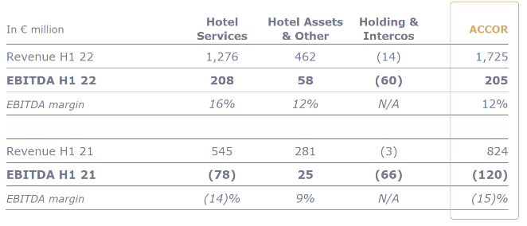  Figure 1: EBITDA margin of Accor International.  Source: (Dobrovolska and Dubrova, 2022). | 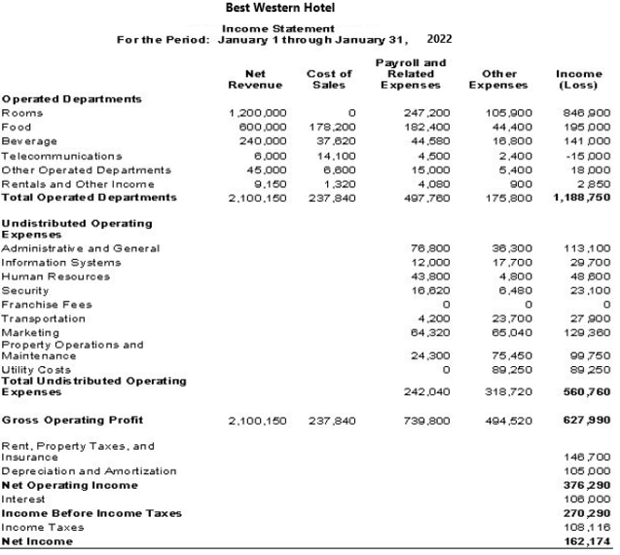  Figure 2: Income statement of Best Western.  Source: (Islam, 2022).

Market Position
Accor International Hotel follows the modern approach of financial management which refers the investment decisions, financial decisions, and dividend decisions (Dobrovolska and Dubrova, 2022). That refers to the financial manager’s focus on measuring the risk of the investment proposal and identifying whether the business has a total volume of funds to support the investment along with ensuring the appropriate mixture of debt-equity capital structure of the organization (Isada, 2022). So, the financial manager of Accor International ensures investment in projects like mergers and acquisitions by funding the investment utilizing available resources within the organization which is the retained earnings that are kept to further growth opportunities of business. That is helping Accor International to gain the 6th position within the international market in 2022 (Islam, 2022). Because Accor has less business cost because of no funding cost. As Accor International does not focus on funding from financial institutions like bank loans, brokerage firms, mortgage companies, and lenders so Accor International has higher profitability by following the modern approach of financial management. That raised the market price of shares of Accor International in 2020 to $300 because Accor International does not have to provide interest on a bank loan, mortgage, and so on that is increasing the value of its stock within the international market (Kenneth, 2022). According to Finnerty (2021), by following a modern approach to financial management Accor International is focusing on merger, acquisition, and franchising which is causing it to have business operations in approximately 110 countries which are generating more revenue than Best Western hotels because Best Western hotel follows traditional approach of financial management which does not support merger, acquisition, and franchising but supports in investment in profitable projects (Kent Baker, 2022).
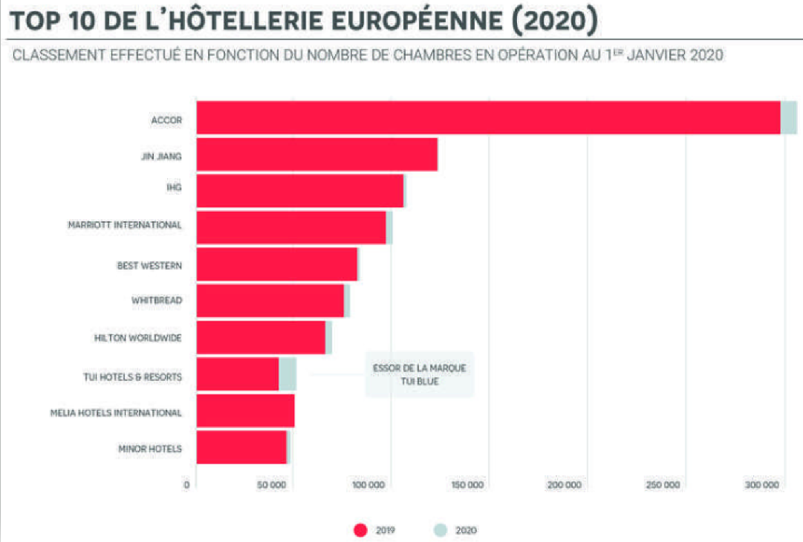
Figure 3: Market position of Accor international and Best Western.
Source: (Khan, 2022).
Best Western is following the traditional approach of financial management which refers to funding in business by taking loans from financial institutions, lenders, and bonds that are increasing the interest cost of Best Western that is creating barriers to gaining more profitability and keeping the large amounts for retained earnings for future growth (Ksiezak and Fischbach, 2022). That causes the stock price of Best Western to be less than $100 while the stock price of Accor International is $300. Also, Best Western gained 12th position in ranking within the market where the difference between the hotel rooms to serve customers of Accor International and Best Western is 777714 – 312166 = 465,548 (Paramasivan, 2019). That is shown by following the traditional approach of financial management Best Western could not able to reduce its funding cost and make investment decisions in acquisition, mergers, and franchising which causes less presence within the international market along with less room to serve customers that are negatively impacting on the profitability of the Best Western hotel (Ramakant, 2022). The modern approach of financial management focuses on maintaining a debt-to-equity ratio where equity remains more than debt by inspiring organizations to focus on funding through retained earnings (Roger, 2022). But the traditional approach creates an imbalance in a debt-to-equity ratio by inspiring organizations to collect funds through debt capital (Aernoudt, 2022).

Growth Potential
According to Aisha (2019), growth potential refers to further growth opportunities for business organizations. As Accor International hotel is following the modern approach to financial management which requires the identifying funding capability of the organization to invest in mergers, acquisitions, and franchising rather than collecting debt funding (Aung, 2022). So, Until Accor International does not gather the appropriate amount of retained earnings it could not focus on growth opportunities (Beluze and Guilloux, 2020). But whether best Western is following the traditional approach of financial management so Best Western could get growth opportunities like establishing new businesses within a new potential market by collecting funds through debt capital (Cardiff, 2022). Also, if Accor International will use its existing retained earnings in investing in any acquisitions, mergers, or franchising then it will face a lack of working capital within the organization that could negatively impact the profitability of Accor International (Chang, 2022). But as Best Western gathered its retained earnings for a long time without using the whole amount of retained earnings in business growth that will inspire Best Western to collect funding to invest in new business ventures from debt capital (Constantin Zopounidis, 2020). That will provide the opportunity for risk-free investment in profitable projects by maintaining the balance of working capital within the organization.

Financial Commitment to CSR
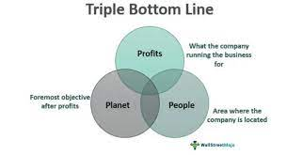
Figure 4: Triple bottom line model of CSR.
Source: (Ksiezak and Fischbach, 2022).
Ksiezak and Fischbach (2022) stated that the triple bottom-line model of CSR is an integrated form of the profit, planet, and people which refers to gaining profitability through business activities and ensuring a positive impact on society and the environment to gain sustainability.
So, the financial commitment to CSR refers to gaining profitability and doing something good for society people, and the environment (Fehre and Weber, 2021). So, by following the modern approach to financial management Accor International is reducing the cost of business which is increasing its profitability which causes Accor International to have €1,149 million in 2022 which is an 83% increase from 2021 (David, 2022). That is helping the financial manager of Accor International to ensure financial commitment to CSR by performing dividend decisions which refer to offering a dividend to the shareholders that could not negatively impact stock value (Dobrovolska and Dubrova, 2022). That helps the financial manager of Accor International to provide a dividend of 5.03% from profitability and kept another amount as retained earnings for further investment that is positively contributing to the profitability of the business (Isada, 2022). Along with helping to invest in digital equipment to reduce carbon footprints and enabling more employment opportunities for society people that is helping to fulfil its commitment to CSR (Islam, 2022). Also, Best Western is following the traditional approach of financial management that is inspiring to keep retained earnings within the business for long-term investment by collecting funds from debt capital for short-term investment (Khan, 2022). That is increasing net income by 13.76% which is $3.191B in 2022 which inspire best Western to donate 0.7% of its net income to society people along with investing funds in recycling to reduce negative impacts on the environment (Kenneth, 2022). That is helping Best Westerns to fulfill its commitment to CSR.

Liquidity
Liquidity refers to the amount of working capital within the organization to repay short-term liabilities of the organization (Ksiezak and Fischbach, 2022). By following the traditional approach of finance Best western collect short-term funding from debt capital like bank loan, mortgage, and so on and kept retained earnings for further long-term business growth which is increasing the short-term liabilities of Best Western which could negatively impact its liquidity (Paramasivan, 2019). But as Accor International is following the modern approach to financial management so its focus is on collecting short-term funds from retained earnings rather than debt capital which is helping Accor International to ensure higher liquidity and increasing inefficiency of the working capital of Accor International (Ramakant, 2022). Because higher liquidity shows a lack of utilization of the current assets of the organization which could negatively impact profitability.

Recommendations
Opportunities for Growth: Accor International uses its retained earnings for short-term investment that is creating barriers for its long-term investment to potential growth projects of the business. So, Accor International should focus on long-term growth opportunities like investing in the project by saving its retained earnings for long-term growth rather than using them in short-term investments.
Potential for Outsourcing: The business cost of Best western is high because it follows the traditional approach of financial management where it collects short-term funding from debt capital and has to provide a huge amount of interest that is negatively impacting its profitability (Roger, 2022). So, Best western should focus on increasing its profitability by reducing its cost of the supply chain where Best Western should focus on outsourcing services, food, or labor where third-party organizations will perform services, offer food to customers, and recruit labour on behalf of Best western at a specific amount of fee (David, 2022). That will reduce the cost of recruitment, and the chef to cook foods, along with reducing the cost of the HR department of Best Western which will positively impact its profitability.

Conclusion
Financial management has two approaches like traditional approach and the modern approach where the traditional approach creates barriers to higher profitability for Best western by increasing its short-term debts. Another side modern approach to financial management increases the profitability of Accor International by reducing the cost of funding by inspiring them to invest in projects by funding from retained earnings of the business. But using retained earnings of Accor International in short-term investments is creating barriers to growth opportunities to perform long-term investments through retained earnings. Another side of Best Wester is getting long-term investment opportunities by using its retained earnings by following the traditional approach of financial management. But both traditional and modern approaches of financial management inspire both Accor International and Best western hotels to fulfil the financial commitment to CSR by investing funds in donations and reducing carbon footprints and contributing to the economy of the country through profitability.

References
Aernoudt, R. (2022). Financial management in practice : How do I finance my enterprise? Cambridge ; Antwerp ; Chicago: Intersentia.
Aisha (2019). 3 Main Approaches to Financial Management | Management. Learn Accounting: Notes, Procedures, Problems and Solutions.
Aung, M. (2022). The Accor Multinational Hotel Chain in an Emerging Market: Through the Lens of the Core Competency Concept’. The Service Industries Journal, 20(3), pp.43–60.
Beluze, G. and Guilloux, V. (2020). Revenue management par place : Une spécificité Accor. Décisions Marketing, 26, pp.07-15.
C Paramasivan (2019). Financial management. New Delhi: New Age International (P) Ltd., Publishers.
Cardiff (2022). The Income Statement Chapter 3 Matakuliah: V Manajemen Akuntansi Hotel Tahun: ppt download. [online] slideplayer.com.
Chang (2022). Approaches to Financial Management and Functions of Finance Manager. [online] BrainKart.
Constantin Zopounidis (2020). New operational approaches for financial modelling. Heidelberg ; New York: Physica-Verlag.
David (2022). Accor goes to 6th Place in the World Ranking Following the Sale of Motel 6. [online] Hospitality Net.
Dobrovolska, O. and Dubrova, N. (2022). EBIT AND EBITDA IN FINANCIAL STATEMENT ANALYSIS: METHODOLOGICAL APPROACH. Market Infrastructure, (52).
Fehre, K. and Weber, F. (2021). Challenging corporate commitment to CSR. Management Research Review, 39(11), pp.1410–1430.
Finnerty, J.D. (2021). Corporate Financial Analysis. McGraw-Hill Companies.
H Kent Baker (2022). Understanding Financial Management [electronic resource] : A Practical Guide. Wiley Uuuu-Uuuu.
Isada, F. (2022). POSITION IN INTER-ORGANIZATIONAL NETWORKS AND PROFITABILITY AND GROWTH POTENTIAL. International Journal of Business and Management, VIII(2).
Islam (2022). Income Statement vs. Comprehensive Income Statement. European Journal of Business and Management.
Kenneth (2022). 2022 World Hotel Group Rankings: behind the apparent calm, there are fundamental movements. [online] Hospitality ON.
Khan (2022). [Ranking] Hotel group offers in Europe: a market as attractive as ever. [online] Hospitality ON.
Ksiezak, P. and Fischbach, B. (2022). Triple Bottom Line: The Pillars of CSR. Journal of Corporate Responsibility and Leadership, 4(3), p.95.
Ramakant (2022). Financial Accounting Techniques.
Roger (2022). Half-Year 2022 Very strong rebound of the activity with Q2 above 2019 level. [online] Accor - Newsroom.

