Joint point Website
Most people search online before they heading to a site. It is very likely that potential customers might look up our coffee shop before they make their first visit. It is very efficient way to increase our visibility and ability to sell some products online.
SEO
To get our coffee shop noticed online, SEO is a crucial element in any website. As much as the website is improved and rich in contents it helps to list the business website first on any search.

This is a list of some popular words: coffee shops, coffee shops near me, espresso, cappuccino, mocha, coffee near me, coffee maker, coffee pot…etc.
I have provided a brief description about Joint Pont café and some Meta Keywords to improve the SEO of the website.
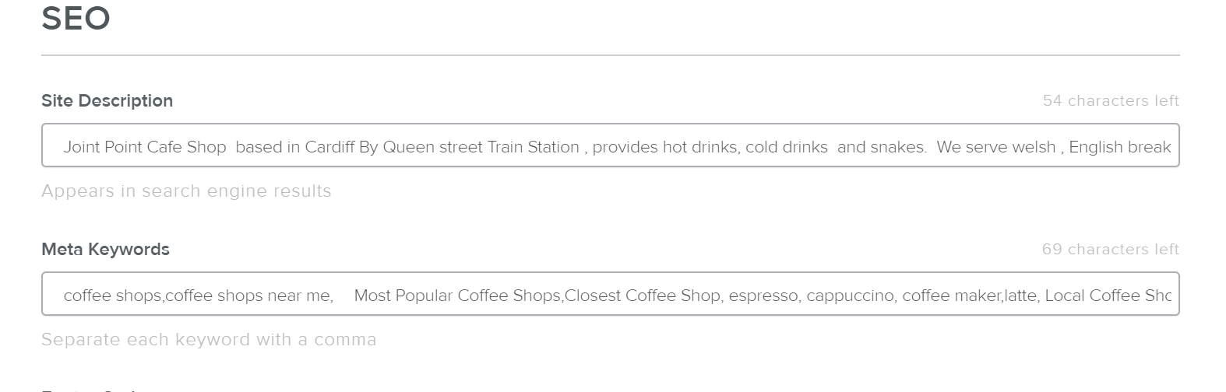
The other topic I contributed to the web is the “our Story “ page .
I tried to provide our business website visitors with a brief story about our journey as a four individual to create a traditional coffee shop. It is a simple attempt to explain our values, give our business human voice . The photo of the background is to inspire our customers.



