

Application of CAE Processes

ACHA6010

Sophie Reed
2000492
Word Count – 2354
Table of Contents
Introduction 3
1.0 Modelling and Assembly 4
2.0 Kinematic Simulation and Structural Analysis 5
2.1 Kinematic Analysis 6
2.2 Static Structural Analysis 7
2.3 Thermal considerations 8
3.0 Optimization and Improvement 10
3.1 Testing of new materials 11
3.1.1 Titanium Alloy T1-6AI-4V 11
3.1.2 Aluminium Alloy 6061 13
4.0 Conclusion 15
References 16

Introduction
This report explores the use of computer-aided engineering (CAE) tools in designing, simulating, and optimising a mechanical system to meet performance goals while reducing costs and enhancing efficiency. CAE is a combination of both finite element analysis (FEA) and kinematic studies with computer-aided design (CAD) to create realistic models of components (PTC, 2024). These tools are valuable in modern engineering as they minimise the need for physical prototypes, saving time and money.
The report involves the creating of a detailed assembly of interconnected components and analysing their behaviour under different operating conditions. Using ANSYS, the study focuses on a static structural and thermal assessment of the Connecting rod, followed by improvements to optimise its performance and mass.
CAE tools play a critical role in improving the components performance. For instance, PTC explains that CAE not only predicts the product behaviour under realistic conditions but also helps reduce over-engineering by optimising material use (PTC, 2024). However, as this report will show CAE can have its limitations, including the need for accurate input data and computational resources.

Modelling and Assembly

For the assembly model, it was decided to do a part of an engine, which includes the Piston, Connecting rod, Crankshaft and Gudgeon pin. This assembly can be seen in figure 1. The model provided was created as accurately as possible, this ensures the test results are as accurate as possible, it was created in SolidWorks and then transferred to Ansys to allow for the testing. SolidWorks assemblies are vital for visualising and validating the functionality of complex models by integrating individual components into the system. Additionally, assemblies enable simulation of dynamic motion and stress analysis, ensuring the model meets functional and structural requirements. The use of advanced tools like interference detection and motion studies ensures the final product is optimised for performance and efficiency (Shih, 2020).
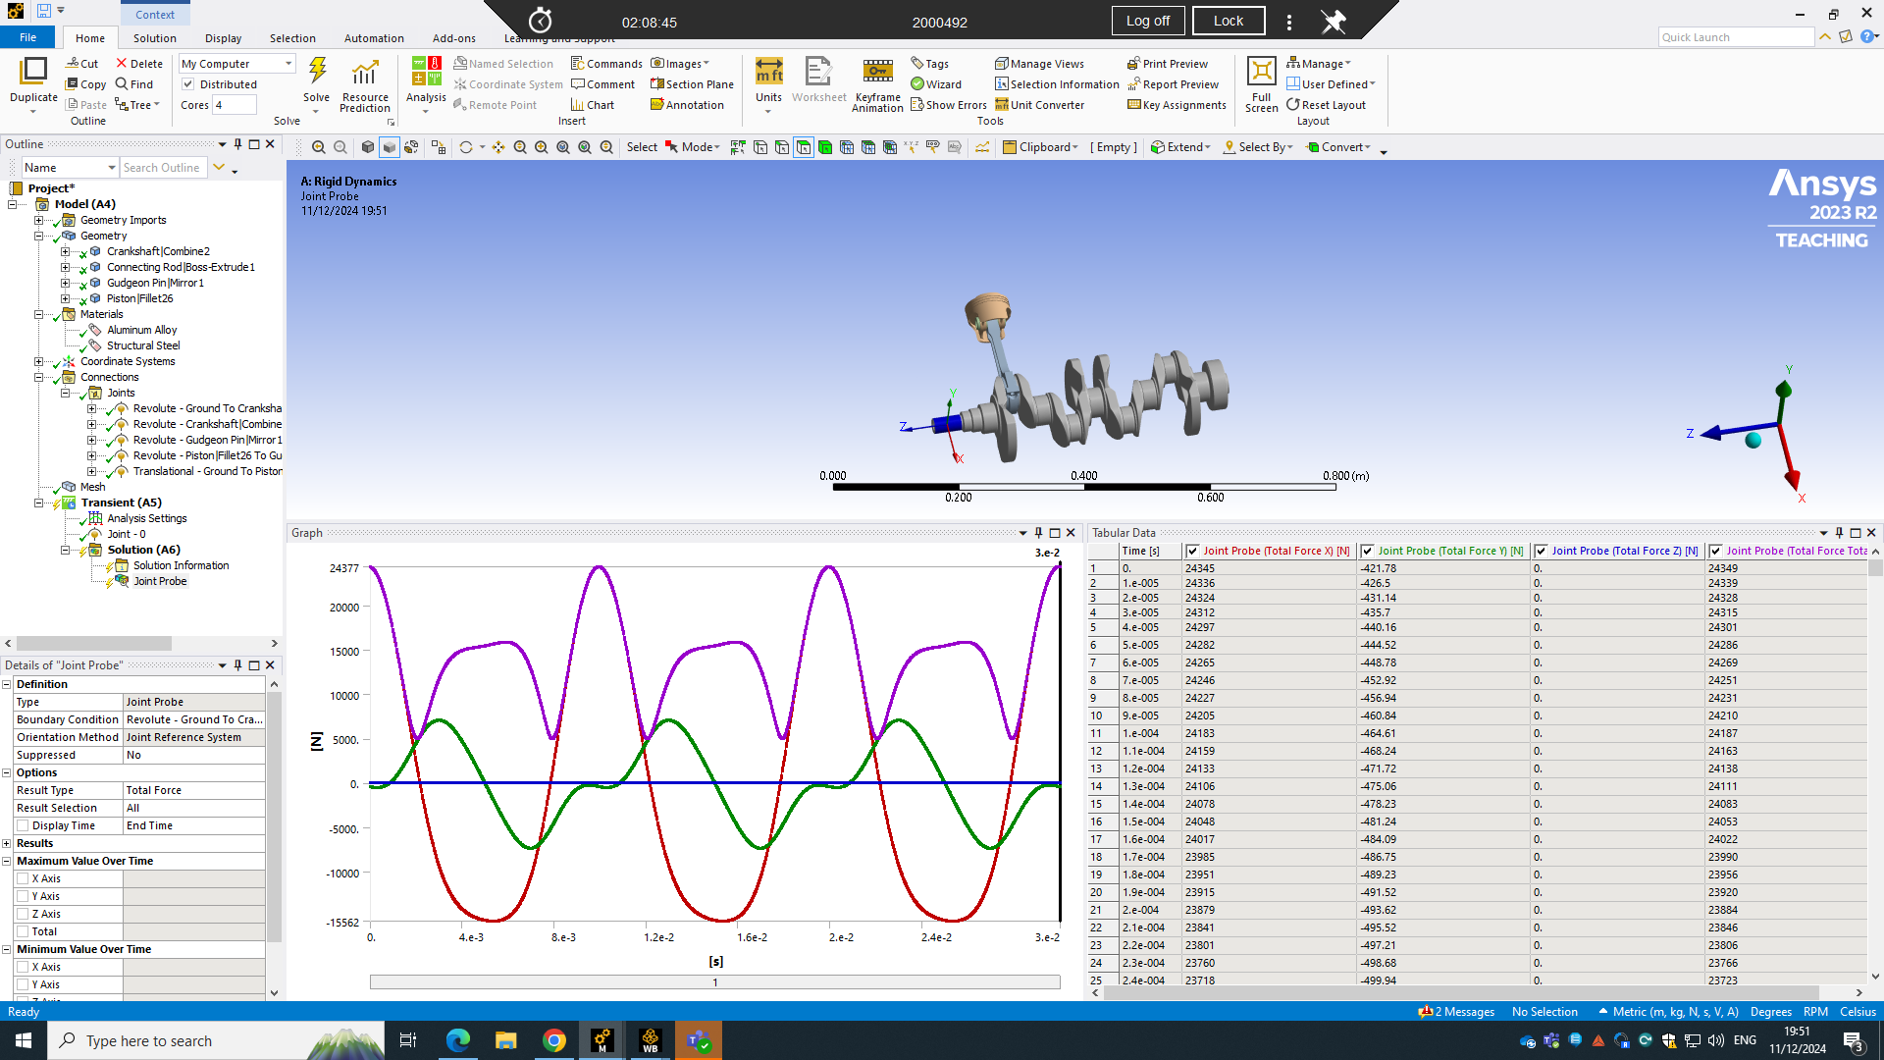

Figure 1 (Reed. S, 2024)

2.0 Kinematic Simulation and Structural Analysis
This report investigates the connecting rod as a singular component and analyses ways to improve it. All the next tests were tested using the most common metal for a connecting rod, this is a forged carbon Steel. This is a Medium-Carbon Steel that provides a good balance of strength hardness and toughness. It is often used for crankshafts, gears and connecting rods as they undergo moderate to high stresses. The properties of this material are (MatWeb, 2021);
- Mechanical properties
  - Tensile Strength: 570 – 700 MPa (varies depending on heat treatment)
  - Yield Strength: 250 MPa
  - Young’s modulus – 200 GPa
  - Poisson’s Ratio – 0.3
  - Density – 7850 $kg/m^{3}$
- Thermal properties
  - Melting point – around 1425°C
  - Thermal Conductivity – around 46 W/mk
  - Coefficient of Thermal Expansion – approximately 11.6μm/m°C

2.1 Kinematic Analysis
Kinematic analysis using ANSYS is a strong approach to studying the motion of mechanical systems, including velocity and acceleration of components under specified forces and constraints. This analysis is particularly valuable for optimising the performance of mechanisms, ensuring smooth operation, and avoiding mechanical failure. It provides precise visualisations and detailed outputs, allowing to refine the systems for better efficiency. This meant it was easy to compare the different materials to each other to see which would be the most appropriate for a Connecting Rod. Below (figure 2) shows the assembly in the analysis and the output results that it produced.
Figure 2 (Reed. S, 2024)

On the left of the image, you can see the joints that were made to ensure the assembly was working correctly. This further ensured that the results were accurate. Along the bottom of the image, you can see the graph is produced and the first 25 inputs in the table. The x-axis represents time, shown in small increments, while the Y-axis measures the forces in Newtons (N). The red curve (Joint probe (total force X) N) shows a sine wave pattern, with peaks and troughs throughout, which indicates significant forces. The green curve (Joint Probe (total force Y) N), fluctuates smoothly and remains minimal which shows a force of a lower amount. The purple curve (Joint probe (total force all axis) N) displays a more complex pattern with substantial peaks. Whereas the blue line (Joint probe (total force z) N) remains zero the entire time, which shows there was no force present on the Z-axis.
The table next to the graph reflects the data from the graph, offering a more detailed insight to the engine’s behaviour. It allows to see exactly what was happening at each millisecond of the test. The test was conducted at 630 m/s which equates to around 6000 rpm using the following equation;
$$rpm= \frac{speed (m/s)}{2πr} x 60$$

2.2 Static Structural Analysis

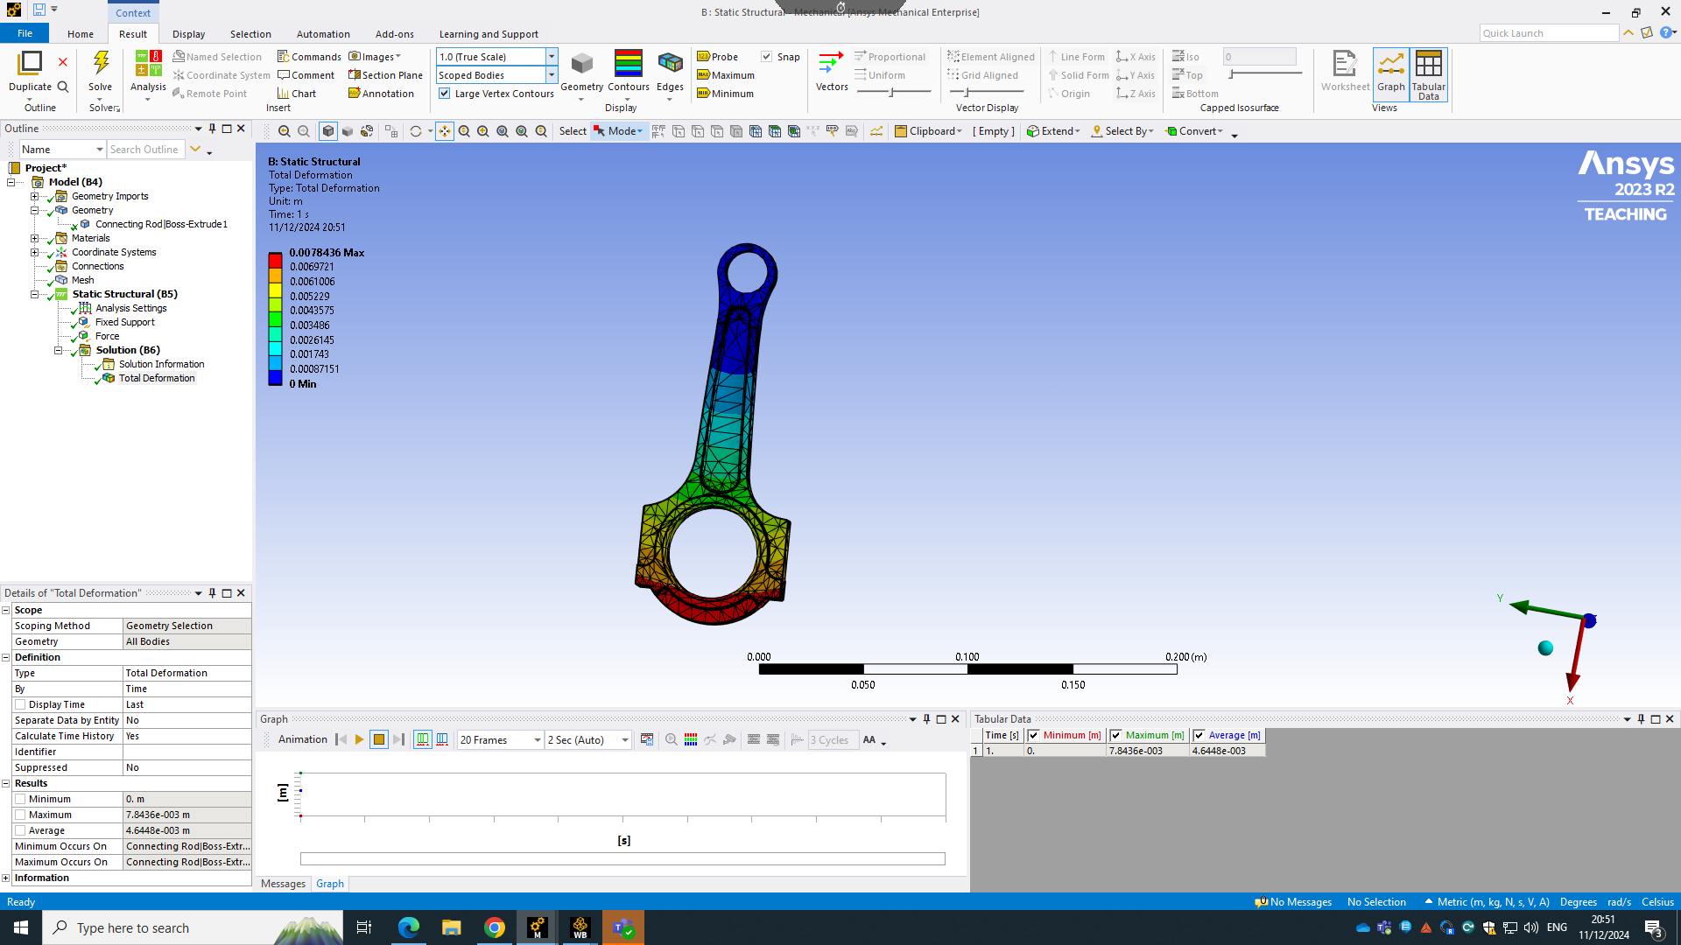
Static structural analysis using ANSYS is a fundamental tool for assessing the behaviour of different materials under constant loads or boundary conditions. This type of analysis is important for determining stresses, strains, and deformations in components whilst they’re being subjecting to forces such as pressure and weight. It allows to see where the component is at its weakest and may need some reinforcement, it also supports the validations of safety factors, providing confidence in the durability and reliability of the structure before manufacturing or implementation (ANSYS, 2023).
Figure 3 (Reed. S, 2024)

Above (figure 3) shows the results of the Steel being tested, it was tested at 10N. The top of the rod was put as a fixed point and then the bottom was being pushed under a pressure of 70kN. This is to try to imitate the way a connecting rod would move and forces it would experience. The reason for testing it at 70kN is because a typical production car engine the connecting rod experience a range of 30kN to 60kN (Heywood, J.B, 2018), therefore if it’s being tested at 70kN it means the material will withhold the force with some excess. As seen in the image the bend of the connecting rod is minimal which is good as it means it can withstand the pressure well and still stay in a working shape, keeping the engine working smoothly. The max movement it experiences is – 0.0078436m – this is 7.8436mm which is very minimal so means the connecting rod will still work well under this pressure.

2.3 Thermal considerations

For this test thermal conditions were added, this allowed for a more in-depth look on understanding how the component would function. For this the component experiences different heat levels, so it was important to include this in the test to get the most accurate results. To do this to the highest accuracy the connecting rod was split into three sections: Crankshaft end, Piston Pin end and the Rod shaft. The Crankshaft end of the connecting rod is typically exposed to oil cool but also endures heat from friction, the area generally experiences 80-120°C during normal operation. So, to ensure the connecting rod could withstand this it was tested at 120°C. The Piston pin end of the connecting rod, connects to the piston pin, is closer to the combustion chamber and therefore experiences higher temperatures again. So, this temperature range is 150°C to 200°C, therefore it was tested at 200°C. The Rods shaft is less directly affected by combustion heat and is generally the cooler part of the component and range from around 60°C to 100°C, so this part was tested at 100°C. Below you can see the thermal considerations and how they affected the connecting rod.

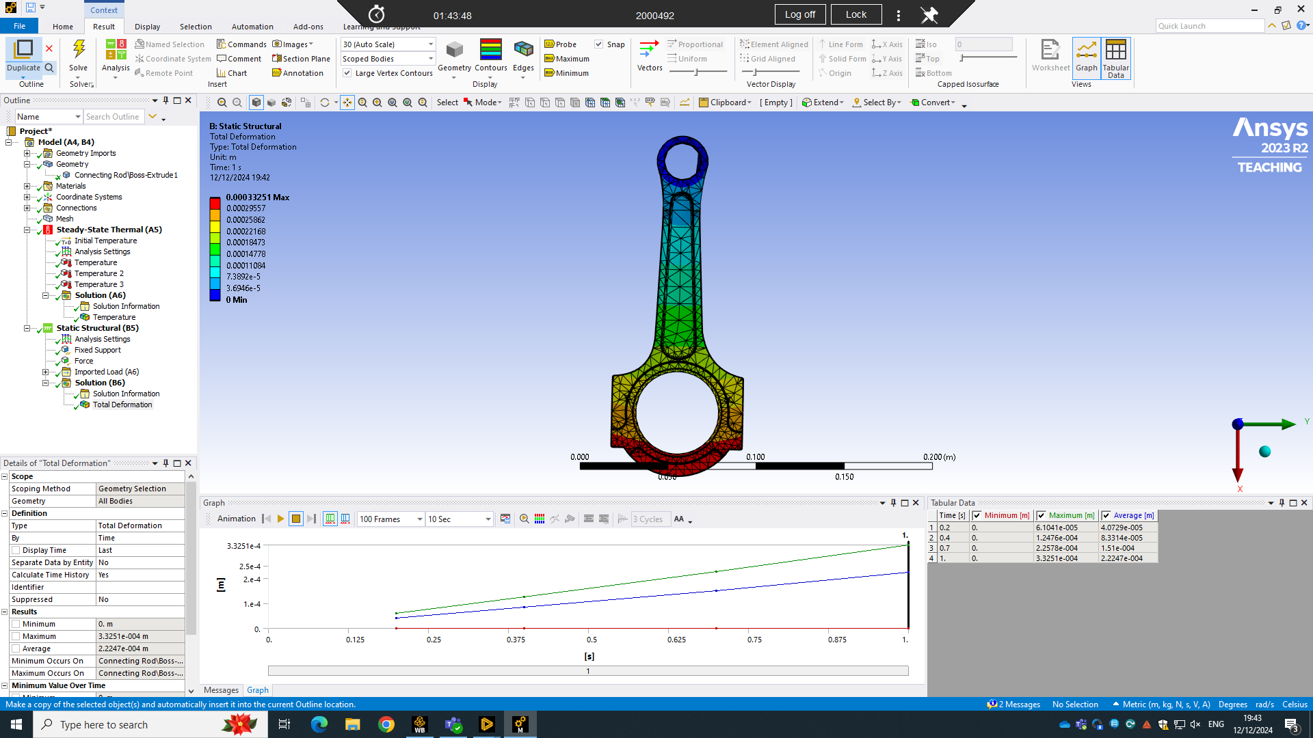
Figure 4 (Reed. S, 2024)
You can see clearly the affects the thermal had on the connecting rod. It also tested the static structural again so you can see a complete affect that happens when its being used. The movement is minimal which is ideal, and the bottom is the hottest which is to be expected from the temperatures put into the test. The graph also shows the increase in the movement the rod experiences. This is expected with the pressure it is also experiencing. To ensure this was as accurate as possible a mesh was completed (figure 5), this is a crucial step in simulation that converts the geometry of a model into smaller elements allowing higher accuracy of results.
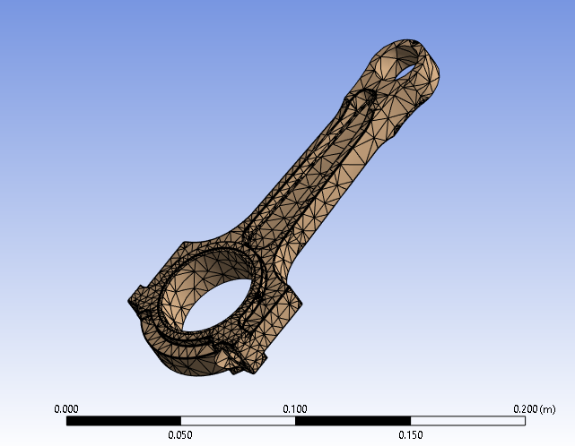

Figure 5 (Reed. S, 2024)

3.0 Optimization and Improvement

For the initial study, the component is analysed under realistic loading and boundary conditions to understand the way it performs. Using Ansys it is clear to see the connecting rods stress distribution and displacement. There is movement in the component however it is minimal, a way to improve this component will be to save weight. This would mean using a material that is lighter in weight with the same strength characteristics, it will also need to withstand the heat it will embrace. The size of the component cannot be changed without changing the size of the entire assembly because of where it sits in the engine. Saving weight is the best option to optimising the component, it will also help the weight of the vehicle it’s in therefore improving performance of that vehicle.
For these improvements two materials were looked at: Titanium Alloy Ti-6AI-4V and Aluminium Alloy 6061. These are both significantly lighter than the Steel that was used originally. The properties are as follows (ANSYS, 2024);
- Titanium Alloy T1-6AI-4V
  - Material properties
    - Young’s Modulus – 114 GPa
    - Poisson’s Ratio – 0.33
    - Density – 4430 $kg/m^{3}$
    - Yield strength – 880 MPa
    - Ultimate Tensile Strength – 950 MPa
  - Thermal properties
    - Thermal conductivity – 6.7 W/mk
    - Specific Heat Capacity – 560 J/kgK
    - Coefficient of Thermal Expansion – 8.6 x 10-6°C
    - Melting point - 1660°C
- Aluminium Alloy 6061
  - Material properties
    - Young’s Modulus – 71 GPa
    - Poisson’s Ratio – 0.33
    - Density – 2700 $kg/m^{3}$
    - Yield strength – 275 MPa
    - Ultimate Tensile Strength – 310 MPa
  - Thermal properties
    - Thermal conductivity – 167 W/mk
    - Specific Heat Capacity – 900 J/kgK
    - Coefficient of Thermal Expansion – 23.6 x 10-6°C
    - Melting point - 652°C
As displayed it is the clear the two new materials have big differences with each other and the original. The exact same tests were then completed so the comparison could be seen side by side to see and to know exactly which material would be best to use.

3.1 Testing of new materials

3.1.1 Titanium Alloy T1-6AI-4V
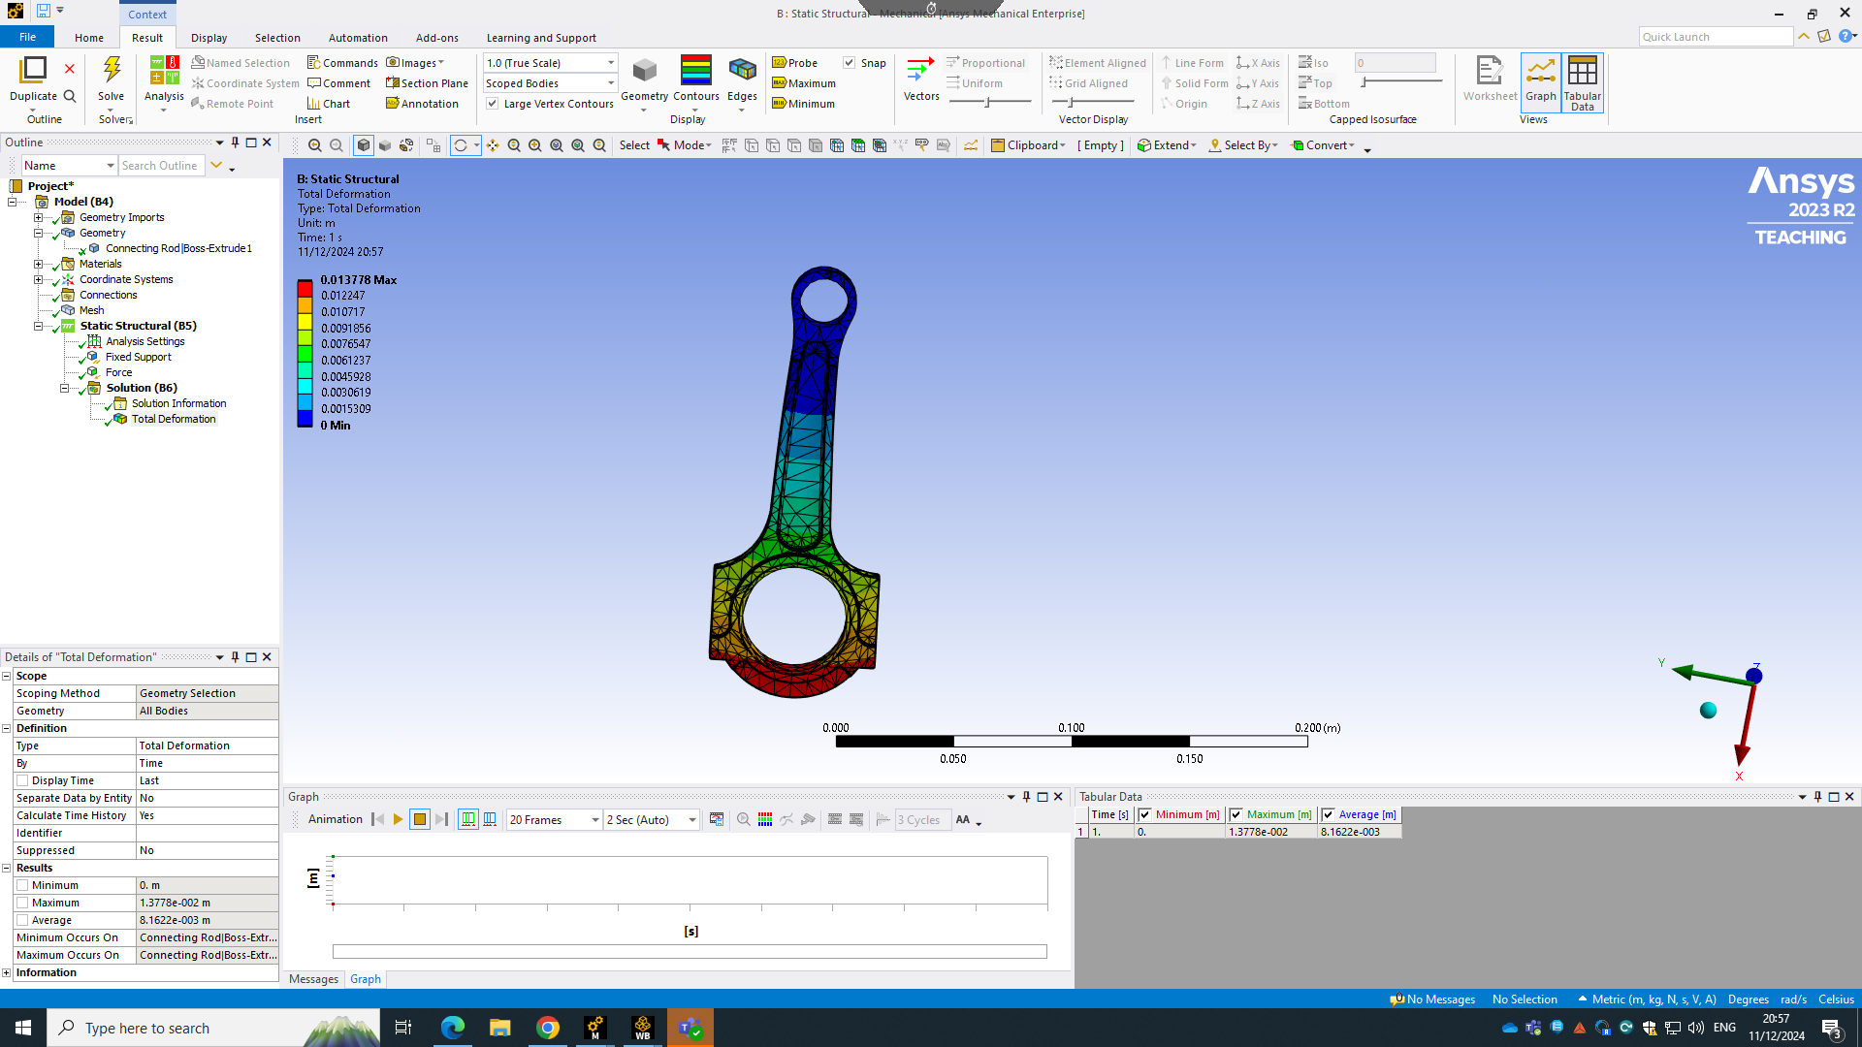
The first material to be tested was the Titanium Alloy, this is the one that seemed to be the most likely to be a good replacement for the Steel. This is because it is lighter than Steel, but the strength of the material is higher. The first test to be completed was the static structural test, this allowed an insight to how it would behave when being used however it is at room temperature (22°C) so not completely realistic.
Figure 6 (Reed. S, 2024)

As seen in the image above (figure 6) the movement due to the force is slightly higher than the Steel with a maximum of 0.013778m, the Steel had a max movement of 0.0078436m which is quite significantly lower. The movement can be seen in figure 6, which you couldn’t really see in the Steels test. This is something that needs to be considered when looking at the final material chosen.
Figure 7 (Reed. S, 2024)
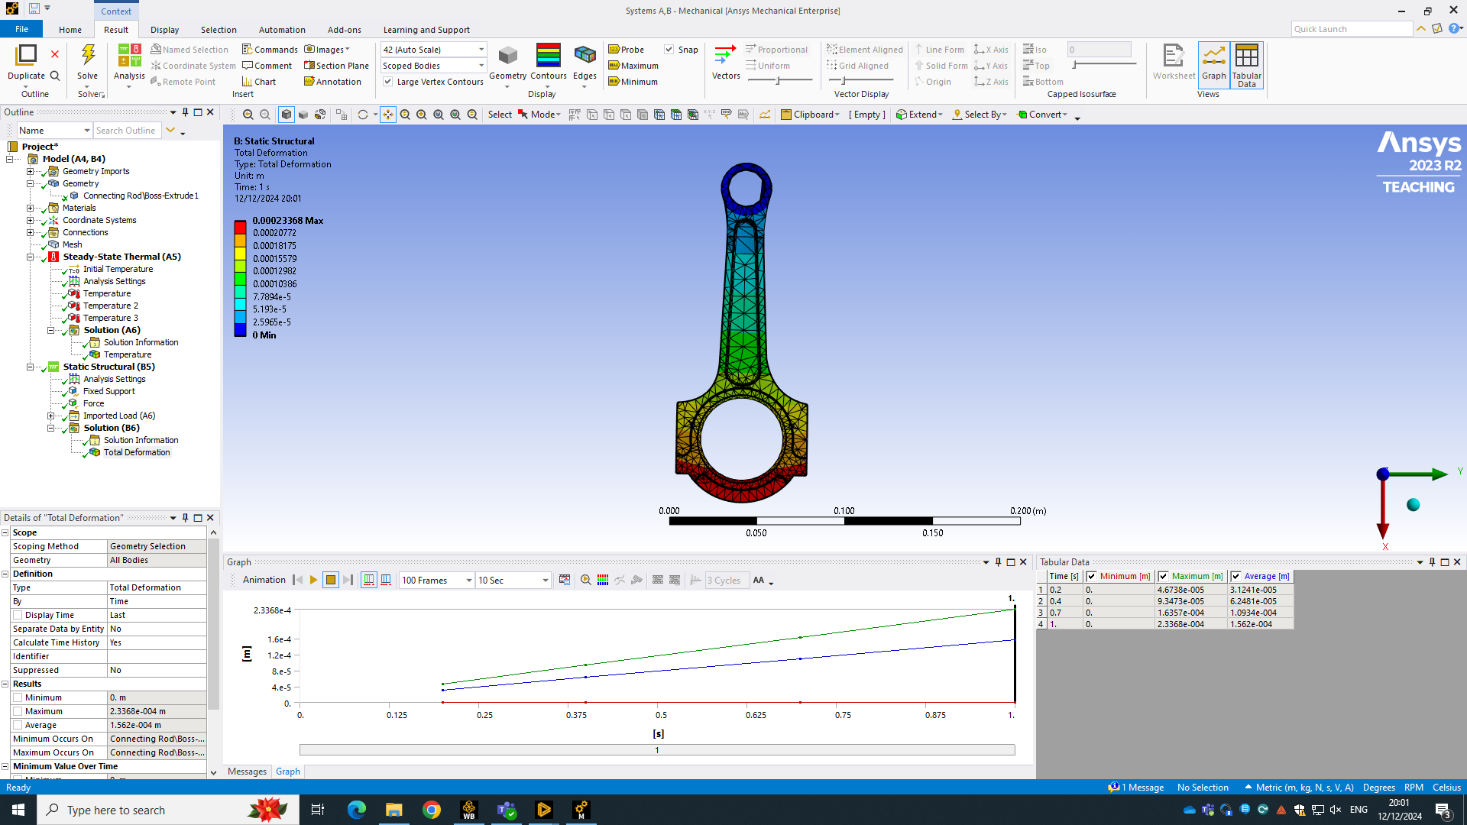

The next test was the thermal test, this can be seen in figure 7. In this test the Titanium performed better which was surprising because of the previous test but may be to do with the better thermal properties than the Steel. The maximum on the Titanium’s scale is 0.00023368m whereas the Steels is 0.00033251, so the amount is minimal but this would have a big effect on the performance of the connecting rod, especially with the weight being saved. Therefore, after the more realistic test (thermal and static structural) it is clear to see that Titanium is currently the better choice.

3.1.2 Aluminium Alloy 6061

This was the last material to be tested, it seemed like it would be a strong contender however the strength of the material might have been an issue. This is the same with the thermal properties of the material, they were all lower, however all higher than they need to be to withstand the heat the connecting rod endures. The first test can be seen in figure 8.

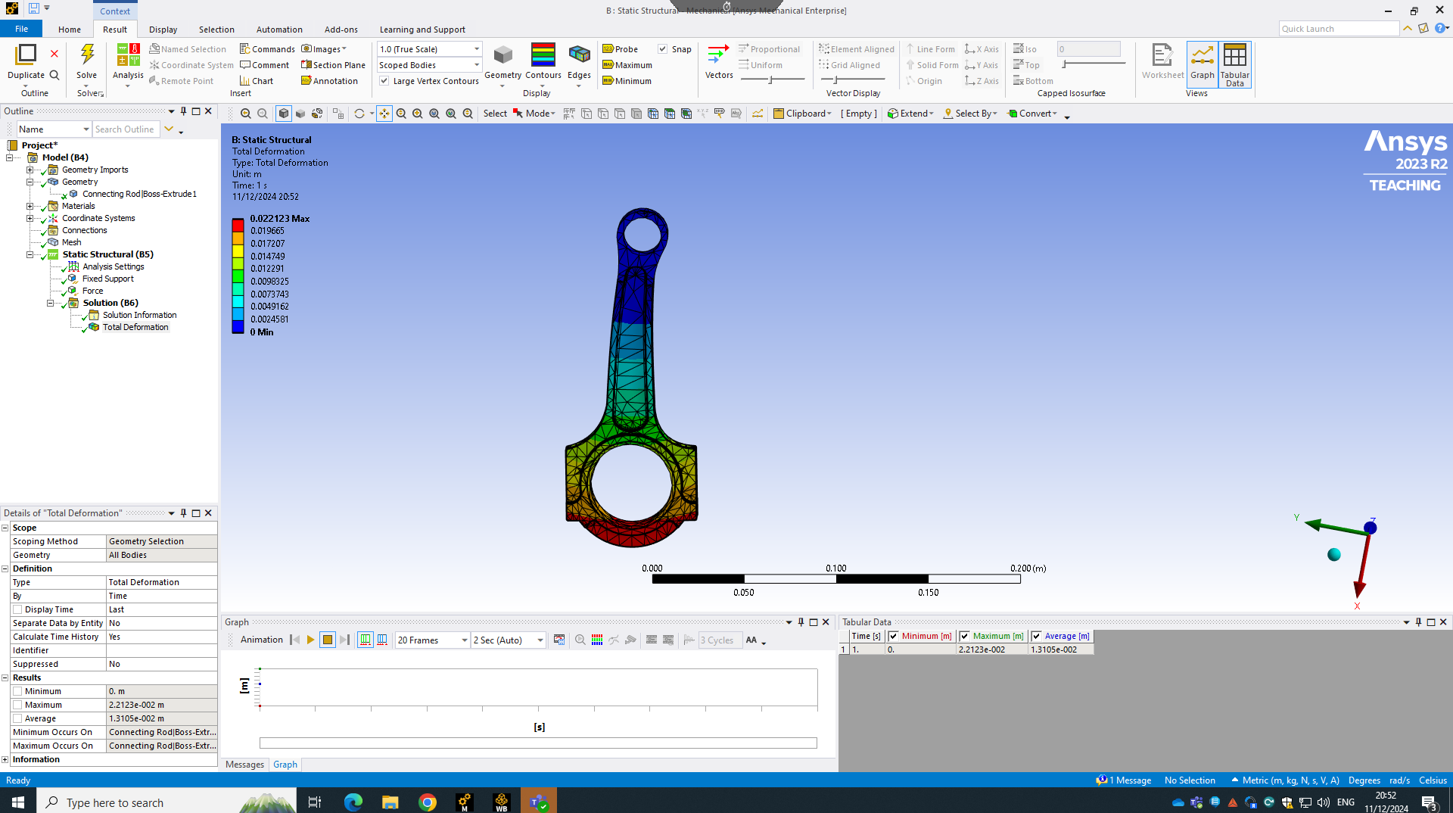
Figure 8 (Reed. S, 2024)

As seen in figure 8, it is clear to see there is a lot more movement in the component than there was in the previous materials. This would be a big issue when it came to the component working properly, after a while of this large movement the material may start to fatigue leading to issues with the engine earlier than if a different material was to be used. The maximum movement the Aluminium Alloy saw was 0.022123m, this is about 100 times worse than the others. This means for this test it performed the worst.

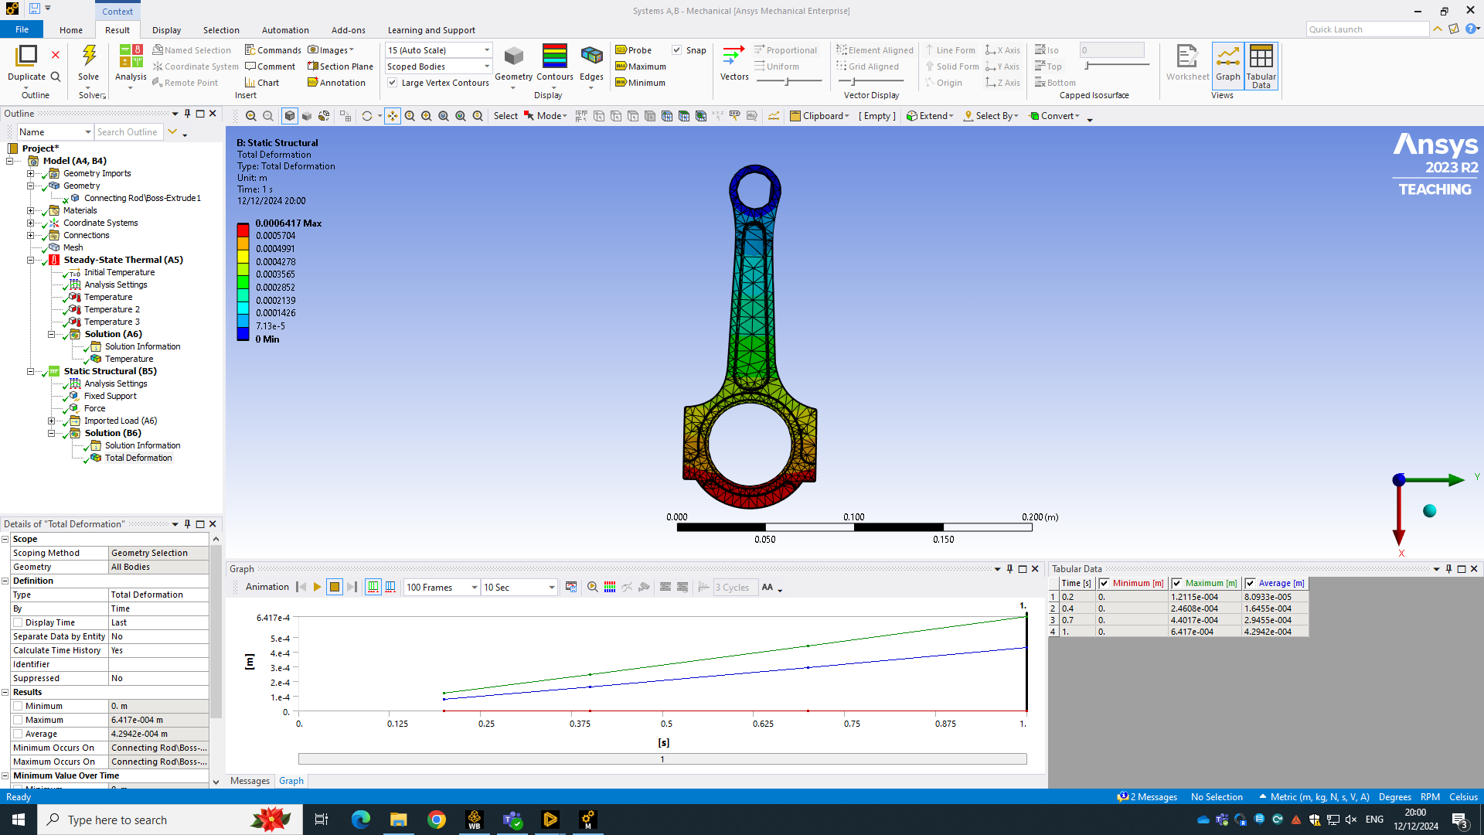
Figure 9 (Reed. S, 2024)

Figure 9 is the results of the Aluminium Alloy under the thermal conditions and the static structural, this allows a full insight into how the material would behave if used. The results aren’t as strong as was expected. The max movement in this test was 0.0006417, this is an improvement with the heat involved however overall isn’t a high enough quality compared to the other materials. This means the Aluminium Alloy would not be appropriate for a connecting rod.

4.0 Conclusion
Looking at the comparison of all the tests Aluminium would not be appropriate compared to the other materials involved. So, between the Steel and Titanium, the titanium would be more appropriate, this is because during the thermal testing it performed better than the Steel by 0.00009883m which is very minimal but could make a difference to the performance of the engine. A negative of Titanium compared to Steel is the price, ‘Titanium is more expensive than Steel due to its lower abundance and the complex processes required to refine and extract it’ (AZoM, 2013). This is something that would need to be considered when choosing the material, dependant on budget. If the budget is high then the Titanium Alloy is the better option for the connecting rod, even with the minimal better performance the weight saving would make a difference to the performance of the engine. The tests allowed for a full insight into how the materials would perform which really helped with the analysis of the materials.

References
ANSYS (2023). Engineering Simulation & 3D Design Software | Ansys. [online] www.ansys.com. Available at: https://www.ansys.com.
ANSYS (2024). Ansys Workbench | Simulation Integration Platform. [online] www.ansys.com. Available at: https://www.ansys.com/en-gb/products/ansys-workbench.
AZoM (2013). Titanium (Ti) - The Different Properties and Applications. [online] AZoM.com. Available at: https://www.azom.com/article.aspx?ArticleID=9118.
Heywood, J.B. (2018). Internal Combustion Engine Fundamentals, Second Edition. [online] www.accessengineeringlibrary.com. McGraw-Hill Education. Available at: https://www.accessengineeringlibrary.com/content/book/9781260116106.
MatWeb (2021). Advanced Materials Search by Property, Composition, or Text. [online] Matweb.com. Available at: https://www.matweb.com.
PTC (2024). What Is Computer-Aided Engineering (CAE)? | PTC. [online] www.ptc.com. Available at: https://www.ptc.com/en/technologies/cad/computer-aided-engineering.
Shih, R. (2020). Parametric Modeling with SOLIDWORKS 2020. [online] Google Books. Available at: https://books.google.co.uk/books/about/Parametric_Modeling_with_SOLIDWORKS_2020.html?id=6Sn0ywEACAAJ&redir_esc=y
Reed. S (2024) ANSYS screenshots. UWTSD

