
DATA HANDLING & BUSINESS INTELLIGENCE
Student name: Kostadin Dimitrov Kostov
[Student ID]2115193
[Module]LCBB5000

Part 1

Introduction
In business intelligence, data mining is essential since it enables the business to use data mining to obtain the required information and to support analytical decisions (Dogan and Birant, 2021). In addition, statistical methods are utilized to identify trends, and interpret information in large databases into meaningful form. In this report, Pivot tables and graphs are used to identify changes in sales and profit trends at Superstore, also the SPSS is use to evaluate the demographics and descriptive statistics. This report will also assist in identifying the relevant trends and changes, as well as the reasons for the changes. The report has comprehensively engage with the graphical and visual representation of data to highlight the incline or decline of the sales and profit. This help superstores to consider the loop holes and rectify the improvement areas to manage the sales.

Pivot Table
The two function used in the analysis of the data are Pivot table and Sum function. A pivot table is a powerful tool in Excel that allows to analyse and summarise data in a flexible and easy-to-understand way (Hürlimann, 2021). The SUM function in excel is a very useful tool for processing, analyzing and visualizing data. It can be used to sum up a column of data, to find the average of a column of data, or to find the median of a column of data (Hossain, 2021). It can also be used to find the mode of a column of data.
The Pivot function is used for processing and analyzing the data more efficiently, understanding complex data, identify patterns and trends, summarize data in a flexible and easy-to-understand way and visualize data in different ways (Ghatak, 2022).
This function help users to quickly summarise large data sets by categories and subcategories, and to calculate and display summary statistics such as counts, sums, averages and percentages. Pivot tables also make it easy to create charts and graphs based on the data, and to explore and analyse data trends. A pivot table has been developed, from the data selected in the worksheet to identify the latest trends for the Superstore data. For example, it can be used to count the number of records in each category or add up numerical values to summarise data. Additionally, select whether to show data as a running total or as a percentage of the total. . Filers are on the data in a pivot table, to show only the records that meet certain criteria. For example, the data can be filtered by date, product, or customer. Further illustration of the data is shown below in the figures.

Processing of the Data
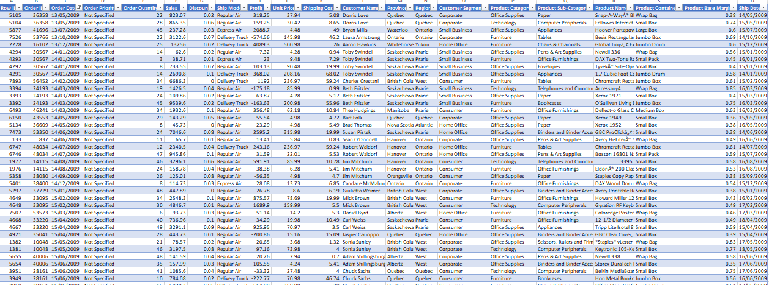
Figure 1
The data shown in above table is in a generic form, which was later processed to present a clear form of the data which can be used to analyze and extract meaning for informed decision making. The generic data is put into the Pivot table and sorted with respect to order id, date and other characteristics of the data.
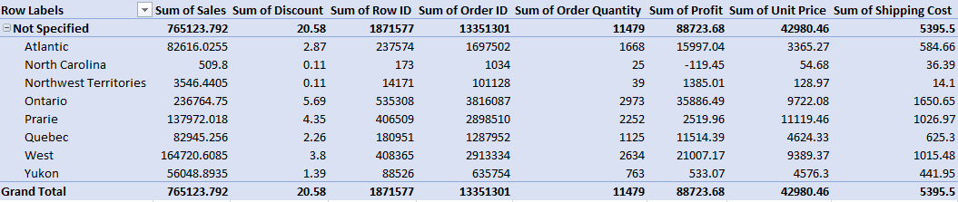
Figure 2
The data shown in table above, illustrate the extracted information from table 1. The data is converted into a PIVOT table with selected rows are order priority and region, and the selected values for columns are sum of sales, sum of discounts, sum of order quantity, sum of profit, sum of unit price, sum of shipping cost. The regions included are Atlantic, North Carolina, Northwest Territories, Ontario, Prarie, Quebec, West and Yukon.

Analysis and Visualization of the Data

Figure 3 Sales and profit of Superstore
The graph below shows the sales and profit for a superstore over a period of time. Sales have been increasing over time, but profit has fluctuated. The data has not a major fluctuation in the sales as the minor % are low in 4 years duration from 2009 to 2012. There are a few possible explanations for this. First, it could be that the store was selling more items at a lower margin, resulting in lower profits. Alternatively, it could be that the store was investing in marketing or expansion during this time, which led to higher sales but lower profits in the short term. It is clear that the store has been doing well overall, with sales and profits both trending upwards. The Sales and Profit graph for a superstore shows that the store had a good year in terms of sales, but profit was down. The store made a lot of money in the beginning of the year, but profit margin decreased as the further coming year. The store did well in terms of sales, but could have done better in terms of profit.
The data shows the sales and profit for a Region from 2009-2012. The Region saw a decrease in sales from 2010-2011, but then an increase in sales from 2011-2012. The Region saw a decrease in profit from 2010-2011, but then an increase in profit from 2011-2012.

Figure 4 Sales
The figure illustrates that blue section highlights the year 2009, the orange proportion of the pie chart highlights the year 2010, the grey section is highlighted in grey whereas the year 2012 is highlighted in yellow. The 2009 has the 28 % of the sales, whereas, in 2010 it shows a significant fall in sale of 4% which is accumulated overall as 24%. However, the succeeding year 2011 has also witness a decrease of 1% in the sales and resulting in a 23 % of the sales of the studied Superstore. Whereas, the year 2012 has revived the sales back to 25 % which is an increase of 2 %, however the superstore has still 3 % decrease comparing to the fiscal year 2009.
However, considering profit terms for the Superstore, the store has made a profit of 29% in the year 2009 which is more than the overall sale ratio. In addition, the superstore has made a 24% profit in year 2010 which is relatively low and a 5% decrease can be interpreted from the above graph. Furthermore, the superstore has made 25% of profit in year 2011 and 22% of the profit in financial year 2012. This variation can be concluded as that the superstore has performed exception in year 2009 both in terms of sales and profits. However, the year 2010, and 2011 has been challenging for the superstore as the store has dropped the sale in these year and result in a lower profit. However, the superstore has revive back in year 2012 with improved and increased sales and profit.

Figure 5 Product Category
The above figure shows the sum of Sales, Discount, Profit, Unit price and Shipping Cost. The table is selected with a row labels holding product categories as furniture, office supplies, and technology. The sum of sales is shown as 244746.576, the discount provided on furniture is highlighted as 3.32. Whereas, the sum of profit on furniture is 19524 and the sum of unit price is 9853. The shipping charges applied are shown as 2376 in the above graph.

Figure 2 Region

The above figure contains the label as per the region in the dataset. The figure above shows the sum of profit, sales, discount, and unit price for each region. The Atlantic region had the highest profit at $239,000, followed by the Northwest Territories at $83,000. The Ontario region had the highest sales at $3.78 million, followed by the West region at $3.60 million. The Quebec region had the highest discount at $38,900, followed by the Prairie region at $32,100. The Yukon region had the highest unit price at $54,200, followed by the Atlantic region at $95,800.
The graph above shows the sum of profit, sales, discount, and unit price by row label. The row labels are the regions in which the Region operates: Atlantic, North Carolina, Northwest Territories, Ontario, Prairie, Quebec, West, and Yukon. The figure shows that the Ontario Region made the most profit in terms of Sales, followed by the West region. The companies made the least profit in the North Carolina region. The superstore had the highest sales in the West region, followed by the Ontario and Quebec regions. The superstore had the lowest sales in the North Carolina region. The companies offered the most discount in the Prairie region, followed by the Northwest Territories and Quebec regions. The companies offered the least discount in the Atlantic region. The companies had the highest unit price in the Yukon region, followed by the Prairie and West regions. The companies had the lowest unit price in the North Carolina region.

Figure 6 Shipping Mode
The extracted graph above shows that the total profit, sales, discounts, unit prices, and shipping costs for each type of customer. Not specified customers had the highest total profit, followed by delivery truck, corporate, and home office customers. Consumer and small business customers had the highest total sales, followed by corporate and home office customers. Discounts were highest for consumer and small business customers, followed by corporate and home office customers.

Figure 7 Customer Name
The above graph has shown the Sum of profit, sales, discount, unit price and shipping cost with respect to customer name.

Figure 8 Discount
The graph shows that the sum of profit, sales, unit price, and discount for each Region. Region 1 had the highest profit, while Region 2 had the highest sales. Region 3 had the highest unit price, while Region 4 had the highest discount. The table above shows the sum of profit, sales, unit price, and discount for each Region. Region 1 had the highest profit at $192,382.73, while Region 2 had the lowest profit at $60,582.77. Region 1 also had the highest sales at $1,640,732.95, while Region 10 had the lowest sales at $1,291,736.79. Region 3 had the highest unit price at $32,422.82, while Region 9 had the lowest unit price at $10,738.82. Finally, Region 8 had the highest discount at $71.25, while Region 5 had the lowest discount at $5.26.

PART II- SPSS

Students who Like Vanilla Flavor of Ice-cream

Table 3 Ice cream flavor
The table is showing the results of a survey in which students were asked their favourite ice cream flavour. 47.5% of respondents said their favourite flavour was vanilla, 23.5% said chocolate, and 29% said strawberry.

Gender of Students

Figure 9 Gender of Students
As shown in above table, the 45.5 % of the survey participants are male and 54.5 of the participants are female. A total 200 students has participated in the survey questionnaire out of 109 are female and 91 are male students.

Mean and Median of Participants who likes Chocolate and Strawberry Flavor Ice-cream

 | Ice-Cream
N | 200
Mean | 1.815
Median | 2

Table 4 Mean, Median
The table shows the statistics for ice-cream flavors shown that the mean value is 1.815 and Median Value is 2.

K-Mean Cluster
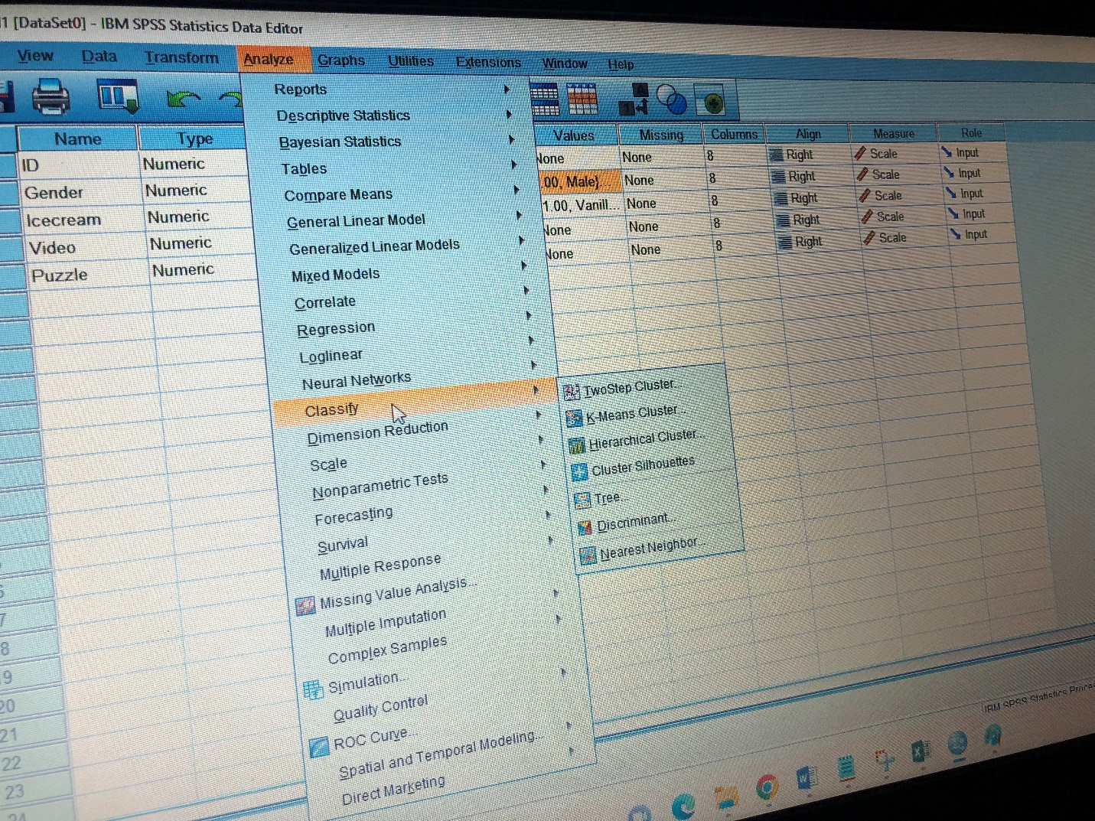
Figure 10 SPSS Screen Shot
Initial step involve opening data set in SPSS, the next step is to check if the data is sorted. Once the data is ready, the next step involve is to click on Analyze as shown in above screen shot. In analyses section, the option to choose is classify, afterwards it will show a series of cluster options. We have opt for K-means cluster Analysis.

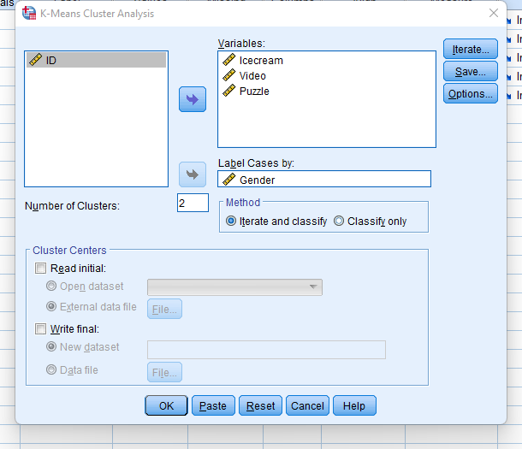
Figure 11 SPSS screen Shot
In this step, the ice-cream, video and puzzle are selected in variable section and the gender is selected in Label to develop the cluster. By clicking on ok button the following is the output;

Initial Cluster Centres
 | Cluster
 | 1 | 2
Ice-cream | 2.00 | 1.00
Video | 29.00 | 74.00
Puzzle | 26.00 | 66.00
Figure 12 Initial Cluster

Iteration Historyª
Iteration | Change in Cluster Centres
Iteration | 1 | 2
1 | 21.987 | 18.395
2 | .740 | .632
3 | 1.084 | .969
4 | .215 | .219
5 | .285 | .263
6 | .000 | .000
Figure 13 Iteration History
Convergence was attained as a result of little to no change in cluster centers. Any center can move its absolute coordinates up to a maximum of.000. Six is the current edition. 60.216 is the bare minimum distance between the original centers.

Most Common Data Mining and Text Mining Methods in Business
The most common data mining methods are clustering, decision trees, and neural networks. Clustering is a method of data analysis that groups data points together based on similarities (Keikhosrokiani and Pourya Asl, 2022). Decision trees are a type of machine learning algorithm that can be used for both classification and regression tasks (Nanfack et al., 2022). Neural networks are a type of machine learning algorithm that are used to model complex patterns in data. Clustering is a type of unsupervised learning that group’s data points together based on similarity. Decision trees are a type of supervised learning that create a model of decisions and their possible outcomes (Jiao et al., 2022). Neural networks are a type of machine learning that are modeled after the brain and can learn to recognize patterns.
There are a few methods for data mining, but some of the most common are regression, decision trees, and artificial neural networks (Jena et al., 2022). Text mining generally uses a combination of these methods to analyse large amounts of text data. Regression is a method of finding relationships between variables. For example, business might use regression to find out how different marketing strategies affect sales (Baashar et al., 2022). Decision trees are a way of representing decisions and their possible outcomes. For example, business might use a decision tree to decide whether or not to launch a new product. Artificial neural networks are a type of machine learning that can be used to predict outcomes. For example, organsiation might use a neural network to predict customer churn (Balakrishnan and Ramesh, 2022). Text mining generally involves pre-processing the text data to clean it up and then using one or more of the above methods to mine for interesting patterns. For example, business use text mining to analyze a customer review dataset to identify which products are most popular.

Advantages and Disadvantages of using SPSS and Excel
The statistical software SPSS is widely used in the social sciences, business and medicine. It is easy to use and has many features that make it a useful tool for data analysis. However, there are some disadvantages to using SPSS that should be considered before using it for data analysis.

Advantages of SPSS

Easy to Use
SPSS is easy to use and has a user-friendly interface. It is easy to input data into the software and to run statistical analyses. There are many tutorials and online resources that can help users to learn how to use SPSS. Widely Used SPSS is a widely used statistical software (Meyer, 2022). It means that there is a large community of users who can offer support and advice. There are also many online resources, such as forums and online manuals that can be used to find answers to questions.

Flexible
SPSS is a flexible statistical software package. It can be used for a wide range of statistical analyses. It is also possible to customize the software to suit the needs of the user (Jakobsen and Mehmetoglu, 2022).

Disadvantages of SPSS

Cost
SPSS is a commercial software package and can be expensive to purchase. It is also necessary to purchase additional modules to add extra functionality to the software.

Limited Support
Although SPSS is a widely used statistical software package, it is not always easy to find support. There are not many online resources that offer support for SPSS.

Complex
SPSS can be a complex statistical software package. It is necessary to have a good understanding of statistics to be able to use the software effectively (McBurney and Kubas, 2022).

Advantages of Excel

Easy to Use
Excel is easy to use and has a user-friendly interface. It is easy to input data into the spreadsheet and running statistical analyses. There are many tutorials and online resources that can help users to learn how to use Excel.

Widely Used
Excel is a widely used spreadsheet application. This means that there is a large community of users who can offer support and advice. There are also many online resources, such as forums and online manuals that are used to address the questions.

Flexible
Excel is a flexible spreadsheet application. It can be used for a wide range of statistical analysis. It is also possible to customise the spreadsheet to suit the user needs (Dhanalakshmi et al., 2022)

Disadvantages of Excel

Cost
Excel is a commercial software application and can be expensive to purchase. It is also necessary to purchase additional modules to add extra functionality to the spreadsheet.

Limited Support
Although Excel is a widely used spreadsheet application, it is not always easy to find support. There are not many online resources that offer support for Excel.

Complex
Excel can be a complex spreadsheet application. It is necessary to have a good understanding of statistics to be able to use the spreadsheet effectively (Kuznetsova et al., 2022).
.

References
Andini, R. and Sasmito, A., 2022, July. Peningkatan Kemampuan Riset Mahasiswa Melalui Keterampilan Olah Data Statistik dengan SPSS pada Mahasiswa S1 Universitas Pandanaran. In Seminar Nasional Riset Ekonomi dan Bisnis (Vol. 1, No. 1).
Baashar, Y., Alkawsi, G., Mustafa, A., Alkahtani, A.A., Alsariera, Y.A., Ali, A.Q., Hashim, W. and Tiong, S.K., 2022. Toward predicting student’s academic performance using artificial neural networks (ANNs). Applied Sciences, 12(3), p.1289.
Balakrishnan, S.G. and Ramesh, V., AN INSIGHT THROUGH REVIEWS ON NEURAL NETWORK-BASED DATA MINING.
Dhanalakshmi, B., Shijith, K.P. and Sharma, P., 2022. A prospective interventional study to assess the advantage of premedication with sublingual nitroglycerin in evaluation of peripheral vascular disease with computed tomography peripheral angiography. Medical Journal of Dr. DY Patil Vidyapeeth, 15(3), p.359.
Dogan, A. and Birant, D., 2021. Machine learning and data mining in manufacturing. Expert Systems with Applications, 166, p.114060.
Ghatak, R., 2022. Role and Deployment of Statistics and Data Science in People Analytics. In People Analytics (pp. 191-223). Springer, Singapore.
Hossain, E., 2021. Excel Crash Course for Engineers. Springer.
Hürlimann, T., 2021. tony. huerlimann@ unifr. ch First Version: 2004 February 4, 2021.
Jakobsen, T.G. and Mehmetoglu, M., 2022. Applied statistics using Stata: a guide for the social sciences. Applied Statistics Using Stata, pp.1-100.
Jena, M., Behera, R.K. and Dehuri, S., 2022. Hybrid Decision Tree for Machine Learning: A Big Data Perspective. In Advances in Machine Learning for Big Data Analysis (pp. 223-239). Springer, Singapore.
Jiao, L., Yang, H., Liu, Z.G. and Pan, Q., 2022. Interpretable fuzzy Jena, M., Behera, R.K. and Dehuri, S., 2022. Hybrid Decision Tree for Machine Learning: A Big Data Perspective. In Advances in Machine Learning for Big Data Analysis (pp. 223-239). Springer, Singapore. using unsupervised fuzzy decision trees. Information Sciences, 611, pp.540-563.
Keikhosrokiani, P. and Pourya Asl, M. eds., 2022. Handbook of Research on Opinion Mining and Text Analytics on Literary Works and Social Media. IGI Global.
Kuznetsova, E., Kindinova, V. and Krinetsky, O., 2022. Numerical methods in the training of aerospace engineers. In MATEC Web of Conferences (Vol. 362, p. 01013). EDP Sciences.
McBurney, J. and Kubas, A., 2022. Limitations to success in academic data reference support. Journal of Librarianship and Information Science, 54(1), pp.121-131.
Meyer, C., 2022. Bringing the World to the Classroom: Teaching Statistics and Programming in a Project-Based Setting. PS: Political Science & Politics, 55(1), pp.193-197.
Nanfack, G., Temple, P. and Frénay, B., 2022. Constraint Enforcement on Decision Trees: a Survey. ACM Computing Surveys (CSUR), 54(10s), pp.1-36.

