EAEC6010/C: Green Childhood: Sustainability in Early Childhood
The Opportunities and Challenges of Integrating Education for Sustainable Development into Day Nurseries in Wales.
Throughout this assignment, I will be critically evaluating the opportunities and challenges of integrating education for sustainable development into early years practice. I will be writing from the perspective of a practitioner within Wales and I will be discussing the situation in Wales as well as comparing international examples to illustrate my own ideas.
My article will be based on a Day Nursery setting and there will be 3 themes within my main body which I have chosen to talk about Practitioners, Environment and Forest School. When discussing each of these topics, I will be discussing the opportunities and challenges of my chosen themes. My introduction, main body and conclusion will be made clear throughout my article. I will be making a critical analysis and evaluation of the links between the principles and ethos of Education for Sustainable Development (ESD) and the Early Childhood theory and pedagogy. I will develop links to several different theorists, for example: Dewey, Piaget, Froebel, Bronfenbrenner and Vygotsky. I will also make an evaluation of the ESDGC in Wales and other ESD approaches in context with Early Childhood theory and pedagogy. When making a critical evaluation of the opportunities and challenges of developing Early Childhood practice it will be supporting the ESDGC.
The ESDGC is built around 7 different themes which are: The Natural Environment, Consumption and Waste, Climate Change, Wealth and Poverty, Identity and Culture, Choices and Decisions and Health (Welsh Government, 2017). The Education for Sustainable Development and Global Citizenship aims to give learners, at all different stages of their education, an understanding of the impact of their personal choices and how it affects other people, the environment around them and the economy in which we live in (Welsh Government, 2017).
Theme 1- Practitioners that promote training opportunities for integrating education for Sustainable Development
There are many different organisations and companies all over the country that offer many different training courses for Childcare Practitioners across England and Wales. There are many online courses from different agencies online that will help practitioners gain extra qualifications that will be helpful for the workplace.
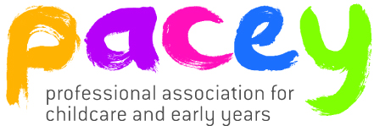
PACEY offer Training and Continuous Professional Development for all childcare providers in England and Wales (PACEY, 2016). Having CPD is vital because it helps us to develop our own knowledge, skills and self-confidence (PACEY, 2016). It will also help us increase the standards of care and learning that we give to the children within our care (PACEY, 2016).
Source: Pacey, 2017 cited in Pacey website.
NDNA is the National Day Nurseries Association. It began as a group of day nurseries who came together to share good practice and ideas. Now, they offer training courses, regular meetings, support and encouragement and influential surveys and campaigns (NDNA, 2017).
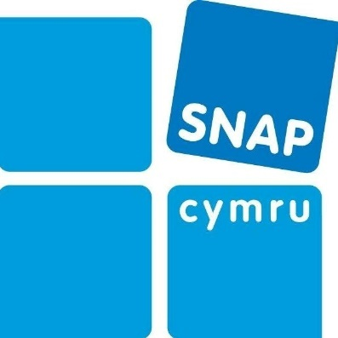
NDNA trains thousands of different early years and childcare practitioners every year. NDNA offer online training courses as well as face to face training courses (NDNA, 2017). The courses NDNA offer are some of the following: Food Hygiene and Nutrition, Health and Safety, Safeguarding and Child Protection, Maths, Literacy and SEND training (NDNA, 2017).
SNAP Cymru offers quality training which is widely recognised. SNAP Cymru helps Parents and Carers become more confident in supporting their child, helps professionals develop different settings and their practice to become more inclusive for children with additional needs (SNAP Cymru, 2017). SNAP Cymru encourages different people to work together for the children within their setting and helps develop a skilled workforce (SNAP Cymru, 2017). SNAP Cymru offers a wide range of courses from Disability Awareness to Equality and Diversity Training (SNAP Cymru, 2017).
Source: Snap Cymru, 2017 cited in Snap Cymru website.
Aspiration Training is an agency that provides training for ESDGC. They teach practitioners about ESDGC and why it is very important to teach children within their setting all about the ESGDC (Aspiration Training, 2017).
The National Training Federation for Wales provides training for practitioners within a work based learning environment. They provide you with the following:
- Finding units in the routes most appropriate to ESDGC
- Providing you with activities you can use within setting
- Giving you an additional qualification
- Including it in ESW activities as themes, projects or activities
- Including ESDGC within appropriate staff agendas such as standardisation and quality groups (National Training Federation, 2017).
The Welsh Government gives guidance (DCELLS, 2008b) to teacher trainees and new qualified teachers that makes sure to highlight the ESDGC. This prepares learners for new challenges that will form part of their futures. There are a few different topics to be aware such as: Climate Change. There are many resources for every topic within ESDGC. It will help the children to understand the complicated, interrelated nature of the world around them (DCELLS, 2000b:4).
For newly qualified teachers to gain Qualified Teacher Status, those training as Foundation Phase Teachers will have to demonstrate that they are very familiar with national guidance about the ESDGC (DCELLS, 2009:40).
The Reggio Emilia Approach to Early Childhood Education was created in the city of Reggio Emilia after the Second World War. This is a hands-on approach. This curriculum focuses on looking after the relationships between children, teachers, parents and the community. It builds on the idea that every child will have the motivation to engage in their own learning and enter a relationship with the environment around them (Reggio Children, 2017).
However, comparing to The Reggio Emilia approach to training opportunities, this shows that members of staff who get sent on courses only get sent on courses to deepen their understanding, together with others, of why it is possible for this approach. Reggio Children is accredited by the Emilia-Romagna Region for education and training courses for long-term professional development (Reggio Children, 2017).
When making comparisons between Wales and Italy when talking about Training Opportunities it shows that there is bigger variety of courses available in Wales compared to Italy. There is also a wider range of agencies and companies providing different types of courses that will help practitioners gain the knowledge and skills they need in Wales compared to Italy.
As well as comparing the opportunities faced for practitioners when it comes to Training, there are also challenges. In School settings, they tend to get funding, this means that they will be able to give their employee’s the chance to send more than one member of staff on a course whereas in some other childcare settings such as Day Nurseries, usually only one member of staff will be able to go on a course. This is negative because every single employee deserves to have regular CPD. CPD is very important for any employee in any type of business. CPD means Continuing Professional Development, this is a combination of different approaches, ideas and techniques that help us manage our own learning and growth as a person and as a practitioner (CIPD, no date).
Theme 2- Having an Environment which promotes integrating education for Sustainable Development
Having a Setting which has a positive approach to sustainable development helps huge amounts when it comes to promoting things like Eco Schools, Recycling and why it is very important to save energy whenever we can.
Piaget’s theory links with Environment because when Piaget outlined several different cognitive structures within this theory. Piaget said that during all of the development stages, the child experiencing his or her own environment using whatever mental maps they had developed. If Children repeat an experience they maintain mental “equilibrium” (Funderstanding, 2011).
In Wales, it is compulsory for all education settings from primary schools to university level of higher education to make sure they include ESDGC within their work. The Welsh Government has made sure to promote how important sustainable development and the United Nations Convention Rights of the Child is to them. Recent publications such as Wellbeing of Future Generations Act (2016) emphasise the importance of rights and sustainability to promote a healthy Wales (Tinney, G. and Hirst, H. 2018)
Tinney (2010) states that Since the UK Government of Wales Act 1998, Wales has made sure to make the concept of Sustainable Development key within their Welsh policy.
Tinney (2010) also states that in 2000, the Welsh Assembly Government published a sustainable development scheme which is called “Learning to Live Differently” (WAG, 2000) that was closely followed by an action plan in 2001 to implement the scheme.
The Foundation Phase is built on a theoretical base influenced by different child-led approaches, socio-constructivism and different international pedagogical approaches such as Reggio Emilia, Forest Schools and Te Whariki (DCELLS, 2008c, revised by the Welsh Government in 2015).
The fact that my setting is a Day Nursery is a hard one because it some countries children don’t start school till 5 years old. In Wales, the early years is very complicated because children can enter the Foundation Phase at 3 years old in school but also younger if they attend private day nurseries or Flying-Start provision (Tinney, G. and Hirst, N. 2018).
Davis et al (2016) states that there are some links between “Knowledge and Understanding of the world” and ESGDC that can be seen within the Foundation Phase. Within the Foundation Phase we learn about lifecycles, the natural world and their impact on the environment.
Tinney (2010) states that there are clear links between the principles of ESDGC and the Foundation Phase. For example, the Foundation Phase centres all activities around holistic development of every individual child within their care and aims to develop skills across the whole curriculum (DCELLS, 2008c:4).
The ESD emphasis on holistic and interdisciplinary learning which builds on children’s previous experiences (Pearson and Degotardi, 2009; Sterling, 2001).
Having a setting which promotes Eco-Schools is very important because it is child-led. This programme is designed to empower young children and help young children make positive changes to their environment (Keep Wales Tidy, 2017). This an example of ESDGC. Doing activities where children are aware of the environment around them and the wider community is examples of promoting ESDGC (Keep Wales Tidy, 2017).
Oxfam (2017) believe young people are critical in helping to develop a world without poverty. They have aimed to make it a focus of their work to get young children involved in the work they do as a charity. Oxfam know that young people have the power to become active global citizens, and create a more fairer and more secure future for everybody including themselves and everybody in the environment around them.
Oxfam Education (2017) offers schools, day nurseries and flying starts resources to use to help develop children’s understanding of ESDGC. They offer a huge range of resources, ideas and support for developing global learning in the whole setting.
Whilst looking at all the resources Oxfam Education provides for teachers and practitioners on ESDGC what is positive is that there are activities for all different ages and curriculums. So, regardless if you’re in the Foundation Phase or not, there is activities for everybody. There are activities aimed directly at the seven different themes of ESDGC and some different activities which are educating young people about Refugees, Climate Change, Poverty and the Crisis in Yemen (Oxfam Education, 2017).
To conclude, having a setting within the Foundation Phase that promotes ESDGC is vital. There is a wide range of sources online that are essential for activities for young children regarding the ESDGC. Incorporating ‘Knowledge and Understanding of the World’ with ESDGC is the best way of doing activities based on the ESDGC. Having a setting which promotes Eco-Schools is also another amazing programme because its child-led and lets the children learn about whatever changes they are making, that it affects themselves in their environment as well as the community around them. Letting children become Global Citizens is the best way for children to understand and learn all about the ESDGC. Promoting recycling within in setting is also a very good idea because you can recycle anything from recycling nappies and wet wipes to plastic, cans, paper and food.
Theme 3- Forest School
Forest School is originated from Scandinavia during the 1950’s (Pound, 2005). The purpose of Forest Schools was so children could live in the open air (Pound, 2011). An organisation called Forest Schools to set up to promote learning for young children. Forest Schools isn’t outdoor education, it isn’t environmental education or play but a combination of all three things (Forest Schools, no date).
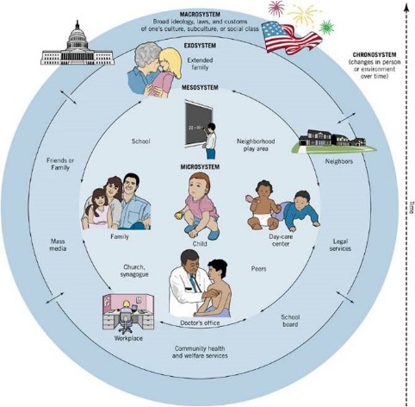
Bronfenbrenner links with Forest School. Bronfenbrenner’s theory explains how children learn through the people that are close to them and close to their environment surroundings. The Exosystem refers to the larger social systems (Drewery and Bird, 2004). This theory links to Forest Schools as it is encouraging children to get outdoors and have hands-on experiences where they can explore, play and create new things (Forest Schools, no date).
Source: Bronfenbrenner’s model. Cited in Forest School website.
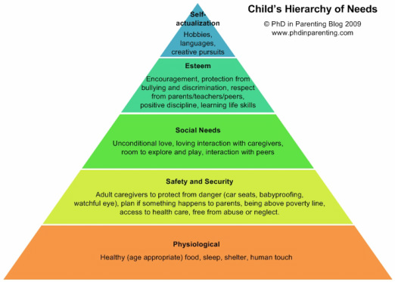
Abraham Maslow (1908-1970) theory proposed that all human’s needs can be put into a hierarchy. The hierarchy that Maslow has identified was focused on the human body, safety, security, love and esteem. These requirements had to be in place for a person to seek fulfilment (Pound, 2008). This theory links to Forest Schools because its allowing the children to explore the outdoors and play and create things from their imagination in the mud for example, mud pies and mud cakes. This also links with Te Whariki which is New Zealand’s Early Childhood Curriculum (Ministry of Education, 1996).
Source: Maslow’s Hierarchy of Needs. Cited in Forest Schools website.
Challenges of Forest School are that the ‘Forest School’ approach has not been a government initiative so as a programme, the Government wouldn’t give the programme funding to develop the programme. The advantages outweigh the disadvantages when it comes to Forest School. The only Disadvantages are that children are expected to be in dirt all day long which isn’t very good for their health and well-being as they could get dirt in their mouths and they could also get injured whilst they are out.
A challenge for this would be that their children so they should be able to get muddy and have fun and experience new things. Personally, seeing this as a positive rather than a negative because holistic development is very important for all children.
Conclusion
To conclude, I have researched about training opportunities for practitioners, environment to integrate ESDGC and Forest School. I made sure to critically analyse my three different themes that I chose to talk about within my article. I critically analysed the opportunities and challenges of Training Opportunities for practitioners relating to the ESDGC, having an environment which promotes sustainable development and Forest School. I made a critical analysis and evaluation of the links between the principles and ethos of Education for Sustainable Development (ESD) and the Early Childhood theory and pedagogy. I developed the links to several different theorists, for example: Maslow, Bronfenbrenner, Piaget and Vygotsky. I made sure to mention different curriculums such as Te Whariki and Reggio Emilia. Relating to theories and curriculums is very important within this assignment. These are both hands-on curriculums and link well with the ESDGC. I enjoyed comparing different aspects of this article and learning new things. I used a wide range of sources but if I created an article again I would use journals to support my work as well as this are vital.
References-
Abdi, A and Shultz, L. (2008) Educating for Human Rights and Global Citizenship. United States of America: State University of New York Press.
Aspiration Training. (2017) ‘What is ESDGC?’ http://www.aspirationtraining.com/environment/ [Accessed: 27th of November 2017].
Boyd, D., Hirst, N and Siraj-Blatchford, J. (2018) Understanding Sustainability in Early Childhood Education. London: Routledge.
CIPD. (no date) ‘About CPD’ https://www.cipd.co.uk/learn/cpd/about [Accessed: 27th of November 2017].
Cutter-Mackenzie, A., Edwards, S., Moore, D and Boyd, W. (2014) Young Children’s Play and Environmental Education in Early Childhood Education. London: Springer Education.
Davis, J and Elliott, S. (2014) Research in Early Childhood Education for Sustainability. London: Routledge.
Forest Schools. (no date) ‘Bronfenbrenner’s model’ https://forestschool.weebly.com/links-within-ece.html [Accessed: 3rd of December 2017].
Forest Schools. (no date) ‘Links with ECE’ https://forestschool.weebly.com/links-within-ece.html [Accessed: 3rd of December 2017].
Forest Schools. (no date) ‘Maslow’s Hierarchy of Needs’ https://forestschool.weebly.com/links-within-ece.html [Accessed: 3rd of December 2017].
Funderstanding. (2011) ‘Piaget’ http://www.funderstanding.com/educators/piaget/ [Accessed: 3rd of December 2017].
Invernizzi, A and Williams, J. (2008) Children and Citizenship. London: SAGE Publications.
Keep Wales Tidy. (2017) ‘Eco-Schools’ https://www.keepwalestidy.cymru/Pages/Category/eco-schools [Accessed: 3rd of December 2017].
National Federation of Wales. (no date) Education for Sustainable Development and Global Citizenship (ESDGC) in Work Based Learning. Cardiff: Welsh Government. [e-book]. Available at: https://www.ntfw.org/wp-content/uploads/2011/11/ESDGC-Ebook.pdf [Accessed: 3rd of December 2017].
NDNA. (2017) ‘About Us’ http://www.ndna.org.uk/NDNA/All_About_Us/About_Us.aspx [Accessed: 27th of November 2017].
NDNA. (2017) ‘Childcare and Early Years Training’ http://www.ndna.org.uk/childcare-training?hkey=2ce8b6c0-ca7a-48bd-a6fb-b5a8a7b4a148 [Accessed: 27th of November 2017].
Oxfam Education. (2017) ‘Resources’ https://www.oxfam.org.uk/education/resources [Accessed: 3rd of December 2017].
Oxfam Education. (2017) ‘Who are we’ https://www.oxfam.org.uk/education/who-we-are [Accessed: 3rd of December 2017].
PACEY. (2017) ‘Image from website’ https://www.pacey.org.uk/ [Accessed: 27th of November 2017].
PACEY. (2017) ‘Main Page’ https://www.pacey.org.uk/ [Accessed: 30th of November 2017].
PACEY. (2017) ‘Training from PACEY’ http://www.pacey.org.uk/training-and-qualifications/training-from-pacey/ [Accessed: 27th of November 2017].
Reggio Children. (2017) ‘Reggio Emilia Approach’ http://www.reggiochildren.it/identita/reggio-emilia-approach/?lang=en [Accessed: 27th of November 2017].
Reggio Children. (2017) ‘Reggio Emilia’ www.reggiochildren.it [Accessed: 27th of November 2017].
Snap Cymru. (2017) ‘Logo from website’ http://www.snapcymru.org/ [Accessed: 27th of November 2017].
Snap Cymru. (2017) ‘Main Page’ http://www.snapcymru.org/ [Accessed: 30th of November 2017].
Snap Cymru. (2017) ‘Our Training’ http://www.snapcymru.org/training/ [Accessed: 27th of November 2017].
Welsh Government. (2017) ‘Education for Sustainable Development and Global Citizenship’ http://gov.wales/topics/educationandskills/allsectorpolicies/europeanandinternational/sustainabledevelop/?lang=en [Accessed: 27th of November 2017].

