

BA (Hons) Leadership and Management Skills for the Workplace
LCLM5001 Understanding and Engaging Stakeholders

Kazi Nelima Begum
Student ID:2330804

Contents
Introduction | P3
SWOT & PESTEL | P4/P5
SMART | P6
Stakeholders | P6/P7/P8/P9
Communication Plan | P9/P10
RACI Matrix | P10/P11
4C’s Model | P11/P12/P13
Stakeholder Engagement | P14/P15
Conclusion | P15
Recommendation | P15
References | P16/P17


Introduction
Hilton Hotels is preparing to launch a new premium customer service offering called StaySmart+. This service uses advanced AI to enhance guest experiences, provide personalised travel planning, and introduce eco-friendly features designed to improve comfort, efficiency, and brand differentiation. The service will be introduced in six months and rolled out across selected hotels worldwide.
This report identifies and categorises the key internal and external stakeholders involved in the development and implementation of StaySmart+, using established stakeholder analysis frameworks. As the project lead, I am responsible for determining who these stakeholders are, understanding their needs and expectations, and ensuring effective engagement throughout the entire lifecycle of the project.
Brief history of Hilton Hotel
“Conrad Hilton opened the first hotel to bear the Hilton name in 1925, aiming to operate the best hotel in Texas; as a result of his commitment, leadership, and innovation, Hilton has become one of the most respected brands in the world” (ExpandedRamblings, 24.).
The origins of Hilton Hotels trace back to 1919, when Conrad Hilton originally travelling with the intention of purchasing a bank unexpectedly entered the hotel business in Cisco, Texas, by acquiring The Mobley, a local hotel. This marked the beginning of what would become one of the most influential hospitality brands in the world. By 1925, Conrad Hilton opened the first hotel formally named Hilton in Dallas, Texas, establishing his vision to operate the finest hotel in the state and laying the foundation for the brand's future expansion. According to Hilton’s official history (Hilton, 2026.), the company has grown into one of the most influential global hospitality brands
The Hilton brand underwent a major transformation in 2010, when it was formally rebranded as Hilton Hotels & Resorts, aligning its identity with its global presence and modernising its image for the future. Today, the hotel operates as part of Hilton Worldwide, which has experienced substantial growth over the past decades.
Hilton Hotels reports that “As of December 31, 2025, Hilton reported 9,158 properties with 1,351,351 rooms across 143 countries and territories, and 243 million Hilton Honors members. For 2025, Hilton reported $12.039 billion in total revenue and $1.461 billion in net income” (ExpandedRamblings, 2024.)

Table 1
There are 6 Hilton-branded hotels in Birmingham | Hilton Birmingham Metropole
There are 6 Hilton-branded hotels in Birmingham | Hampton by Hilton Birmingham Broad Street
There are 6 Hilton-branded hotels in Birmingham | Hilton Garden Inn Birmingham Brindleyplace
There are 6 Hilton-branded hotels in Birmingham | Hilton Garden Inn Birmingham Airport
There are 6 Hilton-branded hotels in Birmingham | Hampton by Hilton Birmingham Jewellery Quarter
There are 6 Hilton-branded hotels in Birmingham | Hampton by Hilton Birmingham Jewellery Quarter

As reported in Table 1, the TripAdvisor website indicates that Hilton has six branded hotels located within Birmingham (TripAdvisor, 2026)

An appraisal of the company to include SWOT and PESTLE analysis
Conducting SWOT and PESTEL analysis will help Hilton understand its internal capabilities and external industry forces, enabling smarter strategic decisions in a highly competitive global hospitality market
Springer mentions that “A SWOT analysis is a strategic planning tool used to identify and evaluate an organisation’s Strengths, Weaknesses, Opportunities, and Threats…” (Springer, 2018).

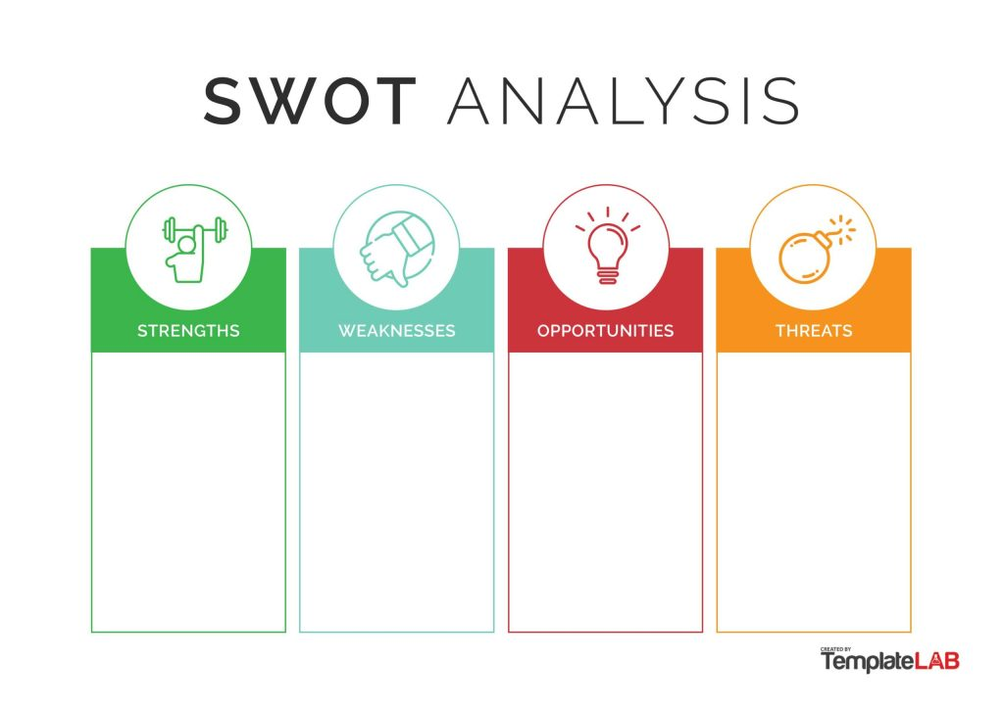
SWOT Analysis on Hilton Holtels Figure 1
- Strong competitive position supported by powerful global brand recognition
- Hilton Honors loyalty program surpassed 173 million members by 2025
- Diverse Portfolio of hotels
- Continuous innovation including digital room keys, AI-powered guest services, and other technology-driven enhancements
- Hilton faces vulnerabilities associated with high long-term debt and dependence on franchisee performance
- High Operating Costs
- Significant competition from leading luxury hospitality companies
- Keeping up with technology integrations
- Growth opportunities exist across emerging markets
- Advancements in lifestyle-focused hotels
- enhanced loyalty partnerships create additional avenues
- Increase in domestic tourism
- Hilton faces strong competitive pressure from major global hotel brands such as Marriott and Fairmount, as well as alternative platforms like Airbnb
- Economic downturns and fluctuations in global demand pose ongoing risks to performance
- Rising labour and energy costs

Hilton Hotels has a strong brand, a popular loyalty program, and keeps improving its technology. However, it still faces challenges. The hotel industry is very competitive, and changes in the global economy can affect how many people travel. Even so,
(Business Model Analyst, 2024.)
Based on figure 1, the SWOT analysis shows that Hilton Hotels is well positioned to influence technology and sustainability trends. The SWOT analysis also shows that Hilton’s strengths lie in its powerful global brand and huge loyalty program. Weaknesses come from its dependence on franchise partners, complex multi-brand structure, and rising labour and operating cost. Opportunities: Expanding into emerging markets, growing value-focused segments, and using AI-driven digital innovation to improve guest experience.
Threats: Rising competition, economic volatility, cybersecurity risks, and increasing operating costs.
PESTEL Analysis on Hilton Hotels
“A PESTEL analysis is a strategic framework used to examine the external macro-environmental factors that can influence an organisation. It evaluates six key external dimensions: Political, Economic, Social, Technological, Legal, and Environmental factors, all of which lie outside the organisation's control but significantly shape its strategic decisions and long-term performance” (WallStreetMojo, 2023).
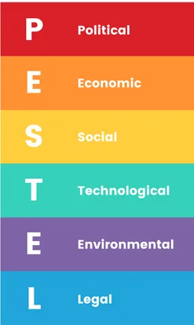
Figure 2
Hilton operates across 143 countries, making it sensitive to political instability, visa regulations, and regional conflicts that can impact travel demand

The company is exposed to different countries inflation and interest rate. Exchange rate fluctuations also can affect revenues
Shifting consumer demand for experiential travel, wellness-focused stays, and sustainable practices presents Hilton Hotels valuable opportunities to expand its hotels appeal and strengthen its appeal to customers
Hilton’s ongoing investment in mobile check-ins, digital keys, AI-driven personalisation, and automation strengthens operational efficiency and customer experience

Hilton plans to become carbon-neutral by 2050, showing that it understands the growing demand for eco-friendly and sustainable travel. Customers are also scrutinising carbon, water, and waste

Operating globally requires compliance with diverse regulations, data protection laws, and labour requirements, presenting operational challenges.

Based on Figure 2 PESTEL analysis Hilton’s external environment is shaped by geopolitical stability, economic cycles, evolving traveller expectations, digital transformation, sustainability demands, and global legal frameworks. Despite economic pressures in the budget segment, strong growth in premium and luxury travel, along with strategic expansion and loyalty upgrades, positions Hilton for continued competitive strength.
SMART Objectives
S - Launch StaySmart+ in 6 months’ time, it is an AI-enhanced guest experience platform offering personalised travel planning
M - Increase in guest satisfaction scores in participating hotels within 12 months. Increase Hilton Honors engagement
A - Supported by Hilton’s strong digital infrastructure and vast loyalty system would support the StaySmart+ system
R - StaySmart+ service aligns with Hilton Hotels luxury and lifestyle experiences, which emphasises on technology and guest engagement and tailored services
T - Complete development and system integration within 6 months
The SMART objectives provide clear, measurable targets for StaySmart+ to achieve a successful launch, improve guest satisfaction, enhance loyalty engagement, and contribute to Hilton’s sustainability goals.

Key Internal and External Stakeholders
“A stakeholder is a person, group or organization with a vested interest, or stake, in the decision-making and activities of a business, organization or project. Stakeholders can be members of the organisation they have a stake in, or they can have no official affiliation. Stakeholders can be internal and external who influence on the activities or projects of an organization”. (TechTarget, 2026). To successfully launch the StaySmart+ service, Hilton Hotels must consider a wide range of internal and external stakeholders.
Internal Stakeholders Table 2
Role | Responsibility
Chief Executive officer  Chief Operating officer | Approve budget, resources, and rollout timelines.  Ensure it meets Hilton’s global brand vision
Product Development Teams | Lead the design, development, and integration of the StaySmart+ platform.  Coordinate with technology partners.  Ensure the service delivers eco-friendly features and personalisation.
IT & Data Teams | Build, secure, and maintain the StaySmart+ systems.  Manage data privacy – GDPR, cybersecurity, and system integration with existing hotel platforms.  Ensure 24/7 IT support.
Hotel Operations Managers | Oversee smooth implementation within the selected hotels.  Manage staff training and guest experience standards.
Finance and HR | Ensure consistent skills across all selected hotels.  Support change management.  Financial planning, and budget monitoring.
Marketing | Develop branding, positioning, and promotional campaigns  Communicate launch updates internally and externally  Support digital marketing for global rollout
Staff | Daily interaction with guests using StaySmart+  Promote service features and support guest adoption.  Report issues and share guest insights.

Based on Table 2 Hilton Hotels internal stakeholders each play a crucial role in the development and successful delivery of StaySmart+. Executive leadership provides the strategic direction, authority, and financial backing needed to ensure the initiative is prioritised and supported across the organisation. The product development team brings creativity and technical skill, transforming the idea into a high-quality premium service that meets guest expectations. The IT team underpins the entire offering by ensuring technological reliability, strong cybersecurity, and effective data management critical foundations for any AI-driven service.
Operational managers contribute practical insight from the hotel environment, helping embed StaySmart+ smoothly and consistently across different hotels. Staff provide the personal interaction that enhances the guest experience, while also gathering valuable feedback through daily engagement. Marketing plays an essential role in shaping clear, compelling communication that builds awareness and positions StaySmart+ effectively. The finance team ensures that the initiative is commercially sound, balancing pricing, costs, and long-term profitability. Meanwhile, HR and training teams ensure that staff have the right skills, confidence, and understanding to deliver the service to a high standard across all locations.
Without executive authorisation, the initiative would lack the funding, authority, and long-term support required to succeed. The product development team creates StaySmart+ system, weak development would directly limit customer adoption. The IT function is fundamental because any technical failure in an AI-driven service would immediately harm the guest experience and reduce trust in the Hilton brand. Marketing is essential for securing guest understanding and interest, which drives uptake. Finance ensures the service remains viable and sustainable, while HR and training are vital because a service blending AI with human interaction requires well trained staff who can deliver it consistently and confidential.

External Stakeholders
Table 3
Role | Responsibility
Guests/Customers | Use StaySmart+ features  Provide feedback that shapes continuous improvement  Influence broader market demand
Travel Agencies  Booking websites | Promote StaySmart+ as part of travel packages  Influence StaySmart+ booking preferences
Governments/Countries | Data protection laws - GDPR  Regulate AI use, environmental standards, and hotel operations  Provide certifications or compliance approvals
Software Developers | Provide or support creation of StaySmart+ software integration  Support updates  Ensure system reliability and innovation

Table 3 shows that external stakeholders are crucial to the success of Hilton’s StaySmart+ service. Guests are the most important group because their satisfaction, engagement, and feedback determine whether the service succeeds and continues to improve. AI technology developers are also highly important, as StaySmart+ depends on their specialised tools, innovation, and technical reliability. Regulatory bodies/ government/countries provide essential rules on data protection, AI use, and environmental standards, and Hilton Hotels must comply with these to avoid legal or reputational issues. Travel agencies and booking websites, help promote the service to wider audiences and encourage adoption. Together, these stakeholders shape the service’s reach, credibility, and long-term success.

Stakeholder map
The stakeholder map, figure 3 shows how different internal and external groups relate to the project based on their level of influence and interest. Internal stakeholders such as the CEO, COO, product development teams, IT and data teams, hotel operations managers, and finance and HR hold both high influence and high interest, meaning they require close involvement and active management. External stakeholders such as governments and software developers have high influence but lower day-to-day interest, so the focus is on keeping them satisfied and compliant.
Guests, travel agencies, booking websites, marketing teams, and staff have strong interest in project outcomes but limited influence, so they need consistent communication and updates. No major stakeholders fall into the low-influence, low-interest category, which is typically monitored with minimal effort. (BALM 5001, Understanding and Engaging Stakeholders, Week8)
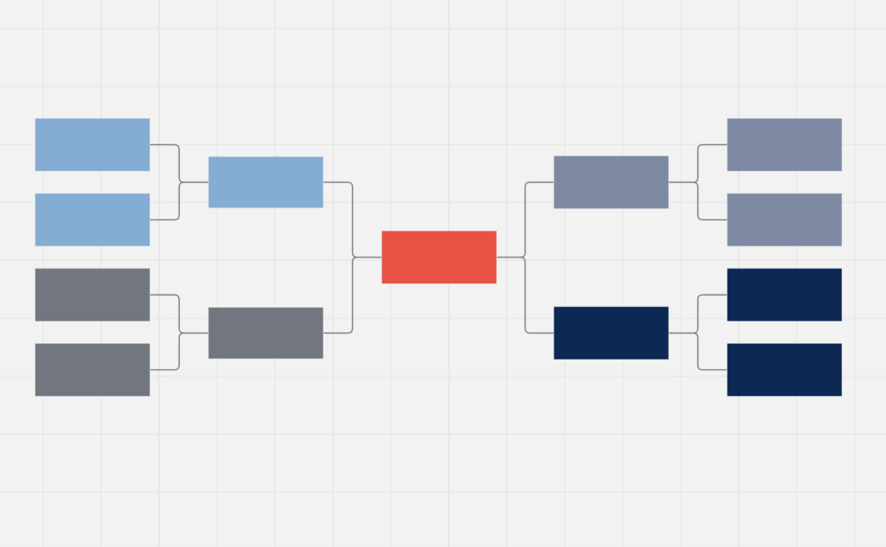
Figure 3
Project
Manager
Guests
Travel
Agencies
Booking
Websites
Governments
Software
Developers
CEO
COO
Product
Developers
IT and Data
Marketing
Ops Manager
Staff
Finance
HR
Internal
External

Regulators

Communication Plan
Communication is essential for coordinating project activities, tracking progress, and monitoring quality, time, cost, and other potential issues. When communication is poor, projects are far more likely to fail because key stakeholders may not receive the right information at the right time, preventing them from making informed decisions or delivering their responsibilities effectively.
The Project Manager will act as the central communication point, ensuring that messages are accurate, timely, and tailored to each stakeholder group. (WHO) - Senior leaders such as the CEO, COO, finance and HR departments, operations managers, IT and data teams, and product development teams (WHAT) - will receive regular strategic updates that focus on progress, risks, budget status, and key decisions requiring leadership input. These communications will take place through (WHEN) - weekly reports, scheduled review meetings, and summaries (HOW) – through face-to-face meeting and emails correspondence.

What Information | Target Audience | When | Method of Communication | Provider
Messaging, promotional content, campaign timelines | Marketing & Communications | Monthly | Internal updates through meetings and email | Project Manager
Budget, pricing strategy, legal compliance updates | Finance COO | As required | Review meetings, and emails | Finance Lead
Features, benefits, and value of the service for premium guests | Guests | Pre-launch and at launch | Website updates, app notifications, social media | Marketing Team and project manager
Project Status | CEO, and management | Weekly | Email and in meetings | Project manager
Issues escalation | COO, COO | As required | Meetings and emails | Project manager
Compliance requirements for AI, data protection, and environmental standards | Governments | As required | Compliance reports, meetings and emails | Development team
Service benefits, booking value, guest experience enhancements | Travel Agencies & Corporate Travel Partners | Pre-launch and launch phase | Websites and email | Team
Table 4
RACI Matrix
(NHS Education for Scotland, n.d.) suggests “The RACI matrix is a responsibility assignment chart that maps out tasks, milestones and key decisions involved in completing a project. It assigns which roles are Responsible for each action item, which personnel are Accountable, and, where appropriate, who needs to be Consulted or Informed on tasks”. Senior leaders (CEO / COO) are kept informed of progress while being consulted on major issues. Operational managers and the other teams are also consulted, and external stakeholders receive information only when project changes directly impact them.

Communication Activity | Project Manager | CEO / COO | Product Development | IT | Hotel Managers | Finance & HR | Marketing | Staff | Guests
Project Planning & Updates | A / R | I | C | C | C | C | I | I | I
Progress Reporting | A / R | I | C | C | C | C | I | I | I
Risk & Issue Escalation | A / R | C | C | C | C | C | I | I | I
Budget & Cost | C | C | I | I | I | A / R | I | I | I
Resource & Task Assignment | A / R | I | C | C | C | C | I | I | I
Operational Changes | A / R | I | C | C | A / C | C | C | I | I
Technical Updates / System Changes | C | I | C | A | I | I | I | I | I
External Communication (Guests, Governments) | A / R | I | I | I | C | C | C | I | C
Table 5

This structure ensures clarity, prevents communication gaps, and supports strong
governance throughout the project lifecycle.

R = Responsible, A = Accountable, C = Consulted, I = Informed

The 4C’s model
Table 6
4Cs | Communication
4Cs | Collaboration
4Cs | Consultation
4Cs | Commitment

According to Growth Tactics, the 4Cs framework supports organisational success by strengthening culture and performance (Growth Tactics, n.d.).
The 4Cs model gives a simple and effective way to manage stakeholders throughout the project

Communication
“Defined as the effective transmission of information, communication is the lifeblood of an organization” (Growth Tactics, n.d.).
With a StaySmart+ project introducing advanced AI, stakeholders may have concerns about system usability, data security, workload changes, or service consistency across the hotels. As the project manager the plan would be to establish targeted communication channels for each stakeholder group, ensuring clarity of message and avoiding information overload.
Conflict
Poor or inconsistent communication can lead to misconceptions, unrealistic expectations, or duplication of effort. By using structured, two-way communication, it can proactively identify emerging issues with the StaySmart+ service before they escalate. Addressing misunderstandings early prevents conflicts from becoming embedded and protects stakeholder relationships.
Collaboration
“Leaders can foster collaboration by actively promoting team-building activities and cross-functional projects.” (Growth Tactics, n.d.).
The Project Manager plan is to bring product development, IT, operations, and marketing together to make sure the service is technically workable, practical for operations, and appealing for customers.
Using workshops, joint problem-solving, and combined testing helps teams share knowledge and understand each other’s limitations. This is especially important in global hospitality hotel projects, where operational, technical, and marketing needs often differ and must be balanced.
Conflict
Collaboration in the StaySmart+ service helps prevent conflict by giving all key stakeholders such as IT teams, hotel operations managers, and staff a chance to understand the project and influence the parts that affect their work. As StaySmart+ introduces AI features, new digital workflows, and sustainability tools, different teams will have different priorities. For example, IT may build an AI system that works well technically, but Operations may find it hard for reception or concierge staff to use.
Consultation
“Consultation in the StaySmart+ project means giving stakeholders a real voice in decisions, not just updating them”. (Growth Tactics, n.d.). By using feedback sessions for the selected hotel testing, surveys, interviews, and technical reviews, the project managers plan is to gathers insights from staff, IT, compliance teams, and regulators. This helps identify issues early, such as usability problems or data-privacy risks. Early and consistent consultation builds trust, reduces resistance, and leads to a StaySmart+ service that works effectively for both guests and staff.

Conflict
Consultation helps prevent conflict in the StaySmart+ project by giving the stakeholders a chance to raise concerns early, before they turn into major issues. When stakeholders feel ignored or left out, they may resist the StaySmart+ rollout or slow down progress. By involving them in decisions makings such as AI-driven features, guest-facing tools, and new staff workflows it creates a sense of ownership. This makes stakeholders far more willing to support the project, even when compromises are needed.

Commitment
The project managers commitment is to make sure the stakeholders truly support the StaySmart+ project and stay engaged from start to finish. It is built through consistent communication, visible support, giving people chances to contribute, and showing that their feedback genuinely shapes decisions.
As Project Manager, the plan is to strengthen commitment by ensuring executive sponsors actively promote StaySmart+, recognising staff contributions, and sharing early feedback from the selected hotels. Providing training, support materials, and ongoing feedback channels helps maintain engagement after launch and keeps the project moving forward.
Conflict
Stakeholders who are not committed to the StaySmart+ project can become sources of hidden resistance. This can appear in subtle ways, such as staff having a slow engagement with training, delays in adopting new digital workflows, or drops in service quality during the transition. By consistently reinforcing the purpose of StaySmart+, showing how the new features improve guest experience and hotel operations, and keeping open communication channels, it will reduce the risk of this potential conflict.

Stakeholder engagement
Moral stakeholder engagement means involving people. It focuses on fairness, rights, privacy, openness, inclusion, and caring for the environment. It also entails honest engagement of stakeholders, and promotes inclusion and voice for stakeholders, many of whom may often be overlooked or ignored. (BALM 5001, Understanding and Engaging Stakeholders, Week 2 – Stakeholder Engagement p 8)
• Moral stakeholder engagement
This approach is based on the belief that organisations have an ethical responsibility to consider stakeholder interests (Donaldson & Preston, 1995 pp. 65–91).
• Strategic stakeholder engagement
This focuses on engaging stakeholders to achieve organisational objectives and secure competitive advantage (Freeman, 1984; Harrison & Wicks, 2013 pp. 97–124).
• Pragmatic stakeholder engagement
This is driven by the need to maintain stakeholder support by responding to practical expectations and social pressures (Suchman, 1995 pp. 571–610)
Moral Stakeholder Engagement
With the StaySmart+ service, this means building privacy-safe AI, giving guests clear data choices, supporting all types of travellers, and providing honest sustainability information. For employees, it means involving staff early, creating safe feedback spaces, ensuring AI supports rather than replaces jobs, and offering fair training. For the software developers and government/communities, it means choosing eco-friendly partners, buying locally when possible, and using fair contracts.
This approach builds trust, reduces risks, improves staff engagement, and leads to stronger long-term results. Ignoring it risks privacy issues, complaints, staff distrust, and community pushback, which can harm bookings and revenue.
Strategic Stakeholder Engagement
Strategic engagement is undertaken with strategic focus, though not necessarily intentionally dishonest or malicious, motivations. The strategic dimension in stakeholder engagement focuses on stakeholders’ willingness to participate in business value creation (BALM 5001, Understanding and Engaging Stakeholders, Week 2 – Stakeholder Engagement . p10)
For the StaySmart+ service it involves collaboration with AI developers through shared plans, performance commitments, and joint marketing. Regulators are consulted early to avoid delays related to data or algorithms.
This type of engagement boosts business results by supporting revenue growth, speeding up decision-making and rollout, improving integration quality, and keeping costs under control through vendor leverage and shared development. However, over-focusing on powerful stakeholders can mean missing frontline or niche guest needs, which can reduce adoption later.
If strategic engagement is neglected, StaySmart+ risks a disjointed rollout.
Pragmatic Stakeholder Engagement
The pragmatic approach allows for examining the alignment of the aims, activities, and impacts of stakeholder engagement as it underlines the contextual and situational aspects. (BALM 5001, Understanding and Engaging Stakeholders, Week 2 – Stakeholder Engagement . p13)
Pragmatic stakeholder engagement is about being practical focusing on what can be done now and finding workable compromises to keep momentum. For the StaySmart+ service, this means releasing features in phases, allowing sensible local adaptations, using quick evidence-based sessions to resolve team conflicts, and staying realistic about budgets and capacity.
This approach speeds delivery, controls costs, and creates smoother early guest experiences. Settling for “reasonable” can limit long-term value, while ignoring pragmatism can create overly complex designs, delays and budget overruns.
.

Stakeholder engagement strengthens performance by speeding delivery, improving service quality, reducing risk, and increasing revenue. Poor engagement through misalignment or weak communication can cause delays, conflict, and service issues that harm financial results and reputation.
Conclusion
Hilton Hotels StaySmart+ initiative is positioned as the next step in the company’s long tradition of service innovation. Strategic analyses – SWOT and PESTLE show that Hilton Hotels strong digital capabilities and brand equity align well with the goals of StaySmart+ service, while regulatory pressures such GDPR requirements highlight the need for strong governance and privacy.
Stakeholder analysis, a communication plan, a RACI model, and the 4Cs framework illustrate the need for coordinated cross-functional engagement across leadership, technology teams, operations, marketing, and external partners to ensure successful implementation.
Overall, Hilton is well-positioned to implement StaySmart+ as a scalable and responsible innovation. With solid governance, operational readiness, and a focus on guest trust, the initiative can strengthen loyalty, increase efficiency, and advance Hilton’s sustainability ambitions helping shape the future of premium, AI-enabled hospitality.
Recommendation on the future
Hilton Hotels should establish formal consultation stages earlier in the project lifecycle, particularly involving frontline staff and operations managers. Early insight ensures the StaySmart+ system and eco-friendly features are designed around operational needs, preventing costly rework and reducing resistance at rollout.
Transparent communication can be improved through shared digital dashboards that give all teams visibility of progress, risks, and timelines. After launch, Hilton Hotels should maintain continuous feedback with guests, staff, and developers to refine the AI service, and training. Finally, stronger governance with external partners and regulators, supported by clear KPIs, will ensure compliance, faster issue resolution, and consistent quality across locations.

References
Hilton (n.d.) History of Hilton. Available at: https://stories.hilton.com/history (Accessed: 1 March 2026).
Hilton (2026) Hilton 2026 Trends Report. Available at: https://stories.hilton.com/2026-trends (Accessed: 1 March 2026).
Expanded Ramblings (2024) Hilton Statistics and Facts. Available at: https://expandedramblings.com/index.php/hilton-statistics-and-facts/ (Accessed: 1 March 2026).
Tripadvisor (2026) Hotels near Snowhill, Birmingham. Available at: https://www.tripadvisor.in/Hotels-g186402-zfb9204-Birmingham_West_Midlands_England-Hotels.html (Accessed: 3 March 2026).
Business Model Analyst (2024) Hilton SWOT Analysis. Available at: https://businessmodelanalyst.com/hilton-swot-analysis/ (Accessed: 4 March 2026).
Springer Nature
Teece, D.J. (2018) SWOT Analysis. The Palgrave Encyclopedia of Strategic Management. Springer. Available at: https://link.springer.com/rwe/10.1057/978-1-137-00772-8_285 (Accessed 7 March 2026)
WallStreetMojo
Choubey, P. (2023) PESTLE Analysis – What Is It, Example, Strategic Management. WallStreetMojo. Available at: https://www.wallstreetmojo.com/pestle-analysis/ (Accessed: 7 March 2026).
NHS Education for Scotland. (n.d.) RACI matrix. Available at: https://learn.nes.nhs.scot/39904 (Accessed: 17 March 2026)
Growth Tactics. (n.d.) 4 Cs of Organisational Success: Corporate Culture. Available at: https://www.growthtactics.net/4cs-of-organizational-success-corporate-culture/ (Accessed: 17 March 2026).
Donaldson, T. & Preston, L.E. (1995) ‘The stakeholder theory of the corporation: Concepts, evidence, and implications’, Academy of Management Review, 20(1), pp. 65–91.
Freeman, R.E. (1984) Strategic Management: A Stakeholder Approach. Boston: Pitman.
Harrison, J.S. & Wicks, A.C. (2013) ‘Stakeholder theory, value, and firm performance’, Business Ethics Quarterly, 23(1), pp. 97–124.
Suchman, M.C. (1995) ‘Managing legitimacy: Strategic and institutional approaches’, Academy of Management Review, 20(3), pp. 571–610.
GuruFocus (2024) Decoding Hilton Worldwide Holdings Inc. (HLT): A Strategic SWOT Insight. Available at: https://www.gurufocus.com/news/3156183/decoding-hilton-worldwide-holdings-inc-hlt-a-strategic-swot-insight (Accessed: 4 March 2026).
PESTLE Analysis (2024) Hilton SWOT Analysis. Available at: https://pestleanalysis.com/hilton-swot-analysis/ (Accessed: 4 March 2026).
Green Lodging News (2023) Highlights from Hilton’s 2023 Travel with Purpose Report. Available at: https://www.greenlodgingnews.com/highlights-from-hiltons-2023-travel-with-purpose-report/ (Accessed: 1 March 2026).
Smartsheet (n.d.) A Comprehensive Project Management Guide to Everything RACI. Available at: https://www.smartsheet.com/comprehensive-project-management-guide-everything-raci (Accessed: 4 March 2026).
Atlassian (n.d.) How to Write SMART Goals. Available at: https://www.atlassian.com/blog/productivity/how-to-write-smart-goals (Accessed: 8 March 2026).
Borealis (n.d.) Stakeholder Mapping: How to Identify Your Stakeholders. Available at: https://www.boreal-is.com/blog/stakeholder-mapping-identify-stakeholders/ (Accessed: 4 March 2026)
AgencyAnalytics (n.d.) Master Goals: How to Set SMART Marketing Goals. Available at: https://agencyanalytics.com/blog/master-goals (Accessed: 8 March 2026).
OLU.BALM 5001 (n.d.) Understanding and Engaging Stakeholders: Week 8 Lecture Notes.
BALM 5001 (n.d.) Understanding and Engaging Stakeholders: Week 7 Lecture Notes.
BALM 5001 (n.d.) Understanding and Engaging Stakeholders: Week 2 – Stakeholder Engagement (p.7).
BALM 5001 (n.d.) Understanding and Engaging Stakeholders: Week 2 – Stakeholder Engagement (p.8).
BALM 5001 (n.d.) Understanding and Engaging Stakeholders: Week 2 – Stakeholder Engagement (p.10).
BALM 5001 (n.d.) Understanding and Engaging Stakeholders: Week 2 – Stakeholder Engagement (p.13).

