Autism:
A Guide for Early Years Settings

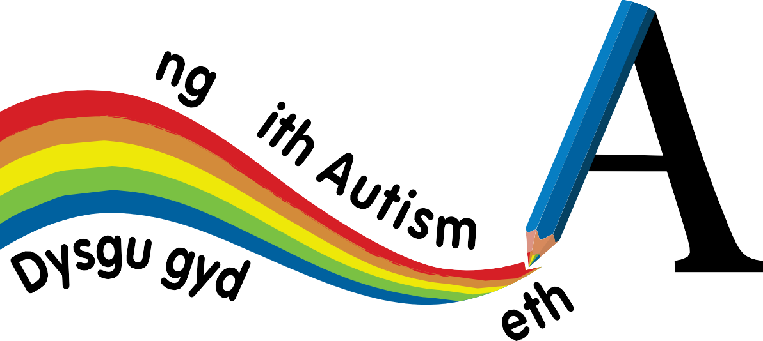
\_earn;
09-"wtist\o
www.A Dinfo a e s.co.Uk




Autism:

A Guide for Early, Years Settings



Acknowledgements

We would like to thank everyone who was involved in developing and reviewing this document.

We would like to recognise the valuable contribution made by the families who helped us to develop this guide, including:

Tracy Hinton Katy Rees Anne Drewett Gaby Worgan
Parent representatives who were involved through the focus groups held across several LA’s during 2015.

Author
This guide was written by:

Johanna Manikiza
ASD National Development Lead, Welsh Local Government Association

References
ASDinfoWales and partners. Autism: A Guide for Mainstream Primary Schools (2016) ASDinfoWales, partners and Wales Autim Research Centre. Autism – do you know the signs?
ASDinfoWales and partners. Autism: A Guide for Parents and Carers Following Diagnosis (2012)

National Institute for Health and Clinical Excellence (September 2011) Autism: recognition, referral and diagnosis of children and young people on the autism spectrum. London: Fish

Books http://www.nice.org.uk/guidance/cg128

The National Archives (2010) The Equality Act 2010 www.legislation.gov.uk/ukpga/2010/15/contents

ISBN: 978-1-78286-031-0

Contents

Acknowledgements 2
Foreword 5
Chapter 1 - Introduction 6
Introduction to Autism Spectrum Disorders 7
Learning With Autism – Programme Overview 8
Chapter 2 – Understanding Autism Spectrum Disorder 9
Recognising the Signs of ASD in Those without a Diagnosis 10
Understanding Autism Spectrum Disorder (ASD) 13
What are the core characteristics of autism spectrum disorders? 13
Social Interaction 13
Social Communication 14
Verbal Communication 15
Non Verbal Communication 15
Social Imagination, Rigidity of Thought and Routines 16
Imaginative Play and Creative Activities 18
Sensory Issues in Autism 18
Autism and Other Disorders 22
Chapter 3- Adapting Day to Day Practice 23
A Child Focused Approach 24
Adapting Communication 24
Supporting Social Interaction 26
The Early Years Setting Environment 27
Routines and Changes to Routine 29
Using Picture Planners 30
Setting Tasks and Managing Unstructured Activities 31
Transitions 32
Repetitive Behaviours 32
Special Interests 33
Imagination, play and creativity 33
Understanding Social Rules 35
Chapter 4 - Managing common issues in the early years setting 37
Working with Parents and Carers 38
Toileting 39
Eating 41
Accidents and injuries 42
Working with Challenging Behaviours 42
Using Reward Programmes 46
Further information 48

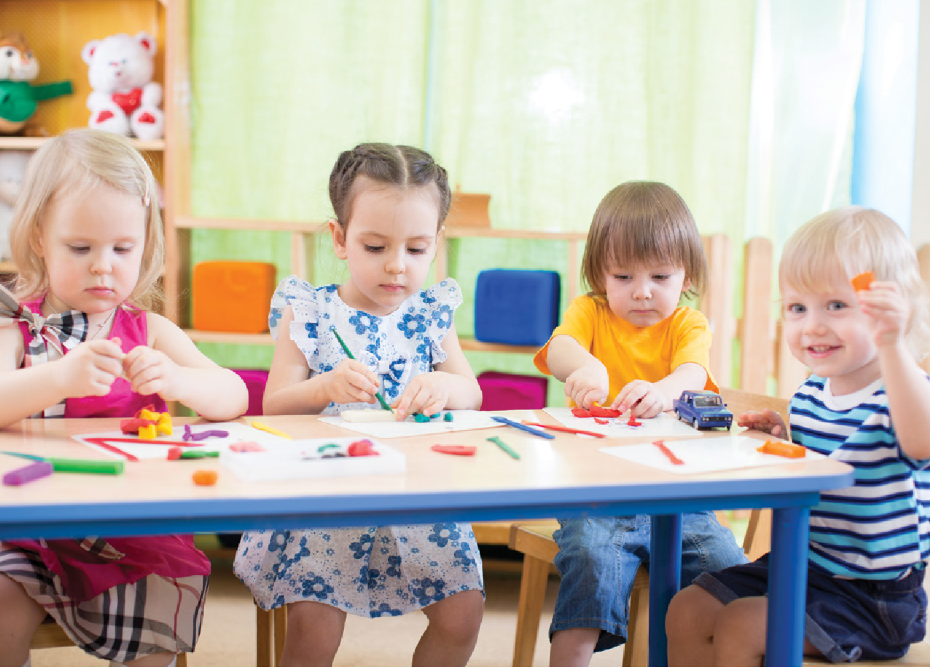Foreword
Page

I am pleased to provide a foreword address to Autism: A Guide for Early Years Settings. Following the success of the Learning with Autism Primary School Programme, I hope that this guide and its accompanying resources will yield similar success in providing practical knowledge and advice for staff within early years settings.

Creating autism friendly learning environments can only be achieved with everyone working together, and the ‘Learning with Autism’ programmes aim to achieve this by providing consistent advice and supportive resources that can be utilised across education provision.

These programmes have been developed with support and advice from a range of professionals, parents and carers. We are very grateful for the continued commitment shown, and hope that our resources continue to improve the lives of children with ASD and their families.

Councillor Ali Thomas OBE


Chapter 1
Introduction

\

Chapter 1

Introduction

Introduction to Autistic Spectrum Disorders

Estimates tell us that around 1 in 100 children have an Autism Spectrum Disorder - or ASD - which means there are children with an ASD in many early years settings.

Some children have social communication difficulties which may or may not lead to investigation for ASD. However, many of the approaches outlined within this guide will benefit all children.

Children with an ASD present with a variety of strengths, difficulties and sometimes behaviour issues. For these children the cause of behavioural difficulties usually relates to the core symptoms of autism not being appreciated, and suitable support and adaptions not being put into place.
By adapting your practice, a child with an ASD will feel safer, less anxious and have an increased understanding of what is expected of them. This in turn will mean that the child is more likely to have increased attainment, improved engagement and is less likely to display challenging behaviour.

All children with an ASD have impairments in social communication, social interaction, social imagination and a preference for routines. Many have sensory issues and a restricted pattern of behaviours. It is important to remember that the way in which this affects a child varies, and strengths or weaknesses in one area are not necessarily accompanied by strengths or weaknesses in other areas.

For example, children with higher functioning ASD may also have good or above average use of language. Having a complex vocabulary does not mean that the child will understand the same level of vocabulary, nor that the child will understand the vocabulary that he or she is using.

We shouldn’t forget the many positive attributes of children with an ASD. Having an ASD often means that children are skilled at paying attention to detail, follow clear rules and are honest. These abilities can be used to encourage engagement, and enable them to make their own, unique contribution within the setting.

Due to the issues children with an ASD experience, many have difficulties in accessing the curriculum especially where play based and will need differentiation in teaching styles and approaches.

The Learning with Autism programme has been developed to equip early years settings with enhanced understanding of ASD and how to meet the needs of children with the condition.

Learning With Autism – Programme Overview
The learning with autism programmes are a series of programmes aimed at raising awareness of autism across mainstream educational settings. Funded by the Welsh Government and developed by the Welsh Local Government association, The Learning with Autism – Early Years can be accessed at www.ASDinfoWales.co.uk/early-years.
In some settings, it may be useful to use the programme in conjunction with our primary school programme which can be accessed at www.ASDinfoWales.co.uk/primary-school

Learning with Autism – Early Years is an invitation to become an ‘Autism Aware Early Years Setting’, and in addition to this guide there’s a package of resources available to support the process:

For Early Years staff
A training film, showing some of the challenges faced by children with an ASD during a normal day, designed to develop awareness, and stimulate discussion about the steps we can take to improve their experience and engagement levels.
Autism: A Guide for Early Years Settings
An online questionnaire leading to a Staff Certificate in ASD Awareness.
A self evaluation tool based on the joint Estyn and CSSIW inspection framework for Early Years and childcare, which will help settings to identify their current provision and practice and plan and monitor improvement

Other staff
are encouraged to take part in a nation-wide ASD awareness programme It includes; An E-learning presentation about the issues involved in autism.
An online questionnaire leading to a Certificate in ASD Awareness.

For children
‘Teifi and Friends’, an animated film showing how children in early years settings can
be kind and accepting towards peers with additional needs.
With everyone on board, the early years setting gets a certificate showing it’s completed the
Learning with Autism programme.
There are also additional resources to help support children with an ASD in the early years setting, including:

An online Child Profile, available to setting staff, parents, carers and other professionals. With everyone working together, it can build into an effective resource, making sure there’s consistency and continuity of care for a child with an ASD.
Children’s Picture Cards, a simple, interactive resource, where you can search, select, download and print from a series of bilingual picture cards, to create a structure chart for a child with an ASD.
Cue cards to support specific activities such as toilet training.

Everyone needs to be on board to create an Autism-Aware Early Years Setting. As individuals come to understand more about ASD, their actions influence those around them, and being an Autism- Aware setting becomes a reality.
Raising awareness about autism has the power to change lives: the lives of children with an ASD, and the lives of those around them. It encourages understanding, tolerance and respect, so that together we can all reach our full potential.

Chapter 2
Autism: A Guide for Early Years Settings

Page

Understanding Autism
Spectrum Disorder

Autism: A Guide for Early Years Settings

Chapter 2
Understanding Autism Spectrum Disorder

Recognising the Signs of ASD in Those without a Diagnosis
Autism Spectrum Disorder can be diagnosed from around the age of 2. However, for many, the symptoms are missed during the early years and many are not diagnosed until much later on. For some individuals, the symptoms are missed in childhood and they are subsequently not diagnosed until adulthood – usually after a long period of struggling to manage day to day.

Early recognition and intervention ensures that children can receive the most appropriate
support and in turn benefit from the best outcomes.

NICE Guidelines (www.nice.org.uk/guidance/cg128/chapter/1-Guidance#recognising-children- and-young-people-with-possible-autism) advise that professionals should use their judgement as to whether a child should be referred for assessment or not. The guidelines recognise,
that scores obtained from ‘symptom recognition tools’ (sometimes inaccurately referred to as ‘screening tools’) should not be relied upon. It is recommended that the decision to refer should be considered on the basis of:

“Early recognition and intervention ensures that children can receive the most appropriate support”

signs or symptoms range
number
severity duration pervasiveness
impact

The guidelines also recommend that special attention should be paid to the level of parental concern about the child or young person.

Common signs of ASD are highlighted in the following pictures and more information about referring a child can be found at www.ASDinfoWales.co.uk/recognise-ASD-child.

10 Page

Social Interaction and verbal communication are impaired

Imagination, ideas and creativity are reduced

Gestures and non verbal communication are limited

Narrow range of interests, routines and repetitive behaviours

Sensory responses are unusual
. I J. 1 +GIG1 Cyhoeddus • •un s•

WWW.ASDinfoWaIe s.co.Uk ==
•:-.-;;;• NHS PublicH•alth (( iifli.a.cvm••
WLCA-CL ILC Wales :::;,;•,=

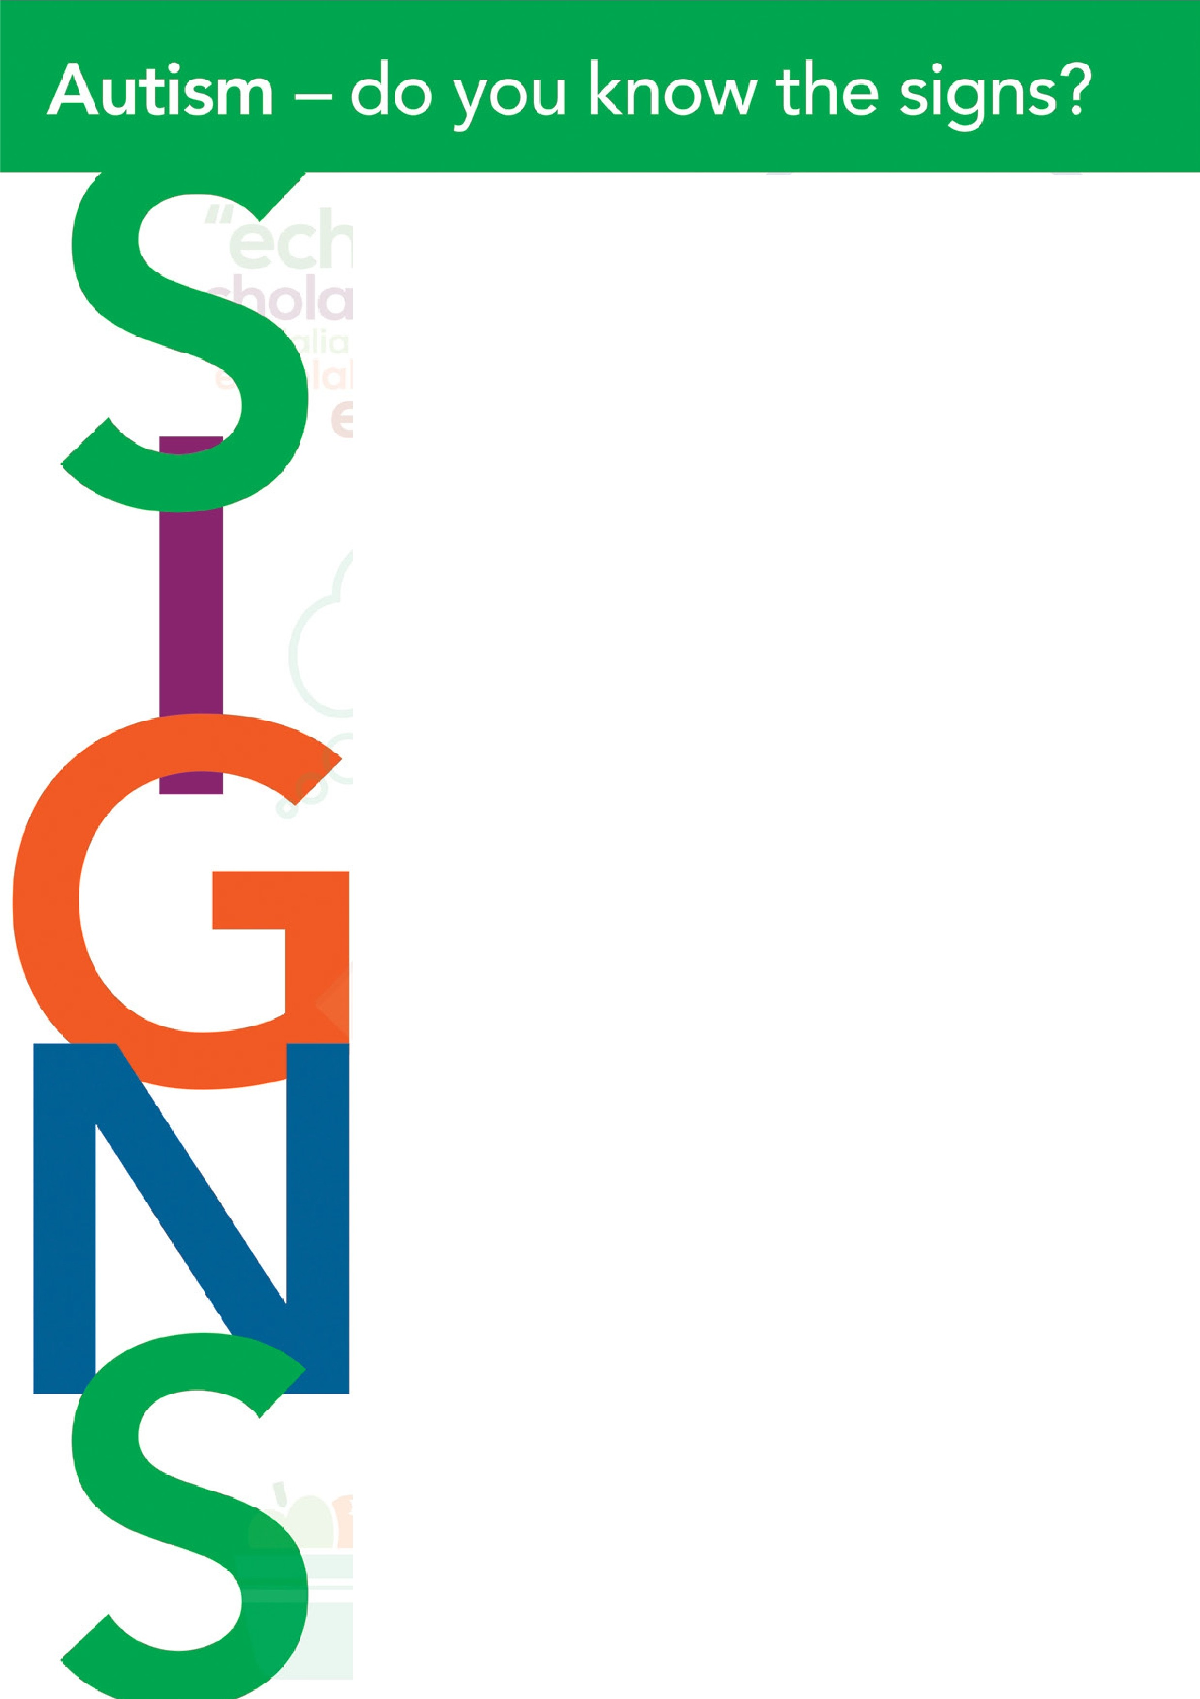www..n=Ji11fowale!Lco.uk/,-ecognis•AStk:hi1d I www.1s.dinfowalas.co.ul:/n1cogns.e-ASO.aduh

Autism
do you know the signs?
Does not seek comfort when in p.,in or distress

Indifferent to, or no interest in, age peers
Does not 's hare' interests or enjoyment with others

Pre School Children - 2 years to 41/2 years
-



□L IC auO Does not yet use 2-3 word
•

Does not offer comfort to others

Approaches others in a
one sided way or on own terms

Does not spontaneously join in or inte ract wi1h others of same age

Repeat ing certain words or phrases
over and over again ("echo lal ia ") Delay in learning to babble, using
first words or comb ining 2-3 words
by age 3
"echolalia
utterances f


Does not respond 10 greetings and farewells

Does not ,e njoy social situ ations t hat most children like (e.g. birthday parties)

echolalia echol 9lia
echolalia echolaha
echol .... I • ,,
Regression in or loss of skills

Does not follow sim ple commands relat ing

Does not respond by looking when name is called
Emotiona I responses to
others can seem rude or inappropriate
•

Unaware of other's feeling>

t=\.1100110

Imagination, ideas and creativity
to objects not in view (such as fetch your toothbrush)


Poor imitation of sounds or peo ple 's actions

Gestures and non verbal communication



Does not use simp le gestures (waving goodbye)

Lack of imaginative pretend play (pretending that dolls and toys are real and enacting out scenarios with them or role play)

Imaginative pretend play or ro le play is repetitive
0 1
I

Imaginative pretend play is over-focused or obsess ive or copied (not invented)

.,,
Narrow range of interests, routines and repetitive behaviours
;

Imag inat ive pretend play is solitary or plays near but not with other chi Idren

Pla ys imaginative pretend play with others but not equally s hared - may passively copy anot he r's imaginative game, or insist that others follows his/her own t he mes
;,nd rules

Insists on following own agenda

Lack of spontaneous gesture that expresses emotion [e.g. putting arm around someone)



Uses someone else 's hand as a tool (e.g. putt ing someone else's hand on a box to open it)

Does not 'show' objects by holding them up or givirng them to so meo ne

Does not follow a pointing gesture to where someone is looking
Lack of social smile

Lack of pointing to show objects and share inte rest

Reduced or unusual eye contact

Displays repet it ive behaviours or rituals 1hat negatively affect daily activities

Repetitive 'stereotypica l' movements such as hand flapping, body rocking while standing, spinning, finger flicking
Arranges objects in patterns or lines and dislikes these to be disturbed


Self-chosen activities are lim ite d and
unchanging

Disl ike of change, which can lead to anxiety or aggression

Over-focused. unusual or highly specific inte rests and hobbies

Prefers fam iliar routines., likes things to be 'just right'

Problems with turn taking

Sensory responses
..!.&C:-•:i•. • ••
- - • •
*

Unusual sensory responses to sound
sight, touch, taste, smell, movement and/or pain


...--..c.. .111..a. S.,(2012). liiwadbillif •nd fi.:r• loru 'ltm-.. rlinj.t"- lll&M'l llf'K'lllmqw.it'-nl n d th- "- t IM th 1.000- ■nd :,,.COO • . J--- 1111l .llfl ti. Anwrl....i ol Chlld 6. ....._.. . 5 1Q1. 2a2:-2 t2. it.n.n, J,.,& , C, '201Jt,.i. ly fflSQorw.ol U h ffl lf"HU',,nl daarMn lnlnlait11ncl lOdalK1pN lmftti-..i inliMSodal Att 9tllliori-.d -C- lri ,r,alla,n, Swdy.. Alniln -. 11,(11,.......

C■m,,.-.s..LN,lI._.,
R.. M J.,.Gaulal,. J.,. Wln,. L. -• No. n■.l ,( 201il, Sl:,ri Nor dag n.tk .f 111A11m 1o1.J"l t h. D ln......,._ f,x Soc:hl rtd Ca Dla« c&.. IPI . lw+vch lnAvdim Sp+c\:R11111Clti..-dwt.. 0."4 .

Understanding Autism Spectrum Disorder (ASD)

An Autism Spectrum Disorder (ASD) is a developmental disorder which affects the way
a person communicates with and relates to other people and the world around them. The way in which people are affected varies from one individual to another and by age and intellectual functioning.
Children with an ASD are affected in a variety of ways and to very different degrees. This is why it’s called ‘the autism spectrum’. Autism can affect children with any level of intellectual ability, from those who are profoundly learning disabled, to those with average or high intelligence. So, having an ASD doesn’t necessarily mean that you have learning difficulties.

The more seriously affected children at one end of the spectrum have learning difficulties as well and require high levels of support. At the other end of the spectrum, some people with Asperger syndrome or ‘high-functioning autism’ are very intelligent academically. They may go on to be successful in their chosen field. However, they still experience significant social and communication difficulties.

What are the core characteristics of autism spectrum disorders?
Children with an ASD have significant difficulties relating to other people in a meaningful way. It is very common for ASD children to have profound sensory issues. This, combined with the triad of impairments, means that children with an ASD experience the world very differently. The ‘triad of impairments’, or ‘the three impairments’ are issues with:

social interaction social communication
rigidity of thinking and difficulties with social imagination

Children with an ASD frequently also experience:
repetitive behaviours / stimming special Interests
sensory issues
It is important to remember that the autism spectrum is broad and therefore different individuals with ASD may display all or only some of the characteristics described. In this guide we will aim to help you understand the characteristics of autism spectrum disorders, the impact of the early years setting on the child with an ASD and support strategies in more detail.

Social Interaction
From birth, most children display signs of wanting to engage with others. They enjoy interacting, and look to others to learn from. As these children grow, they appear motivated by and develop more skills in engaging with others, seeking praise and sharing pleasure and
interests. Children with an ASD find social interaction difficult, and often appear less motivated to socialise. They may seem less interested in people, find it hard to understand what others expect of them - they often seem trapped in a world of their own.

In the early years setting, the child with an ASD may not like to be approached, or only be receptive to approaches from people they know well. They may show preference for individual activities, or prefer to engage with adults over peers.

Some children with an ASD may like being sociable, but struggle to do this appropriately or

may want social contact on their terms only. They may appear ‘awkward’, not liking anyone in their personal space or entering others personal space inappropriately. They may make errors in their interaction with others, be over – formal or over – familiar, make personal remarks without realising there are offending. They may struggle to start, end or take turns in conversation and may appear to talk ‘at’ rather than ‘to’ someone. They may talk excessively about their own interests, and not recognise when someone is bored or disinterested. Whilst
some of these behaviours can be seen in all small children, those with an ASD have a pattern of social impairments that impact on their day to day activities.

This lack of social awareness can also mean that the child has difficulty in understanding and
following social rules such as taking turns, not interrupting or waiting in line.

There are many negative impacts associated with impairments in social interaction. The child can often experience low self-esteem from ‘getting it wrong’ frequently. Friendships with peers can suffer, many children with an ASD want friends but find it difficult to make and sustain friendships.

Not understanding the purpose of social interaction (along with other issues) can make the child choose to avoid social occasions such as birthday parties.

At times, adults who do not understand ASD may assume that the behaviours are caused by ‘rudeness’ or ‘naughtiness’ which results in the child being punished or ‘labelled’ for something they have very little control of.




Social Communication
Children with an ASD may not be eager to communicate. They may not be ready to learn things that other children learn naturally and therefore don’t have the chance to tune into language in the same way. They find it very hard to make sense of the things that happen around them. Words may mean very little to them and they may be unable to link what they see with the things being said to them.

Social communication and interaction are issues that all children with an ASD struggle with and not understanding or misunderstanding can often be a cause of anxiety and subsequent anxiety, withdrawal or aggression in the early years setting.

Verbal Communication
Many higher functioning children have a higher level of expressive language (what they say) than receptive language (what they understand). When language is at an average or an above average level, it is often assumed that level of understanding is equal but this is usually not the case.

Even with higher level verbal skills, children with an ASD still find non-verbal communication difficult and struggle to use, and understand, non-verbal communication methods. These communication difficulties can cause problems in giving information to and gaining information from children with an ASD. Being aware of these difficulties and adapting your own communication style is essential when working with children with an ASD.

Children with an ASD understand language literally and so find it difficult to understand idioms
and metaphors. When interpreted literally, these phrases are very confusing.

Often we will use phrases which literally interpreted mean one thing, when actually we are implying something else. For example we may say “well done for listening” when actually we mean “well done for stopping when I asked you to”, or “wait a second” when we mean “I’ll help you after I have finished this task”.

We often use analogies to try and explain things to children in simpler terms. For example, if we are trying to explain why a child needs to eat his dinner, we might talk about it being like putting fuel in a car and explain that if the car doesn’t have enough fuel it will break down. It is difficult for a child with an ASD to link this sort of an explanation with the original problem you are trying to explain.

Children with an ASD may need more time to process and understand what you are saying.

Non Verbal Communication
Regardless of the level of verbal communication, children with an ASD struggle to use and understand non verbal methods of communication.

Non verbal communication methods include: eye contact
body language
tone of voice gesture
facial expression
Many, but not all, children with an ASD have an ‘unusual’ eye contact. This may be noticed as the child avoiding eye contact, giving too much eye contact or a more subtle differences such as not using eye contact when showing or requesting something.

We often assume that a lack of eye contact implies that someone is not listening or not paying attention to us. For children with an ASD the opposite is often true, they may find it easier to focus on listening to you when they are not concentrating on looking at you.

For those with autism, eye contact is often uncomfortable and has even been described as painful.

Because children with an ASD may have problems interpreting non-verbal communication such as eye contact and body language, they may not realise that you are addressing them, especially when in a group of other children.

Children with an ASD have difficulty in interpreting the communicative intention of changes
in pitch and tone of voice and indeed often present with an unusual pitch, accent or
tone themselves. Indeed, for some children find variations in tone and pitch confusing or
distressing.

Complex humour and sarcasm are often conveyed through contradicting verbal and non-verbal communication. A spoken phrase is compared with tone of voice, facial expression and used to work out whether someone is being serious or not. Children with an ASD will often be unable to do this, and will assume the words used are accurate.

A child with an ASD may not support their verbal communication with body language, facial expression or changes in tone of voice. If they do, they may not accurately reflect how the child is feeling or what the child means.

If a child has sensory problems, environmental issues such as loud noises or bright lights may
affect their ability to communicate.

Social Imagination, Rigidity of Thought and Routines
Imagination helps us understand the world and predict and see the perspective of other people. Children with an ASD are unable to do this to any great extent. In children with an ASD the development of pretend play may occur very slowly, in unusual ways, or not at all.

Problems with imagination make the world a very uncertain place, it makes it difficult to plan, cope with changes, predict other’s responses, empathise with other children and problem solve. Children with an ASD often find reassurance in setting up routines and patterns that they can control and prefer predictability to uncertainty.

This means that children with an ASD:

cannot easily make sense of sequences and events engage in repetitive activities
may become distressed if a familiar routine changes may impose routines on others
prefer consistency, and will often resist new experiences

find it hard to work out what other people are going to do, and cannot make sense of why
other people do what they do

struggle to understand how their behaviour may affect others, may not understand social
hierarchy

have no, or reduced empathy

struggle with imaginative play, pretending and creativity

find it hard to make ‘free choices’

will often pay particular attention to details and struggle to see the bigger picture

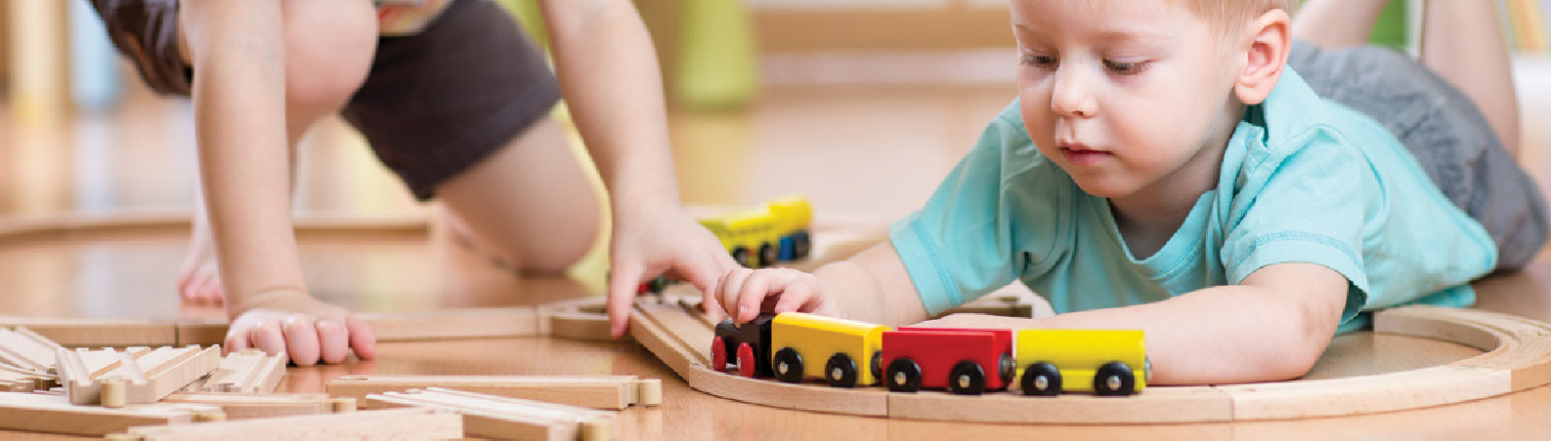
Page

Many children with an ASD find it difficult to cope with changes, they prefer the predictability of
a routine and cope better with structured activities.

Children with an ASD often work better within predictable routines.

Changes to the daily routine can cause a child with an ASD to become very anxious. Often this is purely because the child feels more comfortable with predictability, at times the anxiety can be caused by the child not recognising that key events will still happen. For example, if story time usually takes place before home time, and ‘story time’ is substituted for another activity, the child may not be able to predict that home time will still follow the substituted activity. This may lead to the child worrying that they will not being going home.

Some common changes in early years settings that can cause children with an ASD distress are:
fancy dress days

substitute staff

term time – school holiday changes

transitions to new early years settings / schools trips
indoor play times caused by weather conditions parties, discos and fayres
It is not only changes to the daily / weekly routine that can cause anxiety for children with an
ASD. Changes to the environment can also cause difficulties. These may include:

changes to displays rearranging of furniture
children being away from the setting new child joining the setting
visitors to the setting

changes in other’s appearances such as haircuts, glasses or growing a beard

When asking a child to choose an activity or option they may find it difficult to make a free
choice.

Imaginative Play and Creative Activities
Issues with social imagination mean that activities that rely on social imagination or require the
child to ‘pretend’ can be very difficult, and sometimes impossible for a child with an ASD.

The most obvious activity that is affected is play. Some children never seem interested in what a toy is or what it represents. Some children seem to act out stories or take on particular characters, but the story turns out to be an imitation of a video or book. Most children with
an ASD struggle to understand and engage in imaginative play. Games involving role play and sometimes symbolic play (using toy cars, dolls) can be affected, this doesn’t mean that children with an ASD don’t have any imagination, it just means they tend to have less ability in this area. This deficit is of particular significance in the early years, when the focus on learning through play puts children with an ASD at a disadvantage.

Difficulties with engaging in imaginative play can also have an impact on play times and the
child’s ability to develop friendships and engage with peers.

Sensory Issues in Autism
The seven senses are sight, hearing, touch, smell, taste, balance (vestibular) and body awareness (proprioception). In individuals with autism, the brain sometimes processes sensory information differently to those without ASD. Everybody is different and therefore individuals will experience things differently and respond in different ways.
Sometimes these different sensory perceptions can cause pain, distress, anxiety, fear or confusion and result in ‘challenging’ behaviour as the individual tries to block out what is causing the problem.

In some cases the senses may work too well and the brain receives too much information (hypersensitive) or not well enough where the brain doesn’t get enough information (hyposensitive). When the senses are hyper you may find that individuals with ASD rock, flap, spin, hit their ears, etc as a way of trying to block out the overload that they can’t tolerate and to help them to calm down or relieve the pain. In cases where the senses are hypo individuals may make or seek out noises, bang objects, etc as a way of causing more sensations and getting the senses to work better.

Things to look out for:

Hypersensitive Hyposensitive

Dislikes dark and bright lights
Looks at minute particles, picks up smallest pieces of dust Covers ears
Dislikes having their hair cut Resists touch
Avoids people Runs from smells
Moves away from people Craves certain foods
Uses tip of tongue for tasting Places body in strange positions
Turns whole body to look at something
Difficulty walking on uneven surfaces
Becomes anxious or distressed when feet leave the ground
Moves fingers or objects in front of the eyes Fascinated with reflections, brightly coloured objects Makes loud rhythmic noises
Likes vibration
Likes pressure, tight clothes Enjoys rough and tumble play Smells self, people and objects Seeks strong odours
Mouths and licks objects Eats anything
Rocks back and forth
Lack of awareness of body position in space Spins, runs round and round
Bumps into objects and people

Taken from ‘Sensory Issues in Autism’ by the Autism and Practice Group, East Sussex County Council

Examples of sensory issues that your child may experience include:
Some children with an ASD will demonstrate extreme reactions in relation to sensory stimuli. They may become distressed around bright lights, loud noises or strong smells. They may be ‘fussy’ eaters, only eating certain foods, or foods of a certain colour or texture.

In some cases it is easy to notice the sensory stimuli that is distressing a child. In most cases it is not, and the child may be becoming agitated by things you don’t even notice such as a flickering light, noise from a radiator or the temperature of the room.

A child with sensory difficulties may experience sensory overload as the brain tries to process everything at once without filtering out unimportant things like background noise, displays, people moving about, the feel of clothes on their skin, etc. This can make it difficult for children to focus on what someone is saying when in a busy area. When there is too much information to be processed at the same time it may be difficult for children with an ASD to break a whole picture down into meaningful units. For example, when talking to someone we will see their whole face but some people with autism may see eyes, nose, mouth, etc as individual things which all need to be processed separately. This makes it more complicated to process information and can lead to the child focussing on only one aspect or not having enough memory to process everything.

It is important to remember that when people are tired, unwell or stressed their tolerance levels are affected and this is also true of a child with an ASD, and their ability to tolerate sensory stimuli.

Repetitive Behaviours
The term repetitive behaviour is used to describe specific types of unusual or seemingly odd
behaviours that are often seen in children with an ASD.

Repetitive behaviour is sometimes referred to as self-stimulating behaviour or stimming. This
behaviour may involve any or all of the senses in various degrees in different individuals.

Several examples are listed below:

Visual- staring at lights, blinking, gazing at fingers, lining up objects

Auditory - tapping fingers, snapping fingers, grunting, humming

Smell - smelling objects, sniffing people

Taste - licking objects, placing objects in mouth

Tactile - scratching, clapping, feeling objects, nail biting, hair twisting, toe-walking

Vestibular - rocking, spinning, jumping, pacing

Proprioception - teeth grinding, pacing, jumping

Some repetitive behaviours are very obvious while others are more subtle and hard to detect
such as blinking or eye rolling, tapping fingers and mild hair twisting.

We all engage in some of these behaviours occasionally, especially when we are stressed. However, your child may engage in these activities excessively to the point that they interfere with learning or daily living activities.

It’s not completely clear why repetitive behaviour almost always goes with autism, but it is the case that children with an ASD experience a lot of chaos in their world and repetitive behaviour is a way of bringing predictability to an otherwise unpredictable and frightening world.

Some of the reasons children adopt repetitive behaviour are outlined below:

self regulation, which helps the child become calm and overcome situations of stress or upset
demonstrates excitement

provides the child with an escape route when they are overworked or wound up

makes the child happy. Some children find the behaviour pleasurable even if causing injury
to themselves

provokes a reaction from others, which reinforces the behaviour a way of avoiding a task or activity
Some children eventually learn to monitor their behaviours so they can engage in them in ‘safe’ environments (at home rather than at the early years setting or out in the community).

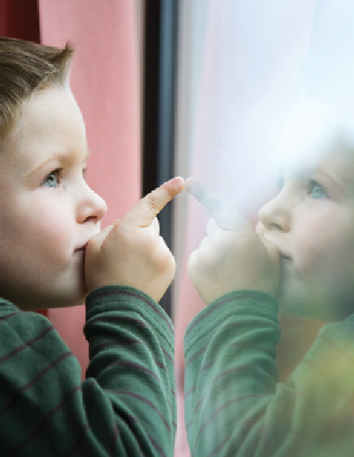
No matter what repetitive behaviour the child engages in, you need to understand this is something that they need to do in order to reduce anxiety.



Special Interests
All children have favourite things games, TV programmes, toys but most children can be distracted or engaged in another activity without too much fuss. Also most children like interaction with other people in order to get the most enjoyment from their activities.

However, some children with an ASD seem to develop interests in an unusual, over focussed way. These interests are usually referred to as ‘special interests’ and to a child with an ASD they might be the most important thing in their life. Children with an ASD normally develop interests that do not involve anyone else, where they can retreat into their own world for hours and hours, whereas other children might want to talk non stop about their interest, which in turn makes it difficult for them to develop friendships.

These interests are different to repetitive behaviours but some of the reasons for the
special interest can overlap, such as:

reducing anxiety maintaining a sense of calm gives them pleasure
a way of avoiding another task or activity

To others some of the interests of children with an ASD may appear pointless or boring but the child will be experiencing something completely unique to them. For some children their ability to focus on detail will mean that they are experiencing something completely beyond your imagination.

Special interests can be anything from weird to wonderful. Some of the more common examples of special interests in children might include:

lining up toys eg cars, trains etc TV characters
watching a particular TV programme types of cars or trains
As with repetitive behaviours children can become engaged in their special interest if they are feeling anxious or scared, but the reality is that they have an uncontrollable desire to involve themselves in these things because their interest is real and their enjoyment and satisfaction is real.

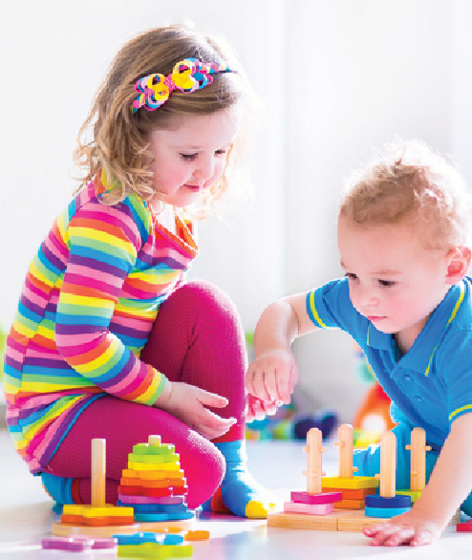


Autism and Other Disorders

Sometimes individuals with an ASD have another disorder as well. Some conditions appear to affect individuals with ASD more frequently, although it is sometimes difficult for professionals to ascertain whether symptoms are part of the ASD or another condition. Some of these disorders are:

Dyspraxia Dyslexia Depression Anxiety Epilepsy
Obsessive Compulsive Disorder (OCD) Attention Deficit Hyperactivity Disorder (ADHD) Tourette’s Syndrome
It is important to recognise that individuals with ASD are not excluded from other mental health and physiological conditions.


Chapter 3

Adapting Day to Day Practice

'\
'

Chapter 3

Adapting Day to Day Practice

A Child Focused Approach
A child with an ASD deserves the same rights to grow, learn, engage and reach their potential as any other child. Each child will have their own unique set of strengths and difficulties, and has potential to play an active part in the early years setting. The way in which a child presents and the difficulties they experience varies from one child to another. However, every child
with an ASD will need adjustments to be made in order to maximize their learning potential and reduce distress. Because of the range of difficulties that these children experience, more structure within adult led and child led activities needs to be added in order for them to access opportunities.

It is vital that you adapt your communication style to promote understanding and decrease anxiety and confusion. It is essential that each child is considered as an individual, and that practice and the environment are tailored to meet the child’s needs.

Many of the suggestions outlined in this guide are no or low cost, and early years settings have a duty to make these reasonable adjustments in line with The Equality Act.

Key to delivering the best outcomes for children with an ASD is working with partners, who can provide information, expertise and advice to help settings to support the child. These partners include professionals from health, social care and the voluntary sector along with parents, carers and other family members.

Adapting Communication
Verbal Communication
Because of the difficulties that children with an ASD have in using and understanding verbal communication, it is vital that you adapt your style of communication and make allowances for the child’s difficulties.
You should recognise that

Long questions and explanations can cause confusion for any child let alone a child with an ASD, so try to avoid using them.
Break down long instructions into smaller stages, and / or support the instruction with pictures or lists.
You should avoid using figurative language when interacting with a child with an ASD. Phrases such as …. “has the cat got your tongue?” Are often not understood or misunderstood. Make sure you say exactly what you mean when talking to a child with an ASD, otherwise it can lead to much confusion and anxiety.

Try and use facts to explain things instead of analogies. For example, if you are trying to explain why a child needs to eat his dinner, don’t use the analogy of putting fuel in a car. It is difficult for a child with an ASD to link this sort of an explanation with the original problem you are trying to explain.
Because young children, especially with autism struggle to ‘read between the lines’ you should always – SAY WHAT YOU MEAN AND MEAN WHAT YOU SAY.
Be clear and specific when questioning a child with an ASD. Try and avoid open ended questions, and don’t use non-specific terms such as ‘often’, ‘usually’ or ‘normally’.
Pause frequently and allow time to process.

When giving information, instruction or choices to the child with an ASD, it is often helpful to use pictures or photographs to help the child understand what you have asked them to do.
Do not make assumptions about the child’s level of understanding, receptive and expressive language skills are not always equal.

Non verbal communication
We use many methods of non verbal communication to replace, emphasise or even to contradict our verbal communication. Children with an ASD are less likely to use these methods of communication, and may not understand or even become confused when others use them.
You should:

Not rely on non-verbal methods to communicate, emphasise or contradict your point as the child with an ASD may not be able to understand these subtle ways of communicating.
Do not rely on gesture (such as pointing) to communicate with a child. Do not force a child with an ASD to give you eye contact, nor punish them for avoiding eye contact with you.
Do not rely on facial expressions to emphasise a point. Avoid changes to facial expression where possible.
Start by saying the child’s name and making sure you are in their view before speaking so they are aware you are talking to them.
When interacting with a child with an ASD, use a relaxed consistent tone of voice. Don’t shout, it will not help to the child with an ASD to understand and may actually cause confusion.
Avoid using sarcasm and humour, it can be very confusing for the child with an ASD.

Be careful not to make assumptions based on non – verbal cues, they will likely be misleading.

Supporting communication – Cue Cards
For children who find it difficult to communicate with you or to understand your communication,
cue cards may be helpful.

To support your communication with the child, show the child the appropriate cue card and say the relevant word or phrase. Cue cards can be downloaded from www.ASDinfoWales.co.uk/ early-years-cue-cards.

You may find it useful to place the cue cards on a lanyard so that you have them to hand at all
times.

You can also use cue cards to assist the child in communicating with you, you can do this by providing the child with a selection of pictures so that they can indicate their needs to you.

Finally, be aware that environmental factors can have a negative impact on the child’s communication skills.
Be sure to minimise sensory distractions - refer to the section on sensory issues.

Supporting Social Interaction
Difficulties with social interaction and communication are a symptom of autism, and will be
present in all children with the condition to varying degrees.

This will impact on the child’s ability to engage with adults and peers, though they may find it
easier to engage with adults than children. The child may: show indifference, or appear uninterested in others show much interest but approach in inappropriate ways
avoid interaction due to not understanding or not being accepted
Promoting Interaction with Adults

Try to find common ground (engaging in special interests is often useful) to begin to
build trust and rapport with the child.

Do not force the child to engage with you, be understanding and take your time. The more familiar the child is with you, the more likely he/she will engage with you.
Do not punish the child for making social mistakes, instead teach the child more appropriate behaviour by creating simple rules around appropriate behaviour and rewarding the child for adhering to them.

Promoting interaction with peers

Opportunities to engage with other children should be available, but the child should be encouraged and not be forced to engage with other children.
Groups of children can be particularly stressful for children with an ASD, encouraging interaction with individual children is a better starting point.
The majority of interaction between younger children is play based, and therefore the child with an ASD is at a disadvantage. You can promote interaction by setting simple structured activities, for example rolling a ball, with another child and supporting.
For some children with an ASD, who appear indifferent to peers, encouraging interaction can be difficult. Patience and perseverance is key. Try activities, as above, at regular times.

The Early Years Setting Environment
The potential impact of the environment on sensory distress needs be considered. Entrance areas, cloakrooms and corridors that are chaotic can make a child agitated as soon as they enter. Settings should seek to decrease sensory stimuli in these areas, by using minimal, neutral wall displays and keeping areas clean and tidy. The movement of others at busy times can also be distressing and this can be minimized by allowing the child with an ASD to utilise a different entrance or to move through the setting before or after the other children. All staff should be instructed to use a calm, consistent tone of voice when addressing children in all areas, and to avoid shouting.
You should recognise that

By adapting the environment, or making allowances for the child, the child will feel less anxious, be less likely to become overstimulated and will be more likely to behave appropriately and access activities.
Developing a sensory neutral environment will help greatly. Minimize displays and where unavoidable choose neutral or pastel shades rather than bold colours. Place items on the wall in an orderly manner, lining them up vertically or horizontally rather than placing them in an ad hoc manner. Do not use displays that may move, such as windmills. Avoid hanging items from the ceiling.
Fluorescent lighting can be a problem for many children with an ASD especially if noisy or flickering. Reduce lighting, and rely on natural light where possible. Ensure flickering or buzzing lights are fixed as soon as possible.
Any background noise is very distracting for a child with an ASD. This may be chatter from other children or noise from toys or other equipment that you hardly notice yourself. Ear defenders can be very useful when this is the case, as they will decrease the background noise whilst enabling the child to focus on your interactions.

Of course, movement, noise or just the presence of other children, can often be enough to effect the child with an ASD concentration or to increase their anxiety. By developing a ‘quiet’ area in the setting, the child with sensory difficulties can move to somewhere that is more comfortable for them when needed, and can reduce stress and anxiety.
Children who are not provided with this opportunity, will sometimes display challenging behaviours (such as shouting) in order to leave the situation (e.g. by being sent to time out). By offering the opportunity, the child will learn more appropriate ways of seeking the quiet space that they require to calm and relax.
For those who find it difficult to recognise when things are getting too much, it may be useful to structure regular quiet times throughout the day. For those who are more able to communicate their needs, a ‘time out pass’ can be very useful. The child should be encouraged to use the pass regularly, and will learn to use this appropriate behaviour rather than inappropriate behaviours to be able to take a break from busy areas within the setting.
Carpet time can be difficult for children with an ASD, hard flooring and being so close to other children can cause sensory issues. Allow the child with an ASD to sit on a chair, or away from the group and don’t let this issue become a source of battle.








Whole School Activities
For those settings based within schools, it is important to realise that many children will with an ASD find certain points of the school day difficult. Walking into a busy hall, lunch breaks and play times can be extremely anxiety provoking. Allowances and adaptations will need to be made in order to decrease stress.

Assembly time can be difficult for children with an ASD. Different children and adults, movement of large groups, not understanding expectations, social cues as well as sensory stimuli from the hall can quickly lead to distress. For children who find assemblies difficult a graded approach should be taken. The child should not be expected to engage in the same way as peers, nor be punished for finding it difficult to manage. If noise is an issue, ear defenders should be provided. If particular sections are difficult (such as singing) the child

should be encouraged to attend for the sections they find less distressing. The child should be allowed to enter the hall before or after the other pupils, so they are not caught up in the bustle of children arriving. The child could be allowed to take a comforter in and sit by the exit so that they can leave if it gets too much.

For the similar reasons, lunch time can also be distressing. The child should be allowed to attend for lunch before the other children arrive, or after they started to leave – when it is quieter. Alternative arrangements could be made, such as allowing the child to have lunch in a quiet area. If the child has sensory issues around food, special dietary arrangements will need to be made with school catering.

Preparation for school concerts, especially around Christmas can mean a distressing period for the child with an ASD. Changes to the usual routine can cause anxiety and confusion.

By using timetables or planners which incorporate concert practice along with activities that will occur before and after, the child can be supported to cope with the change. It is important that all staff are aware of the issue so that practices are not moved or instigated at short notice.
Due to sensory problems, the noise and chaos of the rehearsals can lead to the child feeling overwhelmed. Providing ear defenders to cut out the noise might help.

The child with an ASD should be encouraged, but not forced, to take part. They could be allocated a smaller role that they only have to attend part of the practice time. For children who do not want to perform in the concert, alternative duties could be allocated such as stage hand, or making tickets so that the child still feels a part of the activity.

Routines and Changes to Routine

It is essential that staff within the early years setting environment recognise that
children with an ASD:
need regular routines that are communicated to them in visual format must have changes kept to a minimum
needs to be prepared for unavoidable changes in advance require additional structure across all social and learning activities

By ensuring consistent routines during the day and in the way in which you interact, you will help to alleviate worry and anxiety for the child. In turn the child will be less likely to become distressed and upset.
You should recognise that

It is essential that the day’s activities are planned ahead and communicated to the child.
Using visual aids will help a child with an ASD. These ‘planners’ can help to decrease anxiety and ensure the child understands the order of activities – preventing confusion and distress.

It will help if you prepare the child by providing a visual plan ahead of the anticipated changes, which the child can access regularly. Being able to see clearly what’s going to happen can make a child with an ASD less anxious and confused.
Preparing a child with an ASD for changes by providing countdowns to the change is important. Depending on the child, this may involve counting down from 5 minutes ahead of a change in activity, using timers or using a calendar count down over a week to prepare for a bigger change in routine such as school holidays.
Visitors to the setting or different staff are often changes that can upset the child. Try
to avoid unnecessary visitors, prepare the child in advance.
Different children will need planners presented in different ways, depending on their age and level of functioning. Some children will need planners that use photographs others can manage with graphical representations. For a selection of picture cards for use in planners at the early years setting and at home visit: www.ASDinfoWales.co.uk/picture-cards.

Using Picture Planners
As children with an ASD often respond well to visual cues, picture planners can help a child to predict and therefore be less anxious, about the day ahead, to learn to foster independence around an activity (such as washing their hands before lunch) or to prepare for changes to their routine.

A selection of picture cards can be downloaded for free at: www.ASDinfoWales.co.uk/picture-cards
When using picture planners, try to:

Ensure planners are used in a consistent manner, it is useful to utilise the same pictures at home and early years setting.
Lay out the planner in the same way each time, the most common way of doing this is top to bottom, but you can also choose left to right.
If a child needs a lot of detailed planning support, plan sections of the day each time if necessary – this may be a morning routine or toilet routine.
If the child needs less detailed planning support – plan longer periods in advance.

Place the planner where the child can reach it, and encourage them to remove activities after they are completed.
Ensure that activities are removed after completion (if not by the child, then by someone who can help). It is important that the first card on the planner is the current activity, so that the child can understand what is happening now and what is next.
Make planners transportable, using a clipboard can help the child to understand whilst on the move.

It is useful to utilise the same picture cards at home as in the early years setting so that the child becomes aware of what the symbols represent more easily. A guide for parents can be downloaded from: www.ASDinfoWales.co.uk/advice-sheets.

Setting Tasks and Managing Unstructured Activities
As children with an ASD have difficulties around planning and predicting, as well as their
preference for routines they will need additional structure in many activities throughout the day.

You should recognise that

Many children with an ASD will struggle to undertake multiple tasks at the same time. This may include mimicking actions whilst singing or listening to instructions whilst engaged in another activity. The way in which tasks are set will need to be adapted, taking this into account.
Even with single tasks, many children with an ASD will need additional structured support - especially if the tasks are lengthy or complex. This can be provided in the form of additional support from an adult, or by providing visual cues as outlined previously.
Complex tasks will almost certainly need to be supported by additional structure. Break the task down into smaller components. Start small and build up, set smaller tasks that can be added to over time. Support task setting with visual cues.
When setting tasks or activity, remember to adapt your communication. Be clear and specific, e.g. rather than set the task of ‘play ball with your partner’, say ‘kick the ball back and forth to friend 6 times’.
Unless you are specific, a child with an ASD may not understand what the criteria for success around behaviour. Non specifics lead to the child getting it wrong and then feeling as if they have failed. This decreases self esteem and therefore increases anxiety. Be clear and set measurable objective success criteria such as “return the toys you have used to the toy cupboard” rather than “tidy up”.
Introducing structured activities during times when other children are offered free
time can help a child with an ASD.
Children with an ASD can have difficulty in choosing activities independently; offering a choice between 2 or 3 activities can help.
Within the early years setting frequent task changes with no additional structure can be difficult for children with an ASD. Children can be supported and prepared for changes with picture cards. Providing increased structure within activity or setting smaller tasks is useful. The number and range of activities may need to be decreased for the child to be able to manage.
Children with an ASD find it difficult to understand lengthy explanations and struggle to predict or understand actions that are not present in the ‘here and now’. Therefore, using language alone to explain rewards or consequences may be ineffective. For example, phrases such as “when you tidy the blocks away you can play with the train”. Using picture cards to create a visual representation of the event you are describing will help the child to understand.

Transitions
As mentioned earlier, children with an ASD find changes difficult. This includes transition
between activities, which should be managed as above.

However, transition between home and the early years setting can be difficult, as can transition from the early years setting into primary school. Many children with an ASD, manage differently at home and the early years setting. For some the structure of the setting helps them to cope better than the unstructured time at home. For others being able to access special interests and quieter areas more easily means that they manage better at home.

For those children with an ASD who find the transition between the early years setting and home difficult, this is often more difficult on return from holidays or following the weekend.
You should
Be consistent in routines both at the beginning and end of the day so that the child is familiar with the pattern of events.
Encourage parents to prepare the child for changes. Parents advice sheets can be downloaded from www.ASDinfoWales.co.uk/advice-sheets.
Prepare the child for the transition to primary school by using countdown planners and arranging for visits to the new environment well in advance.
Preparing the child with photographs of the new environment and staff can help the
child to familiarise themselves with the new setting.

Repetitive Behaviours
“Many children with an ASD, manage differently at home and
the early years setting.”
Many children with an ASD display repetitive behaviours such as finger flicking, body rocking and hand flapping. These are often an inherent part of autism and are not purposeful.
Sometimes these behaviours occur when the child is feeling anxious.

Don’t reprimand the child for repetitive behaviours, instead note what may be causing the child anxiety or distress at the time they occur and seek to rectify this.
If repetitive behaviours are causing problems, or are likely to cause harm, seek advice from an occupational therapist.

Special Interests
Children with an ASD will normally have one special interest at a time, but they often change as the child develops and experiences more things.

To others the special interest may seem pointless or silly, but to the child it might be the most precious thing in the world. Don’t criticise the child about their interest.

Special interests can interfere with learning or daily activities but they can also be used to motivate and engage with a child with an ASD.
You should

Look for ways to expand the child’s special interest or use the interest as a motivational tool by including in class work or using as a reward.
Learn more about the interest and talking to the child about it might help you to engage more with the child.
Recognise when the interest is interfering with learning or other activities, try offering specific times for them to spend on their special interests.
Be patient and tolerant, some of the most famous autistic people have developed successful careers from their special interest.

Imagination, play and creativity
Impairments in imagination, ideas and creativity are a feature of the autism spectrum. This means that children with an ASD will struggle with imaginative play as well as generating creative ideas.

It is essential that staff within the early years environment recognise that children with an ASD have difficulties with imaginative play and creative activities.

Play
Children with an ASD have difficulties with social interaction and communication as well as difficulties in using their imagination. These difficulties impact on the child’s ability to play, both alone and with others. This in turn can cause difficulties in forming friendships in the early years setting.

Many children will have difficulties with symbolic play (i.e. using objects as representations of real life such as dolls, trains, cars, plastic food etc) and imaginative play (e.g. acting out stories, role playing or pretending).

Some children may engage in imaginative pretend play with others, however, the play may not be equally shared or may be copied from someone else’s imaginative game.

You should recognise that

Play is an important part of learning social interaction and social skills (such as turn taking) so it is beneficial to encourage the child to engage in play based activities. However, you must remember that the child with an ASD has impairments in this area and you should make allowances for this at all times.
Children with an ASD may not understand the ‘role playing’ element of the home corner for example, and may just see a range of brightly coloured objects and hiding places for them. If the child appears to be destructive when in this area, maybe throwing things or not doing as others ask this may be the reason why. This is not ‘naughty’ behavior, but merely the child exploring the environment in a different
way. You should not discipline the child for this behavior, redirecting them to an activity where making sounds or experimenting with objects is acceptable is a more appropriate response.
You may see that children with an ASD play with toys in different ways to their peers. They may prefer to line toys up, sort them by colours or play with part of the object such as spinning the car wheels or playing with the dolls hair. This may partly be due to the unusual sensory responses the child has, but is often indicative of the child not recognising the symbolic purpose of the object. You should not discourage this exploration, sensory exploration can be important to development. It can be helpful to note these behaviours as it will give you clues as to what the child enjoys, and you can then use these ideas to encourage engagement in other activities.
For example if you notice a child is frequently playing with or tickling themselves with dolls hair, try painting using a paintbrush to paint the child’s hands. If a child is frequently seen to spin car wheels, try playing with a spinning top to help promote engagement.
Children with an ASD will often engage better with structured, functional play and activities. Offer opportunities to undertake activities that do not involve pretending or symbolic representations. Puzzles, building blocks, sorting games or sand and water play may be appealing.
Joint attention is often an area that needs developing, and can impact on play. The child may not appear to be interested in others at all, or may be interested in them but not enjoy joining in or sharing with them. Activities that need an adult to be involved are useful for promoting engagement.
Children with an ASD may also need additional support at playtimes. Difficulties with social interaction and imaginative play may mean that the child will struggle during play times. By encouraging peers to play games that don’t require imagination, the opportunities for the child to engage are increased. You could also try introducing a ‘buddy’ system. Pairing up with another child may help a child with an ASD to feel valued and develop social skills.
Explaining social rules and expectations clearly to a child with an ASD can help them learn the appropriate skills for play. Children with an ASD may not understand concepts such as taking turns, sharing, appropriate conversation subjects or personal space. Be patient and be prepared to repeat your explanations.

Story Time
Many children in the early years setting will enjoy listening to stories. They are able to ‘imagine’ scenerios within the story and to some degree can empathise with the characters, recognising when they are scared, sad or happy. Due to the difficulties with understanding verbal communication and social imagination, children with an ASD very often do not have the skills needed to engage in listening to stories. They may have limited or no ability to empathise with the characters or to create imagined visual images from the words you are sharing with them. In addition to this, changes in tone of voice as part of the story telling can make things even more confusing.

Therefore when you read a story, they may just hear words with little meaning or context. Similar to if you were reading a page from the dictionary to a child without autism, the child will get bored very easily and not understand the purpose of listening to the story. You may find that the child fidgets, becomes distracted or refuses to sit for story time.
You should recognise that

It is unreasonable to expect a child with an ASD to engage in the activity in the same way as peers.
Using pictures to provide visual cues for the story may help.

Children with an ASD will often respond more positively to film verisons of the story. If this is not possible you should provide an alternative activity for the child with an ASD.

Understanding Social Rules
All young children have difficulties in understanding social rules to a degree, and part of this learning takes place informally within the early years setting. Many will already have an understanding of some social expectations such as personal space, behaving differently in different environments or using ‘please’ and ‘thank you’.

For children without autism, many rules are learned as they develop, without the need for formal structure. They want to please others and have some concept of when others are pleased with them. This is often not the case for children with an ASD who may struggle to understand social rules, and have difficulty in understanding how their behavior impacts or is received by others.

Therefore the child may struggle with: personal space
lining up taking turns sharing

Children with an ASD will need more structured, formal teaching about these and may need repeated reminders.
You should recognise that

It is often useful to create rules such as measuring personal space in terms of an arms length.
Children with an ASD will often respond better to ‘rules’, which are clear and boundaried. By offering specific rules, the child is more likely learn what is expected of them. Rules should be specific and not contain complex or emotional words or phrases. For example teaching the child ‘you must not hit other children’ will be more effective than ‘you should be kind to other children’ (because the definition of ‘kind’ is not clear) or ‘you must not hurt other children’ (because ‘hurt’ is what the other child feels).
It is worth noting that a child with an ASD does not always respond to social praise and therefore may not be motivated by social rewards such as verbal praise.
Therefore traditional methods of teaching social behavior may not be effective,
please see advice in last chapter.

Chapter 4
Autism: A Guide for Early Years Settings

Page

Managing common
issues in the early years setting

Chapter 4

Managing common issues in the early years setting
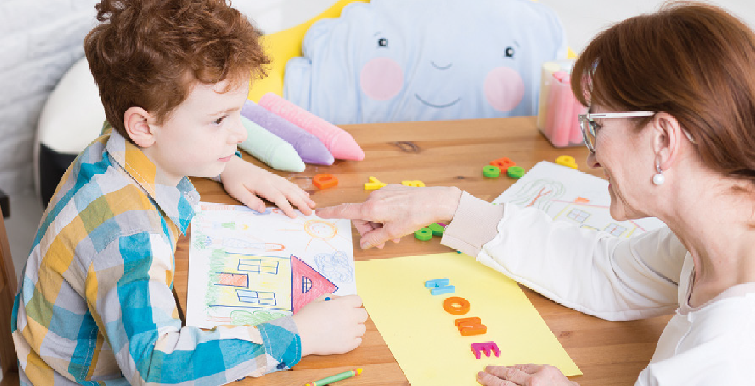

Working with Parents and Carers
Working in partnership with parents and carers is an essential component of a child centred approach. Children with an ASD work better with consistency and utilising the same approaches in early years settings and at home is very beneficial.

Issues from the setting can spill over into home life and vice versa so it is vital to ensure there is open communication between the two. A home – early years setting diary can be used to share relevant information on a daily basis.

Parents and carers of children with an ASD experience higher levels of stress. Caring for a child with an ASD can limit activities, impact on sleep and decrease parental self-esteem. Many parents and carers are not provided with training around ASD. A guide for parents and carers can be accessed at www.ASDinfoWales.co.uk/resource/Autism-English-download.pdf.

Many parents and carers find liaising with staff difficult. They sometimes feel as if staff are judging them, especially when the child seems to cope better at the setting than at home. Sometimes parents and carers feel that staff are not being honest, especially when only positive aspects of the child’s work and behaviours are conveyed to them in reports and at handover.

Developing a transparent relationship with parents and carers can be useful in earning their trust and building rapport. Providing accurate feedback is good starting point for this.

Toileting
When potty training, it is important to ensure that there is consistency in approach between home and the setting. An advice sheet is available for parents / carers here: www.ASDinfoWales.co.uk/advice-sheets.

When potty training a child with an ASD additional structure and visual cues will be needed along with a potentially non-social reward.

Children with an ASD prefer routines, they will reassure them and let them predict what is expected of them. To create a routine for potty training you will need to use a phrase or signal that indicates the child needs to use the potty – this should be the same phrase that is used at home. This could be a signal card, with a picture of a potty on it for example or just choose a phrase (be careful to choose one everyone will be happy to use) such as ‘potty time’ or ‘toilet time’.

Using a picture planner is quite important, you should try and use the same one as parents and carers. Pictures or images should be printed to visually represent the order of events. An example of this is on the next page:
You should recognise that

Planners should be kept near the potty where the child can easily see it.

There will be lots of accidents, don’t scold the child or pay too much attention to the accident. Clean up, be positive and try again.
As soon as the child does a pee or poo on the potty, reward them. For some children social praise such as ‘well done’ or putting a star on the chart. However, many children with an ASD do not respond to this sort of reward and you may need to use a physical reward such as a short activity that they enjoy.
As successes and rewards increase, the child will learn what is expected of them. For those children who are able to communicate they will begin to tell you or signal that they need to use potty. For other children, you may need to continue with a routine of encouraging the child to use the potty at regular times until they are able to communicate their needs to you.

Autism: A Guide for Early Years Settings

Page

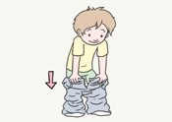
Pull trousers down

Sit on potty


Wipe



Pull trousers up

Wash hands


Dry hands
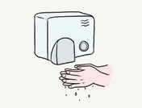

Reward




“If a child is having difficulties sitting with others, provide a quieter
area for the child to eat in.”

Eating
Many children with an ASD eat a limited variety of foods. This is usually linked to sensory issues some children may only eat foods of a certain colour or texture and smell of the food may be significant. If the child’s diet is severely restricted you should discuss referral to a dietician for further advice with parents.
However, many issues around eating in the early years setting can be addressed by adapting practice.
You should recognise that

If a child is taking a long time to eat their food use a visual timer and offer a reward
for eating within the time scale.

If a child is having difficulties sitting with others, provide a quieter area for the child
to eat in.

If the child is becoming distressed at lunch time ensure picture planners are in place and assess the sensory environment to see if this could be the cause of problems.
Work with parents to ascertain how difficulties are managed at home.

Accidents and injuries
Many children with an ASD dislike being touched and this can mean that administering first aid to cuts and grazes can cause significant distress. Also, children with an ASD sometimes have unusual responses to pain this may mean that the way in which they describe their pain is inaccurate and you should not rely on this. Another common symptom of autism is that children do not seek comfort when in distress, again you should not take this as a sign that the child is not injured.
You should

Explain to the child ahead of providing first aid, do not assume they understand what
you are about to do from your body language.

If the child is unwilling to let you provide minor first aid, call a parent to assist.

Inspect the injury rather than relying on the child’s description or reaction. Use pictures to help the child indicate which part of the body is hurting.
If in doubt seek medical attention.

Working with Challenging Behaviours
Understanding the Cause of Challenging Behaviours

All children display ‘challenging behaviours’ at some time because it is a way of communicating what they are thinking or feeling. Those with ASD may seem to display challenging behaviour more frequently than other children but this is because they see the world differently.

They do not always understand social rules, may have difficulty expressing themselves and may struggle to cope with changes in routine and understanding how others, all of which can lead to very stressful situations for them. This, together with any sensory issues they may have, can be overwhelming for them to deal with and their only way to cope and to let you know that they are struggling is through inappropriate or ‘challenging’ behaviour (sometimes described as tantrums, rage and meltdowns).

Anxiety is a common cause of challenging behaviours amongst children with an ASD. High levels of anxiety in children with an ASD are often a common feature.

Children with an ASD are typically unable to communicate their feelings of anxiety, and may present with behaviours that you do not typically associate with feeling worried or anxious.
These might include:

tantrums and aggressive behaviour

becoming withdrawn and resisting any interaction with others complaining of pain or illness
engaging in repetitive behaviours hurting self

Difficulties in understanding language, predicting others, sensory issues alongside other issues
can all cause anxiety, and this is why anxiety common amongst children with an ASD.

We all experience anxiety, it is part of our everyday life and we all react to stressful situations in a way which is personal to us, but the symptoms of anxiety are often similar. Think of a time when you have felt anxious, you may have experienced feelings such as being scared, panic, increased heart rate, sweating, sickness, not knowing where to turn or what to do next, loss
of confidence etc. These are unpleasant feelings and can impact our mood, energy levels and behaviour, so imagine what it must be like to feel anxious every day of your life but not understand why.
Common situations that trigger anxiety are: meeting strangers
being given too many choices

not being able to communicate their needs changes in routine
new activities or places

experiencing unpleasant sensations, eg dog barking, flashing lights, crowded and noisy
environments, overpowering smells

transition from one activity to another - even small transitions

trauma - remembering unpleasant events eg having a haircut, seeing the dentist or doctor, which when being asked to repeat makes them anxious

Sometimes, children with an ASD can be anxious about more than one thing at a time.

Before attempting to address challenging behaviours, it is essential that you identify the causes and / or reinforcing factors. Without doing this, your interventions may lead to increased distress and a likely worsening of behaviours.

Following this you may need to consider if there is also often a function or purpose to the behaviour, and anything that may be reinforcing this.

Step 1 - Track and Analyse Behaviours over a Period of 1 – 2 Weeks
To do this, you will need to record the ABC of the challenging behaviour using a chart, as follows.

Antecedent (what happens before)

This is often the trigger for the behaviour. This can sometimes be clear-cut such as somebody saying ‘no’ to a request but in individuals with ASD it can be more difficult to identify because the cause may be related to sensory issues such as loud noises or specific sounds or related to the need for predictable routines. It is therefore important that you record all relevant information including time, environment, what was said etc...

Behaviour

In this section you will need to record details of the behaviour, without judgement or assumptions.
Describe the behaviour rather than jumping to conclusions as many individuals with ASD have difficulties in expressing their feelings in an appropriate way. For example, anxiety may present as worry but could also present in repetitive behaviours or aggression.

Consequence (what happens after)

Often the consequence or outcome of the behaviour can provide clues as to what the child is feeling, by showing what the child is trying to achieve. Consequences can often be reinforcing the behaviour. Even if the consequence is negative attention, it is still attention…
An example of an ABC recording chart is shown below.

Date and time | Antecedent | Behaviour | Consequence

Step 2 – analyse the antecedent, what could be triggering the behaviour?
It is useful to use the CRISIS acronym to consider the main issues that may be triggering challenging behaviours in a child with an ASD.

Communication – did the child understand? Has the child misunderstood?

Routines – has there been a change in routine? Has the child been supported to know the routine?

Interaction – has there been a social misunderstanding? Does the child understand what is expected?

Sensory Issues – is there an increase / change in sensory stimuli?

Imagination – have impairments in social imagination caused the issue?

Subjective attribution of behaviour – are you treating the child as ‘naughty’ and not supporting?

An example
The Specific Behaviour:
Shouting during story time.

The possible reasons / underlying difficulties:
Communication
I can’t understand the story, is the adult talking to me? I feel anxious, but I don’t understand these feelings and can’t tell anyone about it.
Routines
We don’t usually have story time at this time of day, we usually play in the sand pit – I don’t like things changing.
Interaction
I don’t understand what you expect from me — why do we have to sit on the carpet? Why is everyone being quiet, are they ignoring me?
Sensory
When I sit on the carpet, other children are touching me and I don’t like it. There are lots of
facial expressions and fidgeting, I can’t cope with it all.

Imagination
I don’t ‘get’ the story. It’s just words to me, I can imagine how the characters are feeling or why they are doing what they are doing – it’s all irrelevant to me so I am bored.

Why are we waiting? I thought it was nearly home time, I want to go home now – stop the story so that I can go home.
Subjective judgement of cause of behaviour
The adult thinks I am just being naughty and is punishing me rather than helping me.

By recording ABCs of behaviour in this way, you will be able to identify patterns which will help you to explore triggers and reinforcers.

In the above example, there are clear triggers for the behaviour relating to the child’s lack of understanding.

If the child’s behaviour is appropriate even if it is undesirable (for example becoming anxious around a change in routine) you should not try to change the behaviour, but rather change the environment. If sensory issues are the cause of the unwanted behaviour, altering the environment will also be the way to move forward. Where there are clear triggers, that
are related to the child’s ASD, you should always put in additional support and alter the environment to prevent the behaviour reoccurring.

Step 3 - Working on Behaviour Directly
If the behaviour is not appropriate or desirable you may need to start some work around changing the behaviour.

When implementing a behavioural approach, remember the principle.
If you reward a behaviour you will see more of it.

This works for both positive and negative behaviours, for example if you reward a positive behavior with a treat, the child will be more likely to repeat the behavior. However, if you have a child that dislikes attending the early years setting, and then you reward aggression by sending the child home, the child will be more likely to repeat the behavior to obtain the reward.

Sometimes, the ‘reward’ for a behaviour is the attention you give to it. This includes negative attention such as shouting, statements of disappointment or lengthy attempts at problem solving.

In an individual with ASD the picture can be even more confusing, for example if the individual prefers to spend time alone, using ‘time out’ as a punishment could be rewarding. It is therefore important that you take the individual into consideration when deciding on how to give or remove rewards for a behaviour. When managing an individual with an ASD behaviour, it is important that you adapt your communication as discussed earlier.

When trying to decrease an unwanted behaviour, it is important that you teach a new way of behaving appropriately at the same time. This will prevent other negative behaviours
developing. To do this you will need to remove all rewards from the unwanted behaviour and look for ways to reward a behaviour that is wanted.

For example, ignore the child when they interrupt you talking by asking for something, but respond immediately if they say ‘excuse me’. In this situation the individual will learn that they will only get the response they are seeking by saying ‘excuse me’ first.

Use your ABC chart to help to identify the unwanted behaviour, and ensure you have clarity about this before you start. Many behaviours are grouped together and you need to be sure you are addressing one at a time. For example, if a child is frequently becoming aggressive to leave class, do you want to work on the aggression? Or is leaving the class the main problem?

Be sure to recognise your own thoughts and feelings around the issue, and ensure they are not impacting on your management of the behaviour.

In order to help the learning of new behaviours it is important that your response is clear and consistent, you must respond in the same way each time, and ensure that others are following the same plan too.

When children have complex behaviour issues, it can be difficult to plan your approach alone. It may be worthwhile seeking support from your local advisory team, or other professionals involved.

Using Reward Programmes
Reward programmes can be very effective in reinforcing positive behaviours. Implemented as ‘star charts’, or other systems, reward programmes must follow the same principles. When used incorrectly, reward programmes will have little effect, and may even contribute to a decrease in self-esteem and worsening of behaviour.

Here are some basic rules that must be implemented when using a reward programme.

To ensure motivation, goals must be clear and achievable.

The reward needs to be interesting to the child, and not be available regularly to them. For example, a child will be unlikely to work hard to earn a trip to a fast food restaurant if the family eat there regularly anyway.
Start small, the child needs to achieve the reward before you make the task more
difficult.

Don’t address more than 2 behaviours at a time.

For children with an ASD, the ‘social reinforcement’ (statements of pride, congratulations) may not be useful. Instead use a structured reward such as extra play time, trips out or access to favourite activities.
Use a visual cue to help understanding, increase self-esteem and keep an accurate record. This can be in the form of a star chart, points system recorded in a journal or even making puzzle pieces out of a picture and issuing one each time the target is achieved.
If you lose enthusiasm, so will the child – ensure you visit the reward programme at regular intervals.
Plan ahead. The reward needs to be given near to the point at which it is earned.

Reward programmes only work on behaviours you want to see ‘more of’, the expected behaviours must always be worded positively (e.g. ‘using a calm voice’ rather than ‘not shouting’).
The behaviour to be rewarded must be specific and if necessary time limited (e.g. you will earn a star for brushing your teeth for 2 minutes, or behaving calmly for 1 hour; rather than you will earn a star for being good today).
If the child has completed the target behaviour, the reward should be given – irrelevant to anything else that is going on. (i.e. if you stated that the child would earn a star for brushing their teeth, and they brushed their teeth and then kicked you they must still get the star).
You must never, ever remove rewards that have been earned. To a child, there is very little point in working to earn rewards if they can be removed on a whim, and by doing this you are actually reinforcing negative behaviours.

Reward programmes can be very effective if used in the correct way. Ensuring that you take into account the child’s strengths and difficulties is the key to a successful outcome.

To reiterate, it is essential that you ensure the behaviour is not an appropriate response for that child before implementing behaviour interventions. Most children with an ASD will respond better to preventative interventions.

For further information
www.ASDinfoWales.co.uk is the National website hosted by the National ASD Development Team within the WLGA in partnership with Public Health Wales and funded by Welsh Government. The website provides information and resources for individuals with ASD and those supporting them, including parents and carers and professionals.

