Module Title: International Meetings Management for the Hotel Industry
Module Code: BMIH6007
Assignment 1: Feasibility Plan for an International Meeting. Individual Presentation
Student Name and ID: Rukshana Begum 2120527
Lecturer Name: Kathryn Flynn

Slide 1: Cover Page
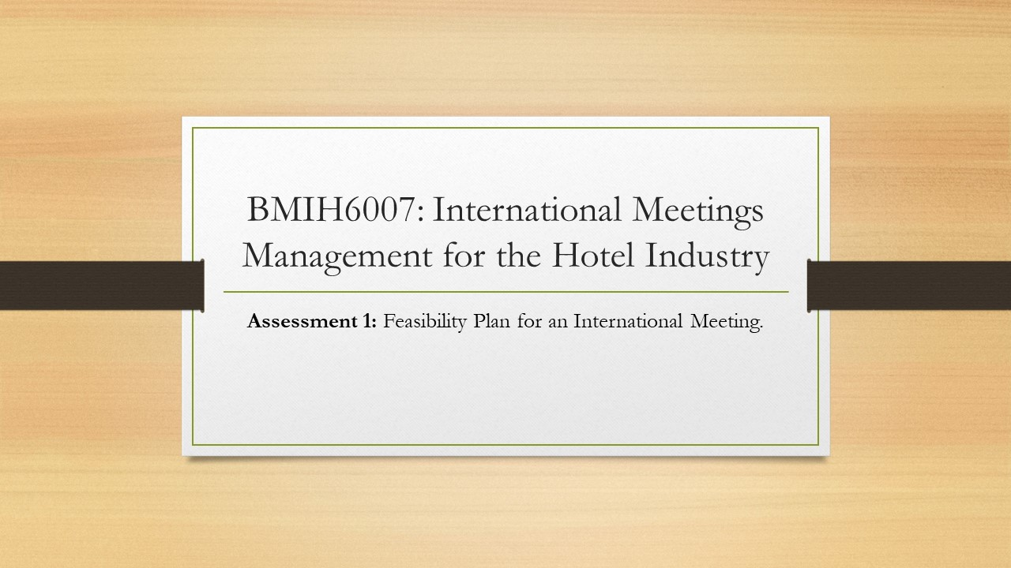
Slide 2: Introduction
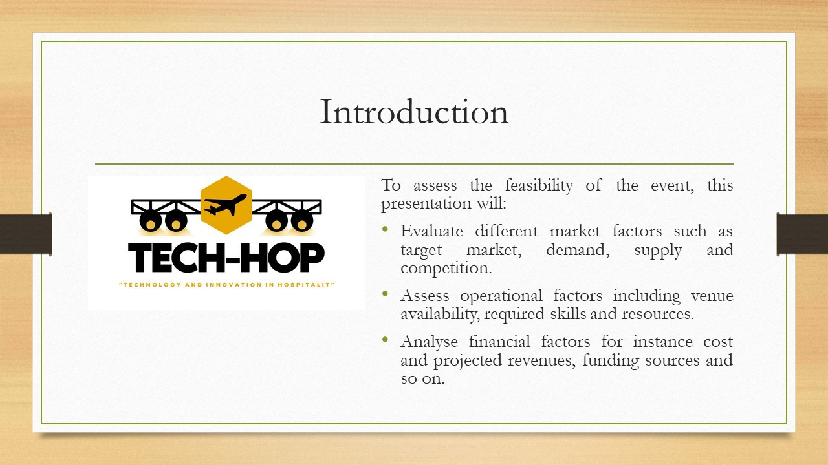
The proposed events for the MICE industry of the hospitality sector of the UK will be named Tech-Hop. It will have speakers from different companies in the industry to come and talk about technology and innovation in the hospitality sector. The structure of the event will be educational to the private sector which is why it will have the aim of creating profits (Volkova, 2018).
Slide 3: Market factors
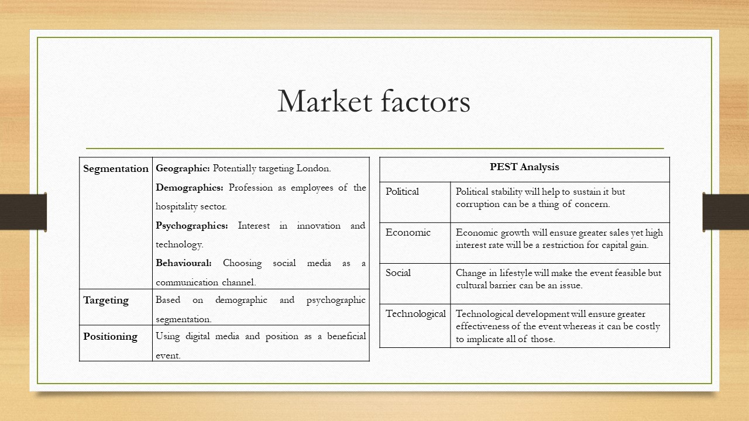
Target market and demand
There are many segmentations of target audiences to choose from, however, the event Teach-Hop will target the audiences who work in the hospitality sector and who have an interest in learning about technology and innovation in their particular industry (Dibb and Simkin, 2018). The reason is, that selecting such audiences will ensure the maximum possible attendance at the event. Furthermore, the positioning strategy will give the event acknowledgement and recognition. That is why the demand for the event is expected to be high (Meredith, 2022). A primary influential factor for his prediction is, that people’s interest towards technology is growing and technology and innovation are becoming a part of every industry (Jung, 2022). The analysis of the external market via PEST shows most of the elements are in favour of Tech-Hop which makes the event more feasible (Chan, Snape and Redman, 2023).

Slide 4: Market factors (Cont.)
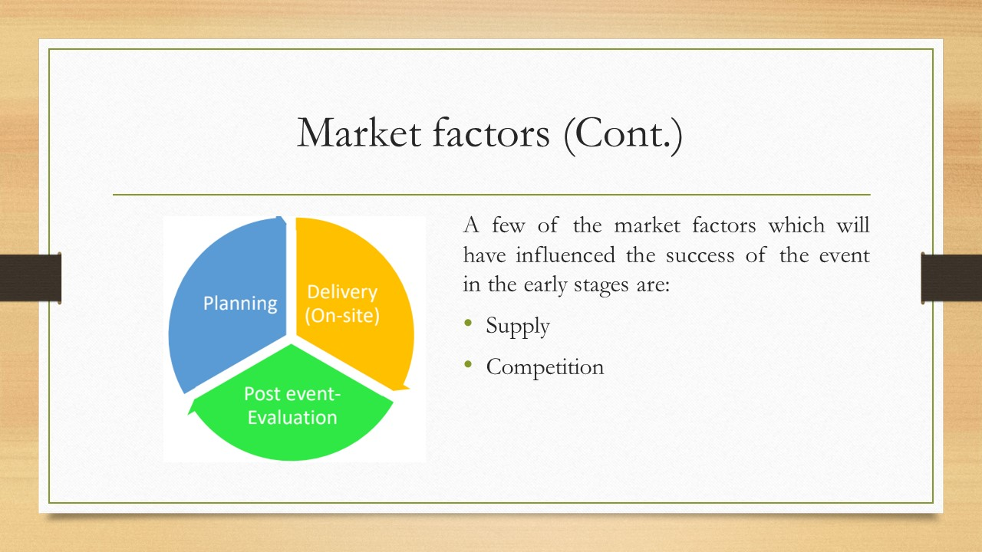
The event will follow the three phases of the event cycle following which planning will be done and delivery of the actions will be done on-site (Tiew and Holmes, 2022). After that, the post-event evaluation will also be held which will ensure the effectiveness of the event. However, certain factors can influence its success which are discussed below.
Supply: As the proposed event is forecasted to have high demand due to the effective as well as careful selection of the target market, the topic itself everything that will be required to successfully organise and retain the event will be ensured. This may include resources, investment, workforce and so on which ensure the fulfilment of supply for demand and the success of the event (O’Toole, 2011).
Competition: Research has been done and such time as well as place have been selected in which no similar event has been appointed (BDO, 2019). Nonetheless, events for different industries can be a thing of concern for Tech-Hop. In spite of that, the unique approach and theme of the proposed event as well as accurate planning with help increase the chances of success for Tech-Hop (Smith, 2012).

Slide 5: Operational factors
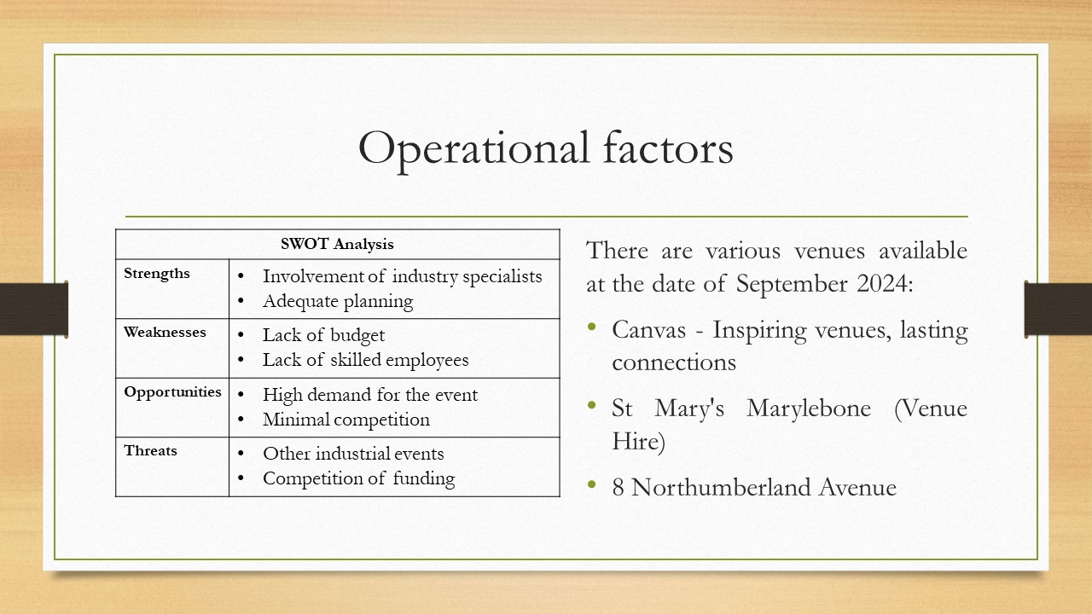
Venues are the host building which offers rental services for short-term events to be held in such places (Bower, 2019). In the proposed location of London, a lot of venues are available on the date of 25 September 2024. However, most of these are very costly and can increase the required investments for the event. That is why the venue Canvas - Inspiring Venues, Lasting Connections has been selected for the proposed event. The venue offers large space with different facilities and areas which are sectioned for dedicated use, the cost of rent indicates value for money and the location of the venue is near the main road which makes it easier to access (Fox et al., 2014). This will help to attract more audience and encourage them to attend the event and help the proposed event to succeed. Furthermore, SWOT analysis indicates the company will be able to grasp the opportunities and mitigate threats with their strengths. However, their weaknesses affect the success of the event (Stacy, 2020).

Slide 6: Operational factors (Cont.)
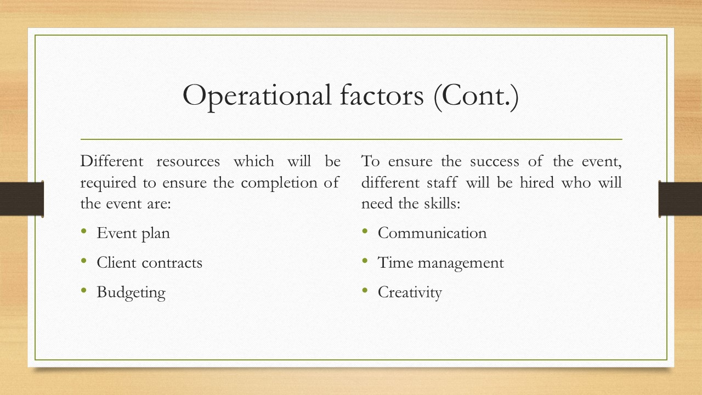
The objectives of the event will be:
- To sell at least 500 tickets on the first day.
- To ensure increment of sales by 10% each day for 7 days.
Required skills of the staff
The skills including time management, communication and creativity will be given priority (Meganck, Smith and Guidry, 2020). The reason is, that time management skills will allow all the activities of the event to be completed within the specified time period, communication will allow the staff to be clear about their goals and work effectively and creativity skills will help them to come up with new and unique ideas which will help them to attract and retain audiences ensuring the success of the event (Padron and Stone, 2020).
Required resources
The resources that will be given the most priority include event plans, client contracts and budgeting (Miranda, 2021). The event plan will be the first rescue which will be obtained that will work as a guideline for all future activities. Additionally, the rescue of client contracts will help to forecast the success of the event and send invitations to the audience as well as potential clients of sponsorships (Getz and Page, 2019). Furthermore, the resources for budgeting will be ensured to control the expenses and produce maximum profitability.

Slide 7: Financial factors
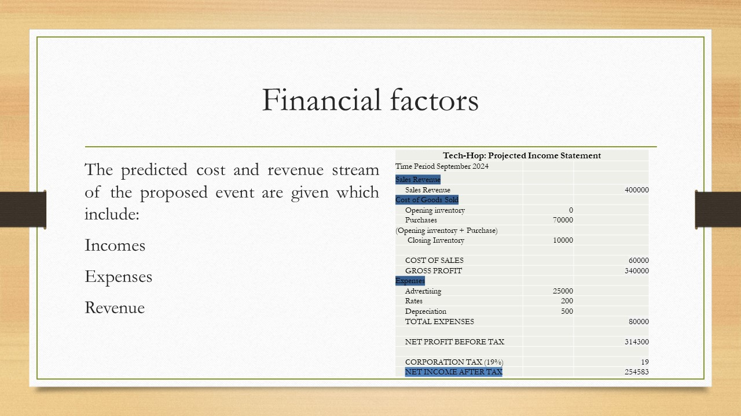
Ensuring various streams of income is crucial for the profit and success of an event. That is why the proposed event Tech-Hop will not rely on a simple source of income rather it will use a diversification strategy (Jung, 2022). The event will also take sponsorships from different brands which will offer them incentives in exchange for portraying their brand logo and other material at the event. However, the event will have to bear a lot of expenses as well which will include wages, rent, supplies and many more. Despite all the factors, the event will be able to create a revenue of over 254,583.

Slide 8: Financial factors (Cont.)
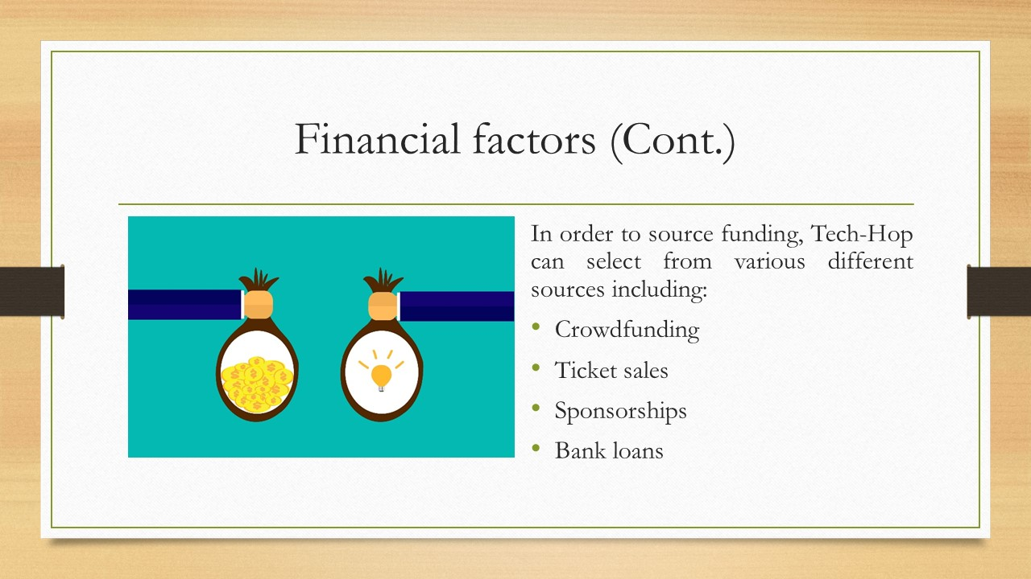
Crowdfunding: Crowdfunding is a recent innovation of modern technology which uses different platforms to present an idea and ask people for investment. This is an effective way to raise high investments. However, it can take a lot of time to happen which is why Teach-Hop will not use this as a source (Kazmierska, 2019).
Ticket sales: Selling the tickets to collect funding beforehand is one of the most traditional ways of funding in event management (Lenz, 2021). So, the proposed event will use this as a source of funding which will not only allow them to raise funds but also ensure attendance of the audience.
Sponsorships: Another funding source that the proposed event will use is sponsorship. It is a type of advertisement facility that the event holders provide in exchange receives money (Klein, 2018). This is very effective as it does not require any interest or payback.
Bank loans: Taking loans from a bank to fund events can be a source of funding. However, Tech-Hop will try to avoid this. As the cost of capital can become too high it can rescue overall profitability (Rogers and Wynn-Moylan 2022).

Slide 9: Conclusion
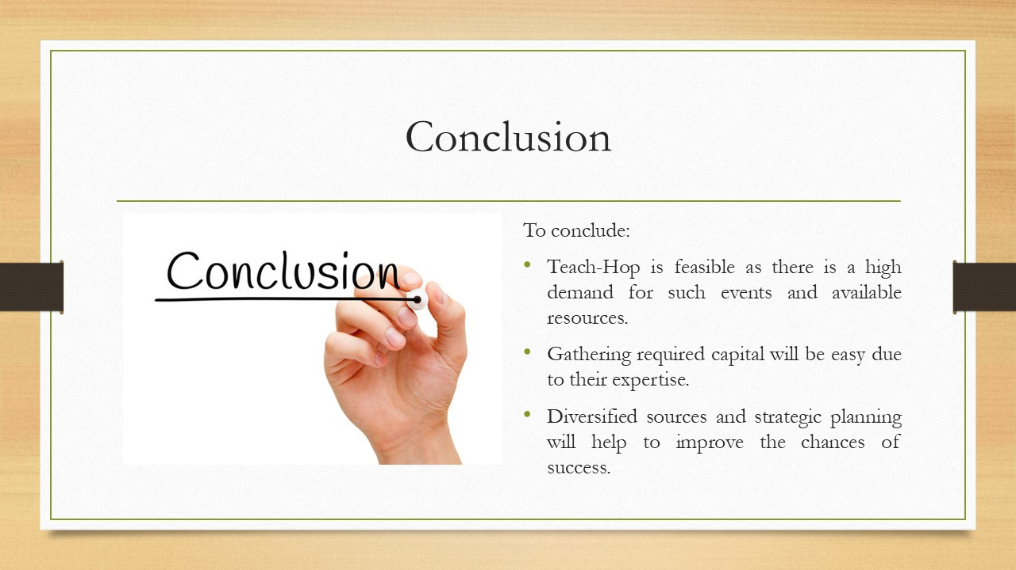
The proposed event Tech-Hop will organise their event in London in which speakers from different companies in the hospitality industry will come and speak. They target audiences who work in the industry and are interested in the subject which will create high demand. However, the event will ensure migration of the demand while having low competition. Various ventures are available at the specified time and location however the most value-for-money venture will be chosen along with skilled employees. Required resources will be ensured. The event will diversify their source of funding and income which will result in high revenue which indicates the feasibility of the proposed event.

Slide 10: Reference List
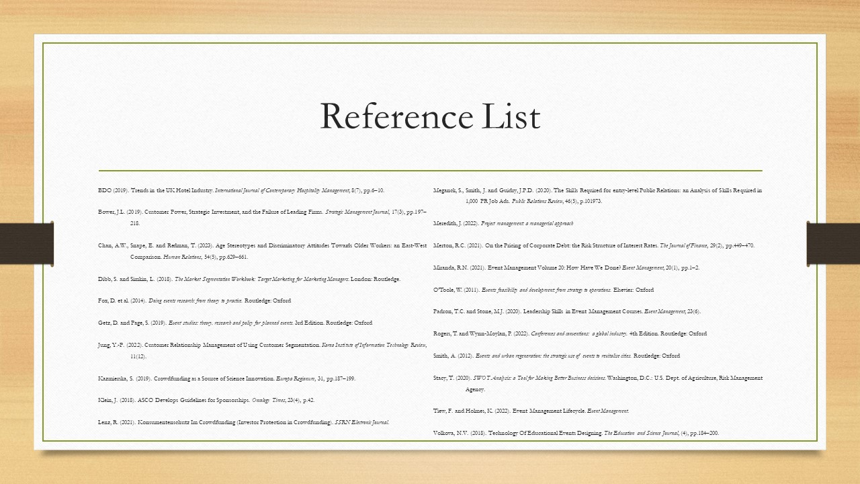
BDO (2019). Trends in the UK Hotel Industry. International Journal of Contemporary Hospitality Management, 8(7), pp.6–10.
Bower, J.L. (2019). Customer Power, Strategic Investment, and the Failure of Leading Firms. Strategic Management Journal, 17(3), pp.197–218.
Chan, A.W., Snape, E. and Redman, T. (2023). Age Stereotypes and Discriminatory Attitudes Towards Older Workers: an East-West Comparison. Human Relations, 54(5), pp.629–661.
Dibb, S. and Simkin, L. (2018). The Market Segmentation Workbook: Target Marketing for Marketing Managers. London: Routledge.
Fox, D. et al. (2014). Doing events research: from theory to practice. Routledge: Oxford
Getz, D. and Page, S. (2019). Event studies: theory, research and policy for planned events. 3rd Edition. Routledge: Oxford
Jung, Y.-P. (2022). Customer Relationship Management of Using Customer Segmentation. Korea Institute of Information Technology Review, 11(12).
Kazmierska, S. (2019). Crowdfunding as a Source of Science Innovation. Europa Regionum, 31, pp.187–199.
Klein, J. (2018). ASCO Develops Guidelines for Sponsorships. Oncology Times, 23(4), p.42.
Lenz, R. (2021). Konsumentenschutz Im Crowdfunding (Investor Protection in Crowdfunding). SSRN Electronic Journal.
Meganck, S., Smith, J. and Guidry, J.P.D. (2020). The Skills Required for entry-level Public Relations: an Analysis of Skills Required in 1,000 PR Job Ads. Public Relations Review, 46(5), p.101973.
Meredith, J. (2022). Project management: a managerial approach
Merton, R.C. (2021). On the Pricing of Corporate Debt: the Risk Structure of Interest Rates. The Journal of Finance, 29(2), pp.449–470.
Miranda, R.N. (2021). Event Management Volume 20: How Have We Done? Event Management, 20(1), pp.1–2.
O’Toole, W. (2011). Events feasibility and development: from strategy to operations. Elsevier: Oxford
Padron, T.C. and Stone, M.J. (2020). Leadership Skills in Event Management Courses. Event Management, 23(6).
Rogers, T. and Wynn-Moylan, P. (2022). Conferences and conventions: a global industry. 4th Edition. Routledge: Oxford
Smith, A. (2012). Events and urban regeneration: the strategic use of events to revitalise cities. Routledge: Oxford
Stacy, T. (2020). SWOT Analysis: a Tool for Making Better Business decisions. Washington, D.C.: U.S. Dept. of Agriculture, Risk Management Agency.
Tiew, F. and Holmes, K. (2022). Event Management Lifecycle. Event Management.
Volkova, N.V. (2018). Technology Of Educational Events Designing. The Education and Science Journal, (4), pp.184–200.

