Assignment Title | Stakeholder Engagement in the Implementation of Green Technology and Digital Transformation at Marriott International London
Student Name: | Hammad Talib
Student Number: | 2423857
Lecturer Name: | Aso Abdullah

Contents
1.0 Introduction 4
1.1 Company Overview 4
1.2 Project Context 4
1.3 Purpose of the Report 5
2.0 Marriott International SWOT and PEST analysis. 5
2.1 PESTLE Analysis 5
2.1.1 Political and Legal Factors 5
2.1.2 Economic Factors 6
2.1.3 Social Factors 6
2.1.4 Technological Factors 6
2.1.5 Environmental Factors 6
2.2 SWOT Analysis 7
2.2.1 Strengths 7
2.2.2 Weaknesses 7
2.2.3 Opportunities 7
2.2.4 Threats 8
3.0 Determination of Key Stakeholders. 8
3.1 Internal Stakeholders 8
3.2 External Stakeholders 9
4.0 Roles, Responsibilities, Benefits and Challenges. 10
4.1 Roles and Responsibilities 10
4.2 Benefits 10
4.3 Challenges 11
5.0 Engagement Frameworks, Models and Theories. 12
5.1 Stakeholder Matrix of Mendelow. 12
5.2 RACI Matrix 13
5.3 Communication Plan 13
6. Project Manager’s Process: The 4C’s and Conflict Management 14
6.1 Communication 14
6.2 Consultation 15
6.3 Collaboration 16
6.4 Commitment 16
6.5 Conflict Management 17
7.0 Impact Assessment and Future Recommendation. 17
7.1 Influence on Business Performance. 17
7.1.1 Financial Impact 17
7.1.2 Reputational Impact 18
7.1.3 Operational Impact 18
7.2 Future Recommendations 19
7.2.1 Creation of Stakeholder Advisory Board. 19
7.2.2 Investing in Continuous Training Programs. 20
7.2.3 Application of a Real Time Feedback Loop. 20
8.0 Conclusion 21
References 22

1.0 Introduction

1.1 Company Overview
Marriott international is a global top hospitality organisations that has thousands of properties in various countries with a wide range of luxury and high end hotel brands. Marriott has a good representation in London with the well-known hotels like the London Marriott Hotel County Hall and London Marriott Hotel Park Lane. Through these hotels the organisation demonstrates its desire to provide high quality services, accommodation facilities and experiences to the guest that should not be forgotten. Marriott is an organization that has to invest a lot in innovation and sustainability to enhance its competitiveness in the global and London hotel markets.


1.2 Project Context
The Green-Tech Integration project is a strategic plan that is formulated to be used to facilitate the effectiveness of operation and improve satisfaction among guests in all properties of Marriott in London. The project is aimed at the use of environmentally friendly technologies, such as energy-saving infrastructure, artificial intelligence-based automation of services, and digital services without contacts. The purpose of these developments is to lessen environmental impact, facilitate the sustainability and Net Zero goals of the United Kingdom and react to the growing trend of environmentally conscientious traveling among the consumers. The project aims at maximising the use of resources, minimising the expenses of the long-term operations and the reinforcement of the brand image of Marriott as a sustainable hospitality leader.


1.3 Purpose of the Report
This report aims to discuss the value of the stakeholder involvement in the successful implementation of the Green-Tech Integration project. The stakeholders are very important in shaping the results of projects since they comprise the employees, investors, guests, suppliers and regulatory authorities (Schoenung, et al. 2023). Stakeholder management will enhance better communication, minimise opposition to organisational change and make sure that project goals and objectives meet the expectations of the stakeholders. This report, based on a stakeholder role and interest analysis and involvement tactics, outlines the contribution of a structured approach towards stakeholder management to the effectiveness of the sustainability and technological transformation programs of the Marriott hotel chain and its long-term success.

2.0 Marriott International SWOT and PEST analysis.

2.1 PESTLE Analysis

2.1.1 Political and Legal Factors
Marriott International has been working under the regulatory framework in the United Kingdom that has been changing since Brexit. The alterations in the labour laws and immigration policies affect the labour force recruitments and retention in the hospitality industry in London. Besides, Marriott should adhere to the General Data Protection Regulation (GDPR), especially when adopting digital guest services and AI-based technologies, which need to gather and keep the customer data. Legal security and protection of customer trust are guaranteed by compliance (Imeri, et al. 2025).

2.1.2 Economic Factors
The economic condition such as inflation and changing tourism demand have profound effects on the operations of Marriott in London. The increased operational costs in terms of energy prices, wages and supply chain costs impact on profitability. London is however a tourist destination in the world and luxury accommodation has continued to offer revenue prospects, particularly to the international travellers and business tourists (Queirós, 2023).

2.1.3 Social Factors
The trend existing in the consumer preferences is towards the environmentally friendly travel and individualised guest experiences. The contemporary traveller is becoming more and more selective in the hotels they stay in that must be responsible to the environment with their practices and be digital in amenities (Talukder, 2025). The Green-Tech Integration project that is implemented by Marriott is in line with these evolving customer expectations and assists in retaining customer loyalty and relevance to the brand.

2.1.4 Technological Factors
Artificial intelligence, mobile apps, and contactless services are some of the technological changes that are transforming the hospitality industry (Inavolu, 2024). The investment of the digital service platforms by Marriott makes the work of the company more convenient and effective to the guests. Nevertheless, regular technological upgrades take a lot of money and employee training.

2.1.5 Environmental Factors
The UK adherence to Net Zero carbon targets affects the regulations in the construction sector and energy consumption rates (Zamparini, 2025). Marriott needs to embrace the use of sustainable technologies to minimize carbon emission and energy consumption. Environmental compliance also boosts the brand image of Marriott as a good and eco-friendly organisation.
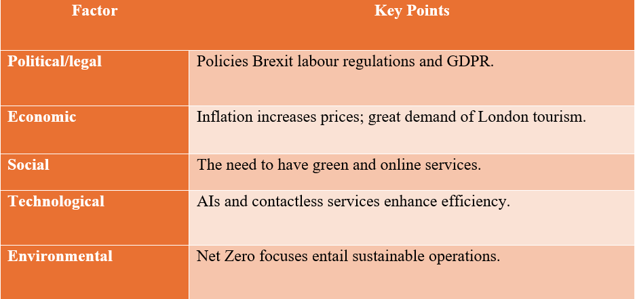

2.2 SWOT Analysis

2.2.1 Strengths
Marriott International enjoys the benefits of good brand recognition around the world, customer loyalty in the form of Marriott Bonvoy programme, and prime positioning of hotels in London, which appeal to leisure and business travellers (Iranmanesh et al., 2022).

2.2.2 Weaknesses
The expenses of operating and maintaining business in central London are also high, which put a financial strain especially where the adoption of sophisticated technologies and sustainability programs are required.

2.2.3 Opportunities
The increasing need to implement sustainable tourism and digital transformation creates potential opportunities to Marriott as the company can improve the experiences of its guests, decrease the operational expenses over the long term, and increase the services of the company that are environmentally responsible.

2.2.4 Threats
The growing competition of boutique hotels and alternative accommodation providers like Airbnb, plus rapidly developing customer demands, demand constant innovations and the enhancement of services at Marriott.
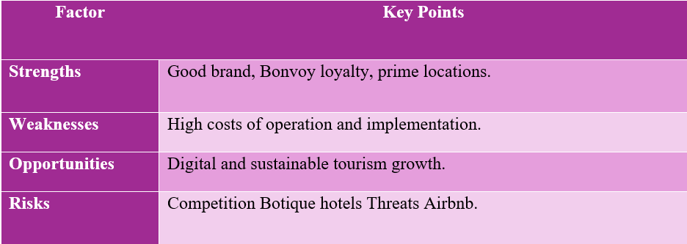

3.0 Determination of Key Stakeholders.
The stakeholders are very crucial in the effective execution of the Green-Tech Integration project by the Marriott International (Owusu et al., 2022). These stakeholders could be classified as either internal or external ones and each of them plays a different role in the development of the project, its execution, and final success.

3.1 Internal Stakeholders
The internal stakeholders are Product Development Team, Marketing and Sales Departments, and Front-of-House and Operations Staff. The Product Development Team is made up of IT experts and a sustainability expert and is tasked with the design and development as well as implementation of the green technologies and digital systems. Their position will make sure that the technology is in line with the operational standards and sustainability goals of Marriott.

Marketing and Sales Departments are critical towards popularizing the Marriott environmental friendly programs. Their role is to convey the advantages of Green-Tech Integration project to the customers, build stronger brand image, and appeal to eco-friendly travellers. Their advertising policies enable them to maximise the commercial advantages of the project.
Front-of-House and Operations Staff directly work with the delivery of services to the guests and the functioning of the newly introduced technologies. Their communication with customers will be smooth to implement the project. They also give useful feedback on the usability and efficiency of new systems and assist the management to make the required changes.

3.2 External Stakeholders
The external stakeholders are hotel guests, suppliers and technology providers, local governments and regulatory bodies, and franchise owners/investors. Another major beneficiary of the project is the hotel guests, especially the members of the Marriott Bonvoy who are the ones who enjoy better quality of services, convenience, and eco-friendly hospitality services.
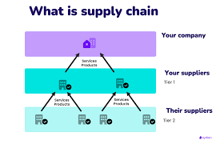
The equipment, software and technical know-how that are needed to implement the green technologies are supplied by the suppliers and technology vendors. The success of the project is directly related to their reliability and innovativeness. Regional authorities and local governments like Greater London Authority make sure that Marriot is adhering to the environmental laws, and construction standards. Franchise investors and owners are very important decision-making stakeholders because they help with funding and prefer long-term returns because of cost-savings and high property value.

4.0 Roles, Responsibilities, Benefits and Challenges.
The successful execution of the project of Green-Tech Integration of Marriott International needs the definition of roles and responsibilities of the stakeholders. Incorporated coordination means that technological improvements, sustainability goals, and enhancements of quality of services are met effectively without causing serious disturbances to the work of hotels.

4.1 Roles and Responsibilities
Planning, designing and implementation of the green technologies is done by The Product Development Team which comprises IT specialists and experts in sustainability. Their responsibilities include choosing appropriate energy-saving systems, installing artificial intelligence solutions, making sure that all technologies correspond to the standards used in the operations of Marriott and its environmental practices. They offer technical assistance and maintenance of systems as well.
The Front-of-House and Operations Staff will also operate the new digital and automated systems and the daily guest interactions. They are supposed to support guests with the use of contactless services, quality of service, and inform about issues related to operations. The members of staff also benefit the management by giving them practical input on the performance and usability of the system.
The Marketing and Sales Departments will be engaging in promoting the sustainability efforts of Marriott and informing customers about the benefits of the project of Green-Tech Integration. They create promotional messages that emphasize environmentally friendly activities of Marriott and contribute to the selection of environmentally friendly travellers and building brand image.

4.2 Benefits
The project has a number of positive attributes to the stakeholders. The automation and digital systems have helped hotel employees reduce their workload, enhance efficiency and employees do not have to work on manual work but rather concentrate on how to deliver personalised guest services (Zade and Sethi, 2024). The reduced use of energy and low costs of operation as well as high value of property in the long run are benefited to the investors and franchise owners. The guests receive higher levels of convenience, faster services, and environmental friendly accommodation and this enhances customer satisfaction and loyalty.
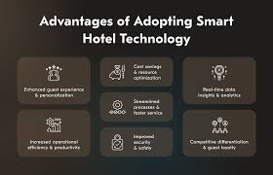

4.3 Challenges
The project also has issues despite its merits. The possibility of resistance to change might arise in employees who are afraid of being displaced in their jobs or employees who cannot easily embrace new technology. This can have an impact on productivity and speed of project implementation. High initial investment on advanced technologies and upgrades on the infrastructure can cause financial problems (Khatter, 2023). Franchise owners are likely to be worried about the short-term financial risks regardless of the long-term cost savings. Moreover, the problem of technical integration and training can lead to the temporary interruption of operations, which will have to be supported by the management and well-established communication strategies to make the project adoption successful.
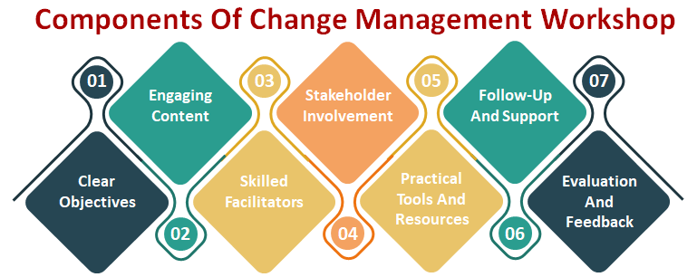

5.0 Engagement Frameworks, Models and Theories.
A successful implementation of the Green-Tech Integration project by Marriott International needs a proper stakeholder engagement. There are numerous participation structures, models, and theories that can be used to determine what the stakeholders expect, outlin the obligations, and secure proper communication in the project lifecycle. Use of structured engagement tools enables Marriott to reduce resistance, enhance collaboration and attain project goals on an efficient basis.

5.1 Stakeholder Matrix of Mendelow.
The Stakeholder Matrix identified by Mendelow is one of the most popular methods to classify the stakeholders according to the intensity of power and interest in a project. This paradigm will assist Marriott in prioritising stakeholder engagement strategies and distribute resources well (Alsayyed et al., 2025). High-power and high-interest stakeholders, including investors and franchise owners, are considered to be under the close management category. These stakeholders need frequent update, participation in decision making and comprehensive performance reports since they play an important role in funding and approval of a project.
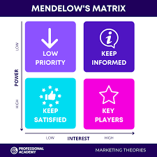
Stakeholders who have high power and less interest like regulatory bodies fall under the category of Keepsatisfied. Marriott should make sure that they adhere to the rules of the environment and the legal premises in order to retain their patronage. Highly interested yet less powerful stakeholders including hotel staff and guests should be kept informed via training, internal meeting and customer communication platforms. The general public and the local communities normally belong in the Monitor category where by little yet regular information dissemination is enough.

5.2 RACI Matrix
Another engagement framework used to explain the duties of the stakeholders is the RACI Matrix, which groups the stakeholders into Responsible, Accountable, Consulted and Informed. In the Green-Tech Integration project, Product Development Team mainly deals with the implementation of the technology solutions. Top management and head of the project is still responsible in the overall project success and also strategic decision-making. The consultations with hotel staff, marketing teams, and vendors are done to make sure that the technology meets the operational and customer service needs. Investors and the regulatory authorities are updated on the progress of the project, its performance and compliance.
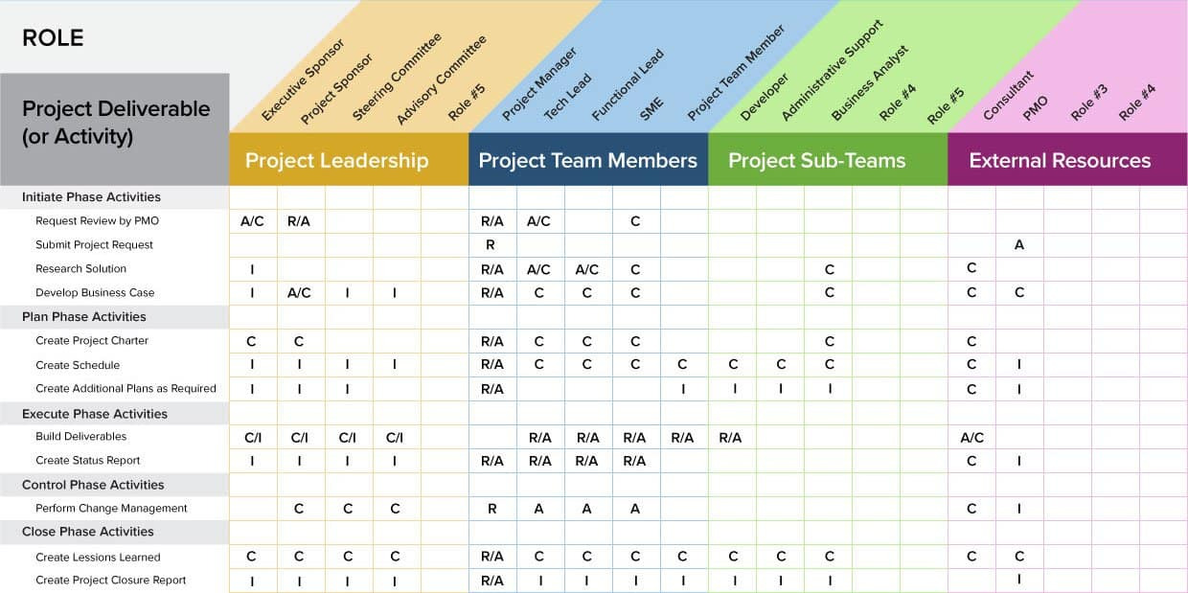
A RACI Matrix will help minimize role confusion, enhance accountability, and enhance coordination among the stakeholders. It also promotes effective decision-making whereby there is a clear definition of roles and good organization of communication channels.

5.3 Communication Plan
The stakeholder engagement requires a well-organized communication plan to ensure the stakeholders remain involved throughout the project. Marriott employs the customized communication plans to meet the needs of the various stakeholder groups. The internal communication will involve staff training workshop, team meetings and town hall meetings to clarify the objectives of the project and changes in technology. These communication channels will foster involvement in staff and minimize opposition to change.
Programs to communicate with the external audience encompass newsletters, online marketing campaigns, and updates via Marriott Bonvoy platform to notify guests regarding sustainability programs. The transparency to the investors and regulation bodies are maintained through formal reports, performance reviews, and stakeholder meetings. Through the numerous communication channels, Marriott will be able to establish a steady flow of information, contribute to the development of the trust between the stakeholders, and contribute to the effective implementation of the Green-Tech Integration project.

6. Project Manager’s Process: The 4C’s and Conflict Management
The Project Manager is very instrumental in the successful delivery of the Green-Tech Integration project of Marriott International. The use of modern technologies and sustainability programs also presupposes high levels of coordination of stakeholders, formal communication, and the development of effective conflict management approaches. The 4Cs model of Communication, Consultation, Collaboration, and Commitment application offers an organized approach that facilitates the involvement of the stakeholders and the success of the project (Thornhill-Miller et al., 2023). The conflict management strategies are also used to overcome interdepartmental, stakeholder and operational team disagreements.

6.1 Communication
Successful project management as well as stakeholder engagement relies on communication. It is important that the Project Manager should care about clear communication about the intention, profits, and anticipated results of the Green-Tech Integration project. Effective communication enables the stakeholders to be aware of the significance of implementing sustainable technologies and eliminates the level of insecurity surrounding organisational change.
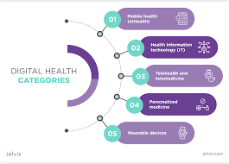
The Project Manager uses the communication method of having internal meetings, training of staff members, online communication tools, and performance reports. The workers are made aware of the ways new technologies will increase efficiency and make the experiences of guests better instead of changing staff. Frequent progress and presentation reports are also provided to investors and top management to show financial gains, meeting of sustainability targets and project performance. Marketing campaign, newsletter, and official compliance reports are used to inform external stakeholders, such as guests and regulatory authorities. Open communication enhances confidence and helps to instill trust in the project by stakeholders.

6.2 Consultation
Consultation can be defined as the process of getting feedback and input of stakeholders in both pre-implementation and implementation of projects. The Project Manager promotes the flow of information to the hotel staff, technology vendors, and operational teams about their views of the systems in terms of usability, technical feasibility and efficiency of the services. The employees, especially the Front-of-House workers, would be highly valuable as the staff members are the ones who get to deal with the guests on the ground and are the ones that would be operating the new digital systems.
Problem identification and development of solutions are also facilitated by consultation. As an illustration, employee comments can be used to identify training needs or operational issues associated with automated systems. Likewise, the cooperation with vendors will promote the recognition of technical enhancements and successful integration of the system. Engaging the stakeholders makes them feel that they are important and part of the decision process that enhances the acceptance of technological changes and improves the performance of the overall project.

6.3 Collaboration
Collaboration aims at fostering partnerships among the departments, teams and external parties in order to meet shared project objectives. The Project Manager is the person who liaises the work of the IT department, sustainability teams, marketing departments, and operations personnel to make sure that technological implementation would reflect the brand image of Marriott and meet the service standards.
The partnership with marketing teams will make sure that sustainability efforts are properly marketed to the guests and add to the brand image. By collaborating with technology suppliers, Marriott will be in a position to adopt tailored digital solutions that can address operational needs. Teamwork also promotes the exchange of knowledge across the departments, which enhances efficiency and eliminates repetitive work. The Project Manager should encourage the teamwork and collective problem solving because this way the stakeholders will be working on the shared goals and the quality of the provided services will be ensured during the project implementation.

6.4 Commitment
Commitment is the winning of the long-term stakeholders and constant investment in the project aims. The Project Manager should secure the high dedication of the top management, investors and franchise owners to ensure that there is enough financial back up and strategic help. Long-term commitment helps to make sure that the sustainability efforts are not immediately abandoned at the stage of their first introduction and are integrated into the corporate culture at Marriott.
The successful project adoption also requires employee commitment. The Project Manager enhances dedication through training programs, professional development and rewarding the staff members. Employees who have a feeling of support and are confident about implementing new technologies will be willing to accept the organisational change and therefore uphold high standards of services (Teng, Asril and Mahardika, 2025). Stakeholder commitment will be the guarantee of continuity of the project and aid the long-term sustainability and technological change objectives of Marriott.

6.5 Conflict Management
Major organisational projects are characterised with conflict because of differences in priorities, expectations, and professional perspective. In the Green-Tech Integration project, there would be a conflict between the IT department and the Marketing department. The IT department can be more focused on efficiency of the system, technical functionality, and security whereas the Marketing can be concerned with brand aesthetics, customer experience, and design that is easy to use.
Project Manager employs Interest-Based Relational (IBR) and Negotiation conflict management strategies in order to resolve such conflicts (Najjuma and Wandiba, 2024). The IBR method is based on achieving good professional relations and consideration of the stakeholder interest. The Project Manager promotes open dialogues in which every department presents their priorities and problems. The Project Manager encourages win-win solutions by determining the common goals, including customer satisfaction and brand management.

7.0 Impact Assessment and Future Recommendation.
The Green-Tech Integration initiative at the Marriott International is likely to bring about a substantial level of positive effects in the financial, reputational, and operational sections. The adoption of eco-friendly technologies and online solutions helps the organisation achieve the long-term strategic goals and enhance the level of stakeholder satisfaction. Making an assessment of the effects of this project can contribute to the evaluation of its success and can be used as a guide in future enhancement and sustainable development.

7.1 Influence on Business Performance.

7.1.1 Financial Impact
Green-Tech Integration project also helps in the financial performance through minimizing the costs of operation and enhancing revenue generation prospects. Epinephrine lighting, intelligent cooling and heating systems, and automated resources help in cutting electricity and water use (Milla-Amekor, 2024). The improvements reduce the costs of utility overheads and contribute to both long-term financial sustainability. The project involves a lot of initial capital investment, but the long-term financial payoffs are the cost savings by decreased energy consumption and savings on the maintenance costs.
The project will also have the challenge of improving Revenue Per Available Room (RevPAR) because of the appeal of eco-friendly travellers who will like environmentally friendly accommodation facilities. The target group of corporate clients and international tourists are always concerned with choosing hotels with high level of environmental responsibility. When encouraging green programs, Marriott will improve its market share and open up possibilities of charging higher price and occupancy rates that will lead to greater profitability (Arnejo and Sarsale, 2025).

7.1.2 Reputational Impact
The initiative improves the brand image of Marriott International as a responsible and sustainable company towards nature (Saxena, 2025). The hospitality market in London is very competitive and therefore reputation is key in the selection of customers and loyalty. The application of environmentally friendly technologies allows Marriott to show its efforts to help the United Kingdom to achieve its sustainability goals and global environmental goals.
Customer trust and loyalty are enhanced by positive brand reputation as a result of Marriott Bonvoy programme. Consumers are willing to patronise organisations that do not contradict their own environmental values. Also, it is more effective to establish corporate social responsibility that enhances relations with regulatory authorities, investors, and local communities. Marriott also focuses on a sustainable reputation to help it in its dominant position within the world hospitality sector.

7.1.3 Operational Impact
Digital transformation and automation have a great impact on operational efficiency. The absence of contacts in check-in and check-out processes, mobile service applications, and customer service platforms with the help of AI make the services faster and more convenient to the guests. All these technologies will decrease the time spent on waiting, lessen manual administrative efforts and enable the employees to concentrate on providing personalised guest experiences.
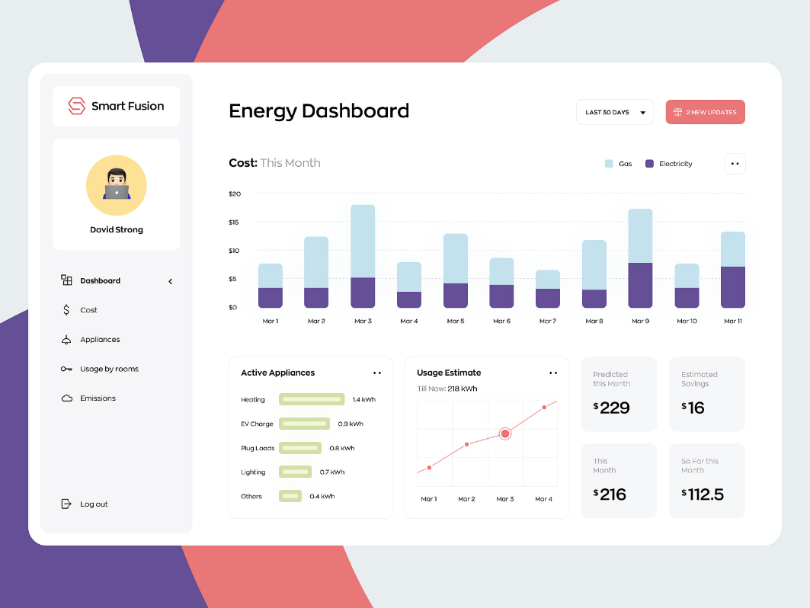
Automation is also effective in enhancing the accuracy in data management, resource allocation and service delivery. With smart energy management systems, Marriott is in a position to manage and control its energy consumption in a better way, lessening wastage and enhancing its sustainability performance (Rao, et al. 2024). Also, enhanced operational efficiency enhances the productivity and job satisfaction of the employees by cutting down on repetitive manual operations. The project, in general, will result in increased quality of the services and improved scores in guest satisfaction.

7.2 Future Recommendations

7.2.1 Creation of Stakeholder Advisory Board.
Marriott ought to have a permanent Stakeholder Advisory Board to maintain constant stakeholder interaction and sustainability of the project. The representatives of internal departments, investors, technology partners, environmental specialists, and guests should be part of the board. The advisory board would give frequent feedbacks, assist in strategic decision-making, and make sure that the expectations of all the stakeholders are always met. This hierarchy would enhance transparency and stakeholder relations and help in the success of the project in the long term.

7.2.2 Investing in Continuous Training Programs.
The adaptation of the staff to the new technologies and digital systems requires continuous training and development programs. Marriott must use frequent training programs, web based-based learning and practical use of software to enhance staff confidence and technical expertise (Werner and Stephens, 2024). The training programs must take into consideration the technical and customer service improvement training to make sure that technology is not used to replace human interaction but enhance personalised experiences of the guest. Continuous professional development also enhances motivation of the employees, minimises resistance to change and enhances organisational performance.

7.2.3 Application of a Real Time Feedback Loop.
Marriott needs to increase customer and stakeholder involvement by using real-time feedback mechanism using Marriott Bonvoy mobile app. The visitors must be in a position to leave instant feedback about the digital services, sustainability projects and general hotel experiences. The ability to receive real-time feedback enables Marriott to detect the gaps in services rather fast, communicate with customers about their concerns and keep enhancing the quality of services.
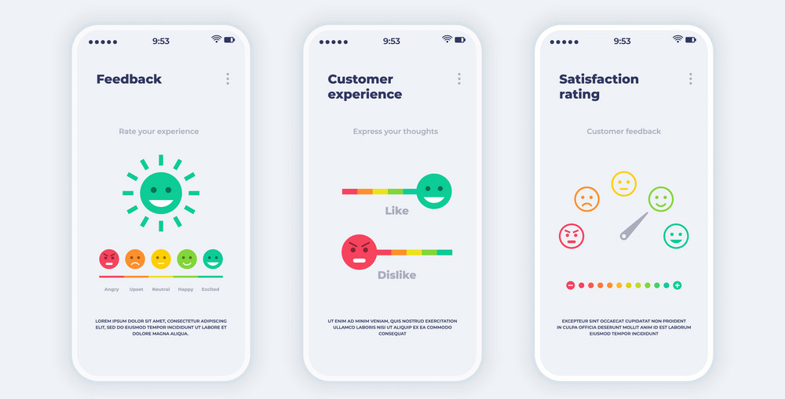
Besides the guest feedback, the digital feedback platforms should be created internally to enable employees to provide operational suggestions and report challenges with the system. Constant feedback helps in innovation, enhancing the level of satisfaction among the stakeholders, and making sustainability efforts to be in line with the evolving customer demands and technological developments.

8.0 Conclusion
The success of the Green-Tech Integration project of Marriott International depends on appropriate stakeholder engagement. Sustainable technologies and digital solutions need to be implemented by involving both the internal teams and external partners, investors, regulatory authorities, and hotel guests. Marriott has selected the main stakeholders and outlined their roles, responsibilities and expectations thus making sure that every group works positively towards the objectives of the project. The communication, accountability, decision-making engagement frameworks like the Stakeholder Matrix of Mendelow and the RACI Matrix can be used to eliminate conflict and enhance efficiency because they can clarify these areas.
The 4C model- Communication, Consultation, Collaboration, and Commitment also helps to strengthen stakeholder involvement. Open communication fosters trust, consultation gives the opportunity to receive feedback and make decisions, teamwork unites the cross-functional teams, and commitment grants the leadership and the staff to provide long-term support. The negotiations and Interest-Based Relational strategies are methods of conflict management where conflicting priorities of the departments are solved in constructive ways to avoid disruption of harmony and project flow.
The Green-Tech Integration project brings in quantifiable rewards in financial, operating and reputational terms. The advantages of matching technology with the requirements of stakeholders are manifested in cost savings, increased efficiency, better guest experience, and better sustainability credentials. Engagement will be enhanced and the project sustainability achieved through a series of future recommendations such as a Stakeholder Advisory Board, continuous training programs and real-time feedback systems. The active stakeholder management of Marriott is an example of sustainable, innovative, and customer-centered hospitality in London.

References
Alsayyed, N.M., Allan, B., Sweis, R. and Sweis, G., 2025. Key enablers affecting blockchain technology adoption in construction industry: a bibliometric analysis and PESTLE framework approach. Journal of European Real Estate Research, pp.1-26.
Arnejo, A. and Sarsale, M., 2025. Measuring hotel financial performance: A bibliometric review. Hotel and Tourism Management, 13(2).
IMERİ, B., TARTARAJ, A. and RUSTANI, M., 2025. ETHICAL AND LEGAL DIMENSIONS OF DIGITAL MARKETING IN THE HOSPITALITY SECTOR: A SYSTEMATIC LITERATURE REVIEW ON TRUST AND COMPLIANCE IN ALBANIA. IMASCON 2025 AUTUMN, p.38.
Inavolu, S.M., 2024. Exploring AI-driven customer service: Evolution, architectures, opportunities, challenges and future directions. International Journal of Engineering and Advanced Technology, 13(3), pp.156-163.
Iranmanesh, M., Ghobakhloo, M., Nilashi, M., Tseng, M.L., Yadegaridehkordi, E. and Leung, N., 2022. Applications of disruptive digital technologies in hotel industry: A systematic review. International Journal of Hospitality Management, 107, p.103304.
Khatter, A., 2023. Challenges and solutions for environmental sustainability in the hospitality sector. Sustainability, 15(15), p.11491.
Milla-Amekor, E.E., 2024. Energy Efficiency and Conservation of Hotels in Ghana: A Systematic Review Article. Asian Journal of Advanced Research and Reports, 18(8), pp.251-258.
Najjuma, A. and Wandiba, A., 2024. Conflict management strategies and academic staff performance: A conceptual review. International Journal of Economics, Business and Management (IJEBM), 1(1), pp.163-173.
Nicole, S.J., Lada, S., Ansar, R., Abdul Adis, A.A., Fook, L.M. and Chekima, B., 2022. Corporate social responsibility and strategic management: A bibliometric analysis. Sustainability, 14(17), p.10526.
Owusu, R., Heupink, L.F., Gulbi, G., Asare, B., Nonvignon, J. and Chola, L., 2022. OP51 improving childhood cancer management and financing in ghana: results from stakeholder mapping and analysis. International Journal of Technology Assessment in Health Care, 38(S1), pp.S20-S20.
Queirós, F.J.D.A.M., 2023. Internationalization Project of Cocktail Team: An In-Depth Analysis of the UK and Literature Review on Entry Modes of Small and Medium Enterprises. PQDT-Global.
Rao, C.K., Sahoo, S.K. and Yanine, F.F., 2024. A literature review on an IoT-based intelligent smart energy management systems for PV power generation. Hybrid advances, 5, p.100136.
Saxena, R., 2025. Emerging Trends in Tourism and Hospitality: Exploring Digital Transformation, Sustainability, and Experience Economy.
Schoenung, J.M., Olivetti, E.A. and Guest Editors, 2023. Sustainable development of materials: Broadening stakeholder engagement. MRS Bulletin, 48(4), pp.362-367.
Talukder, M.B., 2025. Current Trends and Future Research Directions of Eco-Friendly Steps of Hotel Industry. RPER, (71), pp.7-18.
Teng, L., Asril, N.M. and Mahardika, A.N.Y.M., 2025. Sustainability Principles in Hospitality Vocational Education in China: A Comprehensive Review. Business and Social Sciences Proceedings, 3, pp.1-8.
Thornhill-Miller, B., Camarda, A., Mercier, M., Burkhardt, J.M., Morisseau, T., Bourgeois-Bougrine, S., Vinchon, F., El Hayek, S., Augereau-Landais, M., Mourey, F. and Feybesse, C., 2023. Creativity, critical thinking, communication, and collaboration: Assessment, certification, and promotion of 21st century skills for the future of work and education. Journal of Intelligence, 11(3), p.54.
Werner, A. and Stephens, S., 2024. The real Living Wage in the London hospitality sector: opportunities and challenges.
Zade, A.A.R.O.H.I. and Sethi, S.U.R.I.N.D.E.R., 2024. Transforming hospitality: the digital revolution in post-pandemic hotel management. International Journal of Cultural Studies and Social Sciences, 20(2), pp.42-51.
Zamparini, L., 2025. Tourism and Travel: The Challenges of Net Zero.

