VIOREL DRAGOMIR DS1

GOOGLE MAPS APP USE
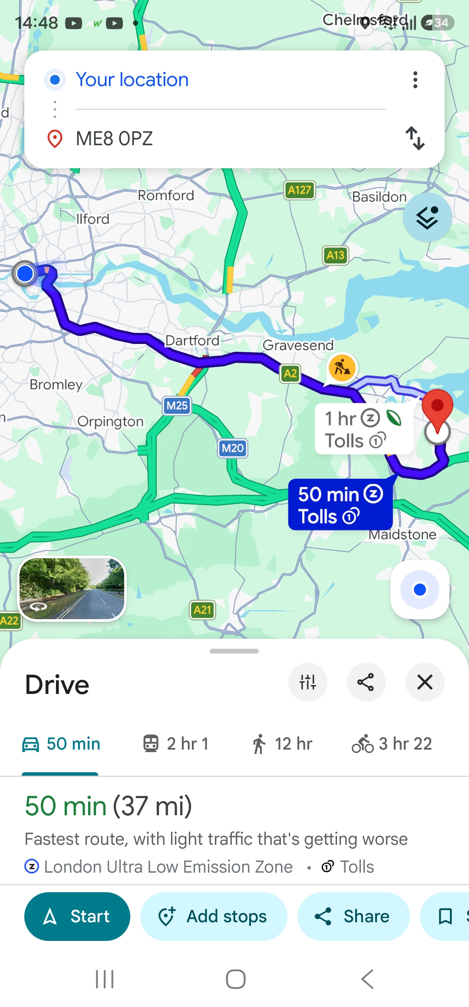 This screenshot from google maps app shows how I use my digital skills in everyday tasks using it. The app helps me with fast routes in my job; I can save addresses and favourite places. It is a very necessary tool in everyday life for me.

AMAZON APP USE
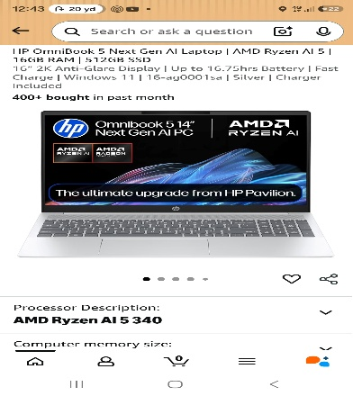
This amazon screenshot shows how I use my digital skills to do shopping for items like this laptop for university. Having lots of options, it is easy to find just the right product for your needs and at a competitive price too.

MY HYUNDAI APP USE
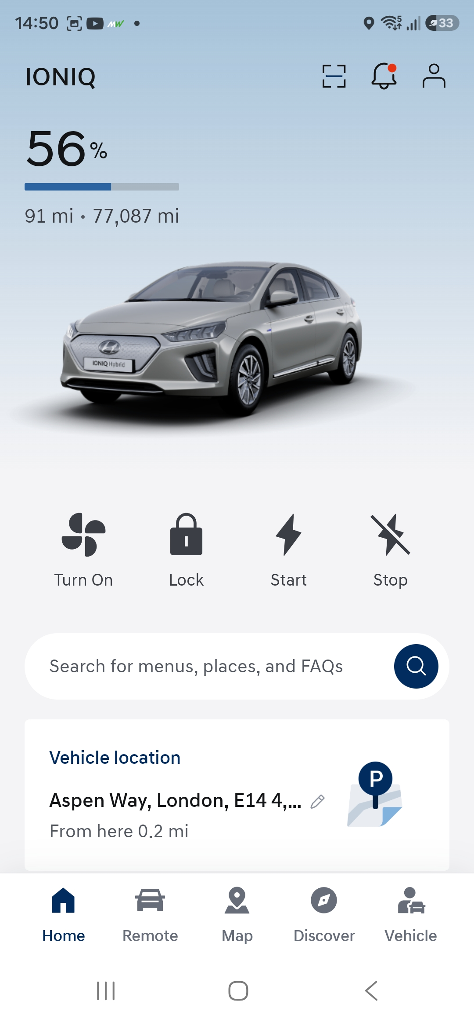 This is an image for my Hyundai app. I am using the app everyday as it is linked with my Hyundai ioniq ev and I can get a lot of information about the car, the level of battery and I can control the car as well like a remote witch is cool.

WHATTSAPP APP USE
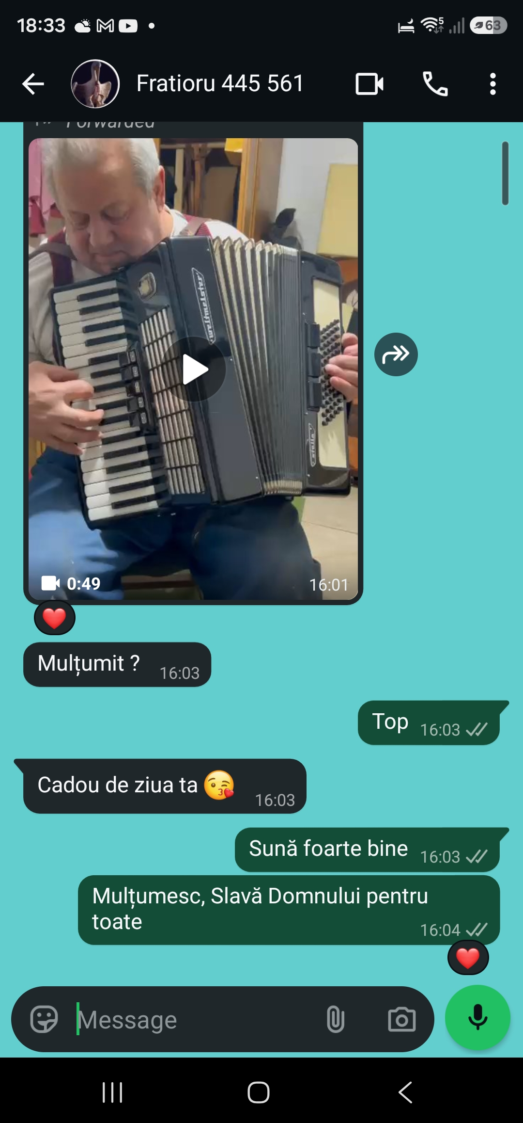
This screenshot shows how easy is to communicate with your family from Romania in my case with WhatsApp. I am using it everyday for work too as we have a group where we help each other with different information’s about the job.

PHONE CAMERA USE
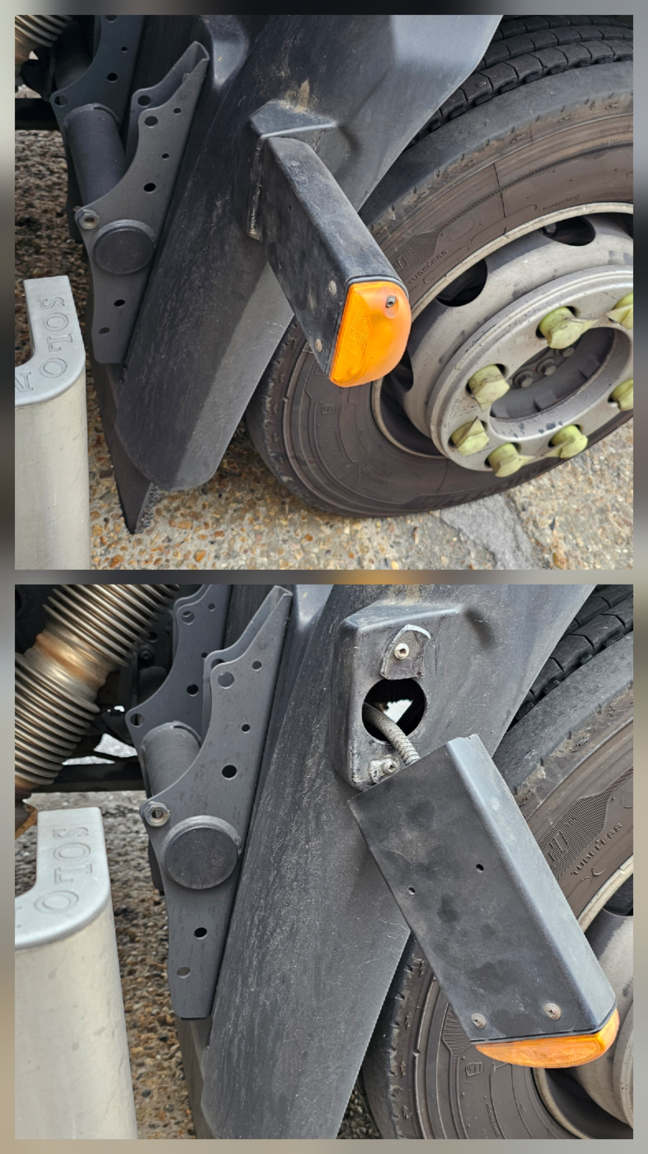 This photo shows how I use my phone camera at my job to register as evidence of work completion the different tasks I must do during the day. Doing the report this way it saves me time and makes the whole process more efficient.

A short reflection of my digital skills

I use digital tools to complete all sort of tasks at my job and in everyday life. I feel confident when I am using my phone for different digital skills, but I also want to improve when I am using the laptop in word, excel, PowerPoint as it is very important in a business environment to know how to use all this tools. I often use these tools now when I am at university and I sometimes feel nervous about pressing the wrong button on the keyboard or clicking on the wrong icon. I hope this module will help me improve my digital skills and build my confidence in using the programs mentioned above. Digital skills are important for me as the progress I want to make in education and in life it can only be achieved by becoming better at using digital tools.

Submission Checklist
Before you submit, please check:
​​​ ☒ I added 4–6 screenshots
☒ I wrote short sentences for each screenshot
☒ I wrote my short reflection
☒ My work is my own
☒ My file opens correctly
​​☒ My file opens correctly

