Effective Team Working and Communication

Student Name-Mihai Mariuta (1920013)
Ioana Cozma 1920014
Andrada Balaban 1920286
Liliana Putaru 1917405
Diana Cotorobai 1920378

Executive summary
The following report has been created with the aim of offering the students a detailed report regarding the team management and team working. All aspects of team working are taken into consideration, on the basis of application of three theories which are Tuckman’s team development theory, Belbin’s team role theory and Hersey and Blanchard’s Situational Leadership Theory. These theories have been demonstrated, and finally a conclusion is dawn as to how these theories are important and effective in team working.

Table of Contents
Effective Team Working and Communication 1
1.0 Introduction 4
2.0 Benefits of team working 4
3.0 Stages of Team development 5
4.0 Team roles 8
5.0 Managing Conflict 400 11
6.0 Successful Team Development 13
References 15

1.0 Introduction
In order to survive in any education sphere, organisation, or creative pursuit, working singularly can never be enough an ideal for achieving success and become the jack of all trades; what is perennially important is having ideal team- working effective goals and its proper execution. A team therefore can be defined as individuals working together in a group, with similar goals and purposes aimed towards achieving excellent quality of services. In order to assure that the levels of self-confidence, emotional security, planning ability and decision making among the team members, efficient team work ensures to achieve these qualities with great heights. Productivity, creativity, strategic planning, morale and success, all are bound to be enhanced with the presence of teamwork in a team (iosrjournals, 2020).

2.0 Benefits of team working
Deloitte had conducted a survey across 130 countries, including 7,000 participants in the year 2016, which has proved that today the teamwork is the most popular trend in the entire global workforce, which makes the collaborative expectation from the employees in any organisation to be very high (Lacerenza, et al., 2018). The rise of team work spans across all levels, beginning from primary school level to organisational work levels. In order to make the teams produce greater outcomes, with the complete commitment of each and every contribution of the individual members of the team, calls for effective teamwork which is driven by team processes. By team processes we understand that, the interdependent acts of the individual members of the team, through behavioural, cognitive and verbal activities, is directed at organization of work tasks in order to succeed at achieving collective goals (apaorg, 2020).
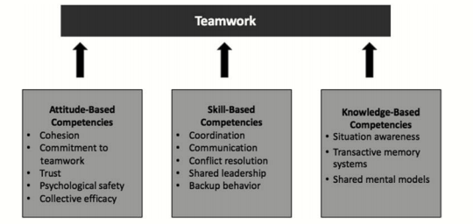
Figure 1: The figure demonstrates the top team competencies, which are divided into three categories, attitudes, behaviours, and cognitions.
(Source: apaorg, 2020)
In any sphere be it work or academia, the presence of the concept of teamwork is absolutely necessary, to induce encouragement amongst students or employees, to help each other, work cooperatively, creatively and dedicatedly towards achieving common aims and goals together. If the performance of the work is considered as a parameter then, it has been reviewed that of the team work performance always has a upper hand and greater rate of success than the individual performance. When engaged in a team work, the scope of opinion, knowledge, adaptability, operational management and judgement is expanded, inducing significant productivity in all behavioural and creative aspects (iosrjournals, 2020).

3.0 Stages of Team development
3.1 Tuckman theory of team development
The team development theory was proposed by Dr Bruce Tuckman, in the year 1965, to understand the importance of the dynamic entities and effectiveness of the team development that has taken place over time. Tuckman tried explaining this dynamic process of team development in four stages primarily, which were “Forming, Storming, Norming, Performing”, in 1965; however the fifth stage, “Adjourning” was added by him later on in the 1970s (Crunk, 2018). Following are the 5 significant steps of the team development model created by Dr Bruce Tuckman, which can be implemented in the student’s activities for achieving better team development methods-
The first stage, FORMING is classified by:
In order to attain the guidance and direction for any new project, the students should be dependent and look up to their leader. The team’s objectives as highlighted by the leader should be both received and discussed about. Due to the students being in the nascent stage, where relationships have not yet been formed, the individual roles and responsibilities should be clearly explained by the leader. The leader must be prepared to answer lots of questions about the team's purpose, objectives and external relationships. Communication would be brief, crisp and informative, relying mostly upon the leader, as members of the team need to introduce themselves to their leaders, thus tolerance of the leader would be tested by the fellows (businessballs, 2020).
The second stage, STORMING is classified by:
After the establishment of the team, lack of agreement/s might crop up while making group decisions. This happens due to the students, here as team members might want to be superior to others in the group, which gives rise to conflict in interest. Even though the clarity of the team's purpose may increases but uncertainties may persist due to power struggles and compromises. Students are advised here avoid being emotionally distracted (Peralta et al., 2018).
The third stage, NORMING is classified by:
The chaos created in the previous stage is resolved, with the leader taking in charge. Roles and responsibilities are outline, big/small decisions are taken, communication develops, commitment and unity strengthens, team discussion develops and thus consensus is formed among the team members and their leader (Peralta et al., 2018).
The fourth stage, PERFORMING is classified by:
The goal of strategic awareness and hence team work is achieved in this step, with the team being clear about their shared vision and roles, which is independent, flexible and unaffected by external interference. The students are expected to achieve a high degree of autonomy and excellence, in this stage, where the leader just delegates over the team members, as they would become self-managers (Kiweewa et al., 2018).
The fifth stage, ADJOURNING is classified by:
The fifth stage adjourning, is more of an adjunct, to the initial four-stage model, as it views the team beyond the four-stage’s purpose. The students are expected to share bittersweet senses of accomplishment, as they face difficulty in parting from the members as new relationships are created. The fifth stage, therefore is an assessment of the purposes fulfilled in the team (businessballs, 2020)
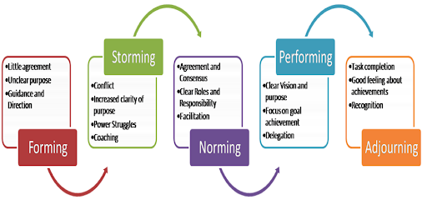
Figure 2: Tuckman’s Team development theories
(Source: multistakeholderpartnerships, 2020)

3.2 Advantages and Limitations of Tuckman theory
Tuckman's model is useful in the sense that it explains the processes in which any team develops, based on the attributes of ability, relationships and maturity of the leader who can alter his/her leadership style (Peralta et al., 2018). However like every theory, this model has a few limitations, the most basic one being, the model does not propose a solution for the small groups or team development. Researchers also view the applicability of Tuckman’s Storming stage to be inappropriate for practitioners in experimental education (Kiweewa et al., 2018).

4.0 Team roles
4.1 Overview of Belbin team roles
In all spheres of academia and workspace, nowadays the team role which is widely adopted is that of Belbin’s, as it proposes to revise Tuckman’s team development theory, suggesting better solutions. Belbin’s team role theory has achieved so much popularity due to the fact that, it is not only centred around achieving the team roles, but also aims at avoiding conflicts and thus inducing optimally managed and sound teams, redefining the team role experience (Omar et al., 2016).
“Storming” according to Belbin
This part of the team work is the most vulnerable as the members of the team are susceptible to new ideas and therefore are in conflict with others, thus compete with them. In case the team members remain over focused, the results may be flawed causing lower motivation, among the group members and also result the group to break up. Therefore it is perennial for the personality clashes and disagreements between individuals to resolve. Belbin propose here that, the new ideas with which the students come up, may need to be analysed on the basis of Monitor Evaluators, and so the leader can refrain from getting involved in team politics, and will focus the discussions on the group’s, aims and objectives (belbin, 2020).
“Norming” according to Belbin
There is greater agreement and consensus in decision-making. Roles and responsibilities are made clear and the team moves towards more harmonious working practices. Discussion centres on the development of working processes. According to Belbin members should have prior knowledge regarding the team roles that they are involved in. This knowledge includes, knowing the individual, strengths and weaknesses of both the team leaders and individual members which creates more co-operation. Therefore Belbin proposes, that every individual team member must take insights out of the group, research, and insights (belbin, 2020).
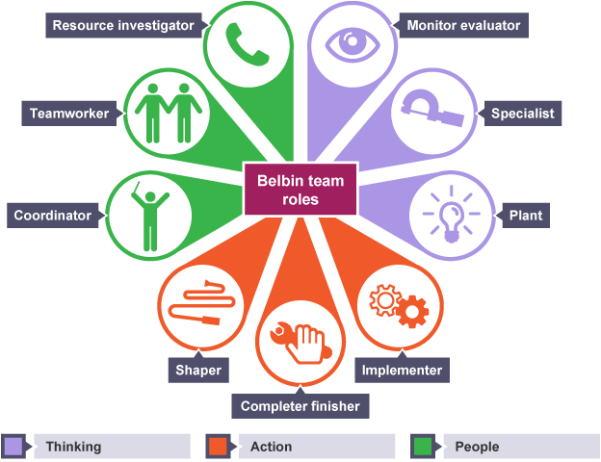
Figure 3: Belbin’s team role model
(Source: belbin, 2020)
4.2 Integrating Belbin with Tuckman theory
The idea of working in a team is to ensure the optimal outcome of the project that has been undertaken. In order to attain the appropriate goals, and have a successful team, it is essential to ensure that, all of the members in the team are assigned to appropriate roles and characteristics. The Belbin team role is the most famous and prevalent team roles (Omar et al., 2016) A couple of years after the Tuckman’s team development theory was published in 1965, Dr Meredith Belbin came up with their own theory, researching into the behavioural aspect of teams at Henley. While Tuckman’s theory was based on the outcome of task completion, and identifying team’s progress through 5 crucial stages; 9 Team Roles, have been uncovered by Belbin, highlighting the contributions and interrelation amongst the team members thus emphasising on the individual contribution of each team member (belbin, 2020)

4.3 Overview of Hersey and Blanchard’s Situational Leadership Theory
According to the Hersey-Blanchard Situational Leadership Theory, is based on the lack of any singular leadership style, but in turn focuses on different factors that govern the workplaces. According to the model, it is the capabilities and abilities of the leaders that can be adjusted. In order to demonstrate their point they created a four tier leadership model, based on the experiences leaders have in the workplace, the following styles can be used-
Delegating style: Here the leader maintains a low-key relationship with the members asking them to take responsibility for multiple task decisions.
Participating style: This method involves in sharing decisions and ideas, using low-task and high-relationship style, to boost the confidence of fellow group members.
Selling style: In this method, using high-key relationship and offering high-task to their in a persuasive manner peers leaders can manipulate them.
Telling style: This is a high-task but low-key relationship oriented method where the leader supervises explicitly the work of its fellow teammates (Thompson et al., 2018).
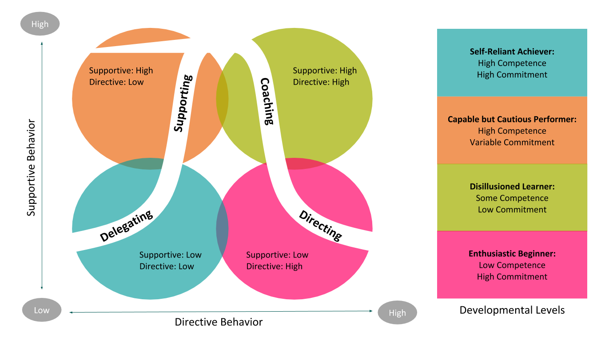
Figure 4: Hersey and Blanchard’s Situational Leadership Theory
(Source: oregonbusiness, 2020)

5.0 Managing Conflict 400
5.1 Reasons why conflict occurs
Lesson objectives
While working in a team be it in academia or in work team, the occurrence of conflict, is inevitable. There are multiple factors which can give rise to conflict in teams. A conflict however is often defined as an antagonistic behaviour, where the decision making is hampered due to unsettlement between two or more parties. In order to solve conflict/s it is important to identify the root of the cause. It is both the duty and responsibility of the team leader to assure there is minimal conflicts in the group (Guo et al., 2019).
Communication factors
Since communication is the key to any discussion, one must always be very pertinent, clear and lucid about his/ her communication skills while working in a team. Observing, hearing and then speaking is the judicious thing to do, however one must be careful of what one is saying, avoiding all possible options to spread miscommunications in the team.
Structural factors
Conflicts can also arise depending on the population, and involvement of the members in the team. Therefore it is becomes very important for the leader to ensure that, judging by the population of the team, equal number of tasks are distribute amongst the members, leaving least scope for complaint.
Personal factors
Most of the time while working in the groups, the personal relationships between the team members, the relationships between the team and their leader, ego issues and judgemental problems become the root of the personal factors which lead to serious conflicts in the team (Guo et al., 2019).
5.2 Ways of managing conflicts
Conflicts don’t last for long, hence they are as easy to resolve, just like they are easy to create. Following are some of the simple methods in which conflicts can be resolved:
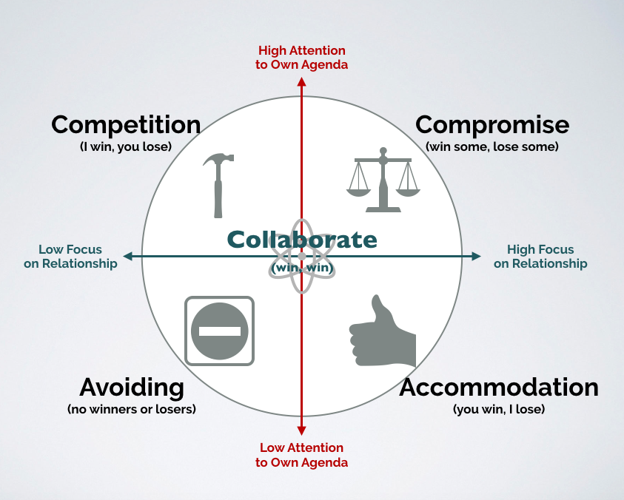
Figure 6: Ways of managing conflicts
(Source: sixandhalfconsulting, 2020)
Competition
One of the smoothest way to resolve a conflict is identify the break-even-point of a conflict, and help achieving a both “win-lose” situation to settle the disputes.
Offering healthy competition among the team members and not leading to conflicting views is something the leader should manage.
Collaboration
Another way to resolve any ongoing conflict in any group is to identify the roots of the solution and applying the law of reciprocity, i.e. to both cooperate and collaborate in order to solve conflict/s with a “win-win” situation. Cooperation and collaboration requires the understanding and trust amongst the teammates and its leader.
Compromise
At times in order to solve particularly futile conflicts it is important to take a step back, and let the other party win. This requires wise decision making, calculation of self-esteem and understanding well the “lose-lose” situation.
Avoidance
Judging on the timing, scope and futility of the conflict, it is best at times to avoid a particular conflict. However it is not always wise to seek this option, but if situation demands it, this is the best possible option that can be taken.
Accommodation
Taking this step becomes one of the most testing option at times because this method often involves the compromise of ones self-esteem in order to settle down a conflict (Neumeyer et al., 2020).

6.0 Successful Team Development
6.1 Problems arising during team development
Achieving the absolute teamwork is actually like making the dream work happen, with best execution of ideas, management, communication, and coordination, however this achievement can at times be very challenging. When grave and conflicting problems arise in the management of the team, it rests upon the responsibility of the team managers or leaders, to successfully develop a team. Following are some of the methods, in which developing teams become challenging (Pinter et al., 2018):
Lack of commitments and trust-
Commitment is perennial to any team management. Even if a single member of the team cannot be trusted wholeheartedly, by the teammates and leaders, there arises trust and commitment issues which leads to the disruption in teams.
Loss of productivity
In order to work in teams, maintaining productivity of the members is important. Being lazy at work, inefficient, unorganised, or conflicted gives rise to loss of productivity among the members.
Poor communication
Since communication is the key to working in a team, exhibiting the poor communication skills by the members like rash behaviours, poor perceptions, miscommunication, misunderstandings, ill representation etc. These behaviours affect the productivity of both the team and its objectives.
Interpersonal Conflict
If there lacks cooperation and collaboration among the members of the team and the team leader, there arises interpersonal conflicts in the team. At times due to conflict of interest, interpersonal Conflicts are inevitable.
Poor leadership
The success of any team is never dependent singularly upon the teammates but also on the leader. The negative ability on part of the leader plays a huge aspect in governing the activities of the team, running it and executing the team’s goals (Pinter et al., 2018) .
6.2 Application of Tuckman, Belbin and Hersey’s theory in successful team development
The theories of team development, team roles and situational leadership theory did not occur in a single day but developed over time according to researchers, and therefore is not a contemporary theory. These theories have evolved having positive effects on team management, based on multiple situations and different perspectives. Every theory is unique in its own way, to bring about changes and developments in the way team leaders and team mates can manage their teams to bring about better outcomes, for example both Tuckman’s theory and Hersey’s theory focus on the productivity of the leader while the focus of Belbin’s theory is on individual capabilities and of the individual teammates as well. Belbin therefore gives a more comprehensive study of both the leader and the teammates, without which both would be impossible to run a team successfully (O'Neill et al., 2018).

7.0 Conclusion
The team work is a very dynamic process, which depends on multiple factors, like the team and task competencies. Speaking of work task competencies, which is inclusive of attributes like attitudes, knowledge, behaviours, and skills, of the individual members of the team, which are extremely necessary if the task performance needs to be achieved (researchgate, 2020). It is therefore perennial for the individual members to interdependently interact with each other, to maintain effective communication based on these team competencies, which would thus lead to the achievement of the positive teamwork outcomes (iosrjournals, 2020). Apart from exhibiting multiple individual-level expertise, it is also important for the team members to exhibit team expertise or team competencies in teamwork. Since individual expertise is at times confuse with existing team competencies, team competencies is in itself a vast and most critical domain, for students and as well as adults to cope up with at times (apaorg, 2020) .

References
apa.org 2020. Apa.org [online]. Available at: <https://www.apa.org/pubs/journals/releases/amp-amp0000295.pdf> [Accessed 3 December 2020].
belbin.com 2020. Belbin and Tuckman: Supporting your team at every stage (2020) [online]. Available at: https://www.belbin.com/resources/blogs/belbin-and-tuckman/ [Accessed 3 December 2020].
businessballs.com 2020. Tuckman: Forming, Storming, Norming and Performing Model – BusinessBalls.com (2020) [online]. Available at: <https://www.businessballs.com/team-management/tuckman-forming-storming-norming-performing-model/> [Accessed 3 December 2020].
Crunk, J., 2018. Examining Tuckman's Team Theory in Non-collocated Software Development Teams Utilizing Collocated Software Development Methodologies (Doctoral dissertation, Capella University).
Guo, H., Zhang, L., Huo, X. and Xi, G., 2019. When and how cognitive conflict benefits cross-functional project team innovation. International Journal of Conflict Management.
iosrjournals.org 2020. Iosrjournals.org [online]. Available at: <http://iosrjournals.org/iosr-jbm/papers/Vol20-issue3/Version-1/C2003011522.pdf> [Accessed 3 December 2020].
Kiweewa, J.M., Gilbride, D., Luke, M. and Clingerman, T., 2018. Tracking growth factors in experiential training groups through Tuckman’s conceptual model. The Journal for Specialists in Group Work, 43(3), pp.274-296.
Lacerenza, C.N., Marlow, S.L., Tannenbaum, S.I. and Salas, E., 2018. Team development interventions: Evidence-based approaches for improving teamwork. American Psychologist, 73(4), p.517.
Omar, M., Hasan, B., Ahmad, M., Yasin, A., Baharom, F., Mohd, H. and Darus, N.M., 2016, August. Towards a balanced software team formation based on Belbin team role using fuzzy technique. In AIP Conference Proceedings (Vol. 1761, No. 1, p. 020082). AIP Publishing LLC.
O'Neill, T.A. and McLarnon, M.J., 2018. Optimizing team conflict dynamics for high performance teamwork. Human Resource Management Review, 28(4), pp.378-394.
Neumeyer, X. and Santos, S.C., 2020. The Effect of Team Conflict on Teamwork Performance: An Engineering Education Perspective. The International journal of engineering education, 36(1), pp.502-509.
researchgate.net 2020. Importance of teamwork in business (2020) [online]. Available at: https://www.researchgate.net/publication/214604986_Importance_of_teamwork_in_business [Accessed: 3 December 2020].
Peralta, C.F., Lourenço, P.R., Lopes, P.N., Baptista, C. and Pais, L., 2018. Team development: Definition, measurement and relationships with team effectiveness. Human Performance, 31(2), pp.97-124.
Pinter, R. and Cisar, S.M., 2018. Measuring Team Member Performance in Project Based Learning. Journal of Applied Technical and Educational Sciences, 8(4), pp.22-34.
Thompson, G. and Glasø, L., 2018. Situational leadership theory: a test from a leader-follower congruence approach. Leadership & Organization Development Journal.

