

Programme: MSc Public Health and Social Care in Practice
Module: Social Epidemiology and Public Health Development
Module code: LCHS7000
Lecturer name: Muhammed Aliyu
Assignment Title: Component 2 Analytical Report
Student name : Hetalben Sandipkumar Patel
Student Id :2508644

Table of Contents
Task 1: Ethnic Inequality and Health Inequalities in the UK 3
1.1 Introduction 3
1.2 Contextual Background and Underlying Factors 4
1.2.1 Disease/illness 1: Higher Type 2 diabetes risk among ethnic minority groups 4
1.2.2 Disease/illness 2: Unequal maternal mortality among Black and Asian women 4
1.2.3 Disease/illness 3: Ethnic inequality in mental illness and mental healthcare outcomes 4
1.2.4 Social issue 1: Poverty and income insecurity as structural determinants 5
1.2.5 Social issue 2: Overcrowded housing and neighbourhood deprivation 6
1.2.6 Social issue 3: Language barriers, racism and unequal healthcare access 7
1.3 National Response to Reduce Ethnic Health Inequalities 8
1.4 Organisation Supporting the Chosen Group 8
1.5 Conclusion 9
Task 2: Epidemiological Assessment of Type 2 Diabetes among South Asian Adults in Newham, London 10
2.1 Introduction: definition, consequences and worldwide/UK severity 10
2.2 Defined target population: South Asian adults in Newham 11
2.3 Public health measures using the 3Ps 12
2.4 Key determinants and risk factors 13
2.5 Epidemiological studies and health needs assessment of at-risk groups 13
2.6 Monitoring and surveillance systems 14
2.7 Epidemiological assessment of short- and long-term public health impact 15
2.8 Proposed intervention programme and evaluation 15
2.9 Strengths and weaknesses of the epidemiological approach 16
References 18

Task 1: Ethnic Inequality and Health Inequalities in the UK

1.1 Introduction
The Ethnic minority populations in the UK consist of South Asian, Black African, Black Caribbean, Arab, Mixed and other minority groups. Around 18.3% of the population in England and Wales identified as either part of the Asian, Black, Mixed or Other ethnic groups (ONS, 2022). These communities may experience health disparities due to ethnicity being in interplay with racism, deprivation, overpopulation, unstable employment, migration history, language, and unequal access to healthcare. WHO associates health with the circumstances under which individuals are born, nurtured, lived, worked and aged (World Health Organisation, 2025). Thus, unequal social conditions are affected by ethnic health inequality, not only through clinical or lifestyle factors.
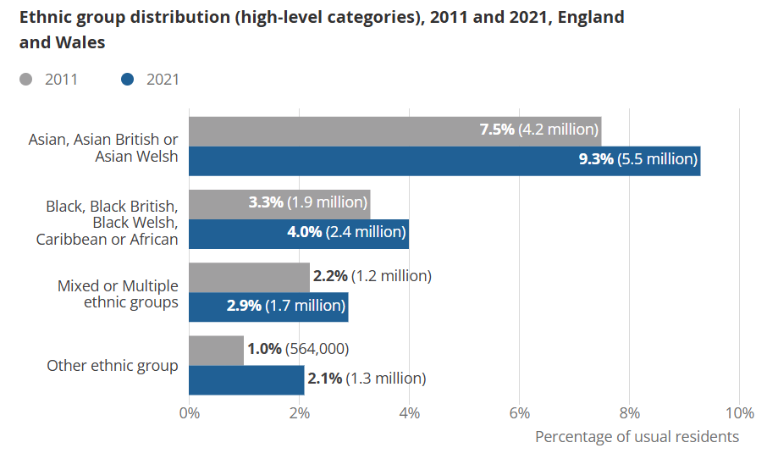
Figure 1: Ethnic group distribution in England and Wales
(Source: ONS, 2022)

1.2 Contextual Background and Underlying Factors

1.2.1 Disease/illness 1: Higher Type 2 diabetes risk among ethnic minority groups
Combining Type 2 diabetes is a transparent ethnicity-associated inequality as it is a high-burden, preventable and socially determined. In the UK, Diabetes UK estimates that over 5.8 million individuals live with diabetes including almost 4.6 million people diagnosed with diabetes and close to 1.3 million potentially with Type 2 diabetes (Diabetes UK, 2025). Diabetes UK also reports that 6.3 million individuals have non-diabetic hyperglycaemia, generating a high-preventable risk category (Diabetes UK, 2026). South Asians and black populations are at increased risk due to earlier onset, deprivation, stress and delayed diagnosis. This cannot be diminished to ethnic diet; behaviour is determined by income, work, housing and access to preventive measures. Interventions need timely HbA1c screening and culturally sensitive prevention.

1.2.2 Disease/illness 2: Unequal maternal mortality among Black and Asian women
Maternal mortality reveals how ethnic inequality can bring about deadly consequences within a universal NHS setup. In 2022–24, Black women had a maternal death risk nearly three times higher than White women, with RR 2.72 and 95% CI 1.80–4.00 (MBRRACE-UK, 2026). In its 2024 report, it was further identified that there is almost a threefold increased risk among Black women and an increased risk among Asian women with RR 1.65 and 95% CI 1.14234 (MBRRACE-UK, 2024). This is an indication of slow escalation, inability to listen, perceived barriers, deprivation and racial bias. Ethnicity monitoring and anti-racism maternity training, interpreter access, and continuity of care need to be offered as solutions.

1.2.3 Disease/illness 3: Ethnic inequality in mental illness and mental healthcare outcomes
Rapid mental health disparities are apparent in forced treatment and cut-off services. According to NHS Digital, the rate of detention under the Mental Health Act of the black or Black British population was 242.3 to 100,000 in 202324, and that of the Whites was 68.4% to 100,000 in the same year, which is more than 3.5 times larger (NHS Digital, 2024 This is not adequate evidence of greater illness requirements. It also measures crisis-induced access, mistrust, late support, racism and poorer early intervention. Bansal et al. (2022) claim that ethnic minority groups have poorer access to and outcomes of mental healthcare. Unmet needs may be concealed by less voluntary service utilisation. The possible solutions are culturally competent counselling, timely referral and community-based support.

1.2.4 Social issue 1: Poverty and income insecurity as structural determinants
Poverty is a structural determinant in the sense that it decreases the capacity of people to avoid sickness. According to the GOV.UK, 38% of individuals in Other ethnic group households, 26% in Asian households and 22% in Black households were in persistent low income, which was 12% in White British households (GOV.UK, 2025a). This impacts health by causing food insecurity, stress, housing, transportation challenges and inability to access appointments. Lifestyle risks may be social, which means poorer populations have a greater exposure to risks and less protection. Welfare support, flexible access to the NHS and community prevention solutions are necessary.
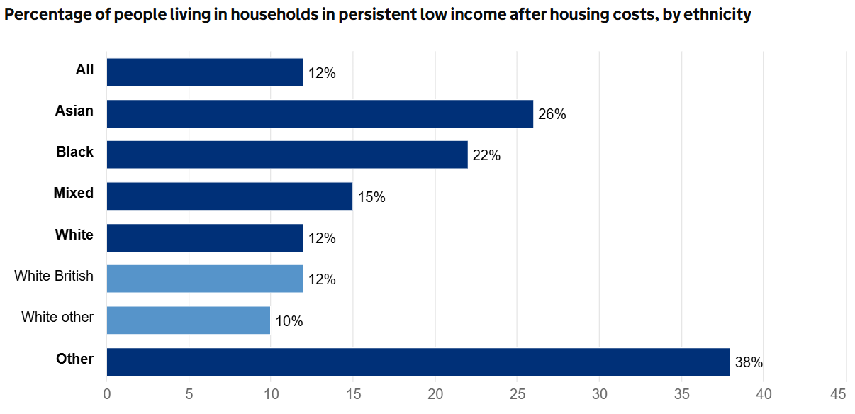
Figure 2: Low-income rate by Ethnicity
(Source: GOV.UK, 2025a).

1.2.5 Social issue 2: Overcrowded housing and neighbourhood deprivation
A social epidemiological exposure that can be measured is housing inequality. GOV.UK reported that 3% of households in England were overcrowded in the three years to March 2023, but overcrowding reached 25% in Arab households, 18% in Bangladeshi households, 16% in Black African households and 14% in Pakistani households, compared with 2% in White British households (GOV.UK, 2025b). This is important since congestion carries with it exposure to infection, loss of sleep, stress, bad mental health and inability to cope with chronic diseases. Housing is not a social background. Stronger housing standards, local authority support, GP identification of risk related to housing, and referral to housing advice services are some of these solutions.
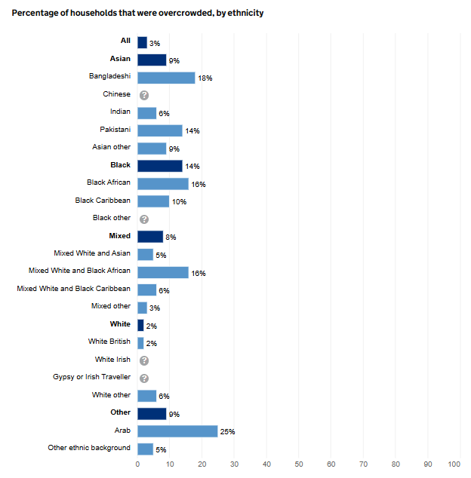
Figure 3: Rate of Overcrowded Households by Ethnicity
(Source: GOV.UK, 2025b).

1.2.6 Social issue 3: Language barriers, racism and unequal healthcare access
According to a study conducted by the NHS Race and Health Observatory, 51% of the surveyed respondents had encountered discrimination, and 38% of the Asian respondents and 49% of the Black respondents indicated that they were treated differently by primary care providers based on ethnicity (NHS Race and Health Observatory, 2025). NHS England lists inaccessibility to information, language barriers and mistrust towards healthcare or statutory systems among barriers to access as well (NHS England, 2025). This demonstrates that equal service availability is not equal healthcare access. Professional interpreters, translated information, community health workers, anti-racist clinical practice, and ethnicity data monitoring are some of the solutions.

1.3 National Response to Reduce Ethnic Health Inequalities
Core20PLUS5 is a plan by NHS England to reduce healthcare inequalities nationally. It focuses on the 20% of the population most in need, locally designated PLUS populations and five clinical regions requiring more rapid uptake (NHS England, 2025). This is applicable because ethnic minority populations tend to cross boundaries with deprived and underserved communities. It focuses on the ethnic inequality issue by researching, advising policies, and the evidence-based transformation in health and social care (NHS Race and Health Observatory, 2026). Nevertheless, all the responses are insufficient when they close healthcare gaps without addressing poverty, housing, language access and racism simultaneously.

1.4 Organisation Supporting the Chosen Group
Race Equality Foundation is a UK charity which has been addressing the problem of racism in British society and strives to make the lives of Black, Asian, and minority ethnic people better (GOV.UK, 2026). Its broader purpose is significant since ethnic health disparity is connected to poverty, housing, racism, accessibility of services and policy exclusion, rather than just clinical care. It generates briefings, reports and projects in the field of health and social care concerning mental health, physical health and wellbeing as well as social care. Nevertheless, charities can affect evidence and awareness, but cannot substitute statutory intervention on housing, access to income and healthcare.
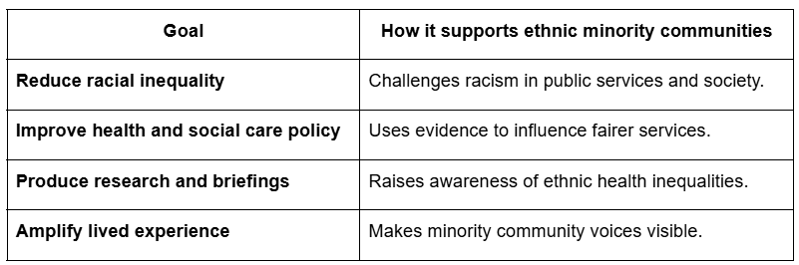
Table 1: Goals of the Race Equality Foundation in supporting ethnic minority communities in the UK
(Self-developed)

1.5 Conclusion
The UK is experiencing ethnic health disparities in Type 2 diabetes risk, maternal mortality disparities, and access and outcome disparities in mental health. Poverty, overpopulated housing, language barriers, racism and inequalities in access to healthcare determine these outcomes. Efficient intervention should involve disease-targeted intervention, as well as structural intervention around housing, income, culturally safe treatment and ethnicity data surveillance.

Task 2: Epidemiological Assessment of Type 2 Diabetes among South Asian Adults in Newham, London

2.1 Introduction: definition, consequences and worldwide/UK severity
Type 2 diabetes is a non-communicable chronic disease whereby the level of glucose in the blood is too high due to the inability to use insulin properly or a lack of insulin. Uncontrolled Type 2 diabetes may lead to coronary heart disease, stroke, kidney disease, retinopathy, blindness, nerve damage and lower-limb amputation (NHS, 2025). It also has social implications such as sickness absence, reduced working capacity, family caring pressure and increased utilisation of healthcare. In the case of South Asian adults, generic dietary recommendations can be culturally weak when they do not consider family eating habits and the stigma of a chronic disease. The number of adults with diabetes around the world has reached 589 million in 2024 and is expected to increase to 853 million in 2050 (IDF, 2025). Over 5.8 million individuals live with diabetes in the UK, of whom possibly 1.3 million are potentially undiagnosed Type 2-driven (Diabetes UK, 2025).
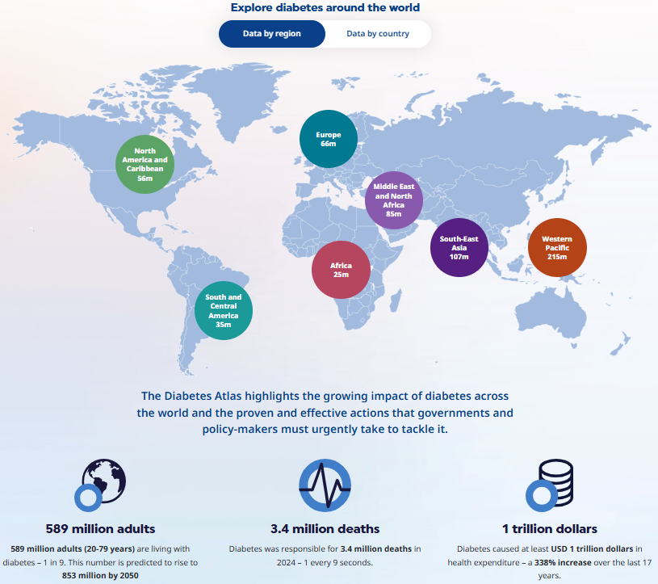
Figure 4: Global Statistics on Diabetes
(source: IDF, 2025)

2.2 Defined target population: South Asian adults in Newham
The target population is South Asian adults in Newham with a particular emphasis on Bangladeshi, Pakistani, Indian and Other Asian adults. The selection of Newham is suitable, because London Borough is a manageable epidemiological unit with both local demographic and health statistics. Around 42.2% of the residents living in Newham identified as Asian, Asian British or Asian Welsh, and 17.5% identified as Black, Black British, Black Welsh, Caribbean or African (ONS, 2023). The local disease relevance is also evident as the JSNA of Newham indicates evidence that the populations affected by the highest levels of diabetes in 2023 are the populations of Bangladeshi, Pakistani, Other Asian and Indian (Newham Council, 2025). South Asian adults cannot be, however, considered as a single group, as there are differences in language, income, diet, religion, migration history and service access among communities.
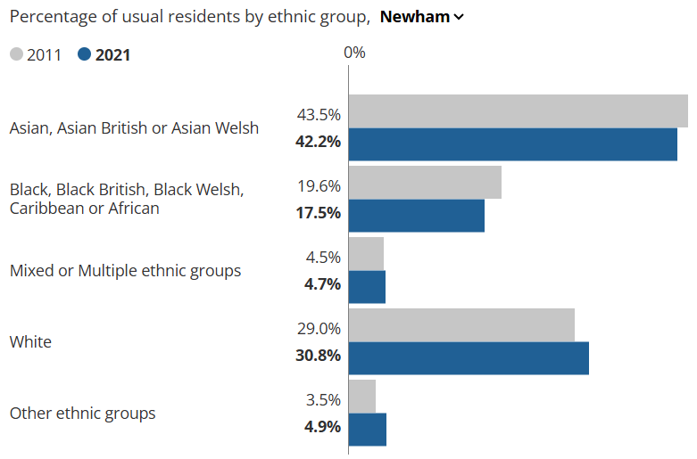
Figure 5: Rate of Newham Residents by Ethnic Group
(Source: ONS, 2023)

2.3 Public health measures using the 3Ps
Prevention: Prevention among South Asian adults in Newham should focus on individuals with non-diabetic hyperglycaemia and obesity, along with those with a family history or low screening uptake. Healthier You NHS Diabetes Prevention Programme is a lifestyle intervention (nine-month healthy eating, weight management, and physical activity) (NHS England, 2026). The initial NHS DPP results were assessed academically, which demonstrated a significant decrease in weight and HbA1c, proving it to be a valid choice of a prevention route (Valabhji et al., 2020). According to reports by NHS England, the completion is associated with a 37% reduced risk of developing Type 2 diabetes and a 3.3 kg average weight loss (NHS England, 2025).
Protection: Protection to be noted, which includes HbA1c testing, NHS Health Checks, GP risk registers, and preceding identification of unidentified diabetes should be mentioned. This is important as approximately 1.3 million people in the UK could have undiagnosed Type 2 diabetes (Diabetes UK, 2026).
Promotion: Multilingual education, community champions, mosque/temple outreach, the example of South Asian food, and family walks should be promoted. Nevertheless, the 3Ps will continue to be weak in case they are not mindful of affordability, language, working hours and trust.

2.4 Key determinants and risk factors
The determinants of Type 2 diabetes that are most influential in South Asian adults in Newham are those that work at biological, clinical and structural levels. Risk is increased clinically with South Asian ethnicity, family history, age, central adiposity, high BMI, hypertension, a history of gestational diabetes and non-diabetic hyperglycaemia. According to diabetes UK, individuals with South Asian, African-Caribbean or Black African ancestry are two/four times more susceptible to Type 2 diabetes, and 6.3 million people in the UK suffer non-diabetic hyperglycaemia (Diabetes UK, 2025a; Diabetes UK, 2025). In Newham, according to the JSNA, the Bangladeshi, Pakistani, Other Asian and Indian groups reported the highest prevalence of diabetes cases in 2023 (Newham Council, 2025). There is, however, a non-biological risk. The factors that affect the conversion of risk to disease are deprivation, insecure work, food insecurity, stress, language barriers and low screening uptake. As Marmot et al., (2020) points out, the circumstances in which individuals live and work result in health inequalities.

2.5 Epidemiological studies and health needs assessment of at-risk groups
Epidemiology involves investigation of how disease occurs, its distribution and determinants in defined populations and can also be used to control disease. In the case of Newham, health needs assessment ought to establish the presence of affected groups, risk groups, burden of diseases, differences by subgroups and gaps in service provision. Recent reports indicate that Type 2 diabetes is more prevalent and occurs earlier in South Asian communities compared to other ethnic groups, with metabolic, lifestyle and socioeconomic risk pathways (Kanaya, 2024). The worth of local records in determining the risk and treatment patterns of diabetes among population groups is also evident in a 2025 cohort study that utilised routinely collected primary-care data (Alfaraj et al., 2025). According to the JSNA in Newham, the population with the highest rates of diabetes in 2023 was composed of Bangladeshi, Pakistani, Other Asian and Indian (Newham Council, 2025). Thus, South Asian adults aged 25+, obese individuals, with central adiposity, hypertension, family history, deprivation, and low screening uptake are at-risk populations. OHID Fingertips, National Diabetes Audit, GP records, JSNA data and community consultation should be incorporated in the needs assessment.

2.6 Monitoring and surveillance systems
Surveillance of public health is the continuous process of gathering, examining, interpreting and distributing data on public health (CDC, 2025). OHID Fingertips Diabetes Profile should be employed in routine passive surveillance to track the prevalence, determinants, treatment, complications, and mortality of diabetes in Newham (OHID, 2025). QOF and GP registers show the number of diabetes cases that are diagnosed in primary care, and the National Diabetes Audit measures care processes and treatment targets in England and Wales (NHS Digital, 2026). NHS Health Checks involve active risk detection in the 40 to 74-year-old group including the risk of diabetes (NHS Health Check, 2025). Hospital Episode Statistics can report on admissions and complications as HES captures NHS hospital activity (NHS Digital, 2025). Nevertheless, surveillance can underreport need in cases of undiagnosed diabetes, incomplete ethnicity coding, and non-GP-registered residents.

2.7 Epidemiological assessment of short- and long-term public health impact
Epidemiology assists in estimating the impact of Type 2 diabetes on South Asian adults in Newham, associating disease burden with service usage and long-term complications. Short-term effects are increased GP consultations, drug demands, dietetic consultations, fatigue, sickness absence, pressure and stress of caring for family and self-management stress. The long-term effects are cardiovascular disease, kidney failure, retinopathy, neuropathy, amputation of lower limbs, disability, untimely mortality and an increase in NHS expenditure. In 2024, 3.4 million people died of diabetes globally and at least US$1 trillion was spent on health in 2024 (IDF, 2025). System pressure is rising in the UK, with diabetes registrations rising by 185,034 between 2022-23 and 2023-24 (Diabetes UK, 2025). Consequently, ethnic inequality may be aggravated if the prevention, early detection and culturally-sensitive follow-up is low.

2.8 Proposed intervention programme and evaluation
The suggested intervention is the Newham South Asian Diabetes Prevention and Early Diagnosis Programme. Its mission is to decrease undiagnosed, preventable Type 2 diabetes in South Asian adults aged 25+ by screening, referral and lifestyle support, tailored to their culture. It must focus on adults of Bangladeshi, Pakistani, Indian and other Asian backgrounds who have a family history of positive central adiposity, obesity, hypertension, non-diabetic hyperglycaemia and are less involved in NHS Health Check. It should also be delivered with GP risk searches, community HbA1c testing, pharmacy/faith-setting outreach, referral to NHS Diabetes Prevention Programme, South Asian diet education, family walking sessions and multilingual reminders (NHS England, 2026). The assessment of equity should be done, not just average improvement.
SMART goals and action plan.
SMART objectives and evaluation plan
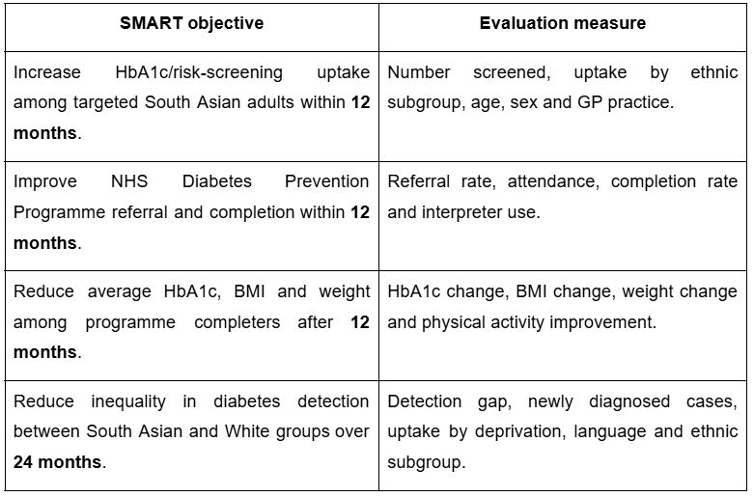
Table 2: SMART objectives and evaluation plan
(Self-developed)

2.9 Strengths and weaknesses of the epidemiological approach
Strengths: The strengths lie in the approach, and it involves a conceptualised disease, population and a borough that implements a person-place-time thinking to the South Asian adults of Newham. Newham is suitable since the Census 2021 reported that 42.2% of the population was Asian (ONS, 2023). Adds also include OHID Fingertips, QOF, National Diabetes Audit, Newham JSNA, GP records and community screening, which will enable the measurable outcome of HbA1c, BMI, referrals, completion rates, complications and admissions.
Weaknesses: Routine datasets can overlook undiagnosed diabetes; Diabetes UK estimates that there are almost 1.3 million individuals who might have undiagnosed Type 2 diabetes (Diabetes UK, 2025). The perfection of ethnicity coding, South Asian sub-group variation, confounding, digital exclusion and selection bias can undermine the accuracy. Consequently, monitoring has to be coupled with community involvement and structural investigation.
Overall, Type 2 diabetes in the South Asian adults of Newham needs Surveillance-led, culturally adapted public health response as generic lifestyle campaigns may shift the averages, but leave deprivation, language barriers, food access, and trust remain unaddressed.

References
- Alfaraj, S.A., Vos, R.C., Spruit, M., Groenwold, R.H. and Mook-Kanamori, D.O. (2025) Sociodemographic and biological determinants of insulin initiation in type 2 diabetes: a cohort study using routinely collected primary care data. British Journal of General Practice, 75(760), pp.e749-e758.
- Bansal, N., Karlsen, S., Sashidharan, S.P., Cohen, R., Chew-Graham, C.A. and Malpass, A. (2022) ‘Understanding ethnic inequalities in mental healthcare in the UK: A meta-ethnography’, BJPsych Bulletin, 46(6), pp. 1–10. Available at: https://pmc.ncbi.nlm.nih.gov/articles/PMC9746991/?
- CDC. (2025) Introduction to public health surveillance. Available at: https://www.cdc.gov/training-publichealth101/php/training/introduction-to-public-health-surveillance.html
- Diabetes UK (2025a) Type 2 diabetes risk factors. Available at: https://www.diabetes.org.uk/about-diabetes/type-2-diabetes/diabetes-risk-factors? .
- Diabetes UK (2026) How many people in the UK have diabetes? Available at: https://www.diabetes.org.uk/about-us/about-the-charity/our-strategy/statistics?
- Diabetes UK. (2023) How Many People in the UK Have diabetes? [online] Diabetes UK. Available at: https://www.diabetes.org.uk/about-us/about-the-charity/our-strategy/statistics
- Diabetes UK. (2025) One in five adults now live with diabetes or prediabetes in the UK. Available at: https://www.diabetes.org.uk/about-us/news-and-views/one-five-adults-now-live-diabetes-or-prediabetes-uk?
- GOV.UK (2025a) Persistent low income: Ethnicity facts and figures. Available at: https://www.ethnicity-facts-figures.service.gov.uk/work-pay-and-benefits/pay-and-income/low-income/latest
- GOV.UK (2025b) Overcrowded households: Ethnicity facts and figures. Available at: https://www.ethnicity-facts-figures.service.gov.uk/housing/housing-conditions/overcrowded-households/latest
- GOV.UK (2026) Written evidence submitted by the Race Equality Foundation (MRS0335). Available at: https://committees.parliament.uk/writtenevidence/3362/pdf/
- IDF (2025) IDF Diabetes Atlas: Global diabetes data and statistics. Available at: https://diabetesatlas.org/?
- Kanaya, A.M. (2024) Diabetes in South Asians: uncovering novel risk factors with longitudinal epidemiologic data: Kelly West Award Lecture 2023. Diabetes Care, 47(1), pp.7-16.
- Marmot, M., Allen, J., Boyce, T., Goldblatt, P. and Morrison, J. (2020) Health equity in England: The Marmot Review 10 years on. London: Institute of Health Equity. Available at: https://www.instituteofhealthequity.org/resources-reports/marmot-review-10-years-on
- MBRRACE-UK (2024) Saving lives, improving mothers’ care: Lessons learned to inform maternity care from the UK and Ireland Confidential Enquiries into Maternal Deaths and Morbidity 2020–22. Oxford: National Perinatal Epidemiology Unit. Available at: https://www.npeu.ox.ac.uk/assets/downloads/mbrrace-uk/reports/maternal-report-2024/MBRRACE-UK%20Maternal%20MAIN%20Report%202024%20V2.0%20ONLINE.pdf?
- MBRRACE-UK (2026) Maternal mortality 2022–2024. Oxford: National Perinatal Epidemiology Unit. Available at: https://www.npeu.ox.ac.uk/mbrrace-uk/data-brief/maternal-mortality-2022-2024?
- Newham Council (2025) Newham Joint Strategic Needs Assessment 2025: Executive Summary. Available at: https://www.newham.gov.uk/downloads/file/8521/50-steps-jsna-exec-summary
- NHS (2025) Complications of type 2 diabetes. Available at: https://www.nhs.uk/conditions/type-2-diabetes/complications/?
- NHS Digital (2024) Mental Health Act Statistics, Annual Figures 2023–24: Detentions, differences between groups of people. Available at: https://digital.nhs.uk/data-and-information/publications/statistical/mental-health-act-statistics-annual-figures/2023-24-annual-figures/detentions-differences-between-groups-of-people?
- NHS Digital. (2025) Hospital Episode Statistics. Available at: https://digital.nhs.uk/data-and-information/data-tools-and-services/data-services/hospital-episode-statistics
- NHS Digital. (2026) National Diabetes Audit Core Report 1: Care Processes and Treatment Targets 2024–25. Available at: https://digital.nhs.uk/data-and-information/publications/statistical/national-diabetes-audit/report-1-cp-and-tt-data-release-2024-25/nda-report-1-cp-and-tt-data-release-2024-25
- NHS England (2025) Core20PLUS5 (adults) – an approach to reducing healthcare inequalities. Available at: https://www.england.nhs.uk/about/equality/equality-hub/national-healthcare-inequalities-improvement-programme/core20plus5/?
- NHS England (2025) Ethnicity Recording Improvement Plan. Available at: https://www.england.nhs.uk/long-read/ethnicity-recording-improvement-plan/?
- NHS England. (2026) NHS Diabetes Prevention Programme (NHS DPP). Available at: https://www.england.nhs.uk/diabetes/diabetes-prevention/ .
- NHS Health Check (2025) What is an NHS Health Check? Available at: https://www.healthcheck.nhs.uk/ .
- NHS Race and Health Observatory (2025) Patients report alarming lack of trust in NHS primary care providers. Available at: https://www.nhsrho.org/news/patients-report-alarming-lack-of-trust-in-nhs-primary-care-providers/ .
- NHS Race and Health Observatory (2026) Tackling race inequities in health and social care. Available at: https://nhsrho.org/ .
- OHID. (2025) Diabetes Profile: Statistical commentary, March 2025. Available at: https://www.gov.uk/government/statistics/diabetes-profile-update-march-2025/diabetes-profile-statistical-commentary-march-2025 .
- ONS (2022) Ethnic group, England and Wales: Census 2021. Available at: https://www.ons.gov.uk/peoplepopulationandcommunity/culturalidentity/ethnicity/bulletins/ethnicgroupenglandandwales/census2021? .
- ONS. (2023) How life has changed in Newham: Census 2021. Available at: https://www.ons.gov.uk/visualisations/censusareachanges/E09000025.
- Valabhji, J., Barron, E., Bradley, D., Bakhai, C., Fagg, J., O’Neill, S., Young, B., Wareham, N., Khunti, K., Jebb, S. and Smith, J. (2020) Early outcomes from the English National health service diabetes prevention programme. Diabetes care, 43(1), pp.152-160.
- World Health Organization (2025) Social determinants of health. Available at: https://www.who.int/health-topics/social-determinants-of-health?#tab=tab_1.

