Exploring the difference between males and females within depression
Student ID:2104485
Alisha Beckett

Abstract
Contained within this report is the study of differences between men and women with depression. Through this report we will look at the method used to discuss the differences between men and women with depression and why we obtained the result that we did. To evaluate the results from the information that was collected from the study, we will be using the independent samples t-test. From the results we have obtained from performing this study we have came to the conclusion that females have a higher level of depression than men do.

Introduction
To formally introduce this study, firstly we are going to look at what other researchers have looked into the depression levels between men and women. The National institute Of Mental health (NIMH, 2022), has also suggested that there is a difference between women and men who have depression. A lot of factors contribute to depression, such as ;child abuse, history of mental health, family history, chronic disorders, substance use. (NIMH, 2022).
Bresla J, et al (2017), stated that the sex difference within depression does not have a fixed age. Females have higher levels of depression, no matter what gestation of age they are at in life. This present study will add credible value to the reasoning behind why women have higher rates of depression recorded, compared to men. This study will also contribute beneficially to understanding the differences of depression rates between men and women. Being able to identify these differences may possibly help doctors to prescribe treatments and also trial and test new treatments. The hypothesis of this study is that from the results obtained, females will score a higher result.
(Shimelpfening N,2020).

Method

Participants
Participants for this study were recruited via volunteer sampling. This was done by sending out a email via the university student email platform to all undergraduate students.
In total, there were thirty participants that took place in this study. This consisted of 18 males and 12 females. All of which participants, made a self-declaration that they have not been diagnosed with depression or been diagnosed previously.
Demographic information as follows;
Range of ages for all participants in the study: 18-45 years.
M= 28.80 , SD= 8.08

Design
For the study, the 30 participants that volunteered to conduct the study, were split into two different groups.

For this study specifically,
The dependant variable= the severity of depression that was collected from the participants ,using the centre epidemiologic studies short depression scale. (C-E-S D R 10).
The independent variable= this is the gender of the participants that took place in this study, male or female.

Materials
The participants that were recruited to perform this study, were instructed to complete the CES-DR 10 questionnaire via online, using the platform Qualtrics. This questionnaire consists of ten questions. Before the questionnaire, all participants were required to state their; age, gender and if they have had any previous diagnoses of depression, if the answer was yes, we asked for more information regarding that matter. All applicants had to self-report their level of depression via this questionnaire by inserting a number that best describes themselves on the level of severity. The questionnaire was marked by using a independent-sample t-test. If the participants did not answer 2 or more questions throughout their questionnaire, this entry would not be scored. This ensures academic reliability and credibility for all results we have obtained. The hypothesis for this study is that females will score a higher number on the questionnaire, this statement is supported. (Shi P,et al, 2021).

Procedure
The procedure for managing this study, firstly started by gathering the applicants for this study, via an email sent out to undergraduate students. Volunteering sampling would be the correct term for this. Once the applicants were collected, they were presented with a consent form entailing the details of the study. Next the applicants were given the demographics questionnaire to complete online via the Qualtrics too platform. The CES-DR-10 was then completed to score the results. Finally to conclude the study that was conducted, all applicants were thanked for their participation in this experiment and were also presented with a debrief form. All of the materials used for this study can be found in the appendices section at the end of this report.

Results
To record the data from the study, an independent sample t-test was created to obtain and keep record of the results for men and women with depression. The aim of this study was to trial our hypothesis of women scoring a higher result to depression.
The mean score for females and males, from the results that we collected during the study are as follows;
Mean score for males- M=6.61
Mean score for females- M= 10.42

The SD scores for females and males, from the results that we collected are as follows;
Female- SD= 3.53
Male- SD= 2.73

After analysing the results that we accomplished, we compared them to our initial hypothesis that we created before conducting the study. Our original hypothesis was that women would score higher than men on the level of depression. In this instance the experimental hypothesis is supported as after conducting the study and evaluating the results, we have come to the conclusion that the results are the same as we originally predicting before starting the st

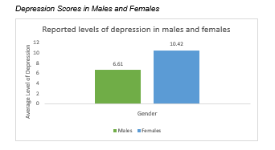

Discussion
To conclude this study, we started with a hypothesis that females would score higher rates of depression rather than men. The study that we have conducted is an credible source to also support previous researchers work into looking at this matter. Some of the researchers are; Paul. R. Albert who questioned ‘why depression is more prevalent in women?’ (Albert R P,2015). More researchers, Eid S R et al, done work on the sex differences in depression. (Eid S R et al, 2019). Thirdly, Breslau J et al also researched into the sex differences in depression and produced an article for their results. ( Breslau J et al,2017). Lastly Moller-leimkulher M A and Yucel M, looked into, male depression in females. ( Moller-leimkulher M A and Yucel M, 2010). All of these researchers had the same hypothesis that we did within this study, females have a higher rate of depression than males do.

References
Albert R P (2015). Why is depression more prevalent in women?. Accessed on 11/07/23. (Available at: Why is depression more prevalent in women - editorial.pdf ).
Björgvinsson, T., Kertz, S.J., Bigda-Peyton, J.S., McCoy, K.L., Aderka, I.M. (2013). Psychometric properties of the CES-D-10 in a psychiatric sample. Assessment, 20, 429-436.
Bresla J et al (2017). Sex differences in recent onset depression, page 1. Sex differences in recenet on-set depression in an epidemiological sample of adolecents. Pages 1-6.
Eid S R (2019). Sex differences in depression- insights from clinical and preclinical studies. Accessed on 11/07/2023. ( Available at: Sex differences in depression.pdf ).
Miller, W.C., Anton, H.A., Townson, A. F. (2008). Measurement properties of the CESD scale among individuals with spinal cord injury. Spinal Cord, 46, 287-292.
Moller-leimkulher M A and Yucel M. (2010). Male depression in females?. Journal of effective disorders. 22-29.
NIMH (2022). Depression facts and statistics. Accessed on: 10/07/23. (Available at: https://www.healthline.com/health/depression/facts-statistics-infographic ).
Radloff, L. S. (1977). CES-D scale: A self report depression scale for research in the general populations. Applied Psychological Measurement,1, 385-401.
Shi P, et al. (2021). A hypothesus of gender differences in self-reporting symptom of depression: implications to solve under-diagnosis and under-treatment of depression in males. Accessed on 11/07/23. (Available at: Frontiers | A Hypothesis of Gender Differences in Self-Reporting Symptom of Depression: Implications to Solve Under-Diagnosis and Under-Treatment of Depression in Males (frontiersin.org) ).
Shimelpfening N (2020). Is depression different in woenn and men. Accessed on: 10/07/2023. (Available at: https://www.verywellmind.com/difference-between-male-and-female-depression-symptoms-3892841).

Appendices
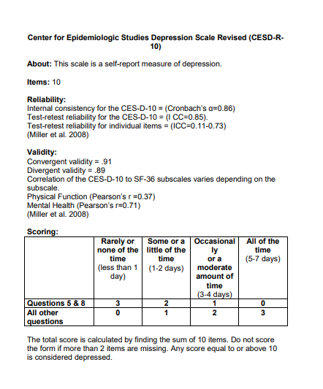
centre of epidemiological score chart

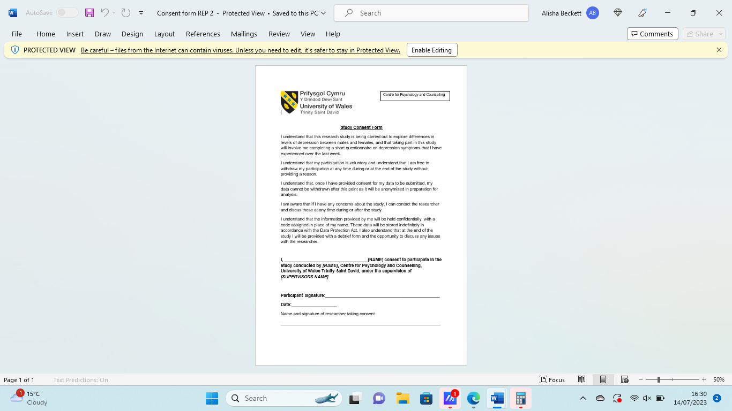
Consent Form
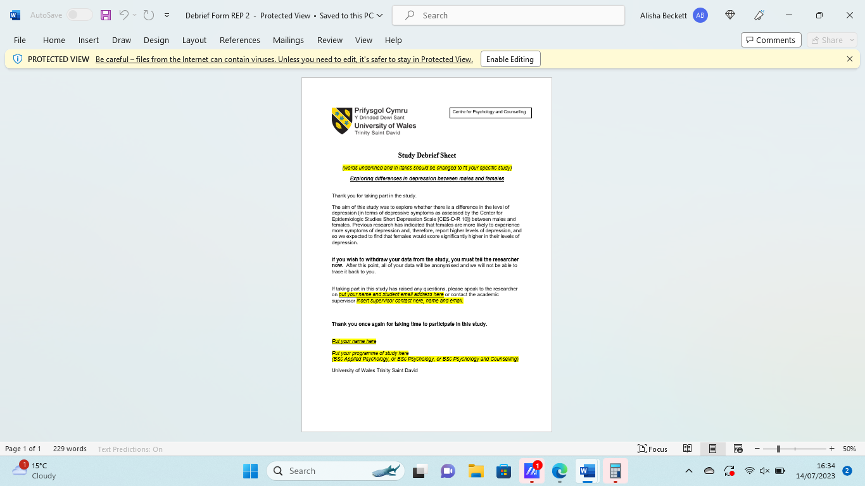
Debrief form
Demographic Questions


