James Hunt (2215832)
[Email address]
Abstract
This report compares Braun's array and Wallace Tree multiplier architectures as 8-bit unsigned multipliers implemented in VHDL and validated on a Digilent Basys 3 board. Using a model-based design methodology, the study moves from Simulink prototyping with custom adders to hardware validation on a Xilinx Artix-7 FPGA.
The study concludes that Wallace Tree multipliers excel in high-speed scenarios, while Braun's offer simplicity and power efficiency. The design approach effectively facilitated the transition from modelling to hardware implementation.
Electronics 2 report
ACDA6001

Table of Contents
Table of Figures 1
Introduction 2
Background Research and Current Developments 2
Evolution of Multiplier Techniques 2
Applications and Advantages 2
Braun's Multiplier Applications 2
Wallace Tree Multiplier Applications 2
System Operation and Methodology 3
Design Methodology 3
Model-Based Design Approach 3
Full Adder Simulink Implementation 3
Half Adder Simulink Implementation 4
Multiplier Block Diagrams and Algorithms 4
Braun's Multiplier Architecture 4
Wallace Tree Multiplier Architecture 4
Implementation Details 5
Model-Based Process 5
Model-Based Design Benefits Realised 5
VHDL Creation 5
FPGA Implementation Results 6
Performance Comparison 6
Timing Analysis and Critical Path Evaluation 6
Power Consumption Analysis 6
Resource Utilisation 7
Recommendations for Future Improvements 7
Speed Optimisation via Pipelining 7
Conclusion 7
References 8
Appendices 9
Embed Reports from Vivado 14

Table of Figures
Figure 1 - Simulink Full Adder 3
Figure 2 - Simulink Half Adder 4
Table 1 - Timing Comparison 6
Table 2 - Power Comparison 6
Table 3 - Resource Utilisation 7
Figure 3 - Braun Multiplier Detail showing signals 9
Figure 4 - Braun Multiplier Full Hierarchical Diagram 10
Figure 5 - Wallace Tree Multiplier Detail showing signals 11
Figure 6 - Wallace Tree Multiplier Full Hierarchical Diagram 11
Figure 7 - Simulation Waveform results on Eight bit Braun 12
Figure 8 - Simulation Waveform results on Eight bit Wallace 12
Figure 9 - RTL Design Eight bit Braun 13
Figure 10 - RTL Design Eight bit Wallace 13
Figure 11 - Netlist of Eight bit Braun 14
Figure 12 - Netlist of Eight bit Wallace 14

Introduction
Digital multiplication is an essential operation in today's computing systems. It plays a key role in digital signal processing, microprocessors, and many arithmetic units used in daily life.[1], [2] The effectiveness of multiplication algorithms directly affects the overall performance of these digital systems, which is why choosing the correct multiplier architectures is vital for optimising speed, power consumption, and hardware resources.
This report examines two notable multiplication techniques: Braun's and Wallace Tree. Both are designed as 8-bit unsigned multipliers using VHDL. The analysis covers the design methodology, performance evaluation, power consumption, and critical path analysis to discover the best option for various application scenarios.

Background Research and Current Developments
Evolution of Multiplier Techniques
Digital multiplication has evolved significantly over the past decades, driven by the increasing demand for high-performance computing and energy-efficient designs. Traditional array multipliers like Braun's multiplier provide straightforward implementation with predictable timing characteristics, while advanced techniques like Wallace Tree multipliers offer improved speed performance through parallel processing architectures.
Recent developments in multiplier design focus on hybrid approaches that combine the benefits of different techniques. Research has shown increasing interest in approximate multipliers for applications where slight accuracy trade-offs can yield significant power and speed improvements. Additionally, integrating machine learning algorithms for optimising multiplier configurations has gained attention in contemporary research.[3], [4]

Applications and Advantages

Braun's Multiplier Applications
- Embedded systems requiring predictable timing
- Educational implementations due to straightforward design
- Applications where silicon area is not a primary constraint
- Systems requiring simple control logic

Wallace Tree Multiplier Applications
- High-performance digital signal processing
- Graphics processing units and multimedia applications
- Arithmetic logic units in modern processors
- Real-time systems requiring fast multiplication
Braun's multiplier's advantages include simplicity of design, a regular structure that facilitates layout, and ease of testing and verification. Wallace Tree multipliers excel in speed performance, reduced critical path delay, and efficient utilisation of parallel processing capabilities. [3]

System Operation and Methodology

Design Methodology
This project implemented model-based design principles throughout the development cycle, beginning with initial prototyping and verification in Simulink before proceeding to VHDL implementation.[5]

Model-Based Design Approach
The implementation followed a model-based design methodology, which provides several advantages, including early verification, design space exploration, and reduced development time. This approach enabled comprehensive testing of design concepts before committing to hardware implementation.
Simulink Prototyping Phase
Initial verification used MATLAB Simulink for rapid prototyping and validating multiplier architectures. The models, built from fundamental logic gates, provided behavioural references for VHDL implementation. Custom full and half adders were designed and tested in Simulink with basic logic gates (AND, OR, XOR, NAND). This approach ensured understanding of component behaviour and confidence in the building blocks before system integration.

Full Adder Simulink Implementation
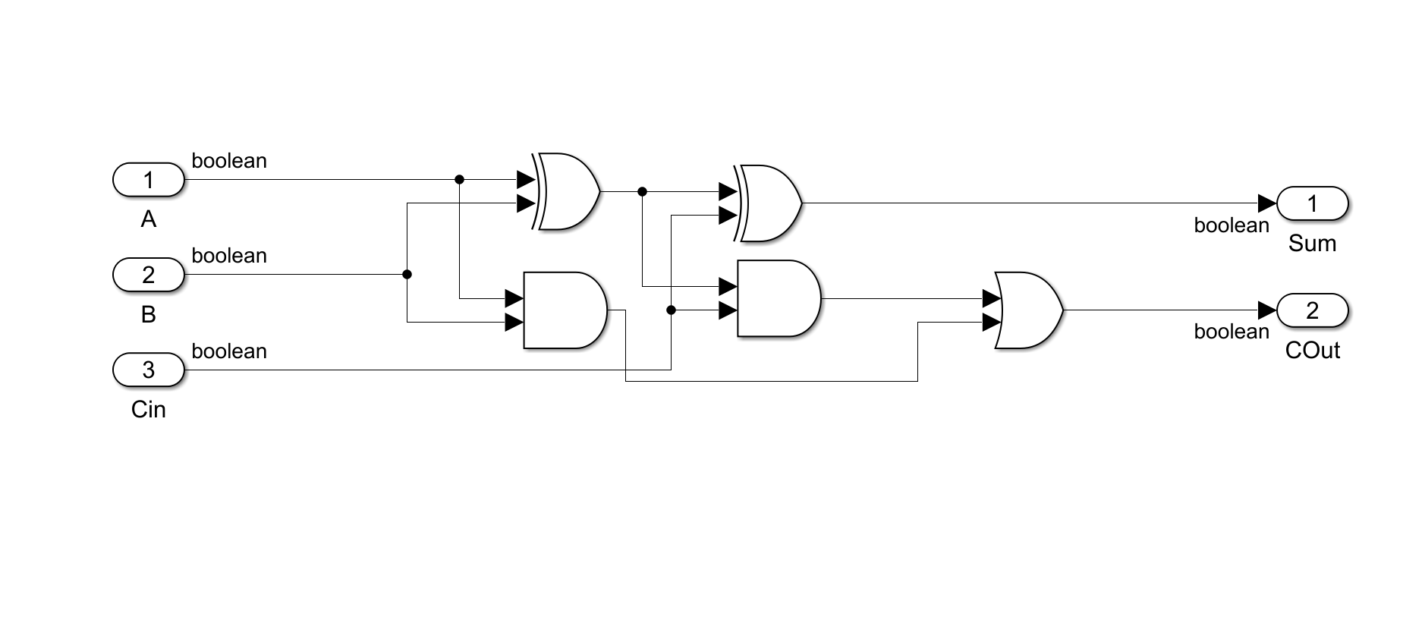
Figure 1 - Simulink Full Adder
- Sum output: A ⊕ B ⊕ Cin (implemented using XOR gates)
- Carry output: (A ∧ B) ∨ (Cin ∧ (A ⊕ B)) (implemented using AND, OR, XOR gates)

Half Adder Simulink Implementation
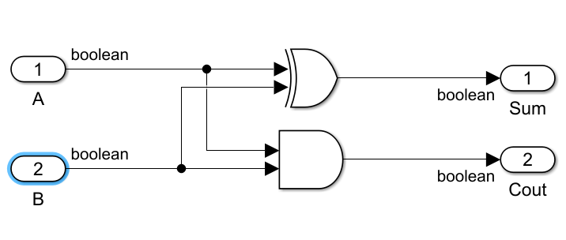
Figure 2 - Simulink Half Adder
- Sum output: A ⊕ B (XOR gate implementation)
- Carry output: A ∧ B (AND gate implementation)
Multiplier Block Diagrams and Algorithms

Braun's Multiplier Architecture
The Braun's multiplier employs a regular array structure where partial products are generated simultaneously and accumulated through a systematic arrangement of adders. The process follows these steps:
1. Generate partial products P[i,j] = A[i] × B[j]
2. Arrange partial products in an array format
3. Use full adders and half adders for sequential addition
4. Propagation carries through adjacent cells
5. Collect the final 16-bit product
The architecture comprises 64 AND gates for partial product generation and 56 adders (a combination of full and half adders) arranged in a triangular pattern.[6]

Wallace Tree Multiplier Architecture
The Wallace Tree multiplier utilises a tree-like reduction structure designed to minimise the critical path delay through parallel processing of partial products.
1. Generate partial products P[i,j] = A[i] × B[j]
2. Group partial products by weight (column)
3. Apply 3:2 compressors (full adders) to reduce three signals to two
4. Apply 4:2 compressors where applicable
5. Continue reduction until two operands remain
6. Perform final addition using carry-propagate adder[6]

Implementation Details

Model-Based Process
Each adder underwent testing in Simulink before VHDL conversion, which included verifying the truth table against theoretical expectation. This led to integration testing within larger arithmetic structures, with a 4-bit multiplier and cross-validation with manual calculations, before creating the 8-bit multipliers. [5]

Model-Based Design Benefits Realised
The model-based approach facilitated early identification of critical design flaws, such as misrouted signals and omitted internal connections. This early detection streamlined the hardware debugging process and reinforced the functional integrity of the final VHDL implementation. The Simulink models also served as executable specifications that could be easily modified and retested during design iterations.
VHDL Creation
Simulink's HDL Workflow Advisor provides comprehensive analysis capabilities that streamline the performance evaluation process for both multiplier implementations. The integrated toolchain automatically generates timing, power, and resource utilisation reports directly from the Simulink model, eliminating the need for manual report generation and analysis. However, for the purpose of this report, the author has chosen to use the reports generated in the Vivado software.
One of Simulink's most valuable features is the ability to highlight critical paths directly on the block diagram model, however as the timing constraints for this project are arbitrary, this was not utilised to its full potential to explore pipelining.
The VHDL was created from the verified Simulink models, which created a seamless transition from behavioural modelling to hardware description language.
The conversion from Simulink to VHDL followed a structured approach that maintained the integrity of the verified designs:
- Component Mapping. Each Simulink basic gate was directly translated to equivalent VHDL constructs
- Hierarchical Preservation. The modular structure established in Simulink was maintained in VHDL
- Signal Integrity. All internal signals and their behaviours were preserved during translation
The VHDL implementation follows a hierarchical approach with separate entities for basic components (full adder, half adder) and top-level entities for complete multipliers. This structure directly mirrors the Simulink subsystem organisation:
- Basic Gate Level: AND, XOR, OR gate implementations verified in Simulink
- Component Level: Full adders and half adders as tested in Simulink subsystems
- Architecture Level: Complete multiplier structures validated through Simulink system models.
- Top Level: Integration entities with port mapping completed in Vivado, ensuring proper signal connectivity.

This design strategy uses the Simulink models as golden references, which are behavioural benchmarks for validating VHDL implementations. This approach includes applying identical test inputs to the Simulink and VHDL implementations to ensure consistency. The benefits of model-based design are significant. One of the main advantages is early confirmation, which enables the identification of design issues during the Simulink phase before reaching the VHDL implementation stage. This proactive approach contributes to reduced debug time, as the confidence in the VHDL implementation is built on the pre-verified models. Also, model-based design enhances design traceability, clearly mapping Simulink blocks and VHDL entities. Port mapping in Vivado ensures proper signal connectivity while maintaining design modularity and reusability, with the added confidence that all connections have been pre-verified through the Simulink modelling phase.[5]

FPGA Implementation Results
Both multiplier designs were successfully implemented and tested on the Digilent Basys 3 prototyping board, which features a Xilinx Artix-7 FPGA (XC7A35T-1CPG236C). This platform provided an ideal testing environment for validating the practical performance of both multiplier architectures in real hardware.
Performance Comparison
This analysis section compares the performance of both 8-bit multipliers, Wallace Tree and the Braun Array, once they had both been synthesised on the Basys 3 board.

Timing Analysis and Critical Path Evaluation
 | Wallace Tree | Braun's | Difference
Critical Path Delay | 13.712 ns | 16.114 ns | +2.402 ns
Timing Slack | -5.737 ns | -8.139 ns | -2.402 ns
Logic Levels | 9 | 12 | 3
Logic Delay | 4.410 ns (37.7%) | 4.783 ns (33.9%) | +0.373 ns
Routing Delay | 7.302 ns (62.3% | 9.331 ns (66.1%) | +2.029 ns
Table 1 - Timing Comparison
The critical path in Braun's multiplier extends from the most significant bit inputs, through the diagonal adder chain, to the final output via all the logic levels.
The Wallace Tree multiplier demonstrates superior performance with a critical path delay of 13.712 ns compared to the Braun Array's 16.114 ns. This represents a 17.5% speed advantage for the Wallace Tree implementation.

Power Consumption Analysis
 | Wallace Tree | Braun's | Difference
Total Power | 0.085 W | 0.085W | 0 W
Dynamic Power | 0.014 W | 0.015W | +0.001 W
Static Power | 0.070 W | 0.070 W | 0 W
Table 2 - Power Comparison
Both implementations exhibit nearly identical total power consumption at 0.085 W, with static power at 0.070 W (82.4% of total power). The key differences lie in dynamic power consumption. The Braun Array consumes 7.1% more dynamic power despite its lower operating frequency, which can be linked to its higher logic levels utilisation and therefore increased switching.
Resource Utilisation
 | Wallace Tree | Braun's | Difference
LUT's Used | 138 | 176 | +38
LUT's Utilisation | 0.66% | 0.85% | +0.19%
Signals | 154 | 193 | +39
Table 3 - Resource Utilisation
Once again, the Wallace Tree demonstrates its superiority by using 27.5% fewer Look Up Tables and 25.3% fewer signals than Braun’s. This translates to the Basys 3FPGA utilisation, where the Wallace Tree utilises 0.66% vs. Braun Array's 0.85% of available LUTs. However, the most significant architectural difference is evident in the logic levels. The Wallace Tree's 25% reduction in logic depth directly contributes to its improved timing performance, as it reduces the number of sequential logic operations in the critical path.

Recommendations for Future Improvements
Speed Optimisation via Pipelining
Pipelining is a technique that divides a complex combinational logic path into smaller stages separated by registers (flip-flops). This can be best described as an assembly line in manufacturing, rather than one worker completing an entire product, multiple workers each complete a state, which enables multiple products to be processed simultaneously.
Both multipliers fail to meet the timing constraints because of the lengthy and intricate logic path that needs to be completed within one clock cycle. Consequently, the clock period must account for this maximum delay.
However, if a degree of pipelining were introduced, this path could be split into smaller subsections. As these are smaller, a faster clock cycle could be used. Therefore, although multiple clock cycles are needed to complete the operation, a quicker overall result can be achieved as multiple operations can be processed simultaneously.[3], [5], [7]

Conclusion
This report demonstrates that Braun's and Wallace Tree multipliers offer distinct advantages depending on the application scenario. The Wallace Tree multiplier provides superior speed performance with quicker operation, making it ideal for high-performance computing applications. However, Braun's multiplier presents benefits in design simplicity, a regular structure, and the ability to extract the partial output at any of the levels.
The choice between these architectures depends on specific system requirements. The Wallace Tree multiplier represents the ideal choice for applications prioritising maximum speed and accepting higher complexity and power consumption. On the other hand, systems requiring predictable timing, similar power consumption, and simpler verification processes benefit from Braun's multiplier implementation.

Any future research could focus on hybrid approaches that combine the benefits of both techniques, potentially through reconfigurable architectures that adapt to varying performance requirements.[4]
Understanding the fundamental trade-offs between multiplication architectures will enable engineers to make informed decisions that optimise system performance for specific application domains. Both multipliers successfully demonstrate the practical application of digital arithmetic principles while highlighting the importance of architectural selection in achieving desired performance characteristics.

References
References
[1] MathWorks, "Signal Processing with Simulink," 2010.
[2] M. Parker, Digital Signal Processing 101 : Everything You Need to Know to Get Started. (2nd ed ed.) Chantilly: Newnes, 2017.
[3] S. P. and A. A. Khan, "Comparison of braun multiplier and wallace multiplier techniques in VLSI," in 2018, . DOI: 10.1109/ICDCSyst.2018.8605173.
[4] V. Padmakumar et al, "A serial-parallel-based 4-bit novel multiplier: Design, implementation, and performance analysis," in 2023 IEEE Silchar Subsection Conference (SILCON), 2023, . DOI: 10.1109/SILCON59133.2023.10404909.
[5] S. Thomsett and Mathworks Cambridge, "Generating HDL Code from Simulink," Available: https://uk.mathworks.com/learn/training/generating-hdl-code-from-simulink.html.
[6] M. J. Selvakumar and M. P. Eswaran, "Fpga implementation of array-based fir filter folding," in .
[7] P. J. Ashenden, Digital Design : An Embedded Systems Approach using VHDL. 2008.

Appendices

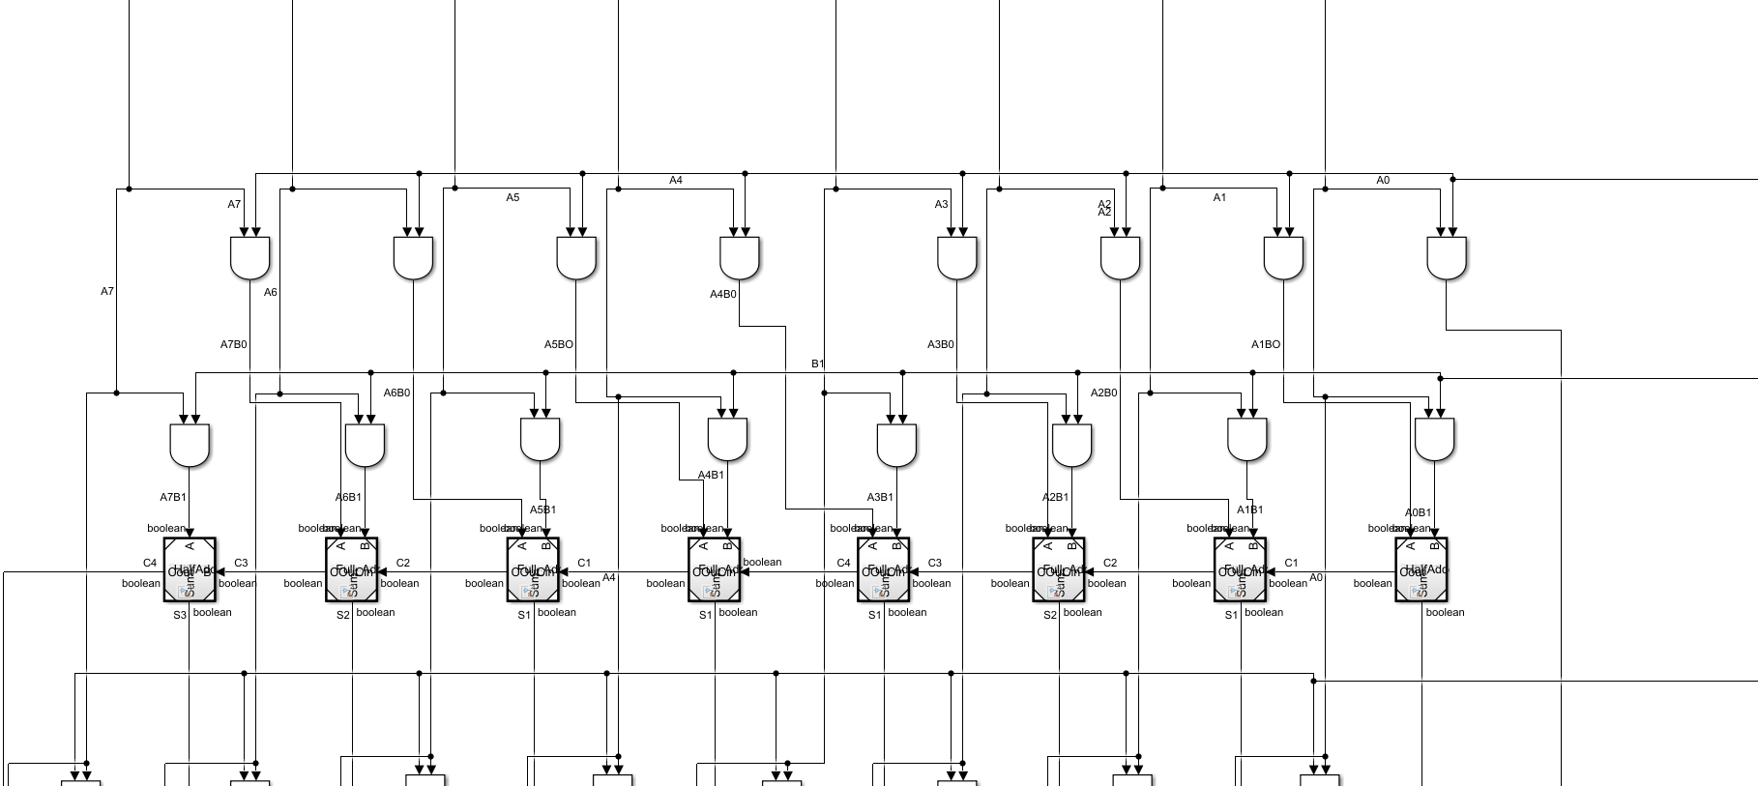
Figure 3 - Braun Multiplier Detail showing signals

Figure 4 - Braun Multiplier Full Hierarchical Diagram
Figure 5 - Wallace Tree Multiplier Detail showing signals
Figure 6 - Wallace Tree Multiplier Full Hierarchical Diagram
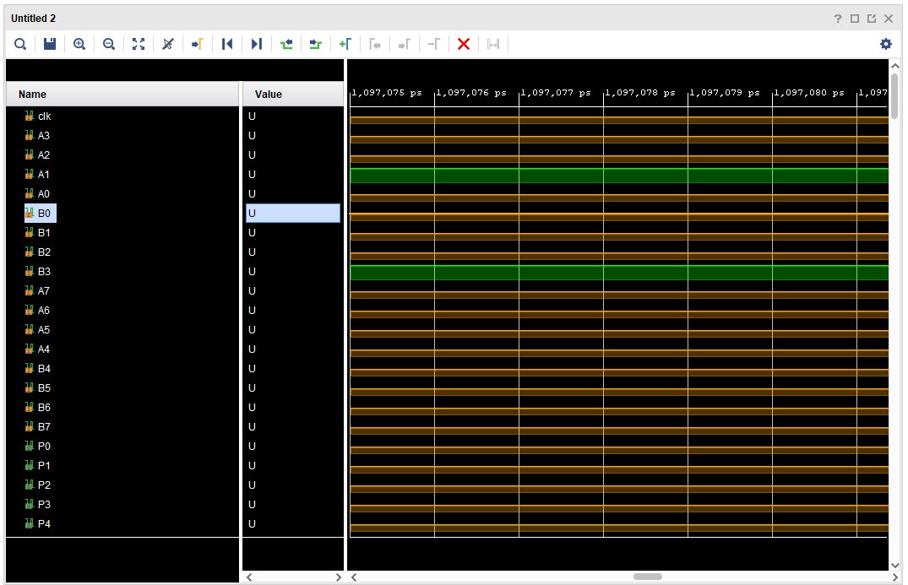
Figure 7 - Simulation Waveform results on Eight bit Braun
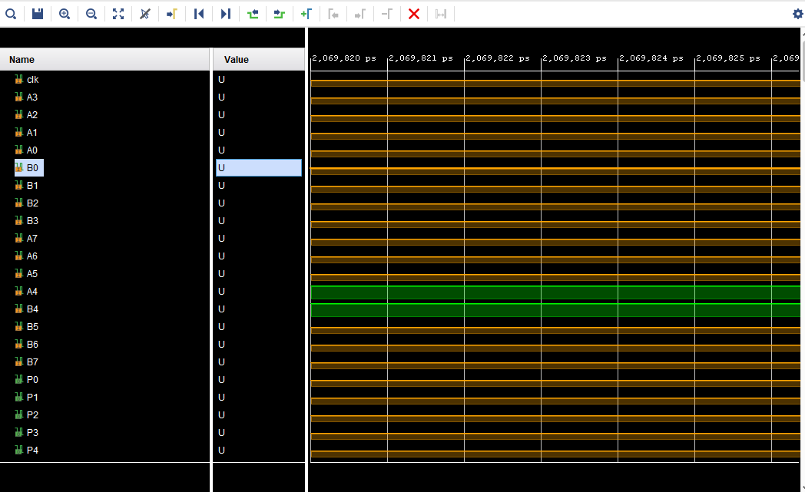
Figure 8 - Simulation Waveform results on Eight bit Wallace
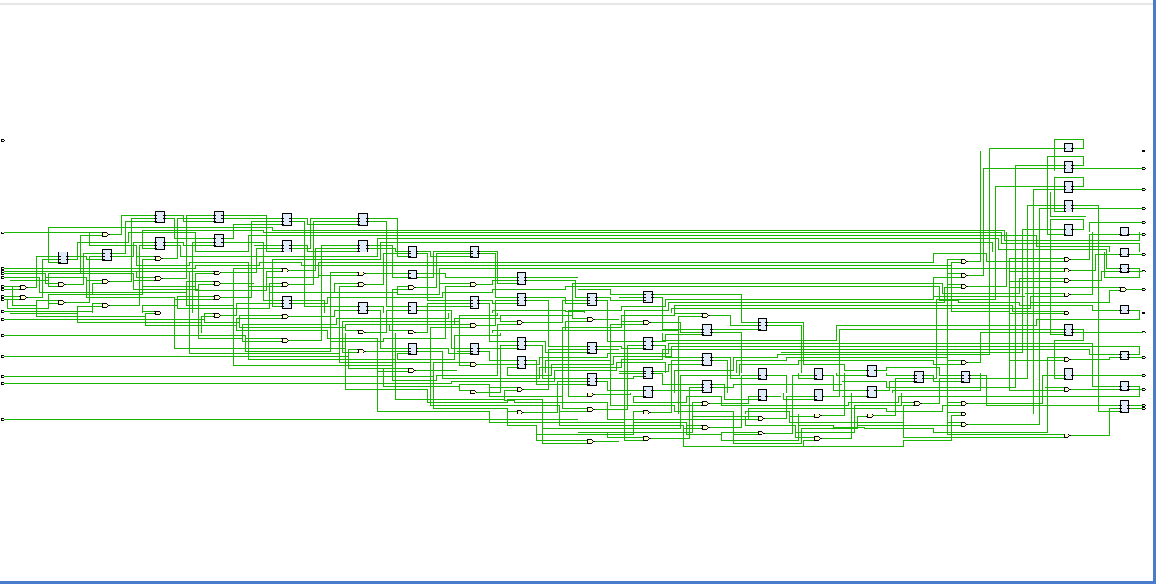
Figure 9 - RTL Design Eight bit Braun

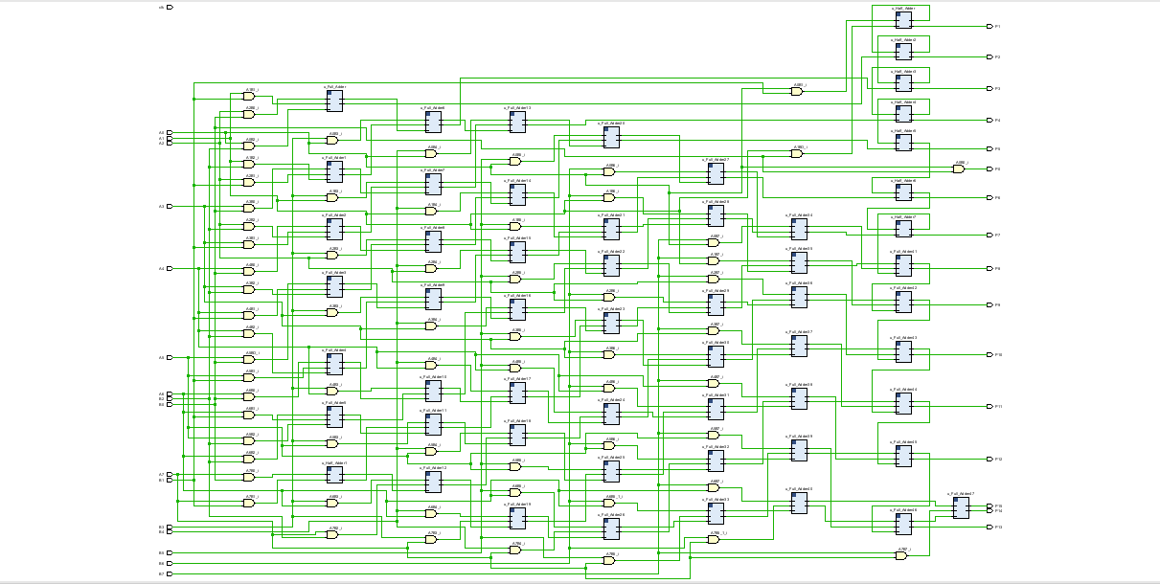
Figure 10 - RTL Design Eight bit Wallace

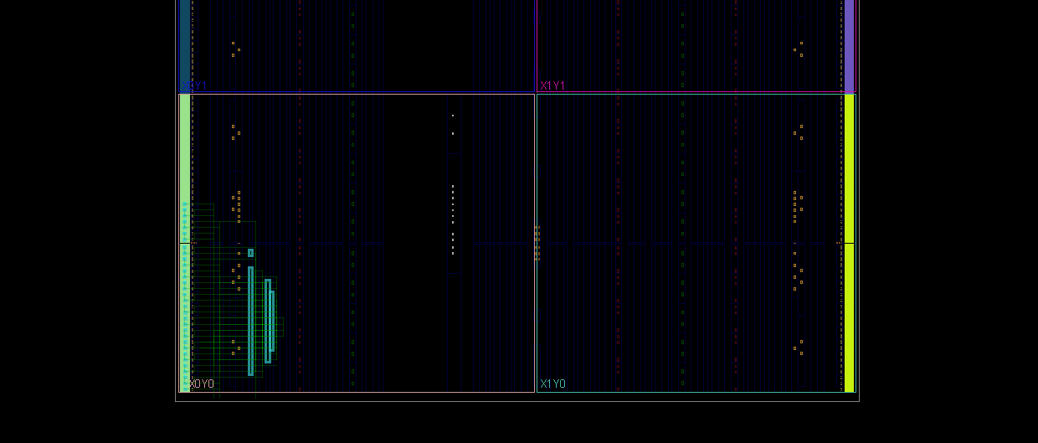
Figure 11 - Netlist of Eight bit Braun

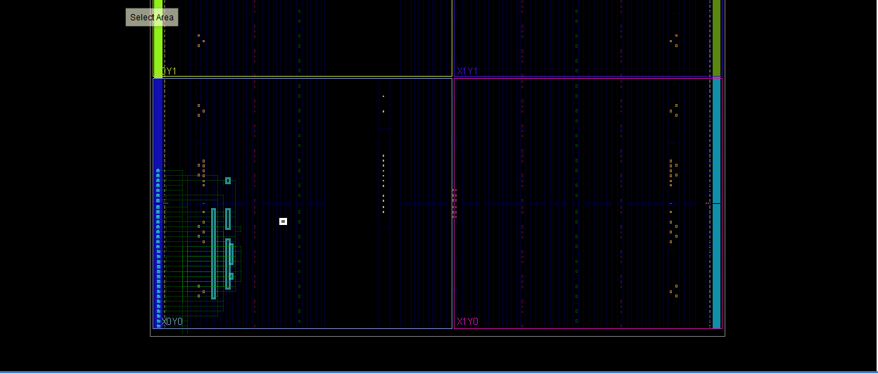
Figure 12 - Netlist of Eight bit Wallace

Embed Reports from Vivado

