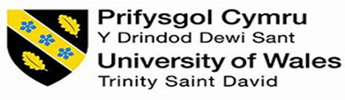

PROFESSIONAL CAREER
DEVELOPMENT

STUDENT NAME: ERIOLA DIKU
STUDENT NUMBER: 1906510
LECTURER NAME: MALANI GUNARATNAM
MODULE NAME: PROFESSIONAL CAREER DEVELPMENT
Contents
INTRODUCTION 3
Reflection 3
Career plans 4
Self-motivation 5
Learning styles 5
Personal development 5
Conclusion 6
References 6

INTRODUCTION
My name is Eriola and I am 21 years old. I come from Italy and I have been living here in for two years. Before coming here, I used to attend a foreign language high school. The first here in London I used to work in a restaurant in Victoria, whereas the second one I started a course to get a certificate in higher education in the University of Wales Trinity S. David, in order to get access to the university. In this report I will focus on my personal development plan, reflect on my experiences and goal. Starting with a short introduction about my future career plans and analysing what employers do want from their employees, I will talk about my personal goals for the future.

Reflection
A model of reflection I will use to develop as I will write my essay will be Gibbs’ reflective cycle model. As shown from the image below it is structured in a cycle and is composed by six elements.

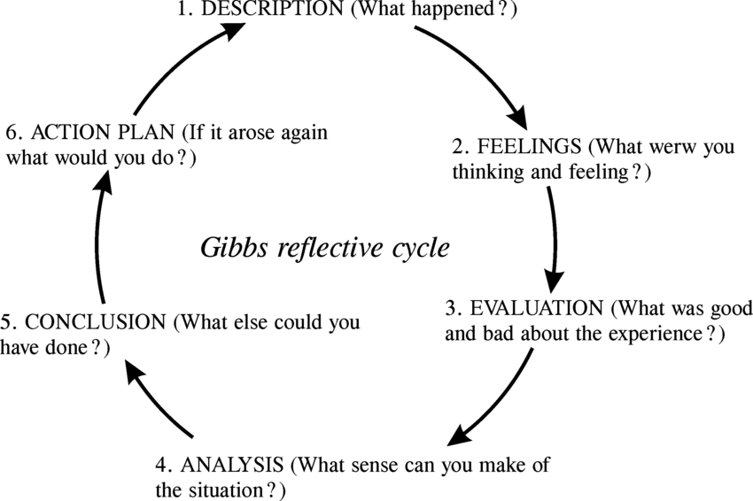

https://www.bing.com/images/search?q=gibbs+reflective+cycle&form=HDRSC3&first=1&scenario=ImageBasicHover

It all starts with the description of a certain situation or problem and describing all the emotions felt on that moment. Then all this must be seen and evaluated from an objective perspective in order to reflect better and analyse it to understand what positive thing we can take from this, even bad, situation. Only after this it will be possible to come to a conclusion and create an action plan on how to effectively handle a situation like this the next time (Rumson,2018). Using this method help me a lot understand how can improve my self when facing problems, it makes me reflect on what I did but also on how I can improve in the future if I will find myself in similar situations.

Career plans
The plans for my future are getting a degree in Bsc (hons) Biomedical science. Once I get this, I will be able to gain employment with the NHS as a trainee biomedical scientist. Doing a job like this means that the patients health and life will be in my hands so I will be required to have different specific skills. Good academic background, capacity to transfer the studied knowledge into practice, good communications skills, be comfortable in using modern technology and complex equipment, be attentive to detail, good interpersonal skills and be good at teamworking are some of the skills required for this job position. Depending on the chosen area the duties may be test for diseases, analyse blood, support the blood transfusion service, analyse tissue samples, and use specialistic procedures to find out a certain disease. The working place may be a university, research facility or a laboratory. With the experience it will be possible for me to move into research, education, specialist or team leader.

Self-motivation
Self-motivation is a force that comes from external or internal factors and drives you to do things. It pushes us into achieving a goal and improve our selves. It comes from a mix of what we have and want to do. When we do some things we love, it is very easy for us to do them and when we are self- motivated we even try to do them as good as we can (Skills you need, 2020). I can say the things that motivate me to wake up every morning is the fact that everything I am doing now is because of my future. I try to do my best in my current work place because I now it is a place where I like to be, surrounded by a great team and that will give me the opportunity to work in a flexible way, in order to keep attending university as well. I know this is a job I do not want to do for the rest of my life but for the moment it suits perfectly my needs as student and gives me certain skills such as teamworking, communication or punctuality that will be very useful for me in my future job. And my motivation to go to university and study comes from the fact I will be able to access a university I really like next year and I will be able to learn things and be able to get a good job in my future.

Learning styles
Every person learns new things based on their experiences and studies. There are different learning styles and one of those is called VAK, which was developed in the 1920s’. This represent the most common way how people can learn and consists in three classification: visual, auditory and kinaesthetic (Mulder, 2019). I have a dominant visual learning style. I remember information better if it is presented by images, graphs or even if it is just written. When I have to memorise some things I always write them down or do summaries of a certain thing so when I have to remember I can relate to my visual memory.

Personal development

Self-motivation and being determined to achieve your goals are two very important aspects that help you going on and working for it. Each of us has his own strengths and opportunities in life that will benefits us but however we do also have weaknesses and threats that may make our path. A tool we can use to identify them can be the swot analyses. By doing this we go to analyse all these four points.
STENGHTS  - GOOD AT TEAMWORKING  - VERY CREATIVE PERON  - GOOD AT RELATING WITH OTHERS  - VERY FLEXIBLE PERSON | OPPORTUNITIES  - LIVING IN A BIG CITY WHICH GIVES ME LOT OF OPPORTUNITIES  - STUDIYNG ABROAD
WEAKNESSES  - DIFFICULTIES IN TIME MANAGEMENT  - I CHANGE MIND OFTEN | THREATS  - SPEAKING DIFFERENT LANGUAGE THAN MINE  - WORKING AND STUDYING AT THE SAME TIME

Conclusion

Every one of us got their own weaknesses but it is important to identify and overcome them. I change mind often and I always get new ideas for my future, but for now I am sure what I want to do and what my goals are. My plans for the next four years are to get an undergraduate degree in biomedical science and then do a master, in the meanwhile I will keep doing the job I am doing.

References
Cherry, K. (2019). Overview of VARK Learning Styles. Available at: https://www.verywellmind.com/vark-learning-styles-2795156. Accessed date: 28/08/2020
Mulder, P. (2019). VAK Learning Styles. Available at: https://www.toolshero.com/communication-skills/vak-learning-styles/. Accessed date: 28/08/2020
Rumson, R. (2018). Gibbs Reflective cycle model. Available at: https://www.eln.io/blog/gibbs-reflective-cycle-model-1988. Accessed date: 18/08/2020
Skills you need (2020). Self-Motivation. Available at: https://www.skillsyouneed.com/ps/self-motivation.html. Accessed date 28/08/2020

