Art of Bill Gates’s Leadership

Xin Wang
1704354
Leadership and Management, Theory and Practice
SBUS6114
Contents
Executive Summary
- Preface
1.1 Introduction
1.2 Overview of Bill Gates
- Main Findings
  - History of Contingency Theories of Leadership
  - Situational Leadership Analysis
    - Practical Application
    - Strengths and Weaknesses
  - Path Goal Leadership Analysis
    - Practical Application
    - Strengths and Weaknesses
- Conclusion
- Recommendations
Reference List

Executive Summary
This report aims to:
- Analyse the leadership approach taken by Bill Gates by applying Situational Leadership Theory and Path Goal Theory
- Evaluate and explain the strengths and weaknesses of his approaches to leadership.
- Make recommendations for how these strengths can be maximised and the weaknesses minimised or overcome.

- Preface
1.1 Introduction
Leadership is an important function of management which helps to maximize efficiency and to achieve organizational goals (MSG, 2018). Moreover, research has shown that there is a strong relationship between effectiveness of leadership and motivation of employees. Therefore, good leadership is essential to business, to government and to the numerous groups and organisations that shape the way we live, work and play.
This report practically analyses Bill Gates's leadership style through two theoretical models (Situational Leadership and Path Goal Leadership), summarizes the strengths and weaknesses of his approaches. Thereby, put forward some constructive suggestions for the sustainable development of the Microsoft Corp.

1.2 Overview of Bill Gates
As we look ahead into the next century, leaders will be those who empower others. —Bill Gates
William Henry Gates III (born October 28, 1955) is an American business magnate, investor, author, philanthropist, humanitarian, and principal founder of the Microsoft Corporation (Britannica,2018). Gates led the company as chief executive officer until stepping down in January 2000, but he remained as chairman and created the position of chief software architect for himself (Einstein, David, 2000).
As one of the most successful companies in the world, the Microsoft Corp. has provided countless outstanding software products to hundreds of millions of users all over the world since its founding. Bill Gates is renowned for his participative style of leadership and empowering subordinates. The fact that Microsoft and the flagship brand Windows still holds its own amidst serious competition stands as testament to Gates' leadership skills (brighthubpm, 2018).

2.0 Main Findings
2.1 History of Contingency Theories of Leadership
In the view of history of human management, it has a long history to take the method of contingency into management. However, it is not until 1960s that a comprehensive contingency theory of leadership was formed. The mature stage is after the formation of several classic models of contingency leadership.
In my opinion, to understand and use contingency theory, understanding of Fiedler’s contingency model, Howse’s path goal theory and Hersey and Blanchard's situational leadership theory is necessary.
These three models reflect the essence of the theory of contingency:
Theory of Leadership | Time of Introduction | Major Contents
Contingency model of leadership effectiveness | 1962 | Factors unique to each situation determine whether specific leader characteristics and behaviours will be effective  (Fred E. Fiedler, 1974).
Path Goal Theory | 1970s | A process in which leaders select specific behaviours that are best suited to the employees' needs and the working environment (Northouse,2015).
Situational Leadership Theory (Model) | 1969-1985 | With situational leadership, leaders adapt their style to match their staff's abilities and their workplace circumstances  (Paul Hersey, 2004).

2.2 Situational Leadership Analysis
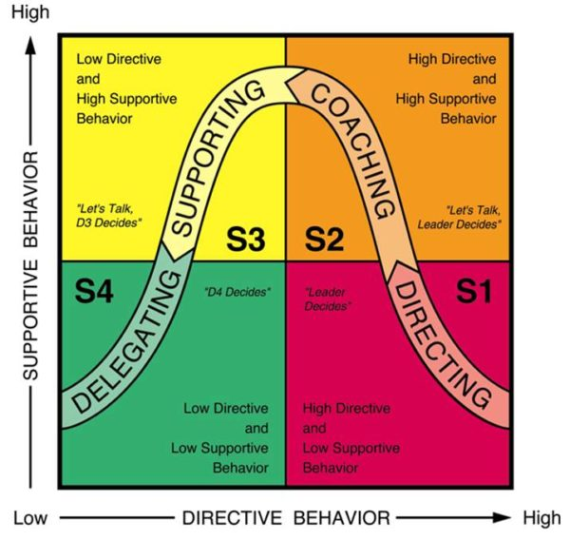
(goitalk, 2018)
The Situational Leadership Model is a model by Paul Hersey and Ken Blanchard. The leadership model is subdivided into directing, coaching, supporting and delegating. Employees are divided into 4 types according to their Maturity levels. It is emphasized that different management model should be adopted for employees with high initiative and low initiative (Hersey, P. and Blanchard, K. H. 1969).
Situational leadership courses had been formally added in the senior staff training program while Bill Gates was the chief software architect of Microsoft Corp. Employees who have worked for more than 5 years are qualified for situational leadership training. This course is one of four required courses for senior managers promotion to senior executives. Microsoft Corp. applies situational leadership for staff management and maintain positive relationship with employees. For years, Microsoft has been an attractive place to work, especially for talented people. Because different levels of talents can get suitable working atmosphere and find right direction in this company (Kaifu. Li, 2005).
2.2.1 Practical Application
On the one hand, Bill Gates is a "cruel" manager. On the other hand, he is a “minister” who has great communication skills. The integration of these two aspects makes him a universally recognized Master of Leadership（Pengcheng. Jin, 2013）.
There are mainly three ways of leadership are adopted by Bill Gates in this model.
D1/Directing:
For employees who lack skills, experience but willing to take responsibility:
- Bill Gates once said: what is the greatest welfare? That is to send employees to be training. For example, the pulpit project held at 14:00p.m. every Friday afternoon. This project invites experts of all industries and Microsoft’s own employees to teach about marketing, technology, management, public relations and so on. It aims to improve the comprehensive ability and competitive advantage of new employees so that they can take responsibility of complex tasks (Jingjie. Zhan, 2014).
- Gates believes that it is necessary to discover and urge those who are poorly behaved and give them a chance to improve. To achieve this goal, a comprehensive evaluation system was established. The performance of employees is regularly examined. Every year, 5% of their employees get the information "Make improvements or leave.” (Kaifu. Li, 2005)
D3/Supporting:
For employees who are experienced and able to do the task but lack confidence：
- Gates inspired experienced employees with low confidence by giving rewards and setting goals for them. He expressed his expectations of excellent performance by words and actions. "Before the company issued the stock publicly, I made some arrangements to allocate most stocks to our staff. Only to let them know how important their performance is. “(Rong. Cao, 2002)
- Encourage capable employees with low confidence to make suggestions for the improvement of the company's environment and the inopportune rules through brainstorming meetings and so on (Kaifu. Li, 2005).
D4/Delegating:
For employees who are experienced and comfortable with their own ability and willing to not only do the task, but to take responsibility:
- Bill Gates adopts the method of empowering employees to explore innovative ideas. For example, he fully trusted in the ability of employees on Asian Research Project. Employees were given enough freedom, money and space to explore the latest technology. The researchers only had to report their results to the headquarters monthly. By giving employee’s expectation, encouraging them to challenge higher performance, recognising their abilities and providing adequate resources, Microsoft has succeeded in promoting Windows technological innovation repeatedly (Jingjie. Zhan, 2014).
- Gates believes that special talents should be given adequate freedom and preferential treatment. For example, the elites of R&D centre in Seattle can go play basketball, go to gym, go swimming, and even get a special massage therapist to give massages when they are tired of work (Guoyong. Zhu, 2010).

.2.2.2 Strengths and Weaknesses
- For mature employees:
Strengths:
This leadership style will give them a great sense of accomplishment which acts as motivator to give their best and increase productivity (Hersey and Blanchard, 1988). Empowerment allows adequate independence which promotes accountability and creativity.
Employees will feel trusted, thus tend to have a closer working relationship with their leader.
Weaknesses:
Leader may wrongly evaluate his employees, when this happens, ideal results will not be achieved.
This approach of leadership is easily to abuse. Employees may take advantage of the low intervention, so that the missions may not be fulfilled in time.
- For relatively immature employees:
Strengths:
Employees need will be recognized. Their skills and confidence will be increased in this process. Stressful and competitive environment will also improve them.
Weaknesses:
When wrongly evaluated, employees may feel untrusted and lose confidence.

2.3 Path Goal Leadership Analysis
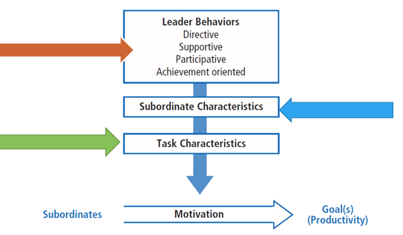
Bill Gates’ leadership style is a very participative and a very directive style because all his other subordinates and employees are involved in decision making and they’re allowed to give their opinions and suggestions. He values his staff and knows the importance of his staffs (wordpress,2018).
Referring to Newstorm (2010), the Path-Goal Model of leadership represents ‘Using structure, support and rewards to help employees reach goals’. This approach represents a complete chain in the relation between employer and employees, which starts at the point of forming a clear goal and system in the company which are in turn will become as a structure to bridge the relation between everyone in the company.
2.3.1 Practical Application
We can divide this chain to three levels:
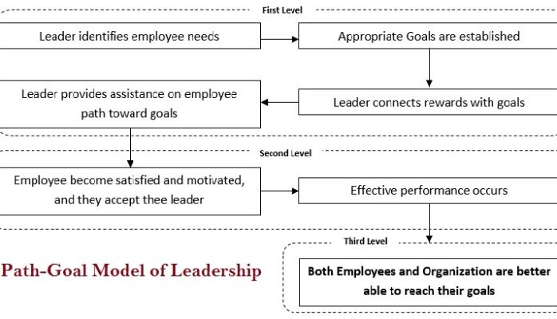
The first level: Building the team and the project goal.
- Identify employee needs: Bill Gate encouraged employees to speak out freely.
Criticization, suggestion, or proposition of company's development and even the shortcomings of boss are welcomed to speak out. Microsoft has also developed a satisfaction survey software, employees are asked to do it once a year. Employees can anonymously give feedback to all aspects of the company. In this process, the needs of employees will get better understand.
- Leader establish goals and connect them with rewards: Microsoft Corp. is the
first enterprise to use stock options to reward ordinary employees. After 18 months’ work, 25% of the stocks in the stock right can be obtained. Since then, 12.5% of the stocks can be obtained every 6 months. The practice of combining the personal interests and efforts of the employees with the benefit of the enterprise, management has obvious incentive effect. This system has a long appeal to employees.
- Leader provides assistance: Gates provided a lot of assistance to employees
through humanistic leadership, such as providing more learning resources, loose and equal working environment, multichannel promotion opportunities and a democratic and open enterprise culture.
The second level: Achieving the satisfaction of employees and going through the effective performance.
- Stott. Koehler of Gattorna group once said, “The success of Microsoft Corp.
depends on the full investment of staff. They are very convinced of their charismatic leader. They trust him, and he never let them down. Their corporate culture is right. "
- With the concerted effort of all employees, Microsoft Corp. has been creating a
miracle of knowledge economy. It is called "the largest and most powerful company in the world which is committed to PC software development". Thousands of millionaires have been produced there.
The third level: Getting result
- The common vision, goal and long-term strategy of employees and enterprises will help to push individual ability to the limit and form the joint force of 1+1=3. Enterprises with high efficiency and synergy can create a good enterprise environment and culture. Talents can not only be retained in this way, but also can promote the development of enterprises so that achieve a virtuous circle of business development. （Jingjie. Zhan, 2014）
2.3.2 Strengths and Weaknesses
Strengths: As one of the first theories to define 4 varieties of leadership, it expands prior research.
Tell us how task and employees characteristics affect the impact of leadership on their performance.
It tries to integrate the motivation principles into leadership.
Weaknesses: So complex, many different aspects of leadership referring in this theory can be confusing.
It fails to explain adequately the leadership behaviours and employee’s motivations.

3.0 Conclusion
Bill Gates once said even if Microsoft. Corp. disappeared, he could lead 20 employees to rebuild a new one.
How does Bill Gate lead these employees effectively? By analysing Bill Gates's leadership style through the application of situational leadership theory and path goal in contingency theory, a lot of valuable strategies are found out: Take corresponding management approaches for employees with different maturity; Adopt Humanistic management to create efficient and synergistic advantages and Use structure, support and rewards to motivate employees to reach goals.
In my opinion, leaders can only achieve their vision and values through their own exercise and practice. In a word, leaders should establish contingency views according to different circumstances. Choose their own way of leadership and become a successful leader.

4.0 Recommendations
- While paying attention to and treating mature employees, focus more on immature new employees. Having face-to-face conversation, helping set goals, holding internal meetings are good ways to motivate them to increase their confidence and ability (Bill Gates’ successor Steve Ballmer did quite well at this point).
- Recruit and cultivate more new employees from college students and seize the opportunities for development. Young people may bring innovative ideas and be helpful to Microsoft's innovative inefficiency.

Reference List
Bill Gates. (2018). Leadership. [online] Available at: https://billgatesanalysis.wordpress.com/leadership/ [Accessed 26 Mar. 2018].
Brighthub Project Management. (2018). Analyzing 5 Real-World Leadership Scenarios. [online] Available at: https://www.brighthubpm.com/resource-management/120498-five-real-world-examples-of-successful-leadership/ [Accessed 26 Mar. 2018].
Cao, R. (2002). 适者生存的管理模式 The management model of the survival of the fittest. Finding, (1004-5023), pp.27-29.
Encyclopedia Britannica. (2018). Bill Gates | American computer programmer, businessman, and philanthropist. [online] Available at: https://www.britannica.com/biography/Bill-Gates [Accessed 26 Mar. 2018].
Fiedler, F. and Chemers, M. (1974). Leadership and effective management. Glenview, Ill: Scott, Foresman.
Forbes.com. (2018). Forbes Welcome. [online] Available at: https://www.forbes.com/2000/01/13/mu7.html#1a3e269a5d83 [Accessed 26 Mar. 2018].
Hersey, P. (2004). The situational leader. Escondido, Calif.: Center for Leadership Studies.
Hersey, P. and Blanchard, K. (1988). Management of organizational behavior. Englewood Cliffs, N.J.: Prentice-Hall.
Hersey, P., Blanchard, K. and Johnson, D. (2001). Management of organizational behavior. Upper Saddle River, N.J.: Prentice Hall.
Jin, P. (2013). 学习和借鉴比尔盖茨的管理思想和管理策略 Learn and draw lessons from Bill Gates's management theory and management strategy. Brand, (1671-100), p.37.
Li, K. (2005). 执着与专注: 微软成功之道 Persistence and Concentration: an Avenue to Microsoft's Success. Securities Daily, p.A01.
Managementstudyguide.com. (2018). Importance of Leadership. [online] Available at: https://www.managementstudyguide.com/importance_of_leadership.htm [Accessed 26 Mar. 2018].
Newstorm, J. (2010). Organizational behaviour, human behaviour at work. New Delhi #h Tata Mcgraw Hill Education Pvt. Ltd.: OH: McGraw-Hill/Irwin.
Northouse, P. (2015). Leadership (International Student Edition). Thousand Oaks: SAGE Publications, Inc.
Visual.ly. (2018). History of Leadership | Visual.ly. [online] Available at: https://visual.ly/community/infographic/education/history-leadership [Accessed 26 Mar. 2018].
Williams, J. (2018). Situational Leadership. [online] Go iTalk. Available at: https://goitalk.com/situational-leadership/ [Accessed 29 Mar. 2018].
Zhan, J. (2014). 微 软 企 业 人 本 管 理 研 究 Study on humanized administration of Microsoft Corp.. MA. University of Nanchang.
Zhu, G. (2010). 比尔·盖茨的管理艺术 The art of Bill Gates' Management. modern youth, (1003-3483), p.52.

