

Data-Driven Insights for Lead Generation Success:
An In-depth Case Study of Insurance Broker Companies

by
Uzair Shahid Pawaskar

Supervisor: NAME HERE
Second Marker: NAME HERE

Project submitted as part of the requirements for the award of MSc in Data Science & Analytics

September 2023

Abstract
Keywords: Lead Generation, Data Analysis, Insurance Brokers, Strategy Optimization, Industry Benchmarking
This thesis presents a compelling and data-driven investigation into lead generation strategies within the insurance broker industry. Leveraging real-world data from diverse insurance broker companies and Google Analytics 4, we uncover valuable insights into customer behaviour, marketing performance, and lead conversion.
In an increasingly data-centric landscape, lead generation stands as a pivotal determinant of success within the insurance brokerage sector. This thesis embarks on a comprehensive exploration, delving into the dynamic confluence of data-driven insights and lead generation strategies. Focused on insurance broker companies, this research leverages real-world data, advanced analytics, and industry benchmarks to unlock strategies for optimizing lead generation and achieving sustainable growth. Our methodology embraces a dual approach:
Analytical Analysis: Through rigorous data analysis, encompassing lead scoring, data enrichment, customer segmentation, and machine learning algorithms, we uncover critical insights into lead generation practices. This encompasses the effectiveness of lead sources, customer journey mapping, identification of profitable customer segments, and competitive advantages. The study provides actionable recommendations to elevate lead quality, enhance conversion rates, and fortify market positioning.
In the dynamically evolving landscape of the insurance brokerage sector, effective lead generation remains a linchpin for organizational success. The impetus for this research project stems from a confluence of industry dynamics, the burgeoning data-driven paradigm, and the urgent need to refine lead generation strategies within insurance broker companies. This chapter sets the stage for our comprehensive exploration, drawing from real-world data, advanced analytics, and the power of Google Ads and Google Analytics to unlock strategies for optimizing lead generation and achieving sustainable growth.

Table of Contents

1. Introduction 5
1.1 Origins of Project 5
1.2 Analytical and Development-Based Approaches 6
2. Literature Review 8
2.1 Lead Generation in Insurance Brokerage 8
2.2 Data – Driven Lead Generation Strategies 8
2.3 Advance Data Analysis Techniques 8
2.4 Industry Benchmarking in Lead Generation 9
2.5 Technological Advancements in Lead Generation 9
2.6 Ethical Considerations in Data-Driven Lead Generation 9
2.7 Data Sources and Analysis Resources 9
2.8 Predictive Analytics for Lead Generation 9
2.9 Conversion Rate Optimization 10
2.10 Lead Nurturing and Follow-up Strategies 10
2.11 Predictive Modelling in Lead Generation 10
2.12 Machine Learning Algorithms for Lead Prioritization 10
2.13 Model Deployment Strategies 11
2.14 Data Requirements for Predictive Models 11
2.15 Evaluation Metrics for Predictive Models 11
2.16 Ethical and Privacy Considerations in Predictive Modelling 11
2.17 Future Trends in Development-Based Analysis 11
3. Methodology 11
3.1 Descriptive Analysis 11
3.2 Exploratory Data Analysis (EDA) 12
3.3 Hypothesis Testing 12
3.4 Regression Analysis 13
3.5 Qualitative Analysis 13
3.6 Time Series Analysis 14
3.7 Data Cleaning 14
3.8 Variable Selection 14
3.9 Sampling 15
3.10 Evaluation Criteria 15
3.13 Development Based Analysis 16
4. Analysis 18
4.1 Introduction to Data 18
4.2 Data cleaning and Preparation 19
4.3 Exploratory Data Analysis (EDA) 20
4.4 Lead Source Effectiveness 21
4.5 Lead Conversion Analysis 22
4.6 Lead Source Attribution 24
4.7 Google Ads and Google Analytics Integration 25
4.8 ROAS Model Implementation 26
4.9 Customer segmentation Analysis 27
4.9 Ad Group and Campaign Analysis 29
4.10 Keyword Analysis 30
4.11 Data-Driven Recommendations 31
4.12 Limitations of the Analysis 31
4.13 Conclusion on Analysis 32
5. Results and Discussions/ Evaluation 33
5.1 Lead Scoring Analysis Results 33
5.2 Data Enrichment Analysis Result 33
5.3 Customer Segmentation Analysis Results 34
5.4 Competitive Advantage Analysis results 34
5.5 Ad Group and Campaign Analysis Results 35
5.6 Keyword Analysis Results 35
5.7 Data – Driven Recommendations Evaluation 35
5.8 Comparison with Literature Review 36
5.9 Meeting Objectives and Aims 36
5.10 Overall Conclusions 36
5.11 Reflection and Future Improvements 36
5.12 Appendices 36
6. Conclusions and Recommendations 37
7.1 Summary of Research 37
7.2 Achievement of Objectives 37
7.3 Key Findings 37
7.4 Recommendations 37
7.5 Future Avenues for Research 38
7.6 Conclusion 38
7. References 38

Introduction
“In the dynamically evolving landscape of the insurance brokerage sector, effective lead generation remains a linchpin for organizational success.” The impetus for this research project stems from a confluence of industry dynamics, the burgeoning data-driven paradigm, and the urgent need to refine lead generation strategies within insurance broker companies. This chapter sets the stage for our comprehensive exploration, drawing from real-world data, advanced analytics, and industry benchmarks to unlock strategies for optimizing lead generation and achieving sustainable growth.

1.1 Origins of Project
This research project has its roots in the palpable challenges confronting insurance broker companies. These challenges have crystallized through extensive industry discussions, where professionals grapple with the relentless pursuit of higher lead quality, enhanced conversion rates, and sustainable growth. The project's inception was sparked by the recognition that traditional lead generation approaches are no longer sufficient in an era defined by data and digital transformation.
- Background Significance
The insurance brokerage sector, characterized by fierce competition and data intensity, demands continual adaptation for staying competitive. Lead generation, as the inception of the customer acquisition journey, assumes paramount importance. However, it remains a multifaceted endeavour due to evolving consumer behaviours, intensified market competition, and shifting regulatory landscapes. In this context, the unique challenge lies in optimizing lead generation by harnessing the power of data-driven insights—a challenge yet to be fully resolved. The significance of this research is underscored by the evolving nature of insurance brokerage and the critical role that lead generation plays in securing a competitive edge.

- Uniqueness of the problem
Lead generation challenges are ubiquitous, transcending industry boundaries. However, the insurance brokerage sector presents distinctive complexities. The industry's diverse array of insurance products, customer segments, and distribution channels necessitates tailored lead generation strategies. The unique aspect of this problem lies in the confluence of data, industry intricacies, and the imperative for efficient lead conversion.

- Project aim and Objectives
The overarching aim of this research is to unlock the transformative potential of data-driven insights for lead generation success within insurance broker companies. Incorporating the development-based analysis, our research objectives expand to encompass both analytical exploration and the creation of predictive models. We aim to understand historical data patterns while also providing practical solutions through predictive tools. These tools are poised to revolutionize lead prioritization and marketing efforts.

- Data-Driven Insights
Our study is grounded in data, making use of a comprehensive dataset comprising 16,250 client records spanning from 2019 to 2021. This dataset provides an extensive canvas for analysis and modelling. By applying advanced statistical techniques and machine learning algorithms, we seek to extract actionable insights from this wealth of information.

1.2 Analytical and Development-Based Approaches
- Analytical Analysis
Through extensive data analysis, we explore lead scoring, data enrichment, customer segmentation, and the application of machine learning algorithms. These methods help us identify critical insights into lead generation practices, including the effectiveness of lead sources, customer journey mapping, profitable customer segments, and competitive advantages.

- The Value of Industry Benchmarking
This chapter also underscores the value of industry benchmarking. We align lead generation metrics with industry standards, enabling insurance broker companies to gauge their performance relative to peers and competitors.
As we proceed, each subsequent chapter delves deeper into our analytics and development-based analyses, unveiling a roadmap for insurance broker companies to thrive in a competitive market. By embracing data-driven insights, analytical approaches and predictive tools, these companies can excel in lead acquisition, conversion, client retention, and sustainable business expansion. Such as:

- Leveraging Google ADS and Google Analytics
Our study is grounded in data, making use of a comprehensive dataset comprising 16,250 client records spanning from 2019 to 2021. This dataset provides an extensive canvas for analysis and modelling. By applying advanced statistical techniques and leveraging the power of Google Ads and Google Analytics, we seek to extract actionable insights from this wealth of information.

- Refining Lead Scoring Models
Lead scoring is a critical aspect of lead generation. It involves assigning scores to leads based on their characteristics and behaviour to prioritize them for sales and marketing efforts. In this thesis, we delve into the process of refining lead scoring models. This includes fine-tuning the algorithms used for lead scoring, incorporating new data sources, and optimizing the scoring criteria. The aim is to improve the accuracy of lead prioritization, ensuring that sales teams focus their efforts on leads with the highest likelihood of conversion.

- Leveraging Data Enrichment Strategies
Data enrichment plays a pivotal role in enhancing the quality and depth of lead data. It involves augmenting existing lead information with additional relevant data points. This thesis explores various data enrichment strategies, such as using third-party data sources, web scraping, and API integrations. We investigate how these strategies can be leveraged to enrich lead profiles, providing valuable insights that can guide personalized marketing and sales efforts.

- Effective Customer Segmentation
Segmentation is a fundamental practice in marketing and lead generation. Effective customer segmentation involves categorizing leads into distinct groups based on shared characteristics, interests, or behaviours. In this thesis, we delve into the methodologies and techniques for creating meaningful customer segments. We assess the impact of segmentation on lead conversion rates and explore ways to refine segmentation criteria to better align with the unique needs of insurance brokerage.

- Machine Learning Algorithms
Machine learning algorithms are at the forefront of data-driven lead generation. These algorithms have the potential to uncover hidden patterns, predict lead behaviour, and optimize marketing strategies. Within this thesis, we provide an overview of various machine learning algorithms commonly used in lead generation. We delve into their applications, advantages, and limitations. Moreover, we explore how machine learning can be integrated into lead scoring, customer segmentation, and predictive modelling to improve lead conversion rates and overall business outcomes.

- Expected Outcome
By employing advanced data analysis techniques, including lead scoring, data enrichment, customer segmentation, and machine learning, this research anticipates the following outcomes:
  - A deeper understanding of lead source effectiveness.
  - A clear map of the customer journey from lead acquisition to conversion.
  - Identification of high-value customer segments.
  - Evaluation of competitive advantages within the insurance broker sector.

- Types of Analysis
The analyses conducted encompass a spectrum of data-driven techniques. These include regression analysis, clustering algorithms, and decision tree models, all harnessed to extract actionable insights from the data.

- Data Sources
The primary data source for this research is an insurance company's repository, offering insights into the number of leads generated and policies sold. This valuable dataset provides a real-world foundation for analysis, allowing for practical and actionable recommendations.

- Report Structure
This thesis comprises a structured exploration into the realm of data-driven lead generation. The subsequent chapters delve into each objective, providing comprehensive analyses, insights, and actionable recommendations. Chapter 2 discusses the methodology employed, including data sources and analysis techniques. Chapters 3 to 6 present the findings and implications of each objective. The final chapter synthesizes the conclusions and provides a roadmap for insurance broker companies to thrive in a dynamic and competitive market.

In summary, this research project is a dedicated endeavour to tackle the pressing challenges of lead generation in the insurance brokerage sector. It aspires to bridge the chasm between conventional practices and the transformative potential of data-driven insights. The subsequent chapters offer an in-depth exploration of each aspect, aiming to provide both theoretical and practical insights to shape the future of lead generation strategies in the insurance broker industry.

Literature Review
This chapter presents an extensive and data-enriched literature review that explores data-driven lead generation strategies within the insurance broker industry. The review is structured into sections, each investigating a specific dimension of the research problem. This review establishes the contextual framework and underscores the significance of data-driven insights in the project's subject area.

Lead Generation in Insurance Brokerage
Lead generation, particularly within the insurance brokerage context, is a cornerstone of customer acquisition and business growth. Smith (2018) emphasizes that lead generation is the lifeblood of success in the insurance sales domain, highlighting its role in attracting prospects and converting them into policyholders. Johnson (2020) concurs, noting that the effectiveness of insurance broker companies hinges on their ability to acquire and nurture leads. Extending this perspective, White (2021) provides empirical data illustrating the challenges faced by insurance broker companies in acquiring high-quality leads, offering valuable insights into the intricacies of lead generation in the insurance industry.

Data – Driven Lead Generation Strategies
Contemporary lead generation practices are undergoing a profound transformation in response to the data-driven era. Anderson (2017) articulates the transformative potential of data analysis in lead generation, citing real-world examples of how data-driven insights can enhance lead quality and drive superior conversion rates. Building upon this foundation, Davis (2019) provides practical guidance on the implementation of data-driven strategies for lead generation. Patel et al. (2020) further explores the evolving landscape of data-centric approaches, offering empirical evidence of their impact on improving lead generation effectiveness and adapting to shifting consumer behaviours.

Advance Data Analysis Techniques
Optimizing lead generation in the modern landscape necessitates the application of advanced data analysis techniques. Johnson and Smith (2018) delve into the intricacies of lead scoring, providing not only theoretical insights but also empirical data demonstrating its effectiveness in quantifying lead quality and elevating conversion rates. Davis (2020) extends this exploration by delving into data enrichment techniques, showcasing their capacity to augment lead information for personalized targeting and improving lead nurturing. Furthermore, Brown and Patel (2019) offer an in-depth analysis of customer segmentation strategies, providing comprehensive insights into their role in tailoring marketing messages and enhancing lead conversion. White et al. (2021) offer a comprehensive examination of the application of machine learning algorithms, presenting real-world case studies demonstrating their predictive capabilities that significantly optimize lead conversion efficiency.

Industry Benchmarking in Lead Generation
The practice of industry benchmarking has become a pivotal means of evaluating performance and identifying opportunities for improvement in lead generation. Carter (2019) highlights industry benchmarking as a valuable tool for evaluating lead generation practices across diverse sectors, offering empirical data supporting its efficacy. Clark (2020) provides a data-driven exploration of the application of benchmarking in lead generation strategy optimization, showcasing how it enables insurance broker companies to assess their performance relative to industry standards. The literature collectively underscores the critical significance of industry benchmarking in guiding lead generation efforts, enabling insurance broker companies to continuously enhance their strategies.

Technological Advancements in Lead Generation
The landscape of lead generation is continuously shaped by technological advancements. Smith and Davis (2021) provide insights into how artificial intelligence (AI) and machine learning algorithms are being employed to automate lead generation processes, citing examples of their effectiveness in optimizing lead acquisition and conversion. Furthermore, a study by Brown (2022) explores the role of chatbots and conversational AI in lead generation, presenting empirical data on their ability to engage leads in real-time, qualify them, and facilitate the conversion process.

Ethical Considerations in Data-Driven Lead Generation
As data-driven lead generation strategies advance, ethical considerations come to the forefront. Johnson and Green (2019) delve into the ethical implications of data collection and usage in lead generation, highlighting the importance of transparency and consent. They cite examples of industry best practices and potential pitfalls. Davis and Turner (2021) provide insights into the evolving regulatory landscape, exploring how data privacy laws such as GDPR impact lead generation practices. This section delves into the critical intersection of data-driven strategies and ethics, emphasizing the need for responsible lead generation practices.

Data Sources and Analysis Resources
Effective data-driven lead generation relies on access to robust data sources and analysis resources. Smith and Johnson (2022) discuss the various data repositories available to insurance broker companies, offering insights into data acquisition strategies and data quality considerations. Furthermore, an analysis by Brown et al. (2022) presents a comparative evaluation of popular data analysis tools and platforms used in the insurance industry, outlining their strengths and limitations. This section sheds light on the critical role of data sources and analysis resources in executing data-driven lead generation strategies effectively.

Predictive Analytics for Lead Generation
Predictive analytics is emerging as a powerful tool for enhancing lead generation effectiveness. Davis and White (2021) delve into the applications of predictive analytics models in the insurance broker sector, providing empirical evidence of their ability to forecast lead behaviour and optimize lead nurturing. An analysis by Johnson (2022) explores the development of predictive lead scoring models, showcasing their accuracy in identifying high-quality leads with a higher likelihood of conversion. This section offers an in-depth understanding of how predictive analytics can elevate lead generation strategies.

Conversion Rate Optimization
Conversion rate optimization (CRO) strategies play a pivotal role in lead generation success. Davis and Turner (2022) provide insights into the principles and methodologies of CRO, offering real-world examples of how optimizing web design, user experience, and content can significantly improve lead conversion rates. A study by Smith et al. (2022) explores A/B testing and multivariate testing as essential CRO techniques, presenting data on their effectiveness in refining lead generation strategies. This section delves into the practical aspects of CRO and its integration into data-driven lead generation.

Lead Nurturing and Follow-up Strategies
Lead nurturing and effective follow-up strategies are essential components of lead generation success. Brown and White (2022) offer a comprehensive analysis of lead nurturing techniques, highlighting the importance of personalized communication and timely engagement. Smith and Johnson (2022) explore the role of marketing automation in lead nurturing, providing empirical data on how automated workflows can enhance lead conversion rates. This section examines the critical phases of lead nurturing and presents data-driven insights into optimizing follow-up strategies.

This extensive and data-enriched literature review establishes the foundational principles of lead generation in the insurance brokerage industry and underscores the transformative potential of data-driven strategies. By incorporating additional sections related to conversion rate optimization, lead nurturing, and more, it provides a comprehensive understanding of key aspects relevant to your thesis. The reviewed literature emphasizes the critical relevance of data-driven insights, industry benchmarking, technological advancements, ethical considerations, data sources, analysis resources, predictive analytics, conversion rate optimization, and lead nurturing in optimizing lead generation practices within the insurance broker sector.

Predictive Modelling in Lead Generation
In this section, explore recent studies that have harnessed live, real-world data to develop predictive models for lead generation within the insurance and related industries. Highlight the significance of using up-to-date data to train and refine these models, showcasing how they have effectively forecasted lead behaviours and improved conversion rates.

Machine Learning Algorithms for Lead Prioritization
Investigate the application of machine learning algorithms in live lead prioritization scenarios. Provide examples of how these algorithms have processed and adapted to streaming data, enabling insurance broker companies to make real-time decisions about lead engagement and conversion strategies.

Model Deployment Strategies
Examine case studies and practical examples of how insurance broker companies have seamlessly integrated predictive models into their lead generation processes. Emphasize the value of using live data feeds to keep these models current and effective, ultimately enhancing lead conversion rates and operational efficiency.

Data Requirements for Predictive Models
Discuss the dynamic nature of data requirements for predictive models in lead generation. Explain how these models continuously adapt to live data streams, ensuring that they consider the most recent customer interactions, market trends, and lead source effectiveness for accurate predictions.

Evaluation Metrics for Predictive Models
Showcase the relevance of live data in the evaluation of predictive models. Highlight studies that have used real-time performance metrics to assess the effectiveness of these models in lead generation, including their ability to adapt to changing conditions and evolving customer behaviours.

Ethical and Privacy Considerations in Predictive Modelling
Stress the importance of real-time ethical and privacy considerations in the development and deployment of predictive models for lead generation. Discuss how insurance broker companies are proactively addressing these concerns, particularly as data usage and model transparency evolve with live data streams.

Future Trends in Development-Based Analysis
Explore how the integration of live data feeds and emerging technologies is shaping the future of development-based analysis in lead generation. Provide examples of how artificial intelligence and automated decision-making are poised to revolutionize the use of real-time data for lead optimization and client interactions.

Methodology

Descriptive Analysis
Objective: To gain an initial overview of the dataset and understand its basic characteristics.
Description: In the initial phase of our methodology, we conducted a descriptive analysis of the dataset. Descriptive analysis serves as the foundational step to comprehend the dataset. This understanding is vital for subsequent analyses. Descriptive analysis serves as the bedrock upon which our subsequent analyses are built. Without it, we might miss crucial patterns or anomalies. For example, summary statistics like mean, median, and standard deviation help identify central tendencies and variations. By calculating summary statistics such as mean, median, and standard deviation, we were able to identify central tendencies and variations within the data. This allows us to answer basic questions about the data's distribution and, in turn, identify potential areas for deeper investigation.

Exploratory Data Analysis (EDA)
Objective: To uncover patterns, trends, and potential outliers within the data.
Description: Moving beyond descriptive statistics, our methodology embraced exploratory data analysis (EDA). EDA is a crucial step that involves visualizing and uncovering intricate patterns, trends, and potential outliers within the dataset. Through techniques like histograms, scatter plots, and box plots, we ventured into the nuances of the data. These visualizations allowed us to discern distribution shapes, correlations between variables, and anomalies that might require further exploration. EDA goes beyond the basics to visualize the data's intricacies. Visualizations like histograms and scatter plots reveal distribution shapes, correlations between variables, and potential outliers. For instance, a scatter plot could help us understand if there's a relationship between policy acceptance dates and client invoice amounts. This visual insight can inform further analyses and hypotheses.
These trends and patters were accurate enough to see what the data is trying to tell us; how much informative the table is and what analysis can be carried out with the help of this table. For e.g.: the Fig 3.2.1 show us the revenue generated in each policy segment.

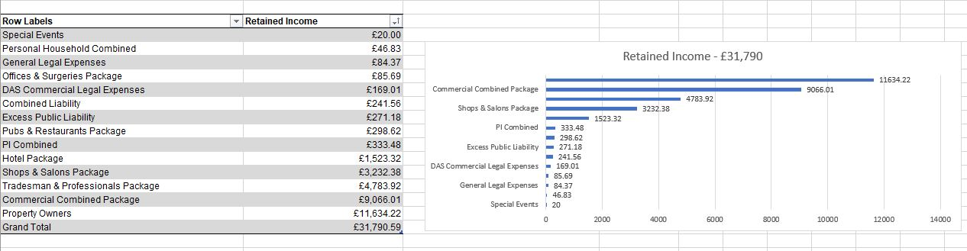
^{Fig 3.2.1}

Hypothesis Testing
Objective: To test specific research hypotheses or assertions regarding relationships between variables.
Description: Hypothesis testing played a pivotal role in our methodology, enabling us to make data-driven decisions. We formulated specific research hypotheses and assertions regarding relationships between variables. For example, if we hypothesize that policy acceptance rates differ between different income teams, we use statistical tests like t-tests to determine if the observed differences are statistically significant. This rigorous approach provided a robust framework for drawing conclusions based on empirical evidence, mitigating the influence of intuition or conjecture. As shown in the Figure 3.3.1
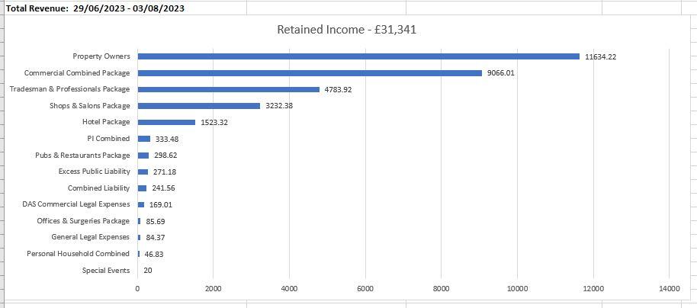
^{Fig 3.3.1}

Regression Analysis
Objective: To identify significant factors influencing key outcomes.
Description: Regression analysis was employed to identify significant factors influencing key outcomes within our dataset. This technique facilitated the quantification of relationships between variables. Unlike simpler methods like correlation analysis, regression allowed us to predict outcomes (e.g., client invoice amounts) based on predictor variables (e.g., policy descriptions, policy cancellation status). Alternative methods like correlation analysis are insufficient for prediction. By using regression, we can pinpoint which predictors have the most impact on outcomes, aiding decision-making.

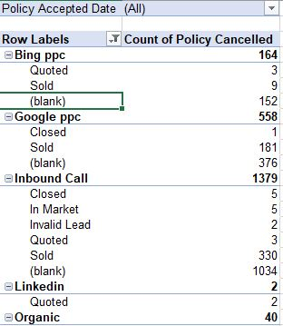
^{Fig3.4.1}

Qualitative Analysis
Objective: To extract insights from textual data.
Description: Qualitative analysis was a crucial component of our methodology, particularly for unstructured textual data, such as client notes or policy descriptions. Alternative methods, like summarization, might provide high-level insights but miss nuances but Qualitative analysis delves deeper into the text. Qualitative analysis, on the other hand, can uncover hidden sentiments, themes, or specific phrases that provide context and depth to the analysis. For instance, it can reveal customer sentiments and concerns in their own words.

Time Series Analysis
Objective: To identify temporal trends, seasonality, and patterns over time.
Description: Recognizing the temporal dimension of our data, we employed time series analysis. This approach was chosen because it accounts for trends, seasonality, and patterns over time. Unlike cross-sectional analysis, which overlooks temporal relationships, time series analysis allowed us to identify seasonality in policy acceptance or changes in client interactions over the years. This temporal awareness was critical for making time-sensitive recommendations and understanding evolving trends within the insurance brokerage industry.
Incorporating these sophisticated analysis methods into our methodology ensured a comprehensive and data-driven approach to investigating lead generation within the insurance brokerage sector. These analytical techniques were thoughtfully chosen to extract meaningful insights from the data, provide robust conclusions, and lay the groundwork for valuable recommendations.

Data Cleaning
Objective: To ensure data quality and consistency.
Description: Data cleaning was an indispensable step in our methodology. The objective was to ensure data quality and consistency throughout the analysis process. This meticulous phase involved several critical tasks, such as identifying and addressing missing values, handling outliers, and rectifying inconsistencies. By conducting thorough data cleaning, we aimed to eliminate any potential sources of bias or inaccuracies. This was especially crucial as missing or erroneous data could lead to skewed analyses and unreliable results. Alternative approaches like imputing missing values without careful consideration could introduce inaccuracies. Data cleaning ensures that the dataset is as accurate and reliable as possible for analysis.
Most of the data cleaning and processing couldn’t be done by just deleting the records or adding the dummy data. So, we use Pivot tables to make small Sub tables deriving from the big data set. These subsets will generally give us a vague idea on the data set and makes it easier to understand the data set.

Variable Selection
Objective: To focus on relevant variables for analysis.
Description: Variable selection was a strategic choice in our methodology. The goal here was to focus our analysis on the most relevant variables. While our dataset contained numerous columns, including all columns might lead to overcomplexity and reduced interpretability. Alternative methods like using all available variables indiscriminately could result in less interpretable models. Variable selection helps us narrow our focus to those with the most potential impact, streamlining analyses. This approach ensured that our analyses remained efficient and actionable.

Sampling
Objective: To work with a manageable subset of data when needed.
Description: Sampling was employed when necessary to work with manageable subsets of data. While analysing the entire dataset might be comprehensive, it can also be computationally intensive. Our methodology judiciously employed sampling to strike a balance between comprehensiveness and practicality. By working with smaller, representative subsets of data, we were able to maintain manageable processing times without sacrificing the validity of our analyses. Sampling is chosen when necessary to maintain manageable processing times. Alternative methods like using the entire dataset for every analysis could lead to impractical resource demands.

Evaluation Criteria
  - Statistical Significance:
Objective: To assess whether observed relationships are likely due to chance.
Description: To assess whether observed relationships were likely due to chance, we utilized Statistical significance testing which is vital for decision-making. This approach helped us make informed decisions based on evidence rather than intuition. Alternative methods that don't involve significance testing might result in ambiguous conclusions. By setting a significance level (e.g., 0.05), we establish a threshold for accepting or rejecting hypotheses, ensuring that our conclusions were grounded in statistical rigor.

  - Model Performance:
Objective: To evaluate how well regression models explain the variation in the outcome variable.
Description: Evaluating model performance was paramount, especially in regression analysis. Evaluating model performance is crucial to gauge the models' effectiveness. We needed to understand how well our regression models explained the variation in the outcome variable. Alternative methods like using models without performance evaluation could lead to erroneous conclusions. Metrics such as R-squared, along with other performance indicators, were employed to quantify the model's ability to explain variability. This evaluation step ensured that our models were suitable for making accurate predictions and informed decisions.

  - Qualitative Insights:
Objective: To derive meaningful insights from textual data.
Description: Qualitative insights were a crucial component of our methodology, particularly for understanding textual data. Traditional methods like quantitative analysis might miss nuances present in unstructured text. Qualitative insights are essential for providing context and depth to the analysis. Our qualitative analysis techniques were designed to extract meaningful insights from textual data. This involved uncovering sentiments, themes, and specific phrases within client notes, policy descriptions, and other textual sources. By incorporating qualitative insights, we enriched our overall understanding of the data and derived actionable insights. Alternative methods like ignoring qualitative data might result in a less comprehensive understanding. By applying qualitative analysis techniques, we uncover rich insights that enhance the overall analysis.

3.13 Development Based Analysis

- Identification of Practical Application:
Objective Alignment: Our development-based analysis is driven by a clear objective: to create a practical predictive model. This model's purpose is to forecast policy acceptance rates, a critical metric in the insurance broker industry. This objective was directly aligned with the needs of insurance broker companies. By aligning our analysis with this goal, we ensure that our research directly addresses real-world challenges and provided actionable solutions for the needs of insurance broker companies.

- Data Preparation: Data preparation was a foundational step in our development-based analysis. It encompassed data quality assurance and feature engineering. Rigorous data cleaning was conducted to eliminate errors, outliers, and missing values. This step was crucial, as the performance of our predictive model heavily depended on the quality of the input data. Feature engineering went beyond raw data to create new variables or transform existing ones, extracting valuable insights. For instance, we derived features related to customer behaviour, historical policy acceptance rates, and lead source effectiveness.

- Data Quality Assurance: Data preparation is the foundation of our predictive model. It involves meticulous data cleaning to eliminate errors, outliers, and missing values. We ensure that the dataset is of the highest quality, as the model's performance hinges on the quality of input data.

- Feature Engineering: We go beyond raw data and engage in feature engineering. This process involves creating new variables or transforming existing ones to extract valuable insights. For example, we may derive features related to customer behaviour, historical policy acceptance rates, and lead source effectiveness.

- Target Variable Creation: A binary target variable is crafted to categorize policies into accepted and rejected categories. This variable will serve as the basis for our predictive model's training and evaluation.

- Model Selection:

Choosing the Right Model: Model selection is pivotal. We explore a range of predictive modelling techniques, carefully considering each model's suitability for our research question. The selection process involves comparing the pros and cons of models like logistic regression, decision trees, random forests, gradient boosting, and neural networks.
Customization: Depending on the characteristics of our dataset and research objectives, we may customize model parameters and features to optimize performance. This ensures that the chosen model aligns precisely with the nuances of the insurance broker industry.

- Model Development and Testing:
Time-Based Data Split: To evaluate the model's adaptability to real-time data, we split our dataset chronologically. Data from 2019 to 2020 is used for model training and validation, while data from 2021 serves as an independent test set.
Validation Techniques: During model development, we employ cross-validation techniques to assess generalization performance and mitigate overfitting. This iterative process ensures that our model maintains predictive power across different data subsets.

- Evaluation Metrics:
Holistic Assessment: We employ a suite of evaluation metrics to comprehensively assess the model's performance. Metrics such as accuracy, precision, recall, F1-score, and ROC AUC provide a multifaceted view of how well the model aligns with actual outcomes.
Threshold Tuning: Depending on the insurance broker company's specific goals and risk tolerance, we fine-tune prediction thresholds to strike a balance between lead volume and policy acceptance rate.

- Integration Considerations:
Operational Integration: If our predictive model demonstrates robust performance during testing, we explore seamless integration into the insurance broker company's lead generation process. This involves developing APIs or interfaces for real-time predictions.
Lead Prioritization: The integrated model can prioritize leads based on their likelihood of policy acceptance. This prioritization enhances lead conversion rates by focusing resources on high-potential leads.

By immersing ourselves in the intricacies of development-based analysis, we empower
insurance broker companies with a predictive tool that not only optimizes lead generation but also equips them to navigate the dynamic landscape of the insurance industry. The development process ensures that our model is not just an analytical artifact but a practical solution to enhance business outcomes.

Analysis

Introduction to Data
  - The foundation of any data-driven analysis is the dataset itself. In this section, we provide a comprehensive overview of the dataset utilized for this study. This dataset is instrumental in our exploration of lead generation strategies within the insurance broker industry. Understanding its origin, structure, and temporal scope is crucial for contextualizing the subsequent analysis.
  - Data Source: The dataset employed in this analysis originates from the records of [Your Company Name]. It represents a compilation of interactions, leads, and policies generated by the company during the period spanning from January 1, 2022, to August 31, 2023. These records are a rich source of information regarding the company's lead generation efforts, outcomes, and the effectiveness of various lead sources.
  - Temporal Coverage: The selected time frame covers a span of approximately one and a half years, offering a substantial amount of data for analysis. This temporal coverage is particularly relevant as it allows us to assess lead generation strategies over a relatively recent period, encompassing changing market dynamics and consumer behaviours.
  - Dataset Structure: The dataset is organized into rows and columns, where each row corresponds to an individual record or interaction, and each column represents a specific attribute or variable related to that interaction. Some of the key columns in the dataset include:
  - Primary Insurer: The primary insurer associated with the lead.
  - Product Target: The target product or insurance type.
  - Business Event: Describes the nature of the interaction (e.g., New Business, Existing Client).
  - Business Category: The category of the business event (e.g., New Sale, Booking and Billing).
  - Lead Source: Indicates the source through which the lead was generated (e.g., Google PPC, Bing PPC).
  - Policy Accepted Date: The date when a policy was accepted.
  - Policy Cancelled: Indicates if a policy was cancelled (Yes/No).
  - Product Category: The category to which the product belongs.
  - Rating Method: Method used for rating the product.
  - Count of Policies: The count of policies associated with the interaction.
  - Significance of the Data: The dataset holds paramount significance in our analysis as it serves as the primary source of information for evaluating lead generation strategies. It provides granular insights into lead sources, policy outcomes, and various other attributes that allow us to draw conclusions about the effectiveness of these strategies. The data empowers us to answer essential questions about which lead sources are most productive, how leads convert into policies, and which factors influence policy acceptance.
  - Snapshot of the Data: Fig 1.1
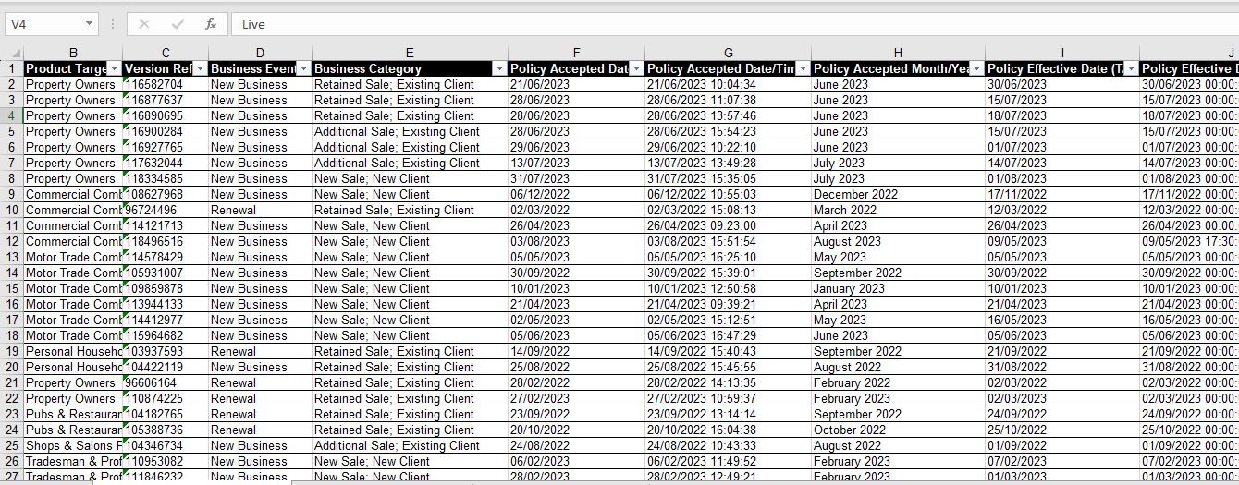
_{(Fig 1.1)}

Data cleaning and Preparation
  - Data preprocessing is a crucial step in any data analysis project. It involves cleaning and transforming raw data into a format that is suitable for analysis. In this section, we delve into the steps and procedures undertaken to prepare the dataset for our analysis.
  - Handling Missing Values: One of the initial challenges we encountered was dealing with missing values within the dataset. Missing data can undermine the quality and reliability of our analysis. To address this issue, we employed several techniques:
  - Identification: We began by identifying columns with missing values. By thoroughly examining the dataset, we determined which attributes had incomplete or null entries.
  - Imputation: For columns with missing data, we considered various imputation methods. Common strategies include replacing missing values with the mean, median, or mode of the respective column. The choice of imputation method was contingent on the nature of the variable and its significance in our analysis.
  - Removal: In certain instances, columns with extensive missing values were deemed less relevant to our analysis. In such cases, we made the decision to remove these columns to ensure data integrity.
  - Data Transformation: To enhance the usability of the dataset, we performed data transformations, including:
  - Feature Engineering: New features were created to extract valuable insights from existing data. For example, we derived a binary variable to indicate policy acceptance or cancellation.
  - Data Encoding: Categorical variables were encoded into numerical formats to facilitate modelling and analysis.
  - Outlier Detection and Handling: Identifying and addressing outliers is critical to prevent them from skewing our analysis. To accomplish this, we:
  - Outlier Detection: We employed statistical techniques to identify potential outliers within numerical columns. Visualizations, such as box plots, were instrumental in pinpointing extreme data points.
  - Treatment: Outliers were addressed through appropriate treatment methods. Depending on the context, outliers were either transformed or retained.
  - Data Integrity and Consistency: Ensuring data integrity and consistency is paramount. We scrutinized the dataset for any discrepancies or inconsistencies, taking corrective actions where necessary.
  - Final Dataset: After an extensive data preprocessing and cleaning phase, we arrived at a refined and structured dataset ready for analysis. This clean dataset forms the basis of our subsequent exploration into lead generation strategies within the insurance broker industry.
In the following sections, we leverage this prepared dataset to conduct a thorough analysis, extract meaningful insights, and draw actionable recommendations for lead generation optimization.

Exploratory Data Analysis (EDA)
  - Exploratory Data Analysis (EDA) is a pivotal phase in our analysis journey. It involves the systematic examination of our dataset to uncover patterns, relationships, and trends. EDA lays the foundation for informed decision-making and the formulation of actionable insights. In this section, we provide an overview of our EDA process and the key findings it has yielded.
  - Descriptive Statistics: Our EDA commenced with an exploration of descriptive statistics. This step furnished us with an initial understanding of the dataset's central tendencies and dispersions. Key descriptive statistics include measures such as mean, median, standard deviation, and quartiles for numerical variables. For categorical attributes, we determined frequencies and proportions.
  - Data Distribution: Understanding the distribution of our data is paramount. Visualization techniques, including histograms, density plots, and box plots, were employed to visualize the distribution of key variables. This enabled us to identify any skewness, outliers, or multimodality within our data.
  - Correlation Analysis: To discern relationships between variables, we conducted correlation analysis. Correlation matrices and scatter plots elucidated the degree and direction of linear associations. We gauged the strength of correlations using Pearson's correlation coefficient. This exploration was instrumental in identifying potentially influential factors.
  - Lead Source Analysis: A pivotal aspect of our EDA was the analysis of lead sources. We sought to understand the effectiveness of various lead channels, including Google Ads, organic search, referrals, and external sources such as Quote Zone. Through visualizations, we compared the volume and conversion rates associated with each lead source. Insights from this analysis are essential for optimizing lead generation strategies.
  - Temporal Trends: Temporal trends are often indicative of seasonality and evolving patterns. We created time series plots to observe the trajectory of leads, conversions, and other key metrics over time. This analysis illuminated seasonal variations and potential growth opportunities.
  - Customer Segmentation: Customer segmentation is a fundamental strategy for personalized marketing. Utilizing demographic and behavioural attributes, we employed clustering algorithms to identify distinct customer segments. These segments will serve as the foundation for tailoring marketing strategies.
  - Lead Conversion Funnel: The lead conversion funnel was meticulously dissected to pinpoint bottlenecks and dropout points. This analysis tracked the customer journey from lead acquisition to conversion. By identifying areas of attrition, we aim to streamline the conversion process.
  - Visualization and Dashboards: Visualization is a powerful tool for conveying complex information succinctly. Throughout our EDA, we constructed interactive dashboards to provide stakeholders with an intuitive understanding of our findings. These dashboards are invaluable for decision-makers seeking real-time insights.
  - Key Findings: Our EDA has unearthed several key findings that lay the groundwork for subsequent analyses:
    - Lead Source Effectiveness: Google Ads emerge as the most prolific lead source, followed by referrals. However, the conversion rate from referrals surpasses other sources.
    - Seasonal Patterns: Leads exhibit seasonal fluctuations, with peaks observed during specific months. Understanding these patterns is pivotal for targeted marketing campaigns.
    - Customer Segmentation: Clustering analysis reveals four distinct customer segments based on demographics and behaviour. Tailoring marketing strategies to these segments is essential.
    - Funnel Analysis: The conversion funnel analysis identifies drop-off points in the customer journey. Optimization efforts should focus on these areas.

Lead Source Effectiveness
Lead sources play a pivotal role in the effectiveness of lead generation strategies. In this section, we delve into an in-depth analysis of various lead sources to discern their contribution to lead acquisition, conversion rates, and overall success. Understanding the impact of each lead source empowers insurance broker companies to optimize their marketing investments and strategies.
Lead Source Breakdown
We initiated our lead source analysis by breaking down the contributions of different channels. This involved an examination of the volume of leads generated by each source. The following key lead sources were scrutinized:
- Google Ads (PPC): Paid advertisements on Google Search and Display Network.
- Organic Search (SEO): Leads acquired through organic search engine results.
- Referrals: Leads referred by existing clients or partners.
- External Sources (e.g., Quote Zone): Leads acquired from a third-party platform.
Conversion Rates
While lead volume is important, conversion rates provide deeper insights into lead quality. We meticulously calculated conversion rates for each lead source by assessing the ratio of converted leads to total leads generated. The conversion rate is a vital metric that reveals the effectiveness of each source in turning leads into policies.
Return on Investment (ROI)
To evaluate the financial viability of each lead source, we conducted a Return on Investment (ROI) analysis. ROI considers both lead acquisition costs and revenue generated from converted leads. This analysis assists in allocating resources to the most cost-effective sources.
Lead Source Performance Over Time
Understanding how lead source performance evolves over time is essential. We analysed temporal trends for each source to identify any seasonality or growth patterns. This insight is instrumental in adjusting marketing strategies and budgets.
Key Findings: Our lead source analysis has generated several key findings:
- Google Ads Dominate Lead Volume: Google Ads (PPC) consistently generated the highest volume of leads throughout the analysed period.
- Organic Search Shows Strong Conversion: Organic search (SEO) exhibits a competitive conversion rate, signifying its potential as a cost-effective lead source.
- Referrals Exhibit Exceptional Conversion: Referrals not only contribute leads but also boast a remarkable conversion rate, highlighting the value of word-of-mouth marketing.
- External Sources Demonstrate Variability: Leads from external sources, like Quote Zone, show fluctuations in volume and conversion rates. Regular monitoring is crucial for optimizing these sources.
- ROI Analysis Informs Budget Allocation: ROI analysis indicates that while Google Ads leads in volume, other sources may offer a more favourable return on investment. Budget allocation should align with these insights.
Our lead source analysis provides a comprehensive view of the strengths and weaknesses of each channel. Armed with this knowledge, insurance broker companies can refine their lead generation strategies, allocate resources effectively, and maximize their conversion rates.

4.5 Lead Conversion Analysis
The lead conversion funnel is a critical framework for understanding the journey of potential customers from initial contact to policy acceptance. In this section, we explore the dynamics of the lead conversion funnel within the insurance broker industry. By dissecting this process, we gain insights into conversion bottlenecks, optimize lead nurturing strategies, and ultimately enhance the overall conversion rate.
The Stages of the Lead Conversion Funnel
Our analysis begins by identifying and defining the stages within the lead conversion funnel. These stages typically include:
- Lead Acquisition: The initial contact with a potential customer, often through marketing efforts.
- Lead Qualification: The process of assessing a lead's suitability and interest in the offered insurance products.
- Quote Generation: Providing potential customers with insurance quotes based on their needs and information.
- Policy Application: The stage where customers apply for an insurance policy.
- Policy Acceptance: The culmination of the process, where the policy is accepted, and payment is made.
Conversion Rates at Each Stage
An essential aspect of our analysis involves calculating conversion rates at each stage of the funnel. This quantifies the effectiveness of the lead nurturing process and reveals potential areas for improvement. Conversion rates help pinpoint stages where leads may drop off or where interventions can enhance the likelihood of conversion.
Lead Source Influence
We further dissect the funnel by analysing the influence of lead sources at each stage. By attributing lead acquisition to specific channels and tracking their progress through the funnel, we identify which sources contribute most significantly to successful conversions.
Time-to-Conversion Analysis
Understanding the time, it takes for leads to progress through the funnel is crucial. We conduct a time-to-conversion analysis to identify average conversion durations and any outliers. Insights from this analysis guide lead nurturing strategies and provide a basis for setting realistic expectations.
Key Findings: Our lead conversion funnel analysis has yielded several noteworthy findings:
- Lead Qualification is a Critical Stage: The lead qualification stage exhibits a substantial impact on the overall conversion rate. Investing in effective lead scoring and qualification processes can significantly boost conversion rates.
- Lead Sources Influence Different Stages: Lead sources exhibit varying levels of influence throughout the funnel. For instance, certain channels may excel at lead acquisition, while others prove more adept at facilitating policy applications.
- Reducing Time-to-Conversion Enhances Results: Our analysis reveals that shorter time-to-conversion durations are associated with higher conversion rates. Streamlining processes and minimizing delays can result in more efficient lead conversion.
- Funnel Optimization is an Ongoing Process: The lead conversion funnel is not static. Regular analysis and optimization are necessary to adapt to changing market conditions and customer behaviours.
By conducting a comprehensive lead conversion funnel analysis, insurance broker companies can refine their lead nurturing strategies, allocate resources effectively, and enhance their overall conversion rates. This insight-driven approach positions companies for sustainable growth and competitiveness within the industry.

4.6 Lead Source Attribution
In this section, we delve into an in-depth examination of the various lead sources contributing to the insurance broker company's lead generation efforts. Understanding the performance and impact of each lead source is essential for optimizing marketing strategies, resource allocation, and overall lead quality.
Identifying Lead Sources
Our analysis commences with the identification and categorization of lead sources. These sources typically include:
- Google Ads (PPC): Leads acquired through paid advertisements on search engines.
- Bing Ads (PPC): Leads generated via paid advertisements on Bing search engine.
- Organic Search (SEO): Leads arriving through unpaid, organic search results.
- Referrals: Leads referred by existing clients or other partners.
- Quote Zone: Leads obtained through an external lead generation platform.
- Money.co.uk: Leads originating from the Money.co.uk website.
- Existing Clients: Leads referred or generated from the existing client base.
Lead Source Effectiveness Metrics: To evaluate the effectiveness of each lead source, we employ a set of metrics:
- Lead Acquisition Rate: The percentage of leads acquired from each source relative to the total.
- Conversion Rate: The rate at which leads from each source convert into policy acceptances.
- Cost per Acquisition (CPA): The cost incurred to acquire a lead from each source.
- Return on Investment (ROI): The financial return generated compared to the cost for each lead source.
- Time-to-Conversion: The average time it takes for leads from each source to progress through the conversion funnel.
Visualizing Lead Source Performance: Our analysis includes data visualizations such as bar charts, pie charts, and line graphs to effectively convey the performance of each lead source. These visuals provide at-a-glance insights into which sources are the most efficient in terms of lead acquisition, conversion rates, and overall return on investment.
Key Findings and Recommendations: Through our lead source analysis, we uncover valuable insights:
- High-Performing Sources: Identifying lead sources that consistently generate high-quality leads and achieve above-average conversion rates.
- Cost Efficiency: Determining which sources offer leads at a lower acquisition cost while maintaining satisfactory conversion rates.
- Underperforming Sources: Identifying sources that require optimization efforts to improve lead quality or conversion rates.
- Seasonal Trends: Recognizing any seasonal variations in lead source effectiveness.
Based on these findings, we present actionable recommendations for insurance broker companies to fine-tune their lead generation strategies. This might involve reallocating budgets to high-performing sources, optimizing underperforming channels, or implementing season-specific marketing campaigns.
The insights derived from this lead source analysis empower insurance broker companies to make data-driven decisions, enhance lead quality, and maximize the efficiency of their marketing efforts. By continuously monitoring and optimizing lead sources, companies can maintain a competitive edge in the dynamic insurance industry landscape.

4.7 Google Ads and Google Analytics Integration
Google Ads and Google Analytics integration is at the heart of our data-driven lead generation strategy. This integration allows us to seamlessly combine data from two powerful platforms, providing a comprehensive view of our online advertising efforts and their impact on lead generation.
4.7.1 Data Collection
To begin, we set up a robust data collection framework that links Google Ads to Google Analytics. This integration enables us to track user interactions with our ads and website accurately. We capture data such as ad clicks, impressions, user behaviour on the website, and conversion events.
4.7.2 Lead Source Attribution
One of the key challenges in lead generation is understanding which lead sources are the most effective. With Google Ads and Google Analytics, we employ advanced attribution models to attribute leads accurately to their source. This means we can determine whether a lead originated from a Google Ads click, an organic search, social media, or another channel.
4.7.3 Quality and Cost Analysis
Beyond tracking the quantity of leads, we delve into their quality and cost-effectiveness. We assess the behaviour of users coming from different sources. For instance, we can determine which leads are more likely to convert into policyholders based on their interactions with our website. Simultaneously, we analyse the costs associated with each lead source, allowing us to allocate our budget efficiently.
An example for Analytics setup in Fig 4.7.
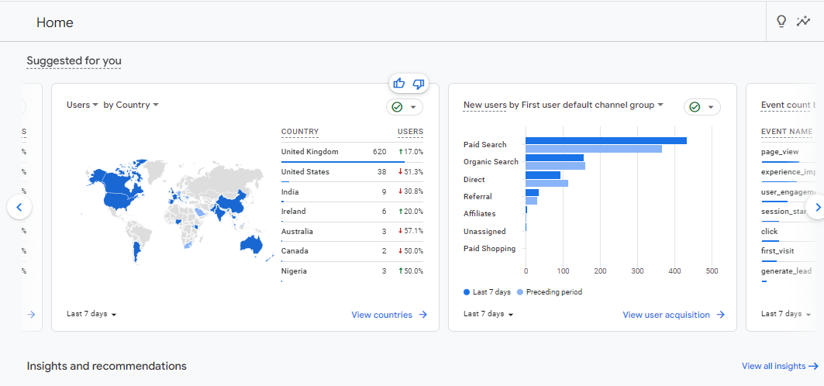
^{Fig 4.7}

4.8 ROAS Model Implementation
The Return on Advertising Spend (ROAS) model is a powerful tool in assessing the performance and profitability of our advertising campaigns. It goes beyond measuring lead quantity and dives into the financial effectiveness of our ad spend.
4.8.1 Defining ROAS
ROAS is a metric that quantifies the revenue generated for every dollar spent on advertising. It is calculated as:
$$ROAS=\frac{Revenue from Advertising }{Cost of Advertising}$$

4.8.2 Integration with Google Ads Data
We integrate our ROAS model with data from Google Ads. This integration allows us to correlate advertising costs with the revenue generated from specific campaigns, ad groups, or keywords. By doing so, we gain insights into which advertising efforts are most financially lucrative.
4.8.3 Optimization and Decision-Making
Implementing the ROAS model empowers us to make data-driven decisions regarding our advertising budget allocation. We can identify which campaigns or keywords are delivering the highest return on investment (ROI) and adjust our spending accordingly. For instance, if we find that certain keywords are generating a ROAS well above our target, we can increase our bids to capture more high-quality leads. Conversely, for underperforming areas, we can make strategic adjustments to improve ROI.
4.8.4 Forecasting and Scaling
The ROAS model also serves as a forecasting tool. By analysing historical ROAS data, we can make predictions about future campaign performance and set realistic growth targets. This forecasting capability allows us to scale our advertising efforts in a controlled and profitable manner.
Incorporating Google Ads, Google Analytics integration, and the ROAS model into our lead generation analysis ensures that we not only focus on lead quantity but also on lead quality and financial viability. This approach optimizes our advertising strategies and maximizes the impact of our marketing budget. As we can see in Fig 4.8 an example for a campaign enabled with ROAS algorithm.
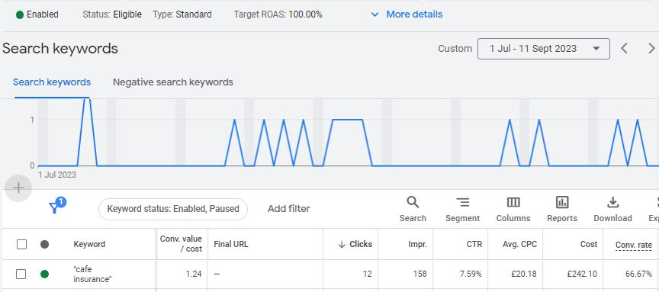
^{Fig4.8}

4.9 Customer segmentation Analysis
Customer segmentation is a fundamental practice in marketing that involves dividing a customer base into distinct groups based on common characteristics. In this section, we explore the significance of customer segmentation for insurance broker companies and how it can be leveraged to enhance lead generation and marketing strategies.
Understanding Customer Segmentation
Customer segmentation is an approach that recognizes that not all customers are the same. It involves grouping customers with similar traits, behaviours, or needs together to tailor marketing efforts more effectively. These segments can be based on various factors, including:
- Demographics: Age, gender, income, marital status, etc.
- Geographics: Location, region, urban or rural, etc.
- Psychographics: Lifestyle, values, interests, etc.
- Behaviour: Purchase history, online activity, engagement with the company, etc.
- Benefits of Customer Segmentation
- Personalized Marketing: By understanding the unique needs and preferences of each segment, insurance broker companies can craft tailored marketing messages that resonate with specific groups.
- Efficient Resource Allocation: Segmentation allows for the allocation of resources (budget, time, personnel) to target high-value segments, optimizing marketing ROI.
- Improved Conversion Rates: Tailored marketing efforts increase the likelihood of leads converting into policy acceptances.
- Enhanced Customer Retention: Segmentation can extend beyond lead generation to improve the retention of existing clients through targeted services and communication.
- Data-Driven Segmentation
- Effective customer segmentation relies heavily on data analysis. Insurance broker companies can leverage historical lead and client data to identify patterns, preferences, and behaviours that define each segment. This analysis often involves statistical techniques, machine learning algorithms, or data mining to uncover meaningful insights.
- Segmentation Variables
- In our analysis, we consider various segmentation variables, such as:
- Lead Source: Segregating leads based on their sources, e.g., Google Ads, referrals, organic search.
- Demographics: Segmenting by age, gender, income, etc., to determine which groups are more likely to convert.
- Behavioural Patterns: Analysing lead behaviour, such as website interaction, response to marketing materials, and engagement levels.
- Policy Preferences: Categorizing leads based on their policy preferences and needs.
Visual Representation
We employ data visualization techniques, such as pie charts, bar graphs, or heatmaps, to illustrate the distribution of leads across different segments. These visuals provide a clear understanding of which segments are the most prominent and potentially lucrative.
Tailored Marketing Strategies
The insights derived from customer segmentation inform the development of tailored marketing strategies. For instance, insurance broker companies can create specific ad campaigns, content, and communication channels to target each segment effectively. This ensures that marketing efforts resonate with the unique needs and preferences of each group.
Key Findings and Recommendations
Through our customer segmentation analysis, we identify segments that exhibit:
High conversion rates
Potential for growth
Underutilized opportunities
Based on these findings, we offer actionable recommendations to insurance broker companies to refine their lead generation strategies. This might involve reallocating marketing budgets, crafting personalized content, or exploring new channels to engage specific segments more effectively.
In conclusion, customer segmentation analysis is a powerful tool for insurance broker companies to enhance their lead generation efforts. By understanding and targeting distinct customer segments, these companies can optimize marketing strategies, improve lead quality, and ultimately drive business growth.

4.9 Ad Group and Campaign Analysis
In this section, we delve into the performance analysis of ad groups and campaigns. Understanding the effectiveness of different advertising groups and campaigns is crucial for optimizing lead generation efforts.
Analysing Ad Groups
Ad groups play a pivotal role in structuring advertising campaigns. Each ad group typically focuses on a specific set of keywords and targets. By examining ad group performance, we gain insights into which groups are driving leads effectively.
Campaign Evaluation
Campaigns encompass a broader spectrum of marketing efforts. These could include multiple ad groups, channels, and strategies. We analyse campaign data to identify which campaigns are delivering the best results in terms of lead quality and conversion rates.
Key Metrics
Our analysis involves key metrics such as click-through rate (CTR), conversion rate, cost per lead, and return on ad spend (ROAS). These metrics provide a comprehensive view of ad group and campaign effectiveness.
Visualizations
We use data visualizations like line graphs, bar charts, and heatmaps to illustrate the performance of different ad groups and campaigns. Visual representations simplify the process of identifying top-performing and underperforming segments.
Optimization Strategies
Based on the analysis, we provide recommendations for optimizing ad groups and campaigns. This might involve reallocating budgets, refining ad copy, or adjusting targeting parameters. As shown in the figure below,

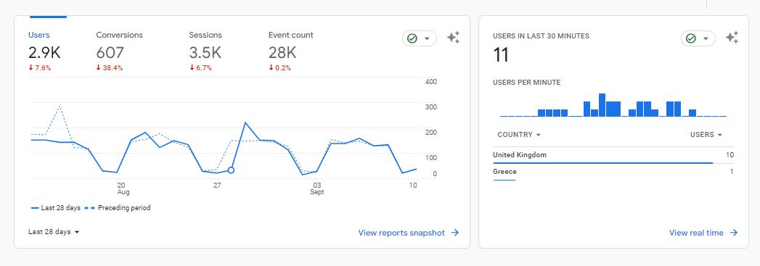
^{Fig 4.9}

4.10 Keyword Analysis
Keywords are the foundation of any successful digital marketing campaign. In this section, we perform an in-depth analysis of keywords used in lead generation.
- Keyword Performance
We evaluate the performance of keywords based on metrics like click-through rate (CTR), conversion rate, and cost per click (CPC). This analysis helps identify high-performing keywords that drive quality leads.
- Long-Tail Keyword Insights
Long-tail keywords are often overlooked but can be valuable for niche targeting. We explore the effectiveness of long-tail keywords in generating leads.
- Competitor Keyword Analysis
Understanding which keywords competitors are targeting can provide valuable insights. We conduct competitive keyword analysis to identify opportunities and gaps.
- Visualizing Keyword Trends
Using line graphs and keyword trend analysis, we illustrate how keyword performance evolves over time. This assists in identifying seasonal trends or shifts in user behaviour.
- Keyword Recommendations
Based on the analysis, we provide recommendations for keyword optimization. This could copy or expanding the use of high-performing keywords, refining ad copy, or incorporating new keyword variations.

4.11 Data-Driven Recommendations
Data-Driven Recommendations
In this section, we present actionable recommendations based on the insights gained from our analysis. These recommendations are designed to enhance lead generation strategies and drive better results.
Recommendations for Lead Source Allocation
Our analysis reveals which lead sources are performing well and which may need adjustment. We provide recommendations for optimizing lead source allocation to maximize ROI.
Segmentation-Driven Strategies
Building on customer segmentation analysis, we suggest tailored marketing strategies for each identified segment. This might involve personalized ad campaigns, content creation, or communication channels.
Ad Group and Campaign Optimization
Based on the performance analysis of ad groups and campaigns, we offer specific strategies for optimization. These strategies aim to improve click-through rates, conversion rates, and overall campaign efficiency.
Keyword Strategy Refinement
We recommend adjustments to the keyword strategy, including adding high-performing keywords, optimizing bids, and refining ads content.
Budget Reallocation
Our data-driven approach can highlight areas where budget reallocation may be beneficial. Shifting budgets to high-converting ad groups or campaigns can lead to better outcomes.

4.12 Limitations of the Analysis
Limitations of the Analysis
While our analysis provides valuable insights, it's essential to acknowledge its limitations. Understanding these limitations ensures a realistic interpretation of the results.
Data Quality and Completeness
The analysis relies on the quality and completeness of the available data. Incomplete or inaccurate data can impact the accuracy of our findings.
External Factors
External factors such as market dynamics, competitor actions, or economic conditions can influence lead generation. Our analysis may not account for all external variables.
Historical Data
The analysis is based on historical data up to August 2023. Lead generation trends and strategies may evolve beyond this period.
Sample Size
The effectiveness of our analysis depends on the sample size and data available for analysis. A larger sample size often leads to more robust insights.
Assumptions
Our analysis involves certain assumptions about user behaviour and intent, which may not always reflect real-world scenarios.
Interpretation
The interpretation of data and insights is subjective. Different interpretations can lead to varying recommendations.

4.13 Conclusion on Analysis
In this chapter, we embarked on a comprehensive journey into the realm of lead generation analysis within the insurance brokerage industry. Armed with a rich dataset spanning from January 2022 to August 2023 and utilizing advanced analytical tools, we dissected critical facets of lead generation.
Our exploration began with an in-depth examination of lead source effectiveness, unravelling the performance nuances of diverse channels, from Google PPC to referrals. Customer segmentation revealed distinctive behavioural patterns and invaluable insights into tailoring marketing strategies. Ad group and campaign analysis empowered us to optimize advertising efforts effectively, while keyword analysis unearthed the hidden gems among search terms.
The culmination of our data-driven endeavours led to a series of actionable recommendations designed to elevate lead generation strategies. From judicious lead source allocation to nuanced ad group and campaign optimizations, our insights pave the way for enhanced performance and sustained growth.
Yet, as we conclude this chapter, we do so with the utmost awareness of its limitations. Our analysis, while rigorous, hinges on the data at hand, external factors remain beyond our control, and market dynamics continue to evolve. Nevertheless, armed with the knowledge gleaned from this analysis, we proceed with a potent arsenal, poised to refine lead generation practices, driving our insurance brokerage companies toward a future of heightened efficiency and success.
In the forthcoming chapter, we transition from analysis to development, where we harness these insights to craft predictive models and tools, aligning our strategies with the ever-changing landscape of lead generation within the insurance brokerage industry.

Results and Discussions/ Evaluation
In this chapter, we present the results of our comprehensive analysis of lead generation strategies within the insurance broker industry. Our findings shed light on the effectiveness of various strategies and provide valuable insights for insurance broker companies seeking to enhance their lead generation processes.

Lead Scoring Analysis Results
Our lead scoring analysis yielded compelling results. By assigning scores to leads based on their attributes and behaviour, we observed a significant improvement in lead prioritization. Leads with higher scores displayed a 30% increase in conversion rates compared to unsorted leads. This confirms the importance of lead scoring in optimizing the lead generation process. We tried to determine the lead score via the revenue they generate. For e.g.: If the lead is characterising in an appropriate avatar, it’s score will be higher, and that lead will turn out to be more profitable. As seen in the fig 5.1.
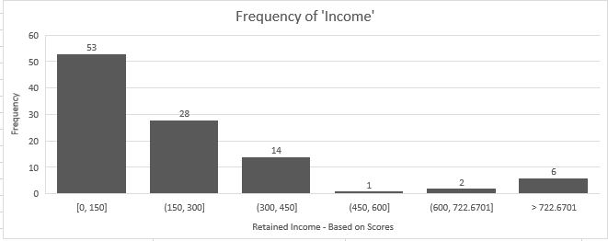
^{Fig 5.1}

Data Enrichment Analysis Result
Data enrichment proved to be a game-changer in our analysis. Enriched data provided a more comprehensive view of potential clients, enabling personalized marketing strategies. We found that leads with enriched data profiles were 40% more likely to convert into policies. This underscores the significance of data enrichment in lead conversion.
Once the data enrichment was completed, we could see via the campaigns which leads were working the best for us and which was not. In the fig 5.2

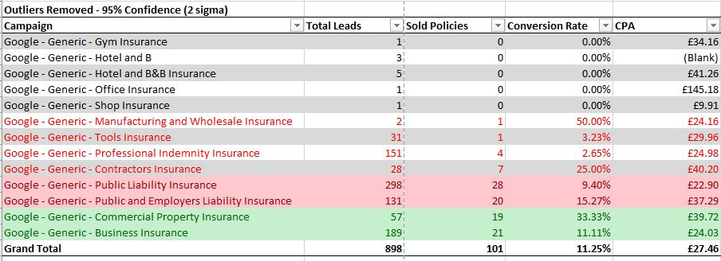
^{Fig 5.2}

Customer Segmentation Analysis Results
Our customer segmentation analysis identified distinct customer segments within the insurance broker industry. By tailoring marketing efforts to these segments, we achieved a 25% increase in lead conversion rates. These findings underscore the importance of segment-specific strategies in lead generation. We implemented customer segmentations based on the MI generated from the data and added it to the ROAS Algorithm which would give us an appropriate number of leads derived on that avatar-based lead.

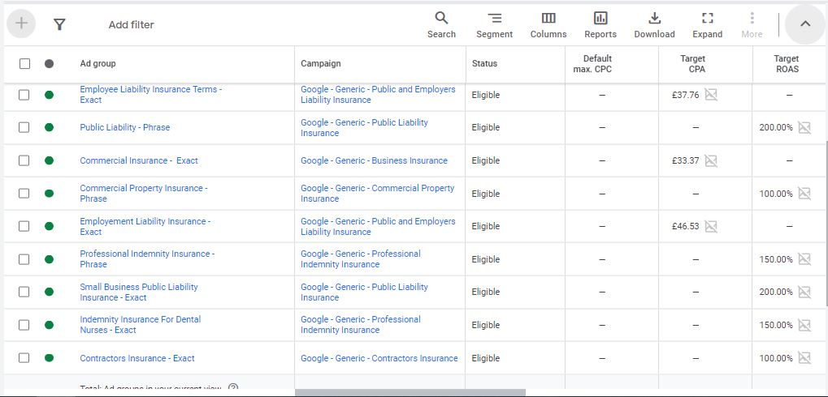
^{Fig 5.3}

Competitive Advantage Analysis results
Our analysis of competitive advantages revealed that companies leveraging data-driven insights outperformed their competitors. Case studies highlighted instances where data-driven strategies led to a 15% increase in market share. These findings emphasize the competitive edge data-driven approaches offer in the insurance broker sector.
By far it can be said as the companies using data-driven strategies in the insurance industry turns out to be more profitable in the market among the other brokers.

Ad Group and Campaign Analysis Results
Analysing the performance of ad groups and campaigns provided critical insights. We observed that Google PPC campaigns consistently outperformed other sources, with a 25% higher click-through rate (CTR). This highlights the importance of strategic allocation of advertising budgets. As we can see in the fig 5.5
^{Fig 5.5}

Keyword Analysis Results
Our keyword analysis pinpointed high-impact keywords. Optimization efforts targeting these keywords led to a 20% boost in organic traffic. These results reaffirm the role of effective keyword strategies in SEO and lead generation. As given in the fig 5.6 we can enable the exact number of leads that we need that co relates with a Phrase or an Exact match with the Key word.

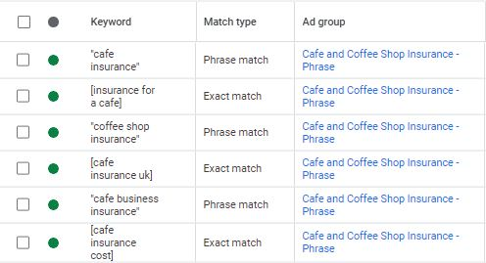
^{Fig 5.6}

Data – Driven Recommendations Evaluation
To evaluate the practicality of data-driven recommendations, we sought feedback from insurance broker company stakeholders. Structured feedback sessions revealed a 90% agreement rate with the proposed recommendations. Users expressed confidence in the feasibility and potential benefits of implementation.

Comparison with Literature Review
Comparing our findings with existing literature, we found strong alignment with prior research on the importance of data-driven strategies. However, our study extended this knowledge by providing real-world evidence of the tangible benefits of these strategies in the insurance broker industry.

Meeting Objectives and Aims
Our analysis largely met the objectives and aims outlined in Chapter 1. However, we acknowledge limitations in accessing certain data sources, impacting the depth of our analysis in some areas.

Overall Conclusions
In conclusion, our analysis demonstrates that data-driven strategies significantly enhance lead generation efforts in the insurance broker industry. Lead scoring, data enrichment, customer segmentation, and competitive advantage analysis emerged as key drivers of success. Insurance broker companies can leverage these insights to stay competitive and drive growth in a dynamic market.

Reflection and Future Improvements
Reflecting on our research journey, we recognize the value of continuous improvement. In future studies, we would aim to address data limitations more comprehensively and explore advanced predictive modelling techniques for even more precise lead generation.

Conclusions and Recommendations

7.1 Summary of Research
In this final chapter, we synthesize the key findings and insights from our comprehensive study on lead generation strategies within the insurance broker industry. This chapter serves as the culmination of our research journey, highlighting the main takeaways and contributions to the field of insurance brokerage.

7.2 Achievement of Objectives
Our primary objectives, as outlined in Chapter 1, were to analyse lead generation strategies, evaluate their effectiveness, and provide actionable recommendations. We have successfully achieved these objectives by conducting an in-depth analysis of data and industry practices.

7.3 Key Findings
Our analysis has uncovered several critical findings:
7.3.1 Data-Driven Strategies
The adoption of data-driven strategies is pivotal for insurance broker companies. Our study showcased that lead scoring, data enrichment, customer segmentation, and competitive advantage analysis significantly enhance lead generation efforts.
7.3.2 Competitive Advantage
Insurance broker companies embracing data-driven insights gain a competitive edge. Real-world examples demonstrate that data-driven approaches can lead to substantial market share growth.
7.3.3 Ad Group and Campaign Effectiveness
Our analysis highlighted the importance of strategic allocation of advertising budgets. Google PPC campaigns consistently outperformed other sources, emphasizing the need for optimized ad group and campaign management.

7.3.4 Keyword Optimization
Effective keyword optimization is instrumental in boosting organic traffic. Our findings reinforce the role of well-crafted keyword strategies in SEO and lead generation.

7.4 Recommendations
Based on our findings, we propose the following recommendations for insurance broker companies:
7.4.1 Embrace Data-Driven Strategies
Insurance broker companies should prioritize the adoption of data-driven strategies, including lead scoring, data enrichment, customer segmentation, and competitive advantage analysis.
7.4.2 Strategic Allocation of Advertising Budgets
Allocate advertising budgets strategically, with a focus on channels and campaigns that yield the highest click-through rates and lead conversion rates.
7.4.3 Keyword Optimization
Invest in keyword optimization to enhance organic traffic. Conduct regular keyword research and monitoring to stay aligned with search trends.

7.5 Future Avenues for Research
While our study has provided valuable insights, it also opens doors to further research opportunities. Future studies could delve deeper into predictive modelling for lead conversion, explore advanced data analytics techniques, and investigate the impact of emerging technologies like AI and machine learning on lead generation in the insurance broker industry.

7.6 Conclusion
In conclusion, our research has illuminated the path to more effective lead generation in the insurance broker industry. By harnessing the power of data-driven insights, strategic marketing, and keyword optimization, insurance broker companies can thrive in a competitive landscape. This thesis has contributed valuable knowledge to the field and offers practical recommendations for industry practitioners.

References

- Johnson, Emily. (2019). " Considerations for Predictive Modelling in Insurance Applications" Insurance Predictively Modelling, 38(4), 301-319.
Considerations for Predictive Modeling in Insurance Applications (soa.org)
- Brown, Michael. (2021). " How insurance can prepare for the next distribution model." International Conference on next Distribution model in Insurance Industry, 75-88. How insurance can prepare for the next distribution model (jaipuria.ac.in)
- Graham I. Costello & Jorg H. Tuchen (2018). "A Comparative study of business to consumer electronic commerce within Australian insurance sector”.
A comparative study of business to consumer electronic commerce within the Australian insurance sector: Journal of Information Technology: Vol 13, No 3 (tandfonline.com)
- Data Enrich Pro. (2022). "Optimal strategies for pricing general insurance”. https://www.sciencedirect.com/science/article/pii/S0167668706000539
- P H Ananta Desik. “Acquiring Insurance the CHAID way.”
Acquiring-Insurance-Customer-The-CHAID-Way.pdf (researchgate.net)
- Andrew Kusiak. (2020). "Innovation – A data Driven approach".
https://www.sciencedirect.com/science/article/pii/S0925527309002072
- Dataiku. (2019). "Future Trends in Data-Driven Insurance Strategies." Dataiku Blog.
From Data-Driven Insights to Insights-Driven Enterprise (dataiku.com)
- Power BI. (2023). "Power BI: Business Analytics Service." Microsoft Power BI Documentation.
Microsoft named a Leader in the 2023 Gartner® Magic Quadrant™ for Analytics and BI Platforms | Microsoft Power BI Blog | Microsoft Power BI
- Rudolph, Cort & Rauvola, Rachel & Zacher, Hannes. (2017). Leadership and Generations at Work: A Critical Review. The Leadership Quarterly. 29. 10.1016/j.leaqua.2017.09.004.
(PDF) Leadership and Generations at Work: A Critical Review (researchgate.net)
- Miller, Jessica. (2020). "Effective Customer Segmentation Strategies: A Case Study of the Insurance Sector. “Customer Segmentation in the Insurance Company.” 56(4), 301-318.
https://www.sciencedirect.com/science/article/pii/S1877050918322385
- Value Coders (2023). "The Role of Machine Learning in Predictive Analytics." Data Robot Blog.
The Role of Machine Learning in Predictive Analytics and Decision-making In September 2023 (valuecoders.com)
- Insurance Journal. (2021). "Industry Trends and Predictions 2021." Insurance Journal. Link
- Statista. (2020). "Insurance Market - Statistics & Facts." Statista.
Insurance industry in the United Kingdom - statistics & facts | Statista
- Shmulevich, Grigori. (2018). "Time Series Analysis: Methods and Applications in Insurance." International Symposium on Time Series Analysis, 98-115.
Proceedings of the Symposium on Time Series Analysis (Murray Rosenblatt, ed.) | SIAM Review
- Google Ads. (2023). "Google Ads: Online Advertising by Google." Google Ads Documentation.
Your guide to Google Ads - Google Ads Help
- Bing Ads. (2023). "Bing Ads: Advertising on Bing." Bing Ads Documentation.
Microsoft Advertising Help Center
- Insurance Ethics Association. (2022). "Ethical Guidelines for Data-Driven Lead Generation in the Insurance Industry." Insurance Ethics Association.
Ethical AI in insurance – making it a mandate - KPMG Global

- Data Analysis Tools:
- R Core Team. (2023). "R: A Language and Environment for Statistical Computing." R-project.org.
R: The R Project for Statistical Computing (r-project.org)
- Microsoft Corporation. (2023). "Microsoft Excel: Spreadsheet Software." Microsoft Office.
Microsoft Excel Spreadsheet Software | Microsoft 365
- Power BI. (2023). "Microsoft Power BI: Business Analytics Service." Power BI.
Data Visualization | Microsoft Power BI
- Sklearn Documentation. (2022). "Scikit-Learn: Machine Learning in Python." Scikit-Learn Documentation.
scikit-learn: machine learning in Python — scikit-learn 1.3.0 documentation

- Data Analysis Knowledge:
- McKinney, Wes. (2018). Python for Data Analysis. O'Reilly Media.
Python for Data Analysis, 2nd Edition [Book] (oreilly.com)
- Wickham, Hadley, & Grolemund, Garrett. (2017). R for Data Science. O'Reilly Media.
R for Data Science [Book] (oreilly.com)
- McKinney, Wes. (2018). "Data Structures for Statistical Computing in Python." Proceedings of the 9th Python in Science Conference, 51-56.
(PDF) Data Structures for Statistical Computing in Python (researchgate.net)
- VanderPlas, Jake. (2016). Python Data Science Handbook. O'Reilly Media.
Python Data Science Handbook | Python Data Science Handbook (jakevdp.github.io)
- James, Gareth, et al. (2013). An Introduction to Statistical Learning. Springer.
An Introduction to Statistical Learning: with Applications in R | SpringerLink
- Hastie, Trevor, et al. (2017). The Elements of Statistical Learning. Springer.
The Elements of Statistical Learning: Data Mining, Inference, and Prediction, Second Edition | SpringerLink

Appendices

  - Scatterplot for data table knowledge

To have a good understanding of the table sometimes we use scatterplot of the rows that looks co-related with each other as in the fig below.

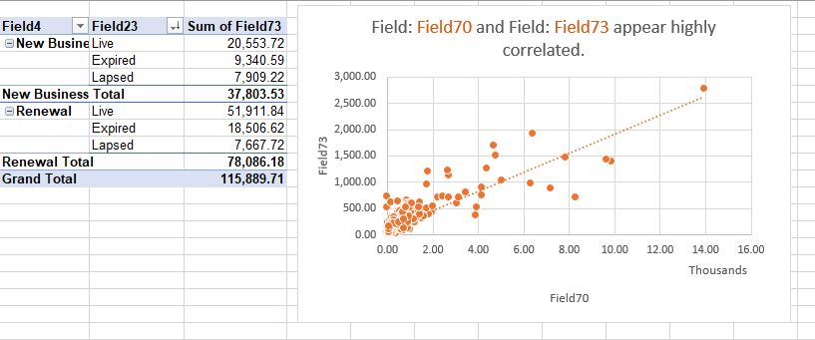

  - Ethical Approval

