

Sefydliad Dysgu Canol Dinas /
Institute of Inner-City Learning

BA Leadership and Management

An Analysis of Leadership Styles at a Large Automobile Group and Their Impact on Innovation and Organisational Performance

Andrei Valentin Gavrila
2311201

Supervisor: Eric Osei

Dissertation submitted as part of the requirements for the award of BA Leadership and Management

07/2026

DECLARATION

I, Andrei Valentin Gavrila, 2309588, would like to declare that I have limited my AI use according to the University regulations in regards to using GAI tools. Also, I declare that the submitted work is entirely my own work.

ANDREI VALENTIN GAVRILA 27.07.2026

ACKNOWLEDGEMENTS

I am really thankful to the supervisor for the guidance given to me, encouraging words and the constant support during the writing of this essay. Besides that, I would like to thank all the interviewees and focus group participants of this study which was conducted for this research thesis for their time and inputs. Last but not the least, my thanks are to my loved ones for their motivation, encouragement, understanding, and constant support through the process of writing the dissertation.

CONTENTS
DECLARATION 3
ACKNOWLEDGEMENTS 4
LIST OF FIGURES 7
CHAPTER 1 – INTRODUCTION 8
1.1 Introduction 8
1.2 Background of the Study 8
1.3 Company Background: BMW Group 9
1.4 Research Problem 9
1.5 Research Aim 10
1.6 Research Objectives 10
1.7 Research Questions 10
1.8 Rationale of the Study 11
1.9 Significance of the Study 11
CHAPTER 2 – LITERATURE REVIEW 12
2.1 Introduction 12
2.2 Concept of Leadership and Leadership Styles 12
2.3 Transformational Leadership Theory 13
2.4 Transactional Leadership Theory 14
2.5 Servant Leadership Theory 15
2.6 Leadership and Innovation 16
2.7 Leadership and Organisational Performance 17
2.8 Organisational Culture as a Mediating Factor 17
2.9 Leadership and Change Management 18
2.10 Research Gap 19
2.11 Conceptual Framework 20
CHAPTER 3: RESEARCH METHODOLOGY 22
3.1 Introduction 22
3.2 Research Philosophy 22
3.3 Research Approach 22
3.4 Research Design 23
3.5 Research Strategy 23
3.6 Research Methods 24
3.6.1 Primary Research 24
3.6.2 Secondary Research 24
3.7 Data Collection Methods 25
3.7.1 Questionnaire Design 25
3.7.2 Secondary Data Sources 26
3.8 Sampling Strategy 26
3.9 Data Analysis Techniques 27
3.9.1 Quantitative Data Analysis 27
3.9.2 Qualitative Data Analysis 28
3.10 Reliability and Validity 28
3.11 Ethical Considerations 29
CHAPTER 4: FINDINDS AND DATA ANALYSIS 30
4.1 Introduction 30
4.2 Demographic Profile of Respondents 30
4.2.1 Gender 30
4.2.2 Age 31
4.2.3 Department 32
4.2.4 Length of Service 33
4.3 Questionnaire Findings and Interpretation 34
4.4 Summary of Findings 47
CHAPTER 5: CONCLUSION AND RECOMMENDATIONS 48
5.1 Conclusion 48
5.2 Recommendations 48
5.3 Limitations of the Study 49
5.4 Suggestions for Future Research 49
REFERENCES 51
Appendices 55
Appendix 1 – Questionnaire 55

LIST OF FIGURES

Figure 2.1: Conceptual framework 21
Figure 4.1. Gender of respondents………………………………………………………….31
Figure 4.2: Age group of respondents 32
Figure 4.3: Department of respondents 33
Figure 4.4: Length of service 34
Figure 4.5: My manager communicates a clear and motivating vision 35
Figure 4.6: My manager encourages employees to suggest new ideas 36
Figure 4.7: Good performance is recognised and rewarded 37
Figure 4.8: Managers intervene when standards are not achieved 38
Figure 4.9: My manager listens to employee concerns and provides support 39
Figure 4.10: Employees are involved in decisions that affect their work 40
Figure 4.11: The leadership approach creates a safe environment for experimentation 41
Figure 4.12: Leadership encourages collaboration and knowledge sharing 42
Figure 4.13: Leadership improves employee motivation and engagement 43
Figure 4.14: Leadership contributes to higher productivity and efficiency 44
Figure 4.15: Leadership helps the organisation respond effectively to change 45
Figure 4.16: Overall, leadership has a positive effect on organisational performance 46

CHAPTER 1 – INTRODUCTION

1.1 Introduction

The automotive industry is undergoing major changes as a result of new digital technologies, sustainability efforts, electrification, and self-driving vehicles. Such changes mean that companies have to lead in ways that promote innovation, yet at the same time deliver excellent organisational results.
Operating globally, the automobile group, which ranks among the top premium car makers, is heavily immersed in this fiercely competitive market where it constantly tries to keep its edge through innovative and advanced technologies. Therefore, finding out how different leadership styles influence innovation and organisational performance has grown in importance not only for researchers but also for practitioners.

1.2 Background of the Study

Leadership is undoubtedly one of the most important aspects of organisational success and has been the subject of many research works in the field. Various leadership styles affect employee motivation, decision-making, workplace culture, and organisational results in different ways. According to Yukl (2013), contemporary leadership theories argue that leadership behaviour can largely determine an organisation's success in adapting to the changes of the external environment and in fulfilling its strategic goals.
One of the most popular leadership styles in the discussion of leadership approaches is transformational leadership that aims at motivating employees through vision, intellectual challenge, and personalised support. Transformational leaders ask their followers to question traditional ways, come up with fresh ideas, and help the organisation to innovate. Research findings show that transformational leadership is linked to higher levels of creative behaviour among employees, knowledge sharing, and overall organisational success, especially in situations of uncertainty and rapid technological changes (Burns, 2012; Northouse, 2021).
On the other hand, transactional leadership centers around managing performance via incentives, supervision, and disciplinary measures. Though this leadership style may result in higher operational effectiveness and control, an overdependence on transactional ways can result in the curtailment of employee discretion and loss of creativity, which may negatively affect the level of innovation (Yukl, 2013).

1.3 Company Background: BMW Group

The group is recognized worldwide as a manufacturer of automobile, with some of the most exclusive and luxurious vehicles and motorcycles in the market. It was founded in Germany and is now operating worldwide by the most recognizable brands. The company is known for its excellent engineering, leading edge technology, high-quality products, and customer satisfaction. Being a multinational company, BMW hires a lot of people in different production shops,
The automobile group is a crucial member of the wider group family. The company plays a major role in manufacturing, sales, and customer support in the United Kingdom market. All staff from different departments are expected to take part in initiatives aimed at continuous improvement without compromising the high level of operations. Leadership is thus a key factor in determining employee motivation, innovation behaviours, and overall organisational performance.

1.4 Research Problem

The automotive industry's move towards digitalization, sustainability, and advanced mobility solutions has made innovation a key factor for competitive advantage. Nevertheless, innovation doesn't just happen on its own; it is usually shaped by leadership styles, company culture, and employee involvement. Even though the company is continuously investing in technological innovations, the interplay between leadership styles and how they affect the creativity, innovative behaviours and consequently, the organisational performance of employees remains unclear.
Earlier studies have shown the significance of transformational, transactional, and servant leadership styles in determining workplace outcomes (Northouse, 2021; Meyer and Stensaker, 2019). Besides, most of the studies are based on the leadership views of top management, neglecting the employees' understanding of how they actually experience leadership behaviours at the operational levels.
The purpose of this paper is to fill this void by examining the link between leadership styles and their effect on innovation and performance of the organisation within a large automobile group in the UK. The results of the research will offer insights on how leadership strategies could effectively facilitate employee motivation, creativity, and organisational performance in an environment that is both highly competitive and driven by innovation.

1.5 Research Aim

This research aims to analyse leadership styles at a large automobile group in the UK and examine their impact on innovation capability and organisational performance.

1.6 Research Objectives

To identify the dominant leadership styles experienced by employees at a large automobile group in the UK.
To examine how leadership styles influence employee innovation and creativity.
To evaluate the relationship between leadership styles and organisational performance outcomes.

1.7 Research Questions

What leadership styles are commonly experienced by employees at a large automobile group in the UK?
How do leadership styles influence employee innovation and creativity?
To what extent do leadership styles affect organisational performance within a large automobile group in the UK?

1.8 Rationale of the Study

The reason behind the research is the increased need for leadership in organizations that operate in highly competitive and innovation-driven industries. The automotive sector is going through immense changes with the help of technology, digitalization, sustainability, and the growing use of electric cars. As one of the best premium car makers, the company has to keep coming up with new ideas while also ensuring good performance. The role of leadership is really important in meeting these goals, as leaders' actions have an impact on how employees feel motivated, have new ideas, get involved, and change (Northouse, 2021).

1.9 Significance of the Study

The importance of this research lies in how it provides both the advancement of academic knowledge and the improvement of the leadership effectiveness in innovation-driven organisations from an organisational practice point of view. As far as academia is concerned, the paper builds on current literature on leadership by exploring the link between leadership styles, innovation and organisational performance in a very specific context. It also fills a well-recognised gap in the literature by including the views of employees rather than only those of managers (Yukl, 2013).
On the ground, insights from this work could be valuable for a large automobile group in the UK and organisations like it which want to enhance leadership effectiveness and innovation capability. By finding out the effect of various leadership styles on employee creativity, engagement, and organisational performance, the managers can use this knowledge to create leadership development programmes and change their workplace practices for the better (Meyer and Stensaker, 2019).

CHAPTER 2 – LITERATURE REVIEW

2.1 Introduction

This chapter performs a thorough review of the literature on leadership styles and their influence on innovation and corporate performance. The chapter presents a discussion of the main leadership models like transformational, transactional, and servant leadership. Then it elaborates on leadership and organisational culture, innovation, and change management. The last part of the chapter shows where in the literature less work has been done and sets out the conceptual framework on which the study is based.

2.2 Concept of Leadership and Leadership Styles

Leadership is a term that refers to the way one person influences others to work towards common corporate goals. On the other hand, management deals chiefly with planning, organising, and controlling resources; leadership, however, is about spurring and directing people to produce outcomes that are desirable (Northouse, 2021). Without leadership, the organisation would be doomed as employee commitment to the company's objectives and readiness to go beyond the minimum requirements of the job are crucial to success.
Different perspectives and theories have been put forward to account for leadership efficacy. Initially, the focus was largely on leaders hanging personal traits and characteristics that set them apart from followers. Still, nowadays, leadership effectiveness is viewed to rely more on behaviours, relationships, and organisational circumstances than on leader's individual traits (Dinh et al., 2014). So, present-day leadership research is more centred on leaders' powers to influence team members' attitudes, organisational culture, capacity for innovation, and performance.
Leadership styles are the distinct ways in which leaders behave through their interactions with members and decision-making activities. Different styles of leadership bring about different results in organisations by causing through different channels variation in levels of motivation, engagement, creativity, and performance of employees (Yukl, 2013). The most frequently mentioned leadership styles in current literature are transformational leadership, transactional leadership, and servant leadership.

2.3 Transformational Leadership Theory

The modern concept of transformational leadership is highly anchored in management literature having been vigorously researched and documented. Burns is credited with its evolution (2012) and Bass and Riggio (2006) further developed it into a more complete theory. The central theme of transformational leadership is elevating individuals to attain results they had not thought they were capable of, by inspiring and motivating. Transformational leadership goes beyond issuing commands or rewarding compliance, it influences employees through aligning them with a leader's vision and inspiration as well as their personal focus on development.
Northouse (2021) states that transformational leadership involves four components: idealised influence, inspirational motivation, intellectual stimulation, and individualised consideration. Under idealised influence, leaders are so ethical and committed that employees want to walk in their footsteps. Inspirational motivation means that leaders are able to inspire and energize those around them by presenting attractive future images. Intellectual stimulation refers to overturning ingrained ways of thinking and encouraging creativity. Individualised consideration means treating each employee as a unique individual with his/her own developmental needs.
There is substantial research backing up the constructive consequences of transformational leadership on organisational success. Hoxha (2019) demonstrated that transformational leadership significantly influences performance of employees, loyalty to the organisation, and effectiveness of the workplace. Along similar lines, Lai et al. (2020) found that transformational leadership results in better job performance through boosting employee engagement. The above-mentioned studies point out that transformational leadership is great for individual and company results.
Transformational leaders may be the best fit for innovation-led organisations due mainly to the intellectual stimulation dimension of the theory which causes employees to come up with creative ideas and be courageous in their actions. Ahmed et al. (2018) discovered that the behaviours of transformational leaders lead to the fostering of an innovative environment through collaboration, empowerment, and openness to sharing knowledge. Rosing, Frese and Bausch (2016) support this view by stating that through creating a culture in which learning and trying out new things are normal, transformational leaders facilitate innovative behaviours.

2.4 Transactional Leadership Theory

Transactional leadership is a form of leadership that's mostly based on leaders and subordinates acting in return for services rendered. Employees are not inspired by the leader's vision and motivation but are satisfied by the leader's monitoring the work, issuing rewards, and taking corrective action (Burns, 2012). This kind of leadership evidently presupposes that employees mainly respond to external motivators and that the goals of the organisation can be attained by following orderly administrative mechanisms.
Avolio, Bass and Jung (1999) according to suggest that transactional leadership is made up of contingent reward and management-by-exception. The former is a type of performance recognition and its reward that is delivered when a result has been met by the employee. Management-by-exception (active or passive) is the act of overseeing work and intervening when a problem arises or rules have been broken. Both of these processes serve to keep control of the organisation and its operations and ensure that staff follow the set norms and standards.
There are certain reasons why transactional leadership is beneficial. Clear communication of expectations and the linkage of performance to rewards are some of the features promoting accountability, efficiency, and consistency. Yukl (2013) tells us that transactional leadership can be best utilised in environments where there is a requirement for a great deal of operational control, quality assurance, and compliance with procedures. Here, employees know exactly what the standards are and receive rewards once they achieve those standards. Makambe and Moeng (2020) also show that transactional leadership is able to stimulate production of staff members when the tasks to be performed and the rewards have been communicated clearly.

2.5 Servant Leadership Theory

Servant leadership is a philosophy of leadership that can be seen to place employees' needs, development, and well-being far ahead of everything else. It differs from the traditional methods that focus predominantly on organisational goals and the exercise of managerial authority in that it presupposes that leaders help members through being of service. The central idea is that leaders properly support and empower their subordinates and as a result, these achieve their potential and at the same time make their contribution possible to organisational objectives (Northouse, 2021).
The traits that servant leaders uncover in their subordinates and develop, amongst others, are empathy, listening, stewardship, humility, and dedication to the development of their employees. As Alvesson and Sveningsson (2015) point out, servant leadership predisposes an atmosphere of co-operation in which people sense that they are esteemed and appreciated. Servant leadership is deemed by the creation of trust, openness in communication, and other positive workplace relationships with the ultimate outcome of facilitating employee satisfaction and engagement.
According to the proponents of servant leadership, organisations flourish as a result of leaders being concerned about the well-being of their employees. Motivated, committed and carrying out citizenship behaviours are just some of the positive effects on employee performance that are expected to flow from feeling supported and cared for. As one of the studies Wijesiri and Amarawansha (2019) suggests, leadership that is supportive can significantly raise employee engagement levels and as a consequence result in improved organisational performance. After examining the styles of leadership that are characterised by support and empowerment, the researchers AlFayyeh and Alghamdi (2023) reach a similar conclusion concluding that positive leadership behaviours are directly influencing employee performance and commitment to the workplace.
Close to innovation is servant leadership, given that it very much sets the stage, through the leadership focus on psychological safety and collaboration, for groups to share, take part in decision-making and contribute to the improvement of the organisation. Employees will have less hesitancy to expose their ideas and thoughts when they feel trusted and respected. Ahmed et al. (2018) go as far as to say that a leadership style that is centred around empowerment and relationship building support innovation via participation in creative problem-solving activities by the employees.

2.6 Leadership and Innovation

Innovation is by far one of the most crucial factors determined by research to impact the competitiveness, growth, and long-term sustainability of an organisation. Firms in fast changing and technology-oriented sectors, for example, must keep on inventing new lines, services, or operations, if they want to remain at the top of the race. Leadership comes into play in a big way in making the innovation process happen because leaders change employees' mindset, the culture of the enterprise and the kind of behaviour at the workplace that encourage new ideas and continuous improvement (Meyer and Stensaker, 2019).
Within the management literature, the leadership-innovation nexus has been heavily spotlighted. Leaders that get results find ways to inspire their workforce to coming up with fresh ideas, query the status quo and get involved in collective problem-solving work. Transformational leadership has been linked the most to innovation since these types of leaders offer intellectual challenge and push their followers to come up with creative responses to organisational problems (Bass and Riggio, 2006). Those employees who experience support and empowerment are not only more inclined to show innovative work behaviours but also to make a difference to their organisation's learning.
Studies have proved that leadership is a major determinant of employee creativity and innovation capability. According to Rosing, Frese and Bausch (2016), leadership behaviours that spur trying out new things and taking risks in a controlled manner result in successful innovation. The same line of thought is shared by Ahmed et al. (2018), who demonstrated that leadership is a vehicle whereby empowerment, collaboration, and knowledge sharing are fostered, hence leading to innovation.

2.7 Leadership and Organisational Performance

Organisational performance refers to an organisation's ability to achieve its objectives efficiently while positioning itself to be productive, competitive and sustainable over a long period. Leadership is commonly held to be one of the most powerful factors that define the outcome and performance of an organisation as it is leaders who drive the changing of employee conduct, the creation of the workplace culture, and the enhancement of organisational effectiveness (Northouse, 2021).
Studies on effective leadership several times have found a direct link between leadership and organisational performance. The evidence is that good leaders uplift employee spirit, interaction, work rate and also long-term dedication, all of which lead to the success of a company. Using separate case studies, Hoxha (2019) and Makambe and Moeng (2020) showed the influence of certain leadership styles on employee performance and productivity of the organisation as well as on other factors of effectiveness in the workplace.
The key way that leadership determines a company's performance is by way of employee engagement. This is because, engaged employees are committed, usually do extra mile, and are in favour of the organisational goals at the highest. Lai et al. (2020) reported that transformational leadership can boost job performance via engagement of employees. Wijesiri and Amarawansha (2019) found that leadership styles characterized by a high level of trust and employee participation also have a strong influence on engagement and, by extension, on workplace performance.
Leadership also plays a key role in organisational resilience and adaptability to changes brought by competitors, technology as well as customer trends. According to Meyer and Stensaker (2019), good leadership is capable of helping organisations simultaneously manage the present while at the same time creating the future.

2.8 Organisational Culture as a Mediating Factor

Organizational culture is technically the amalgamation of values, beliefs, assumptions and behavioural norms shared that collectively shape the way employees think, interact and perform in an organisation. Such culture is crucial in shaping employees' mindset and attitudes towards innovation, collaboration, learning and performance. It is not unusual to find researchers describing culture as a key vehicle by which leadership exerts influence on organisational results (Schein and Schein, 2017).
Leadership and organisational culture have a two-way influence on each other. This is basically because it is the leaders who decide on the values that guide the behaviours of the organisation that they oversee. Schein and Schein (2017) have said that culture generally embodies the beliefs and values of leaders. The ways in which people communicate, make decisions, and behave set the tone for how individuals perceive their organisational goals as well as the nature of workplace relationships, and this situation is the work of leaders.
Ogbonna and Harris (2015) reason that leadership styles have a major impact onorganisational culture and hence organisational performance. For instance, leadership through support tends to bring about a culture of trust, collaboration, and employee involvement. Such a culture would encourage employees to share knowledge, involve them in decision-making, and innovate. However, the result of a very controlling style of leadership may be a culture where fear is predominant, communication is limited and there is resistance to change.
Organisational culture matters a lot when it comes to innovation. Alvesson and Sveningsson (2015) maintain that open, learning, and psychologically safe cultures are more conducive to creativity and experimentation. When mistakes are seen as opportunities for learning rather than failures, people are more likely to take risks and come up with new ideas.

2.9 Leadership and Change Management

Change management is gaining prominence as companies strive to keep up with the ever-changing technological, economic, and social environment. Leadership is a key factor during organisational change as leaders shape employees' minds, gaining their acceptance and eliciting their response to change measures (Kotter, 2006).
Communication is an area where leadership is pivotal as it helps to announce change and lessen the stress among workers. Meyer and Stensaker (2019) state that at the core of leadership for change is the ability to build a change-ready organisation without sacrificing the commitment and engagement of the employees. They say that those leaders who can paint a picture of the future and get employees on board with the change tend to be the ones leading successful transformations.
With the capacity to inspire employees to see new paths and master changed environments, transformational leadership is a key element of change management. Northouse (2021) believes that by helping employees envision a successful future, transformational leaders are able to both motivate and win over the employees for the change.
Change managers find change resistance to be the toughest hurdle they have to cross. Workers, among other reasons, may resist change due to lack of clarity, fear of failure, or worry about disruption of the time-tabling of and tempo of their lives (Alvesson and Sveningsson, 2015). Besides helping employees to understand change, leadership in this instance, serves to foster trust and communication, as well as to encourage employee participation in all stages of change, thus reducing resistance.

2.10 Research Gap

Leadership styles and organisational outcomes have been the focus of a great number of research endeavours, yet there are still some unaddressed issues. A lot of the research has been generalised to the leadership-performance links across industries without the leadership in specific organisational contexts being the focus. As a result, very little is known as to how leadership styles impact innovation and organisational performance in premium automotive organisations such as BMW UK (Meyer and Stensaker, 2019).
One more issue is the habit of the researchers to independently study leadership styles. Investigations are often conducted into transformational, transactional, or servant leadership each one on its own with these not being different leadership behaviours depending on organisational circumstances that leaders often combine. Northouse (2021) argues that the secret of effective leadership may lie in a leader's ability to change behaviours to fit the situation rather than stick to only one leadership style.

2.11 Conceptual Framework

The proposed conceptual framework is derived from the body of knowledge cited here. Charting leadership behaviours, innovation potential, organisational culture, and organisational success, the model shows their interconnectedness. Research results have established a link between leadership behaviours and employee innovation, involvement, cooperation, and overall organisational success both directly and through innovation and culture (Ogbonna and Harris, 2015; Bass and Riggio, 2006).
Three leadership approaches of transformational, transactional, and servant leadership styles serve as the independent variable here. Innovation capability and organisational culture as the mediators, influence the way leadership impacts organisational outcomes. Dependent variable is organisational performance, measured in terms of employee engagement, productivity, efficiency, and ability to compete.
According to the framework, good leadership has a positive impact on innovation capabilities and organisational culture and these, in turn, lead to better organisational performance. This framework serves as a theoretical underpinning to the empirical work carried out at a large automobile group in the UK and analysis of leadership styles, innovation, and organisational performance.

Figure 2.1: Conceptual framework
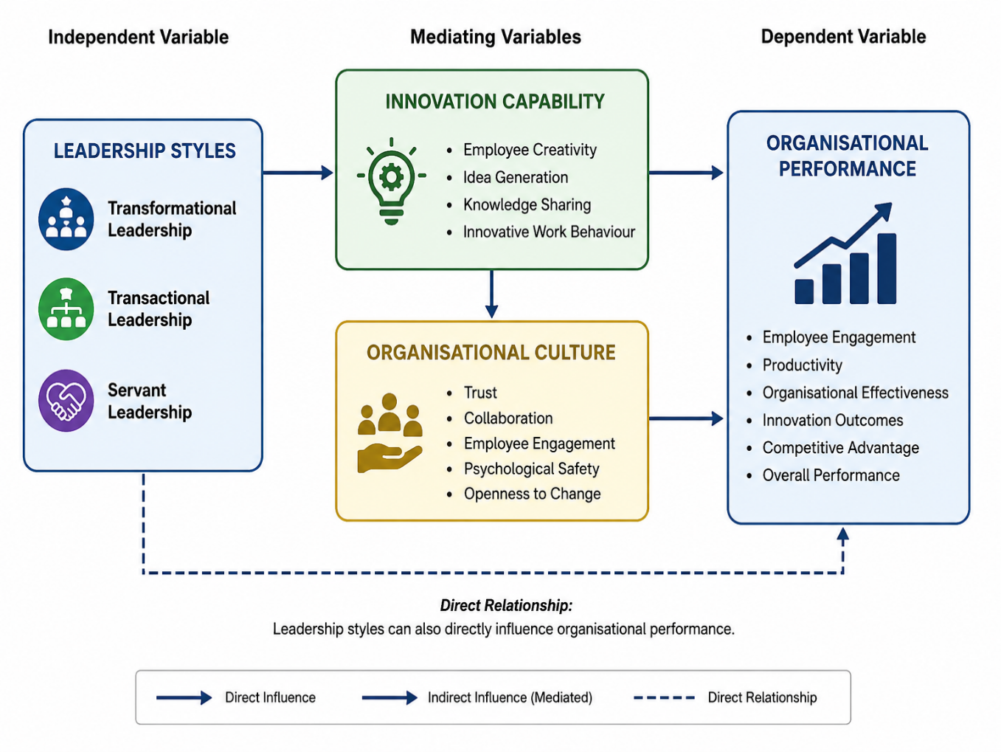
Source: self-made

CHAPTER 3: RESEARCH METHODOLOGY

3.1 Introduction

This chapter explains the research methods used to study the influence of different leadership styles on innovation and organization performance at a large automobile group in the UK. Research methodology refers to the overall structure within which data are collected, analysed, and interpreted to fulfil the research aim and objectives. Choosing the right methodology is very important as it guarantees that the research work is systematic, trustworthy, and able to deliver reliable results (Saunders, Lewis and Thornhill, 2019).

3.2 Research Philosophy

Research philosophy is the organization of human understanding about the basic features of the universe. It provides the general framework within which methodological choices can be made and influences how researchers view knowledge and reality in a given study (Saunders, Lewis and Thornhill, 2019).
Pragmatist research philosophy, based on practical consequences and real effects, is the choice for this research. Pragmatism places a premium on fulfilling a research project's objectives in the most effective and efficient way possible at the same time. In addition, whereas other philosophies are bound to one mode of reality or knowledge, pragmatism permits the mixing of different types of evidences and multiple research methods as necessity dictates (Creswell and Creswell, 2018).

3.3 Research Approach

This research work follows a deductive research approach. The rationale for this choice is that the study is based on well-known leadership theories such as transformational leadership, transactional leadership, and servant leadership. These theories have been widely discussed in the literature and serve as a basis for analysing the relationship between leadership styles, innovation capability, and organisational performance (Northouse, 2021; Yukl, 2013).

3.4 Research Design

The research at hand utilizes a mixed-methods research design. Mixed-methods research is a combination of quantitative and qualitative approaches for the fulfilment of research purposes within a single study (Creswell and Creswell, 2018). The researcher can take advantage of the strengths of each approach as well as decrease the weaknesses of each by using both quantitative and qualitative data.
One aspect of the project is the quantitative study which is primarily concerned with data that are elicited by a structured questionnaire which is filled out by a large automobile group in the UK employees. The questionnaire mainly deals with employee views about the leadership styles, support for innovation, and company performance. Quantitative data provide the means by which the researcher can use statistics to explore and discover the existence of patterns, trends, or the relationships between variables (Saunders, Lewis, and Thornhill, 2019).
The qualitative part consists of secondary research obtained from the academic journals, books, industry reports as well as the corporate reports by a large automobile group in the UK. These give a great deal of background information on leadership theories, organisational culture, and innovation as well as performance management. The integration of qualitative data gives a more profound interpretation of the quantitative results and again makes an overall contribution to the understanding of leadership in a large automobile group in the UK (Meyer and Stensaker, 2019).

3.5 Research Strategy

The strategy of this research is case study that mainly focuses on BMW UK. Case study strategy is a suitable when researchers intend to find out a current phenomenon in real-life of organisational context. This way, researchers can do a thorough study of leadership styles and understand aspects of innovation and organisational performance in the context of specific organisational environment (Creswell and Creswell, 2018). As leadership behaviour is the reflection of organisational structures, culture, and industry conditions, case study can offer contextual insights that are not easily found through broader industry-level investigations.

3.6 Research Methods

Research methods are the exact ways in which data is gathered and analysed. Methods selection should be consistent with research philosophy, approach, and objectives so that data collected can adequately respond to research questions (Creswell and Creswell, 2018). In line with the pragmatist belief and mixed-methods design chosen for this paper, main and secondary methods of research are used.

3.6.1 Primary Research

For this research, primary materials will be acquired using a large automobile group in the UK employees as a target group and distributing a structure questionnaire to them. The questionnaire comprises closed questions only and aims at measuring leadership perception of employee by, innovative capabilities, employee engagement, and organizational performance.
The questionnaire, which is consist of closed questions, has been developed on the basis of the concepts which transformation of leadership as well as transactional, servant leadership, innovation and performance of the organisation is on highlight in literature review. Along with the collection of data, Likert scale of five points has been used to measure the extent of agreement of respondents with the statement. Such scales are, in fact, the most common tool in leadership studies as they help in quantifying the perceptions and attitude of employees (Northouse, 2021).

3.6.2 Secondary Research

In this study, secondary data are obtained from academic journals, books, industry reports, and a large automobile group in the UK corporate publications. Secondary research provides theoretical and contextual information that supports the interpretation of primary findings and strengthens the overall quality of the study.
Academic sources are very critical as a majority of academic references have theoretically established the concepts of leadership, innovation, organisational culture, and organisational performance in their research. These are some of the main sources that have been referred to: the text of Northouse (2021), Yukl (2013), Meyer and Stensaker (2019), and Bass and Riggio (2006), all these materials give theoretical support to this study.
Other journal articles serve as contemporary documentation of the link, for instance, between leadership styles and employee performance, engagement, and innovativeness (Lai et al., 2020; AlFayyeh and Alghamdi, 2023).

3.7 Data Collection Methods

This research will utilise both primary and secondary data collection methods to obtain in-depth information about leadership styles, innovation, and organisational performance at a large automobile group.

3.7.1 Questionnaire Design

One of the main tools for collecting data in this research is a structured questionnaire. Questionnaires are quite common in research on business and management as they enable the researchers to get standardized data from a large group of participants in a very cost-effective and efficient way (Creswell and Creswell, 2018). This paper's questionnaire comprises closed-ended questions which aim to capture employees' perceptions of leadership styles, support for innovation, and overall organisational performance.
The questionnaire is organised into different parts. The initial part is designed to get demographic details from the participants such as their job level, department, and tenure at a large automobile group in the UK. The following parts are mainly concerned with leadership traits representing transformational, transactional, and servant leadership styles.
Throughout the questionnaire, a five-point Likert scale is employed that varies from 1 (Strongly Disagree) to 5 (Strongly Agree). Leadership research often makes use of Likert scales since they produce measurable data that can undergo statistical analysis and at the same time give respondents an opportunity to show how strongly they agree with certain statements (Northouse, 2021).

3.7.2 Secondary Data Sources

Secondary data is usually gathered from a wide range of academic and organisational sources. Academic books, peer-reviewed journal articles and research reports give both theoretical and empirical backing about leadership styles, innovation, organisational culture, and organisational performance.
These types of sources are really the main ingredients for the literature review and at the same time set the theoretical background for the dissertation (Northouse, 2021; Meyer and Stensaker, 2019).
Besides academic literature, the automobile group corporate reports, sustainability reports, and organisational publications are also examined to understand the company's strategic priorities, leadership philosophy, innovation initiatives, and organisational values. These sources provide the background to reveal research findings and also make a comparison between the employees' perceptions and the company's goals.

3.8 Sampling Strategy

This research uses non-probability convenience sampling as a sampling technique. Convenience sampling is the method of collecting participants who are available and willing to take part in the study. This approach is commonly used in organisational research when getting access to participants is difficult due to time, resources, and organisational limitations (Creswell and Creswell, 2018).
The target population for the research is the staff of the large automobile group in the UK at different operational and managerial levels within the company. It is important to get a diverse set of stakeholders from various departments and roles to ensure that all aspects of leadership styles and organisational performance are covered. As leaders and leadership styles have a direct impact on employees, it is particularly logical that they be the participants who will provide the most insight into that area since they witness the behaviours of leaders first-hand.
This research intends to collect data from around 50 employees through survey questionnaires. This number of participants is suitable for a minor organisational case study and matches business researches that have been carried out based on questionnaires (Saunders, Lewis and Thornhill, 2019). The use of convenience sampling restricts the extent to which one can apply the research findings to the whole workforce of the large automobile group in the UK. Nevertheless, for research that is exploratory and focused on a particular organisational context, this research method is deemed suitable.

3.9 Data Analysis Techniques

3.9.1 Quantitative Data Analysis

Quantitative data gathered via employee survey are subjected to descriptive statistical methods to be analysed. Descriptive statistics are a good fit for this research as it aims at discovering patterns, trends, and relationships in employees' perceptions of different leadership styles, innovation support, and organisational performance (Creswell and Creswell, 2018).
Answers to the questionnaire are first coded and then put into Microsoft Excel for further analysis. The process of analysis comprises calculating percentages and producing graphical formats like charts and tables. Through these methods, participant responses are succinctly captured and identifying commonly held views about leadership styles in a large automobile group in the UK is made easier.

3.9.2 Qualitative Data Analysis

Qualitative data gathered from secondary sources are analysed using thematic analysis. Thematic analysis is a very popular method for the identification, organisation, and interpretation of patterns that repeat in qualitative data (Creswell and Creswell, 2018). Since this study is aiming at finding out the way leadership styles impact innovation and performance of an organisation, this method is highly relevant.
The process is done by examining academic works, market reports, and the company corporate literature in order to delineate the common motifs pertaining to leadership style, organisational culture, commitment of employees, innovation capabilities, and performance of the organisation. The themes from the literature are checked against the questionnaire data to recognize areas where they line up and diverge.

3.10 Reliability and Validity

Reliability is about how consistently research measurement is done, and how likely it is that if the study was repeated under the same conditions, the results would be similar. So, to make the research more reliable, this investigation will use a structured questionnaire consisting of standardized questions and response scales. All the respondents will be provided with the same questions, which substantially decreases the chances of inconsistency due to variations in the data collection method (e.g., Northouse, 2021; Yukl, 2013).
Validity is when research tools measure the right thing. This research enhances content validity by making sure that questions in the survey are very much related to the topics reviewed in the literature, such as different leadership styles, innovation capability, employee engagement, and organisational performance. Thus, a set of questions serve as a reflection of the theoretical framework that forms a basis of the research (Northouse, 2021; Bass and Riggio, 2006).

3.11 Ethical Considerations

Governance issues represent a necessary part of business research as they promote responsible making of research efforts combined with visiting participants' rights and welfare in a respectful way. Protecting human subjects from possible harm, confidentiality maintenance and voluntariness of participation are the basic requirements that researchers, according to them, should observe in the whole time of research activities (Saunders, Lewis and Thornhill, 2019).
In this research, established ethical standards have been observed along the whole data collection and analysis process. To make them participate, all the respondents who turned into participants have been adequately informed about the objectives of the study, their role, and the future use of the data, etc. signed approval or consent to participation is mandatory before the respondents can submit the questionnaires. Consent to participation is not only a legal document that can be used in court but also a proof that the signing persons have been fully informed first and then have voluntarily decided to participate in the research (Creswell and Creswell, 2018).

CHAPTER 4: FINDINDS AND DATA ANALYSIS

4.1 Introduction

This chapter provides an account of the authors' interpretation of the results from a 50-participants structured questionnaire. Patterns in employees' perceptions of leadership styles, innovation and organisational performance were identified through frequencies and percentages. Pie and bar charts have been interspersed in order to clarify the presentation of the results, with each of the figures bearing data labels showing the number and percentage of responses. The first section gives a characterization of the sample while the rest goes into a detailed discussion of the questionnaire items related to the three research objectives of the study. Meanings of the response patterns are brought out without pointing to specific participants or departments.

4.2 Demographic Profile of Respondents

4.2.1 Gender

The demographic data of the participants show that 28 respondents (56%) were male, 20 (40%) were female and 2 (4%) preferred not to disclose the gender. This sample is reasonably balanced as male participants only formed a small majority. It is good that the male-to-female ratio is close since it lowers the possibility that the results only mirror one gender group; therefore, it would be fairer to say that employees' diverse experiences are captured in the chapter. A small number of those who chose to remain silent on the gender question also reveals that there was an acceptable level of anonymity available to the respondents.

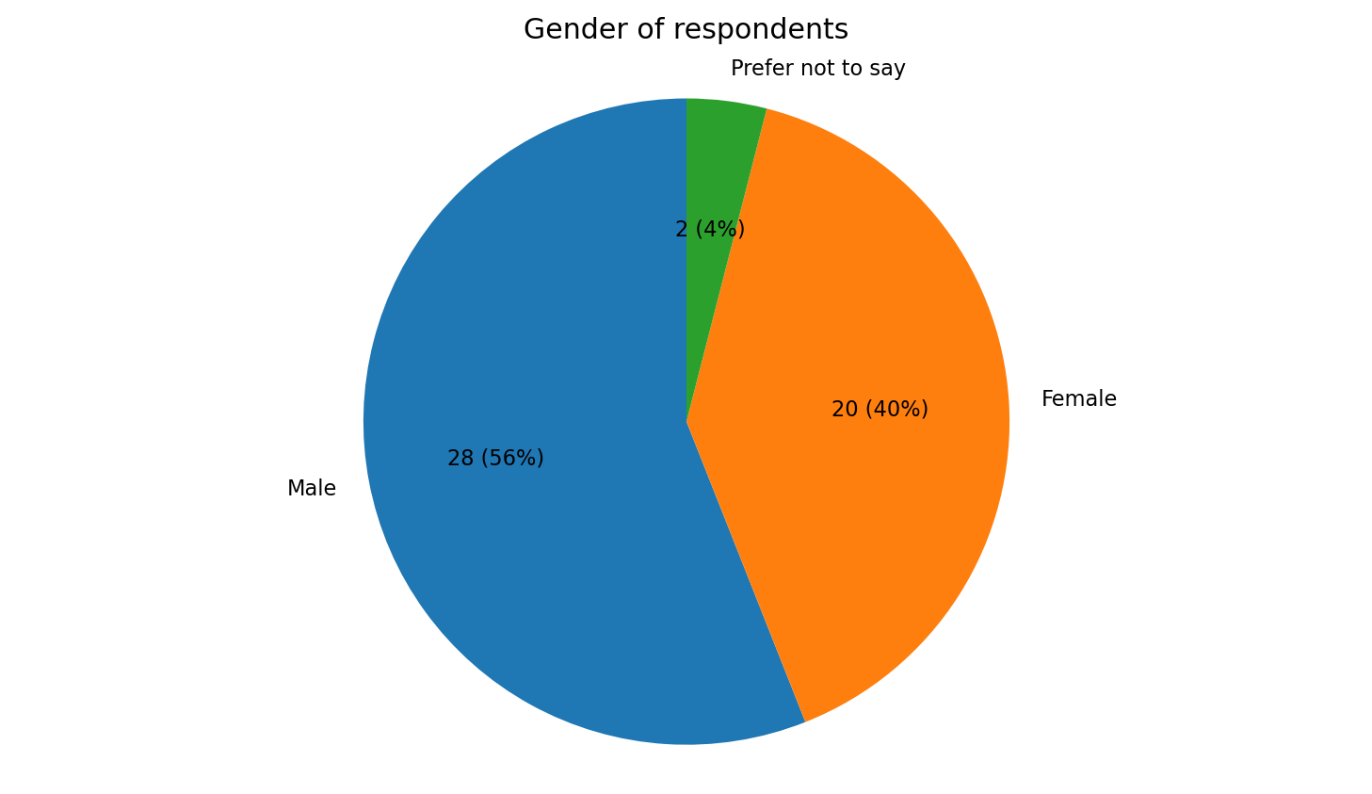
Figure 4.1: Gender of respondents
Source: Primary survey data (2026)

4.2.2 Age

Age patterns in the surveyed group indicate that those aged between 26 and 35 made up most of the participants with17 (34%) of the total number of participants. This age group was closely followed by people in the 36 to 45 age brackets, representing 14 people (28%) in total. Eight participants (16%) were aged between 18 and 25, eight participants (16%) were aged between 46 and 55 participants, and three respondents (6%) were aged 56 or more. The fact that most of the age brackets are in the middle age groups suggests that many of the people who contributed to the study were probably fairly experienced at work but still kept doing the day-to-day activities, as well as development works. Also, having a variety of young and old workers in the study makes the research more comprehensive and allows one to gather different leadership points of view coming out of the same organization but from different career stages and not only from a single age group.

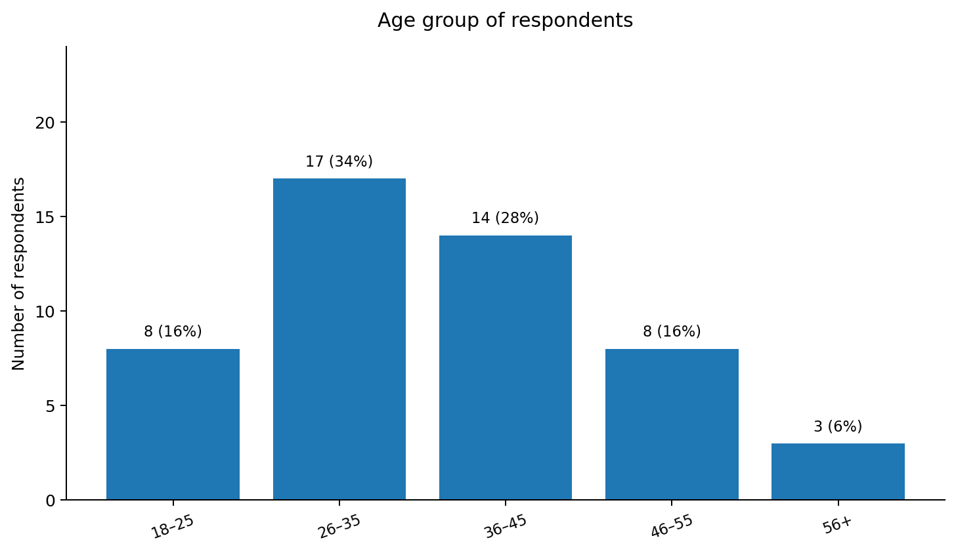

Figure 4.2: Age group of respondents
Source: Primary survey data (2026)

4.2.3 Department

Departmental representation has brought about a quite colourful picture of the organisation. Production department had 15 (30%) respondents while engineering had 12 (24%). Sales and Marketing had 9 (18%) employees whereas Administration had 8 (16%) and Customer Support just 6 (12%). The fact that respondents from Production and Engineering departments represented a large chunk of the survey is expected, as an automotive company is mainly driven by these functions, both operationally and technologically. At the same time, the inclusion of respondents from the Customer service and administrative roles has made this survey more credible and well-rounded as it captures different work styles and roles from different parts of the company. Therefore, the results portray leadership experiences from a range of technical, operational and support departmental environments.

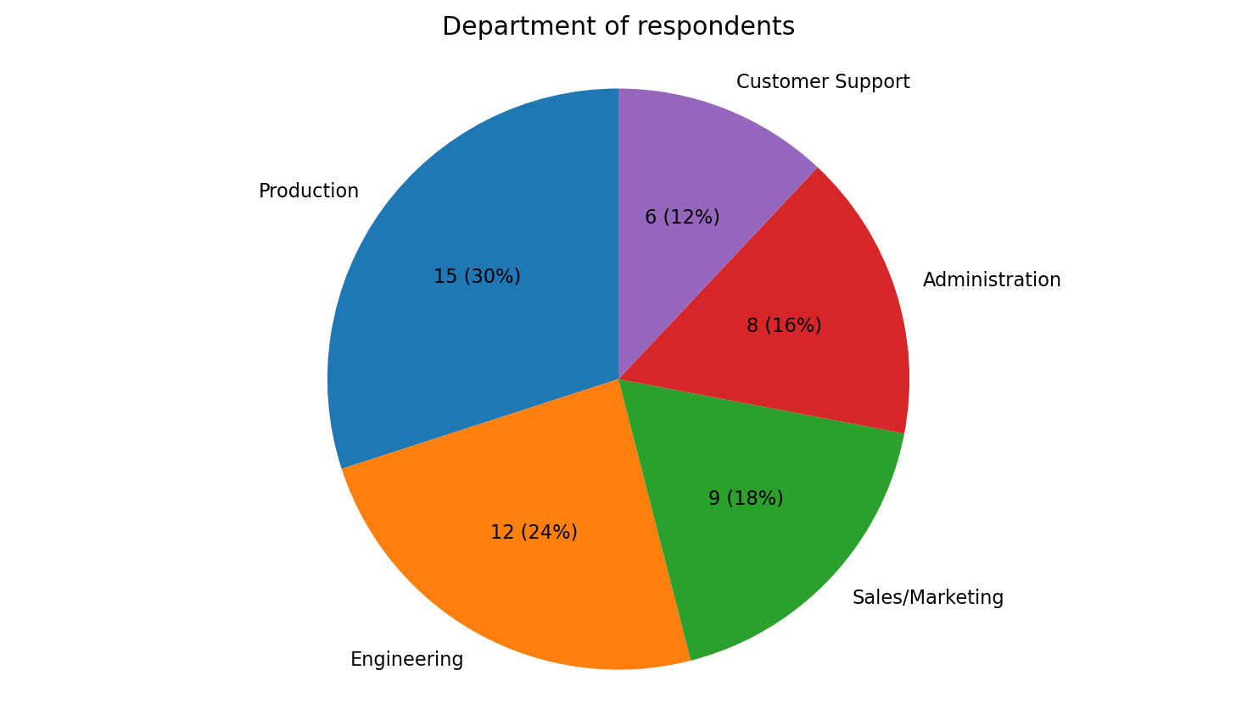
Figure 4.3: Department of respondents
Source: Primary survey data (2026)

4.2.4 Length of Service

The service profile of the respondents reveals that the sample was composed of individuals who were not only employees relatively new to the company but also long-term, experienced staff. About half of the participants (23%) had been working with the organisation for only one to three years, and another similar proportion (25%) had been in their positions for four to six years. Among the rest, those with seven to ten years' experience accounted for 20%, while those with more than ten years represented another 16%. A small 10% of respondents revealed that they had only been employed for less than one year.
In other words, the fact that the survey respondents were a combination of long-term and relatively new employees allowed for an understanding of the leadership styles of the company. As time elapsed, the former can evaluate how a leader's behaviour changes while, on the contrary, newcomers are best placed to tell the latest story of the company's management. As such, the results not only reflect the deep-rooted culture and traditions of the company but also the fresh views of current employees. That way, a much more realistic picture of leadership, innovation and performance emerges.

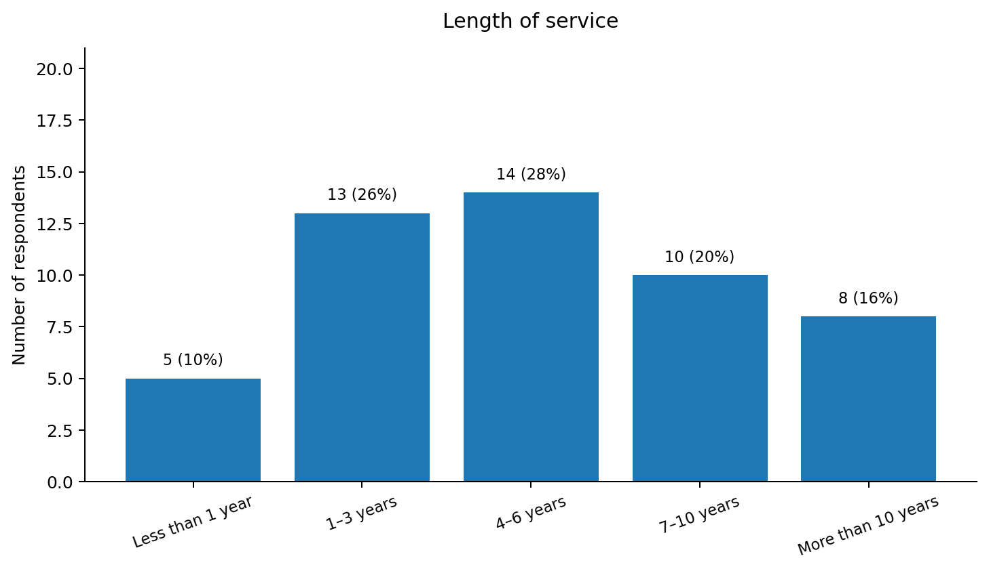
Figure 4.4: Length of service
Source: Primary survey data (2026)

4.3 Questionnaire Findings and Interpretation

The results below are based on the 50-respondent employee's completed questionnaires. Each question is individually explored both through visual illustrations and descriptive explanations to discover common trends in participants' answers. The focus of this investigation is the employees' views regarding leadership styles, innovation, and organisational performance, and this will be the evidence base for the research objectives and answering the questions.

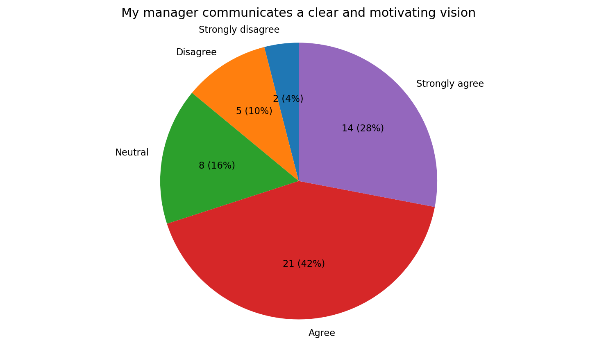
Figure 4.5: My manager communicates a clear and motivating vision
Source: Primary survey data (2026)

Participants who responded expressed that the overwhelming majority had experienced clear and motivating communication from their managers. Twenty-one individuals (42%) said they agreed and 14 people (28%) confirmed their strong agreement. This gives a total of two-thirds to one-fourth positive response combined. Eight individuals (16%) expressed no opinion while three others (i.e., 7+1?) who expressed disagreement to the degree of being different. The outcome seems to indicate that transformational leadership, including motivational leadership, is a part of the company's culture. When employees grasp where the company is headed, it becomes likely to them to cooperate towards common objectives and they see that their jobs are meaningful. On the other hand, the minority of dissatisfied responses highlights that communication is not equally effective across all teams. This suggests that there is considerable room improvement in manager's consistency in communication.

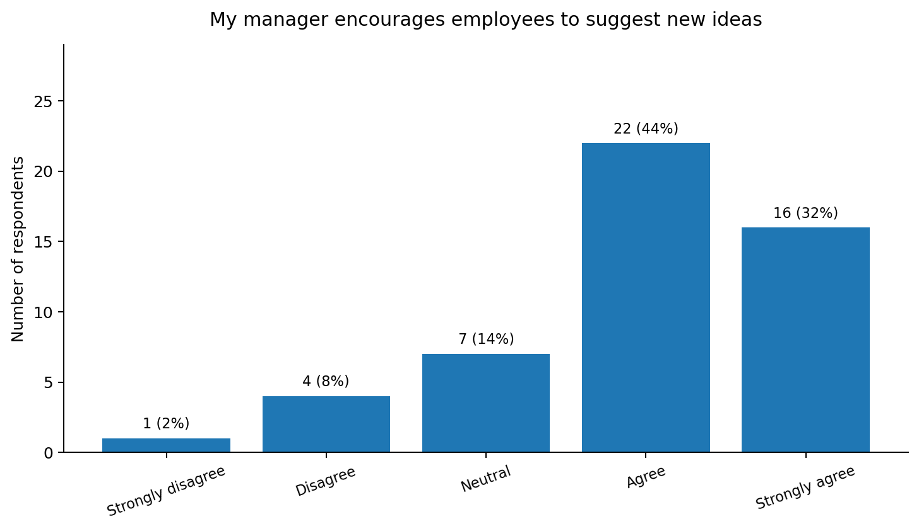
Figure 4.6: My manager encourages employees to suggest new ideas
Source: Primary survey data (2026)

The general view expressed by employees seems to indicate an active promotion of innovation by companies. Sixteen respondents (32%) indicated the strongest level of consensus while 22 (44%) supported the view that a manager's request for a new work method or idea would be met and implemented. Altogether, the two groups account for 76% of the participants surveyed. Five, just five individuals (10%) expressed dissent or a very negative view; seven others (14%) remained neutral. This is a clear illustration supporting the fact the leadership makes available conditions and possibilities for development, creativity and ideas sharing. By encouraging employees' ideas, the company will benefit in a better way problem solving, process changes and product development as those in closest touch with daily work will also understand and be able to implement those work changes. The other neutral or negative responses are hints that, in some teams, perhaps involvement is still limited or very limited, hence innovation-enhancing leadership should be the norm in every department.

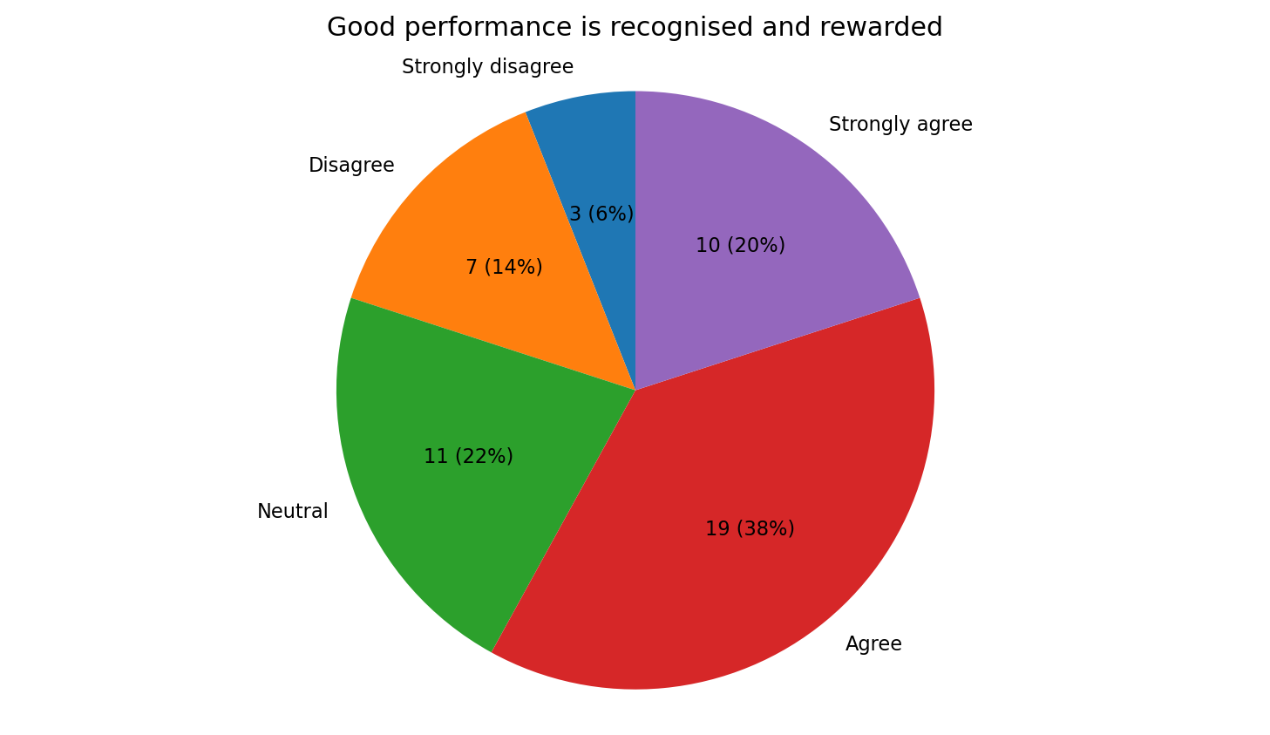
Figure 4.7: Good performance is recognised and rewarded
Source: Primary survey data (2026)

Responses regarding recognition and rewards were generally positive although they were not as convincing as the results were on the vision and creativity topic area. 19 people (38%) agreed, and 10 out of 50 (20%) strongly agreed that performance is recognised and rewarded properly, resulting in a total positive reaction of 58%. 11 of the participants (22%) didn't take sides while 10 others (20%) disagreed partially.
This data reflects that there is certainly leadership that uses contingent reward as part of reward management but also indicates that employees may have had mixed experiences. Recognition is a way to strengthen desirable behaviours, increase motivation and set clear performance standards. Whereas, if rewards are seen to be inconsistent or not enough, employees might feel that they would not even make the effort to do their work beyond the minimum required. Therefore, managers should always make it clear, prompt and link recognition with criteria that are explained to the employees clearly.

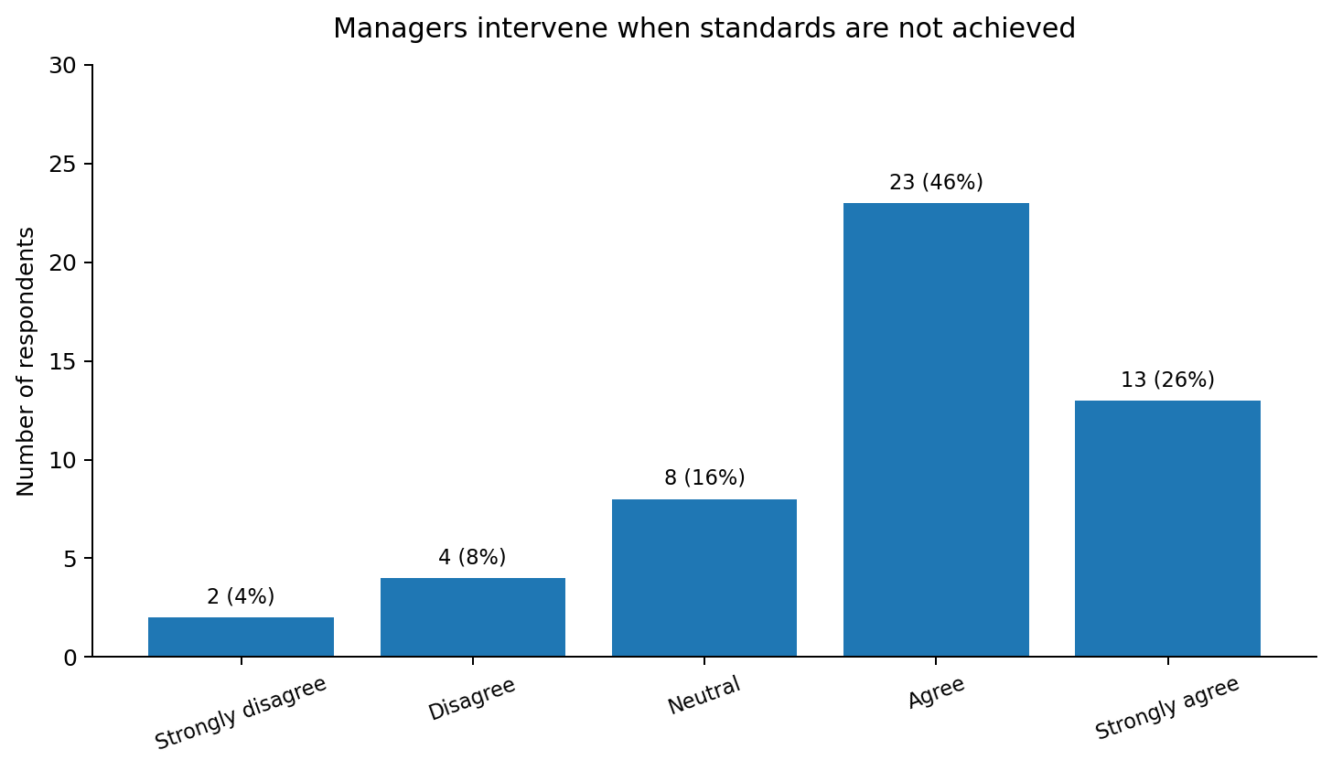
Figure 4.8: Managers intervene when standards are not achieved
Source: Primary survey data (2026)

A consistent trend relating to managerial control appeared: only 23 respondents (46%) were in agreement with and 13 (26%) were strongly in agreement that the leader’s step in when the requirements are not met. Adding those proportions together we have 72% which means that checking-up on things and correcting mistakes are very much the hallmarks of leading at this level. 16% of the respondents said it was a grey area (Neither agree, nor disagree) and 12% of the respondents disagreed. These results indicate the use of management-by-exception which can support quality, safety and operational reliability by ensuring that non-conformities are not only picked up but rectified. Such management control is essential in a complicated working environment yet, overstepping may lead to less personal control if only errors are looked out for by the manager. The best of managers however finds a healthy compromise between being very transparent in the results of the performance and also building employees' trust and offering them chances to figure the problems out for themselves.

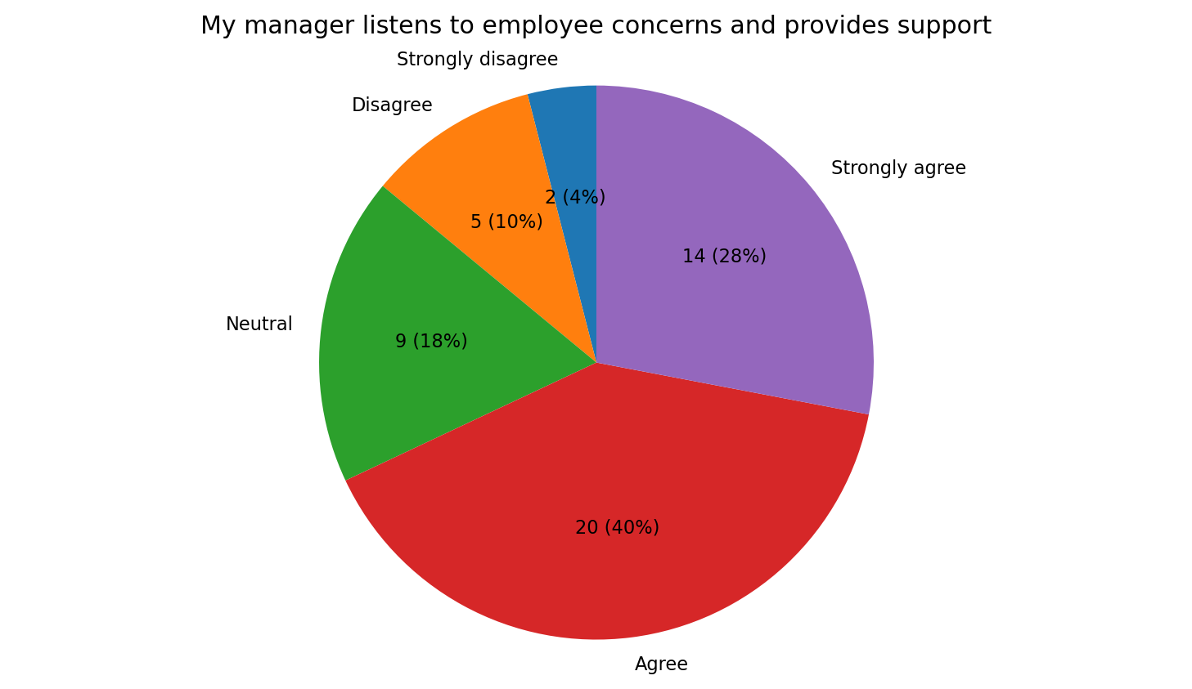
Figure 4.9: My manager listens to employee concerns and provides support
Source: Primary survey data (2026)

Overall, participants' perceptions of managerial support were mostly positive. Fourteen of them (28%) said they strongly agree and twenty (40%) said they agree with the statement that their manager listens to his/her concerns and at the same time provides support. In total, 68% of the replies were positive. Nine participants (18%) considered the question to be neutral while the disagreement categories were chosen by seven (14%). The above-mentioned results correspond well with the principles of servant leadership and especially to the traits of listening, empathy and being attentive to the employee's well-being. Supportive relationships are able to deepen trust, enhance psychological safety and therefore make employees more forthcoming with their difficulties or improvements proposals. Still as one third approximately of the participants were not sure or negative about the support they received, it can be argued that support in management is likely to vary between different managers. Hence, leadership training should place particular value on the development of skills associated with listening, being accessible and reacting constructively to employee concerns.

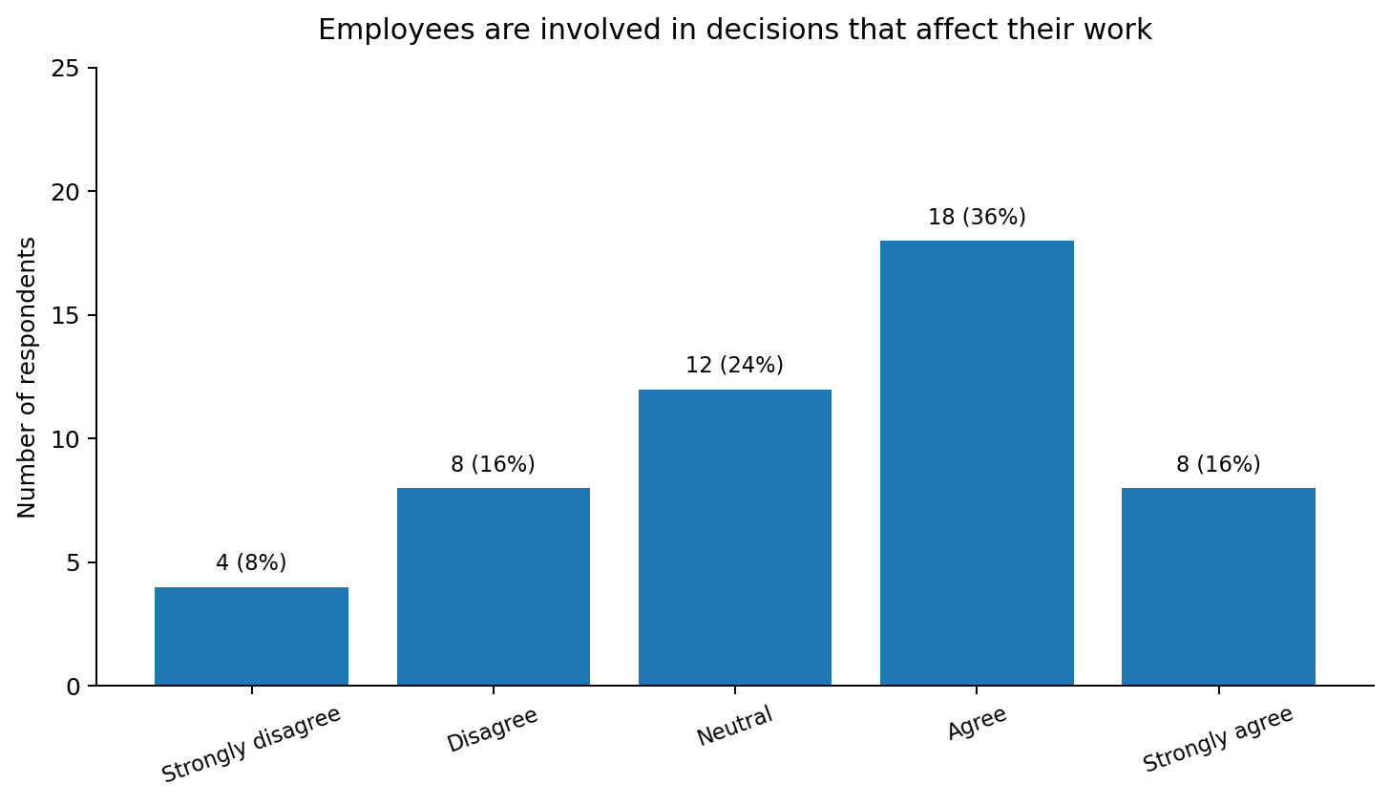
Figure 4.10: Employees are involved in decisions that affect their work
Source: Primary survey data (2026)

The outcomes regarding decision-making involvement proved to be less clear cut when compared with other major leadership factors. Sixteen of the participants (32%) agreed, five of them strongly, while nine others (28%) disagreed or strongly disagreed that workers are consulted before major decisions are taken that have a direct effect on their tasks and work conditions. The combined percentage of people who felt positively about such decision-making was 61%. Twenty-one people were indifferent in their reaction to the question, that is, almost half of the group did not express a positive or negative feeling.
Managers, on the one hand, must be wary when employees only appear to participate, but, on the other hand, they can also be quite wrong as to what is going on. If staff take part, then that is fine, but if they only pretend or feel like they are not heard, that can result in problems like resistance or loss of ownership and commitment to the change.
Therefore, it is highly recommended that managers involve their employees not only in a token way but in an impactful and authentic manner, particularly when the decisions made are likely to affect employees' jobs or working methods. Employees who are actively involved will tend to be more committed and their inputs will help to improve the quality of decisions because they are the ones doing the job who therefore have hands-on knowledge of the tasks and procedures involved.

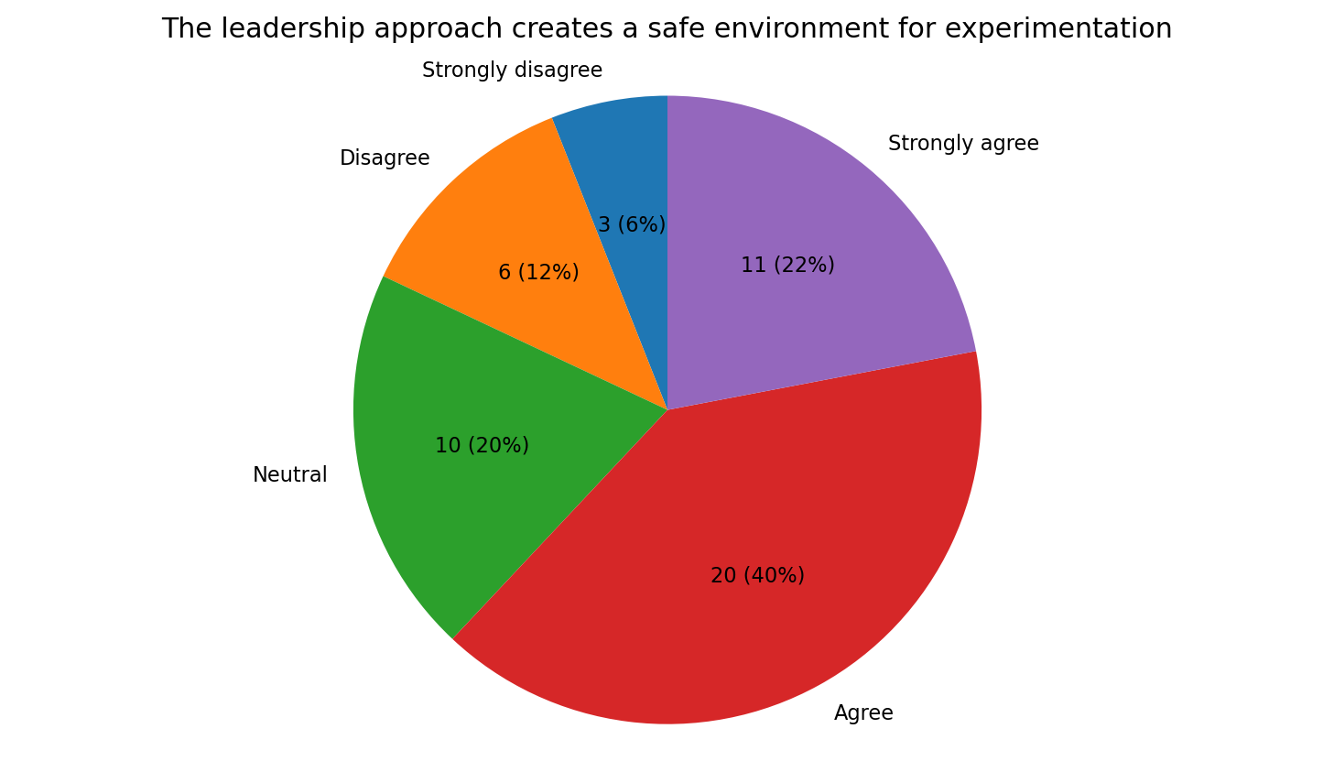
Figure 4.11: The leadership approach creates a safe environment for experimentation
Source: Primary survey data (2026)

Attitudes towards innovation through experimentation and psychological safety reveal leadership environment to have moderate level of trust. The 20 out of 50 participants (40%) were in agreement whereas 11 (22%) strongly agreed that a leadership setting safe for experimentation was being created by a leadership and therefore gave a total of 83 positives. Ten respondents (20%) were indifferent and nine (18%) were against. The large percentage is an indicator that the majority of the workforce feel it is safe to bring in a trial idea and that if you make mistakes under control, which is crucial for innovation, you will still be encouraged. The other way round, although it is an innovation-friendly workplace, those big parts of the sample that still showed hesitation or worries mean that possibly different forms of initiative have still been forbidden or discouraged in various sectors. It is a leadership challenge to draw the line between a thoughtful and a rash experimental approach, and in this respect, one must encourage employees who make reasonable changes, and one should prevent them from feeling guilty if a thoroughly planned action does not yield the immediate expected result.

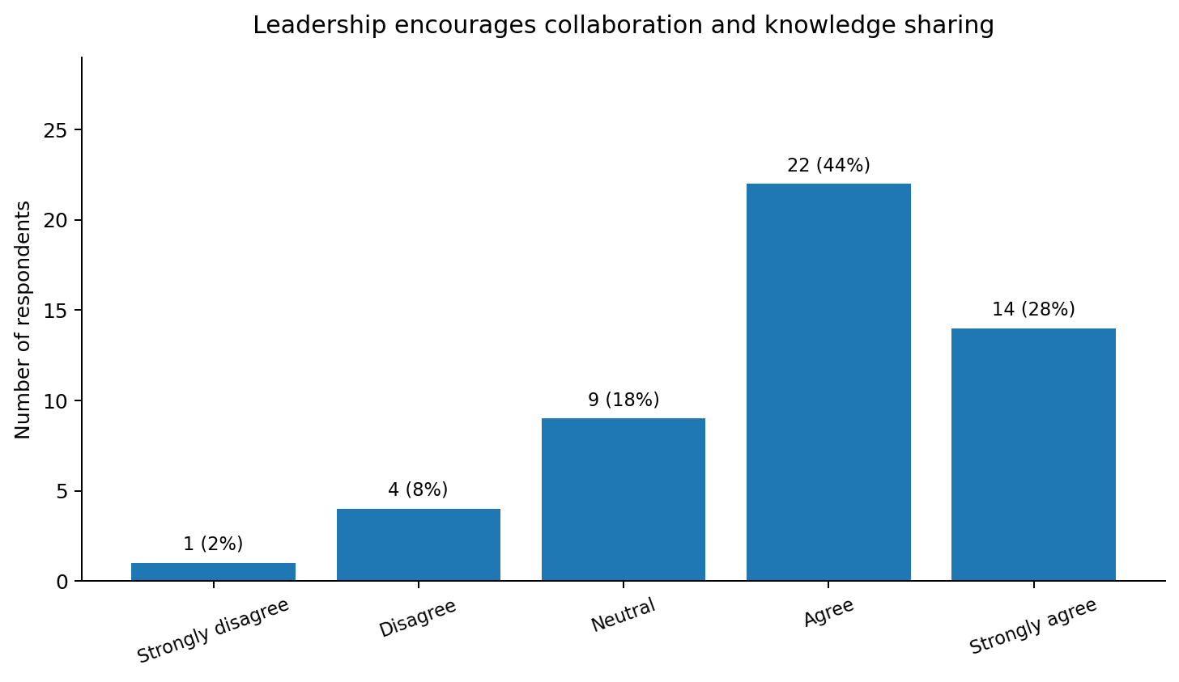
Figure 4.12: Leadership encourages collaboration and knowledge sharing
Source: Primary survey data (2026)

The main areas that got very enthusiastic feedback were Collaboration with others and Sharing knowledge. Out of 50, 22 respondents (44%) said they agreed and 14 (28%) stated they strongly agreed that leadership supports these two, resulting in an impressive positive score combined of 72%. Nine people (18%) were neutral, only five (10%) disagreed. The pattern indicates that bosses encourage employees to interact and exchange their know-how generally. Why is this relevant? Because many of the most successful products are the results of combinations of ideas by people who have different backgrounds such as technical, operational and customer knowledge, rather than single individuals. In addition to that benefit, if teams work closely together, they may be more likely to detect and solve issues together rather than duplicating efforts. Besides the small negative portion, the fact that some teams do not cooperate much anymore is an indication that it would be nice if cross-functional communication and shared learning practices were more widespread.

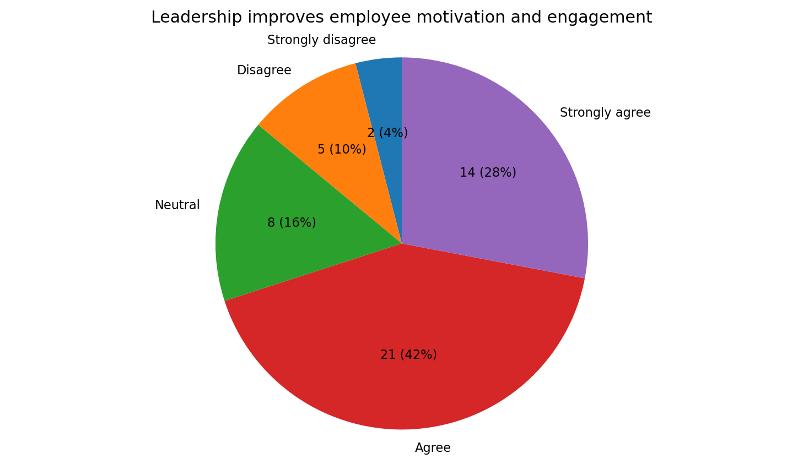
Figure 4.13: Leadership improves employee motivation and engagement
Source: Primary survey data (2026)

The connection between leadership and motivation was perceived as beneficial predominantly by the majority of participants. 21 participants (42%) expressed consent and 7 (14%) even went ahead and agreed heartily that leadership definitely motivates employee and keeps them engaged, hence making a favourable combined reply at 70%. Eight people (16%) held a neutral stance whereas another seven (14%) to certain degree refused to accept. This pattern can be interpreted in a way that leadership behaviours directly or indirectly influence employees' willingness to work and be committed to the organisation. Clear direction, appreciation and encouragement can lead to the situation where staff feel and are more motivated. Nevertheless, the few unfavourable replies still show us that motivational change is not a natural outcome and that managers have to vary their methods according to the needs of individuals and also not to use one way of management only in each case.

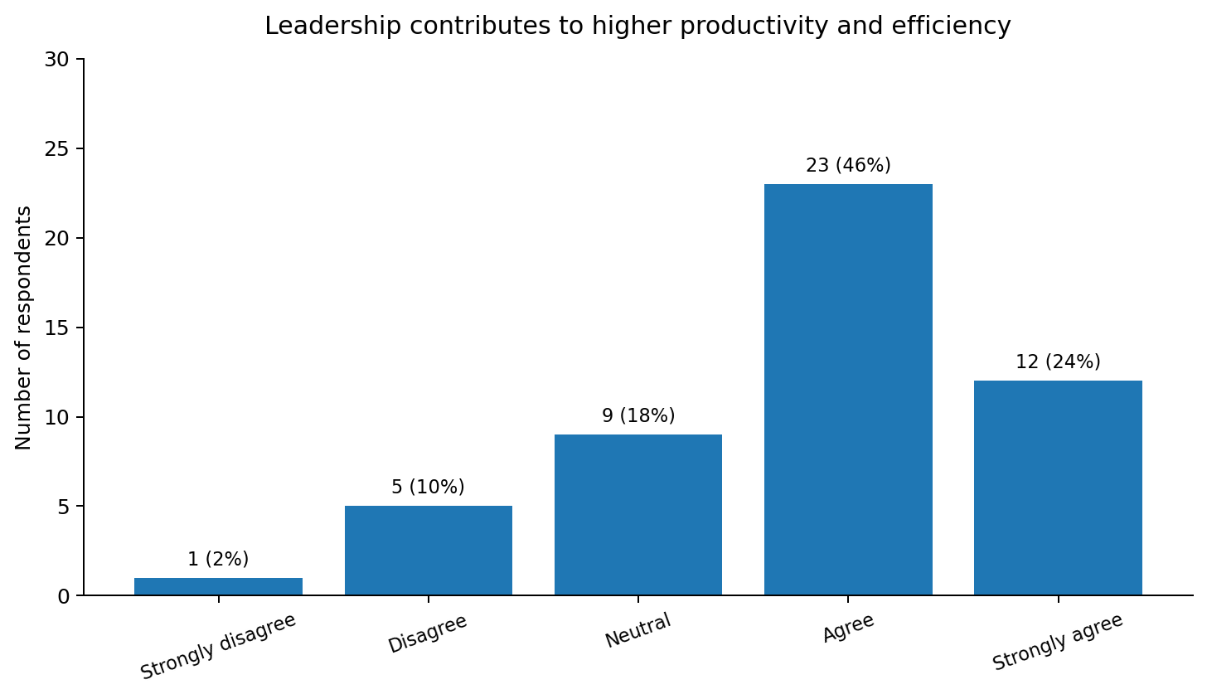
Figure 4.14: Leadership contributes to higher productivity and efficiency
Source: Primary survey data (2026)

Responses regarding productivity were predominantly positive. In fact, 23 people (46%) and 12 people (24%) expressed their agreement and strong agreement that leaders have brought about better productivity and improved efficiency.
This means altogether 70% employees from the survey group, while 9 were neutral (18%) and 6 gave negative responses (12%). It appears that, to a great many employees, leadership means setting clear priorities, good coordination and better use of resources. Through transactional ways such as leaders' instructions and orders, team work can get consistent results and standards. Besides that, through transformational and supportive leadership styles, leaders might inspire subordinates to put in more effort and be more committed.
A relatively small percentage of the replies that were negative in nature was pleasing. However, it could also mean that these teams had been led in such a manner that the leader created unnecessary delays, provided unclear work instructions or supervised to an excessive degree. A little further in time, when the goals are set, feedback being given and the delegating is consistent, then the company's operational performance will be greatly improved.

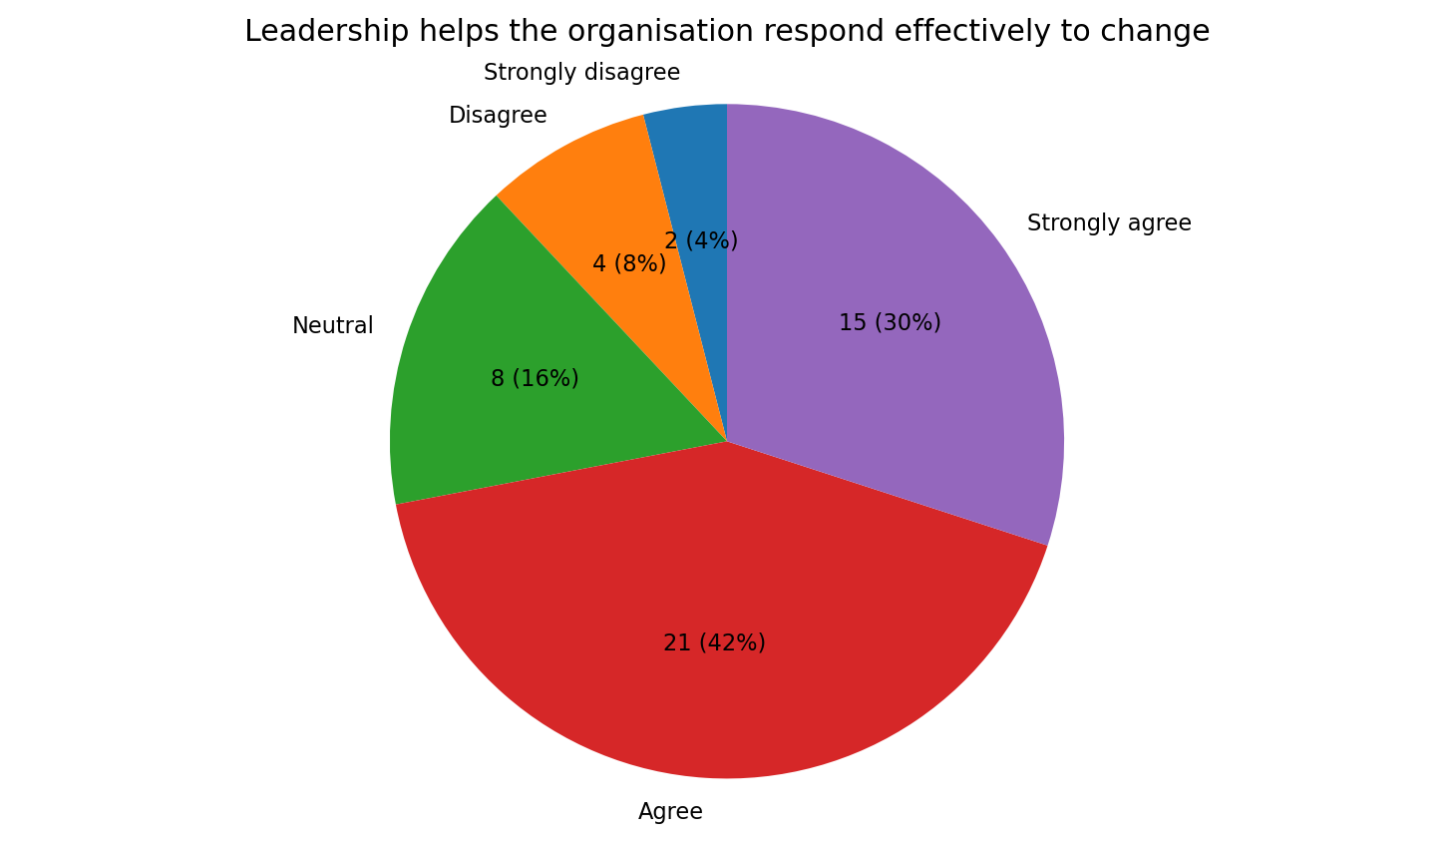
Figure 4.15: Leadership helps the organisation respond effectively to change
Source: Primary survey data (2026)

Adaptability to organisational change was viewed in a really positive way by the majority of the respondents. 18 out of 60 (30%) respondents strongly agreed and 27 (45%) of them felt that leadership helps the organisation respond to change effectively with 75% in all positively responding. Four of them (8%) were neutral and two (4%) disagreed with the statement. This implies that leaders usually explain changes, support staff members during a period of uncertainty, and assist groups in adjusting to new circumstances. Such leaders' abilities are especially valuable as new technologies, customer expectations as well as sustainability standards change so quickly. It looks like some staff members were unaware or dissatisfied to some extent when a change took place. They were not well informed and did not have adequate support. Regular updates and involvement might have made the change process less worrying and secured more commitment from the employees in the future.
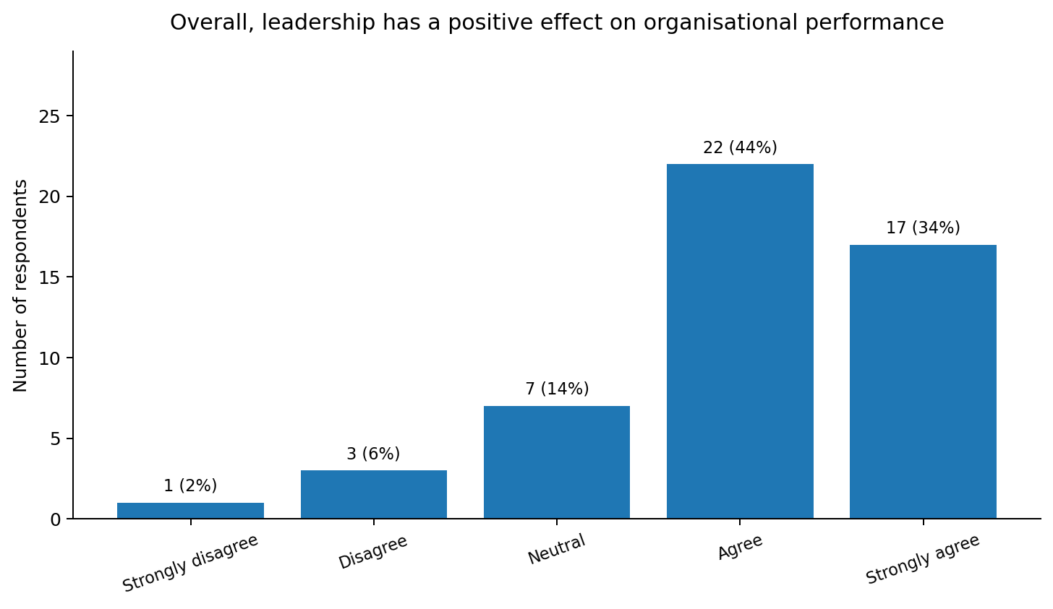
Figure 4.16: Overall, leadership has a positive effect on organisational performance
Source: Primary survey data (2026)

The highest levels of positive assessments of effective leadership were recorded in the survey. Seventeen out of twenty-seven respondents (34%) strongly agree and twenty-two (44%) agree that effective leadership leads to organisational performance, and that gives a total positive response of 78%. Only seven participants (14%) were neutral while four (8%) disagreed. Such a finding gives strong support to the research's main hypothesis that a leader's style can determine the organisation's results. Staff members seem to link successful leadership with increased motivation, greater idea generation, better coordination, greater adaptability and higher productivity. Even if such a conclusion is based on employees' perceptions rather than audited performance indicators, the consistency of positive answers between closely themed questions makes it harder to challenge it. Still, it remains a minority group so it means that a quality level of leadership has still to be monitored and improved through all teams.

4.4 Summary of Findings

The combined data from the questionnaire reveal that most employees are regularly exposed to a mix of leadership styles including transformational, transactional, and servant leadership characteristics. The most prominent results related to encouraging idea sharing, cooperation, flexibility and the general beneficial effects of leadership on results. Rewards and giving employees a voice received the lowest scores, which would suggest that these initiatives are not as uniformly carried on by employees of all teams. Consequently, these results show that great leadership is not dependent on just one leadership method. Encouraging creative ideas and setting challenging goals go hand in hand with innovative work, checking, and rewards are linked to maintaining the company standards, while listening and support are necessary to raise the morale of the people. The data, on the whole, meet the research purposes by showing how leadership influences employee creativity, motivation, productiveness and organizational agility.
Secondary research from Chapter two is an example of how different forms of leadership have been shown to have considerable impacts on the ability for innovation to be fostered, employee engagement increased, communication improved and performance in the organization is strengthened. The literature consistently shows that transformational and participative leadership styles produce situations or circumstances where employees feel safe enough to be creative, communicate effectively, and continuously improve. What is more, the literature review points out the fact that good leadership helps the employees get motivated, is supportive during organizational changes, and leads an overall better business performance. These theoretical standpoints are the reference framework in relation to which the research results are interpreted, making it possible to draw a contrast between academic literature and employees' point of view in the company.

CHAPTER 5: CONCLUSION AND RECOMMENDATIONS

5.1 Conclusion

This study looked at the effect of leadership styles on innovation and organisational performance through the integration of secondary literature and primary questionnaire data. The objectives of this research were attained by gauging employees' perceptions of leadership effectiveness, investigating the nature of the link between leadership and innovation, and examining the potential influence on organisational performance. The results, which revealed the contribution of effective leadership in communication, employee engagement, collaboration, and innovative practices to employees' work, confirmed the theories discussed in the literature review. Although there is still room for growth and development, collectively, the results indicate that leadership is a very significant element in fostering a productive organisational culture and, in turn, enhancing long organisational performance.

5.2 Recommendations

This paper recommends to the organisation that it continues focusing on leadership development, through regular leadership programmes, to help managers and leaders better embody transformational and participative leadership styles. Managers should foster decision-making by giving employees more say, provide consistent acknowledgment to their innovators and maintain open channels for communication on all organisational levels.
The leadership should be in a state of change, where investing in learning and developing leadership will not only enhance motivation and employee participation but also increase organisational resilience to change. In addition to the above, conducting regular employee engagement surveys will help the organisation keep track of its leadership effectiveness and spot any potential weaknesses that need a solution.
The application of all the recommendations is to be done for innovation and organisational performance improvement and ensuring success to the organisation for the long run.

5.3 Limitations of the Study

There are a few problems the research study needs to point out which limit the usefulness of the findings. For starters, the results are primarily based on 50 questionnaires, a very limited number, which might not reflect the entire workforce's opinion accurately.
In fact, the paper was written with the data of one company only, so the results cannot be applied to other sectors without being validated.
Moreover, the fact that a self-reported data was used may have biased the results as participants may not have been sincere in answering. The main reason is perhaps they were influenced by their social environment not to provide the true answer and instead give socially acceptable one.
Last but not least time and personnel limitations were two of the key reasons that the scope of data collection was restricted and, as a consequence, qualitative data such as interviews or focus groups were not included.

5.4 Suggestions for Future Research

It is a good idea to conduct researches for further clarification. The most important of them is expansion of the research sample by involving the staff members belonging to different organisations and/or sectors so that the findings will be more representative. As well as that, adding qualitative methods of data collection such as interviews or focus groups should give deeper understanding how leadership styles employees experience affects innovation and organisational performance. In other words, it can be said that by using these qualitative approaches one can uncover the subtle nuances that quantitative methods will never show.
Long-term research on the effects of leadership practices over time and how they eventually affect the performance of organisations can also be conducted. It is possible that future researchers may want to find out if new models of leadership, digital transformation and artificial intelligence have a positive effect on the leadership capability, innovation and organisational performance of current business environments.

REFERENCES

Adams, J., Khan, H.T.A., Raeside, R. and White, D. (2007) Research Methods for Business and Social Science Students. 2nd edn. Delhi: Sage Publications.
Adler, R.W. and Reid, J. (2008) ‘The Effects of Leadership Styles and Budget Participation on Job Satisfaction and Job Performance’, Asia-Pacific Management Accounting Journal, 3(1).
Ahmed, F., Naqshbandi, M.M., Kaur, S. and Ng, B.K. (2018) ‘Roles of leadership styles and relationship-based employee governance in open service innovation’, Leadership&Organization Development Journal.
AlFayyeh, S. and Alghamdi, A.B.M. (2023) ‘Leadership Styles and its Impact on Employee Performance: An empirical investigation of Riyadh Private Hospitals’, Journal of Population Therapeutics and Clinical Pharmacology, 30(15), pp. 19–33.
Alvesson, M. and Sveningsson, S. (2015) Changing Organizational Culture: Cultural Change Work in Progress. 2nd edn. London: Routledge.
Armstrong, M. (2012) Armstrong’s Handbook of Human Resource Management Practice. New Delhi: Kogan Page Limited.
Avolio, B.J., Bass, B.M. and Jung, D.I. (1999) ‘Re-examining the components of transformational and transactional leadership using Multifactor Leadership’, Journal of Occupational and Organizational Psychology, 72(4), pp. 441–462.
Bass, B.M. and Avolio, B.J. (1993) ‘Transformational leadership and organizational culture’, Public Administration Quarterly, pp. 112–121.
Bass, B.M. and Riggio, R.E. (2006) Transformational Leadership. 2nd edn. Mahwah, NJ: Lawrence Erlbaum Associates.
Boehm, S.A., Dwertmann, D.J., Bruch, H. and Shamir, B. (2015) ‘The missing link? Investigating organizational identity strength and transformational leadership climate as mechanisms that connect CEO charisma with firm performance’, The Leadership Quarterly, 26(2), pp. 156–171.
Burns, J.M. (2012) Leadership. New York: Harper Perennial.
Creswell, J.W. and Creswell, J.D. (2018) Research Design: Qualitative, Quantitative, and Mixed Methods Approaches. 5th edn. London: Sage Publications.
Daft, R.L. (2008) The Leadership Experience. 4th edn. Boston: South-Western College Publishing.
Dastane, D.O. (2020) ‘Impact of leadership styles on employee performance: A moderating role of gender’, Australian Journal of Business and Management Research, 5(12), pp. 27–52.
Denison, D.R., Nieminen, L. and Kotrba, L. (2015) ‘Diagnosing organizational cultures: A conceptual and empirical review’, European Journal of Work and Organizational Psychology, 23(1), pp. 145–161.
Dinh, J.E., Lord, R.G., Gardner, W.L., Meuser, J.D., Liden, R.C. and Hu, J. (2014) ‘Leadership theory and research in the new millennium’, The Leadership Quarterly, 25(1), pp. 36–62.
Goleman, D. (2017) Leadership That Gets Results. Boston, MA: Harvard Business Review Press.
Griffin, R.W. (2013) Management. United States of America: Cengage Learning.
Hoxha, A. (2019) ‘Transformational and transactional leadership styles on employee performance’, International Journal of Humanities and Social Science Invention, 8(11), pp. 46–58.
Hughes, R.L., Ginnett, R.C. and Curphy, G.J. (2019) Leadership: Enhancing the Lessons of Experience. 9th edn. New York: McGraw-Hill Education.
Judge, T.A. and Piccolo, R.F. (2004) ‘Transformational and transactional leadership: A meta-analytic test of their relative validity’, Journal of Applied Psychology, 89(5), pp. 755–768.
Kotter, J.P. (2006) Leading Change. Boston, MA: Harvard Business Review Press.
Lai, F.Y., Tang, H.C., Lu, S.C., Lee, Y.C. and Lin, C.C. (2020) ‘Transformational leadership and job performance: The mediating role of work engagement’, Sage Open, 10(1).
Makambe, U. and Moeng, G.J.M. (2020) ‘The effects of leadership styles on employee performance: A case of a selected commercial bank in Botswana’, Annals of Management and Organization Research, 1(1), pp. 39–50.
Malik, S.Z., Saleem, M. and Naeem, R. (2016) ‘Effect of Leadership Styles on Organizational Citizenship Behaviour in Employees of Telecom Sector in Pakistan’, Pakistan Economic and Social Review.
Meyer, C.B. and Stensaker, I.G. (2019) Developing Capacity for Change. 2nd edn. London: Routledge.
Northouse, P.G. (2021) Leadership: Theory and Practice. 9th edn. Thousand Oaks, CA: Sage Publications.
Ogbonna, E. and Harris, L.C. (2015) ‘Leadership style, organizational culture and performance’, International Journal of Human Resource Management, 26(9), pp. 1282–1301.
Otieno, B.N. and Njoroge, J.G. (2019) ‘Effects of leadership styles on employee performance: Case of Technical University of Kenya’, International Journal of Education and Research, 7(6), pp. 115–132.
Page, L., Kramer, M.R. and Klemic, G. (2019) ‘A decade of reviews on leadership: A conceptual perspective and direction’, Journal of Leadership, Accountability and Ethics, 16(5).
Rathore, K., Khaliq, C.A. and Aslam, N. (2017) ‘The influence of leadership styles on employees’ performance under perceptions of organizational politics: A study of telecom sector in Pakistan’, International Journal of Management Research and Emerging Sciences, 7(1).
Robbins, S.P. and Judge, T.A. (2013) Organizational Behavior. 15th edn. Harlow: Pearson Education.
Rosing, K., Frese, M. and Bausch, A. (2016) ‘Explaining the heterogeneity of the leadership–innovation relationship’, The Leadership Quarterly, 22(5), pp. 956–974.
Sahito, A.A., Khoso, M.A., Dharejo, N., Mahesar, H.A. and Nisa, N.U. (2023) ‘The impact of leadership styles on employee performance in Hyderabad Electric Supply Company, Sindh, Pakistan’, Journal of Humanities, Social and Management Sciences, 4(2), pp. 1–17.
Saunders, M., Lewis, P. and Thornhill, A. (2019) Research Methods for Business Students. 8th edn. Harlow: Pearson Education.
Schein, E.H. and Schein, P.A. (2017) Organizational Culture and Leadership. 5th edn. Hoboken, NJ: John Wiley&Sons.
Tourish, D. (2019) Leadership and Leadership Development in Healthcare: The Evidence Base. London: Routledge.
Tushman, M.L. and O’Reilly, C.A. (2016) Lead and Disrupt: How to Solve the Innovator’s Dilemma. Stanford, CA: Stanford University Press.
Van Knippenberg, D. and Sitkin, S.B. (2013) ‘A critical assessment of charismatic-transformational leadership research’, Academy of Management Annals, 7(1), pp. 1–60.
Wimalarathna, W.P.R., Deshika, N.P.T. and Perera, D.A.M. (2022) ‘Effect of employee skills on customer satisfaction: A study on automobile sector employees in Kurunegala District, Sri Lanka’, Journal of Accountancy and Finance, 9(1).
Wijesiri, N.G.T.D. and Amarawansha, T.G.A.H.C. (2019) ‘The impact of leadership styles on employee engagement: With special reference to apparel industry’, Proceedings of the 8th CIPM International Research Symposium.
Yukl, G. (2013) Leadership in Organizations. 8th edn. Harlow: Pearson Education.
Zaawawi, A. and Putrawan, I. (2019) ‘Linking leadership styles and organizational culture to organizational commitment in the industry of automotive components’, International Journal of Innovative Technology and Exploring Engineering, 8(6), pp. 48–54.
Zhu, W., Newman, A., Miao, Q. and Hooke, A. (2013) ‘Revisiting the mediating role of trust in transformational leadership’, Journal of Organizational Behavior, 34(1), pp. 94–115.

Appendices

Appendix 1 – Questionnaire

Research Title: An Analysis of Leadership Styles and Their Impact on Innovation and Organisational Performance at BMW Group

Dear Participant,
This questionnaire is a tool to gather a little information to use in an academic research study that is about looking at how leadership styles have effects of both innovation and organisational performance through the lens of a large automotive group located in the UK.
We encourage you not to feel obliged to participate and if you do that is great, the answers you give will remain absolutely confidential. We are not collecting any personal information which could be used to link you to a person. The collected data will be strictly limited to be utilized to the purpose of academic studies.
Kindly be truth-telling with your answers and go with your gut when selecting the response that closely approximates your views on each issue.
We are most grateful and you shall be appreciated if your participation in this matter.

Section A: Demographic Information
Q1. Gender
☐ Male
☐ Female
☐ Prefer not to say

Q2. Age
☐ 18–25
☐ 26–35
☐ 36–45
☐ 46–55
☐ Over 55

Q3. Department
☐ Production
☐ Engineering
☐ Human Resources
☐ Sales and Marketing
☐ Administration
☐ Other

Q4. Length of Service
☐ Less than 1 year
☐ 1–3 years
☐ 4–6 years
☐ 7–10 years
☐ More than 10 years

Section B: Leadership and Innovation
Please indicate your level of agreement with the following statements.
Scale
1 = Strongly Disagree
2 = Disagree
3 = Neutral
4 = Agree
5 = Strongly Agree

Q5.
Leadership within BMW Group motivates employees to perform at their best.
☐ 1
☐ 2
☐ 3
☐ 4
☐ 5

Q6.
Managers encourage employees to contribute new ideas and innovative solutions.
☐ 1
☐ 2
☐ 3
☐ 4
☐ 5

Q7.
Communication between managers and employees is open and effective.
☐ 1
☐ 2
☐ 3
☐ 4
☐ 5

Q8.
Leaders provide adequate support for employee development and learning.
☐ 1
☐ 2
☐ 3
☐ 4
☐ 5

Q9
Employees are encouraged to participate in decision-making.
☐ 1
☐ 2
☐ 3
☐ 4
☐ 5

Q10.
Leadership practices positively influence teamwork and collaboration.
☐ 1
☐ 2
☐ 3
☐ 4
☐ 5

Q11.
Leadership contributes to higher organisational performance.
☐ 1
☐ 2
☐ 3
☐ 4
☐ 5

Q12.
Leadership encourages innovation throughout the organisation.
☐ 1
☐ 2
☐ 3
☐ 4
☐ 5

Q13.
Employees receive regular recognition for good performance.
☐ 1
☐ 2
☐ 3
☐ 4
☐ 5

Q14.
Managers effectively manage organisational change.
☐ 1
☐ 2
☐ 3
☐ 4
☐ 5

Q15.
I am satisfied with the current leadership approach used within BMW Group.
☐ 1
☐ 2
☐ 3
☐ 4
☐ 5

Q16.
Overall, effective leadership has a positive impact on innovation and organisational performance.
☐ 1
☐ 2
☐ 3
☐ 4
☐ 5

Thank you for completing this questionnaire. Your participation is greatly appreciated.

