A Data Centre Implementation for University of Wales Trinity Saint David

Author Name: Claudiu Octavian Albus
Dept. name of organization: BSc Cloud Computing
Name of organization: University of Wales Trinity Saint David
City, Country: London, United Kingdom
Email: claudiu.albus@yahoo.co.uk

Abstract— To manage the technological information and the associated equipment, a conventional data center is needed. For data centers, the power usage has become a growing fraction of the overall cost of the maintenance. By properly planning the network physical facilities and designing of the IT architecture, it is difficult to eliminate the energy output of tier-level data centers. This paper is showing how to introduce virtualization in the data centers to improve the efficiency and the competitiveness. This research provides a comprehensive discussion of data center implementation within the University of Wales Trinity Saint David (UWTSD). Also, it provides all the details about the architecture of the data center from the geographical location to other hardware components, which are considered IT assets. Lastly, it provides security recommendations that are necessary for the data center implementation.
Keywords— Data Center; Data Center Performance; Energy Efficiency; Server Consolidation.

INTRODUCTION

Data Centers are constantly changing and growing from year to year, while also improving the security demands. Over the past few years, the standard Layer 2 and Layer 3 architectures have not been modified significantly, but the strict uptime and service compatibility requirements, combined with the modern technologies and protocols, have created a complex and challenging design. The innovation of the companies and corporate activities focused on information and communication technology (ICT) has turned several economies into e-economies and industries into e-businesses. Uninterrupted development of the companies using the internet has given way to massive server dependent network facilities, called data centers [1]. To handle customer queries, these massive data centers absorb an immense amount of resources, contributing to significant energy and power demands. The areas for the development of scientific sustainability [2] are described as critical. They are business resources that support a wide variety of Internet-based facilities and resources, such as e-commerce, website development, social networking, transfers, and reconstruction. Other services such as Internet as a Service (IAAS), Software as a Service (SAAS), Application as a Service (PAAS), Technology as a Service (IAAS), Cloud Storage and Virtualization [3] are accessible. In numerous organizations, data centers are used and managed to facilitate enterprise operations, database processing, storage, backups, and recovery functions [4]. Owing to the broad adoption of hosting and executing comprehensive resources and applications by massive multi-tier server structures called blades and energy managers in various enterprises, internet and e-commerce companies, scientific computing data centers are growing increasingly across both size and significance.
In environmental compliance and under efficient control, the data centers are essential, using computing services that enable companies to work during the night according to the specific business requirements. Multiple servers, site and web applications, shared file data centers, software programs and operating systems running them, including IP or storage area network (SAN), are included in these computing services.
Applications can vary from existing financial resources and business-to-business systems to external e-commerce. In addition, a range of servers enable network functions and software based on the system. There are few Online Data Centers (IDCs) that are typically designed and managed by the service providers according to these servers, but IDCs are now built and operated by businesses whose business model is focused on internet the trading. Enterprise IDC architecture is similar to those of IDCs for service providers, but the scalability criteria is usually reduced because the end user appears to be smaller and there are less networks that host many users relative to those of SP IDCs. An important concern in enterprise IDCs is that the services used with the Data Centre could be installed in a service provider Data Centre if the business model calls for it, and that continues under the jurisdiction of the enterprise.
The main purpose of this research paper is to implement a data center for UWTSD, being able to assure the protection of their data by reliable security systems and to protect critical infrastructure from any threats such as natural disasters, DDos attacks and so on.

LITERATURE REVIEW

The IT equipment within a data centre absorbs a tremendous volume of electricity and resources, that produce higher energy costs onward with the increasing demand for supplementary cooling and other working equipment purchases [7]. These types of data centers are filled by blade server racks, which use all the power that IT infrastructure takes to run. The concern with these shelves is that they've been underplayed, but the energy and the resources are also consumed. An estimated 15 to 20 kWh of power is often used by the cooling equipment used to cool servers and other equipment, equal to peak energy needs for more than 30 average homes in California [8]. The study case continues to develop strategies and resources to help data centers make smarter choices to ensure a safe supply of electricity, to protect the atmosphere by minimizing the impacts of global warming and to build feasible enterprises. In computer systems ranging from portable systems to computing infrastructure, power efficient computing is now recognized as a significant feature. Wide deployments of cloud instruments and other devices well-known as data centers are becoming common as they are connected to nearly most businesses to ensure business entities with essential services [10]. There is tremendous scope for advancements in energy quality for the data center sector. Several innovations that have the potential to increase the energy consumption of microprocessors, servers, computing units, network appliances and other systems are currently widely viable or will eventually be released.
The UWTSD requires a proper location to build the data center. In order to build this data center for UWTSD, it is advisable to acquire a large space to create a reliable building that is capable to sustain this type of data center.

RESEARCH METHODS

Every organization has one or two data centers. Evolution has led to diverse and varying ecosystems that are costly to control and sustain. The supporting network architecture could not have improved rapidly sufficient to be versatile in continuing resilience, scalability, stability, and control criteria in addition to the application setting. Data Centre downtime, failure of the infrastructure to incorporate new services means that SLAs are not reached, resulting in a lack of access to essential resources and a significant effect on daily activities. The advantages offered by a data centre consists of conventional business priorities, such as:
- Assistance for the companies around the clock (Resiliency).
- Reducing the overall operational costs and repairs needed to manage company operations (Total cost of ownership).
- The accelerated technology implementation and aggregation of computing services (Flexibility) [6].

A variety of information technology (IT) initiatives are created by these business priorities, such as the following:
- Business continuity.
- Improved security.
- Consolidation of applications, servers, and data centers.
- Integration of client/server and multi-tier (n-tier) systems or applications linked to network services.
- Storage consolidation.

DESIGN

The data centre architecture requirements are:
• Availability
• Scalability
• Security
• Quality
• Manageability[1]
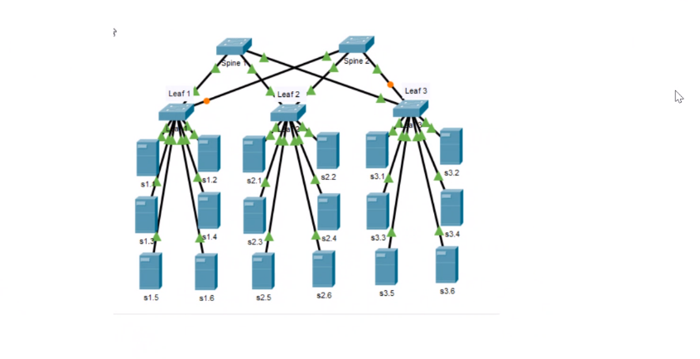
Fig. 01 – System Design

For the various functional areas of a Data Centre network, these architectural requirements are applied:
- Infrastructure services: design of routing, switching and server-farm;
- Load balancing, Secure Socket Layer (SSL) offloading and storage of application resources;
- Security Services-Packet screening and inspection, detection of intrusion and avoidance of intrusion;
- SAN Architecture, Fibre Channel Switching, Backup, and Archive facilities;
- Company continuity - SAN expansion, location selection and interconnectivity with the Data Centre [5].
Companies must prepare specific provisions in regard the buildings that contain the infrastructure and the manpower needed for a 24-by-7 service. The data centers house has essential computer services. A heavy concentration of the server services and the network infrastructure is likely to sustain these facilities, such as:
- Electricity potential
- Cooling power
- Connectors
- Controls for temperature and humidity
- Smoke and fire systems
- Data security: accessibility and surveillance devices.
- Storage space and elevated floors [5].
Fig. 02 – The Role of a Data Centre

Unlike the business context, the part of the economy that supports collocated cloud farms for business users are the data centers through service provider (SP) systems, referring to them as Internet Data Centers (IDCs). The SP Data Centre is a provider system meant to hold or manage the business user's ecosystem under securely controlled SLAs for uptime. Companies also build IDCs where the primary aim of the data centre is to sustain Internet oriented applications. The IDCs are segregated from the current SP data centers that sustain the private business software habitats [6].
Fig. 03 - Client-Server Model

Fig. 04 - N-Tier Application

The n-Tier Model
Across several various situations, a client and a web server are used to view the data in the n-tier model. The server side of the n-tier model is separated into separate organizational functions that constitute the network, program, including data warehouses. The n-tier model is based on a conventional network architecture where the data retrieved from the web server is viewed by the web user. The server side consists of multiple various servers in the architecture design, which are technically distinct. This architecture is more scalable and manageable, and it allows application systems to transition into distributed computing environments, even if is more complicated than the typical client/server model. The n-tier model offers a framework to expand the efficiency and the control of the client/server structures while streamlining the maintenance of the current software [6].

INFRASTRCTURE TIERS

- Tier 1 - Non-redundant capacity components (single uplink and servers)
- 28.8 Hours of downtime per year.
- Tier 2 - Tier 1 + Redundant capacity components
- Experienced 22 hours of downtime per year.
- Tier 3 - Tier 1 + Tier 2 + Dual-powered equipment and multiple uplinks
- Not more than 1.6 hours of downtime per year.
- Tier 4 - Tier 1 + Tier 2 + Tier 3 + all components are fully fault-tolerant including uplinks, storage, chillers, HVAC systems, servers etc. Everything is energy dual powered
- 26.3 minutes of annual downtime.
This standard focused on IT cable and network oriented based on the Uptime Institute’s Tier Standard. TIA-942 assist the distribution for the infrastructure of UWTSD data center, based on the essential equipment. The critical area is the server’s room where all the data is stored, followed by generator room providing the electricity to power up the entire building, the UPS room, and the networking room.
UWTSD’s case falls under Tier 3 of TIA-942, because the data center is constantly maintained, as all the planned maintenance activities for power and cooling systems unfold without disrupting the daily operations.

MULTITIER ARCHITECTURE

Within UWTSD, it is important to build a data centre that uses the conventional networking system for the data centre, such as routers, servers, controllers, clients, switches, and gateways. The architecture of the UWTSD involves a multitier design such as Layer 3 and Layer 2 design.
Multitier architectures applied to the applications to perform Data Centre server farms that seem to have a conceptual and physical distinction between separate functions of the application. The architecture of the network is determined by the specifications of applications in operation and their priorities of availability, scalability, and protection and management. There seems to be a one-to-one routing for each server-side tier to a particular network that serves the application feature and its specifications.
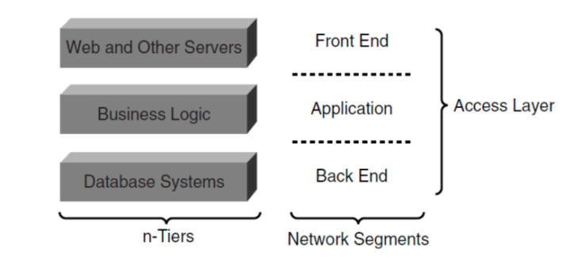
Fig. 05 - Multitier Architecture
.

DATA CENTRE ARCHITECTURE

Fig. 06 – The Architecture of the Data Centre

The suggested data centre architecture for UWTSD, includes the access tier, the aggregate tier, and the core tier. The core tier is formed by the core router and the core switch, the aggregation tier contains the aggregation or distribution switch and the server farm. The access layer is composed by the access switch and the workplace.

SCALABILITY

The scalability transforms into to the capacity to handle rapid output growth, the number of data centre hosting machines, and the consistency of the services provided. For the number of hosted devices, scalability applies the ability to connect additional ports to servers, routers, switches, as well as all the devices, including server load balancers, firewalls, IDSs, and off loaders with SSL. Within a Data Centre there are three types of server farms, as follows:

- Intranet
- Internet
- Extranet

Fig. 07 - Data Centre Topology

Internet Server Farm
The end users are mostly using the server farms that are placed over the Internet and access them by using the Internet. Online server farms are open and support business-to-consumer applications for the Internet population at large scale. Users often rely on web interfaces and web browsers that have two types: Dedicated Internet Server Farm & DMZ Server Farm. The internal users also have access. It was constructed to support Internet-facing large-scale systems to uphold the core of the business purpose.
In general, the dedicated Internet server farms comes to support the e-business ambitions. A big issue is the security and the scalability. Most of the users access the server farm are on the Internet, which implies high security risks. But then, the number of users is very high, which may determine issues about the scalability. Often referred as an Internet Data Centre, the data centre that serves this sort of server farm (IDC) [5].
Built in addition to Internet connectivity from the enterprise to support Internet-based applications. These data farms are usually situated in a specific zone (DMZ), so they are still available to the Internet as part of the business network. These server farms provide utilities such as e-commerce which are the door to interfaces used by the Internet and intranet users for most general applications.

Intranet Server Farm
Intranet server farms are only open to internal users of the enterprise. Almost all the enterprise computing tools that sustain the corporate operations and the internal applications involve intranet server farms. The campuses and private WANs are available for the users to access the Intranet Server Farm. Currently, the internet users are not authorized to share the intranet. However, most of the users are using the virtual private network (VPN) technologies to access the intranet.
Extranet Server Farm
The Extranet server farm is between Internet and Intranet server farms from a practical point of view. Extranet server farms are generally open to business associates that are recognized to be remote, but reliable customers. In a simplistic and safe environment, the aim of extranets is to enhance business-to-business connectivity by facilitating quicker knowledge sharing. In the design of the extranet topology, several variables must be considered, including scalability, availability, and security.
The security measures suggest that business members require access to business software but are restricted from reaching the rest of the network. For a stable and a flexible network infrastructure, dedicated firewalls and routers are used. Some partners need direct connections or dedicated private links, and other users expect VPN links to have a stable connection [8].
Online Data Centers (IDCs) are typically designed and administrated by service providers according to these three types of servers, but IDCs are now built and operated by businesses whose business model is focused on internet trading. Enterprise IDC architecture is somewhat similar to those of IDCs for service providers, but the scalability requirements are typically reduced since the customer base seems to be limited and there are fewer networks that host more users than those of SP IDCs. An important concern in enterprise IDCs is that the services used with the Data Centre that can be installed in the Data Centre service provider if the business model calls for it and that continues under the jurisdiction of the enterprise [8].
There are several common functions of organizational or corporate data centers that promote distinct approaches focused on Internet services, Intranet services, or both. As a result, it is not unusual to support Internet, Intranet, and Extranet server farms. The primary goal of corporate data centers remains the support of intranet server farms. Enterprise Data Centers are emerging, and this growth is partially due to emerging developments in the framework settings, such as n-tier, web networks, but mostly due to the reactivity including its data stored in data centers [8].

SECURITY
Aggregation Layer
For devices that offer resources to all the server farms and the aggregation layer is the aggregation centre. Multilayer switches, encryption, load balancers and similar systems are those equipment’s that usually provide utility for all the servers.
This layer is crucial for the UWTSD data centre because it acts as an aggregator of sessions being transferred to and from the data centre.
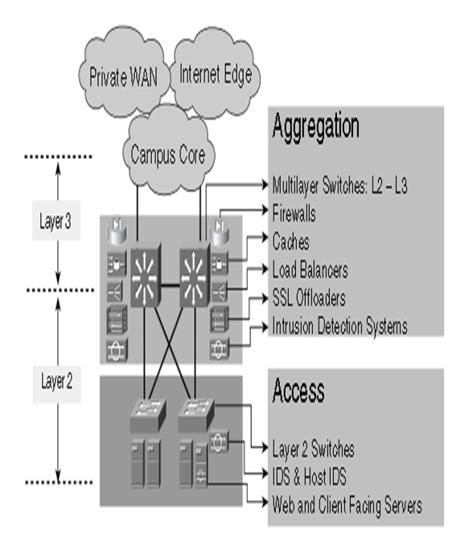
Fig. 08 - Aggregation Layer

Access Layer

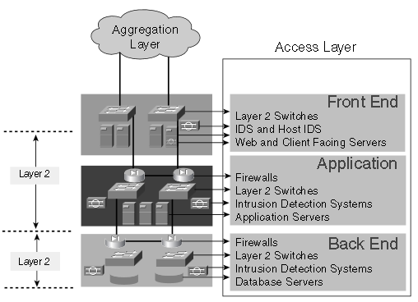
Fig. 09 - Access Layer

- Front-End Layer
Usually, the front-end server farms include:
- Telnet, TN3270, FTP, Quick Mail Transfer Protocol (SMTP), Site servers, DNS servers, IP television (IPTV) transmission servers, IP telephony call management and other enterprise application servers.
- In the front-end portion, the particular network analyses the characteristics rely mostly on servers and certain features.
For example, if the network allows video streaming over IP, multicast probably will be needed, or if allows Voice over IP (VoIP), it should allow Quality of Service (QoS). Between load balancers and servers or firewalls that divide server farms, layer 2 communication via VLANs is required [1].
In the UWTSD case, the front-end cloud scaling methods will involve installing other servers with the same material and then sharing the load that they generate by applying load balancers equally.

- Application Segment
Involves the identical network infrastructure modules, as the previous section. Additional security will be added to the UWTSD data centre, because is a definite concern for how much security is needed for the application servers when they are allowing direct access to database networks, based only on Layer 2 connectivity. (Using firewalls between the site and the application servers, IDs, based on security policies). A part of the functionality used for enterprise apps is managed by application servers. It provides the logic communication that is usually referred to as the middleware or organization logic between the front end and the back end. Application servers are usually CPU-stressed since the business logic must be supported. The load balancers also provide scaling methods for the application servers. The best application server can be chosen by the load balancers. Deep packet inspection on load balancers enables application server farms to be partitioned by content [1].

- Back-End Segment
Back-End section also facilitates the access to the database servers. The features are almost similar with the previous section, but the security requirements are strict. The Back-End Segment includes a hardware that serves standard size database management systems for high-end servers, others with direct locally storage, and some with SAN-attached disk arrays [1]. Within UWTSD data centre, the database servers are connected to the Ethernet switch and the SAN, while the storage is divided. The communication assured is through a Fibre Channel interface to the SAN.

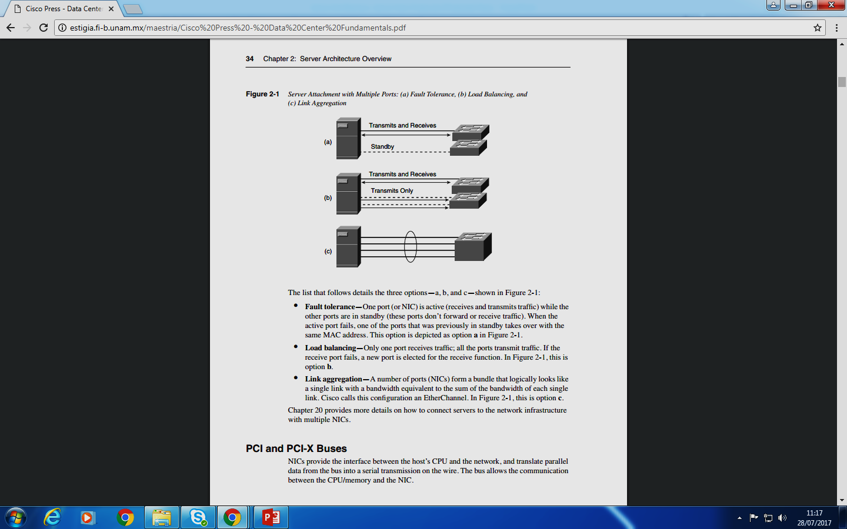
Fig. 10 - Server Architecture

SERVER ARCHITECTURE

The servers room is a critical area within the UWTSD, which is providing data storage for the entire campus. The server room is designed to protect the servers from any physical and environmental damage all the time, while preserving the server equipment for long-term usage.

FAULT TOLERANCE

The cloud architecture that relies on the hardware and the software of the server that includes network adaptors. The NIC converts data from the computer into signals to be sent over the network and vice versa. Today's NICs are Ethernet fast (gigabit Ethernet cards being popular). The transmission speed, as well as the duplex setting are negotiated by the NIC. The incoming traffic is stored in the queue and transferred to the memory using the hardware. NIC features:
- DMA (memory access without involving CPU);
- Disrupt Merging (delay notification of newly arrived packet);
- Help for Jumbo frame (use of bigger Ethernet frames).
- Support for IEEE8021Q (connection of servers to several VLANs);
- Offloading TCP/IP (does TCP checksum and segmentation functions);
- Fault resistance & balancing loads (attaching server to network with multiple ports);
- Support for the IEEE 802.3 ad (IEEE 802.3 ad is a protocol that allows communication between ports to separate devices from creating a channel) [1].

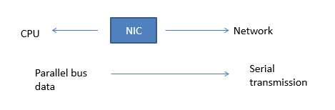

Fig. 11 - PCI Bus

Load Balance

One port for receipt and the other ports for transmission; one port between the other ports will be used as a processing port, if the port fails to receive data.

Link Aggrregation

As shown in Fig. 09, there is a logical single link (Ether Channel) which is responsible for sending and receiving the data.

PERFORMANCE

In a single location, data centers are built to hold vital computing services. These services can be used from a business network's campus building, from a branch office over the wide area network (WAN), and from remote areas over the public Internet. The network also have an important part in the provision of services in the data centre. The network infrastructure addresses several data center functional areas and guarantee the data center resources that operates around the clock. Virtual machines enable effective testing and performance management software that can be installed to debug operating environments in the virtual machine monitor without losing the efficiency [12].

MANAGEMENT

The management of the date centre within the UWTSD, in order to accomplish the desired results, is a continuous process, especially when it comes to having a deeper understanding and relationship between the elements of virtualization and the process as a whole. The data center management process is usually applied in two stages. All tasks and specifications required for proper virtualization and implementation should be carefully tracked and handled.

ENERGY SAVING

The data center energy utilization resource control is now becoming a fundamental requirement for implementing renewable and environmentally sustainable data centers that are energy efficient [9]. The actual energy used by the UWTSD data center does not have a big impact over the infrastructure costs, but represents the cost of power used over time to operate the facility. The key issue for the power usage in data centers is to minimize the power needed to feed all the consumers’ devices. That means using high quality equipment that has built-in energy saving systems and is also environmentally friendly. [11].

CONCLUSIONS

This paper emphasizes the significance of the introduction of virtualization technologies in data centers in order to save money and optimize the productivity of UWTSD. For a better incorporate virtualization, is proposed a five-step model. It is important for this process to start by categorizing servers into various resource pools and their related programs and services. The virtualization not only needs to define the workloads scheduled for virtualization, but also to target the environments in which the workloads are to be implemented. It is necessary to decide the type of the servers, their current state, whether idle or busy, the cost of introducing server virtualization, the type of infrastructure needed to accomplish the appropriate service standards and eventually fulfil the goals of security and privacy. Finally, it is also critical for the data centre to check if the increased power and cooling concentrations have the requisite infrastructure to be managed due to the implementation of the virtualization.

REFERENCES

[1] Mauricio Arregoces, M. P., 2004. Data Center Fundamentals, Cisco Press.

[2] Santana, G. A. A., 2014. Data Center Virtualization Fundamentals, Cisco Press.
[3] Lefurgy, C., Rajamani, K., Rawson, F., Felter, W., Kistler, M. and Keller, T.W., 2003. Energy management for commercial servers. Computer, 36(12), pp.39-48.

[4] Schulz, G., 2016. The green and virtual data centre. CRC Press.

[5] K. Kant, "Data center evolution: A tutorial on state of the art, issues, and challenges," Computer Networks, vol. 53, pp. 2939-2965, 2009.

[6] Daim, T., Justice, J., Krampits, M., Letts, M., Subramanian, G. and Thirumalai, M., 2009. Data center metrics. Management of Environmental Quality: An International Journal.

[7] Koomey, J.G., 2008. Worldwide electricity used in data centers. Environmental research letters, 3(3), p.034008.

[8] Pierson, J.M., 2011. Green task allocation: taking into account the ecological impact of task allocation in clusters and clouds. Journal of Green Engineering, 1(2), pp.129-144.

[9] Uddin, M. and Rahman, A.A., 2012. Energy efficiency and low carbon enabler green IT framework for data centers considering green metrics. Renewable and Sustainable Energy Reviews, 16(6), pp.4078-4094.

[10] Uddin, M. and Rahman, A.A., 2011. Techniques to implement in green data centres to achieve energy efficiency and reduce global warming effects. International Journal of Global Warming, 3(4), pp.372-389.

[11] Zeadally, S., Khan, S.U. and Chilamkurti, N., 2012. Energy-efficient networking: past, present, and future. The Journal of Supercomputing, 62(3), pp.1093-1118.

[12] Kusic, D., Kephart, J.O., Hanson, J.E., Kandasamy, N. and Jiang, G., 2009. Power and performance management of virtualized computing environments via lookahead control. Cluster computing, 12(1), pp.1-15.

