Understanding the Business Context – Task 2 Infographic

Natalie Mills – 1451133
Word count - 1030

Infographic Information

Audience – SBUHB HR Staff for Understanding how PESTLE factors could affect the organisation (SBUHB)

What is PESTLE?
The CIPD describes PESTLE as “broad fact-finding activity around the external factors that could affect an organisation’s decisions, helping it to maximise opportunities and minimise threats” (CIPD, 2023a). A PESTLE looks at six external factors: Political, Economic, Sociological, Technological, Legal and Environmental and can be used in strategic planning. A PESTLE Analysis is a simple framework that supports “understanding the wider business context” (CIPD, 2023a) although when undertaking the analysis there is a risk of capturing too much data and being unsure what to do with it, to combat this the PESTLE should be undertaken regularly and with sufficient data (CIPD, 2023a).
A PESTLE analysis should not be undertaken by itself and should be used in tandem with other tools such as a SWOT analysis that looks at the organisations Strengths, weaknesses, opportunities and threats (CIPD, 2023b) to gain an understanding of what the organisation in succeeding in, areas to improve, future opportunities and emerging threats. To ensure a robust scan of the external environment a Porter’s Five Forces may be undertaken. Porters five forces involves scanning an industries environment for “Competition, New Entrants, Power of Suppliers, Power of Customers and Threat of Substitutes” (Scott, G. 2023) working in tandem with a PESTLE and SWOT analysis it can support creating an understanding of the external factors affecting the organisation, however without depths to the analysis it can lead to poor decision making, misanalysis and poor organisational decision making (Dobbs, M. 2014).

Sociological
A sociological factor that can affect SBUHB is the demographics of the population we serve. Demographics look at populations, population growth, ages within that population, birth rates and death rates (Kew, J and Stredwick, J. 2016a). When planning healthcare services its important that we take into consideration the sociological factors that affect the populations health such as, housing, work, education, employment, age, and sex factors(Holmes, J. 2022) (Dahlgren, G and Whitehead, M. 2021). The health board operates across two local councils (Swansea and Neath Port Talbot) and from the recent census we can ascertain that Swansea experienced a 0.4% decrease in population from 2011-2021 (Swansea Council, 2023), whereas Neath Port Talbot increased by 1.8% (ONS, 2023) these changes in population affect the demand for health services (Perrot, G and Holland, D. 2005) and affect the birth and death rates.
The birth rate is “usually expressed in terms of number of live births per 1000 population…a rate of 2.1 is required to maintain the population” (Kew, J and Stenwick, J. 2016b) and within Wales, Public Health Wales found that the average birth rate is 1.9 (Public Health Wales, 2016). A decline in birth rates can be attributed to sociological factors such as the increased use in contraception (Nargund, G., 2009) where women can make decisions on family planning or the increased cost of bringing up families with childcare costs rising by 78% (Turn2Us, No Date) and with a decline in birth rate this subsequently means there is an aging population which increases the demands on services. NHS England predicts that “the number of people living with long-term conditions is set to increase, with more individuals managing multiple conditions” (NHS England, No Date. a) which means we will need to strategically plan our long-term workforce and service delivery plans to ensure the provision meets the demands of the population.

Technological
The impact of technology on society and within organisations is profound and ever evolving, we are living in an “age of acceleration”(Friedman, T. 2016). Technology can be used for better health with apps to monitor blood pressure, streamlined access to patient records and improved access to care (IRIS, 2019) although it’s adoption within the healthcare sector is “slow and disparate” and historically the NHS has been reactive to changes in technology (Liddell, A., Adshead, S., and Burgess, E. 2008). However, due to the COVID19 pandemic, the NHS and SBUHB had to quickly adopt new technologies at an incredible pace (Hutchings, R. 2020) such as virtual clinics (SBUHB, No Date.a), the use of laptops and VPNs to work from home (SBUHB, No Date.b) and video conferencing technology (NHS England, No Date. b). Within SBUHB, the use of technology is being explored with clinical services at the forefront. In 2023, Cardiac surgeons broadcast intricate open heart surgeries in real time to a conference in India to share best practices and create international health care links (SBUHB, No Date. C). As new emerging technologies become available such as AI tools it’s vital that as HR professionals we understand not only the scope of the technology but also it’s risks (Ali, Z. 2023) and how it can support the organisation.

Environmental
The world health organisation has called climate change the single biggest threat to humanity (World Health Organisation, 2023) and climate change is affecting the ability for health boards to deliver health care, in 2022, heatwaves caused multiple issues for hospital IT systems (National Institute of Clinical Excellence, No Date). The NHS accounts for 25% of public sector carbon emissions in the UK (Naylor, C. 2012) with emissions coming from purchased energy sources such as electricity, heating, steam and colling to the indirect emissions from the health care supply chain and disposable goods and pharmaceuticals (Karliner, J and Slotterback, S. 2019).
SBUHB has taken steps to reduce its carbon footprint by becoming the first hospital in Wales to implement a solar farm (SBUHB, No Date. d) and this initiative has come directly from the Decarbonisation Plan 2022-2024 which looks to integrate sustainability across all operations (SBUHB, No Date. e). SBUHB staff have also set up a “green group” to be able to strategically implement green initiatives with members from across the health board including clinical and nonclinical staff (SBUHB, No Date. f) and from this work the health board has funded three sustainability lead positions for clinical staff (SBUHB, No Date g) due to the need to integrate sustainability into clinical practice (Dunne, H., Rizan, C., Jones, A. et al. 2022). The environmental impact healthcare has on climate change is evident, however with new initiatives and increase awareness on sustainability health care organisations such as SBUHB can be at the forefront of sustainable healthcare.

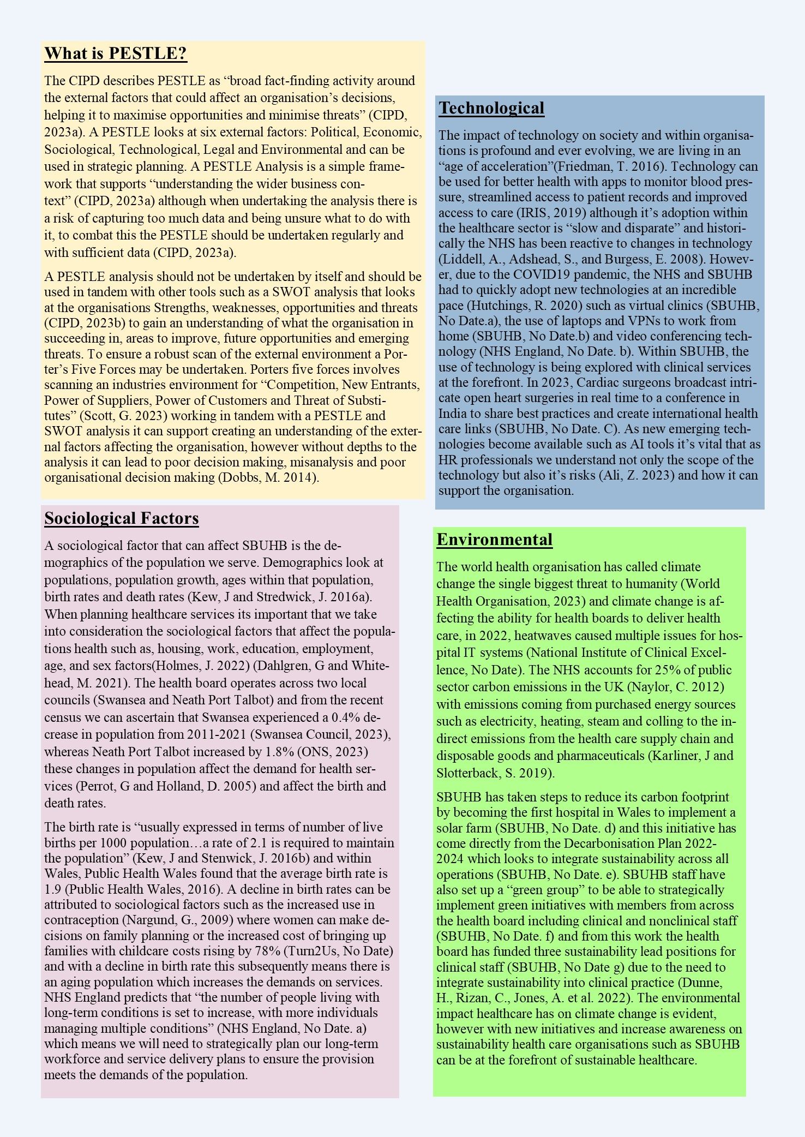

References
Ali, Z. (2023). Avoiding the dangers of workplace AI. [Online]. People Management. Available at: https://www.peoplemanagement.co.uk/article/1837618/avoiding-dangers-workplace-ai
CIPD. (2023a). PESTLE Factsheet. [Online]. CIPD. Available at: https://www.cipd.org/uk/knowledge/factsheets/pestle-analysis-factsheet/
CIPD. (2023b). SWOT Analysis. [Online]. CIPD. Available at: https://www.cipd.org/uk/knowledge/factsheets/swot-analysis-factsheet/#:~:text=A%20SWOT%20analysis%20
Dahlgren, G and Whitehead, M. (2021). The Dahlgren-Whitehead model of health determinants: 30 years on and still chasing rainbows. Public Health Journal. 199(20), p.24. [Online]. Available at: 10.1016/j.puhe.2021.08.009
Dobbs, M.E., (2014). Guidelines for applying Porter's five forces framework: a set of industry analysis templates. Competitiveness Review, 24(1), pp. 32-45.
Dunne, H., Rizan, C., Jones, A. et al. (2022). Effectiveness of an online module: climate-change and sustainability in clinical practice. BMC Medical Education. 22(1), p.682.
Friedman, T. (2016). Thank You For Being Late: An Optimist’s Guide to Thriving In The Age Of Accelera. New York: Farrar, Straus and Giroux. pp.24-30.
Holmes, J. (2022). What is a population health approach?. [Online]. The Kings Fund. Available at: https://www.kingsfund.org.uk/publications/population-health-approach?gclid=CjwKCAiAjrarBhAWEiwA2qWdC
Hutchings, R. (2020). The impact of Covid-19 on the use of digital technology in the NHS. [Online]. Nuffield Trust. Available at: https://www.nuffieldtrust.org.uk/research/the-impact-of-covid-19-on-the-use-of-digital-technology-in
IRIS. (2019). 3 Benefits of Technology in Healthcare. [Online]. IRIS. Available at: https://retinalscreenings.com/blog/top-benefits-of-technology-in-healthcare/
Karliner, J and Slotterback, S. (2019). HEALTH CARE’S CLIMATE FOOTPRINT. [Online]. Health Care without Harm. Available at: https://noharm-global.org/sites/default/files/documents-files/5961/HealthCaresClimateFootprint_09231
Kew, J and Stredwick, K. (2016a). Human Resource Management in a Business Context. 3rd ed. London: CIPD. p.288
Kew, J and Stredwick, K. (2016b). Human Resource Management in a Business Context. 3rd ed. London: CIPD. p.289-291
Liddell, A., Adshead, S., and Burgess, E. (2008). Technology in the NHS Transforming the patient’s experience of care. [Online]. The Kings Fund. Available at: https://www.kingsfund.org.uk/sites/default/files/Technology-in-the-NHS-Transforming-patients-experie
Nargund, G. (2009). Declining birth rate in Developed Countries: A radical policy re-think is required. Facts View Vis Obgyn. 1(3), pp.191-193.
National Institute of Clinical Excellence. (No Date). Environmental sustainability. [Online]. National Institute of Clinical Excellence. Available at: https://www.nice.org.uk/about/who-we-are/sustainability
NHS England. (No Date.a). Evolving to meet a changing world. [Online]. NHS England. Available at: https://www.england.nhs.uk/future-of-human-resources-and-organisational-development/the-future-of-nh
NHS England. (No Date b). Video conferencing technology in primary and secondary care. [Online]. NHS England. Available at: https://transform.england.nhs.uk/covid-19-response/technology-nhs/web-based-platform-which-offers-vi
ONS. (2023). How life has changed in Neath Port Talbot: Census 2021. [Online]. ONS. Available at: https://www.ons.gov.uk/visualisations/censusareachanges/W06000012/
Perrot, G and Holland, D. (2005). Population Trends and Problems of Public Health. The Milbank Quarterly. 83(4), pp.569-608.
Public Health Wales. (2016). Population and births. [Online]. Public Health Wales. Available at: https://www2.nphs.wales.nhs.uk/PubHObservatoryProjDocs.nsf/3653c00e7bb6259d80256f27004900db/9a40ed88
SBUHB. (No Date.a). Virtual clinics reducing hospital visits for patients and saving clinician's time. [Online]. SBUHB. Available at: https://sbuhb.nhs.wales/news/swansea-bay-health-news/virtual-clinics-reducing-hospital-visits-for-pa
SBUHB. (No Date b). SBUHB Working From Home Wellbeing Advice. [Online]. SBUHB. Available at: https://sbuhb.nhs.wales/about-us/staff-info/occupational-health-staff-wellbeing-service/staff-wellbe
SBUHB. (No Date c). Morriston's UK-leading team broadcasts real-time cardiac procedures to India. [Online]. SBUHB. Available at: https://sbuhb.nhs.wales/news/swansea-bay-health-news/morristons-uk-leading-team-broadcasts-real-time
SBUHB. (No Date d). Morriston the first hospital in Wales to develop its own solar farm. [Online]. SBUHB. Available at: https://sbuhb.nhs.wales/news/swansea-bay-health-news/morriston-the-first-hospital-in-wales-to-develo
SBUHB. (No Date e). Swansea Bay University Health Board: Decarbonisation Action Plan 2022-2024. [Online]. SBUHB. Available at: https://sbuhb.nhs.wales/files/freedom-of-information-disclosure-log-2022/october/22-j-058-sbuhb-deca
SBUHB. (No Date f). Healthcare staff launch new Swansea Bay Green Group. [Online]. SBUHB. Available at: https://sbuhb.nhs.wales/news/swansea-bay-health-news/healthcare-staff-launch-new-swansea-bay-green-g
SBUHB. (No Date g). New roles boost Swansea Bay's sustainability aspirations. [Online]. SBUHB. Available at: https://sbuhb.nhs.wales/news/swansea-bay-health-news/new-roles-boost-swansea-bays-sustainability-asp
Scott, G. (2023). Porters Five Forces. [Online]. Investopedia. Available at: https://www.investopedia.com/terms/p/porter.asp
Swansea Council. (2023). RECENT POPULATION CHANGE IN SWANSEA Briefing Note. [Online]. Swansea Council. Available at: https://www.swansea.gov.uk/populationtrends
Turn2Us. (No Date). The cost of raising a child exceeds £230,000. [Online]. Turn2Us. Available at: https://www.turn2us.org.uk/about-us/news-and-media/latest-news/the-cost-of-raising-a-child-exceeds-2
World Health Organisation. (2023). Climate change. [Online]. World Health Organisation. Available at: https://www.who.int/news-room/fact-sheets/detail/climate-change-and-health

