Advertisement for team member at Greggs

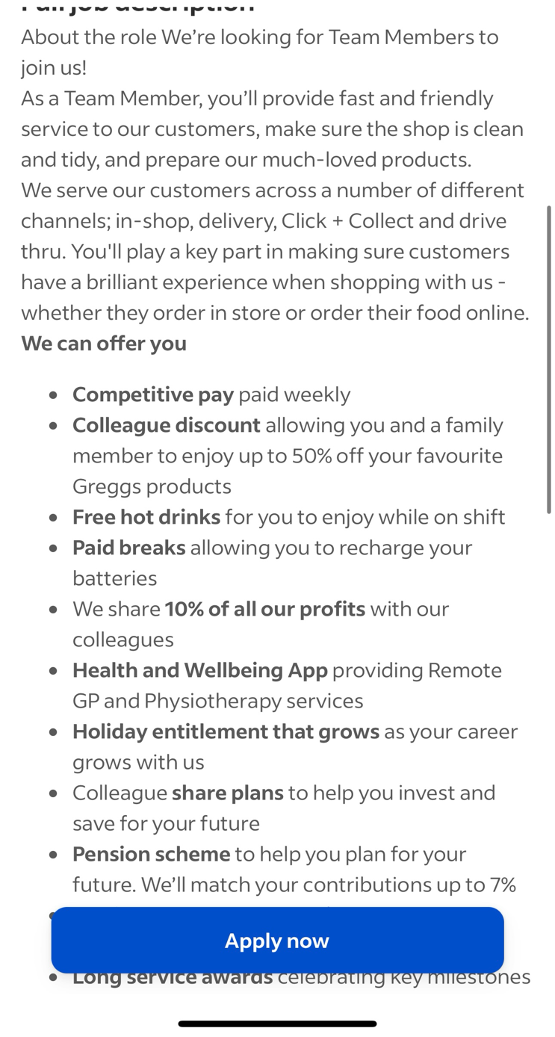
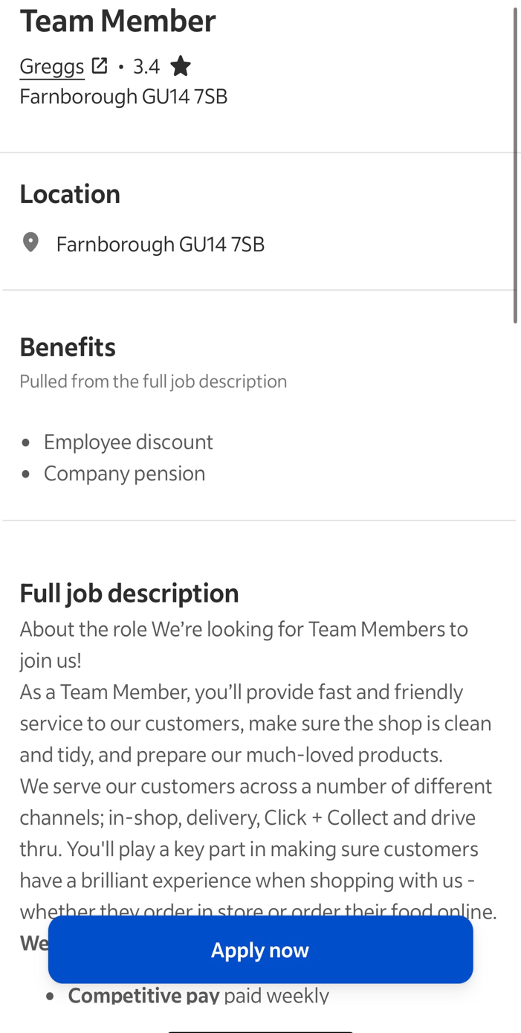

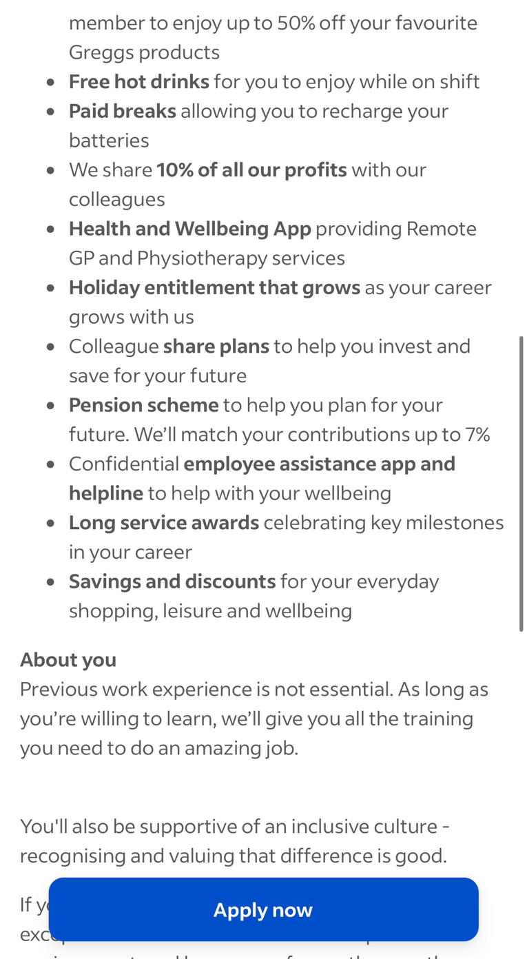
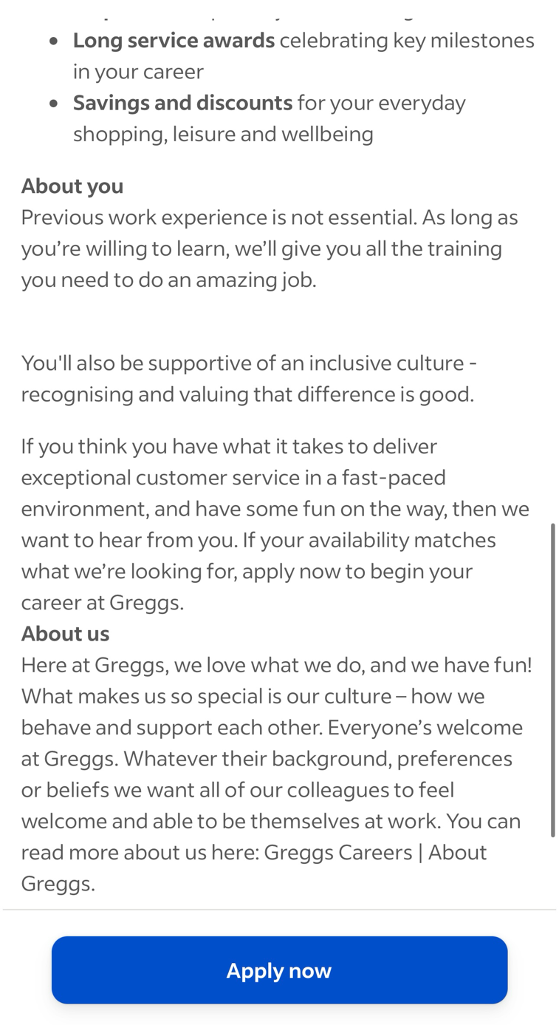

Programme: Certificate in Higher Education Business in the Workplace

Module code: LCLM4005

Module Title: Employability and Career Development

Lecturer name: Dr. Jaya Gopalkrishnan

Assignment Title: Mock Interview

This is the job I applied for

Bianca-Georgiana Puitau
25 Hamilton Place
Aldershot
Hampshire
GU11 3TD

Greggs
GU14 8BL
Farnborough
10/11/2025

Dear Mrs,
I wish to apply for the role of the team member at Greggs, currently being advertised on indeed. Please find enclosed my CV for your consideration.
As you can see from my attached CV, I have over three-year experience in the fast food industry, and I believe that I can make the company grow, focus on customers services, team working and managing all around the store during this time makes me the right candidate for the role.
In my current role as a crew trainer at McDonald’s, I have handled training and coached new team members on food preparation, customer service and safety procedures. Helped in keeping a positive work environment by promoting teamwork and communication among staff.
During my time as a crew trainer at McDonald’s I had developed strong leadership, communication with people and being more organisational. I learned how to train members of the team and motivate the team members and keep high standards with customers service and food hygiene.
All of this, coupled with my enthusiasm and dedication for this job has helped me to manage time, pay attention, safety and hygiene, cash handling and problem solving.
I am confident that I can bring this level of success with me to your organisation and help dominate international, fast-food industry and build upon their reputation as I had been taught. With my previous experience and ability, I believe my contribution will have a positive impact on the teamwork efficiency and overall customer satisfaction as this is all about.

Thank you for reviewing my application. I look forward to the opportunity to share how my experience was as a crew trainer can add value to your organisation.

Yours sincerely,
Bianca Puitau

📍 25 Hamilton Place, Aldershot, Hampshire, GU11 3HD
📧 puitaubianca001@hotmail.com | 📞 07553 516597

Personal Profile

Friendly, motivated, and adaptable professional with over 4 years of experience at McDonald’s, specialising in customer service, food safety standards, and team training. Skilled at delivering excellent customer experiences, handling complaints. Dedicated, hardworking, and passionate about providing outstanding service in every shift I do.

Key Skills
- Customer Experience: Delivering friendly, professional service and ensuring customer satisfaction.
- Food Safety Standards: Knowledge and practice to keeping high hygiene and safety at work
- Complaint Handling: Skilled at resolving customer issues quickly and professionally.
- Team Communication: Strong communicator, able to train and support colleagues when the need the most.
- Adaptability & Flexibility: high-pressure environments.
- Work Ethic & Motivation: Reliable, dedicated, and always doing my best.

Work Experience

McDonald’s, Aldershot — Crew Trainer
2019 – Present
- Over 4 years of experience working in a fast-paced, high-volume restaurant.
- Ensured compliance with food safety standards and company policies.
- Delivered excellent customer experiences through friendly and efficient service.
- Developed strong skills in team communication and collaborate with my colleagues.
- Handled customer complaints effectively, resolving issues quickly and professionally.
- Promoted to Crew Trainer for consistently proving leadership and high performance to the company.

Poppies Day Nursery, Aldershot — Work Experience
- Assisted staff with daily activities and supported children in a caring environment.
- Gained experience in teamwork, patience, and communication.

Education
- Business course – at the present time
- Pre-Access Course Health & Social Care (Level 2) — Farnborough College of Technology (2023–2024)
- Health & Social Care (Level 1) — Farnborough College of Technology (2022–2023)
- ESOL (English for Speakers of Other Languages) — Farnborough College of Technology
- Maths Functional Skills (Level 1)

Activities & Achievements
- Promoted as a Crew Trainer for excellent performance and dedication at McDonald’s store for long time now.
- Active lifestyle: enjoy fitness, gym, and helping others when they need.

