3/24/2025
University of Wales Trinity Saint David
London campus
E-Portfolio Link: https://londonking513.wixsite.com/my-site-1
Module Name: Learning In the Digital Era
Module Code: ACCA 4025

Student Name: Muhammad Saqib Khan
Student ID:2542020
Group: 3

Lecturer’s Name: Anees Baqir

LDE Assignment 1
E-Portfolio
Table of Contents
Introduction 2
Main Body 2
Task 2: Collaborative Mind Map and Individual Poster 3
Mind Map (Collaborative) 3
Poster (Individual) 4
Task 3: Virtual Collaboration and RefWorks 5
Report on Virtual Collaboration 5
Task 4: E-Portfolio Creation and Evaluation 13
Task 4 (a): E-Portfolio Creation [1] 13
Task 4 (b): Illustrative Review of E-Portfolio tool Selection 13
Conclusion 15
References 15
Task 3 References: 16

Introduction
Game development is the techniques where the programmer design, create develop programs and testing of games for the laptop, PCs, mobiles and consoles. There are many tools and languages to develop a game which was discuss in this report below.
Mind map is a visual diagram that organise the ideas of the main topics. It’s used a branch to connect the related concepts, information makes easy for the user to understand.
Virtual team dynamics is referred to connect people to interact, meeting, communication together as a team through a virtual platform such as zoom, Microsoft team and many more.
Wix is online platform use for the making website to create a professional website without coding.

1(a). Game Developer:
- Introduction:
A game development is art that the developer design, programmes, and testing of games for a PCs, laptops, mobiles and consoles. [1]
To gain Game development skill the person needs some skills that are the programming, communication, critical thinking, time management, team management, Research skills, tools, physics and mathematics skills.
- Programming:
A program is a sequence of codes that instruction for work in a programming language that enable the computer to understand the instruction.
There are many programming languages that are used for gaming development like Python, C#, C++, Java, swift and Kotlin.
- Critical Thinking:
Critical thinking is the ability to analysis and evaluate the options to understand the problem to get the solution for it.
It is important in gaming development to understand:
- Fix the bugs
- Choose the programming language
- Improve the user experience
- Technical challenges in development
- Time Management:
Time management is a techne manage the time, plan and organise the use time to complete the task before the deadline.
Time management is use in gaming development for:
- Project schedule
- Priorities the important task
- Work efficiently
- Time deadline

- Game Engine:
A game Engine is software framework that provides tools and features for the design, developing and testing of video game.
There are many engines but the mostly one Unreal Engine and Unity. [2]
- Research skill:
The ability to find, evaluate, organise and use the information from the sources to solve the problem and make decision.
- Communication
- Creativity
- Adaptability
- Teamwork
1b. Similarity Report:
The task 1(a) similarity report on Turntine score was 5% which shows that task 1(a) have 95% my own words. The rest 5% is the definition of game Engine of same words from the website ( [2]) which used as references as well. In the future I will try to continue my work more my own word and try less similarity in the future. I will be more reliable on the academic resources more in the future. And for more report I will do my best to cover everything my own and get less similarity in future. I will be put more efforts in my work.
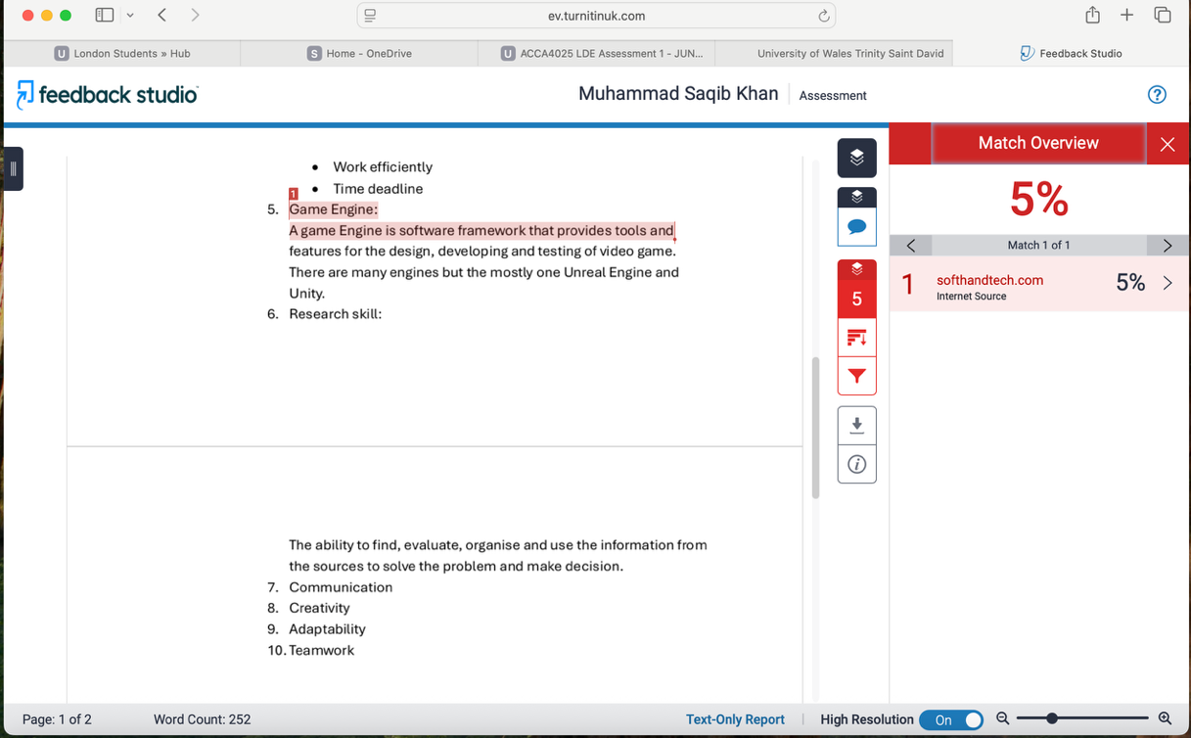

Mind Map (Collaborative)

Effective Teamwork Mind Map:
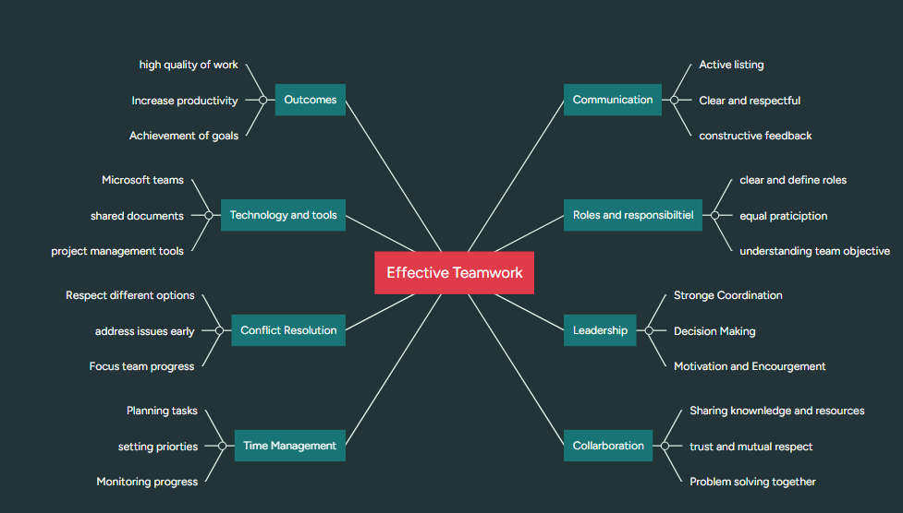
1. Clear Communication
Clear communication is one of the most important foundations of effective teamwork. Team members should share information openly, express their ideas clearly, and actively listen to others. Good communication reduces misunderstandings, prevents mistakes, and ensures that everyone understands their responsibilities and project goals. It also encourages constructive feedback, allowing team members to solve problems quickly and improve their performance. When communication is honest and respectful, teams build stronger relationships and work more efficiently towards common objectives. [3]

2. Trust and Respect
Trust and respect create a positive working environment where team members feel valued and confident in one another's abilities. Trust develops when individuals keep their promises, complete tasks on time, and support each other during challenges. Respect means recognising different opinions, backgrounds, and skills without discrimination. Teams with high levels of trust and mutual respect tend to collaborate more effectively because members are comfortable sharing ideas, asking questions, and accepting feedback without fear of criticism. [4]

3. Collaboration and Cooperation
Collaboration and cooperation involve working together to achieve shared goals by combining each member's knowledge, skills, and experience. Effective collaboration encourages people to contribute their strengths while supporting others when needed. Team members share responsibilities, solve problems collectively, and make decisions through discussion rather than working in isolation. Strong collaboration improves creativity, increases productivity, and often leads to better solutions because different perspectives are considered before decisions are made. [5]

Get an idea from Chat gpt
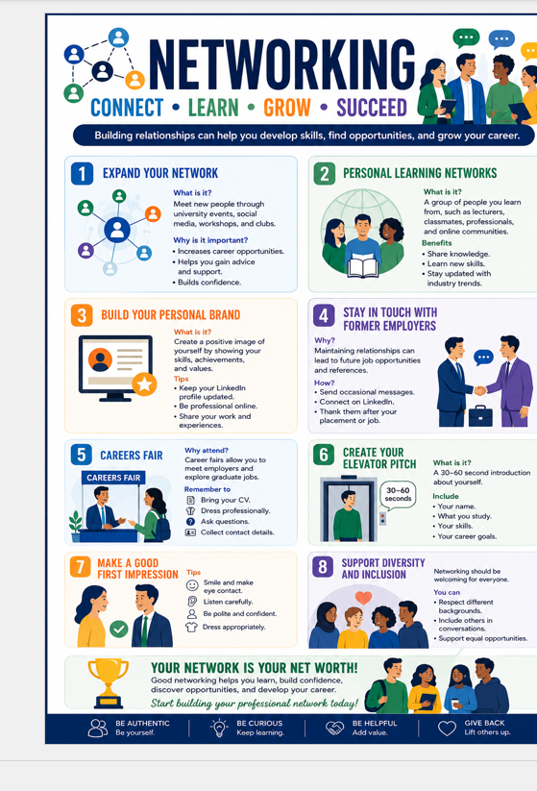
Virtual team dynamics
Virtual team dynamics refers to the interactions, behaviours and relationship between team member who collaborating remotely using digital communication technology. The industries quickly adopted quickly remote and hybrid technology working models, understand to update to the modern world and work effective of team and organising success.
Communication is one the most important elements in e team of successes teams. Unlikely Face to Face meeting and waste of time to travel. Digital Platform like to Zoom, MS team and slack. Clearly, timely and respectful communication can helps reduce misunderstanding and ensure the team are on the right path. High level of trust improve collaboration to increase motivation, enhanced the teamwork.
Leadership is also the most important part of the virtual team dynamics. The excellent leadership provide the team motivation, coordinate of task, regular check on the work, feedback and support the team. Strong leadership provide the team exact time and task to complete. [1. 1. 2. 1. 2. 3]
WoC are still disproportionately under-represented in leadership positions in STEM sectors nationwide, despite modest advancements. As of 2024, just 7% of C-suite roles are held by women of colour, compared to 22% for white women and 56% for white males, underscoring ongoing inequalities in corporate leadership (LeanIn.Org & McKinsey Company, 2024). The "broken rung" phenomenon—only 81 women being promoted overall for every 100 males promoted to manager—remains a significant obstacle. Promotion rates are 99 for Asian women, 89 for White women, 65 for Latinas, and 54 for Black women when broken down, demonstrating structural barriers to job development for women of colour (LeanIn.Org & McKinsey Company, 2024).
This study created a theory of global virtual team dynamics and effectiveness based on prior literature and a qualitative, longitudinal field survey. We suggested that proper interaction episodes and the organization of those occurrences into a temporal rhythm are what lead to successful global virtual team outcomes.
Effective interaction episodes within the framework of the available technology match form to function and complexity, which are influenced by task and group characteristics. The temporal rhythm is characterised by regular, intense face-to-face meetings, followed by less intense, shorter interactions via various mediums. [2]

Step-by-step process of using RefWorks with visuals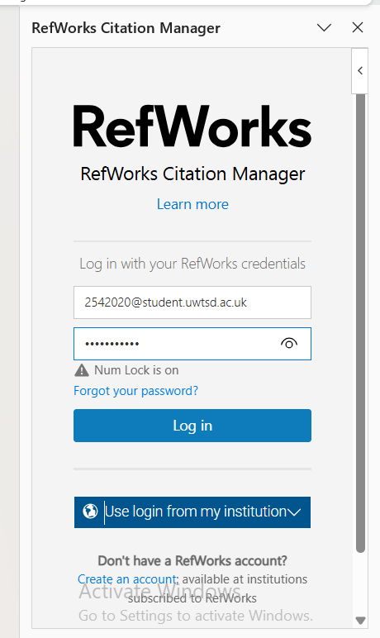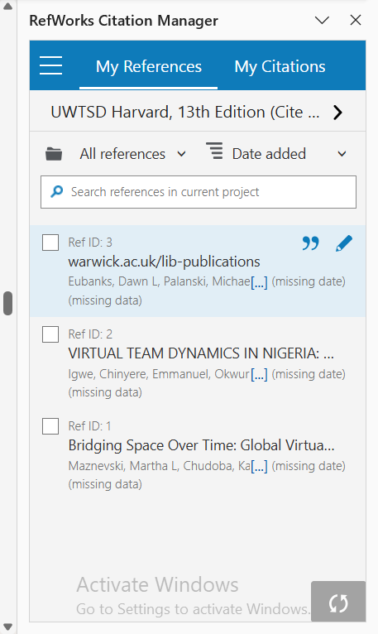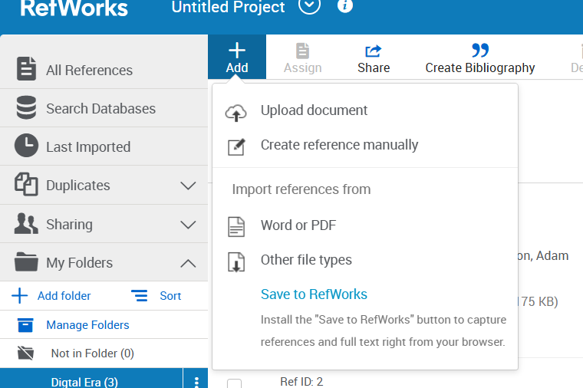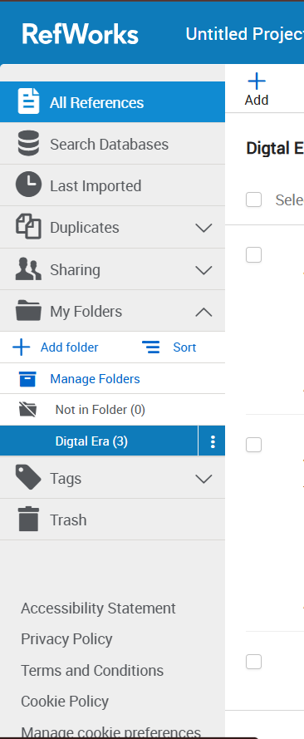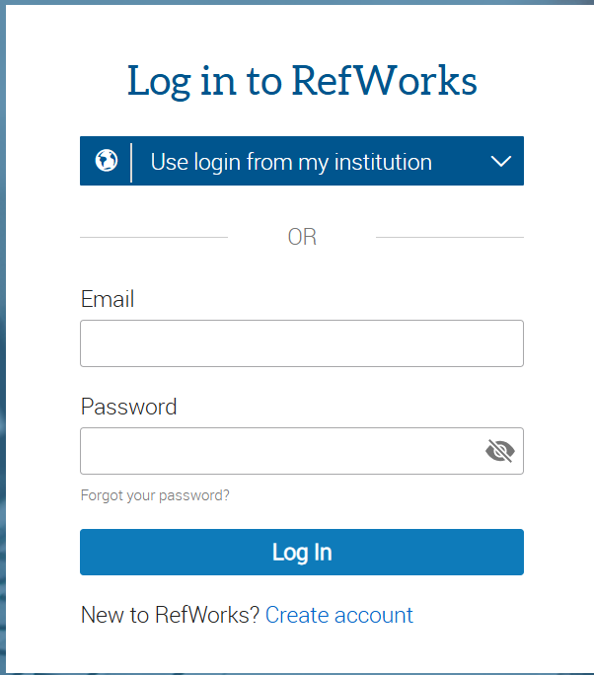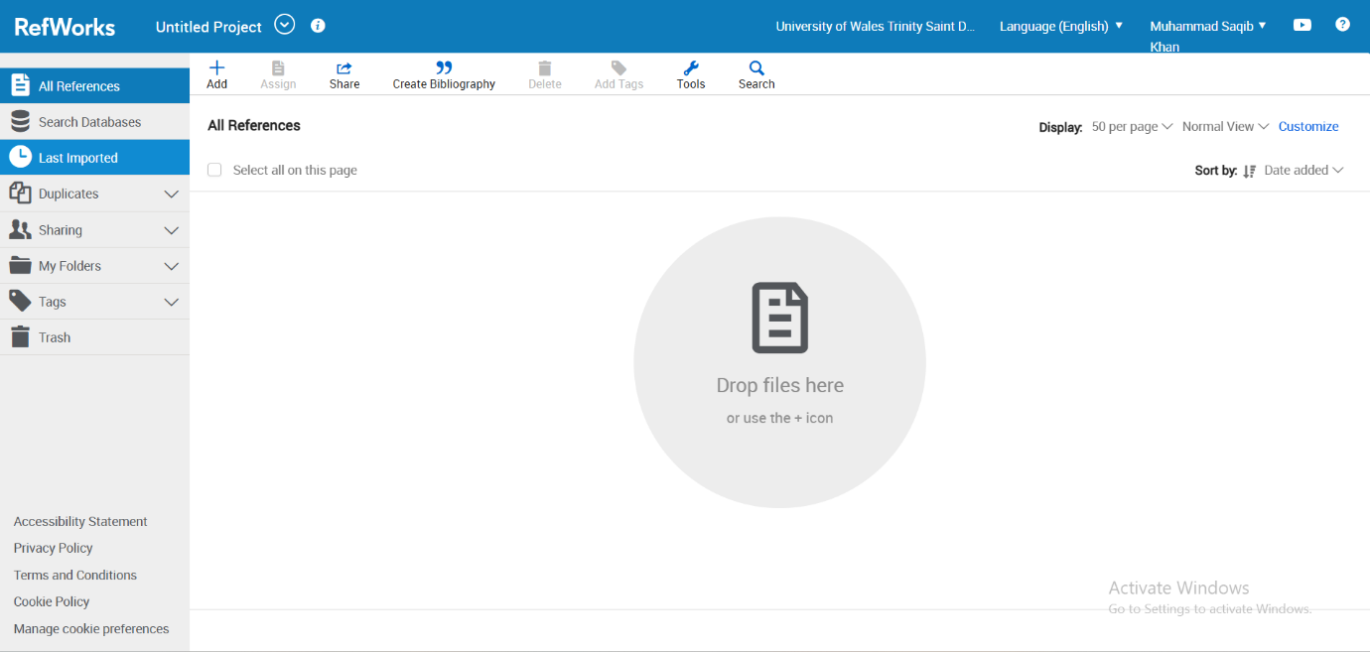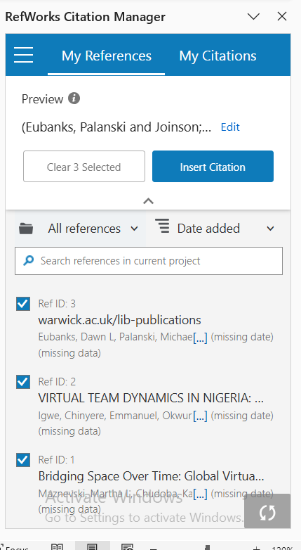

Task 4: E-Portfolio Creation and Evaluation

Task 4 (a): E-Portfolio Creation [1]
Wix is a cloud-based website development platform that allows individuals, businesses, and organisations to create professional websites without requiring advanced programming skills. Founded in 2006, Wix provides an intuitive drag-and-drop editor, website templates, hosting services, domain connection, e-commerce capabilities, blogging tools, and marketing features, all within a single platform.
ne of Wix's greatest strengths is its user-friendly interface. The drag-and-drop editor allows users to customise almost every part of a website simply by moving elements into place. This flexibility makes website creation straightforward, even for beginners.
Another major advantage is the large collection of professionally designed templates. Users can choose from hundreds of templates covering industries such as education, healthcare, restaurants, fashion, portfolios, and online stores. These templates are mobile responsive and can be customised to match individual branding.
Advantages of Wix
- Easy drag-and-drop website builder with no coding required.
- Large collection of professional templates.
- Built-in hosting and website security.
- AI-powered website creation tools.
- Strong e-commerce functionality.
- Mobile-friendly website designs.
- Integrated SEO and marketing features.
Disadvantages of Wix
- Switching templates after publishing is limited.
- Some advanced customisation requires developer knowledge.
- Premium plans may become costly for growing businesses. [3]

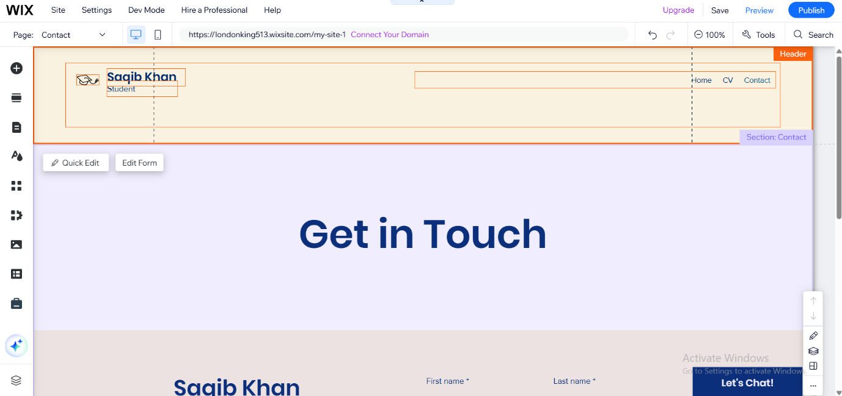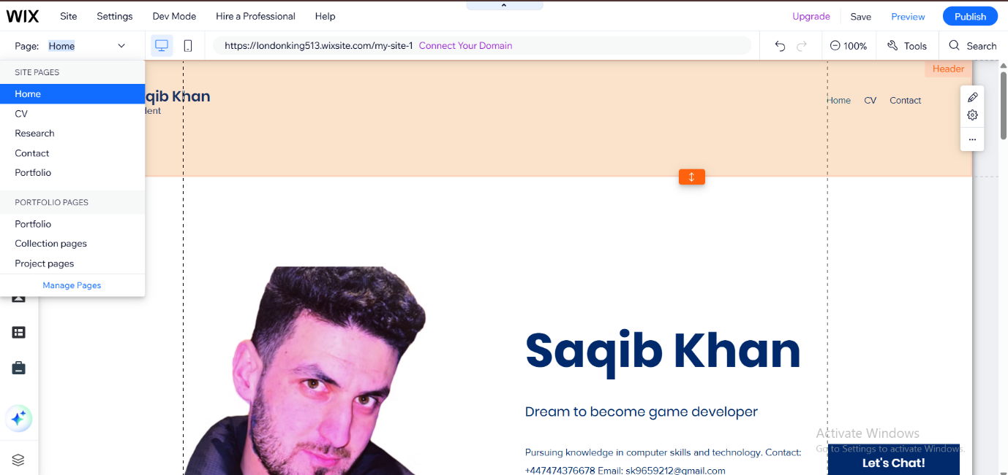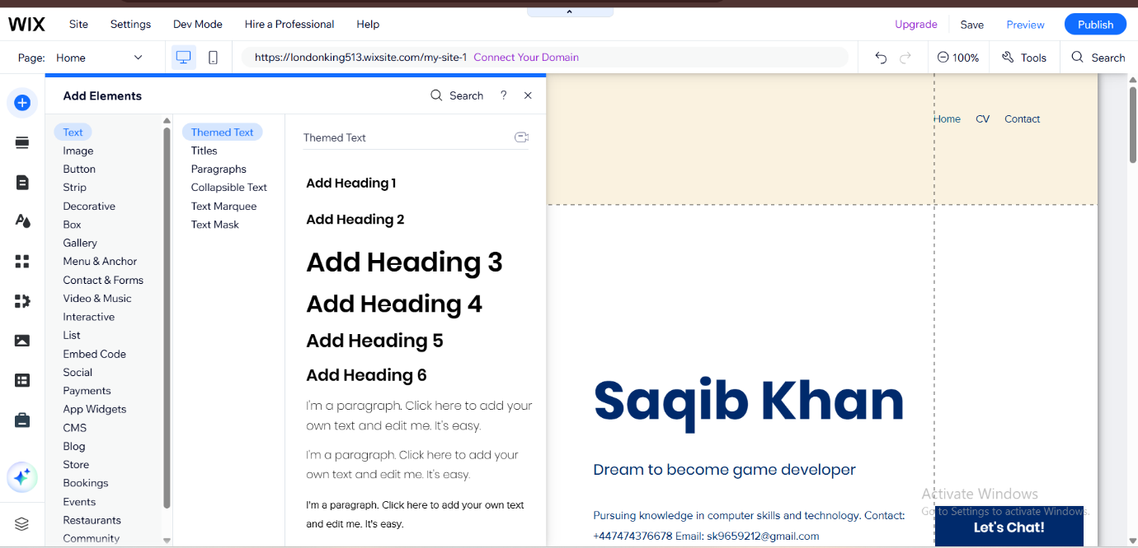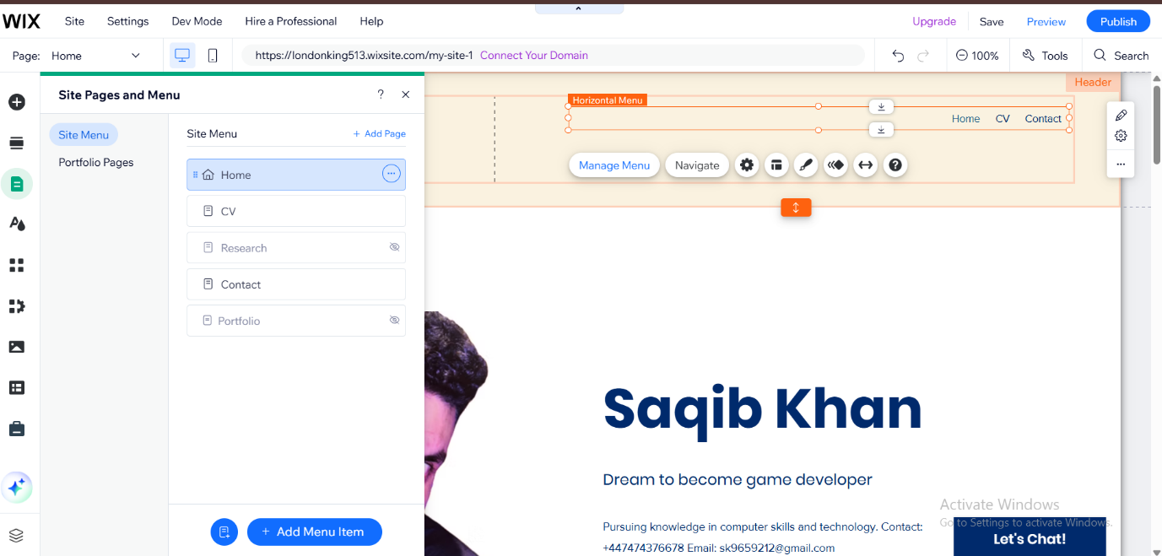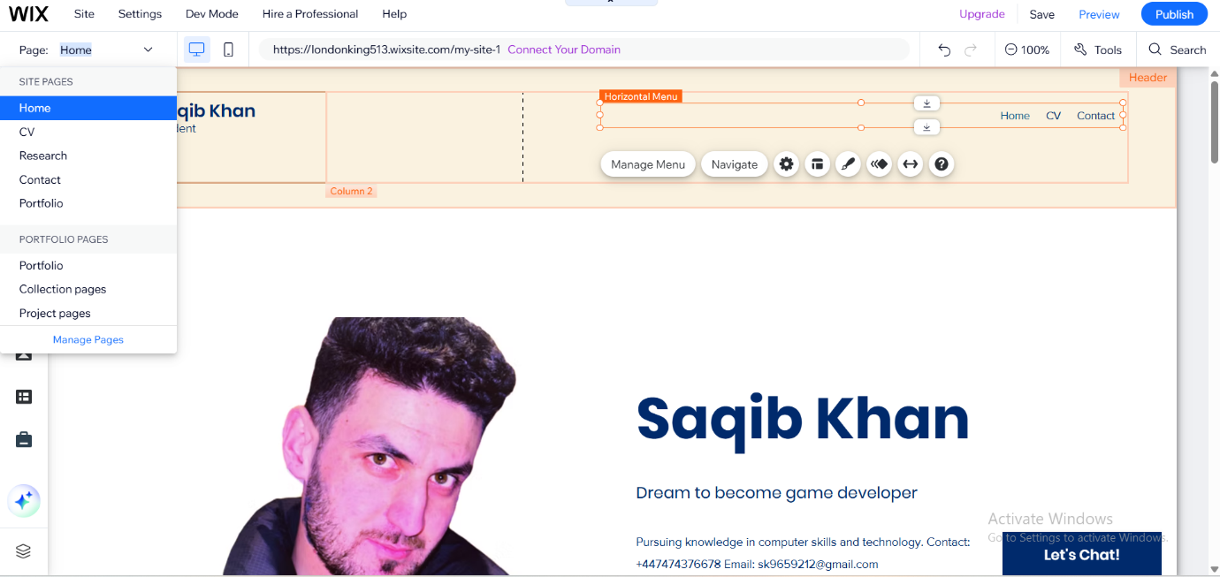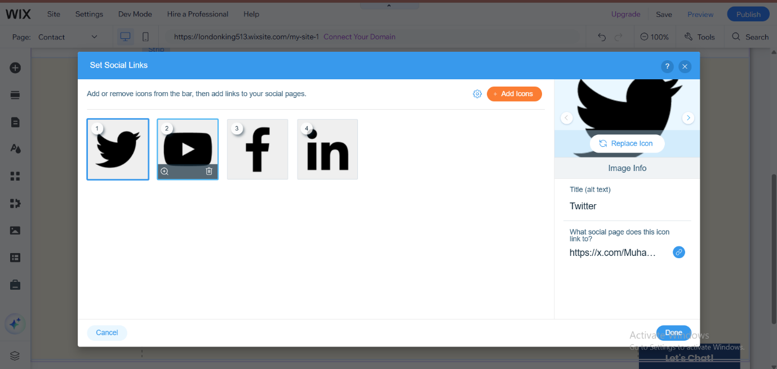

Conclusion

References

[1] | J. Novak, Game development Essentials.
[2] | T. Sharrow, “Tech Tips,” 07 04 2025. [Online]. Available: softhandtech.com.
[3] | E. Ryan and O. Simpson, “website builder,” [Online]. Available: https://www.websitebuilderexpert.com/website-builders/wix-review/.

[1] | J. Novak, Game development Essentials.
[2] | T. Sharrow, “Tech Tips,” 07 04 2025. [Online]. Available: softhandtech.com.
[3] | E. Ryan and O. Simpson, “website builder,” [Online]. Available: https://www.websitebuilderexpert.com/website-builders/wix-review/.

Task 3 References:

References

