11/5/2020
Module code: ACCA7019
Lecturer: Carlene Campbell
Network Security
Chris Morris
Student number: P149915

Contents
Abstract 1
Introduction 1
Findings 2
Task 1 - Literature review 2
HTML 2
IOT 3
Other future trends in cybersecurity 3
Task 1 evaluation 5
Task 2 – Security testing 5
Vulnerability assessment 6
DVWA tool 7
Recommendations 8
Conclusion 8
References 9

Abstract

Introduction
The objectives of this task are to gain an understanding as to how computer network security has evolved over time (looking at least two growing trends), and then perform testing on network security tools to demonstrate knowledge of experimentation.
Network security is the broad idea of putting as many procedures in place as possible to ensure devices are exposed to as little danger as possible. It may come in several forms, including acting as alternatives to broaden one’s variety (e.g. more usage of mobile devices) or being able to share data within a defined scope easier (e.g. IOT and 5G.)
Security is designed to protect devices from either “active” or “passive” attacks (passive means gaining information without damaging operations like active). The most defences are anti-viruses (protecting the device from malicious dangers such as viruses), authentication (making a user verify their access to data), and firewalls (controlling what data enters and leaves a system).
These measures continue to grow with expansion, which comes with added importance as so do does measures by attackers to break through them. Smarter protection in turn requires smarter planning by attackers to exploit them. Each security measure comes with its benefits and drawbacks, which must be considered carefully by a user before one is set up.
From the list provided, the topics chosen were: any future trends in cybersecurity that were not listed, database applications such as HTML5, and “smart” trends such as IOT.
List of acronyms
HTML – HyperText Markup Language
IOT – Internet of Things
XSS – Cross-Site Scripting
AI – Artificial Intelligence
BYOD – Bring Your Own Device
DDOS – Distributed Denial-of-Service
HTTP – HyperText Transfer Protocol
DVWA – Damn Vulnerable Web Application
PHP – Hypertext Preprocessor
CSRF – Cross Site Request Forgery

Findings

Task 1 - Literature review
Examples of two popular elements in network security include HTML and IOT. Both come with their benefits and security issues. Other, broader, trends are growing in popularity, which are constantly being expanded to deal with growing demand and are therefore open to security risks.

HTML
HTML is a computer programming language, mostly used to load Internet scripts and carry out commands. The most recent version is Version 5, released in 2016. [1] While HTML was released in 1993 and has remained a consistent popular element within the Internet, it therefore requires updates and tweaks to handle its popular demand.
The advantages of HTML5 include how well it integrates itself with said required updates. This maintains consistency as HTML remains relevant enough to have its strengths enhanced and flaws ironed out, which leads to more accurate and appropriate data for users as HTML is able to pick out the most popular and relevant data. [2]
It is also flexible, leading to data that lends well regardless of its intended use (e.g. for audio/video), and allowing users to tweak data to their preferences regardless of limitations such as not having a certain operating system.
On the contrary, what was identified as the most obvious security risk in HTML is a user inputting incorrect data unintentionally. Having any inaccurate code will prevent the intended outcomes and slow the performance of a device, as well as allow for exploitation unethically by hackers. [3] Tests are the cause to combat this, with data being checked and code being improved as developments occur.
Malicious code can not only come from inaccuracies by the user in question, but from another risk known as XSS. [4] This involves an outside user flooding coding such as HTML with damaging codes to negatively affect its performance. This is a case where too much outside involvement can be a determinant to HTML, and why accessibility restrictions play an important role.
Speaking more broadly, issues of database applications such as HTML in general can include weak infrastructure. Having no backups or failsafe protection software to fall back on can result in data breaches having a higher impact if, for example, customer records are leaked. Therefore, organisations place a high emphasis on having their data stored in more than one location in the case of a disaster, to ensure recovery can be achieved as quickly as possible.
Lastly is the subject of storage. Not having enough storage to handle all data or having all sensitive data stored in an unideal location (somewhere that is easily identifiable to an outside user) can pose dangers without sufficient protection.
Taking these advantages and risks into account, it is easy to see the important role that HTML plays in providing the backbone of Internet usage. However, as developments occur and demand rises, it needs constant review to remain consistent and keep its flaws to a minimum.

IOT
IOT is the process of combining devices together into a group to allow them to share data. It first came to prominence in the early 21st century before being coined in the late 2000s. IOTs are an important aspect of “Smart Cities”, the name given to overall groups of devices that apply IOT.
Aside from being able to collaborate and improve on existing data, IOT’s advantages comprise it increasing efficiency. As a result of simplifying the process of collaborating between users, costs are saved and accessibility is quicker, resulting in higher productivity. [5]
The most apparent security danger is files being accessed or destroyed via dangers such as viruses (malicious files that are often hidden and designed to steal data or at least slow a device’s performance) or ransomware (locking a user out of a device and forcing them to pay a fine in a currency such as Bitcoin, which may itself by unattainable to many users, before apparently returning it). This makes applying file restrictions and strengthening (before preferably changing) passwords an important security protection.
While IOT opens being able to share data with other users, it can also lead to issues with compatibility if users do not share the same defined requirements (e.g. having two different operating systems which do not share the same compatibility of a certain application). This can lead to more time being spent having to find common ground or searching for ways to achieve the amount of required storage.
Secondly, IOT runs the risk of being entirely reliant on Internet usage. If the Internet is not available after a disaster and an organisation is dependent on IOT, productivity will be lower and therefore the slower access to data will allow for higher risk of outside interference. Having data in multiple places is the ideal solution.
Next is the issue of complexity. While IOT is cost-effective in the long run, its initial setup can prove challenging and pose a security risk without prior knowledge. Setting up complex software in the process can result in more training having to be provided. [6]
Lastly is the fact that IOT can have a negative impact on organisation employment. Having security not handled by employees lessens the need for their involvement, and if the resulting restrictions to data from user to AI are not handled with care, can be damaging to an organisation.
Overall, IOT can be considered an effective security aspect of cybersecurity, though being over-reliant on it added with the initial complex setup can result in security risks if not considered beforehand.

Other future trends in cybersecurity
Besides HTML and IOT, an example of another growing element of cybersecurity is AI. This is where software and networks play a bigger role in maximising network security (e.g. analysing whether any email received contains any malicious code inside the link that can damage data if clicked or acted upon). [7] While firstly available, it is only now emerging to assist with network security and become a countermeasure to attacks.
The benefits of this trend are that it lessens the pressure on users to perform tasks correctly and spot any dangers, and lessens time spent searching manually for any errors that are easily missed. Also, AI has been a concept since the 1950s, meaning there has been more time to gain an understanding of how it can integrate itself.
On the negative side, AI itself can be at risk of not performing to its intentions if tweaked too much (e.g. having too many variables) or damaged by outside users. Also, having too much control taken away from users can lead to lower productivity due to inactivity.
Secondly is the topic of mobile devices, which are being more commonly used as cybersecurity expands to broaden the location scope of employees. [8] BYOD is a major contributor in the increased usage of mobile devices.
While this brings benefits such as being less reliant on organisational devices and having a separate method of carrying out activities, it results in double the amount of protection being required to prevent data loss/breach, and requires the setup of data endpoints to ensure data access is kept to its intentions.
The third chosen trend is the expansion of 5G, the trend designed to have a key impact on cellular networks and released in 2019 to improve upon the previous four versions. [9]
5G brings benefits such as increased bandwidth, helping it cover a wider range of devices within a specific area. It is also scalable, being able to easily integrate itself with “smart” devices such as virtual reality.
However, this results in more data having to be shared across the bandwidth range to compensate, meaning there is a higher chance of data not being available when desired. Also, its status as a recently released measure will work against it as it will have had less time for growth.
The fourth and final trend worth mentioning is the advancement of phishing (attempting to trick users into revealing data under the guise of an organisation, such as telling users that their Apple ID is locked until they send their personal details). [10]
Unlike the other three, this is a trend that is more likely to result in defensive measures having to be put in place rather than having immediate benefits, due to the risks of data it poses to an organisation.
As cybersecurity evolves and security improves, attackers must become more creative within their plans to breach it. The primary method is to trick users into clicking on malicious links within emails via procedures such as crypto jacking (which sets the basis for ransomware demanding that a user pay Bitcoin after having data stolen). [11]
While phishing is commonly seen as negative as it results in illegal access of data, when done ethically and on a low scale, it can be useful for organisations to gain a greater understanding of how to protect themselves (as will be evident in Task 2).
Overall, of the four growing trends discussed, mobile devices are determined to be the most promising trend due to having the most immediate benefits and growth over time via BYOD.

Task 1 evaluation
To conclude, between HTML, IOT, and the four other trends identified, IOT has been chosen as the strongest network security trend overall due to its high amount of collaboration and having the most apparent immediate benefits.
While HTML plays an important role in stabilising internet usage, the fact that the code can be easily tampered increases the risk of damaging data. AI may become the beneficial in future as it expands but appears to have the most challenges in the meantime. 5G, while a useful and growing security measure, is limited by pertaining to a specific audience (cellular devices).
Advancements in phishing is most likely to prove a danger to most users, hence why developments in cybersecurity is important to help stamp it out. Mobile devices, while beginning to see more usage over time, that is also a factor working against it as other measures such as IOT will have received more effort towards it.
While IOT has its own issues such as taking control away from users and proving challenging to firstly set up, it is determined to have the most focus out of all chosen trends and therefore the most apparent benefits. With enough training and an appropriate scope, it will be in the best position to effectively handle network security.

Task 2 – Security testing
The next step was to use the knowledge retrieved from Task 1 to perform security testing.
Originally, the goal was to perform penetration testing on a security website; Tevel Cyber, an organisation that specialises its website in customer satisfaction.
However, the intended testing would not prove effective against a live and secured website because the website is consistently being changed to cope with demand. Tevel Cyber also suffered from a DDOS attack as testing was due to commence, strengthening the case not to do testing due to lack of network traffic.
Therefore, a vulnerability assessment will instead be conducted on Tevel Cyber due to being less intrusive while still providing useful knowledge, and testing will carried out on several vulnerable web applications to lessen the risk of harming the existing data of Tevel Cyber, as well as ensure that results are more specific as the scope is restricted to solely the author.
The knowledge from Task 1 meant that risks to look for going forward include the easy alteration of script coding, files being harmed by malware, being overly reliant on Internet usage, and the attacks getting smarter as well as the benefits.

Vulnerability assessment
The Tevel Cyber was scanned via the Website Vulnerability Scanner provided by Pentest-Tools to gain an understanding of areas where it can improve. [12]
The free version of the scan identified five security concerns, two ranked as “medium” risk and three “low” risks. However, the risk level overall was described as “medium”, indicating the quality of the two risks outweigh the quantity of the three.

Low risks
The “low” risks were the HTTP security headers being absent, a “robots.txt” text file being present, and the risk of server software not being up to scratch. Where this links into Task 1 is the manipulation of HyperText and using IOT to combine elements together can lead to issues if not thought through enough.
Having no HTTP security headers is a risk because they are a line of defense against attacks such as XSS. They are the identifiers that allow websites to communicate and share data, including measures such as the amount of security features applied and any protection.
Having them absent will make identification of data slower, but the fact they are marked as a “low” risk in this case indicates that enough data is currently present not to be alarming to Tevel Cyber though may be a look for future improvement.
A “robots.txt” file is a file granting access permission to website “crawlers” (robots and spiders that help safeguard and pass information along with the Internet). [13] While useful in helping a website grow, it can be classed as low-risk due to granting outside access and opening for exploitation if not careful.
Tevel Cyber relies on a wide variety of server software to function efficiently. While having a wide range avoids the issue of being over-reliant on one manufacturer, having different publishers still requires care separately in case of issues. Having at least two pieces of software come from the same manufacturer to test the waters could be a possible fix to this issue.
None of these threats pose an immediate risk (hence why they ranked as “low”), but could future problems (especially, in the author’s opinion, the lack of HTTP headers). Removing them will help Tevel Cyber’s security flourish.

Medium risks
The “medium” risks encompassed the HTTP cookies not being secure and directory listing not being disabled.
A HTTP cookie is data that is saved for future reference by the Internet, usually commonly visited webpages. While useful with regards to saving times, not all cookies may prove useful (e.g. links to pages containing personal details such as banking).
They can be made more secure via encryption, but are prioritized as a higher risk than the others identified here due to the quick access of cookies sacrificing security for speed.
A directory listing is the listing of all web servers present and their current requests. The listing provides an index and full picture of all servers, not disabling it or at least restricting it to private usage will lead to it being a gateway for outside manipulation.
These risks are not classed as “high” because they do not outright result in leakage of data or damage to customers, but are the prioritized first steps in improving Tevel Cyber’s network security.

Malware detection
The website was then scanned via Sucuri to check for any risks of malware (the general name given to malicious network data). [14]
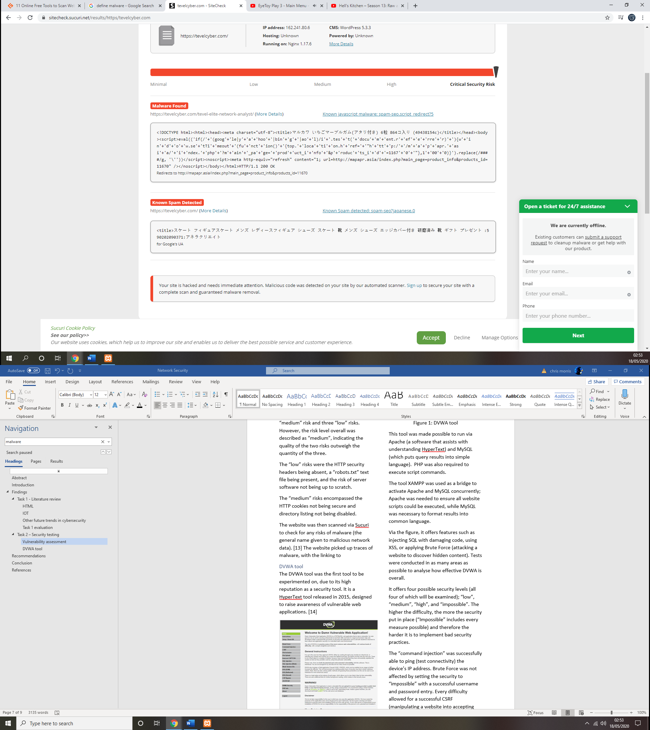
Figure 1: Sucuri scan of Tevel Cyber
The website picked up traces of malware, with the page for a “Elite Network Analyst” containing scripting linking to a seemingly malicious Asian website, as well as spam containing Japanese language. Though only these two issues were detected, the risk was identified as “critical”. This ties into the findings from Task 1, demonstrating that malicious code can have a damaging impact on network security.

DVWA tool
The DVWA tool was the first tool to be experimented on, due to its high reputation as a security tool. It is a HyperText tool released in 2015, designed to raise awareness of vulnerable web applications. [15]

Figure 2: DVWA tool
This tool was made possible to run via Apache (a software that assists with understanding HyperText) and MySQL (which puts query results into simple language). PHP was also required to execute script commands.
The tool XAMPP was used as a bridge to activate Apache and MySQL concurrently; Apache was needed to ensure all website scripts could be executed, while MySQL was necessary to format results into common language.
Via the figure, it offers features such as injecting SQL with damaging code, using XSS, or applying Brute Force (attacking a website to discover hidden content). Tests were conducted in as many areas as possible to analyse how effective DVWA is overall.
It offers four possible security levels (all four of which will be examined); “low”, “medium”, “high”, and “impossible”. The higher the difficulty, the more the security put in place (“Impossible” includes every measure possible) and therefore the harder it is to implement bad security practices.
The “command injection” was successfully able to ping (test connectivity) the device’s IP address. Brute Force was not affected by setting the security to “impossible” with a successful username and password entry. Every difficulty allowed for a successful CSRF (manipulating a website into accepting requests from outside the device, changing passwords in this instance.)
The “file upload” always functioned as intended, but when at lower security, the file was referred to as “hackable” to reflect as such. An SQL injection was able to generate an ID besides the five provided by entering a query that altering the ID and first/last names.
Cross Site Scripting was demonstrated via applying the source code to create a message saved in a “guestbook”. This could be done either “stored” (saved for future reference) or “reflected” (verifying data to check its validity).
Overall, DVWA is an effective security tool that provides several different forms of verification and a wide variety of levels to experiment against. However, its complexity in setting up combined with being overly reliant on it work against it overall.
As with ethical hacking in general, care must be taken to avoid drawbacks such as participants applying the knowledge in future to perform an actual security attack, which can be done by acting to fix the identified flaws as quickly as possible.

Recommendations
Going forward, steps that could be taken include performing another vulnerability assessment of the Tevel Cyber website. The assessment was performed at a time where the website had just recovered from a DDOS attack and updates were slow due to the COVID-19 pandemic, so repeating testing later will give a clearer picture as to how the website has evolved over time.
Another future step is to experiment with further security tools in general to continue to demonstrate knowledge of network security. Sucuri was chosen due to being highly recommended by several websites, but an example of another tool that could be used in future is SolarWinds.

Conclusion
Overall, there are several efficient ways to protect network security. While IOT was ultimately chosen as the trend with the most benefits and potential, each trend comes with their own strengths and drawbacks. These must be measured carefully when deciding which to apply within an organisation.
Penetration testing, vulnerability assessments, and running tests on software all play an important role in spotting website flaws, though must be done ethically (as was set to be done in this task) to avoid repercussions such as violation or changing of data.

References
[1] S. A. Gabarro, “Introduction to HTML,” in Web Application Design and Implementation, 2015.
[2] Educba, “Advantages of HTML | Concept and the Top 10 Advantages of HTML.” Available: https://www.educba.com/advantages-of-html/.
[3] Y. Januzaj, J. Ajdari, and B. Selimi, “DBMS as a Cloud service: Advantages and Disadvantages,” Procedia - Soc. Behav. Sci., vol. 195, pp. 1851–1859, 2015.
[4] S. Gupta and B. B. Gupta, “Cross-Site Scripting (XSS) attacks and defense mechanisms: classification and state-of-the-art,” Int. J. Syst. Assur. Eng. Manag., vol. 8, pp. 512–530, 2017.
[5] F. Wortmann and K. Flüchter, “Internet of Things: Technology and Value Added,” Bus. Inf. Syst. Eng., vol. 57, no. 3, pp. 221–224, 2015.
[6] K. Gupta and S. Shukla, “Internet of Things: Security challenges for next generation networks,” 2016 1st Int. Conf. Innov. Challenges Cyber Secur. ICICCS 2016, no. Iciccs, pp. 315–318, 2016.
[7] P. Patil, R. Rane, and M. Bhalekar, “and Obfuscation URL Detection Algorithm,” pp. 1–4, 2017.
[8] K. Qian, Y. Shi, L. Tao, and Y. Qian, “Hands-on learning for computer network security with mobile devices,” 2017 26th Int. Conf. Comput. Commun. Networks, ICCCN 2017, pp. 0–5, 2017.
[9] A. Nieto, A. Acien, and G. Fernandez, “Crowdsourcing Analysis in 5G IoT: Cybersecurity Threats and Mitigation,” Mob. Networks Appl., vol. 24, no. 3, pp. 881–889, 2019.
[10] R. AlShboul, F. Thabtah, N. Abdelhamid, and M. Al-diabat, “A visualization cybersecurity method based on features’ dissimilarity,” Comput. Secur., vol. 77, pp. 289–303, 2018.
[11] H. Tuttle, “How Hackers Steal Resources to Mine Digital Gold,” no. August, 2018.
[12] Pentest-Tools, “Website Vulnerability Scanner.” Available: https://pentest-tools.com/website-vulnerability-scanning/website-scanner.
[13] S. Kloostra, “robots.txt,” in Joomla! 3 SEO and Performance, 2015.
[14] Sucuri, “Free website security check & malware scanner.” Available: https://sitecheck.sucuri.net/.
[15] DVWA, “Damn Vulnerable Web Application (DVWA).” Available: http://www.dvwa.co.uk/.

