Data Handling & Business Intelligence Component 1

Executive summary
The report covered the company, pip & nuts along with a huge focus on its technological upgradation and integration of technologies such as BI, AI, DW, DM, etc. It also took into account data mining techniques like clustering and association rules along with their effectiveness. Predictive analysis along with tools like Power BI, SPSS, Excel, RapidMiner were also highlighted. Ethical considerations and concerns featuring GDPR were also covered in this report and they provided solutions that can help in protecting confidential data of individuals.

Table of Contents
Executive summary 2
Introduction 4
Trends in BI, DW, DM 4
Data warehousing in the organisation applications 5
Data mining techniques 6
Predictive analysis 7
Ethical and data security considerations 9
Reporting and dashboard solutions 10
Conclusion 10
References 12
Appendices 14

Introduction
Technological upgradation is the need of the hour and implementation of technologies like BI, DW, DM, etc., helps in predicting the behaviour of the market segment. The company, Pip & Nut is a food and beverage based company in UK. The core aim is to produce natural and oil free snacks. The company is highly engaged in sustainability initiatives. The company uses authentic oleic peanuts as a secret ingredient. It also works with peanut growers of Argentina to produce sustainable peanuts (Pip and nut, 2025). The sector is operates is a retail sector and the huge focus is on nut butters. The sector is filled with health conscious individuals and the focus is heavily on packaged food items.
The core purpose of the report is to identify the core concepts of BI, DW, DM, AI and related technologies. It will also highlight the current trends along with connecting things with the chosen organisation. Data mining techniques such as clustering and association rules will also be discussed. Ethical concerns along with necessary recommendations will also be highlighted throughout.

Trends in BI, DW, DM
BI, also termed as business intelligence is a technology that helps in conversion of relevant data and information into an actionable information so that strategic objectives or goals can be made. DW, also known as data warehouse is a technology which is a huge digital storage technique via which data from various sources is extracted and kept in the warehouses so that access can be gained (Paramesha, Rane, and Rane, 2024). DM, also termed as data management is a technique of collecting data and information and protecting them and also to make sure the data is reliable.
Talking about real time BI, it uses IoT and social media platforms to take data so that delays can be eliminated and market demand can be met. But, it comes with a high cost and it is not possible for a medium enterprise to integrate it. Cloud warehousing such as Snowflake helps in saving cost and time as businesses can easily manage inventory level (Kashyap, 2023). While, heavy dependency on one cloud provider can be a major challenge. AI integration helps in predicting the behaviour of target market segment but the private data of consumers can be leaked.
Data warehouse helps in maintaining data and information of various companies at once and the application of Kimball DW architecture can prove to be beneficial for better understanding.
Star schema- This helps in organising the data and information in a tabular form with relevant facts and it takes into consideration profit margin or total sales. This facilitates businesses in simplifying the core activities and things are presented via evidence. Facts table are there to represent sales amount and sold quantity.
Conformed dimensions- Dimension table with proper arrangement which is then shared with various star schemes. Example- a dimension table of product can be used when details regarding sales have to be known.
While the application of CRISP-DM model is more appropriate as it takes into account understanding of the business, information preparation, business model, monitoring and applying the model (Schröer, Kruse, and Gómez, 2021). It ensures that forecasting tactics are aligned with needs of the organisation.
Example- Pip & Nut’s using Amazon for marketing purposes. It helps the organisation in forecasting the trends and interests of the target market segment via the determination of buying history.

Data warehousing in the organisation applications
Data warehousing is a technique of storing data and information of the target market segment so that during the time of emergency, such can easily be extracted. The data facilitates organisations in making strategic decisions regarding key areas of business like marketing, sales and finance (Nambiar, and Mundra, 2022). Pip and nut can also take the advantage of data warehousing by collecting the data of individuals and making strategic analysis. The company can easily identify total sales across all the platforms and in this way, it can come to know the effectiveness of each platform.
Improvement of data access and efficiency
It enhances the quality of the data via the help of extract, transform and load mechanism that it generally follows. It can also help the marketing department of the company and tailored marketing campaigns can easily be formed. Data can easily be accessed and the company can determine the key areas for improvement like reasons for lack of demand, failed marketing campaigns, failed innovation, etc. It also helps in prioritising the necessary tasks with the help of advanced analytics. It can also help the company in identifying complex data into simpler form if the company lacks technical knowledge. It is also connected with ample amount of tools and the major one is BI and this helps in gaining a visual pleasure so that informed decisions can be made.
DW supporting strategic decision making
This technique helps in making strategic decision as the organisation can easily determine the past purchases of the customers and diets to produce related food items. DW is the key driver for BI techniques because it helps in providing dashboards that are embedded with relevant information like common trends, past purchase behaviour, market demand, etc. (Nambiar, and Mundra, 2022). Competitors often rely on manual process and track record via maintaining a journal but the company can take the advantage of via introducing DW system. Strategic planning can also be made and financial analysis can easily be made as the organisation can gain a deep insight into the success of a new food item so that further investment can be made.
Examples- the organisation is also engaged in the adoption of this and it can be seen in the form of sales reporting as well as supply chain consolidation. The organisation can extract information regarding sales and the most profitable food item can be determined to make marketing campaigns for. Talking about supply chain consolidation, DW can help in making an ethical supply chain with the help of extracting data of the supply chain such as inventory, shipping related evidence, etc.
The core competitor of the company is Justin’s nut butter, which lacks DW technique while Pip & nut is highly engaged in the adoption of DW. Justin’s nut butter finds difficulty in comparing the record of sales across multiple channels. While Pip & Nut can easily make strategic decisions with a predictive analysis.

Data mining techniques
The very first technique of data mining is clustering and it takes into consideration dividing of data points and joining the common ones together. The core aim is the creation of different groups of common interests. The common example is of dividing the market segment on the basis of premium or budget conscious individuals (Oyewole, and Thopil, 2023). Another major technique is association rules, which helps in determining relationship between several items (Jain, 2023). A common example is of retail industry in which data is extracted and it is identified which items are more likely to be purchased together and then such items are placed at the same place to grab the attention of customers.
Relevance to the organisation's data and goals
The clustering technique is highly aligned to the chosen organisation, pip and nuts as the company deals with variety of food items and identification of segmentation can be helpful in creating tailored marketing messages for each segment. Example- an advertising campaign showing gym freaks and food items for health conscious individual is shown while another camping can be formed for food enthusiasts and it can take into consideration showing advertisements of chocolate peanut butter. Association rules is also aligned as the organisation can offer combos on the basis of the information gained via this technique. Also, website can contain content related to the same via showing suggestions to people who bought items similar to others.
Tools or platforms that support these techniques
Tools for clustering consist of open source software that helps in the creation of nested cluster. Data visualisation is another major tool that helps in picturising the data to enable the company making better decisions based on the visuals (Uddin, 2024). For association rules, Tableau is the major tool that helps in visualising the data. Open source software is also its cote tool and it helps in making combinations of items being purchased together.

Predictive analysis
Predictive analysis tools
Elements | Power BI | SPSS | Excel | RapidMiner
Features | Anomaly detection and visual insights. | Advanced algorithms help in gaining key statistics. No coding is required for understanding the pattern and makes the process easier. | Consist of embedded formulas for forecasting related to time series. ToolPak helps in performing regression related questions. | No heavy coding is needed and machine learning is its core feature. It is also connected with cloud storage.
Usability | Easy to use as it is similar to excel but demands deep information regarding tough data. | Simplifies complex data and can help pip & nuts in understanding the data structure without programming language related knowledge. | Spreadsheet related knowledge is enough to operate this but it is a time consuming process. | Graphs are there to analyse the information and can be used easily by individuals with basic knowledge as well as those embedded with advanced skills.
Integration | Embedded into Microsoft ERP techniques such as Azure. | Can easily be embedded into organisation’s database and provides per minute details. | Third party techniques are to be taken into consideration for better integration. | It is integrated with SQL, cloud storage, Spark, etc.
Reporting and forecasting | Dashboards are distributed automatically and real time information can easily be accessed. | Helps in automating repetitive activities. Predictions are also made accurately. | Pivot tables and formulas are often used to automate tasks and predictions are made via charts and graphs. | Embedded picturising tools are there to forecast future needs. All the necessary tasks present in this are automated.

The company, pip & nits is suggested to go for Excel as it is easy to operate and is also embedded with advanced features and techniques.

Ethical and data security considerations
GDPR and various regulations
The company is suggested to use GDPR regulations so that private information of the individuals can be kept safe. The data of the customers collected for a particular purpose also cannot be used to diverse objective as this can be termed as breach of data. It is also essential to integrate privacy and security in BI, AI, DW and DM techniques.
Data ownership, consent, and transparency
The company performs the role of a custodian during the maintenance of private information of individuals but people possess the rights to own their data and it is the responsibility of the company to protect such. Consent is another major concern for ethical practices as it is necessary to ask permission of the customers before using their personal data for marketing campaigns (Lukic, Miller, and Skiera, 2024). Transparency is essential to build great relationship, using concise language can be helpful.
Access controls, encryption, and other safeguards
Safeguards are essential to embedded organisation with technologies and the company ought to integrate heavy security so that strong access can be made and restricting data is necessary. Encryption is ought to be implemented as well for warehouse and in transit items.
Internal (employee misuse) and external (cybersecurity) threats
Internal threats need to be addressed and it takes into consideration using of private data of customers by the employees while external threats like attackers can be a major threat. These can be controlled by adopting strong GDPR rules.

Reporting and dashboard solutions
BI dashboards
The BI dashboards that can be used by pip & nuts are power BI and Tableau, which can help in providing minute details of the target market segment to the company (Zamil, Mohiuddin,. and Mamun, 2024).The dashboards can also help in tracking marketing campaigns’ effectiveness, sales, supply chain management, etc.
Their value for real-time monitoring and decision-making
The dashboards can help in assessing the behaviour of the customers as well as the market demand. They can provide details regarding total sales from all the channels and the company can make decisions regarding selling of food items on the most effective platform. Marketing dashboard can prove to be beneficial in determining the success of marketing campaigns and total traffic on the website as well as reach on social media platforms. Real time supply chain monitoring can also be made and with the help of this, an ethical supply chain can easily be produced.
Metrics/KPIs
One of the major KPI to track is growth in revenue because it can help in tracking annual sales and the total profit margin. Customer lifetime value is also a core KPI and it takes into consideration determination of loyal customers. Customer acquisition is also important to track as it helps in identifying the effectiveness of google ads and pay per click.

Conclusion
From the above, it can be concluded that it is essential for large companies to adopt ample amount of technologies as technological upgradation can facilitate in grabbing major opportunities. The presence of technologies such as BI, DW, DM, AI, etc., helps in tracking the behaviour of target market segment and with the help of this, tailored marketing campaigns can be generated in no time. Apart from this, it can also be concluded that data mining technique are also essential to take into account as such can help in extraction of relevant and authentic data as well as information. Also, the application of Kimball’s DW architecture can prove to be beneficial in understanding data warehousing better. The major recommendation is to build a trustable relationship with the customers by protecting their data and seeking permission before using personal data. The company, pip & nuts also adopted such technologies to ensure coping up with the dynamic environment and fulfilling the market demand. Power BI, SPSS, Excel, RapidMiner are another major tools for future predictions and can help in picturising things so that strategic decisions can be formed easily.

References
Books and journals
Jain, Y., (2023). An efficient association rule hiding algorithm for privacy preserving data mining. International Journal.
Kashyap, R., (2023). Data Sharing, Disaster Management, and Security Capabilities of Snowflake a Cloud Datawarehouse. International Journal of Computer Trends and Technology, 71(2), pp.78-86.
Lukic, K., Miller, K.M. and Skiera, B., (2024). The impact of the general data protection regulation (gdpr) on online tracking. Available at SSRN 4399388.
Nambiar, A. and Mundra, D., (2022). An overview of data warehouse and data lake in modern enterprise data management. Big data and cognitive computing, 6(4), p.132.
Nambiar, A. and Mundra, D., (2022). An overview of data warehouse and data lake in modern enterprise data management. Big data and cognitive computing, 6(4), p.132.
Oyewole, G.J. and Thopil, G.A., (2023). Data clustering: application and trends. Artificial intelligence review, 56(7), pp.6439-6475.
Paramesha, M., Rane, N. and Rane, J., (2024). Big data analytics, artificial intelligence, machine learning, internet of things, and blockchain for enhanced business intelligence. Artificial Intelligence, Machine Learning, Internet of Things, and Blockchain for Enhanced Business Intelligence (June 6, 2024).
Schröer, C., Kruse, F. and Gómez, J.M., (2021). A systematic literature review on applying CRISP-DM process model. Procedia computer science, 181, pp.526-534.
Uddin, M.K.S., (2024). A review of utilizing natural language processing and AI for advanced data visualization in real-time analytics. Global Mainstream Journal, 1(4), pp.10-62304.
Zamil, M.H., Mohiuddin, M. and Mamun, M.N.H., (2024). Business Intelligence Systems In Finance And Accounting: A Review Of Real-Time Dashboarding Using Power BI & Tableau. American Journal of Scholarly Research and Innovation, 3(02), pp.52-79.
Online

Coupler, (2024). Power BI Architecture: a Complete Guide to Mastering the Platform. [Online]. Assessed through: <https://blog.coupler.io/power-bi-architecture/ > [Assessed on: 15th October, 2025].
Geeks for geeks, (2025). Top 11 Best Data Analytics Softwares That You Must Know. [Online]. Assessed through: < https://www.geeksforgeeks.org/data-science/top-11-best-data-analytics-softwares-that-you-must-know/ > [Assessed on: 15th October, 2025].
Grand view research, (2025). Data Mining Tools Market (2025 - 2033). [Online]. Assessed through: <https://www.grandviewresearch.com/industry-analysis/data-mining-tools-market-report> [Assessed on: 15th October, 2025].
Pip and nut, (2025). Our ingredients. [Online]. Assessed through: < https://www.pipandnut.com/pages/our-nuts?srsltid=AfmBOopxyAd8B1CC3k9gW-nVrHQl5658MawWXzqpbEcik7ngOyRd0nLV > [Assessed on: 15th October, 2025].

Appendices

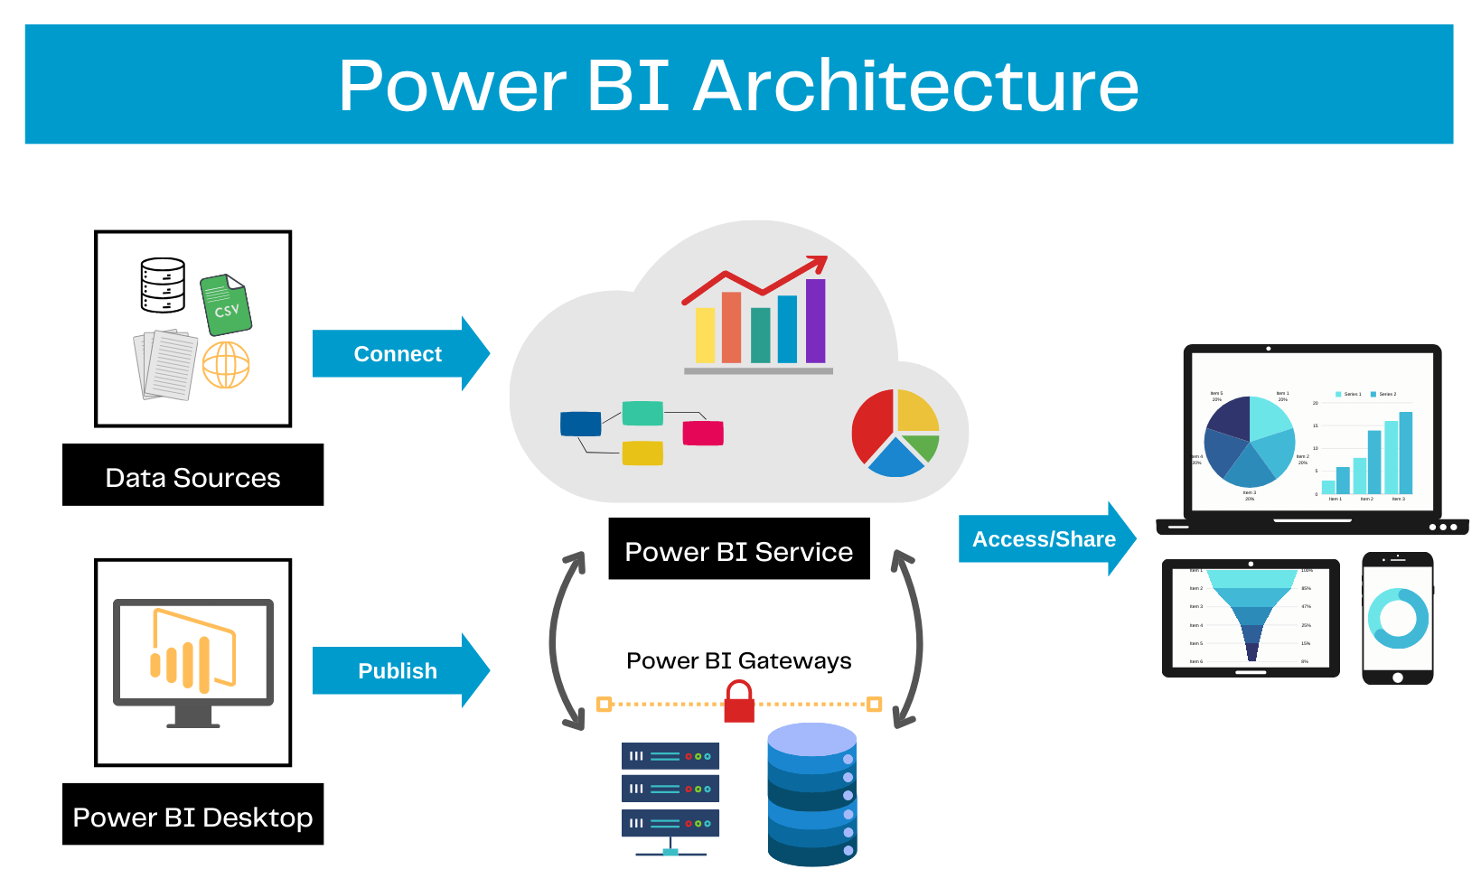https://blog.coupler.io/power-bi-architecture/
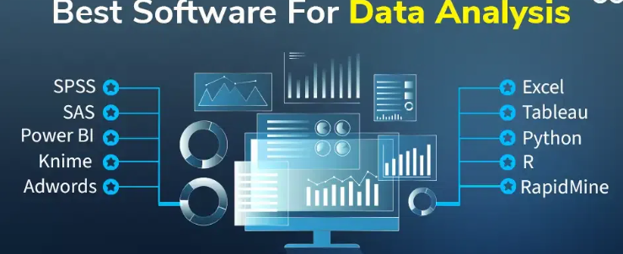https://www.geeksforgeeks.org/data-science/top-11-best-data-analytics-softwares-that-you-must-know/
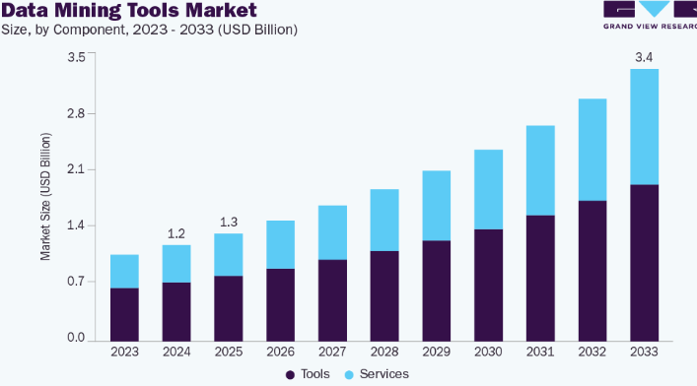https://www.grandviewresearch.com/industry-analysis/data-mining-tools-market-report

