Consultancy Report
By Manu’s Consultancy Company
For The Royal Hotel Clacton on Sea

Module: Organisational Consultancy
BMIH6005

Lecturer: Gayathri Nadeeshani Senanayake Mudiyanselage
Student: Radasanu Manuela 2021029
Level 6
Content page:
- Executive summary…………………………………………………. pp. 3-5
- What are the tasks for a consultancy report? …………………. pp. 5-6
- Introduction …………………………………………………………. pp. 7-9
  - What are the Advantages for a good hotel management?.. pp. 9-11
  - Strategic plan for hospitality industry………………………. pp. 11-12
- SWOT Analysis for The Royal Hotel ……………………………. pp. 12-13
- PESTEL Analysis of The Royal Hotel …………………………… pp. 14-15
- TOWS Analysis the Royal Hotel …………………………………. pp. 15-16
- Fish bone frame for The Royal Hotel …………………………… pp. 17-21
7.1 How the customer service department of The Royal hotel can be improved? ……………………………………………………………. Pp. 21-23
8. Cleaning and maintenance department ………………………….. pp. 24
9. Table/ structure problem vs. timeframe …………………………. pp. 25
10. Porter’s Five Forces ………………………………………………… pp. 26-28
11. The Strategic Choice Cascade ……………………………………. Pp. 28-30
12. KPI in a hotel …………………………………………………………. Pp. 30
12.1 Price matching ………………………………………………. pp. 31
13. Action Plan …………………………………………………………. pp. 32-33
14. Conclusion …………………………………………………………... pp. 34-35
15. References …………………………………………………………... pp. 36- 47

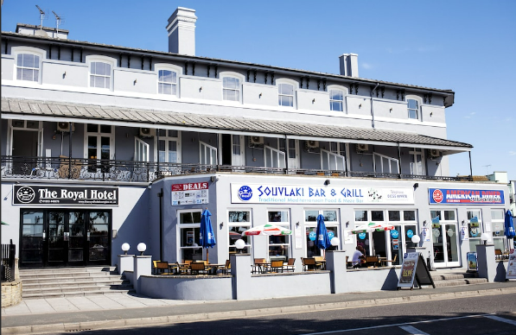
1.Executive summary
(www.theroyalclacton.co.uk),
For the past few months, Manu’s Consultancy has been working with the The Royal Hotel to analyse the various financial and operational procedures of the facility. Using Fish Bone, Cascade Framework and KPI the consultant was able to identify areas of improvement and enhance the efficiency of the hotel's operations. The five main pillars: leadership, policies, resources, people, and systems (Wiles, 2021).
Through an environmental scan, the consultant was able to identify the various factors that affect the operations of the hotel. The report also highlighted the key information that the company was able to provide to the hotel. This information helped the consultant in formulating a strategy to improve the customer service and maintenance department of the hotel. The manager of the Royal Hotel has undergone various changes over the past six months and is in strong collaboration with the consultant to create the best result (www.forbes.com). There were various factors that affected the maintenance operations and the front desk of the hotel. Some of these include the poor financial performance of the hotel, high running costs, lack of communication and trained staff. The objective of this consultancy strategy is to make the staff members more aware of the various aspects of the management's plan and implement them in a manner that will make them more motivated and contribute to the hotel's performance.
The consultant also suggested using the SWOT, PESTLE, and TOWS to identify the various challenges that the hotel faces. It said these tools can help the management identify areas of improvement where they can make the necessary changes. The report also noted that the standards implementation of investors around maintenance and staff training could help boost the hotel's sales and profitability. During the inspection, the consultant discovered that the hotel has no standard operating procedures. Although the general manager was aware of the issue, he said that he was still determined to implement it because it was the work of the previous manager.
The report will recommend new value and mission statement for the hotel:
The Mission Statement
To create a pleasant and memorable experience for each guest.
Organisation values:
• Quality maintenance
• Communication
• Client - Focused
• Innovation
• Fun
The consultant also suggested that the hotel establish a culture of continuous improvement and develop a training program for its employees. It should additionally regularly carry out an external and internal audit to monitor its operations.
The records of the hotel should also be regularly monitored to ensure that they are to comply with the requirements of the law. They should additionally ensure that the employees are following proper procedures and that the environment is safe and clean.
The hotel's facilities management is another issue that the hotel should address regularly. One of the main reasons why the hotel has a poor maintenance program is due to the retirement of its maintenance man. He reportedly doesn't care about providing the best possible service because he's already retired and doesn't want to continue working.
The report noted that the overworked maintenance man and another employee are contributing factors to the hotel's poor facilities management. It suggested that the hotel hire more staff members.
Another issue that the consultant identified was the lack of methods for collecting feedback from the customers. It was suggested that the hotel establish an online survey and a form of nonverbal feedback to gather opinions and views from its customers. The consultant suggested that the hotel create a housekeeping strategy that involves increasing the number of staff members per shift and developing a checklist that will help them meet the cleanliness and maintenance standards. They should also clean all surfaces, change the beds, and disinfect the electrical equipment to prevent the expense of diseases (Example Covid-19), (reviewproblog.shijigroup.com).
The goal of the consultancy firm was to improve the morale of the hotel's employees and motivate them to work harder to implement the best service to its customers (Kanter, 2012). This strategy should be implemented to boost the hotel's sales and improve its operations.
The objective of this project is to help the hotel make a fresh start and improve its services.
The objective of the consultancy firm is to help the hotel establish a bold new start and improve its operations. Doing so will allow it to achieve high sales and profitability indexes (Elberse, 2013).
2.What are the tasks for a consultancy report?
According to McGhee (2003) & (www.climbtheladder.com).
1. Gather information: Conduct research and interviews to collect data related to the project.

2. Analyse data: Interpret the information and identify patterns, trends, and insights.

3. Develop recommendations: Based on the analysis, formulate recommendations for the client.

4. Write the report: Organize and write the report, including an executive summary and clear conclusions.

5. Present the report: Deliver the report to the client and discuss the findings and recommendations.

Advantages:
-A consultancy report can provide an unbiased, independent evaluation and analysis of an organization's operations and performance.
-It can provide valuable insight into areas of the organization that may be inefficient or underperforming.
-It can also provide recommendations for improvement and provide guidance for the organization to move in the right direction.

Disadvantages:
-The cost of hiring a consultant can be expensive and may not be affordable for all organizations.
-The consultant may not be familiar with the organization's culture, operations, or performance, which can lead to inaccurate or incomplete analysis.
-The report may also be outdated or irrelevant, as the external consultant may not have access to the most up-to-date information or trends (www.slidemodel.com),

3.Introduction
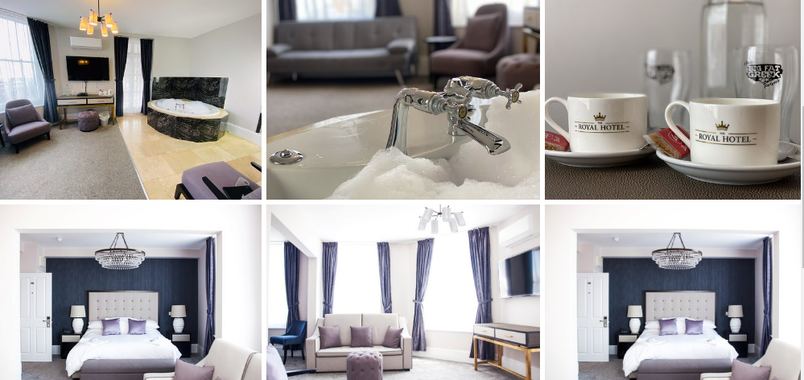
(www.theroyalclacton.co.uk).
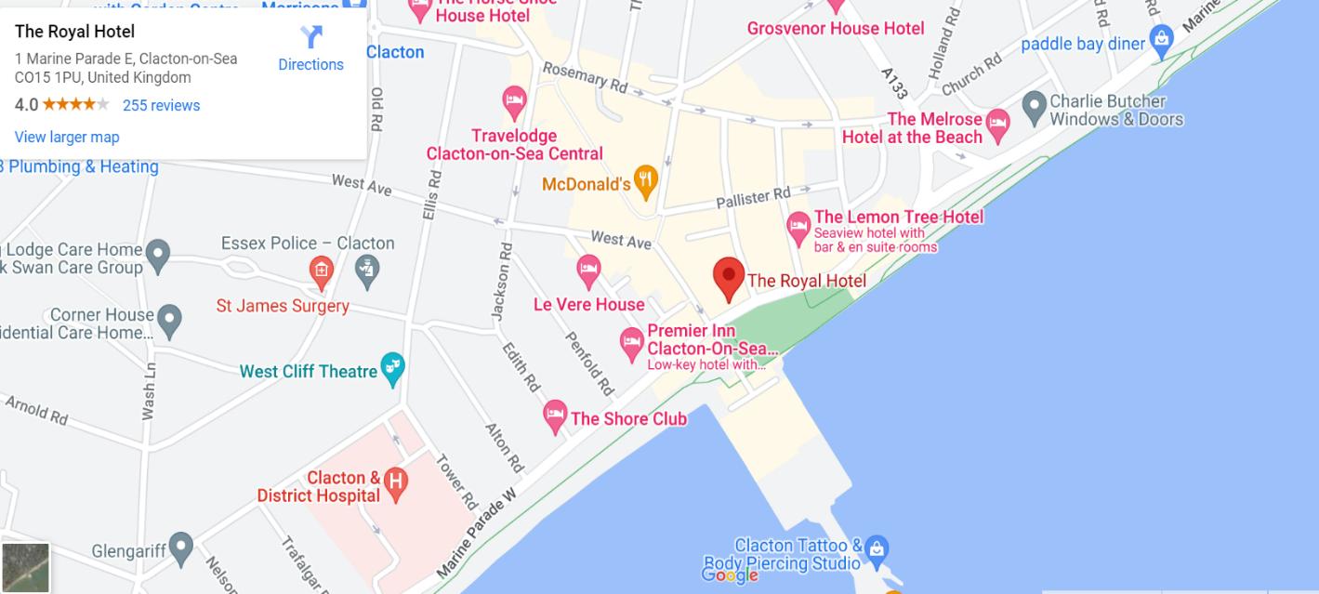
(Googlemaps.com),
The Royal Hotel in Clacton on Sea is a great place to stay when visiting the area. Located on the seafront, the hotel offers magnificent views of the beach and pier, creating an ideal atmosphere for a holiday, business travel or weekend away. The hotel offers a range of facilities, such as a restaurant, bar, and a heated swimming pool. The restaurant and bar are popular for their delicious Greek Mediterranean (The Big Fat Greek Restaurant) food and drinks, while the pool is perfect for cooling off during the summer months or the unique jacuzzi located in most of the rooms. The rooms at the hotel are comfortable and well appointed, with a range of amenities such as tea and coffee making facilities, television, and free Wi-Fi, jacuzzi. All rooms are in-suite and come with personalized towels, soap, shampoo, and body lotion. There are also a range of activities and attractions in the surrounding area, such as golf courses, theme parks, and historical sites (www.theroyalclacto.co.uk). The hotel also offers a variety of packages, ranging from romantic breaks to active getaways. The Royal Hotel in Clacton on Sea is an ideal place to stay for those looking for a relaxing break or an active holiday. With its great location and range of facilities, it offers everything you need for a great stay. But to all this great factors it needs to be added well trained front desk staff and a very good maintenance and cleanliness of the building and rooms.
A consultancy report is a document produced by an external consultant or consulting firm that provides analysis and recommendations to an organization. It may be used to address a specific issue or need, or it may be used to provide an overall assessment of an organization's current situation (Hollander,2022).
As a consultant, there are several areas to focus on to improve the Royal Hotel in Clacton. Here are some suggestions:
Customer experience: First most important aspects of a hotel is the experience it provides to its customers. Focus on enhancing the guest experience by ensuring that the hotel is clean, well-maintained, and equipped with modern amenities. Warm and welcoming atmosphere, staff to be friendly and helpful, and offering personalized services to guests (Homburg & Stock, 2018).
Marketing and branding: It are essential to have a strong brand image and a well-defined marketing strategy to attract customers. Conduct market research to understand the target audience and tailor the branding and marketing efforts accordingly. Utilize social media, email marketing, and other digital marketing channels to reach out to potential customers (Campbell, 2023).

Revenue management: Optimize pricing strategies to maximize revenue while ensuring that prices remain competitive. Analysing demand patterns, using dynamic pricing tools, and offering attractive packages and promotions (Wang,2012).
Facilities and amenities: Evaluate the current facilities and amenities offered by the hotel and identify areas for improvement. Add new amenities like a fitness centre, to attract guests looking for these features. Also, invest in upgrading existing facilities to ensure that they are modern and functional.
Sustainability: Implement environmentally friendly practices to attract eco-conscious guests. Is possible by reducing energy and water consumption, minimizing waste, and using eco-friendly materials and products throughout the hotel (Costa & Costa,2022).
By focusing on these areas, Royal Hotel's reputation can be improved and attract more guests, ultimately increasing revenue and profitability.

3.1 What are the Advantages for a good hotel management?
1. Improved Customer Service: A good hotel management system can help improve customer service by providing faster and more efficient service. It can also help hotel to better understand customer preferences and needs, leading to increased customer satisfaction.
2. Increased Efficiency: A hotel management system can help streamline processes and automate mundane tasks, thus increasing the efficiency of operations. It can also help to reduce wait times for guests, leading to better customer experiences.
3. Improved Revenue Management: Hotel management systems can help hotels better track their revenue, leading to more accurate forecasts and better budgeting. It can also help hotel set pricing that better reflects the demand for their services, thus increasing their revenue (Wood, 2015).

4. Enhanced Security: Hotel management systems can help improve security by providing better access control and monitoring of guests. It can also help track suspicious activity, thus reducing the risk of theft and fraud (Rutherford & O’Fallon,2007).
5. Reduced Operational Costs: A good hotel management system can help reduce operational costs by automating manual processes and reducing labour costs. It can also help reduce the amount of energy and resources used, thus reducing the hotel’s environmental impact (Wood, 2015).
According to Hayes, (2009), The hospitality industry is rapidly changing, with several trends emerging in terms of consumer preferences, technology, and competition. Companies must stay abreast of these changes to remain competitive. By understanding the current state of the industry, companies can position themselves strategically to capitalize on new opportunities and remain successful.

Consumer Preferences According to Sarma (2018).
Consumer tastes and preferences in the hospitality industry have shifted significantly in recent years. Consumers have become strongly focused on convenience, sustainability, and affordability. As a result, there is a growing demand for online booking services, delivery options, and eco-friendly amenities. Additionally, consumers are seeking out more diverse dining and entertainment experiences.

Technology According to Vidal (2019),
Technology is a major factor in the hospitality industry, with customers expecting a variety of online services and options. Mobile applications, online booking systems, and automated checkout systems are all becoming more and more common. Additionally, the use of artificial intelligence, machine learning, and voice recognition systems is increasing, allowing for more personalized and efficient customer service.

Competition According to Bahar, et.al., (2022)
The hospitality industry is highly competitive, with an increasing number of players entering the market. This has resulted in increased competition on prices, as well as an increase in the number and variety of services offered. Additionally, the industry is seeing a shift towards boutique-style hotels and restaurants, as well as the emergence of new trends such as pop-up restaurants and food trucks.

3.2 Strategic plan for hospitality industry.
1. Develop a comprehensive understanding of the hospitality industry: Research and analyse key trends and issues within the hospitality industry, such as customer service, technology, marketing, and cost control. Understand the competitive landscape, customer preferences, and regulatory requirements (hospitalityinsights.ehl.edu),
2. Develop a customer-centric culture: Develop a customer-centric approach by creating a culture of customer-centricity and customer service excellence. Focus on providing an excellent customer experience that meets customer needs and expectations. Leverage technology and data to provide personalized service (Guido, et.al., 2015).
3. Build a strong brand: Develop a strong brand identity that resonates with customers and conveys the values and mission of the hospitality business. Create a unique voice and point of view in the industry, and leverage marketing and social media to tell the story of the brand (Hollis, 2010).
4. Invest in technology: Invest in technology to enhance operations, improve customer service, and increase efficiency. Develop a technology strategy that enables the business to stay ahead of the competition and meet customer needs.
5. Enhance operational efficiency: Implement best practices in operations to improve efficiency and reduce costs. Streamline processes, measure performance, and use data to make decisions (Guido, et.al, 2015).
6. Develop a strong workforce: Recruit, develop, and retain the best talent in the hospitality industry. Invest in training and development to ensure that employees are well-equipped to deliver excellent customer service.
7. Develop a marketing strategy: Develop an effective marketing strategy to reach new customers and retain existing customers. Leverage digital and traditional marketing channels to promote the brand, products, and services.
8. Measure and monitor progress: Track and measure progress to ensure that the strategic plan is on track. Measure the effectiveness of initiatives, customer feedback, and customer satisfaction.
9. Monitor the competitive view: Monitor the competitive view to keep ahead of the competition. Analyse market trends and customer preferences to adjust the strategy as needed (Hollis,2010).

4. SWOT Analysis for The Royal Hotel
(www.cipd.co.uk),
Strengths | • Prime location in the heart of the city.  • High quality service and amenities, with a wide range of luxurious rooms and suites.  • Well-known and respected brand with a long history.  • Diverse range of dining and entertainment options.  • Experienced and knowledgeable staff.
Weaknesses | • Competition from other hotels in the area.  • High prices may deter some customers.  •Limited advertising and promotion budget.  • Lack of parking spaces  • Weather may affect the hotel
Opportunities | • Expansion into new markets such as business travellers and family vacations.  • Increased presence on social media and other digital platforms.  • Cross-promotional opportunities with other businesses.  • To create MICE events at the hotel restaurant and.  • Contributes to local economy
Threats | • High staff turnover rates  •Limited staff trainings  • Outdated services and no renovation  • Increased profits  • Tax holidays  • Expansion and growth  • Growing competitors  • Changing consumer preferences and tastes.  • Economic downturns that could lead to decreased consumer spending.  • Increased competition from budget hotels.

5. PESTEL Analysis of The Royal Hotel
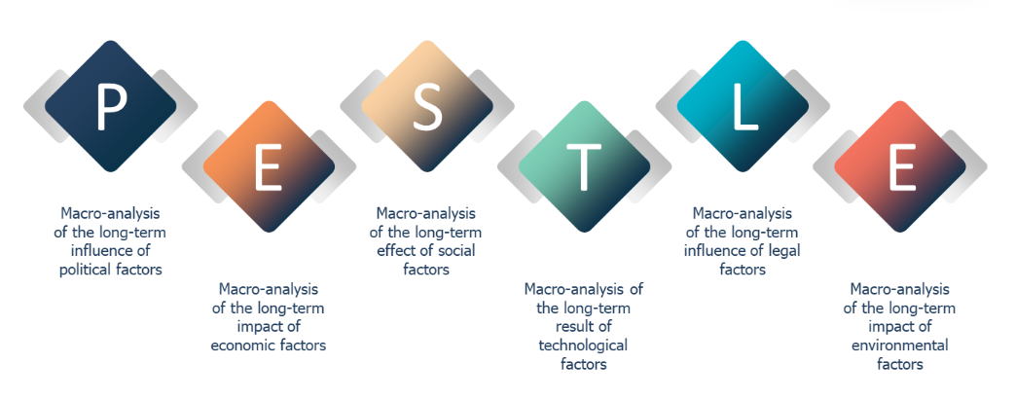
(google/image) & (www.cipd.co.uk).
Political: The Royal Hotel is based in a country with a stable political climate, meaning that the hotel and its operations are not exposed to any political risks. The local government also provides incentives for businesses and investment, which could benefit the hotel in the future.
Economic: The Royal Hotel is in a growing economy, which has helped to attract more customers and tourists to the area. The hotel is also able to benefit from a competitive exchange rate, providing guests with value for money.
Social: The Royal Hotel is in an area with a diverse and vibrant culture, which helps to attract a range of customers and visitors. The hotel also has a strong commitment to providing a positive customer experience, as well as a commitment to sustainability.
Technological: The Royal Hotel has adopted several modern technologies to improve its operations and customer experience. This includes online booking systems, virtual reality tours, and automated check-in and checkout.
Environmental: The Royal Hotel is committed to reducing its environmental impact and has implemented a range of sustainable practices. This includes reducing energy consumption, using renewable energy sources, and reducing waste.
Legal: The Royal Hotel is subject to a range of local and international laws and regulations. This includes employment laws, health and safety regulations, and rules relating to the sale and consumption of alcohol.

6. TOWS Analysis the Royal Hotel

The TOWS analysis table helps The Royal Hotel identify strategies that leverage its strengths, mitigate its weaknesses, capitalize on opportunities, and minimize threats. By implementing the recommended strategies, The Royal Hotel can improve its overall performance and gain a competitive edge in the Clacton on Sea hospitality industry.
(Momin, 2021 & www.online.visual-paradigm.com).
SO  Strengths/Opportunities  Strategies (Maximize Strengths) | - Implement customer service training programs to improve service quality.  - Develop and implement a sustainability strategy to attract eco-conscious customers.  - Develop a targeted marketing strategy to attract more staycation customers
WO  Weaknesses/ Opportunities  Strategies (Overcome Weaknesses) | - Invest in staff training to improve service quality and reduce complaints.  - Hire an external maintenance and cleaning company to improve the hotel's overall cleanliness and appearance.  - Offer special promotions and discounts to attract more customers during off-season periods.
ST  Strengths/ Threats  Strategies (Minimize Threats) | - Conduct a competitive analysis and develop a strategy to differentiate the hotel from its competitors.  - Develop contingency plans to reduce costs and increase revenue during economic downturns.  - Develop a targeted marketing strategy to attract customers during off-season periods.
WT  Weaknesses/ Threats  Strategies (Mitigate Weaknesses and Threats) | - Offer competitive pricing and special promotions to attract customers away from competitors.  - Diversify revenue streams by offering additional services such as event hosting or catering.  - Partner with local businesses and attractions to offer packages that promote tourism during off-season periods.

- Fish bone frame for The Royal Hotel
(www.managementconsulted.com, 2022)
Problems: Poor customer service, maintenance, and cleanliness at The Royal Hotel
Cause
1. Unclear customer service standards
2. Untrained staff/ to old
3. Poor customer service policies
4. Old equipment
5. Lack of staff, training, and manager communication
Effect
1. Unhappy customers
2. Low customer satisfaction
3. Negative reviews

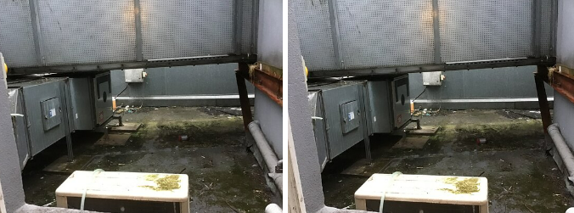
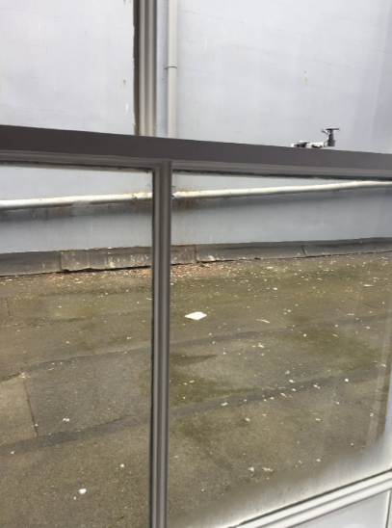

(www.tripadvisor.com).
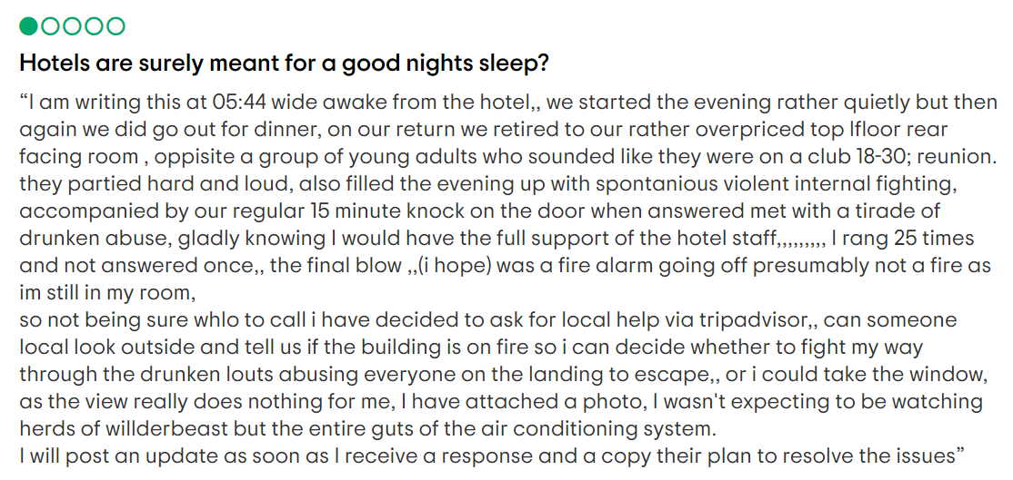

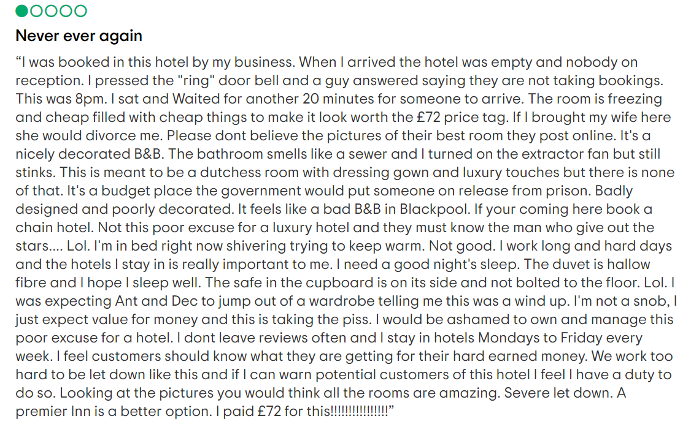
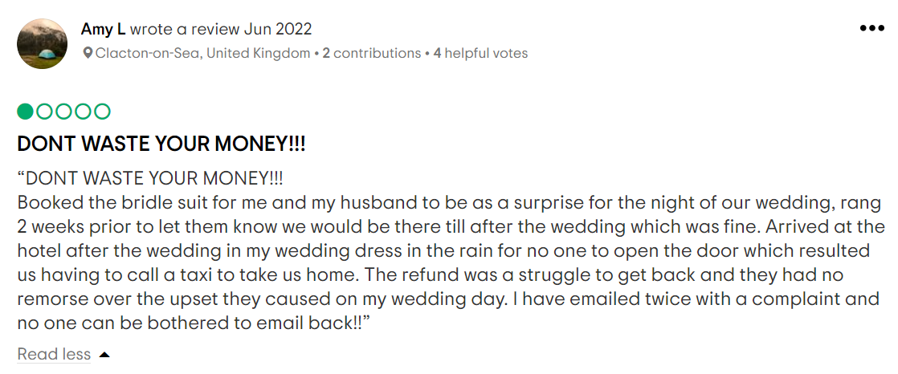
(www.tripadvisor.com)
A customer service department is a division within a company that is responsible for interacting with customers and providing them with assistance, support, and answers to their questions. This department is typically responsible for handling customer inquiries, complaints, and feedback, as well as providing product and service information (Heppell, 2015).
Advantages:

1. Enhances the customer experience: Offering customer service in a hotel industry allows customers to have their queries answered quickly and efficiently, leading to a better overall customer experience.
2. Improves customer loyalty: Consistent customer service helps to build customer loyalty, as customers feel they are being heard and taken care of.
3. Helps to increase sales: By providing customer service, hotels can identify customer needs and provide solutions that can lead to increased sales.
4. Enhances customer satisfaction: Providing customer service leads to increased customer satisfaction as customers feel that their needs are being met.
(www.yumpingo.com, 2021).

Disadvantages:
(www.indeed.com, 2022).
1. Costly: Providing customer service can be costly, as it requires staff, technology, and other resources.
2. Time consuming: Depending on the complexity of the customer’s query, providing customer service can be time consuming.
3. Lack of training: Without proper training, customer service staff may not be able to provide the best possible service.
4. Negative feedback: If customer service is not up to date, customers may take to social media to express their dissatisfaction (www.bbc.co.uk).
Having a well-trained staff is essential for any hotel. A well-trained staff can ensure that guests have a positive experience and make a lasting impression. It is important for the staff to be able to anticipate and provide the guests with their needs. However, a an-trained staff:
1. Poor Service Quality: A poorly trained staff can lead to poor service quality, resulting in unhappy guests and potential loss of repeat customers.
2. Negative Reputation: Poorly trained staff can create a negative reputation for the hotel and lead to a drop in bookings.
3. Reduced Efficiency: Poorly trained staff can reduce the efficiency of the hotel, resulting in wasted time and resources.
4. Increased Costs: Poorly trained staff can lead to increased costs as mistakes are made and time is wasted.
5. Increased Liability: Poorly trained staff can also increase liability for the hotel as guests are not receiving the service that they expect and deserve.
The Royal Hotel suffers from a lack of experienced staff or training provided by the management ( Saini, 2014 & Patel, 2022).

7.1 How the customer service department of The Royal hotel can be improved?
1. Develop an effective communication system: The customer service department of a hotel should strive to develop an effective communication system that allows for quick and efficient responses to customer inquiries. This includes having a dedicated phone line and email address, as well as a live chat feature to quickly answer questions (www.hotello.com).
2. Trained customer service personnel: Ensuring that customer service personnel are well-trained and knowledgeable about the hotel’s services and policies is essential. Hotel staff should be trained on how to effectively handle customer problems and be able to answer any questions a customer may have (Saini, 2014).
3. Utilize customer feedback: Collecting customer feedback is a great way to identify areas where the customer service department needs to improve. The feedback should be used to make changes and ensure that customer service issues are addressed quickly and efficiently.
4. Monitor customer service calls: It is important to monitor customer service calls to ensure that staff members are following the proper procedures. By monitoring calls, you can identify areas where customer service could be improved and take steps to make changes.
5. Offer personalized service: Offering personalized service is key to improving customer service. Taking the time to get to know customers, understand their needs, and provide them with the best possible service is the best way to ensure that customers have a positive experience (Patel,2022).
6. Keep It Simple: Simplicity is key when it comes to customer service and support. Make sure your customers can easily understand your instructions and solutions
7. Follow Up: Following up with customers after providing a service or solution is essential to ensure customer satisfaction. Make sure to check in with customers to ensure that their issue was resolved and that they are happy with the service received (Zeithaml, et. al., 2010).
8. The hotel must conduct an audit every 6 months regarding the customer service department and the facilities management team, and the processes related with this. However, after each audit the hotel must keep a good record and increase customer satisfaction.
9. Be Responsive: Respond quickly to customer inquiries and issues and make sure to provide a timely solution. Showing customers that you are available and willing to help will show them that you are invested in their satisfaction.

Customer Feedback
(Goodman,2009)
The customer feedback has been negative overall. Surveys conducted by the company indicate that customers are not satisfied with the products and services offered. The customer satisfaction levels are not in line with industry standards and the company is not performing well in this area.

Market Positioning
The company’s market position is strong. The company has a good brand image and is well-known in the industry. The company’s products and services are competitively priced, and the company is well-positioned to capture more of the market share (Chaffey, 2022).

Employee Satisfaction
The company is facing challenges when it comes to employee satisfaction. Surveys conducted by the company indicate that employees are not satisfied with the company’s compensation and benefits packages. Additionally, employee morale is low and turnover rates are high.

Recommendations
The following recommendations are provided to help improve the company’s performance and success:
• Increase compensation and benefits packages to improve employee satisfaction
• Implement employee recognition programs
• Develop a comprehensive marketing strategy to capture more of the market share
• Implement customer feedback surveys to identify areas for improvement
• Utilize data analytics to better understand customer needs

8. Cleaning and maintenance department

According to Booty (2009), The purpose of the cleaning and maintenance department is to ensure that all areas of the hotel are kept clean and presentable for guests. This includes bedrooms, bathrooms, public areas, and other spaces. The cleaning department is typically staffed by a team of cleaners and supervisors. Cleaners are responsible for cleaning and sanitizing hotel rooms, bathrooms, and other areas. Supervisors are responsible for overseeing the work of the cleaners, ensuring that all areas are cleaned and sanitized properly, and that all cleaning products and supplies are used appropriately. The cleaning department typically follows a set of cleaning protocols and procedures. These may include specific instructions for cleaning each room or area, the use of specific cleaning products and supplies, and the disposal of waste and other materials. Supervisors ensure that all cleaners adhere to these protocols and procedures (www.hotelfriend.com, 2020).
The Maintenance Department of a hotel is responsible for maintaining and repairing the building and its infrastructure, as well as keeping all its systems in working order. This includes plumbing, electrical, HVAC, carpentry, painting, and other general repairs. The maintenance department is also responsible for inspecting and testing equipment, as well as ensuring that all safety regulations are met (Olawale & Sun,2010).
In Royal Situation cleaning department suffers a lack of employee turnover and an unexperimented staff or untrained staff, also the maintenance man is just one for the entire hotel and he is already retired, in conclusion he is not engaged any more.

9. Table/ structure problem vs. timeframe
Problem | Recommendation | Timeframe | Responsible party
Poor Customer service | Conduct customer service training for all staff | Within the first month | HR department
 | Implement a customer feedback system | Within the first month | Management team
 | Hire additional staff to manage customer needs | Within the first 3 months | HR department
Lack of a good maintenance and cleaning department | Conduct a thorough assessment of maintenance needs | Within the first month | Maintenance manager
 | Hire additional maintenance and cleaning staff as needed | Within the first 3 months | HR department
 | Implement a preventive maintenance program | Within the first 6 months | Maintenance manager

10. Porter’s Five Forces is a framework developed by Michael Porter in 1979, which is used to analyse the competitive environment of a business and to identify the competitive forces that shape strategy and profitability. This framework is used to help businesses assess the competitive landscape in their industry, understand the dynamics between their competitors, and evaluate their competitive position.
(Magretta, 2012).
Threat of New Entrants According to Dobbs, (2014),
New entrants into the market can be a significant threat to an established business. The threat of new entrants is determined by the barriers to entry into the industry, such as the cost of entering the market and the availability of resources. If the barriers to entry are low and resources are abundant, then the threat of new entrants is high.
Advantages and disadvantages for the Threat of New Entrants in hospitality industry
Advantages:
1. Increased competition: new entrants can bring more competition to the hospitality industry, which can help to drive down prices and improve services.
2. Greater innovation: new entrants can introduce innovative products and services, which can be beneficial for customers.
3. More choice: With new entrants, customers will have more options when it comes to finding the perfect hotel or restaurant (Porter, 2008).
Disadvantages:
1. Increased costs: new entrants may require additional investments in infrastructure and marketing, which can increase overall costs.
2. Lower quality of service: new entrants may not have the same level of experience or training as established players, resulting in a lower quality of service.
3. Loss of loyalty: new entrants can lead to customers switching over, resulting in a loss of loyalty for existing players (Schweinsberg, et.al., 2022).

Threat of Substitutes
The threat of substitutes is determined by the opportunity of different products or services that can provide similar function as the product or service the business offers. If there are many substitutes, then the threat of second teams is high (Kasi,2017).

Bargaining Power of Suppliers
The bargaining power of suppliers is identified by the total of suppliers, the availability of substitute inputs, and the relative size and strength of each supplier. If there are few suppliers and they are large and powerful, then the bargaining power of suppliers is high (Anastasiu, et. al., 2020).

Bargaining Power of Buyers
The bargaining power of buyers is created by the total of buyers, the availability of substitute products, and the relative size plus strength of each buyer. If there are few buyers and they are large and powerful, then the bargaining power of buyers is high (Cook, 2022).

Rivalry Among Existing Competitors (www.statista.com, 2020).
The rivalry among existing competitors is determined by the sum of competitors, the degree of variety among products or services, and the ability to answer fast to changes in the market. If there are many competitors, the products or services are not differentiated, and the competitors are able to respond fast to changes in the market, then the rivalry among existing competitors is high (Saleh & Al-Hakimi, 2022).
- The Comfort Hotel Clacton-on-Sea: This hotel is in the same area as The Royal Hotel and offers similar amenities and services, making it a direct competitor.
- The Kingscliff Hotel: This hotel is also located in Clacton-on-Sea and offers luxury accommodations and high-end services, which could attract customers who are looking for a more upscale experience ((www.guestreservations.com).
- The Premier Inn Clacton-On-Sea (North/Great Clacton): Premier Inn is a chain of budget-friendly hotels that offer clean and comfortable accommodations at affordable prices. This could make them a competitor for The Royal Hotel, particularly for customers who are looking for a more affordable option (www.premierinn.com),
- The Old Surgery: This is a small boutique hotel located in nearby Frinton-on-Sea, which offers a unique and personalized experience for customers who are looking for something different from the typical chain hotel experience (uk.hotels.com).
- The Hotel Continental: This is another nearby hotel that offers luxury accommodations and high-end services, making it a direct competitor for The Royal Hotel.
Overall, The Royal Hotel from Clacton on Sea faces competition from hotels that offer similar amenities and services, as well as those that offer a different and unique experience for customers. It's important for The Royal Hotel to differentiate itself from its competitors by focusing on areas such as customer service, maintenance, and cleanliness, as well as offering unique experiences and services that set it apart from other hotels in the area

11. The Strategic Choice Cascade
The model consists of three primary stages: Identification of Strategic Alternatives, Evaluation of Alternatives, and Selection of Strategy. At each stage, the company considers the various options and their associated benefits and disadvantages to arrive at the best possible decision. The goal is to identify the most appropriate course of action to achieve a desired outcome (www2.deloitte.com). The strategic choice cascade is a decision-making tool that can be used in the hospitality industry to help identify potential strategies and analyse their impacts on the business (Rozas-Vásquez, et.al. 2019).
- Identify the current state of customer service, maintenance, and cleaning at the hotel by conducting a thorough assessment of these departments. Gather feedback from guests, employees, and management to get a comprehensive view of the current situation (www.stories.hilton.com, 2020).

- Analyse the feedback and data collected to identify areas where improvements can be made. This could include improving response times for maintenance requests, enhancing the cleanliness of guest rooms and common areas, and enhancing the training of customer service staff (Ramos, et.al., 2020).

- Develop a plan to address the identified areas of improvement. This plan should be comprehensive and include specific goals, timelines, and metrics for success. It should also include strategies for communicating the changes to staff and guests, and for tracking progress over time.

- Implement the plan, starting with the areas that will have the most significant impact on guest satisfaction and the hotel's reputation. This may involve hiring additional staff, investing in new cleaning equipment, or providing training and support for employees (SCHNEIDER & NORTHCRAFT 1999).

- Monitor progress and adjust as needed. Regularly assess the effectiveness of the strategies implemented and make changes where necessary to ensure that the hotel is meeting its goals.

- Continuously gather feedback from guests, employees, and management to maintain a strong focus on improving customer service, maintenance, and cleaning. Use this feedback to inform ongoing improvements and to ensure that the hotel is meeting the evolving needs of its guests (www.apty.io,2020).

12. KPI in a hotel
Key performance indicators (KPIs) used by hotels to measure their performance. It outlines the main KPIs used in the industry, the reasons why they are important, and the ways in which hotels can use them to monitor and improve their performance (Parmenter, 2015).
- Housekeeping efficiency: A KPI that measures the time it takes for housekeeping staff to clean and prepare guest rooms for new arrivals. This metric is important for ensuring that guests have a positive and comfortable experience during their stay (Gupta & Zeithaml, 2006).
- Maintenance response time: A KPI that measures the time it takes for maintenance staff to respond to and resolve guest requests for repairs or maintenance issues. This metric is important for ensuring that guest rooms and common areas are well-maintained and in good condition (Martin, 2019).
- Food and beverage revenue: A KPI that measures the amount of revenue generated by the hotel's food and beverage operations, including restaurants, bars, and room service. This metric is important for evaluating the hotel's profitability and potential for upselling to guests.
- Direct booking rate: A KPI that measures the percentage of bookings that are made directly through The Royal Hotel's website or reservation system, rather than through third-party booking sites. This metric is important for evaluating the effectiveness of the hotel's marketing and direct booking strategies.
- Online review ratings: A KPI that measures the hotel's average rating on popular online review sites, such as TripAdvisor or Yelp. This metric is important for evaluating the hotel's reputation and guest satisfaction levels, as well as for identifying areas for improvement in guest experience and service (Kandampully & Suhartanto,2003).
12.1 Price matching
The hospitality industry is highly competitive, and having a dynamic pricing system in place can be a great asset. A pricing matching allows hospitality providers to adjust their prices quickly and accurately in response to changing demand and market conditions, maximizing profits while remaining competitive. It also allows them to better track pricing trends and adjust their strategies accordingly. As such, a pricing match can be a valuable tool for the hospitality industry (www.travellifemedia.com).
- The Royal Hotel offers a price matching guarantee to ensure that guests get the best possible rate when booking their stay.
- If a guest finds a lower rate for same room range and dates on another website, The Royal Hotel will fix the price and offer an additional 10% discount.
- The price matching guarantee applies to rates found within 24 hours of booking on The Royal Hotel's own website or through an authorized third-party booking site.
- To take advantage of the price matching guarantee, guests must provide evidence of the lower rate, such as a screenshot or a link to the website where the rate was found.
- The Royal Hotel's price matching guarantee is subject to terms and conditions, including restrictions on the types of rates that are eligible for matching and the availability of rooms.
- The price matching guarantee is part of The Royal Hotel's commitment to providing guests with the best possible value for their money and ensuring that they have a positive and memorable experience during their stay.
(www.ons.gov.uk).

13. Action Plan
The rates used in this table are based on industry standards. According to a study by Consultancy.uk, management consultants in the UK charge an average hourly rate of £150 to £400, depending on the type of consulting services provided Consultancy.uk, "Consultancy Fees and Pricing Models for Consultants," 2022 (Blackbyrn, 2022). For The Royal Hotel case the consultancy costs and time are as followed:
Service | Description | Solution | Desire outcome | Hours | Money/h | Final  cost
Initial investigation | Research on The Royal Hotel's problems and needs | Using different consultancy framework, we create a strong report to understand that the hotel suffers because it has poor customer service and maintenance and cleaning department | To be able to conduct the study and to find the solution | 20 h | £150/h | £3.000
Site visit | On-site assessment of the hotel's operations | Employee feedback, customer feedback and manager thoughts | Generate an action plan to start the recovery of the company | 10 h | £200/h | £2.000
Intern feedback visit | Meeting with hotel management to discuss progress | Taking in consideration all the above, the consultant needs to keep strong relation with the manager during the process | Create a team, involve the employee and the management, create a team | 5h | £250/h | £1.250
Final visit | Final review and recommendations for improvement | All the final findings, solutions and recommendations are discuss with the manager, he will be able to apply them and to solve them in the next 12 months |  | 10 h | £250/h | £2.500
Total |  |  |  | 40 h |  | £8.750

14. Conclusion

(www.theroyalclacton.co.uk),
After conducting an consultancy report analysis for The Royal Hotel's operations and performance, there are significant opportunities for improvement in the areas of customer service, maintenance, and feedback management. By implementing the recommendations outlined in this report, The Royal Hotel can position itself for future success and increase its revenue potential.
One of the key findings of this report is that customer satisfaction is a critical driver of success in the hospitality industry. By improving the quality of service and attention to detail provided to guests, The Royal Hotel can enhance the overall guest experience and increase the likelihood of positive reviews and repeat business. This can be achieved through targeted training and development programs for staff, as well as the implementation of technology-enabled solutions to streamline service delivery and improve communication with guests.
Another area of focus for The Royal Hotel should be on maintenance and cleaning, which are essential components of ensuring that guests feel comfortable and safe during their stay. By implementing a more proactive approach to maintenance and cleaning, The Royal Hotel can minimize downtime due to maintenance issues and reduce the risk of negative feedback from guests.
Finally, the management of feedback is critical for ensuring that The Royal Hotel can respond to guest concerns and feedback in a timely and effective manner. By implementing a structured feedback management system, The Royal Hotel can capture and respond to guest feedback in a more efficient and effective manner, ultimately improving guest satisfaction and loyalty (Verhoef, et.al., 2009).
Overall, the recommendations outlined in this report offer a roadmap for The Royal Hotel to improve its performance and increase its revenue potential. By taking a proactive approach to addressing customer service, maintenance, and feedback management, The Royal Hotel can position itself as a leader in the hospitality industry and attract more guests to its property in Clacton-on-Sea.

(www.ldn-lb.org),

15. References:
Apty.io, (2020), 13 Types of Change of Management Models You Should Know, [online blog], Available at: https://www.apty.io/blog/organizational-change-management-models/, Change management, Accessed on: 22/03/2023.

Anastasiu, et. al., (2020), Is Human Capital Ready for Change? A Strategic Approach Adapting Porter’s Five Forces to Human Resources, [online], Available at: https://www.proquest.com/docview/2379354308?accountid=130472&parentSessionId=dLx%2BRbzEGskXb1V0rJfPrjkLpzSZ%2FCiocX%2FCBtbj3O4%3D&pq-origsite=primo, Vol. 12, Iss.6, Publication Basel: MDPI AG,Accessed on: 04/03/2023.

Bahar, V.S. et.al., (2022), Coopetition with platforms: Balancing the interplay of cooperation and competition in hospitality, [online library], , Tourism management, Available at :
https://www-sciencedirect-com.ezproxy.uwtsd.ac.uk/science/article/pii/S0261517721001369, Volume 88, Accessed on: 22/02/2023.

BBC, co.uk, Good customer service, Available at: https://www.bbc.co.uk/bitesize/guides/zhxrbdm/revision/3, Accessed on: 22/02/2023.

Blackbyrn, S. (2022), Consulting Fees and Pricing Structure, [online blog], Available at:
https://consultantfoundation.com/consulting-fees-and-pricing-structure/, Accessed on: 02/03/2023.

Booty, F., (2009), Facilities Management Handbook, [ONLINE BOOK], Available at:
https://web-p-ebscohost-com.ezproxy.uwtsd.ac.uk/ehost/ebookviewer/ebook/bmxlYmtfXzI3MjIzN19fQU41?sid=2c780be0-84fe-4596-a07a-7c3d0165a433@redis&vid=0&format=EB&rid=1, Routledge Publication, 4th Edition, Accessed on: 05/03/2023.

Campbell, S. (2023), The Importance of IT in Hospitality and How Technology is Changing the Customer Experience, [online], Available at:
https://www.linkedin.com/pulse/importance-hospitality-how-technology-changing-stuart-campbell/, Accessed on: 27/02/2023.

Chaffey, D., (2022), Introducing the RACE Growth System and RACE Planning Framework: practical tools to improve your digital marketing, [online], Available at: https://www.smartinsights.com/digital-marketing-strategy/race-a-practical-framework-to-improve-your-digital-marketing/, Accessed on: 24/02/2023.

Consulting report, (2021), Consulting Report: How to Write and Present One, [online web], Available at: https://slidemodel.com/consulting-report-how-to-write-and-present-one/, Accessed on: 03/03/2023

Costa, V. & Costa, C., (2022), Sustainability and Competitiveness in the Hospitality Industry, [online], Available at:
https://www-igi-global-com.ezproxy.uwtsd.ac.uk/gateway/book/277196, Business Science Publication., Portugal, Accessed on: 22/02/2023.

Cook, B. (2022), Bargaining Power of Buyers: Overview & Strategy, [online article], Available at: https://tipalti.com/en-uk/bargaining-power-of-buyers/, Accessed on: 27/02/2023.

Deloitte. Cascade, Available at: https://www2.deloitte.com/us/en/pages/deloitte-analytics/articles/strategic-growth-transformation.html, Accessed on: 28/02/2023.

Dobbs, M.E., (2014), Guidelines for applying Porter's five forces framework: a set of industry analysis templates, [online book], Available at : https://www.proquest.com/docview/1491112407?accountid=130472&parentSessionId=4qr3Snocqc59jDu6wWL6tYQbaMhPVmsYhKJncE6l68Q%3D&pq-origsite=primo, Bingley Emerald Publication Vol. 24, Iss.1. Scholarly Journal, Accessed on: 27/02/2023.

Elberse, A, (2013), Ferguson’s Formula [online magazine], Available at: https://hbr.org/2013/10/fergusons-formula, ‘’Harvard Business Reviewed’’, Accessed on: 28/02/2023.

EHL.Insights, (2023), Available at: https://hospitalityinsights.ehl.edu/hospitality-industry-trends, Accessed on: 25/02/2023.

Forbes.com, (2011), Change Management vs. Change Leadership -- What's the Difference?, Available at: https://www.forbes.com/sites/johnkotter/2011/07/12/change-management-vs-change-leadership-whats-the-difference/?sh=3dbb3f634cc6, Accessed on: 03/03.2023.

Fishbone Diagram, (2022), Available at: https://managementconsulted.com/fishbone-diagram/, Accessed on: 05/03/2023.

Gupta, S., & Zeithaml, V. (2006). Customer metrics and their impact on financial performance. Marketing Science, [online library], 25(6), 718-739. Linthicum Publication, Vol. 25, Iss. 6, Available at:
https://www.proquest.com/docview/212250815?accountid=130472&parentSessionId=%2F4KiuHsaUc78Wl5rWIjc%2B9pmTvQ%2BHlFMvFlkXmnKHuU%3D&pq-origsite=primo, Accessed on: 19/02/2023.

Guido, G., et. al., (2015), Hospitality, Travel, and Tourism: Concepts, Methodologies, Tools, and Applications, [online book], Chapter 6, ‘’Customer-Centric Strategies in Place Marketing: An Analysis of Places' Identities and Perceived Images’’, Available at:
https://www-igi-global-com.ezproxy.uwtsd.ac.uk/gateway/chapter/119208,
Business Science Publication, Hershey, Accessed on: 27/02/2023.

Goodman, J. A., (2009), Strategic customer service: managing the customer experience to increase positive word of mouth, build loyalty, and maximize profits, [online book], Available at: https://www-vlebooks-com.ezproxy.uwtsd.ac.uk/Product/Index/2002019?page=0, Amacom Publication, Accessed on: 03/03/2023.

Hayes, D. K., (2009), Human resources management in the hospitality industry, [online library], Available at: https://r2.vlereader.com/Reader?ean=9780470190548,
John Wiley & Sons Publication, Accessed on: 03/03/2023.

Heppell, M. (2015), Five Star Service: How to Deliver Exceptional Customer Service, [online library], Available at: https://ebookcentral.proquest.com/lib/trinity/reader.action?docID=5174530,
Pearson Publication, 3rd Edition, Harlow., Accessed on: 24/02/2023.

Homburg, C., & Stock, R. (2018), The link between customer satisfaction and loyalty: A meta-analysis. ‘’Journal of the Academy of Marketing Science’’, 46(2), 212-233, Available at:
https://www.proquest.com/docview/224894348?accountid=130472&parentSessionId=qIWlZ7tRmy5d26UB4q9GwuihbrEc2baihg0Eyxa4D0w%3D&pq-origsite=primo,
New York Vol. 32, Iss.2, Accessed on: 19/02/2023.

Hollis, N., (2010), The global brand: how to create and develop lasting brand value in the world market, [online book], Available at: https://r1.vlereader.com/Reader?ean=9780230105676, Palgrave Macmillan Publication, pp7, Accessed on: 05/03/2023.

Hotel Cleanliness In A Post COVID-19 World, [online], Available at: https://reviewproblog.shijigroup.com/hotel-cleanliness-in-a-post-covid-19-world/, Accessed on: 25/02/2023.

Hotel Friend.com, 2020, Available at: https://hotelfriend.com/blogpost/how-to-avoid-chaos-in-your-housekeeping-department, Accessed on: 26/02/2023.

Hollander, J., (2022), Hospitality Consultants from A-Z: What You Need to Know, [online], Available at: https://hoteltechreport.com/news/hospitality-consultants. Accessed on: 27/02/2023.

Hotello.com, The importance of customer service in the hospitality industry, [online], Available at: https://hotello.com/en/customer-service-hotels/, Accessed on: 23/02/2023.

Indeed, (2022), The Pros and Cons of Working in Hospitality: A Definitive Guide, [online], Available at: https://www.indeed.com/career-advice/career-development/pros-and-cons-of-working-in-hospitalilty, Accessed on: 23/02/2023.

Kasi, A., (2017), Porter’s Five forces model of hotel industry, [online], Available at: https://www.porteranalysis.com/porters-five-forces-model-of-hotel-industry/, Accessed on: 03/03/2023.

Kandampully, J., & Suhartanto, D. (2003), Customer loyalty in the hotel industry: The role of customer satisfaction and image. [online library], ‘’International Journal of Contemporary Hospitality Management’’, 15(5), 213-217, Available at:
https://www.proquest.com/docview/228310387?accountid=130472&parentSessionId=pp5DVVsjbxyPx5sO%2FlJB6%2FRgiF0HsE0HbJaJ7P6Ok2Q%3D&pq-origsite=primo, Bradford Publication, Vol. 12, Iss. 6, Accessed on: 21/02.2023.

Kanter, R. M. (2012), Ten Reasons People Resist Change, [online blog], Available at: https://hbr.org/2012/09/ten-reasons-people-resist-chang, Accessed on: 27/02/2023.

Martin, A. (2019), The Practical Guide to Understanding and Raising Hotel Profitability, [online], Available at: https://read.kortext.com/reader/pdf/703272/Cover, 1st Edition, London, Routledge Publication, Hospitality and Events, Tourism Subject, Accessed on: 26/02/2023.

Magretta, J. (2012), Understanding Michael Porter the essential guide to competition and strategy. [online book], Boston, Harvard Business Review Press, Available at:
https://ebookcentral.proquest.com/lib/trinity/reader.action?docID=5181983,
pp211-230, Accessed on: 03/03/2023.

Momin, A., (2021), TOWS Analysis: The Framework and How it Works in 4 Steps, [online article], Available at:
https://pestleanalysis.com/tows-analysis/, Accessed on: 25/02/2023.

McGhee, S. M. et.al., (2003), How to critique consultancy reports? [online library], Available at:
https://www.proquest.com/docview/1781880020?accountid=130472&parentSessionId=zlPBSO8UGCNDX%2Bja6jNxq93ABCk4nuSyCRaXk0p%2FYCo%3D&pq-origsite=primo, London, Vol.12, Iss.1, Accessed on: 19/02/2023.

Olawale, Y.A. & Sun, M. (2010), Cost and time control of construction projects: inhibiting factors and mitigating measures in practice’, [online library], ‘’Construction management and economics’’, 28(5), University of the West of England, Coldharbour Lane, Bristol, Taylor, and Francis Publication, Available at:
https://web-p-ebscohost-com.ezproxy.uwtsd.ac.uk/ehost/pdfviewer/pdfviewer?vid=0&sid=beadb25d-dc68-43cc-aaaf-83fd3a50da63%40redis, Accessed on: 27/02/2023.

Office for National Statistic, Available at: https://www.ons.gov.uk/economy/inflationandpriceindices/bulletins/consumerpriceinflation/latest, Consumer price inflation, UK: January 2023.

Patel, S., (2022), 7 Examples of Bad Customer Service Experience (And How to Fix Them), [online], Available at: https://www.revechat.com/blog/bad-customer-service/, Accessed on: 22/02/2023.

Parmenter, D., (2015), Key performance indicators: developing, implementing, and using winning KPIs, [online library], Available at:
https://r2.vlereader.com/Reader?ean=9781119019848, 3rd Edition, Wiley-Blackwell Publication, Accessed on: 13/03/2023.

PESTLE, (2021), Available at: https://www.cipd.co.uk/knowledge/strategy/organisational-development/pestle-analysis-factsheet, Accessed on: 18/02/2023.

Price matching, 12 Tourism Pricing Problems and How to Avoid Them, Available at: https://www.travellifemedia.com/12-tourism-pricing-problems-how-to-avoid/, Accessed on: 01/03/2023.

Porter, M. E., (2008), The Five Competitive Forces That Shape Strategy, [online], Available at: https://hbr.org/2008/01/the-five-competitive-forces-that-shape-strategy, Harvard Business Review, Accessed on: 01/03/2023.

Ramos, C. M. Q. et.al., (2020), Handbook of Research on Social Media Applications for the Tourism and Hospitality Sector, [online library], Available at: https://www-igi-global-com.ezproxy.uwtsd.ac.uk/gateway/book/234647, Portugal, Accessed on: 01/03/2023.

Rozas-Vásquez, D. et. al., (2019), Integrating ecosystem services in spatial planning and strategic environmental assessment: The role of the cascade model, [online library], Available at: https://www-sciencedirect-com.ezproxy.uwtsd.ac.uk/science/article/pii/S0195925519300629, Vol. 78, Accessed on: 22/02/2023.

Rutherford, D.G. & O’Fallon, M.J., (2007), Hotel Management and Operations, [online], Available at: https://ebookcentral.proquest.com/lib/trinity/reader.action?docID=257559,
John Wiley & Sons Publication, 4th edition, Chapter 5, Accessed on: 04/03/2023.

Sarma, S., (2018) Global observations of the influence of culture on consumer buying behavior. [online library], Hershey, Pennsylvania: IGI Global., Available at:
https://www-igi-global-com.ezproxy.uwtsd.ac.uk/gateway/book/178538, IGI Global Publication, Accessed on: 26/02/2023.

Saleh, M. H. & Al-Hakimi, M. A., (2022), The Effect of Marketing Ethics as a Moderator on the Relationship Between Competitor Orientation and SMEs’ Performance in Saudi Arabia, [ONLINE BOOK], Available at: https://www.proquest.com/docview/2719671781?accountid=130472&parentSessionId=eshNyJKf7cI4PvYTHkNNrOXXYrQIugodUrZNJ5yS%2F50%3D&pq-origsite=primo, Sage Open; Thousand Oaks Vol. 12, Iss. 3 ,Los Angeles, CA: SAGE Publications, Accessed on: 25/02/2023.

Saini, P., (2014), Workforce diversity at workplace: A report on Tata Consultancy Service, [online library], ‘’Indian Journal of Health and Wellbeing ‘’, Available at:
https://www.proquest.com/docview/1614409579?parentSessionId=tq8fTflyLOjkTQ8tFu3VljUmLpvEBRkqrGt%2Fw3w6fCY%3D&pq-origsite=primo&accountid=130472, Vol. 5, Iss.7, 88-108. Accessed on:20/02/2023.

Schneider, S. K. & Northcraft, G. B., (1999), Three social dilemmas of workforce diversity in organizations: A social identity perspective, [online library],
‘’Journal of Human Relations’’ , Thousand Oaks Publication Vol. 52, Iss.11, Available at:
https://www.proquest.com/docview/231476398/fulltextPDF/46C64CAC74894C52PQ/1?accountid=130472, Accessed on: 28/02/2023.

Schweinsberg, S. et. al., (2022), Competitive positioning of tourism academic knowledge, [online book], Available at: https://www-sciencedirect-com.ezproxy.uwtsd.ac.uk/science/article/pii/S0261517722000152,
Tourism Management, Volume 91, August 2022, Publication Elsevier Ltd, Accessed on: 02/03/2023.

SWOT Analysis, (2021), Available at: https://www.cipd.co.uk/knowledge/strategy/organisational-development/swot-analysis-factsheet#8012, Accessed on: 18/02/2023.

Statictica.com,(2020), Hotel industry in the United Kingdom - Statistic & Facts Available at: https://www.statista.com/topics/3146/hotel-industry-in-the-united-kingdom-uk/#topicHeader__wrapper, Accessed on: 24/02/2023.

TOWS, Available at: https://online.visual-paradigm.com/knowledge/strategic-analysis/tows-analysis-guide/, Accessed on: 26.02/2023.

Understanding the Customer Experience in the Hospitality Industry, (2021), Available at: https://yumpingo.com/technology/understanding-the-customer-experience-in-the-hospitality-industry/, Accessed on: 22/02/2023.

Verhoef, P.C. et,al, (2009). Customer experience creation: Determinants, dynamics and management strategies, [online library], ‘’Journal of Retailing’’, 85(1), 31-41.
Greenwich Vol. 85, Iss.1 , Available at: https://www.proquest.com/docview/228627521?accountid=130472&parentSessionId=UPpl4JtwB%2FNCQ3D3wFNhBZGksm5v1smMb3REA5R3bjI%3D&pq-origsite=primo, Accessed on: 18/02/2023.

Vidal, B., (2019), The New Technology and Travel Revolution, [online blog], Available at: https://www.wearemarketing.com/blog/tourism-and-technology-how-tech-is-revolutionizing-travel.html#:~:text=The%20seven%20most%20important%20tech%20solutions%20for%20the,more%20powerful%20with%20help%20from%205G%20networks.%20, Business Intelligence, Accessed on: 01/03/2023.

Wang, X.L., (2012), International Journal of Hospitality Management, Relationship or revenue: Potential management conflicts between customer relationship management and hotel revenue management, [online library],
Volume 31, Issue 3, Available at: https://www-sciencedirect-com.ezproxy.uwtsd.ac.uk/science/article/pii/S027843191100168X, Elsevier Ltd, Accessed on: 03/03/2023.

Wood, C. R., (2015), Hospitality Management: A Brief Introduction, [online library], Available at:
https://books.google.co.uk/books?id=T_4aCAAAQBAJ&printsec=frontcover#v=onepage&q&f=false, Sage Publication, London, Accessed on: 01/03/2023.

Wiles, J., (2021), The 5 Pillars of Strategy Execution, [online], Available at:
https://www.gartner.com/smarterwithgartner/the-five-pillars-of-strategy-execution, 26th April, Accessed on: 27/02/2023.

Zeithaml, V. A., Bitner, M. J., & Gremler, D. D. (2010). Services marketing: Integrating customer focus across the firm. McGraw Hill. Marketing Strategy, Available at: https://onlinelibrary.wiley.com/doi/full/10.1002/9781444316568.wiem01055, Accessed on: 25/02/2023.

Websites:
https://climbtheladder.com/hospitality-consultant/#:~:text=Hospitality%20consultants%20typically%20have%20a%20wide%20range%20of,to%20improve%20operations%20or%20increase%20profits%20More%20items,
https://theroyalclacton.co.uk/,
https://www.ldn-lb.org/services/consulting,
https://www.expedia.co.uk/Hotels,
https://www.tripadvisor.co.uk/Hotel_Review-g503776-d12622361-Reviews-The_Royal_Hotel-Clacton_on_Sea_Essex_England.html#REVIEWS,
https://stories.hilton.com/releases/hilton-defining-new-standard-of-cleanliness,
https://www.guestreservations.com/the-kingscliff-hotel/booking?msclkid=e38e563ed18b179d777f323b1739cbca,
https://www.premierinn.com/gb/en/search.html?searchModel.searchTerm=clacton-on-sea?,
https://uk.hotels.com/de1636179/hotels-clacton-on-sea-united-kingdom/?dateless=true&destinationid=1636179&locale=en_GB&pos=HCOM_UK&,

