Mukul Bakkolla (2220398)
University of Wales Trinity Saint David
Digital Intelligence and Future Development
Comprehensive BusinessIntelligence System Design and Analysis

Table of Contents
System Design 2
Data Warehousing Architecture 2
Selection of B.I and data mining tools 3
B.I Tools 3
Data security and quality management 3
Excel Implementation And Data Analysis 4
Critical Evaluation 8
Effectiveness of BI system 8

System Design

SSL Ltd is a firm that specialises in preparing comprehensive business intelligence systems for data analysis, for multi-national companies. In this system design, the firm makes a business intelligence system, which gives information about the top three dominant airlines in the Indian commercial aviation sector, Air India is among the top three players trying to take over or acquire one of its competition.

Data Warehousing Architecture
According to Google (n.d.) A data warehouse is a company data platform that analyses and reports structured and semi-structured data from a variety of data sources such as point-of-sale transactions, automated marketing, customer relationship management, and more. The process of sourcing the data that a company can store is called,
Data sourcing is the process of gathering data from several internal and external sources and developing it into analysis that serves business purposes, such as developing a company's B.I for regular operations and other business goals.
Data sourcing SSL Ltd has used to obtain the information are Internal Sources and External sources.
Internal Sources:- Flight punctuality records, customer satisfaction surveys, and operating expenses are the internal sources of information that will be used for the analysis.
External sources- Reports on market share, operating costs, revenue reports, analyses of competitors, and trends in the industry are going to be used as external sources of information.
(ETL)Using a process known as extract, transform, and load (ETL), according to Amazon Web Services (2024) the process involves individual raw datasets that may be processed in a format and structure that is more accessible for analytics, which ultimately results in more relevant insights. SSL has followed the same process as following To extract, we will need to collect raw data from CSV files, online sources, and databases. Clean the data by eliminating duplicates, dealing with missing information, and standardising formats. This is required for the transformation. The modified data should be loadable into Excel for analysis, and it should be formatted in a way that allows for operations to be performed using pivot tables.
(OLAP) Online analytical processing, according to (Amazon Web Services, 2024b) also known as OLAP, is a software tool that may be utilised to analyse business data from several different perspectives. Organisations gather and retain data from a variety of sources, including websites, apps, smart meters, and internal systems. OLAP can organise and arrange this data into categories, which enables it to generate insights that can be put into action for strategic planning. Excel may be used to implement OLAP , which will enable for multidimensional data analysis and provide insights into flight performance indicators, revenue streams, and customer satisfaction levels.

Selection of B.I and data mining tools

B.I Tools
According to Microsoft (n.d.) & Google Cloud (n.d.) In typically, the process of business intelligence requires the collection of business data into a data warehouse or another repository, followed by the utilisation of a tool that has been specifically built to analyse the data. The transformation of raw data into consumable insights that can be utilised by all members of the organisation is carried out by business intelligence with a series of four critical stages. data gathering, analysis, and visualization the next phase, which is decision-making, is carried out. Jawaid (2017)
SSL has used the following B.I tools-
Excel is the key business intelligence tool, and it gives elaborate data analysis abilities through functions, pivot tables, and dashboards. Excel is the primary business intelligence tool.
Pivot tables will be used to summarise and analyse huge datasets, pivot tables provide dynamic querying and reporting on important indicators such as revenue per flight, market share and many more. Pivot tables are also used to summarise and analyse large datasets.
Excel dashboards will generate a visual overview of the data, which will include key performance indicators (KPIs), trends, and charts that compare results. The use of slicers and timeline will give even more thorough and specific charts.

Data mining
According to Kanade (2022) Data mining is the process of filtering, sorting, and sorting data from bigger datasets that reveals hidden trends and correlations, allowing organisations to find and solve difficult business challenges through data analysis. Data mining software and methods enable organisations to forecast future market trends and make vital business decisions at critical moments. The usage of data mining has increased dramatically over the last two decades as additional data sources have given a big data environment. Big data refers to huge amounts of data, frequently in continuous streams from various sources and moving at fast speeds. In the early days of business intelligence, data tables were frequently extracted from devices and manually compiled for analysis. However, as the world has gotten more linked, data might arrive in amounts too large for manual breakdown, particularly when it is a combination of organised and unorganised information. said Oracle (n.d.)
Data Mining for SSL The following data mining activities will be carried out with the use of Excel's built-in features: Identifying trends in the preferences of customers is the goal of association analysis. Previous information may be utilised to make forecasts about future performance, such as trends in revenue or an increase in customer base.

Data security and quality management
Data governance is the complete management of an organization's data assets, including their accessibility, integrity, usefulness, and security. It includes establishing policies, processes, roles, duties, and standards for data management. Effective data governance provides a standardised framework for organisations to ensure that their data is securely stored. Says Darius (2024). According to Rib Software (2024), Data quality is the assessment of the information you have in relation to its purpose and capacity to serve that purpose. The quality of data is defined by a variety of variables, including accuracy, completeness, consistency, and timeliness, which are required to meet a business's operational, planning, and decision-making objectives.
The management of quality and the protection of data in regards to SSL Business System The implementation of password protection on Excel files, the restriction of access to sensitive data, and the utilisation of data masking methods are a handful of data security measures that can protect sensitive data.
Utilise Excel's data validation tools to guarantee the accuracy of the data, and conduct frequent audits to verify that the data's integrity is preserved with regard to quality management.

Excel Implementation And Data Analysis

Here is the link for the Business dashboard made by SSL for their client, analysing the top three airlines in India.

https://uowtsd-my.sharepoint.com/:x:/g/personal/2220398_student_uwtsd_ac_uk/EcOiLFVNVsdAveQTeS6moKsB1TwUPJVRErxnRdNTevxTzA?e=kfiTLl

Visuals of the dashboard made by SSL Ltd

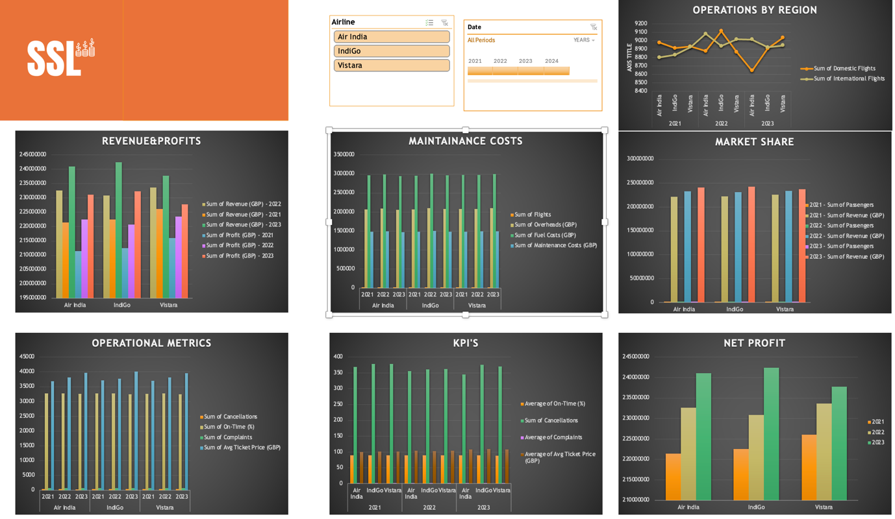

Here is a detailed analysis of each chart
1.Revenue and Profit
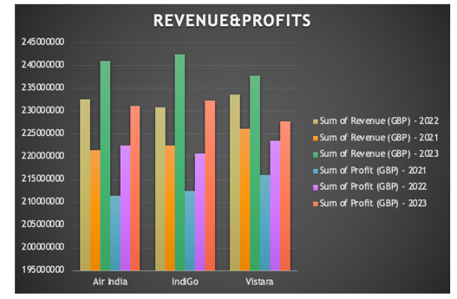

Revenue trends: The chart shows the revenue trends for Air India, IndiGo, and Vistara across the period that was chosen. Following Air India and Vistara in terms of revenue generation, IndiGo consistently generates the best revenue.
Profit Trends: revenue trends reveal that IndiGo has the highest revenue, but it also has the best profit margins, which suggests that it manages its costs effectively. Despite experiencing periodic losses, Air India has a reasonable profit margin, which indicates that there are possible opportunities for cost optimisation. Despite having the lowest sales, Vistara continues to maintain a consistent profit trend, which indicates that its operations are dependable.
2. Maintenance costs

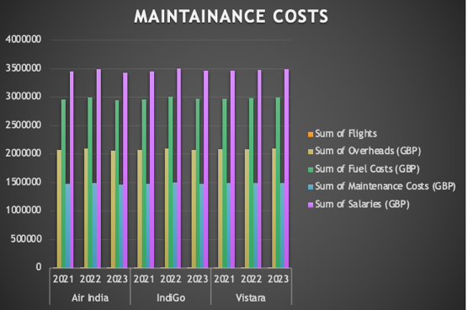

A breakdown of the expenses associated with maintenance is presented in the chart, which compares the three airlines in consideration. As a result of its larger fleet and higher frequency of flights, IndiGo has the highest maintenance expenses, which is to be anticipated given the circumstances. Even though Air India and Vistara have lower maintenance expenses, it is important to consider these expenditures concerning the size of their fleets and the size of their operations.
Efficiency in costs: When compared to revenue and profit, the expenses of maintenance can give valuable insights into the efficiency of expenditures. IndiGo's greater maintenance costs are neutralised by the company's higher revenue and profit, which is evidence of the company's successful control of expenses. To increase their profitability, Air India and Vistara need to make certain that their maintenance expenses are optimised.

3. Key Performance Indicators.
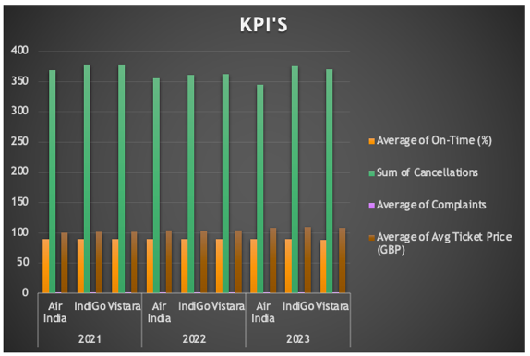

On-Time Performance: IndiGo maintains a leading position in terms of on-time performance, which is an essential measure of both operational efficiency and customer happiness.
Average Ticket Price: The average ticket price varies per airline, with IndiGo often charging higher fees, reflecting its market positioning and service excellence. A more competitive price structure may be found on Air India and Vistara.
Cancellations and Complaints: If you look at the amount of cancellations and complaints, IndiGo has the lowest number, which indicates that they have excellent customer service and operational reliability. Both Air India and Vistara have higher numbers, which indicates that there are areas in which the quality of service might be improved.

4. Operations of flights by region

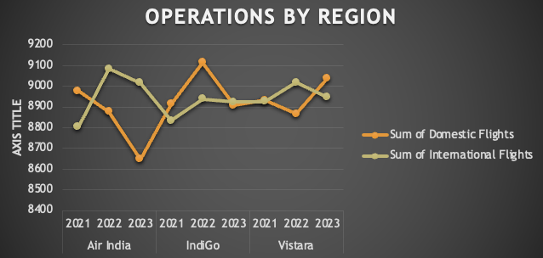

Domestic Flights and International Flights: The chart presents the total number of domestic flights as well as the number of international flights on each airline. The stronger presence that IndiGo has in the domestic market and the stronger presence of air India in the International market. is reflected in the fact that it runs a greater number of domestic and international routes. There is a good balance between local and foreign flights on Air India and Vistara, which is indicative of the company's broad operational approach.

5. Market Share
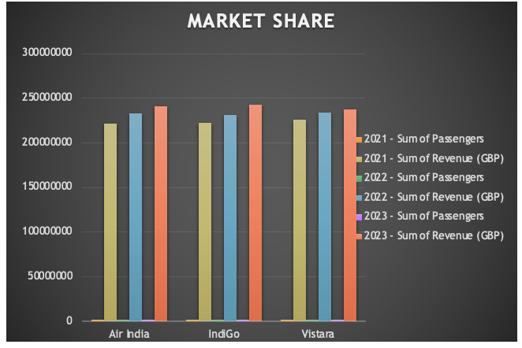

Passenger Market Share: Vistara has the greatest market share of passengers, followed by Air India and Indigo. This demonstrates Vistara’s strong market presence and client preferences.

6. Net Profit

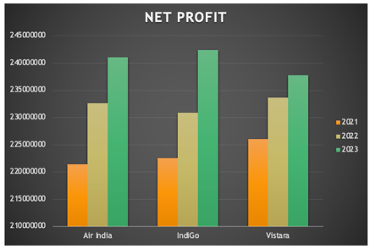

In the profit analysis, we can find a clearer understanding of the airlines growth in profits, we can see that Indigo stands at the highest profit levels compared to Vistara and Air India, and has a very constant growth, considering carefully Vistara can be seen that it had the highest profits in 2020 and 2021, which gives it a scope for betterment in the coming years however Air Inda seems to be consistent in the growth and giving a cutting edge competition to its competitors

Critical Evaluation

Effectiveness of BI system
According to Farr (2024), BI gives visibility into areas of unexplored progress. Data-driven insights also help firms optimise operations, increase productivity, and run more effectively. Executives and managers may utilise BI dashboards and analytics to improve operations, minimise expenses, and increase profit margins effectively.
Strategic Business Insights
Strategic business insight is the complete understanding and foresight derived from analysing internal and external aspects that affect your business's operations and decision-making processes. It includes the capacity to analyse data, trends, market dynamics, and new technology to develop successful plans and make intelligent choices. Says Karl (2024).
SSL relies heavily on the Business Intelligence (BI) system to provide strategic business insights as it considers the prospective acquisition of one of two airlines: IndiGo or Vistara. Using the BI system, SSL can gain a thorough insight of each airline's financial stability, operational efficiency, and market share.
- Financial Stability: The BI system collects and analyses financial data, such as revenue, profit, and cost breakdowns. This enables SSL to evaluate the financial health of each airline. For instance, IndiGo's constant sales and profit patterns suggest great financial stability, making it an appealing acquisition prospect.
- Operational Efficiency: The system gives information about operational parameters such as the number of flights, passengers, on-time performance, and cancellations. IndiGo's strong on-time performance and low cancellation rates indicate high operational efficiency, which is crucial for maintaining customer satisfaction while lowering operational expenses.
- Market Positioning: By analysing market share, SSL may better grasp the competitive position of each airline. Vistara’s significant market share in terms of passengers and revenue demonstrates its market strength.

Decision support

According to Olavsrud (2024), A decision support system (DSS) is an interactive information system that uses immense volumes of data to inform business decisions. A decision support system (DSS) helps an organization's management, operations, and planning levels make better decisions by assessing the seriousness of uncertainties and the compromises involved in choosing one option over another. A decision-support system (DSS) uses raw data, documentation, individual expertise, and/or business strategies to assist users in making decisions. A DSS's data sources could include relational databases, cubes, data warehouses, income estimates, sales projections, and more.
SSL is able to make informed choices regarding the most suitable acquisition target because of its business intelligence system, which offers a data-driven basis for analysing the performances of the three airlines. Significant insights that are beneficial to strategic decision-making are brought to light by the system through the utilisation of charts and pivot tables for displaying important indicators.
- Revenue and Profit Analysis: SSL uses bar charts to compare the financial performance of airlines over time. IndiGo's steady earnings and revenue growth make it an attractive acquisition target. Air India's financial potential is promising, as are Vistara's consistent profits.
- The operational metrics chart allows for a clear comparison of flight, passenger, and on-time performance. IndiGo's operational efficiency and customer satisfaction measures contribute to its potential as an acquisition prospect. The indicators for Air India and Vistara suggest areas for operational improvement that can be capitalised on after the acquisition.
- Cost Breakdown: The maintenance expenses chart helps SSL understand the airlines' cost structures.
- Market Share: The market share chart gives information about the competition setting.
- Flight Operations by Region: The chart showing the number of domestic and international flights offers insight into each airline's operational plan.

Challenges and Limitations

Data Latency According to Chen (2024) and Evans (2023) Data latency refers to the time it takes for data to travel from its source to its destination, as well as the time it takes to analyse and make it available for use. This delay can be caused by a variety of circumstances, including network congestion, hardware restrictions, data gathering configuration, and bottlenecks in data processing systems. To mitigate this, SSL should ensure that data sources are updated frequently and, where possible, employ real-time data integration solutions.

Scalability and adaptability

In terms of scalability, The present business system will be able to handle more data but will require expertise to add more airlines for comparison or to add in further data for the year 2024.

Adaptability can be made to power BI which will be able to handle data even more efficiently. It can be integrated to the present BI system in place.

Ethical Implications

Gohil (2023) says that In this age of fast technology innovations, data has become the vitality of businesses across sectors, providing innovation, driving decision-making, and allowing personalised services. However, with increased dependence on data comes the obligation to treat it responsibly, and firms who prioritise data ethics not only safeguard their consumers but also gain in the long term.
Adhering to data privacy rules such as GDPR is important for ensuring that consumer data is utilised responsibly and with permission. SSL needs to establish strong data governance procedures to secure sensitive information and maintain compliance with laws.
Transparency in data use is essential for establishing trust with stakeholders. SSL must provide clear information on the procedures of data collection, the process, and analysis.
the B. I system prepared by SSL Ltd will help Air India, gain valuable insights into its competition and aid Air India in making a calculated investment. This will give Air India answers to two major questions, being is the aviation sector growing in India, and which airline is performing better Indigo or Vistara. For the first question, according to the Ministry Of Civil Aviation (2023) Over the last decade, India's aviation sector has grown significantly. The country's operating airports went up from 74 in 2014 to 157 in 2024, with plans to rise to 350-400 by 2047. Domestic airline passenger numbers have more than doubled during the last decade, with Indian airlines considerably increasing their fleets. By using the business intelligence system and other vital information, SSL is able to get significant insights into the market positioning of Air India, IndiGo, and Vistara, as well as their financial stability and operational efficiency. Through the use of data-driven research, SSL is able to arrive at well-informed judgements about the most suitable acquisition target.

Reference List:

Amazon Web Services (2024a). What is ETL? ETL Explained - AWS. [online] Amazon Web Services, Inc. Available at: https://aws.amazon.com/what-is/etl/ [Accessed 8 Jan. 2025].
Amazon Web Services (2024b). What is Online Analytical Processing? - Online Analytical Processing Explained - AWS. [online] Amazon Web Services, Inc. Available at: https://aws.amazon.com/what-is/olap/ [Accessed 8 Jan. 2025].
Atlan (2023). Power BI Data Governance: Elements, Features & Approach. [online] Atlan.com. Available at: https://atlan.com/power-bi-data-governance/ [Accessed 10 Jan. 2025].
Chen, M. (2024). What Is Data Latency? An Expert Guide. [online] Oracle.com. Available at: https://www.oracle.com/data-latency/ [Accessed 10 Jan. 2025].
Darius (2024). The Role of Data Governance in Data Quality Management - Attention Insight. [online] Attention Insight. Available at: https://attentioninsight.com/the-role-of-data-governance-in-data-quality-management/ [Accessed 8 Jan. 2025].
DataSemantics (2023). 10 BI Implementation Challenges And A Foolproof Guide To Overcoming Them - Data Semantics. [online] Data Semantics. Available at: https://datasemantics.co/bi-implementation-challenges/ [Accessed 10 Jan. 2025].
Evans, H. (2023). Top 7 Business Intelligence Challenges and the Ways to Handle Them. [online] Velvetech. Available at: https://www.velvetech.com/blog/bi-challenges/ [Accessed 10 Jan. 2025].
Farr, C. (2024). The Transformative Power of Business Intelligence for Driving Growth and Efficiency. [online] Sontai. Available at: https://www.sontai.com/post/the-transformative-power-of-business-intelligence-for-driving-growth-and-efficiency [Accessed 8 Jan. 2025].
Gohil, R. (2023). ISBA | The importance of Data Ethics: Why businesses must take it seriously. [online] www.isba.org.uk. Available at: https://www.isba.org.uk/article/importance-data-ethics-why-businesses-must-take-it-seriously [Accessed 10 Jan. 2025].
Google (n.d.). What is a Data Warehouse? [online] Google Cloud. Available at: https://cloud.google.com/learn/what-is-a-data-warehouse [Accessed 7 Jan. 2025].
Google Cloud (n.d.). What is Business Intelligence? [online] Google Cloud. Available at: https://cloud.google.com/learn/what-is-business-intelligence [Accessed 8 Jan. 2025].
Jawaid, S. (2017). Business Intelligence in the Airline Industry. [online] Syntaxtechs.com. Available at: https://www.syntaxtechs.com/blog/business-intelligence-in-airline-industry/ [Accessed 10 Jan. 2025].
Kanade, V. (2022). What Is Data Mining? Definition, Techniques, and Tools. [online] Spiceworks. Available at: https://www.spiceworks.com/tech/big-data/articles/what-is-data-mining/ [Accessed 8 Jan. 2024].
Karl, T. (2024). What Is Strategic Business Insight & Why Does It Matter? [online] New Horizons. Available at: https://www.newhorizons.com/resources/blog/strategic-business-insights [Accessed 10 Jan. 2025].
Microsoft (n.d.). What Is Business Intelligence | Microsoft Power BI. [online] Microsoft.com. Available at: https://www.microsoft.com/en-gb/power-platform/products/power-bi/topics/business-intelligence/what-is-business-intelligence [Accessed 9 Jan. 2025].
Ministry Of Civil Aviation (2023). India’s Soaring Skies with Inclusive and Booming Aviation. [online] Available at: https://static.pib.gov.in/WriteReadData/specificdocs/documents/2024/sep/doc2024915394601.pdf [Accessed 10 Jan. 2025].
Olavsrud, T. (2024). Decision support systems: Sifting data for better business decisions. [online] CIO. Available at: https://www.cio.com/article/193521/decision-support-systems-sifting-data-for-better-business-decisions.html [Accessed 10 Jan. 2025].
Oracle (n.d.). What is data mining? [online] Oracle.com. Available at: https://www.oracle.com/uk/big-data/what-is-data-mining/#data-mining-definition [Accessed 8 Jan. 2025].
Rib Software (2024). What Is Data Quality Management? Tips For Data Control. [online] RIB Software. Available at: https://www.rib-software.com/en/blogs/data-quality-management-and-metrics [Accessed 8 Jan. 2025].

