

Assignment 2
Academic Skills
(Group Report)

Students:
Antoaneta Andreeva-Metodieva (2215257)
Ivan Georgiev (2213140)

Lecturer:
Dr Lizeta Demetriou

Table of Contents

Introduction 3
Time management 4
Introduction 4
Strategic thinking 4
Time-use strategy 4
Procrastination 5
Time management techniques 5
Conclusion 7
Motivation 8
Introduction 8
Evaluation of the relative importance of motivation 8
Implementation of motivation in professional or academic work 9
Conclusion 11
Conclusion 12
References 13

Introduction

Transferable skills are a comprehensive set of skills that can be adapted to many fields in life. They are important to success in education and play a vital role in professional life.
Those are skills that can be used in different job roles and play a vital role when considering a career change or applying for a new position. They are also called soft skills and can be adapted to many industries and roles.
Transferable skills are acquired through different work positions or outside of work – in education. They can also be developed in general life through hobbies or volunteer work.
Mastering those skills makes academic and professional life easier and improves performance, promotes better relationships through improved interaction and reliability, and increases competitiveness by being competent in a wider range of roles (Indeed, 2022).
This report observes the topics of Time management and Motivation, and evaluates their importance and application in education and professional life.

Time management

Introduction
Achieving success in academic and professional settings requires a set of qualities, techniques, and routines also called academic skills. Developing these skills can enhance a person’s ability to study, take exams, communicate successfully with peers as well as complete academic or professional tasks.
One of these skills is time management. Time management is the ability to make the most of your time both in professional and personal aspects. Mastering this skill can help a person achieve more while devoting sufficient time to studying, working on academic projects or work assignments, and successfully meeting deadlines (Indeed editorial team, 2022).
Strategic thinking
Levine (2007) thoroughly explores the topic of time management in his book “Skilful time management”, where he outlines the different aspects of the topic starting from strategic thinking when considering an approach for optimal use of time, suggests different methods for visualizing the number of tasks present, their importance and allocation of time for execution.
Thinking strategically gives an opportunity to take considered decisions rather than acting compulsively. It gives an overall view of the situation and helps make the best use of one’s time.
Creating a strategy can help allocate time for several tasks to be undertaken, therefore increasing efficiency and cutting down on stress.
As Levine suggests - “strategic thinkers are skilful ‘time managers’”. They are always aware of their pending tasks and deadlines, they think actively, and make full use of their time. Developing a habit of looking ahead and being aware of upcoming tasks helps being prepared and cuts down on stress from not having time for unexpected work.
Time-use strategy
Levin also discusses the ‘idea of time-use strategy’ - a plan for how future time should be used. Time use strategies can be individual or overall, where individual strategy depicts a path towards achieving a single objective. Nevertheless, there rarely is a time in life in which a person must deal with a one-only task, and often have to manage multiple objectives at a time. In this case, an overall strategy is needed, where several individual strategies are coordinated and allocated in time according to their completion demands.
Time use strategy also involves finding time for the completion of a task; making a commitment to accomplishing it; understanding the exact requirements of a task; acquiring the necessary resources and working environment for fulfilling the work (Levin, 2007).
Procrastination
As suggested by Van Eerde (2015) “Time management and procrastination would appear to be logically related, in the sense that time management may be a way to overcome procrastination”.
Procrastination is a voluntary act of delaying tasks until the last moment. Procrastinators are more likely to spend time on non-essential (and not necessarily pleasant) tasks in order to avoid getting on with an important project with an approaching deadline, thus feeling stressed and pressured by the reseeding time.
Procrastination could be attributed to a lack of effective time management, perfectionism, anxiety etc.
Use of visual tools such as time sheets or charts can be used to aid in more effective time management. Although procrastination could be seen more as a psychological state, visualizing tasks in time can give a clearer view of pending activities and encourage a more efficient approach towards completing them.
Time management techniques
Learning how to manage time can help a person achieve success in all areas of life and reduce stress from bulging tasks.
There are several methods that can be used to better utilize one’s time depending on their objectives and personality:
- Pareto analysis (80/20 rule) – created by the Italian economist Vilfredo Pareto, this method helps prioritize problems that are most effective at solving problems. With the 80/20 rule, 20% of the efforts yield 80% of the achievements.
- Pomodoro technique – created by Francesco Cirillo, this method uses a timer to break down tasks into intervals. Each task has a set amount of time (an interval) in which it should be completed.
- Eisenhower Matrix – created by US president Dwight Eisenhower, this method organizes tasks by importance and urgency into four quadrants (as below), prompting the individual to only work on the tasks in the top quadrants, and delegate or delete the ones that fall in the bottom quadrants.
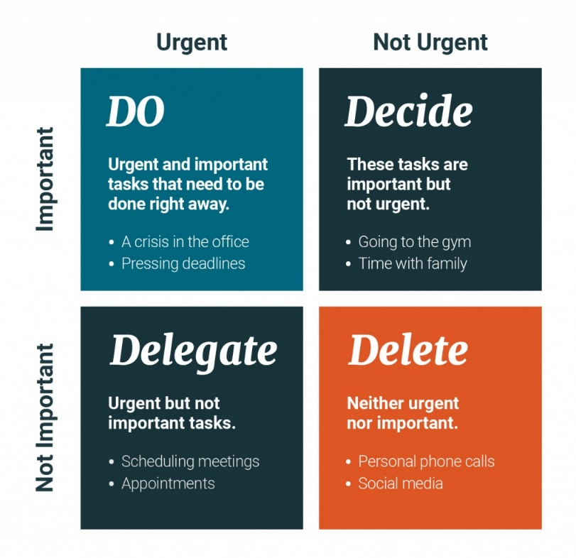
- Parkinson’s Law – named after British historian Cyril N. Parkinson, the idea of this law is to allocate less time for the completion of each job. Parkinson is famous for his phrase “work expands so as to fill the time available for its completion”, which is where this law originates from.
- Time blocking method – the idea behind this method is to divide the time of a day into blocks (for example 30 and 60 minutes); decide how long pending duties will take and allocate them to a certain time block allowing buffer time for adjustments.
- Getting things done – this method works by writing down all pending duties, analyzing if they could be acted upon now, organizing by urgency, and dealing with tasks that can be done now.
- Rapid planning method – developed by motivational speaker Tony Robinson, this method works by capturing all pending duties for the week, dividing them by common features (personal, school, work), creating RPM blocs by drawing three columns on a sheet of paper and writing down the goal, the desired outcome and reason for completing it.
- Eat that frog technique – the idea behind this technique is to do the hardest task for the day 1st so all remaining would seem easier (usa.edu, 2019).

Conclusion
Time management skills can be developed with the use of the above methods and techniques. This skill is an essential part of one’s life and has many benefits like achieving goals faster, doing more in less time, feeling fulfilled and self-confident, reduce stress of impending tasks.
Good time management has the benefits of meeting deadlines and appointments, improving focus and reducing procrastination, lower stress, maintaining a good reputation, and improving work-life balance (Kojic, 2022).

Motivation

Introduction
Motivation acts as a key component for maintaining the commitment and engagement of individuals in both academic and professional fields. Accordingly, the present study has evaluated the relative importance of motivation and its implementation in professional and academic work from theoretical perspectives.
Evaluation of the relative importance of motivation
Motivation has played the most pivotal factor that has helped an individual to improve their performance as well as accelerate career growth in a more effective way. Furthermore, motivation has been seen as the pathway to change the way of thinking, feeling and behavior of people. Based on the views of Paais and Pattiruhu, (2020), in today's age when competition has increased day by day, thus this has had a negative impact on their motivation level. In this context when the person has lost their motivation this has adversely affected their workplace performance.
On the other hand, motivation leads to the stability of the workforce and develops confidence among the subordinates. Besides this, when all of the team members in the workplace have felt motivated it has also improved the image of the organization as well as it has enhanced the productivity level. Therefore, in recent days most of the companies have focused on building a leadership management team so that they have provided training to the team members as well as encouraging them in a more effective way. They have also utilised different theories in their business such as “Maslow's motivation theory” so that they properly analyse the needs of the individuals in a better way. As per the views of Niknam et al. (2020), this theory has provided ideas of how an individual has felt unmotivated in their workplace. Other than this, the companies have adopted different strategies such as allowing the team members to provide their feedback and suggestions so that they have felt that they are an active part of the business as well.
In this context, this has also enabled the team members to improve their motivation and perform well in the business. Furthermore, motivation has been defined as the importance for the overall development of the personality and mind of the people as well as it has also put a person in the action. Thus, it has also improved the efficiencies as well as created a desire to upgrade them to develop their career performance (Werdhiastutie et al. 2022). More to this context, all the importance of motivation has been seen as interrelated because this has enabled the company to utilise the resources as well as achieve better outcomes in the business environment. Hence, it can be stated that in today's competitive age, motivating employees have considered necessary to improve performance and increase profit percentages.
Implementation of motivation in professional or academic work
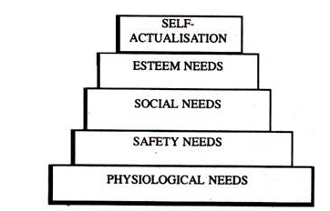
Figure 1: Maslow’s Need Hierarchy Theory of Motivation
(Source: Shoib et al. 2022)
Based on the above discussions, it can be stated that motivation acts as a crucial source for removing obstacles and managing the flow of work. Accordingly, in order to implement motivation in both the academic and professional world, theories and frameworks become useful. For example, the theories such as Maslow’s Need Hierarchy Theory and McGregor’s participation Theory become effective. According to the findings of Shoib et al. (2022), from a professional perspective, the application of Maslow's Need Hierarchy Theory can become essential as it would allow one to actualise the professional perspective of the employees. The hierarchical order of needs from the lower line of the organisational hierarchy towards the upper order would help to classify the needs of the employees all along the hierarchy as per their position within the professional and academic fields. Following this theoretical model, the organisational leaders try to identify the psychological needs of the employees and monitor their aspects of safety. On the other hand, the theory also helps to analyse the social needs of the employees in respect of their self-esteem. Thus, analysing the needs of the employees from various dimensions would help the organisational leaders to fulfil their requirements and bring satisfaction.
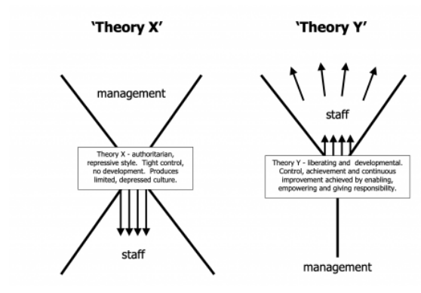
Figure 2: McGregor’s Participation Theory
(Source: Terras et al. 2021)
On the other hand, McGregor’s Participation Theory becomes effective in motivating learners within the academic field. In the opinion of Terras et al. (2021), the theory of participation categorises the learners into two categories namely the X Group and the Y group that analyses their indolences towards the learning. The learners who belong to the X group appear to be self-centred and not very bright. On the other hand, the Y group appears to be bright, sharp and committed to the learning objectives. Based on these characteristics, the teachers can motivate the learners within the academic field and improve their performances accordingly.
According to the observations of Bailey et al. (2021), satisfaction among employees about their jobs helps them to increase their performance. The fulfillment of the employee requirement from both psychological and physical perspectives helps them to remove the obstacles of work and increase their engagement with the work. Similarly, in the case of the learners in the academic field as well, proper motivation from the teacher helps the learner to increase their commitment towards the objectives of learning and their participation in the learning process.
Conclusion
In respect of the above analysis, it can be stated that motivation appears to increase the satisfaction of the employees towards their jobs in the professional field and enhance the learning process of academic students. The practical application of motivation with help of Maslow’s theory help to identify emotional and physical requirement. On the other hand, participation theory helps to characterise the traits of learners and motivate them accordingly.

Conclusion

Motivation and time management are commonly important to achieving an objective. They share a relationship in which one depends on another for a goal to be reached, however motivation on it’s own would not be enough to accomplish a task. Being motivated without having managed time appropriately will result in time lost.
Being able to manage time efficiently will lead to easier and faster completion of tasks, therefore increasing productivity. Increased productivity imposes reliability which is often appreciated by others and can further boost motivation.
Sahito and Vaisanen (2017) explore in their study the connection between time management, job satisfaction, and motivation in university teachers in Pakistan. The study shows that teachers who have received time management training show greater motivation, job satisfaction, and work-home life balance. Effective time management promotes motivation and job satisfaction by practical time planning which also lowers stress.

References
Bailey, D., Almusharraf, N. and Hatcher, R., (2021). Finding satisfaction: Intrinsic motivation for synchronous and asynchronous communication in the online language learning context. Education and Information Technologies, 26(3), pp.2563-2583.
Indeed editorial team (2021) Time-management skills: definition, examples and tips for improvement. Available at: https://uk.indeed.com/career-advice/career-development/time-management-skills, (Accessed on: 28 December 2022)
Indeed editorial team (2020) Transferable skills: definitions and examples. Available at: (https://uk.indeed.com/career-advice/career-development/transferable-skills (Accessed 3 January 2023)
Kojic, M. (2022) The importance of time management. Available at: https://clockify.me/blog/productivity/importance-time-management/#Conclusion_Good_time_management_helps_us_maintain_control_in_life (accessed: 30 December 2022)
Levin, P. (2007) Skilful time management. Maidenhead: Open University Press
Usa.edu (2019) 9 Proven Time Management Techniques and Tools | USAHS. Available at: https://www.usa.edu/blog/time-management-techniques/ (accessed: 28 December 2022)
Niknam, S., Dhillon, H. S., and Reed, J. H. (2020). Federated learning for wireless communications: Motivation, opportunities, and challenges. IEEE Communications Magazine, 58(6), pp46-51.
Paais, M., and Pattiruhu, J. R. (2020). Effect of motivation, leadership, and organizational culture on satisfaction and employee performance. The Journal of Asian Finance, Economics and Business, 7(8), pp577-588.
Sahito, Z., Vaisanen, P. (2017) "Effect of Time Management on the Job Satisfaction and Motivation of Teacher Educators: A Narrative Analysis", International Journal of Higher Education 6(2) Accessed: 3 January 2013, https://doi.org/10.5430/ijhe.v6n2p213
Shoib, S., Amanda, T.W., Menon, V., Ransing, R., Kar, S.K., Ojeahere, M.I., Halabi, S.E. and Saleem, S.M., (2022). Is Maslow’s Hierarchy of Needs Applicable During the COVID-19 Pandemic?. Indian Journal of Psychological Medicine, 44(1), pp.98-100.
Terras, M.M., Jarrett, D. and McGregor, S.A., (2021). The importance of accessible information in promoting the inclusion of people with an intellectual disability. Disabilities, 1(3), pp.132-150.
van Eerde, W. (2015). Time management and procrastination. In M. D. Mumford, & M. Frese (Eds.), The psychology of planning in organizations: research and applications (pp. 312-333). (Series in organization and management). Routledge.
Werdhiastutie, A., Suhariadi, F., and Partiwi, S. G. (2020). Achievement Motivation as Antecedents of Quality Improvement of Organizational Human Resources. Budapest International Research and Critics Institute-Journal (BIRCI-Journal) Volume, 3, pp747-752.

