Report for Blaenavon city
Ishag Osman Ishag
Distinctiveness and Regeneration (BMSP4005)
Professor Anthony Burns/ Professor Davina Evans
15th May 2018

Table of Contents
Introduction: 2
Townscape Analysis of Blaenavon City 2
Heritage of Blaenavon City 4
Emergence of the Truck Shop and Source of Discontentment in Blaenavon City 5
Rise of Independent Shops and Businesses in Blaenavon City 6
Development of the Market in Blaenavon City 6
Options for Shopping in Victorian Era of Blaenavon City 7
Formation of Cooperative Society in Blaenavon City 8
People of Blaenavon City 9
The Civic Life of Blaenavon City 11
Religious Nonconformity of Blaenavon City 12
Recreation, Culture and Leisure of Blaenavon City 13
Conclusion 13
References: 15

Introduction:
The report aims at providing an insight into the Blaenavon City in UK. The city before the emergence of the Ironworks in the year 1787-89, was a representation of a smaller community consisting of the part time miners and the sheep farmers scattered across the Blorenge and Coity Mountains. The city had small-scale industrial activity but had no virtual infrastructure and had very few roads and no terraces and streets. However, the emergence of the ironworks brought the Blaenavon city into its existence during the year 1789. The works of Ironmasters Thomas Hopkins, Thomas Hill and Benjamin Pratt attracted many people from the West of England and rural Wales in the search of better life and employment. The Solicitor General, Sir Samuel Shepherd, described Blaenavon as a city that represented an industry for British nation and the monument of commercial grandeur. However, Blaenavon remained underdeveloped for many years even after the commencement of the industry due to the lack of quality roads, sufficient housing and commercial centre. The city also had a growing population whose basic needs included food, clothing, water and shelter. In the initial years of Blaenavon enterprise, the ironmasters met the necessities of the local population along with providing them with necessary housing and made sure the employees had access to the essential supplies. The built heritage of Blaenavon puts forward an evidence of the cultural heritage of the South Wales during the early twentieth and the nineteenth century. Here the report tries to provide an insight into the exploration of the cultural heritage and the social history of Blaenavon townscape.

Townscape Analysis of Blaenavon City
Blaenavon represents an interesting instance of the valley settlement of South Wales. The Blaenavon city lacked the linearity of valley towns and was unplanned although it had certain townscape qualities along with buildings that had historic interest (Cigna, Tapete & Lee, 2017). The town however emerged from three different clusters of the development that revolved around the Ironworks, St Peters Church and the King Street that resulted in the huge homogeneous settlement of the present times. The centre of the Blaenavon city is designated as the conservation area and the town remains coupled with not only economic problems but also various environmental problems. The primary issues faced by the resident or visitor in terms of amenity within town centre included (Davis, Wulff & Guirnaldos, 2014):
A. The poor quality of the streetscape particularly the Broad Street had various unused buildings that added to the feeling of neglect and decline.
B. The existence of fewer visual linkages between bypass and the Town Centre did not encourage any exploration by the visitors.
C. There is no stop on the Church Road/ Prince Street and the town centre did not benefit from the passing traffic.
D. The presence of the double yellow lines acted as a visual distraction from the quality of streetscape and seemed too much for the traffic in Town Centre.
E. There existed no pedestrian linkage between Ironworks and Town Centre
F. The front portion of the Ironworks had a lower visual quality due to the walling and the fencing. The town had an opportunity of creating a strong image for town through the improvement of the front portion.
G. The move towards the Big Pit had poorer visual quality although the recently implemented planting eventually tried to improve the situation. The front portion of ‘All Dimensions Scaffolding’ contributed to the negative perception of the visitors.
H. There existed a vital linkage between the Coity Mountain and the Blaenavon town and the Coity Mountain has been sensitive changes.
I. The beech woodland possessed the potential of heavy utilisation. The proximity it had to the Ironworks gave it the potentially value to be considered as route to town centre and the place for picnic. In present times, it is overgrown and remains unmanaged which leads to the problem in the ownership.
J. There also existed features like the Working Men’s Hall that acted as vital landmarks that gave the town the sense of the identity. The heritage buildings across the high streets lead to the creation of identifiable Heritage Precinct. There existed opportunity for reinforcing this which could also contribute to the growth of an identifiable core of the town.
K. There existed poor location of parking for the visitors and lesser concentration of the pedestrian due to the dispersed layout of the Blaenavon city

Heritage of Blaenavon City
Blaenavon city had various listed buildings and ancient monuments along with various artefacts that related Blaenavon City to exploration and mineral extraction. There has also been identification of broader areas that contained the evidence of the past workings. The study of the Pwll Du area by the Ironbridge Gorge Museum Trust Archaeological Unit portrayed led to the exploration of preserved industrial landscape that had an individual importance and possessed direct connections to the wider industrial landscape thereby possessing a higher group value (Schofield, 2014). The unit also found the existence of another site that received ready appreciation due to the existence of relationship between the ironworks, the area of the mineral exploitation and the associated transport. There outstanding area that had well conserved industrial landscape lay in the northern side. The Blaenavon city had tramways, tunnels and main tracks. The centre of the town contained various prominent buildings. The however existed an identifiable heritage grounds around the Broad Street and Church Street defined by (Landorf, 2016):
- St Peters Church
- St Peters School
- Co-operative Building
- Post Office
- Horeb Baptist Church
- Workmens Hall and Institute

Emergence of the Truck Shop and Source of Discontentment in Blaenavon City
After the commencement of the ironworks production, there existed very little infrastructure and the workers along with their families depended hugely on ironmasters for catering to their needs (Minchinton, 2013). This led to the emergence of the company truck shop that acted as invaluable resource for providing the clothing and groceries for local inhabitants. Thus, for several years, people belonging to Blaenavon depended on buying of the goods at the truck shop of the company. The company shop had its location within the Middle Row that was behind the Engine Row and closer to ironworks that later extended to the Engine Row by the year 1813. However, the growing population portrayed the need for bigger premises that led to the relocation of the shop to the North Street. The shop had an extensive establishment that sold everything for covering the needs of workers and families. This included, bread, butter, meat, cheese, clothing, footwear and the general groceries.
There company shop in the Blaenavon City faced massive demand. Huge women crowd descended upon shop fighting with one another to receive a serving. Thus, the company shop acted as a necessary source for the supply of good in the frontier industrial communities without any alternative provision (Stratton & Trinder, 2014). The prices of the goods has 20 to 30 percent higher than what is found in the independent shops and represented an effective means for the company in making profit. During the period of 1830s, close to one tenth of the income of the company came from the shop.
The company implemented a long pay system under which workers were paid every four and six weeks during which the debt accrued to the company shop. At the final payment day, the debt were deducted from pay leaving worker with almost very little or no fund and in most of the cases the debts were carried to next payment cycle (Curtis & Thompson, 2014). Insufficiency in cash meant people had no option but to spend the wages anywhere other than company shop. This represented a kind of social control that made it difficult for the indebted worker with hardly any financial aid to move out from the area and seek resort somewhere else. Thus, the truck system resulted in major discontentment that led to observable disturbances like that of the Merthyr Riots in the year 1831 triggered through injustices.

Rise of Independent Shops and Businesses in Blaenavon City
There was no development in primary commercial centre of the Blaenavon City until early years of the reign of Queen Victoria (Walker, 2014). The city had only close to five shops that had only the necessary items required by the customers that included drapery, grocery and footwear.

Development of the Market in Blaenavon City
The determination of John Griffith Williams provided the necessary impetus required for developing a commercial centre within the city (Blockley & Hems, 2013). He was the son of a watchmaker who was born in the year 1809 in Breconshire and moved to the Blaenavon city during the period 1830 and took to trade as general shopkeeper and draper. On his arrival to the city, he was dismayed by the fact that the city did not have any roads that fitted vehicles but only had four shops, five chapels, few cottages and only five public houses. Since then he committed towards improving things in the city and held the responsibility for establishing the first covered regular market of Blaenavon in the year May 1840 situated on the Market Street (Xie, 2015). This helped in replacing the original market place of the Blaenavon City situated near ironworks and opposite the Engine Row and operated in open air.

Options for Shopping in Victorian Era of Blaenavon City
During mid Victorian era, there was development of retail core around the Broad Street and surrounding streets of King Street, Ivor Street and Albert Street. There were close to eighty businesses that operated around town centre by 1871 census. By the year 1901 that also marked the death of Queen Victoria, the city of Blaenavon had close to 150 businesses and town remained bustling with activities.
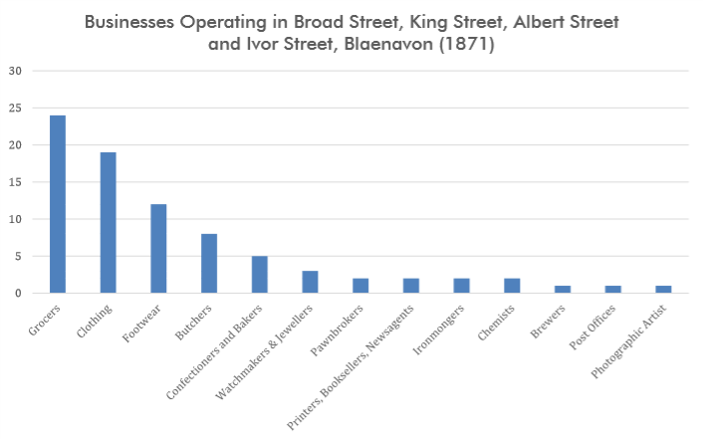
Figure1: Business Operation During 1871
Source: (Wood & Walton, 2016)

Formation of Cooperative Society in Blaenavon City
Robert Owen marked by the period between 1771 and 1858, a philanthropist and Welsh business pioneered the idea of the cooperation in United Kingdom (Horn, 2015). The workers at the New Lanark knew him for his benevolent treatment. The movement further developed by Rochdale during the October 1844.
However, the initial venture of the city of Blaenavon commenced during the latter half of 1861. The movement of cooperation depended on the Rochdale Principles and included democratic control, voluntary membership, promotion of education and dividend on the purchases. However, the concept of the cooperative society resulted in failure due to debts. Nevertheless, there was an establishment of the newer Blaenavon Industrial and Provident Society in the year 1889. The new formed society had close to 455 members along with a store in the King Street. This new society moved to Ivor Street building during 1893 (Farr, 2018). The new formed co-operative society actually took over the initial grocery business of David Lewis who was one of the earliest shopkeepers of the Blaenavon city. However, the new society was not devoid of difficulties. This is because the stores of the Ivor Street were burnt in the year December 1899 and were rebuilt. The newly built store also underwent major fire breakout in the year August 1918 and not rebuilt until the year 1928 due to the economic difficulties. In spite of the challenges, the newly formed Co-operative Society experienced greater success compared to the predecessors. The people of Blaenavon City operated the society and provided them with reasonable furniture, groceries, insurance, housing and funeral expenses. There were also further branches that later opened around the town.

People of Blaenavon City
The commencement of Ironwork in the year 1789 led to the flocking of the people in search of work. The city became the home to various migrant workers from the Wales and West of England. There was almost a gap of half century between the initiation of the ironworks and the development of commercial centre in the Blaenavon.
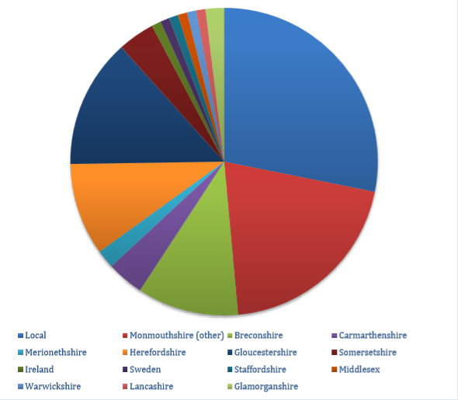

Figure 2: Birthplace of the Residents of Broad Street
Source: (Oerters, 2015)

The initial generation of the Broad Street traders were born in the city of Blaenavon. However, the economic structure of the city during the early part of the nineteenth century portray that most people within community had experience in either business or the trade. A consensus carried during the year 1851 based on New Road and Market Field portrayed that within a decade’s time the newer commercial area of the Blaenavon city attracted diverse traders from then south and mid Wales and the English countries of Somersetshire, Herefordshire and Gloucestershire (Flynn, 2016). There were close to around 103 people living within new shopping street found employment in the service and the retail sectors. However, out of the total 103 people, there were close to thirty-three people were born outside the Wales, twenty-nine were born in the Blaenavon and fifty born in the Monmouthshire.
During nineteenth century, the town centre of the Blaenavon City in addition to attracting migrants from the overseas also attracted them from Wales and England thereby making it a home to the migrants from the overseas (Palmer, 2017). The Winterhalter family serving as the jewellers and the watchmakers came to the Wales all the way from Germany and the business in the Blaenavon city was ran by Leopold Winterhalter during the period between 1855 and 1921.
Population Characteristics:
The demographic trend in Blaenavon possesses a trend of long-term decline. 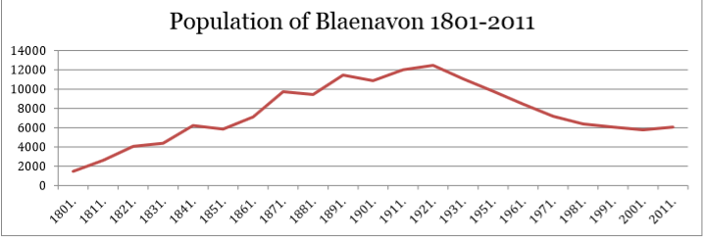
Figure 3: Blaenavon Population between 1801 and 2011
Source: (Flynn, 2016)

The Civic Life of Blaenavon City
The Public Health Act of the year 1848 led to the formation of the Local Boards for Health for administering the health of the public within the locality (Flynn, 2016). The formation of such board called for the requirement of a petition by the ratepayers, an investigation by the General Board of the Health, a report, an order of the council that finally leads to the election of the board members. The Local Board of Health comprised of an appointed surveyor, a clerk, a nuisance inspector and a treasurer for carrying on all the board functions. The Board has the power of dealing with sanitary issues like drainage, sewerage, nuisance removal, street cleaning, slaughterhouse regulation and sanitation of the cellar dwellings and lodging houses.
The Local Government Act of 1858 superseded the Act of 1848 by affording greater powers to Local Boards along with making the process of Board formation easier(Davies, 2015). According to the Act, any place without a defined or known boundary allowed the right of petitioning to the Principal Secretary of the state for settling the boundaries for serving the purposes put forward by the Act. During the meeting of Board of Roads that took place in the year 1859, it was proposed that adoption of the provisions of 1858 Local Government Act will lead to the better management of the highways and local affairs of the Blaenavon city. There was further agreement of forwarding a petition to the Home Secretary that requested the formation of Districts for the portion of the parishes that included Llanfoist, Llanover, Trevethin and Llanwenarth.
In the year, 11 January 1860, Sir George Cornewall Lewis, the Home Secretary led to the issuance of an order in the Council that defined and confirmed the boundary of the Blaenavon District (McGauran, 2017). Under the order, Mr Israel Morgan, a churchwarden and grocer appointed as the summoning officer for undertaking the necessary steps for adopting the boundaries of local district government of the city of Blaenavon. He put forward the notice of a meeting especially directed towards the ratepayers and the property owners within district on the 22nd of February 1860. The meeting led to the unanimous resolution that the Local Government Act of 1858 be accepted and applied to the district of Blaenavon and the election of fifteen members for constituting the local district board.
Amongst the elected fifteen members, eight of them were either business or traders. Six members held the senior positions within Blaenavon Company and the other members were the incumbent of the Anglican Church (Grant & Drew, 2017). This led to the increase in the influence of traders in the growing city of Blaenavon.

Religious Nonconformity of Blaenavon City
During nineteenth century, there existed religious nonconformity across the coalfield of the South Wales. Chapels allowed expression of religious convictions of various individuals who worked and lived in the area (Watts, 2015). The influence and power of the Chapels led to the lifelong learning, politics and leisure. Nonconformity also represented the expression of regional, national, local or the class identity. Women also remained active in chapels, involved in the Sunday Schools and sisterhood groups and in certain cases were the lay preachers. The religious census of 1951 portrayed the strength of the nonconformity amongst the Welsh who were also nonconformist in religious beliefs.
Nonconformity Across the South Wales Coalfield, during the nineteenth century, chapels allowed for the expression of the religious convictions of many individuals who lived and worked in the area. The power and influence of the chapels extended into lifelong learning, leisure and politics. Nonconformity could also be an expression of national, regional, local, or class identity. Women were also active in the chapels and were involved in sisterhood groups and Sunday Schools and, in some cases, were lay preachers. The strength of Welsh nonconformity was evident with the 1851 religious census, which showed that most Welsh worshippers were nonconformist in their religious beliefs.

Recreation, Culture and Leisure of Blaenavon City
The culture that persisted in South Wales during industrial revolution was primarily the recreational behaviour of growing population (Grant & Drew, 2017). This implied rough elements who believed in spending the spare time through drinking and gambling in some unpopular beer houses. The landscape around the Blaenavon city believed in prize fighting and sports like cockfighting. There were various beer shops and public houses across the city of Blaenavon and hence drinking alcohol was a more common compared to drinking of milk and water.
However, with the progression of the nineteenth century there were engagements of pursuits that are more respectable. The self- help organisations, clubs, cooperative societies, friendly societies, workingmen’s institutes and reading rooms encouraged political, social, educational and charitable functions (Altorki, 2016). During the initial period, many organisations and clubs were not able to afford meeting in clubrooms of the public houses. This led to the building of purposeful venues.

Conclusion
The report ends in the note by providing a reflection of the fortunes of the wider economy of Blaenavon city. The town centre reflected the hardship of the workers along with the families during the industrial unrest, lockout and strikes as the businesses and shops struggled to do business. However, the economic depression of 1920s and 1930s played a damaging role to the city of Blaenavon as most of the families left the area. Nevertheless, after the Second World War, lighter industries were attracted to the city of Blaenavon that complemented the coal industry that was facing a decline. These industries however did not provide similar types of job opportunities to the people.

References:

Altorki, S. (2016). Jung, Dietrich, Marie Juul Petersen & Sara Lei Sparre. Politics of modern Muslim subjectivities: Islam, youth, and social activism in the Middle East. Xi, 213 pp., bibliogr. London: Palgrave, 2014. £ 22.00. Journal of the Royal Anthropological Institute, 22(2), 453-454.
Blockley, M., & Hems, A. (2013). Heritage interpretation. Routledge.
Cigna, F., Tapete, D., & Lee, K. (2017). Geological hazards in the UNESCO World Heritage sites of the UK: From the global to the local scale perspective. Earth-Science Reviews.
Curtis, B., & Thompson, S. (2014). ‘A Plentiful Crop of Cripples Made by All This Progress’: Disability, Artificial Limbs and Working-Class Mutualism in the South Wales Coalfield, 1890–1948. Social History of Medicine, 27(4), 708-727.
Davies, R. (2015). People, Places and Passions: A Social History of Wales and the Welsh 1870–1948 (Vol. 1). University of Wales Press.
Davis, J., Wulff, F., & Guirnaldos Diaz, F. M. (2014). Heritage, culture and regeneration: the role of coal in the future of Cardiff Bay.
Farr, M. (2018). Reginald McKenna: Financier among Statesmen, 1863–1916. Routledge.
Flynn, K. E. (2016). Welsh Heritage and Cultural Tourism: Engendering Community Regeneration and Environmental Sustainability in the Lower Swansea Valley. In Heritage and Tourism in Britain and Ireland (pp. 99-112). Palgrave Macmillan, London.
Grant, B., & Drew, J. (2017). Local Government in Australia: History, Theory and Public Policy. Springer
Horn, P. (2015). Behind the Counter: Shop Lives from Market Stall to Supermarket. Amberley Publishing Limited.
Landorf, C. (2016). Broken hill: A comparable case study of sustainable heritage management. Historic Environment, 28(1), 10.
McGauran, J. P. (2017). George Cornewall Lewis, Irish character and the Irish poor law debate, 1833–1836. Journal of Historical Geography, 57, 28-39.
Minchinton, W. E. (Ed.). (2013). Industrial South Wales 1750-1914: Essays in Welsh Economic History. Routledge.
Oerters, K., 2015. Industrial Heritage in the Ruhr Region and South Wales in Historical Comparison. In Regions, Industries, and Heritage (pp. 240-261). Palgrave Macmillan, London.
Palmer, M. (2017). Understanding the workplace: a research framework for industrial archaeology in Britain. In Understanding the Workplace: A Research Framework for Industrial Archaeology in Britain: 2005 (pp. 9-17). Routledge.
Schofield, J. (Ed.). (2014). Who needs experts? counter-mapping cultural heritage. Ashgate Publishing, Ltd..
Stratton, M., & Trinder, B. (2014). Twentieth century industrial archaeology. Taylor & Francis.
Walker, D. (2014). Local world heritage: Relocating expertise in world heritage management. Who Needs Experts? Counter-mapping Cultural Heritage, 181-201.
Watts, M. R. (2015). The Dissenters: Volume III: The Crisis and Conscience of Nonconformity. OUP Oxford.
Wood, J., & Walton, J. K. (2016). Reputation and Regeneration: History and the Heritage of the Recent Past in the Re-Making of Blackpool. In Valuing Historic Environments(pp. 129-152). Routledge.
Xie, P. F. (2015). Industrial heritage tourism. Channel View Publications.

