Embedding Sustainability within Organisations (BMSP7003D)

Lecturer – Dr Roisin Mullins

Assessment 3 – Critical Reflection

Steven Saunders (1903236)

 | 7th FEBRuary 2021

to: |  | Senior LEADERSHIP TEAM
from: |  | STEVE SAUNDERS (MBA SUSTAINABILITY GRADUATE)
subject: |  | SUSTAINABILITY PLAN – A CRITICAL REFLECTION
CC: |  | TARMAC SUSTAINABILITY DIRECTOR
Executive summary
Following the acceptance and subsequent roll out of the Apprentice+ sustainability initiative proposed in my previous report, this paper critically reflects on the achievements to date. It will consider the barriers and drivers witnessed across the business over the first 12 months of implementation and aim to further entrench the initiative within the DNA of the business.
I will review why performance against KPIs has not been as successful as first hoped and consider the organisational culture change that needs to take place. This will be based on the understanding of where Griffiths sits within the five stages of behavioral change and five pillars to improving (Carmazzi, 2019).
Using the Corporate Sustainability Drivers Model and most commonly recognised barriers to change (Lazano, 2015), I will aim to make further recommendations to change business culture and maximise the success of the Apprentice+ sustainability initiative.
Apprentice+ overview and achievements to date
Apprentice+ was developed to address HR risks within the business. These included an ageing workforce, widening skills gap and ever-increasing competition for the best people as more large-scale infrastructure projects commence in our operational areas. Apprentice+ also aimed to reduce costs associated with agency workers, stabilise a growing staff turnover rate and deliver a diverse workforce with higher levels of employee engagement.
The following Key Performance Indicators (KPIs) were developed under four headings and, using a traffic light system, I highlight performance over the past 12 months:

Recruitment KPIs
KPI | Target | Performance
1 Apprentice employed for every £3m turnover | 83 | 26
5% increase in CITB Apprentice funding per annum | 5% (£80,000) | 8.5% (£86,850)
95%+ Apprentice completion rate | 95% | 88%
Reduce staff turnover rate to under 6% | 6% | 7.69%

School Engagement KPIs
KPI | Target | Performance
Number of primary school pupil contacts | Set Baseline | 6,534
4 parent/teacher construction training events | 4 | 0
26 work experience person-weeks per annum | 26 | 32
3 student surveys undertaken | 3 | 0
% secondary school students selecting STEM subjects | Set Baseline | No data
12 women in construction events | 12 | 4
8 Appentice/Trainee good news stories published | 8 | 11

Gender KPIs
KPI | Target | Performance
Apprentice gender ratio of 50:50 | 1:1 | Male 7.5:1 Female
30%+ Senior Leadership Team positions held by Women | 30% | 28.5%

Diversity & Inclusion KPIs
KPI | Target | Performance
Complete Business in the Community’s Diversity Benchmark | Set Baseline | No longer members of BitC
Set diversity baseline for the business | Set Baseline | Age  Gender  Race  Religion  Sexual orientation  Welsh Language
100% of hiring managers to receive unconscious bias training | 100% | 18%

It is clear from the KPIs above, many of the KPIs are showing performance has not met targets. This paper will look at the potential reasons for these short comings. However, it should be noted that this is the first-time social-economic KPIs, such as apprentice recruitment, school engagement, diversity, have been set and some of the targets were extremely stretching. Even those targets which have not yet been achieved have already delivered significant business benefits and offer more than our ‘business as usual’ approach. Those who have contributed should be proud of their efforts and the data collected will be valuable as we continue to embed and extend Apprentice+ throughout the business.
Sustainable Organisational Culture Change
Upon refection of the past 12 months and in trying to understand why Apprentice+ started so well but faded with time, I have assessed where I believe Griffiths to be placed regarding organisational culture change.
Firstly, just three years ago, Griffiths was as a privately owned family business. I believe we were in the “live and let live” culture (Carmazzi, 2019), where the business was doing well, growth was steady and, in general employees were happy in their routines. Innovation was low and most people were in their comfort zone. However, due to the family nature of the business and everyone knowing who was leading, there was a strong brand congruent culture at operational level.
Over the past three years, and since the acquisition of Griffiths by Tarmac, the business has gone through some rapid top-down changes. Employees may now be struggling to focus on a common goal or organisational purpose and become disengaged. Currently, I believe the business to be closer to a “multi-directional” culture. Whereby there is a level of cohesiveness within individual departments but not between then. Upon reflection, this may be one of the root causes for a number of Apprentice+ KPIs not being achieved. For instance, apprentice completion rates is a multi-faceted target with many factors contributing to the success or otherwise of each apprentice completing their studies and progressing within their roles. It requires extensive collaboration between site/delivery teams, training and development, human resources and our small team of apprentice mentors.
To support all future sustainability initiatives – not just Apprentice+, our priority needs to be the development and communication of a corporate purpose, vision and behaviors. This will help Griffiths climb the stages of organisational culture change and develop an ideal working environment whereby individuals and departments work together to achieve the common goal – be that our corporate purpose or the objectives of Apprentice+.
I would recommend using Tarmac’s purpose, values, behaviors, mission and goals to develop a Griffiths-centric version. “The Tarmac Way” outlines ‘why we do what we do’ (their purpose), ‘how we do it’ (their values and behaviors) and ‘what we do’ (their mission and goals). Guided by our parent company, Griffiths should develop the “The Griffiths Way” and create a ‘leadership enriched’ culture. Embedding these characteristics would have a positive impact on the successful integration of Apprentice+ into the business, as identified in Table 1. This theory is support by Blanco-Portela et al. who identified that Sustainability changes need to go beyond ‘technocentric’ changes and management efforts by addressing ‘soft’ organisational issues, which include values, visions, philosophies, policies, employee empowerment, and change management practices.
Development of ‘The Griffiths Way’, should be driven from the bottom up and extensive employee engagement undertaken at all levels to create a feeling of collective ownership and a common goal.
Characteristic | Impact on Apprentice+
Employees view the organisation as an extension of themselves | Employees understand the current HR risks to Griffiths and recognise the need for succession planning. Turnover targets within the Business Plan are understood with the knowledge HR must grow in tandem despite industry challenges, such as a skills gap and ageing construction workforce.
Employees feel good about what they personally achieve through the organisation | All employees get satisfaction from helping new and younger employees grow and develop. Site-based employees are fully engaged with Apprentice+ and there is a desire to become a mentor with appropriate training for them to succeed.
Cooperation is exceptional | Human Resources, Training and Development, Health & Safety, Sustainability departments and Operational Teams are working collaboratively to achieve the objectives of Apprentice+ for the benefit of the business, not the department or individual.
Individual goals are aligned with the goals of the organisation | Employees recognise the shared benefits of Apprentice+. For instance, apprentice recruitment and the development and progression of people internally provides mutual benefits for the employee and business. The employee sees more opportunities for promotion and career progression. Whilst the business reduces costs related to making senior hires.
People use group resources to actively solve problems | In the delivery of project-based targets, such as school engagement activities, delivery teams are able to call on the support and expertise form across the business. This would include peers onsite, existing apprentices and graduates, and support functions - H&S, HR, Community Engagement, Sustainability and Training and Development.
Not limited to job description, will do what it takes to make things happen | Employees actively seek to go beyond their job descriptions to help deliver Apprentice+ objectives. This maybe attending careers fares after working hours or supporting an apprentice with coursework during the lunch hour. Everyone working together for the common goal.
Most everyone is in sales, marketing and PR; they are walking ambassadors | If we are to successfully change the perception of the construction industry and entice the brightest and best young people, every employee must be a walking, talking ambassador. This is just as important when working on site as it is when visiting a local school. More STEM Ambassadors need to be identified, trained and communicated across the business.
People are consistently brining out the best in each other | Mentors bring out the best in their apprentices and apprentices bring out the best in their mentors. Similarly, by working together, rather than despite each other, brings out the best in our supporting departments.  It is known that mentoring enables other employees to develop, get a taste of management and flex their leadership skills while demonstrating organisational values. Working with, guiding and inspiring apprenticeship talent can be a rewarding experience for the whole business (Husband, 2017).
Leaders do not develop followers, but develop other leaders | Ownership of Apprentice+ needs to move closer to where it has most impact - On site. HR and Training and Development must support and guide, but operational teams must take ownership of the initiative and feedback to HQ on improvements, support required and continuous improvement. As highlighted in Derek Sivers TEDx Talk, early adopters need to be accepted as equals and be coached into being future leaders of Apprentice+.
Leadership is contribution driven and not ego driven | Award ceremonies, like the National Constructing Excellence People Development Award which was won in 2018, should be attended by those delivering and driving the initiative. Success stories should be shared throughout the business by those contributing most. By sharing the successes of Apprentice+, the vision not only keeps in mind, it gives meaning to all involved. What happens? When people know how they are contributing to this vision they feel that they matter, engagement and motivation will soar (Eden Project, 2021)
Very Low employee turnover | Apprentice+ will directly impact employee turnover by recruiting, identifying and retaining the best young people. It is also a clear indication to the wider workforce that the company invests in its people. It should be noted however, that low staff turnover can have negative impacts, such as employees set in their ways, lack of innovation and unambitious workforce (Sullivan, 2011).
Most are passionate about the organisation and what it represents | Apprentice+ increases the number of employees within the 16 – 24 year old bracket, reducing the business risks associated with an ageing workforce. The new apprentices are passionate about Griffiths, its new purpose, values and behaviors. They will bring a fresh approach and a positive attitude into the workplace, which will have a knock-on effect on existing staff (National Apprentice Events, 2021).
Table 1: Characteristics of a leadership enriched culture (OCEAN Organisational Culture Assessment Tool, 2021) and how they could deliver the objectives of Apprentice+
Barriers and drivers to organisational change
As part of my refection on the achievements and areas for improvement of Apprentice+ over the last 12 months, I thought it would be useful to look at the potential drivers of and barriers to integration of the initiative.
Using the Corporate Sustainability Drivers Model (Lazano, 2015) and the most commonly recognised barriers to change (Lazano, 2009), I will assess each of the four areas of my original Apprentice+ proposal (apprentice recruitment, primary school engagement, secondary school engagement and promotion of STEM subjects and diversity and inclusion). I will reflect on achievements and areas for further development moving forward.
Figure 1 identifies both internal and external drivers of Apprentice+ and internal and external stakeholders which were perhaps not clearly explained in my initial proposal.
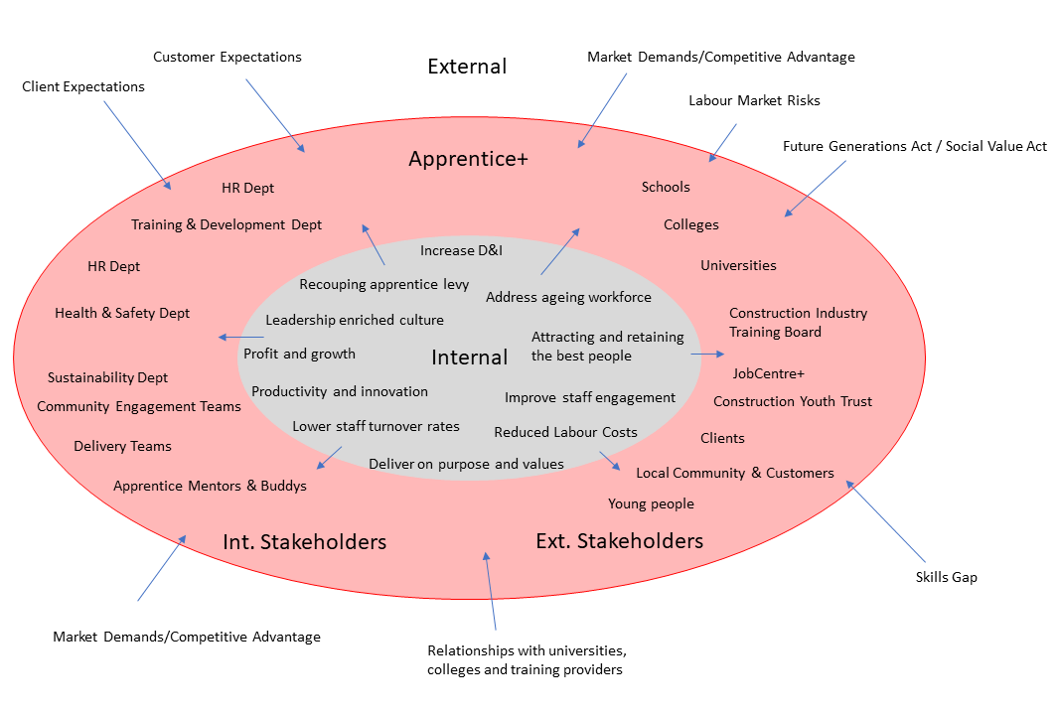
Figure 1: Lazano’s Corporate Sustainability Model applied to Apprentice+ (connecting drivers replaced with internal and external stakeholders)

 | Systems level
 | Individuals | Groups | Organisational
Barriers to change | Misunderstanding/lack of communication | Group culture | Lack of strategy/long-term plans (Managerial)
Barriers to change | Lack of trust | Ignoring institutions in the group | Bureaucracy/patriarchal models (Organisational)
Barriers to change | Threat to job status / security | Individual – Group Conflict | Lack of top management commitment/walking the talk (Managerial)
Table 2: Most commonly recognised barriers to change (Lazano, 2009)

Apprentice recruitment
Achievements
Despite falling short of the target of 86, 26 new entrant apprentices in a year hit by a global pandemic can still be considered a significant achievement. The business recognises drivers, such as the risk of our ageing workforce and the competitive labour market in which we are operating. And, our HR Department also recognises our reliance on agency staff and the increased costs associated with this approach. Apprentice+ is recognised as a strategy to address these risks.
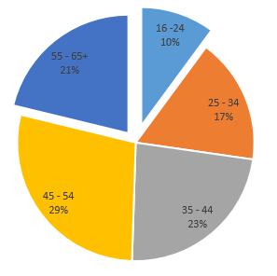
Figure 2: Griffiths has an ageing workforce
Through closer working relationships between HR, Training and Development and our delivery teams, we have successfully increased the funding we receive from the CITB which recoups some of our training and apprentice levies.
Areas for development
The total number of apprentices recruited needs to increase. Our 86 new apprentice target was based on industry recommendations (Department for Transport, 2016) and competitors are gaining competitive advantage through stronger commitments to apprentice recruitment. Barriers to implementation could include a misunderstanding or lack of communication from our marketing and bid writing teams with operational teams and HR regarding Apprentice commitments made in tender submission. Exceeding client expectations regarding apprentice recruitment is a clear driver.
HR suggest that a lack of suitable site mentors is another barrier to apprentice recruitment (trust barrier). There may also be a resistance from site-based operatives to become mentors as they may see apprentices as a threat to their own job status and security.
Our failure to appoint a director-level sponsor for Apprentice+ also demonstrates a lack of top management commitment.
Primary school engagement
Achievements
Engaging with 6,534 primary school pupils is a huge step in the right direction if we are to successfully address the current skills gap. Across Griffiths, we have six Construction Ambassadors and a further five STEM Ambassadors. However, it should be noted that these roles are generally being filled by our Community Engagement Teams and we should actively seek to train more operational staff and involve them in school engagement programmes. As recommended in my initial proposal, Construction or STEM Ambassador Training should form a mandatory part of our Apprentice+ Training Programme, with young apprentices set a target to deliver at least 7.5 hours of school engagement as part of their Personal Development Plan. This should be incentivised and incorporated into Performance Reviews and linked to salary increases.
Another success has been the development of several new engagement activities aimed at primary schools – despite Covid-19 restrictions preventing face to face visits. The Community Engagement Team have developed and delivered home schooling activities which were promoted via the company’s social media feeds – this follows the advice set out in a report by an independent group commissioned by the Scottish Government, which advised early engagement in primary schools and better use of social media to promote the construction sector could help attract new workers (Grellier, 2019).

As an example, the Griffiths DENgineering Challenge was taken up by numerous schools and pupils learning from home, challenging school children to design and construct their own den. Over 100 photos of dens were received under the #DENgineering Twitter hashtag and received positive feedback from many teachers.

Figure 3: The Griffiths DENgineering Primary School Challenge

Areas for development
Although engagement numbers were high, our efforts need to turn to collecting data and tracking pupils that show an interest in STEM subjects through to secondary school. We need to develop a way of assessing our primary school engagement is positively affecting students as the come to select their subjects at Key Stage 3 and 4. Recently, we produced a case study regarding one of our current apprentices as we inadvertently discovered he had first had contact with Griffiths at primary school and again at secondary school before joining the business. More case studies like this and promotion of our school engagement programme would offer great examples of our work to address the skills gap to Clients with a growing interest in Social Value.
Secondary school engagement and promotion of STEM subjects
Achievements
Work experience, attendance at careers fairs, mock interviews and career insight days remain our best forms of engagement with secondary school pupils. Four Women in Construction Days were held and it is worth noting that three of our existing female apprentices are active STEM or Construction Ambassadors and support these events. However, all female apprentices are either engineers or quantity surveyors. We need to do more to attract females into vocational, site-based roles.
This year Griffiths participated in the Engineering Education Scheme Wales (EESW) for the first time, partnering with King Henry VIII in Abergavenny. The EESW has strengthened ties with the closest secondary school to our headquarters and resulted in six local students pursuing Civil Engineering or Mechanical Engineering at University. Consideration could be given to sponsorship and summer placement work for these students.
Also, our target to publicise the personal achievements and business benefits of our apprentices and graduates was exceeded. The Community Engagements Team to engage more with of future workforce should be commended. Our use of Twitter, YouTube and Instagram have helped share case studies and good news. One of the prime examples was the weeklong Twitter Takeover, which saw a different apprentice in charge of our Twitter account every day throughout national apprentice week. During the week our Twitter followers surged with large numbers of younger followers engaging with the videos our apprentices posted about their roles and responsibilities.
Areas for development
Despite strong progress in primary schools, secondary school engagement is still a challenge. Despite exceeding our targeted work experience weeks provided, no teacher/parent engagement events were held, no student surveys undertaken and no data was collected regarding students choosing STEM subjects once they reach Key Stage 3 and 4.
We know both parents and careers advisors do not actively promote our industry, with construction scoring just 6.2 out of 10 by parents and 5.6 out of 10 by careers advisors. Furthermore, the industry is still seen as being outdoors, dirty and most suited to young people who could not get into higher education (Waters, 2021).
Moving forward, Apprentice+ must include engagement with parents, teachers and careers advisors just as important as engagement with the students. I would recommend Griffiths investigate creating a formal link with Careers Wales and identify new ways of changing the perception of those who have most influence on our future workforce.
Diversity and Inclusion (D&I)
Achievements
Upon reflection, it is probably our diversity and inclusion KPIs which Apprentice+ has had least impact. The main achievement has been the commencement of unconscious bias training rolled out to hiring managers. A re-structure of the Senior Leadership Team has also seen female representation at board level increase to 28.5%.
Sustainability and HR departments have been working together to undertake D&I benchmarking with some external support from Business in the Community (BitC). However, at the end of 2020, our membership with BitC expired and it was not renewed. This has hindered the D&I Benchmarking Process.
Work has also been undertaken to amend our recruitment processes to align with the Tarmac Resourcing Portal. This will help attract a more diverse range of candidates and less reliant on internal recommendations.
Areas for development
Without the support of BitC, we should identify new partners to work with to help embedded D&I within Apprentice+. Faith schools could be priorities and Women in Construction Events should be extended. Once again, I feel it is important to identify a diverse range of members of staff to support school engagement programmes. This leads back to increasing the number of STEM and Construction Ambassadors we have throughout the business. On reflection, perhaps more experienced members of staff need some type of incentivisation to join and support such programmes. Again, perhaps this could be linked to Personal Development Plans and Performance Reviews.

Conclusion
Overall, I think a lot has been achieved during the first 12 months of Apprentice+. I believe our focus now needs to shift on to organisational change if we are to truly embed this sustainability initiative into the business.
Our priority must be an all-encompassing staff engagement programme which can be used to develop a new corporate purpose with associated values and behaviors. This will play a crucial role in setting a common goal all employees can work towards and underpin our existing sustainability strategy and activities, as well as any new initiatives such as Apprentice+. Creating a culture where by individuals and departments can work together for the good of the company needs to be our ultimate aim.
Although not placed in Lazano’s list of most commonly recognised barriers to change, I believe resource allocation as a key barrier to the successful implementation of Apprentice+. It should be noted the fine efforts of the Community Engagement Team who deliver most, if not all, of our school engagement work. Either additional resource needs to be allocated or supporting functions and operational teams need to play a more active role. I believe engagement at primary school level will be crucial in addressing the construction skills gap and creating a workforce that can deliver civil engineering problems that will help tackle global issues.

References:
Blanco-Portela, N. Benayas, J. Pertierra, L and Lozano, R. 2017, Journal of Clearer Production - Towards the integration of sustainability in Higher Education Institutions: A review of drivers of and barriers to organisational change and their comparison against those found of companies
Carmazzi, A. 2019, TEDx - Creating Sustainable Organisational Culture Change in 80 Days. Accessed online 28/01/2021 https://www.youtube.com/watch?v=r2XE87EoI7M&feature=emb_title
Department for Transport. 2016, Transport Infrastructure Skills Strategy: Building sustainable skills - Moving Britain Ahead. Accessed online 29/01/2021 https://assets.publishing.service.gov.uk/government/uploads/system/uploads/attachment_data/file/495900/transport-infrastructure-strategy-building-sustainable-skills.pdf
Eden Project. 2021, Four ways to motivate your team by sharing success. Accessed online 29/01/2021 https://www.edenproject.com/learn/for-organisations/creative-leadership/creative-leadership-resources/four-ways-to-motivate-your
Grellier, M. 2019, Skills shortage means it’s back-to-school for construction sector. Accessed online 02/02/2021 http://cinmagazine.co.uk/skills-shortage-means-its-back-to-school-for-construction-sector/
Husband, S. 2017, Four ways to better engage your apprentices. Accessed online 29/01/2021 https://www.peoplemanagement.co.uk/experts/advice/ways-to-better-engage-apprentices
Lazano, R. 2009, Orchestrating Organisational Change for Corporate Sustainability: Strategies to Overcome Resistance to Change and to Facilitate Institutionalisation.
Lazano, R. 2015, A Holistic Perspective on Corporate Sustainability Drivers
National Apprentice Events. 2021, The positive effect apprentices have on businesses. Accessed online 29/01/2021 https://nationalapprenticeshipevents.co.uk/questions-answered/the-positive-effect-apprentices-have-on-businesses/
OCEAN Organisational Culture Assessment Tool. 2021, Leadership Enriched Culture Characteristics. Accessed online 28/01/2021 https://cultureevolution.com/leadership-enriched-culture/
Sullivan, J. 2011, A Low Turnover Rate Could Mean That You Have Ugly* Employees. Accessed online 28/01/2021
https://www.ere.net/a-low-turnover-rate-could-mean-that-you-have-ugly-employees/
Waters, L. 2021, Construction as a Career of Choice for Young People. Accessed online 02/02/2021 http://cinmagazine.co.uk/skills-shortage-means-its-back-to-school-for-construction-sector/

