Seren Zero-Waste Community Coffee Initiative

Module name: Creativity and innovation (BMSW5013_SWAN)
Student name: Ionela -Catalina Simion
Student number: 2227035
Word count: 4198

Contents
Executive Summary 3
Task 1 4
1. Introduction to the Organisation and the Issue 4
2. Creativity, Innovation and the Challenges of Capitalist Business Growth 5
3. Proposed Innovation: Seren Zero-Waste Community Coffee Initiative 6
4. The Creativity Process Behind the Innovation 8
5. Evaluating the Idea Using Lewin’s Force Field Analysis 9
6. Organisational Climate and Support for Innovation 10
Conclusion 11
Task 2 12
Supplementary Reflection on the Use of AI in Developing My Solution 12
Reference List 15

Executive Summary

This report examines the role of creativity and innovation within Seren Coffi, an independent coffee shop operating in a highly competitive market dominated by large corporate chains. The analysis highlights the challenge of balancing financial sustainability with ethical values, particularly in the context of increasing consumer demand for environmentally responsible business practices.
To address this challenge, the report proposes the Seren Zero-Waste Community Initiative, a phased and incremental innovation model designed to integrate sustainability with community engagement. The concept focuses on introducing low-cost waste reduction practices, developing local circular partnerships and, in later stages, implementing a light membership scheme to encourage customer participation.
The innovation is analysed using key theoretical frameworks, including the 4P model of innovation, the Business Model Canvas and Lewin’s Force Field Analysis. These frameworks demonstrate that the proposed concept is not only creative but also strategically viable. The analysis identifies strong driving forces, such as growing sustainability trends and opportunities for differentiation, while recognising constraints including financial limitations and operational complexity.
From a broader perspective, the report evaluates the feasibility of the concept in current economic and social conditions. While cost-of-living pressures may affect customer behaviour, increasing awareness of environmental issues supports the long term viability of the initiative. The organisational culture of Seren Coffi, characterised by flexibility and community values, further enhances the possibility of successful implementation.
Overall, the report concludes that incremental, sustainability focused innovation provides a realistic and effective strategy for small businesses. By aligning creativity with market trends and organisational capabilities, Seren Coffi can achieve competitive differentiation while maintaining its ethical identity.

Task 1

1. Introduction to the Organisation and the Issue

Seren Coffi is an independent coffee shop located in Cardiff that operates with a strong emphasis on ethical sourcing, sustainability and community engagement. Unlike large multinational cafe chains, the organisation seeks to balance commercial objectives with social values by supporting local suppliers and fostering an inclusive community environment. Independent cafes often play an important role in local economies by creating spaces that encourage social interaction, collaboration and community participation (Florida, 2014). Seren Coffi represents a small business integrating ethical values in a competitive market.
However, the modern coffee industry is highly competitive and dominated by large corporations such as Starbucks and Costa Coffee, which operate using efficiency-driven business models. These organisations typically rely on economies of scale, global supply chains and aggressive expansion strategies to achieve market growth (Ponte, 2002).
For Seren Coffi, this creates a strategic dilemma. On the one hand, the business must remain financially viable in a competitive market. On the other hand, adopting traditional capitalist growth approaches may conflict with its ethical values and community-focused identity. As a result, Seren Coffi must explore innovative approaches that allow the organisation to differentiate itself while maintaining its commitment to sustainability and social responsibility.
Innovation is widely recognised as a key driver of competitive advantage in modern organisations (Tidd and Bessant, 2021). Through creative problem solving and the development of new products, services or business models, organisations can respond to changing market conditions and create new sources of value.
Creativity refers to the generation of novel and useful ideas, while innovation involves the successful implementation of those ideas within an organisational context (Amabile, 1996). Within the independent coffee sector, creativity and innovation are essential for survival, as small businesses must differentiate themselves from large corporate chains and respond to changing consumer preferences. Innovative approaches combining sustainability and customer engagement are increasingly important for competitiveness.
This report proposes a refined innovation, the Seren Zero-Waste Community Coffee Initiative, and evaluates it using relevant theories and frameworks.

2. Creativity, Innovation and the Challenges of Capitalist Business Growth
Creativity and innovation are central concepts in modern management and entrepreneurship literature. While innovation can drive competitive advantage and growth, it may also involve risk, high costs and uncertainty, particularly for small businesses.
Within capitalist economies, innovation is frequently linked to economic growth and competitive advantage. Schumpeter (1934) described innovation as a process of “creative destruction,” where new technologies and business models replace existing ones. This process drives economic development by enabling firms to differentiate themselves and capture new market opportunities.
However, the relationship between innovation and capitalism is complex. Traditional capitalist systems prioritise profit maximisation, efficiency and continuous expansion (Harvey, 2014). While this can improve efficiency, it may discourage sustainability-focused innovation (Mazzucato, 2018).
Small independent businesses such as Seren Coffi face particular challenges within this context. Small businesses often have limited resources, making it difficult to compete on price or scale. As a result, many independent cafes rely on creative differentiation strategies that emphasise unique customer experiences, ethical sourcing or community engagement.
Recent research suggests that consumers increasingly value ethical and sustainable business practices (Schaltegger et al., 2016; Geissdoerfer et al., 2017). As awareness of environmental issues grows, businesses are under increasing pressure to adopt more sustainable practices. This trend has encouraged organisations to develop innovative business models that integrate economic, social and environmental objectives. This highlights how business strategy differs across the industry, with large corporations prioritising cost efficiency and scale, while small independent cafes rely on differentiation, niche positioning and customer experience
Porter and Kramer (2011) introduced the concept of shared value, which emphasises the potential for businesses to create economic value while simultaneously addressing social challenges. From this perspective, innovation can create both economic and social value. Different economic approaches influence how organisations engage with innovation. Traditional capitalist models prioritise profit maximisation and efficiency, whereas alternative approaches such as social business (Yunus, 2010) and shared value emphasise balancing economic performance with social and environmental impact.
For Seren Coffi, innovation must support financial sustainability while aligning with Seren Coffi’s ethical value. The proposed innovation aims to address these challenges by combining sustainability initiatives with community participation.

3. Proposed Innovation: Seren Zero-Waste Community Coffee Initiative

The proposed innovation for Seren Coffi can be refined into a phased and strategically manageable model, titled the Seren Zero-Waste Community Initiative. The innovation would be introduced gradually to balance sustainability with financial and operational constraints.
The need for this innovation can also be linked to customer expectations, as increasing awareness of environmental issues has led to greater demand for sustainable products and practices. Feedback from consumers, as reflected in wider market trends, indicates that customers are more likely to support businesses that align with their ethical values.
In the first phase, Seren Coffi would focus on low-cost, high-impact sustainability practices, such as a reusable cup incentive scheme and partnerships with local community gardens to redistribute used coffee grounds. These initiatives require relatively limited investment while still reinforcing the cafe’s ethical identity. This reflects a form of process innovation, as operational practices are adapted to improve environmental performance without significantly disrupting existing business activities.
In the second phase, Seren Coffi could develop local circular partnerships with nearby organisations, including urban farms, artists or sustainability groups. For example, coffee waste could be repurposed into compost or products for use or sale. This stage represents both process and position innovation, as the cafe strengthens its role within the local community while differentiating itself from corporate competitors.
Only after establishing customer engagement and operational stability would Seren Coffi introduce a light-touch membership scheme. Rather than a fully structured collective model, this would be an optional programme offering small incentives, such as discounts for sustainable behaviours or access to occasional community events. This reduces the risk associated with overestimating customer willingness to participate, which is a common limitation in sustainability-focused business models.
The proposed innovation can be classified as incremental rather than radical, as it builds on existing business practices through gradual improvements rather than introducing a completely new business model. This incremental approach is particularly appropriate for small businesses, where resource constraints require careful risk management.
The innovation can also be analysed using the 4P model of innovation. It reflects process innovation through the introduction of waste-reduction practices and partnerships, position innovation by repositioning Seren Coffi as a sustainability-focused cafe, and elements of product innovation through new environmentally conscious offerings. While the revised model is less radical than the original concept, it still reflects aspects of paradigm innovation, as it shifts the cafe’s role towards community engagement and shared value creation.
From a Business Model Canvas perspective (Osterwalder and Pigneur, 2010), the innovation enhances Seren Coffi’s value proposition by offering sustainable and community focused experiences. It targets environmentally conscious customer segments, while introducing new revenue streams through potential membership schemes. The model also relies on local partnerships.
From a critical perspective, this phased approach addresses key feasibility challenges identified in small business innovation. Independent cafes typically operate with limited financial and human resources, meaning that large-scale transformations may create excessive risk (Mazzucato, 2018). By implementing incremental changes, Seren Coffi can test customer response and adapt its strategy over time, aligning with theories of incremental innovation and risk management.
However, even with a phased model, challenges remain. Customer participation in sustainability initiatives is often inconsistent, and there is a well-documented gap between consumer attitudes and actual behaviour. Additionally, while sustainability initiatives can enhance brand identity, they do not always translate into immediate financial returns. This creates a tension between ethical objectives and short-term profitability, which is characteristic of small businesses operating within capitalist markets (Harvey, 2014).
Despite these limitations, the refined innovation remains strategically valuable. By focusing on gradual implementation and community-based partnerships, Seren Coffi can achieve meaningful differentiation without overextending its resources. In contrast to purely profit-driven models, this approach aligns with the concept of shared value, where economic and social benefits are developed simultaneously (Porter and Kramer, 2011).
Overall, the revised model is more feasible than the original large-scale collective as it recognises operational constraints while maintaining its core objectives. This demonstrates that effective innovation in small businesses is not necessarily radical, but often involves carefully managed, incremental change.

4. The Creativity Process Behind the Innovation

The development of the Seren Zero-Waste Community Initiative can be understood through the Seren Coffi case and theories of the creative process. The concept was developed by focusing on key aspects of the case study, particularly the cafe’s emphasis on sustainability, community engagement and the challenge of competing with large corporate coffee chains.
One influential model of creativity is Wallas’ (1926) four-stage framework, which includes preparation, incubation, illumination and verification. In the preparation stage, the core problem was identified as the need to balance financial sustainability with ethical values in a highly competitive market. During the incubation stage, a range of potential solutions were considered, including traditional growth strategies, differentiation approaches and sustainability initiatives.
The illumination stage led to the development of the idea of combining zero-waste practices with community engagement, creating a more distinctive and value-driven business model. Finally, the verification stage evaluated the idea’s feasibility using analytical tools.
Inspiration for the concept was derived from wider industry trends and existing organisational practices. Increasing awareness of environmental issues has encouraged many cafe’s to adopt sustainability initiatives such as reusable cup schemes and waste reduction strategies. For example, companies such as Starbucks have introduced reusable cup incentives, while independent cafes have experimented with zero-waste models and community-based initiatives to strengthen customer relationships. These examples demonstrate how creativity often builds on existing ideas and adapts them to new contexts.
The concept represents a form of incremental and business model innovation, as it combines existing practices into a more integrated and community-focused approach. Its validity lies in its practicality and alignment with both market trends and organisational capabilities. Rather than relying on radical transformation, the idea reflects a realistic and achievable form of innovation that is particularly suited to small businesses with limited resources.
Creativity within organisations is also strongly influenced by organisational culture. Amabile (1996) argues that supportive environments that encourage experimentation and intrinsic motivation are essential for fostering creative thinking. Seren Coffi’s emphasis on community and ethical values suggests that it may provide a suitable environment for developing and implementing such ideas. Additionally, small organisations can also test and adapt ideas more quickly.

5. Evaluating the Idea Using Lewin’s Force Field Analysis
Lewin’s Force Field Analysis provides a useful framework for evaluating organisational change (Lewin, 1951). The model identifies driving forces that support change and restraining forces that resist it.
The Driving Forces include: increasing consumer interest in sustainability , strong community values in independent cafes, opportunities to differentiate from corporate chains and potential to build customer loyalty though participation.
The Restraining Forces include: initial costs associated with implementing zero-waste systems, operational challenges associated with waste management,
potential resistance from customers unfamiliar with sustainability initiatives and
limited financial resources typical of small businesses.
Overall, while the driving forces supporting the innovation remain significant, the restraining forces highlight the importance of a phased implementation strategy. Incremental adoption reduces financial risk and allows Seren Coffi to adapt to challenges over time, improving the overall feasibility of the innovation.
Looking at the idea from different perspectives makes its value clearer. From a financial point of view, there are obvious concerns around costs, especially at the beginning. However, because the model is introduced gradually, Seren Coffi does not need a large upfront investment, which makes it much more manageable for a small business.
From an operational perspective, adding partnerships and waste systems could make daily activities more complex. That said, by introducing changes step by step, the cafe can learn what works and adjust along the way rather than becoming overwhelmed.
From a customer perspective, the idea fits well with the growing interest in sustainability. Many customers are more likely to support businesses that reflect their values, which could strengthen loyalty. At the same time, not all customers will actively engage, so the model needs to remain simple and accessible.
Strategically, the innovation offers a clear way for Seren Coffi to stand out. Instead of competing with large chains on price or scale, it focuses on values, experience and community, which are much harder for large corporations to replicate. From an environmental perspective, the initiative also has clear benefits, particularly in reducing waste and supporting more sustainable practices.
Even if the innovation does not maximise short-term profits, it can generate value through stronger customer relationships and enhanced reputation. This aligns with the concept of shared value creation, where businesses create economic value while addressing societal challenges (Porter and Kramer, 2011).
Overall, when these different perspectives are considered together, the idea becomes more convincing. While there are challenges, they are not unmanageable, and the phased approach helps reduce risk. This supports the argument that the innovation is both practical and valuable for Seren Coffi.

6. Organisational Climate and Support for Innovation

The success of innovation depends heavily on the organisational climate. According to West and Farr (1990), innovative organisations typically encourage experimentation, open communication and employee participation.
Seren Coffi’s emphasis on community engagement and ethical values suggests that the organisation may possess a supportive climate for innovation. Independent businesses often benefit from flexible structures that allow employees to contribute ideas and participate in decision-making processes.
Based on Seren Coffi’s existing culture, the proposed innovation is likely to be positively received by both employees and customers. The cafe already values sustainability and community involvement, which aligns closely with the proposed initiative. This increases the likelihood of acceptance and engagement compared to more rigid, profit-driven organisations.
In the current economic and social context, the viability of the concept is mixed but generally positive. While ongoing cost-of-living pressures may make some customers more price-sensitive, there is also a growing awareness of environmental issues and demand for sustainable business practices. As a result, the concept remains viable, particularly if implemented in a way that does not significantly increase prices or inconvenience customers.
However, certain constraints may limit innovation within small businesses. Limited financial resources may restrict investment in new technologies or sustainability initiatives. In addition, daily operational demands may reduce the time available for strategic planning and experimentation.
If Seren Coffi had access to greater financial resources and time, the innovation could be expanded further. For example, the cafe could invest in more advanced waste management systems, develop a fully integrated zero-waste model, or expand its community initiatives through regular workshops and events. Additional resources could also support marketing and customer engagement, increasing participation and overall impact.
Leadership therefore plays a crucial role in fostering an innovative environment. Leaders who encourage collaboration and recognise employee contributions can strengthen organisational creativity (Mumford et al., 2002). By promoting open communication and shared values, Seren Coffi can create conditions that support the successful implementation of the proposed innovation.

Conclusion

This report has explored the role of creativity and innovation within Seren Coffi, highlighting the challenges faced by small independent businesses operating in highly competitive, profit-driven markets. While traditional capitalist models emphasise efficiency, scale and short-term profitability, they often limit the ability of smaller organisations to pursue ethically driven and sustainability-focused innovation.
The proposed Seren Zero-Waste Community Initiative offers a strategically balanced response to these challenges. By adopting a phased and incremental approach, the concept demonstrates how innovation can be both realistic and impactful, allowing Seren Coffi to strengthen its competitive position without overextending its limited resources. Through the application of the 4P model, Business Model Canvas and Lewin’s Force Field Analysis, the report has shown that the idea is not only creative but also practically viable when implemented gradually.
Critically, the analysis has also acknowledged the limitations of the concept. Financial constraints, operational complexity and uncertain customer participation present real challenges, particularly within the current economic climate. However, these risks are mitigated through incremental implementation and alignment with growing consumer demand for sustainability.
Ultimately, the report argues that effective innovation in small businesses is not necessarily radical, but rather involves carefully managed, context-sensitive change. By aligning creativity with organisational values, market trends and strategic planning, Seren Coffi can achieve meaningful differentiation while maintaining its ethical identity. This highlights the broader importance of innovation not only as a driver of competitive advantage, but also as a tool for creating social and environmental value within contemporary business environments.
This demonstrates the importance of balancing innovation with practical constraints in small business contexts.

Task 2

Supplementary Reflection on the Use of AI in Developing My Solution
In developing my solution for the Seren Coffi case study, I used AI (ChatGPT) as a tool to evaluate and challenge my thinking rather than to generate the idea itself. My initial concept ,a phased “Zero-Waste Community Coffee Initiative” was already formed before using AI, and my intention was to test its strength, identify potential weaknesses, and explore whether it could be improved.
The idea focused on sustainability and community engagement, including reusable cup incentives, partnerships with local groups such as urban farms, and a membership scheme that rewards sustainable behaviour and participation in small events. At the time, I believed the concept was strong, but I was unsure how well it aligned with the deeper issues in the case.
When I presented my idea to the AI, the initial response, as shown in Screenshot 2, was that the concept was “strong” and, more importantly, aligned with the “soul of the case.” This was a significant moment in my process, as it reframed how I understood the problem. Rather than viewing Seren Coffi as a struggling business that needed innovation, the AI suggested that the cafe was instead drifting away from its identity. This is further developed in Screenshot 3, where it highlights that the issue was not a lack of demand but a loss of connection to its core values—community, transparency, and care.
This insight did not change my idea, but it strengthened how I understood and justified it. It made me realise that my concept was not just about sustainability, but about restoring something that had already existed within the business. In that sense, the AI helped deepen my interpretation of the case, even though it did not alter my overall direction.
Another useful aspect of the AI’s feedback was how it positioned my idea strategically. In Screenshot 4, it explains that my concept avoids competing with chain cafes on price, speed, or convenience, and instead shifts the focus toward meaning, belonging, and ethics. This was something I had not explicitly articulated before. I understood my idea intuitively, but the AI helped me express it in more formal, strategic terms. This improved the clarity of my argument and made it easier to link my idea to broader business concepts.
Similarly, the breakdown shown in Screenshot 5, where my idea is mapped against specific problems in the case, such as declining engagement and price sensitivity, helped me see the structure of my solution more clearly. It showed that my idea was addressing multiple issues at once, which increased my confidence in its relevance. Again, this did not change the idea itself, but it improved how I analysed and presented it.
The AI also highlighted that my phased approach was a strength, particularly given the financial constraint of £2,000, as shown in Screenshot 6. This reinforced that my idea was not only creative but also realistic. It confirmed that I had considered feasibility, even if I had not explicitly framed it in those terms.
However, the most important part of this process was not simply accepting the AI’s feedback, but critically evaluating it. The AI provided several recommendations for improving my idea, but I ultimately chose not to implement them. This decision was intentional and reflects my attempt to use AI critically rather than passively, as I wanted to preserve a clear and focused concept rather than over-develop it through multiple additions.
For example, the AI suggested that my concept should be made more emotionally compelling, rather than focusing primarily on sustainability, as seen in Screenshot 7. While I understand the reasoning behind this, particularly in relation to Seren Coffi’s identity, I felt that my idea already incorporated elements of community and connection. I was concerned that shifting the focus too much toward abstract concepts such as meaning might make the idea less clear and harder to implement. As a result, I chose to acknowledge this suggestion but not adopt it.
Another recommendation was to reduce the effort required from customers, particularly in relation to reusable cups, as shown in Screenshot 8. The AI suggested systems such as borrowing cups instead of requiring customers to bring their own. Although this was a practical and well thought out idea, I decided not to include it because it introduces additional operational complexity. Given the cafe’s limited resources and existing challenges, I felt that this might not be realistic. This highlighted a limitation of AI, as it can generate strong ideas conceptually but does not always fully account for practical constraints. In this sense, the AI’s suggestion assumes a level of customer participation that may not fully reflect real consumer behaviour in practice.
The AI also suggested that the membership scheme should be given a stronger identity and framed as a community rather than a programme, as shown in Screenshot 9. While I agree that this could enhance the concept, I chose not to focus on branding elements such as naming. My priority was the functionality of the scheme, how it would work and what value it would provide, rather than how it would be presented. In this case, I felt the suggestion was useful but not essential.
One of the stronger recommendations was the idea of tying all elements into a single narrative, as shown in Screenshot 10. This made me reflect on whether my concept was too fragmented. However, I concluded that the different components of my idea, sustainability, partnerships, and membership, were already connected through a common theme of community engagement. While the AI’s suggestion improved my awareness of narrative coherence, I did not feel it required a fundamental change to my proposal.
The AI also offered several additional ideas, such as introducing an impact board, a pay-it-forward wall, and smaller, more manageable events, as seen in Screenshots 11 to 13. These were creative and clearly aligned with the values of the cafe. However, I chose not to incorporate them because they extended beyond my original concept. Including too many additional elements risked making the solution overly complex and less focused. I felt it was more important to develop a strong central idea than to include multiple smaller initiatives.
Reflecting on this process, one of the main successes of using AI was that it helped me think more critically about my own work. Importantly, the core concept remained my own, with AI acting as a tool for reflection rather than creation. It did not provide me with a final answer, but it challenged my assumptions and encouraged me to justify my decisions more clearly. It also helped me structure my analysis and express my ideas in a more strategic way.
At the same time, there were limitations to using AI in this process. While many of the suggestions were useful, they often required interpretation and adaptation before they could be applied to the case. This meant that AI did not reduce the amount of thinking required, but instead shifted it toward evaluation and selection. In some cases, the recommendations felt slightly idealised, focusing on what could work in theory rather than what would realistically work within the constraints of a small independent business. This is evident in Screenshot 8, where suggestions such as reusable cup borrowing systems assume a level of operational capacity and customer participation that may not be fully realistic.
Another limitation was the risk of over-development. As seen in Screenshots 11 to 13, the AI generated multiple additional ideas and extensions, which, although creative, could easily have led to a loss of focus if all were included. This made it necessary to step back and prioritise the core concept, rather than attempting to incorporate everything suggested. In this sense, using AI required discipline, as it was important to recognise when further input was no longer improving the idea but instead complicating it. This experience highlighted that AI is most effective when used selectively and critically, rather than continuously.
Overall, I found that AI was most useful as a form of critical feedback. It helped me refine my understanding of the case and strengthen my argument, but it did not replace my own thinking. In fact, choosing not to implement the suggestions was an important part of the process, as it required me to evaluate their relevance and make independent decisions.
In conclusion, the use of AI enhanced my work by improving the depth of my analysis and the clarity of my reasoning. However, its value came not from changing my idea, but from helping me understand and defend it more effectively. This experience painted the importance of engaging critically with AI, rather than relying on it, and demonstrated how it can be used to support, rather than replace, creative thinking.

Reference List

Amabile, T. (1996) Creativity in Context. Boulder: Westview Press.
Bessant, J. and Tidd, J. (2021) Innovation and Entrepreneurship. London: Wiley.
Florida, R. (2014) The Rise of the Creative Class. New York: Basic Books.
Geissdoerfer, M. et al. (2017) ‘Circular economy’, Journal of Cleaner Production, 143.
Harvey, D. (2014) Seventeen Contradictions and the End of Capitalism. Oxford: Oxford University Press.
Kaplan, R. and Norton, D. (2004) Strategy Maps. Boston: Harvard Business School Press.
Lewin, K. (1951) Field Theory in Social Science. New York: Harper.
Libby, T. and Lindsay, R. (2010) ‘Beyond budgeting’, Management Accounting Research.
Manners-Bell, J. and Lyon, K. (2022) Logistics and Supply Chain Innovation: A Practical Guide to Disruptive Technologies and New Business Models. 2nd edn. London: Kogan Page.
Mazzucato, M. (2018) The Value of Everything. London: Penguin.
Mumford, M. et al. (2002) ‘Leading creative people’, Leadership Quarterly.
Osterwalder, A. and Pigneur, Y. (2010) Business Model Generation. Wiley.
Pine, B. and Gilmore, J. (1999) The Experience Economy. Harvard Business Press.
Ponte, S. (2002) ‘The coffee commodity chain’, World Development.
Porter, M. and Kramer, M. (2011) ‘Creating shared value’, Harvard Business Review.
Schaltegger, S., Hansen, E. and Lüdeke-Freund, F. (2016) ‘Business models for sustainability’, Organization & Environment.
Schumpeter, J. (1934) The Theory of Economic Development. Harvard University Press.
Tidd, J. (2018) Managing Innovation: Integrating Technological, Market and Organizational Change. 6th edn. Hoboken: Wiley.
Tidd, J. and Bessant, J. (2021) Managing Innovation. Wiley.
Wallas, G. (1926) The Art of Thought. London: Harcourt.
West, M. and Farr, J. (1990) Innovation and Creativity at Work. Wiley.
Yunus, M. (2010) Building Social Business. PublicAffairs.
Screenshot 1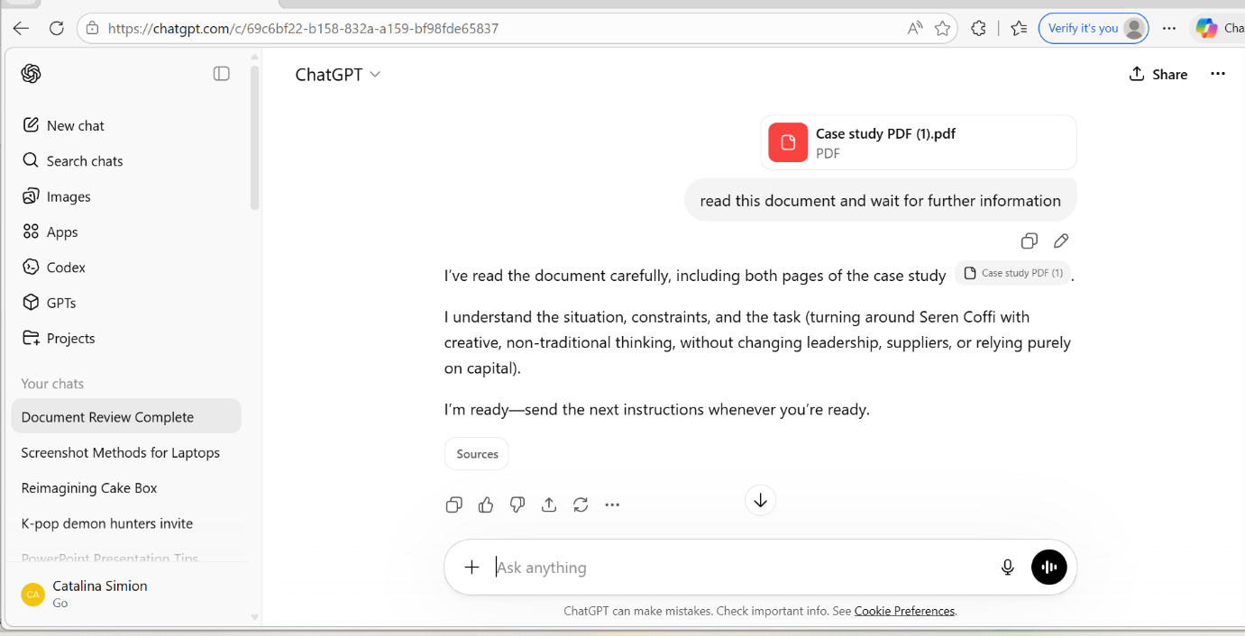

Screenshot 2 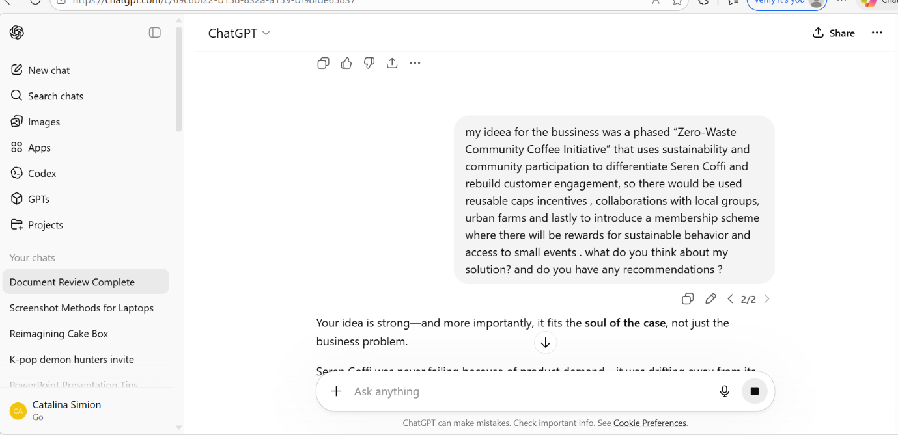

Screenshot 3 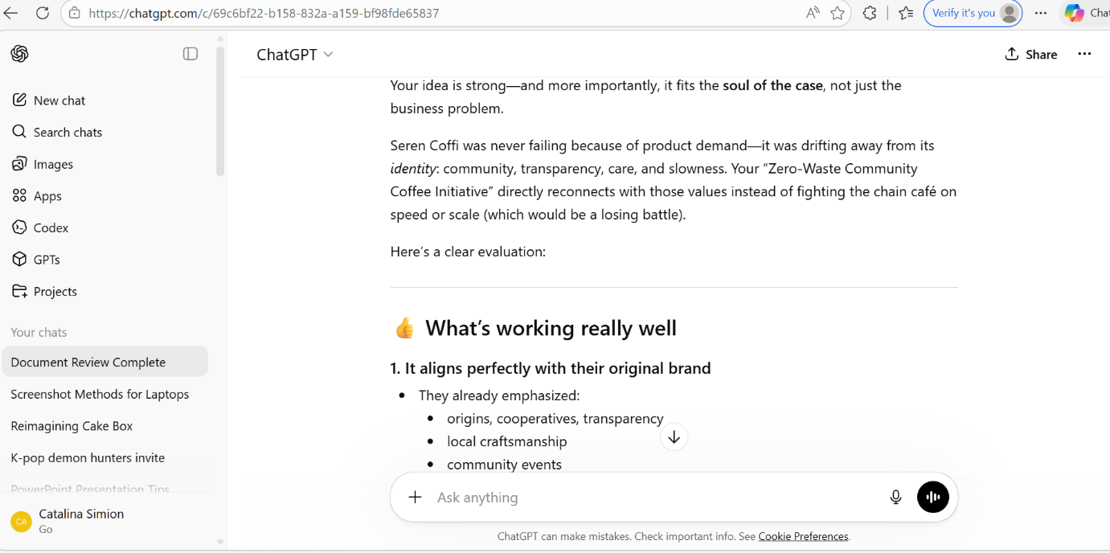

Screenshot 4
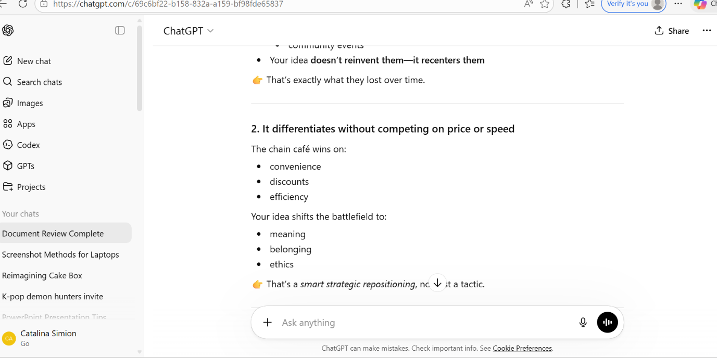

Screenshot 5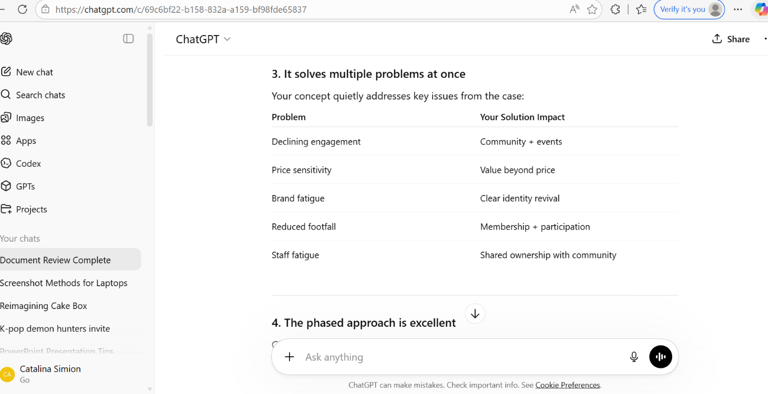

Screenshot 6
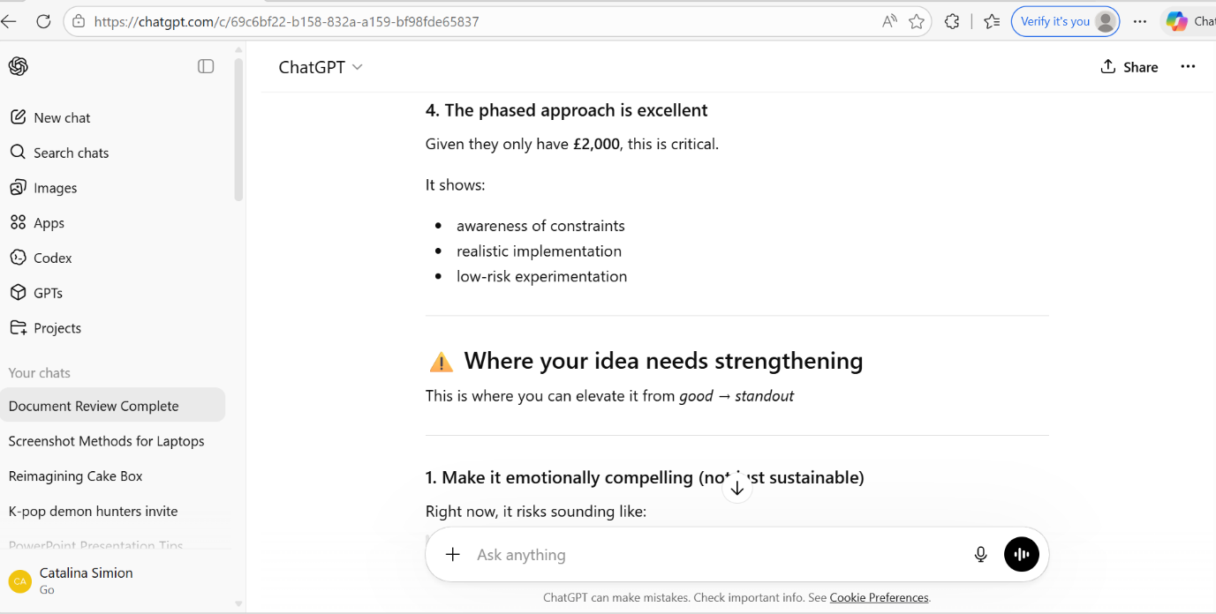

Screenshot 7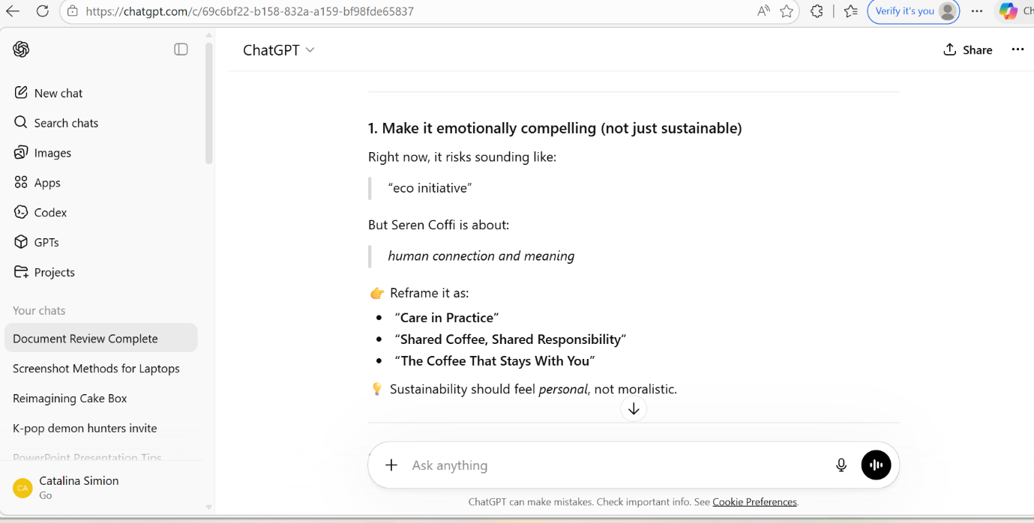

Screenshot 8
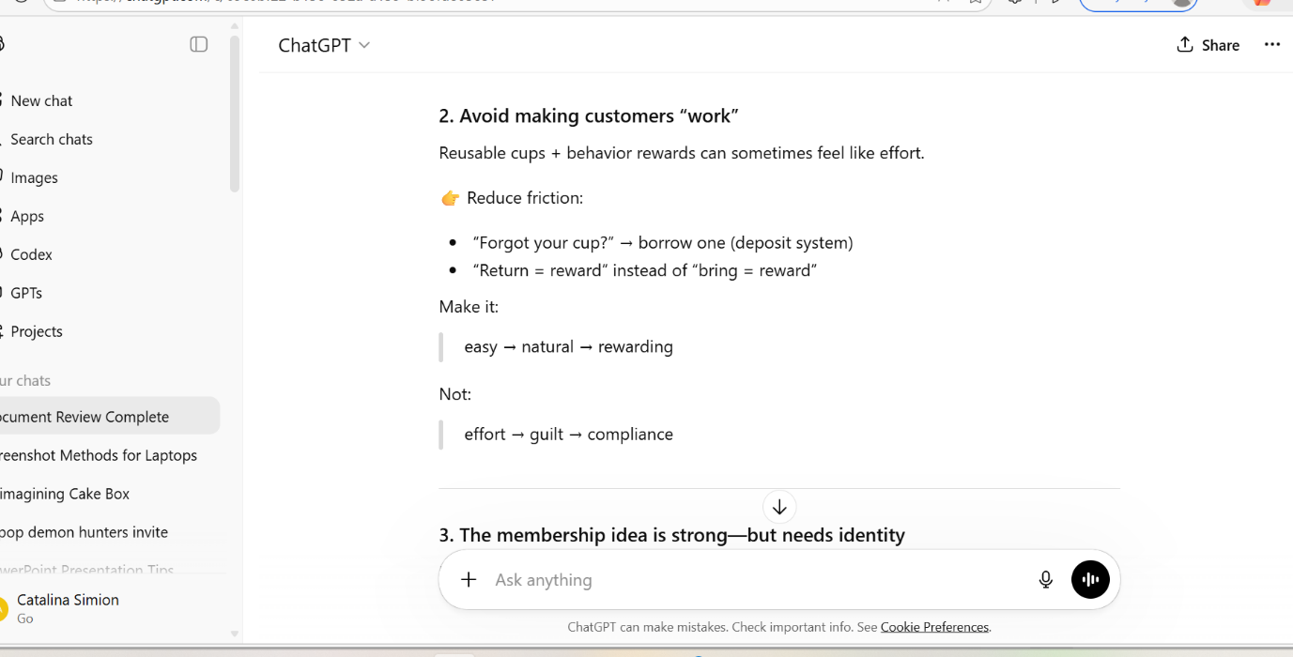

Screenshot 9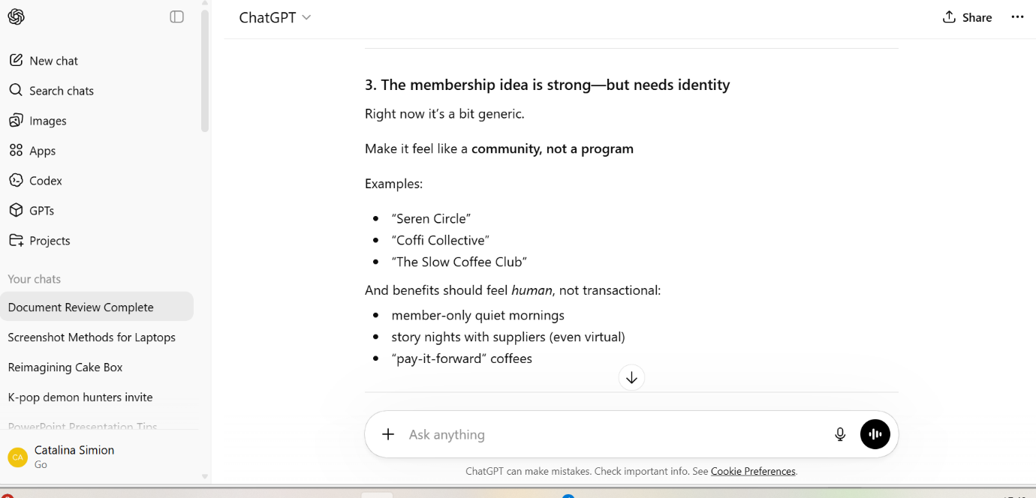

Screenshot 10
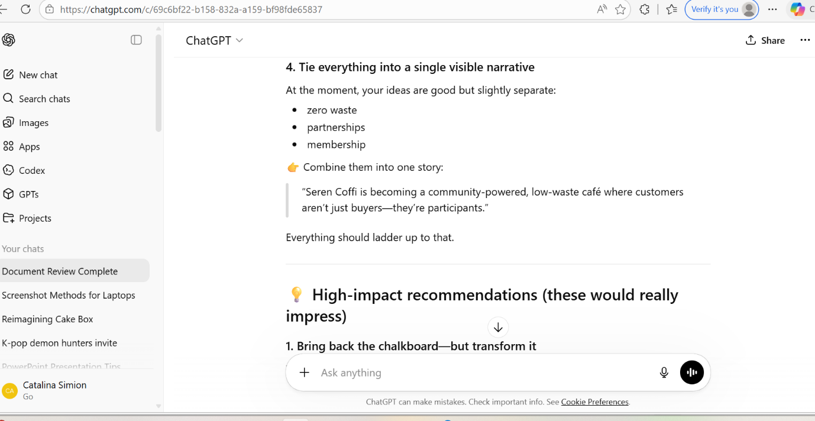

Screenshot 11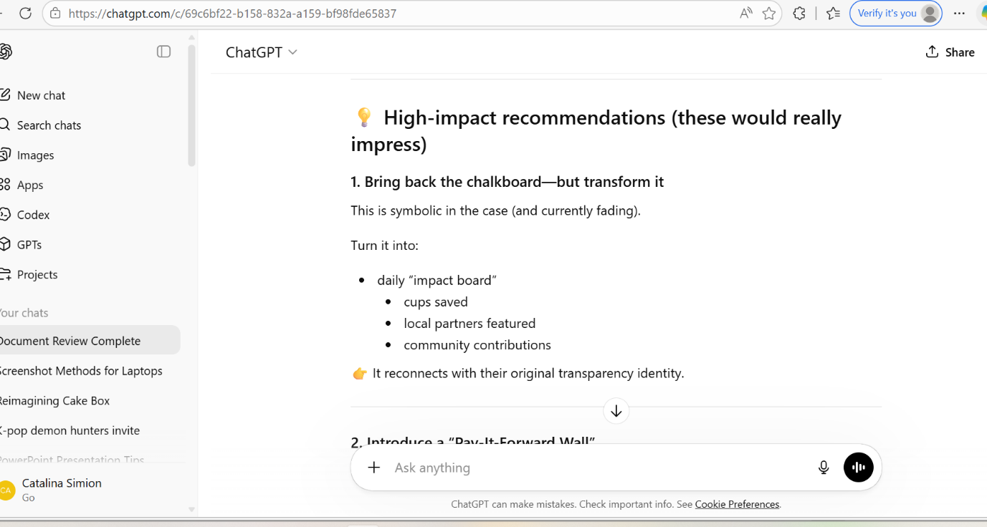

Screenshot 12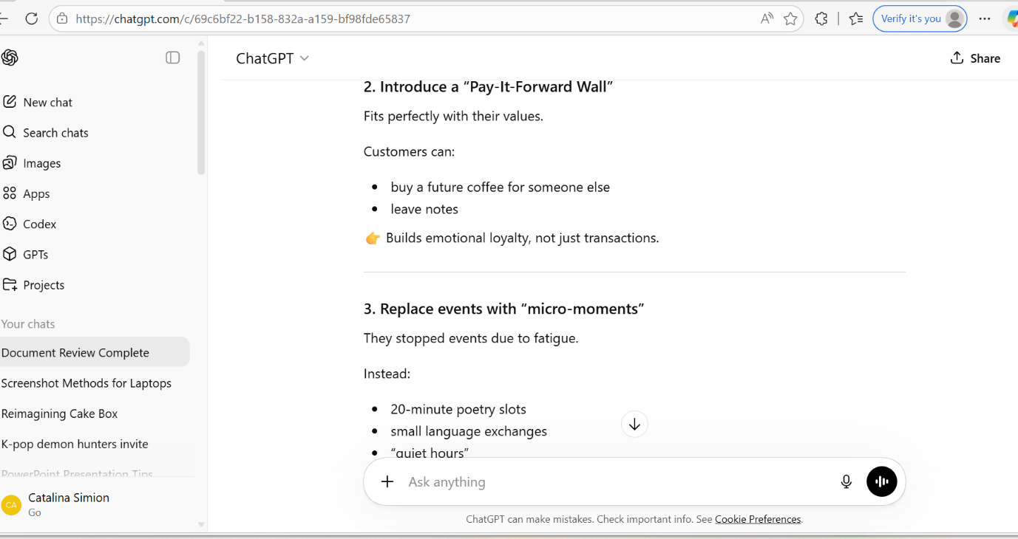

Screenshot 13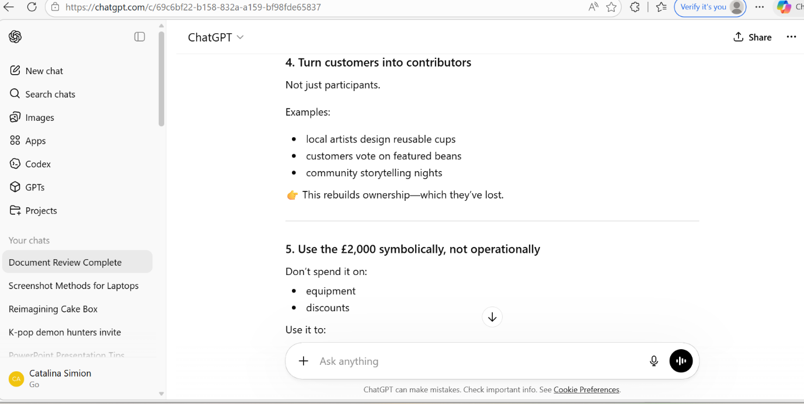

Screenshot 14


