
Swansea five story hotel
Tesco’s Superstore Phase 1 feasibility stage

11 January 2025
Swansea city council
Unit 1 Swansea Industrial Estate

Contents Page

Page 1 - Contents Page

Page 2 – Introduction / Historical background

Page 3 – Introduction / Historical background continued

Page 4 – Image of site

Page 5 – Site investigation recommendations

Page 6 – Site investigation recommendations continued

Page 7 – Site investigation recommendations continued

Page 8 – Borehole Log

Page 9 – Foundation decision

Page 10 – Foundation decision calculations

Page 11 - Foundation decision (what size diameter)

Page 12 – Reference List

Phase 1 preliminary study.
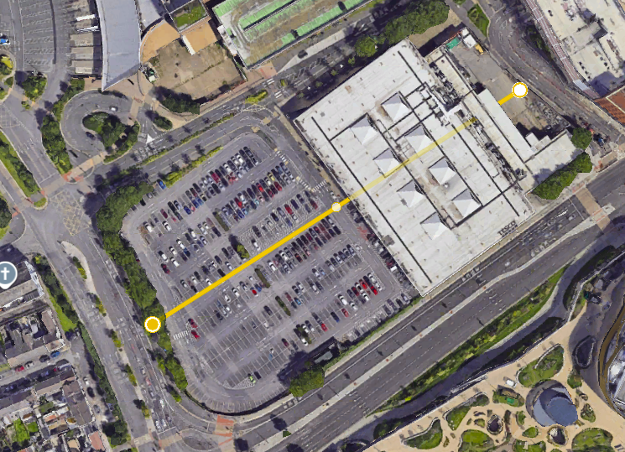
Figure 1 Birdseye view of Tesco site (https://earth.google.com/web/search/Oystermouth+Road,+Swansea/@51.61676898,-3.94471982,4.09366083a,438.006657d,35y,-0h,0t,0r/data=CiwiJgokCbFu2N7Dz0lAEYPy4i5NzklAGUr0IUv-Yw_AISdFYa4Msg_AQgIIAToDCgEwQgIIAEoNCP___________wEQAA)

Introduction
The Tesco site is approximately 115 x 200m making it 23,000m2. Previous to it being Tesco’s it was originally a gas works site where it played a huge factor in the development of gas supply for Swansea in the 19th and early 20th centuries. This site is located just off the main road taking you into Swansea (mumbles road) its also located in the centre of Swansea.
Due to such high demand for energy the creation of the Swansea gas works was a huge part of the industrial revolution in Swansea, it first opened in Swansea in the 1840’s. The gas works main purpose was to provide gas for street lighting and domestic use, in the 1840’s gas was starting to become crucial for lighting as cities were starting to adopt gas lighting in streets gas was also starting to be used to heat domestic properties. This was the start of the high demand for gas.
Gas works involved heating up coal and capturing the gases released while being heated, the byproducts to heating up coal would include coal tar and ammonia. These could of possibly contaminated the environment in which it was created, particularly coal tar as large amounts of it was made as a byproduct of the gas works.
Just after both World Wars there was a considerable decline in the demand for gas powered energy. By the 20th century the gas works started to decline due to electricity which began to replace gas as it was a lot cleaner. Due to the reduction in demand for gas powered energy, Swansea gas works decided it was best to scale down operations as it was less profitable and relevant. By 1950-1960s Swansea gas works shut down.
After the gas works shut down it was then labelled as a brownfield site due to contamination from all of those hazardous chemicals and was deemed too polluted for safe use without a lot of expensive remediation work. These became contaminated eyesores so Swansea decided to modernize the city centre by plans to build new shopping centres, offices and recreational spaces. Before any work could start with the gas works site it would need a thorough investigation to gain a better understanding of how contaminated the brownfield site is.
“.The Dyfatty gasworks were dismantled after Oystermouth Road gasworks opened in March 1842. The gasworks site was a long-standing fixture in the city of Swansea. The original site was acquired in July 1841, a Mr. Spinney acted as consultant. The Neath Abbey Ironworks supplied gas plant to the Swansea Gas Company in 1841 (the drawings are held by the West Glamorgan Archive Service ref: GB 216 DD NAI/2/42/hub). The Swansea Gas Light Company began producing gas on the six-acre site in March 1842. In 1844 Swansea Corporation obtained a second private act for the better paving, lighting and further improving the town. By 1867 the borough of Swansea had been greatly extended, so much so that the length of Swansea‘s streets had increased to approximately 40 miles and the number of public gas lamps to 589.” Swansea Gas Works Depot (no date) Coflein. Available at: https://coflein.gov.uk/en/site/85432/ (Accessed: 11 January 2025).

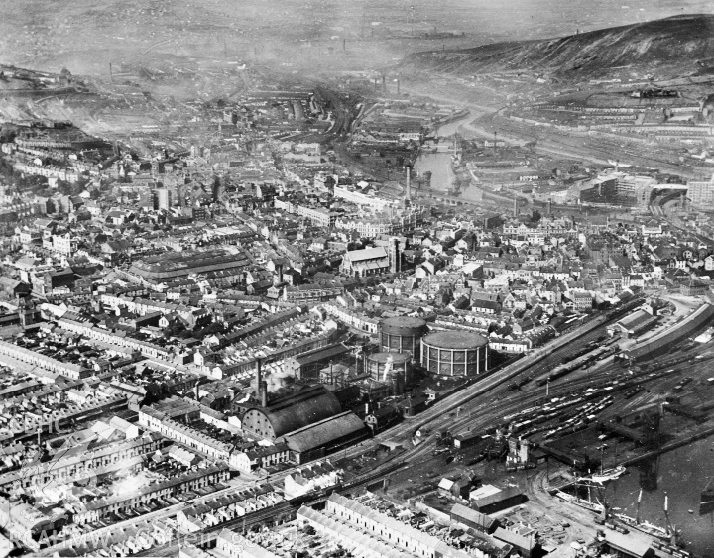
Figure 2 Photo of old gas works on site( https://coflein.gov.uk/media/27/550/large_WPW006114.jpg )

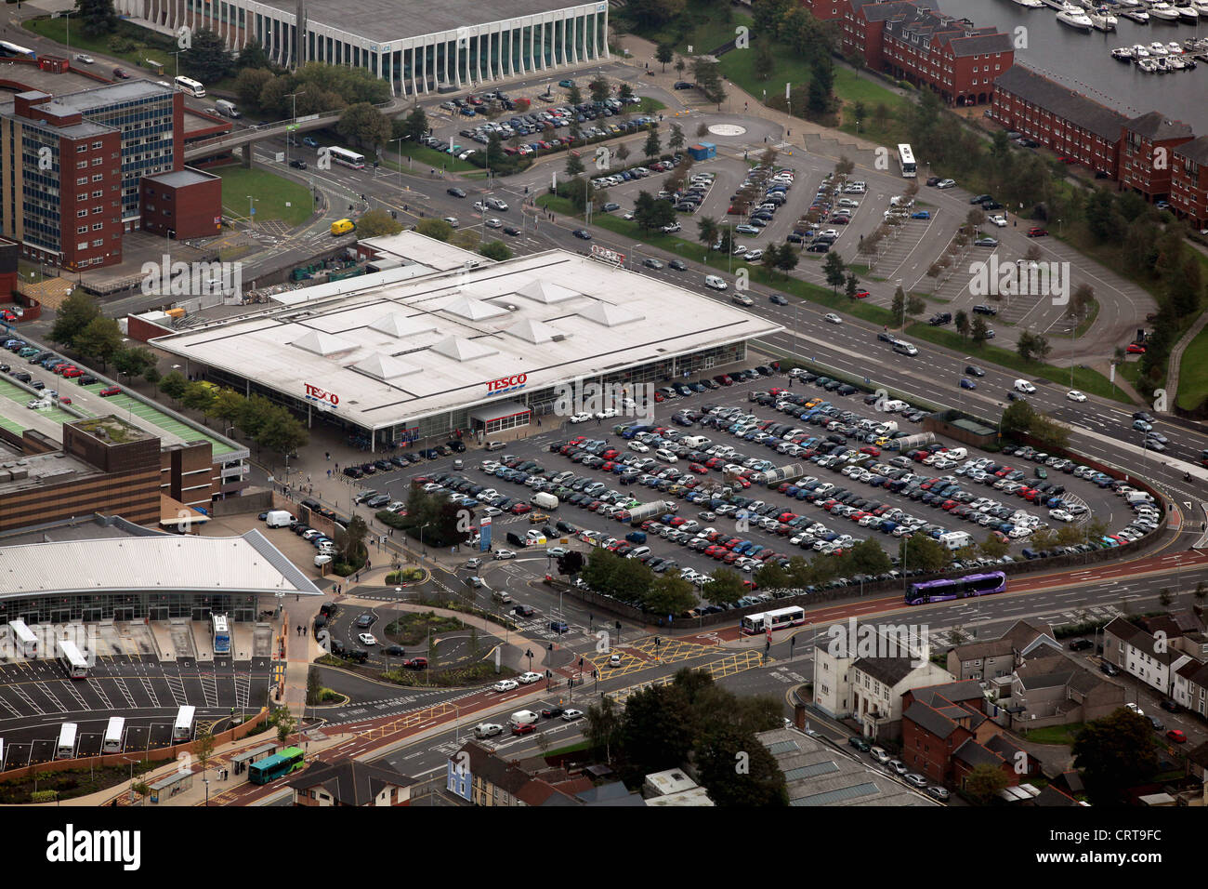
Figure 3 Photo of Tesco's site (https://www.alamy.com/stock-photo-aerial-view-of-the-tesco-marina-supermarket-store-in-swansea-city-49092160.html?imageid=131305B9-190D-49D9-878B-7CC09C13AB0A&p=130214&pn=1&searchId=9adc81700fd05a12c41105e071b26288&searchtype=0)

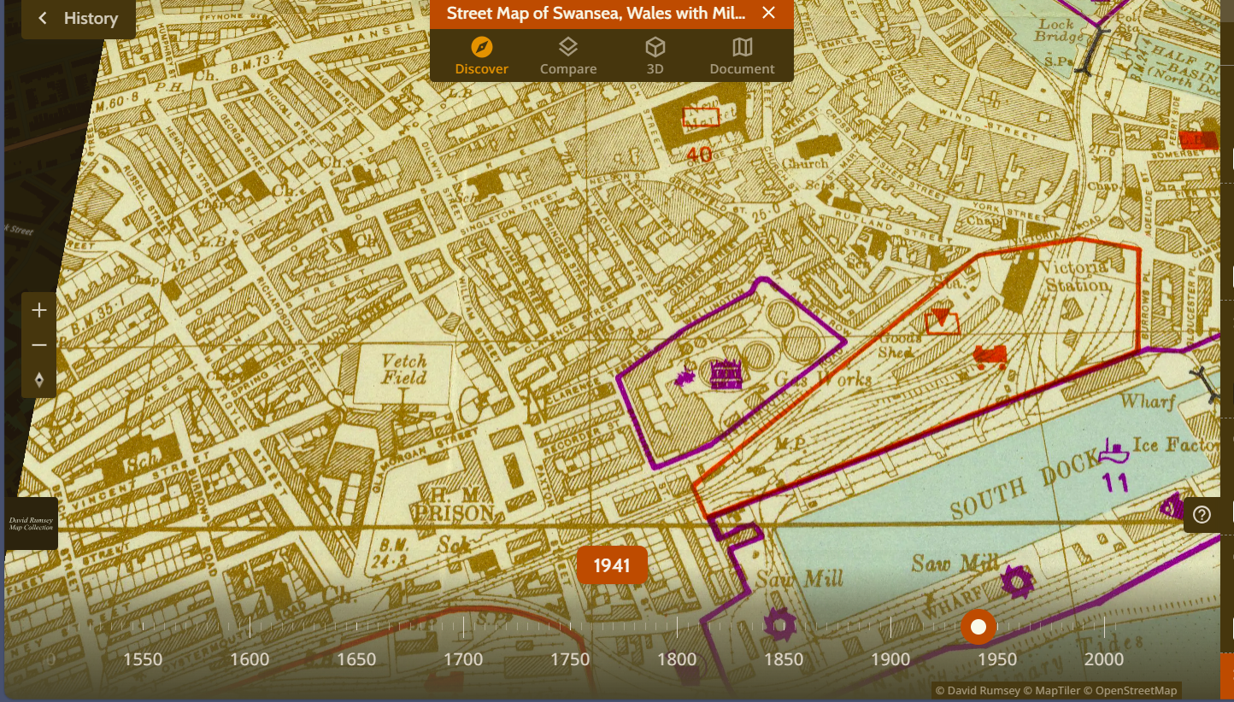
Figure 4 Drawing for previous gas works site highlighted purple. (Oberkommando der Wehrmacht,1940) (Street Map of Swansea, Wales with Military-Geographic Features. BB 26. by Oberkommando der Wehrmacht (OKW) (Nazi German Supreme Command of the Armed Forces) | OldMapsOnline.org)

Given the historical background on the site of Tesco’s Swansea my recommendations to complete the most significant site investigations would be:
Soil sampling: My professional input to this investigation is the need to find out what contaminants are in the soil as this is a primary concern given the previous gas works surrounding the area by completing the soil sampling we will then be complying with The Environment Agency’s Contaminated Land Report 11 (CLR 11) . To ensure that we have the most accurate results we will complete soil samples at different parts of the site as well as at various depths. This will tell us what contaminants are in the soil such as metals, coal tar and hydrocarbons and will also tell us what how deep the soil is contaminated.
Contaminated Groundwater: It is essential we test for groundwater contamination to test for volatile organic compounds and other organic pollutants. Due to the houses and businesses surrounding the site we will have to test the ground water to ensure the safety of drinking water. By carrying out this test we can ensure that our site would comply with The Groundwater (England and Wales) Regulations 2009, The reason this regulation was introduced was to stop any contamination that could potentially gain access to the groundwater and potentially harm the environment.
Decision on Foundation: Due to the previous industrial operations on the site we would have to carry out a geotechnical survey. This would be essential to assess the ground conditions, we will then receive a borehole log which will then help us determine the suitability for redevelopment on the site.
Landfill Gas: A landfill gas assessment is also extremely important to ensure safety of others and also to comply with the Part C of the Building Regulations 2010 where it tells us that we must take necessary precautions to ensure health and safety of everyone that could be effected by the contaminants on or in the ground such as gas and other dangerous substances. during the creation of gas it was not unusual for them to also generate methane and hydrogen sulphide which is highly dangerous if it is not managed correctly. The assessment will determine if gas migration will cause risks for the surrounding environment.
Ecological impact: Carrying out an ecological survey is very important as we can correctly identify any risks that could affect the ecosystems around the area of our site. Within this survey we would need to complete an assessment of SSSI (Sites of Special Scientific Interest) this would determine if there are any rare wildlife, geology or landform features. By carrying out this assessment we can ensure that we are complying with Wildlife & Countryside Act 1981
Asbestos survey: in the regulation Control of Asbestos Regulations 2012 it tells us that every building built before the year 2000 it is mandatory to carry out an asbestos survey. Due to Tesco being built in the February of the year 2000, therefore its not mandatory but due to it being 2 months out of being mandatory and for the safety of everyone involved in the process of demolishing Tesco it would be highly recommended that we carry out an asbestos survey to ensure the safety of all.
Domestic dwellings: if we look at the image below we can clearly identify all of the residential homes and businesses surrounding the area of Tescos (highlighted pink). During our demolition and installation of a five storey hotel we will need to focus on their health and safety considerations. Particularly during the demolition stage; we will create a large amount of dust, noise and emissions these considerations must be addressed and mitigation measures will have to be included to reduce the impact our project has on the nearby businesses and homes. This is very important as we will need to take this into consideration to comply with both the Building Regulations 2010 (England and Wales) Part E Resistance to the passage of sound and the Considerate Constructors Scheme (CCS) which provides us guidelines to minimize the environmental and social impacts our construction site could cause.
Demolishment of Tesco’s
In order to comply with The British Standard BS 6187:2011 we would need to do the below:
“Choosing a method and sequence of work
All structures are different. When choosing the appropriate method of demolition, you’ll need to consider the structural form of the building, its load paths, floor loadings, shear walls, lift shafts and staircases. Full knowledge of the structure is essential.
Your decisions about the sequence and method of demolition should be based on the information gathered at the start of the project.
You must consider:
- structural form of the building
- condition of the building, including the effects of any historic alterations
- presence of any stability-sensitive elements, such as arches and overhangs
- how stability is achieved and can be maintained as the building is dismantled
- effects of debris build-up on the partly demolished structure
- locations of any stiff restraining features
- proximity of other structures and services
- whether there is the potential for unknowns that could increase the likelihood of an uncontrolled collapse
- space available around the structure
A sequence of work should be adopted that eliminates the possibility of an uncontrolled collapse. For example, elements not critical to overall stability should be removed first, with work then proceeding towards stiff elements such as braced cores.
The method of demolition chosen must be fully documented in the plan of work and be communicated to the contract team. If the structural fabric changes through the building, the demolition method may also need to change.” Demolition (no date) HSE. Available at: https://www.hse.gov.uk/construction/safetytopics/demolition.htm (Accessed: 11 January 2025).

We also need to demolish Tesco’s, which is currently taking up 7000m2 of the site. Although this seems simple and easy we need to follow crucial steps in order to safely and efficiently execute the demolition of Tesco’s. First we will need to liaise with a competent demolition engineer, this will benefit us massively as he will then give us an insight into what is needed to be done prior to demolition. Demolition tends to get complicated when the site is located in an urban area or close to a road, unfortunately both of those apply to our site therefore having a demolition engineer will be crucial to safely and efficiently demolishing Tesco’s.
After working with the demolition engineer and planning on the best way to demolish Tesco’s we will then need to contact building control atleast 6 weeks prior to starting demolition. He will then input his view and may recommend to do certain things in a different manner. At the same time of contacting building control we will have to contact highways due to our site being on Oystermouth road. Oystermouth road is one of the main roads in Swansea, therefore we will have to come to an agreement with highways to figure out the best way to ensure safety for people driving and walking in the nearby areas
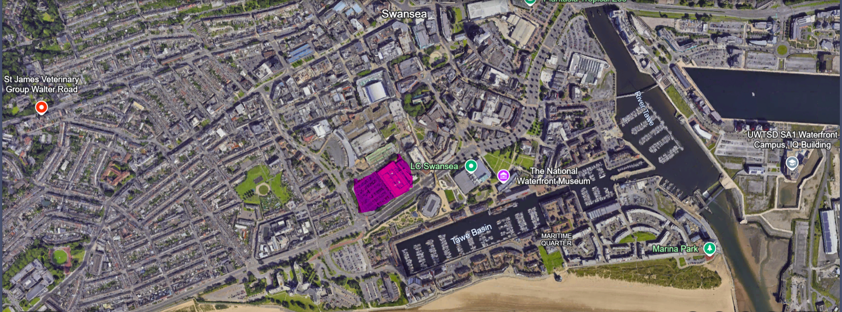
Figure 5 Birdseye view of Tesco site (highlighted pink) (https://earth.google.com/web/search/Oystermouth+Road,+Swansea/@51.61676898,-3.94471982,4.09366083a,438.006657d,35y,-0h,0t,0r/data=CiwiJgokCbFu2N7Dz0lAEYPy4i5NzklAGUr0IUv-Yw_AISdFYa4Msg_AQgIIAToDCgEwQgIIAEoNCP___________wEQAA)

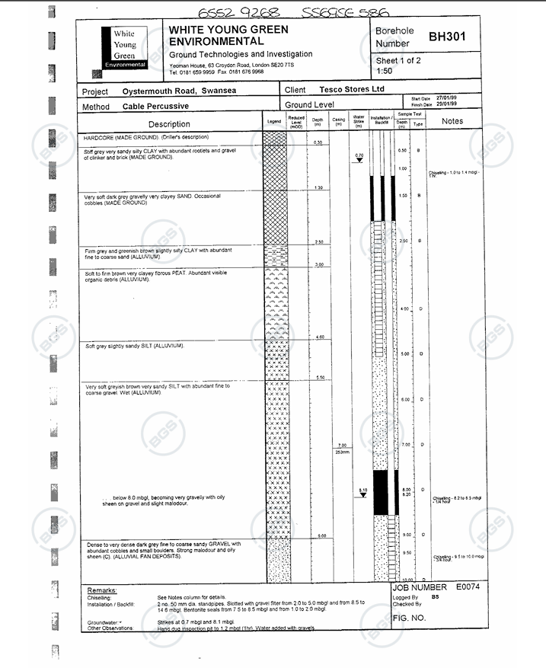
Figure 6 Borehole log 10m depth. (https://api.bgs.ac.uk/sobi-scans/v1/borehole/scans/items/370487)
Estimating the building weight once built:
Due to us needing a big area to install a five storey hotel, bar, restaurant and conference centre on the site I will suggest taking up as much of the site as possible without sacrificing accessibility. The site is approximately 200m x 115m there for I’m going to utilise 185m x 100m of the site, this will ensure we have access for everyone including disabled to our five storey hotel.
Our proposed hotel area is 18,500m2. Typically mid-rise hotels have a weight of around 350 to 700kg pm2, we will have to allow for the worst case scenario of 700kg to ensure no future problems will arise. Our estimated weight of the hotel will be 12,950,000 kg which is 12,950 tonne
Borehole analysis
After analysing the bore hole log above I am suggesting we excavate to a depth of a minimum of 3 meters because then we will be sure we are taking all of the contaminated ground away. We will then have to back fill with hardcore at 300mm intervals, for the first 300mm of hardcore we will first compact it with a heavy duty roller then apply teram sheet to ensure that no left over contaminants from more than 3 meters down will come through. We will then repeat this process until we have reached 900mm away from ground level (300mm compacted then another 300mm compacted and so on) without the teram. Once we are 900mm away from ground level we will infill our foundations ensuring building stability. We will have to make sure the hardcore is compacted with a heavy duty roller to ensure stability for the hotel above.
After a complete analysis of the borehole log I have decided the correct foundation to use for this project will be pile foundation. Looking at the borehole log I would want the piles to come down to at least 8m in depth but preferably down past 9m as we would then get to very dense dark grey fine to coarse sandy gravel but we will drill down until the machine cannot drill the pile any further, this will ensure we have hit the strata needed. We will order 12m in length piles so that we will be able to get to the depth needed with enough pile sticking out so we can create our base with the steels provided in the pile, this will then ensure building stability and protect our hotel from problems in the future.
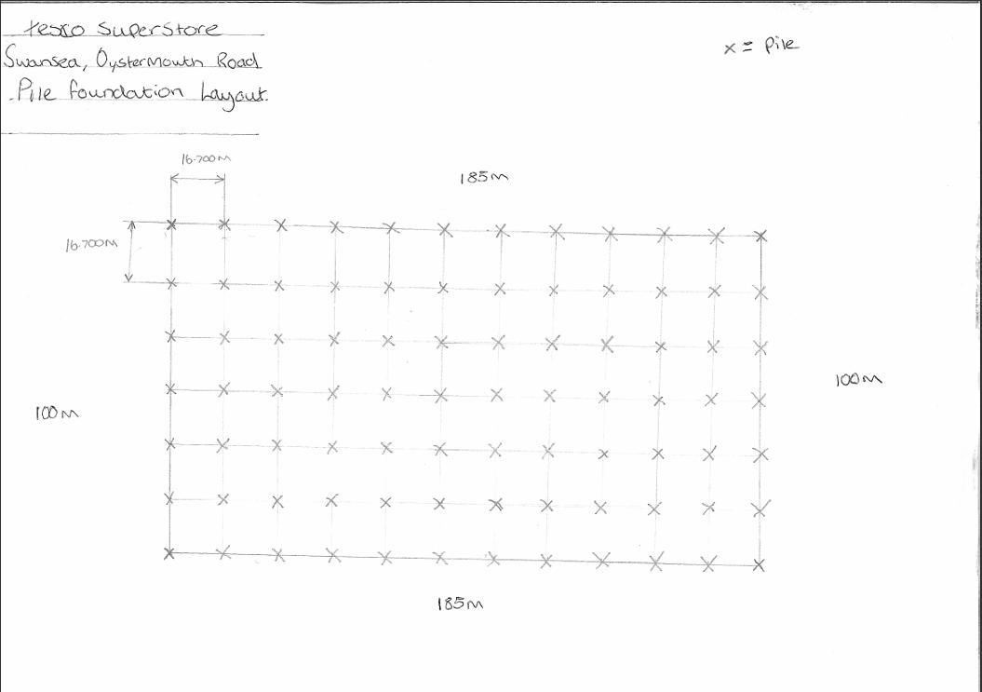

Pile Calculations
The estimated weight of my building will be 12,950 tonne, looking at my drawing above I have specified there to be a pile every 16.7m vertically and horizontally starting from the corners of the structure in total I have specified there to be 84 piles in total. To work out the load on each of the piles I would need to do the following: 12,950/84 = 154.17 tonne

What size pile is sufficient to hold the live weight of the hotel?
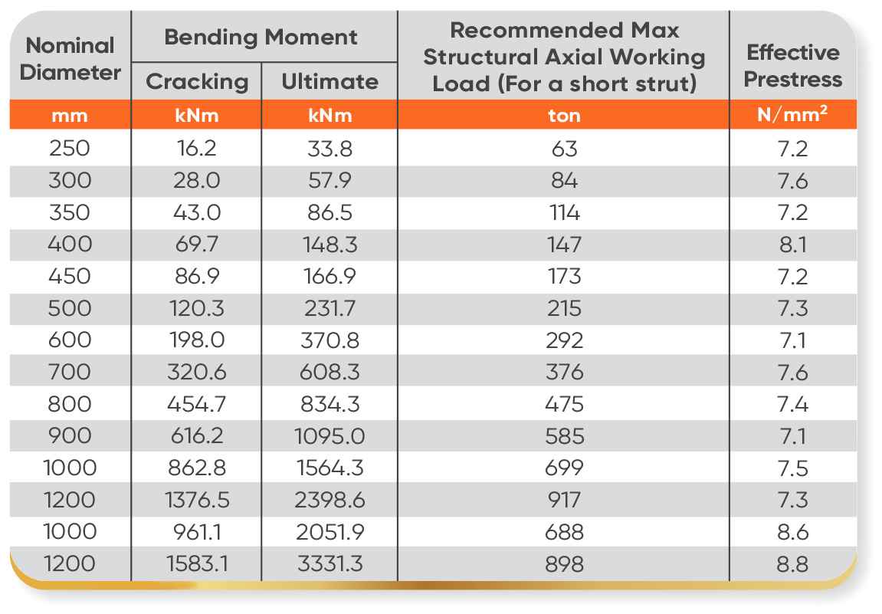
Figure 7 Table of pile foundation diameter correlating to strength (https://www.icpb.com.my/products/)
After understanding and analysing the table we can agree that we will need to have 84 piles where all of them would have a recommended max structural axial working load of at least 154.17 tonne. By using the table above we would be able to use a 450mm in diameter pile but given the height of the building and also the terrible ground conditions seen on the bore hole I will highly suggest using a 500mm diameter pile by doing this we will then ensure our building will easily meet the requirements, which will then be checked over by building control. By using a 500mm diameter pile we will have a max load of 18,060 ton (215ton x 84 piles). The other reason to be using a bigger pile and having a higher max load is so we can account for the extra weight such as live weight, doors and bathrooms.

Referencing
Swansea Gas Works Depot (no date) Coflein. Available at: https://coflein.gov.uk/en/site/85432/ (Accessed: 11 January 2025).
Demolition (no date) HSE. Available at: https://www.hse.gov.uk/construction/safetytopics/demolition.htm (Accessed: 11 January 2025).
Figure 1 Birdseye view of Tesco site (https://earth.google.com/web/search/Oystermouth+Road,+Swansea/@51.61676898,-3.94471982,4.09366083a,438.006657d,35y,-0h,0t,0r/data=CiwiJgokCbFu2N7Dz0lAEYPy4i5NzklAGUr0IUv-Yw_AISdFYa4Msg_AQgIIAToDCgEwQgIIAEoNCP___________wEQAA)
Figure 2 Photo of old gas works on site( https://coflein.gov.uk/media/27/550/large_WPW006114.jpg )
Figure 3 Photo of Tesco's site (https://www.alamy.com/stock-photo-aerial-view-of-the-tesco-marina-supermarket-store-in-swansea-city-49092160.html?imageid=131305B9-190D-49D9-878B-7CC09C13AB0A&p=130214&pn=1&searchId=9adc81700fd05a12c41105e071b26288&searchtype=0)
Figure 4 Drawing for previous gas works site highlighted purple. (Oberkommando der Wehrmacht,1940) (Street Map of Swansea, Wales with Military-Geographic Features. BB 26. by Oberkommando der Wehrmacht (OKW) (Nazi German Supreme Command of the Armed Forces) | OldMapsOnline.org)
Figure 5 Birdseye view of Tesco site (highlighted pink) (https://earth.google.com/web/search/Oystermouth+Road,+Swansea/@51.61676898,-3.94471982,4.09366083a,438.006657d,35y,-0h,0t,0r/data=CiwiJgokCbFu2N7Dz0lAEYPy4i5NzklAGUr0IUv-Yw_AISdFYa4Msg_AQgIIAToDCgEwQgIIAEoNCP___________wEQAA)
Figure 6 Borehole log 10m depth. (https://api.bgs.ac.uk/sobi-scans/v1/borehole/scans/items/370487)
Figure 7 Table of pile foundation diameter correlating to strength (https://www.icpb.com.my/products/)
The Environment Agency’s Contaminated Land Report 11 (CLR 11)
The Groundwater (England and Wales) Regulations 2009
Part C of the Building Regulations 2010
Wildlife & Countryside Act 1981
Control of Asbestos Regulations 2012
Building Regulations 2010 (England and Wales) Part E Resistance to the passage of sound
Considerate Constructors Scheme (CCS)
The British Standard BS 6187:2011

