

Alternative Manufacturing Methods for a helicopter cockpit floor

By:
Elizabeth Roberts

Advanced processes and materials assignment for
BEng Mechanical and Manufacturing Engineering

University of Wales Trinity Saint David
Faculty of Engineering

Table of Contents

Abstract 3
Introduction 4
Materials 5
Methods 6
CNC Milling 6
Abrasive Water Jet Cutting (AWJC) 7
Direct Metal Laser Sintering (DMLS) 8
Discussion: 10
Types of Processes 10
Advantages of Abrasive Water Jet Cutting and Direct Metal Laser Sintering 12
Disadvantages of Abrasive Water Jet Cutting and Direct Metal Laser Sintering 14
Conclusion 16
References 17

Abstract

This report presents an examination of three manufacturing processes; cnc milling, abrasive water jet cutting and direct metal laser sintering for the use in the manufacturing of an aluminium helicopter cockpit floor. The intent of this paper is to 1) depict one superior process compared to the original process, cnc milling 2) discover a process with improved dimensional accuracy and surface roughness compared to cnc milling, 3) and highlight advantages /limitations of each process in comparison to cnc milling. This paper also provides a generalised summary of each process and its current and potential applications.

After extensive research, it was apparent that cnc milling is still a valued traditional method, with the capabilities to produce a range of dimensionally accurate components. However, it is long outdated and therefore, not as versatile as its successors.

While abrasive water jet cutting has many advantages in terms of accuracy, tolerances and versatility. The manufacturing rate requires a significant decrease to achieve optimum dimensional tolerance. Therefore, demonstrating itself to be a less favourable alternative when compared to direct metal laser sintering.
Inferring that direct metal laser sintering is an innovative process, with extremely advanced applications, which surpass that of cnc milling and abrasive water jet cutting. Direct metal laser sintering provides high quality components, with excellent tolerances and surface finish within a lower production time. This process also has the ability to improve company growth with its multi-application opportunities ranging as far as the medical community.

Introduction

As previously mentioned the traditional manufacturing method is to cnc mill the required profile from a sheet of aluminium metal and then to finish by heat treating the component. This method is long outdated, sometimes inaccurate and not very cost effective. Therefore, the aim of this report is to look for alternative methods which can manufacture the component with improved surface finish, keeping all tolerances to +/- 0.0127cm and provide a more cost-effective method.
The cockpit floor of an aircraft is placed inside the “front fuselage and attached to the fuselage frame” [1]. The cockpit floor supports any pressure such as the pilots and control stick loads. Therefore, the component must have a high “yield and thermal strength” [2], which is why keeping aluminium as the preferred material was essential.
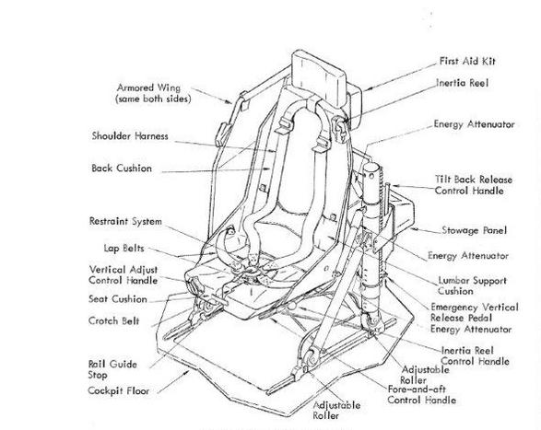Schematic of Pilots seat and cockpit floor [3]
Considerations to be acknowledge; Components from all processes will require heat treatment after production, both cnc milling and abrasive water jet must have additional components welded at a later date.
I will be referring to direct metal laser sintering as DMLS and abrasive water jet Cutting as AWJC throughout the report.
Materials
The material used for the manufacture of the cockpit floor is aluminium, this is a favourable material for the use on aircrafts due to its “light weight” [2], “corrosion resistant” [4]and creep resistant properties. To ensure dislocations and defects in the crystal lattice do not occur in the aluminium, it is therefore, heat treated to minimise the risks and increase yield stress of the material. Meaning both processes must not affect the molecular structure of the material.
The cockpit floor is usually heat treated to a ‘T6 standard after fabrication” [5], cooled at room temperature, heat treated with a much higher temperature and quickly quenched to retain its molecular structure. This process “offers an increase in hardness” [5]

Methods

CNC Milling
Cnc milling is a machining process which relies on “computerized controls” [6], with several “rotating cutting” [6] tools to remove material from a workpiece and produce a custom product. The component is “secured to the bed of the milling machine” [7], a facing tool will machine the component to its desired orientation and dimension, it will then locate “drill” and Ream the holes into the component. The process operates by using several types of tooling; facing tools, boring tools, drills, tip cutter etc. These tools can be quite expensive due to various tools being manufactured from carbide or high-speed steel to ensure a long life for each tool. During the entire process the component is flooded with a special coolant to prevent the material from heating up and effectively case hardening it.
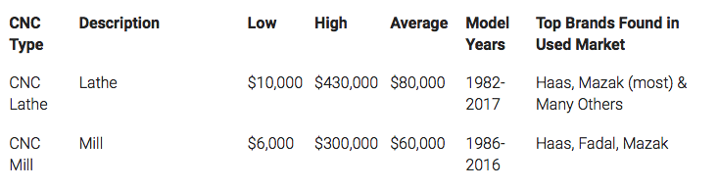
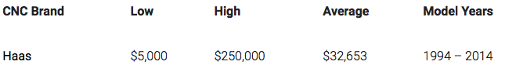
Shown above are images with the average prices for cnc milling machine in 2018. [8]
Some would say cnc milling is a revolutionary process within the engineering industry. Manufacturers will argue that one advantage of CNC milling is its ability to “eliminate the probability for human error” [9] and therefore, requiring less trades people. The Machine only “requires one skilled programmer “[9] and that individual can over see more than one machine at a time. “Cnc machines can and will produce uniformed components” [10] achieving dimensional accuracy within 1/1000th of a mm. A cnc machine can produce components “24 hours of the day without the need of much monitoring. “[10] providing reduced down time, ascertaining the process to be cost effective on all levels compared to other traditional methods.
However, cnc milling isn’t without its disadvantages, their start-up costs are high, due to the initial cost of the machine [8], Maintenance parts and lavishly priced training for all machine operators. Cnc milling does not totally eliminate errors, operators can make mistakes by loading wrong programs or pushing wrong buttons. Whilst manufacturing “A skilled operator is required to choose between different tools, speeds, cutting paths and any repositioning of the material the part is being created from.” [11]. During machining “thermal distortion” [12] can occur from the friction caused between the cutter and the part. This can produce “micro cracks on the surface” [12], which will affect the yield strength and toughness of the part. The entire Process Produces a considerable amount of material wastage and for optimum surface finish (0.58um) [13] a finishing cut is required. This is not cost effective when you compared to alternative processes.

Abrasive Water Jet Cutting (AWJC)
AWJC is generally classed as a mechanical manufacturing method. The material is secured to the bed of the machine, just like the cnc milling. “high pressure” [14] water flows through an aperture in a carbide jewel orifice. Through the vacuum intake abrasive added to the water [14] to “increase cutting efficiency” [15] and the mixture is forced out of the pressurised abrasive nozzle onto the workpiece causing micro erosion to occur. The processes operate a single point application to accurately cut away material at high speeds. As this technique is a cold cutting method, no heat is dissipated onto the workpiece, the water acts as a coolant, providing a high surface finish. Below is an example of a Water jet cutting Head. [16]
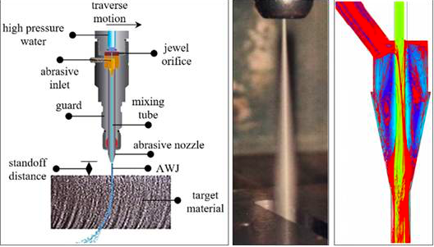
The entire process is controlled by several interfaces; cnc, which is run on real-time platform, Microsoft windows, for its graphical interface for the operator and typically supports both CAD and CAM so completed drawings can be uploaded onto the system and the machine is prepared for manufacturing. There is also a motion controller technology built in so the machine is more sensitive and aware to the functions of the waterjet nozzle. The process can be fully operated or left to independently run by itself. A schematic of the entire process can be seen below. [17]
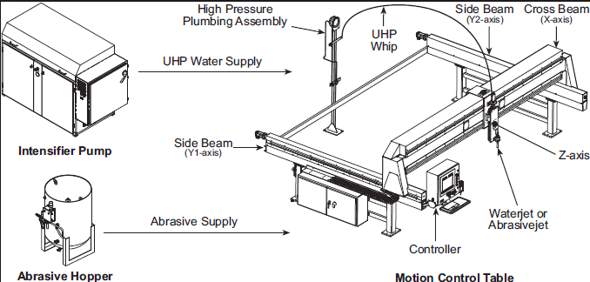

Direct Metal Laser Sintering (DMLS)
DMLS is a rapid prototyping technology, which produces “finished quality” [18] components directly from CAD. It achieves this utilising a “fibre laser” [10] [18] which sinters a variety of powdered materials, creating solid layered parts. This technology provides the option to create complex geometries, which would otherwise be impossible to manufacture. A 2D CAD drawing is uploaded into the operating system, this informs the machine what profile to construct onto the enclosed bed of preheated levelled powder. Once the first layer of “sintered powder bonds” [19] are formed to the required shape, the “platform is lowered by one layer thickness” [28] and the distribution roller creates another layer of powder. This process continues until the “3D CAD” [10] component is completed, all residual power in and around the component acts as a support whilst being manufactured, the residual powder can simply be brushed off and reused again. A cooling down period is required, in order to allow the bonds and structure to strengthen more efficiently. However, due to the components lattice structure, impurities and deformations can occur internally and externally. Therefore, the parts are heat treated to make “the microstructures more homogeneous” [20]
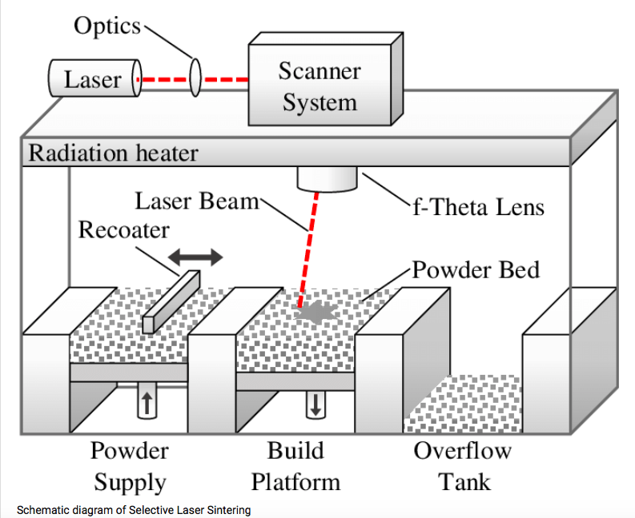Schematic of SLS Machine. [21]
DMLS uses an advanced CNC / CAD system to operate its process. However, it also has a “closed loop control” [21] system integrated into it to achieve uniformed conditions, along with an array of sensors; thermographic cameras, pyrometer, laser beam cameras and emission sensors. This process would need extensive training on the physical aspect, and the operating system as it is exceptionally advanced. The operator must know how and when to alter settings, this can be as simple as adjusting the laser during manufacturing to allow uniformed sintering to occur.
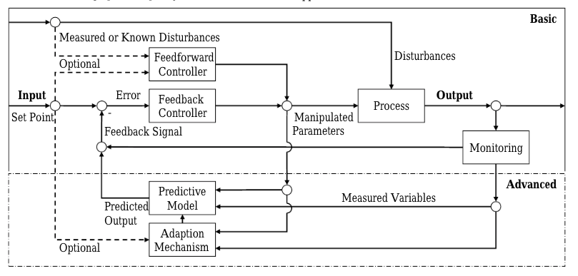Schematic of Basic SLS operating system [21]

Discussion:
Through my own knowledge and research, I have compiled a referenced table of several variables to consider in the comparison between; CNC Milling, AWJC and DMLS.

Types of Processes
Fig 1: Table of variables

One of the aims of this report was to source a process which had improved surface roughness and tolerances, compared to cnc milling. DMLS surface roughness and tolerance excels that of AWJC and cnc milling. It’s surface finish is far more accurate, when you consider 0.58um [26] and 0.1um [23]to that of 0.025um [30], and tolerances are far more advanced. SLS tolerances can be monitored and altered throughout the process ranging from 0.03mm to as little as 0.05mm [28] [29], cnc milling does not have this capability and its max tolerance could be as large as 1mm.

The effects from the process show us that heat migration from cnc milling can cause “micro cracks” [12] to occur, causing potential component failure. AWJC strain hardens the material, causing subsurface deformation [31]. This could negatively affect surface finish and the integrity of the material. This however, is still an improvement to cnc milling.
The DMLS lattice structure can incur deformations or impurities [21] during manufacturing, this can affect the strength and fatigue life of the component. Effects from both DMLS and AWJC can be improved via heat treatment.

When comparing machine cost, DMLS and AWJC are of relatively similar prices ranges. But when compared to cnc milling they are almost double, meaning a high initial cost for both processes.

In order to attain a uniformed understanding of DMLS and AWJC, I have complied two tables, outlining advantages and disadvantages for each process (Fig 2 and Fig 3).

Advantages of Abrasive Water Jet Cutting and Direct Metal Laser Sintering
Fig 2 Advantages Table.
When examining AWJC and DMLS, there are many advantages which sufficiently outweigh cnc Milling and must be considered. Firstly, the waste concern, there is limited waste with AWJC and DMLS, only abrasive and unusable powder waste. Cnc Milling produces material and unusable cutting tool waste. DMLS and AWJC do not require “specific tooling” [39] and therefore do not require a “tool change” [34], cnc Milling requires both variables. Both DMLS and AWJC have Less production set up time, DMLS prints the object straight from CAD or a Scanned copy and AWJC can start cutting the component at any point in time, meaning pre-machining preparation is not required, reducing manufacturing time. Cnc milling may need several operations performed before actual manufacturing, e.g. Cutting material to required dimension, start holes, deburring etc. therefore, it requires longer production time.
No cutting stress is incurred during the manufacturing of AWJC and DMLS components. AWJC is a “cold cutting” [35] method, meaning “hardened “[26] materials can be machined, and no thermal degradation or mechanical heat is transferred onto the component. DMLS completely manufactures “full density” [18] components, meaning no stress is incurred and complex “finished quality” [27] parts are made, creating stronger longer lasting components. cnc Milling however, causes heat degradation and micro cracks to appear on the component, this weakens the internal and external structure.
DMLS is an additive manufacturing (AM) process. AM is renowned for producing light weight components. Due to the nature of DMLS manufacturing process, it has ability to reduce component weight, therefore, cutting manufacturing costs and aircraft fuel costs. For every ‘1kg removed” [37], “litres of fuel” [37] can be saved.
The operating system for all 3 processes are relatively similar, using CNC as their platform. AWJC system would need little training, and could be adapted for 3D printing. However, DMLS system is far more advanced, allowing new and complex applications. Not only is DMLS used in the engineering industry, but is widely used in the “medical community” [41] as DMLS and SLS. Extensive training would be required, but the future opportunities for company growth outweighs this.

Alongside the Advantages of SLS and AWJC. There are many important disadvantages to consider, in the comparison between CNC milling, DMLS and AWJC.

Disadvantages of Abrasive Water Jet Cutting and Direct Metal Laser Sintering
Fig 2 Disadvantages Table.
DMLS and AWJC Produce high quality components, but are not without their limitations. DMLS parts can be manufactured “porous” [25], which can cause “ductile fatigue striations” [43], potentially jeopardising its structural integrity and fatigue life. When direct metal laser Sintering aluminium, “cracking” [39] may occur and “surface roughness” [39] maybe reduced. AWJC “dimensional accuracy” [34] can be compromised when tapers occur, whilst cutting harder and thicker materials. AWJC surface roughness can also be compromised, appearing dull or “matte” [36]. To resolve this, the “speed of the head” [34] must be reduced significantly, meaning longer manufacturing time. If we compare this to cnc milling, “micro cracks” [12] can form, this too can be resolved through reduction in cutting speed, but also via sharper cutting tools and an increase in the flow of coolant.
When investigated closer at the alternative applications for DMLS and AWJC, we see many limitations. The use of 3D printing for AWJC is a complex, time consuming process, which can emit “100db” [36] of noise pollution. Dimensional accuracy is compromised and hard to monitor due to “spent abrasives” [38]. When introducing DMLS as a “medical application” [39], we must take into consideration the cost implications and the component “shrinkage and warpage” [41] possibilities, causing inaccurate parts. Cnc milling however, has been around for many years, all applications have been fully established and recognised.
Both cnc milling and AWJC need the additional welding of 4 additional components meaning longer production time, whereas DMLS will not require this addition meaning less production time.

Conclusion
From the previous report, it has been observed that although cnc milling is a highly accurate process, which can produce a range of products to desired specification. Cnc Milling heavily relies on personnel to control and run it, creating potential for human error. The process is time consuming, requiring additional finishing cuts, to achieve the preferred surface roughness. Resulting in an increased turnover of tooling through working at high speeds, thus producing poor dimensional accuracy. Although its initial costs are low, its upkeep costs are significant and its applications are limited also. It is certainly clear that cnc milling is far outdated and must allow room for the more advanced techniques such as DMLS and AWJC to come to the forefront of industry.
The benefits of AWJC are a vast improvement to cnc milling, with tighter tolerances and surface roughness. The need for tooling is made redundant, with the possibility for complete automation, fast cutting speeds and rapid component turn around. This process ensures continued material integrity alongside an economical process. However, AWJC is not without its limitations. At higher cutting speeds, the water nozzle produces tapers in the workpiece, meaning dimensional accuracy is compromised. The surface of the material can be damaged during production, and initial set up costs are high. AWJC and cnc milling applications are very similar, meaning alternative applications for future company development are unlikely.
Based on the Advantages of DMLS presented earlier, it is fair to say that this process is by far, the most multifunctional, economical processes, producing superior accuracy in terms of tolerances and surface roughness, when compared to cnc milling and AWJC. DMLS is not without its drawbacks, component lattice structure can be porous, but is resolved through heat treatment. Surface cracks can appear, but can be prevented by regulating the laser beam correctly. The advantages of DMLS sufficiently outweigh these draw backs; an extensive range of geometries can be created; 24/7 automation is readily available. Component weight can be cut by half, resulting in reduced manufacturing costs and reduced fuel costs. Although initial investment is high, low tooling and low maintenance costs outweigh this. The potential for medical application could offer new exciting investment and growth for the company in the near future.

References
[1] Shekar, S, Kumar, R. (2015). Stress Analysis of Aircraft Fuselage Cockpit Floor Structure Using Patran and Nastran Software and Hand Calculations. International Journal of Innovative Research in Science, Engineering and Technology. Volume 4 (Issue 6), 4579 - 4586.

[2] YASHPAL, JAWALKAR, C.S., KANT, S. (2015). A REVIEW ON USE OF ALUMINIUM ALLOYS IN AIRCRAFT COMPONENTS. I-manager’s Journal on Material Science. Volume 3 (No 3), 33-37.

[3] ARA, Inc. (2013). UH60 Blackhawk Seat. Available: http://www.ara-incorp.com/ARA-UH60-Seat.html. Last accessed 13th April 2019.

[4] Festus, I, Prof Jha, E. (2017). WHY ALUMINIUM IS PREFERRED AS AN AIRCRAFT FUSELAGE MATERIAL: A REVIEW. Conference: International Conference on Emerging Trends in Mechanical Engineering. 1 (1), 1-6.

[5] AL Cast. (2019). Heat Treatment of A356 Aluminium Castings to T5 and T6 Hardness. Available: http://www.alcastcompany.com/heattreat.html. Last accessed 13th April 2019.

[6] Ardel Engineering. (2019). What is CNC Milling. Available: http://www.ardelengineering.com/what-is-cnc-milling. Last accessed 13th April 2019.

[7] US Army Correspondence. (2014). MILLING MACHINE OPERATIONS. SUBCOURSE NO. OD1644. Volume 8 (1), 1-22 & 30-34.

[8] CNCMachines.net, Manufacturing Tomorrow. (2018). 2018 Used CNC Machine Price: Average CNC Machine Price. Available: https://www.manufacturingtomorrow.com/article/2018/12/2018-used-cnc-machine-price-average-cnc-machine-price/12676. Last accessed 13th April 2019.

[9] Reed, B. (2016). ADVANTAGES OF CNC OVER CONVENTIONAL. Available: https://www.fairlawntool.com/blog/advantages-cnc-machines/. Last accessed 13th April 2019.

[10] Virasak, L. (21 February 2019). Chapter 8: CNC. In: Creative Commons Attribution 4.0 International License Manufacturing Processes 4-5. -: Open Oregon Educational Resources. 174-178.

[11] Jamie D. (2018). 3D Printing vs CNC Machining: Which is best for prototyping? Available: https://www.3dnatives.com/en/3d-printing-vs-cnc-160320184/. Last accessed 13th April 2019.

[12] Pradeep Kumar, M., Amarnath K., Sunil Kumar, M. (2015). A Review on Heat Generation in Metal Cutting. International Journal of Engineering and Management Research. Volume 5 (Issue 4), 193-197.

[13] kokpujie Imhade, P, Okonkwo Ugochukwu, C. and Okwudibe Chinenye, D. (2015). Cutting Parameters Effects on Surface Roughness During End Milling of Aluminium 6061 Alloy Under Dry Machining Operation. International Journal of Science and Research (IJSR). Volume 4 (Issue 7), 2030-2035.

[14] Groover, M (2013). Principles of Modern Manufacturing. 5th ed. Singapore: Wiley & Sons. 1003.

[15] Aswathy, K, Govindan P. (2015). MODELING OF ABRASIVE WATER JET MACHINING PROCESS. international Journal of Recent advances in Mechanical Engineering (IJMECH). Volume 4 (No.3), 60-71.

[16] Mohammad, S. Alsoufi. (2017). State-of-the-Art in Abrasive Water Jet Cutting Technology and the Promise for Micro- and Nano-Machining. International Journal of Mechanical Engineering and Applications. Volume 5 (Issue 1), 1-14.

[17] Jet Edge. (2019). HOW WATERJETS WORK. Available: https://jetedge.com//learn/waterjet-101. Last accessed 13th April 2019.

[18] Saffarzadeh, M, M.S., Gillispie G, M.S., Brown P, PhD. (2016). SELECTIVE LASER SINTERING (SLS) RAPID PROTYTPING TECHNOLOGY: A REVIEW OF MEDICAL APPLICATIONS. Conference: Rocky Mountain Bio-engineering Symposium. 1 (1), 1-8.

[19] Mazzoli, A. (2013). Selective laser sintering in biomedical engineering. international Federation for Medical and Biological Engineering. Volume 1 (No.1), 245-256.

[20] Gibson, I, Rosen, D, Stucker, B (2014). additive Manufacturing Technologies: 3D Printing, Rapid Prototyping, and Direct Digital Manufacturing. 2nd ed. New York: Springer. 510

[21] Reiff, C, Wulle F, Riede, O, Epple, S, Onuseit, V. (2018). ON INLINE PROCESS CONTROL FOR SELECTIVE LASER SINTERING. International Conference on Mass Customization and Personalization – Community of Europe. 8th Edition (No1), 1-10.

[22] Jacobs, M. (2012). Introduction to Aluminium as an Engineering Material. Interdisciplinary Research Centre in Materials. Volume 1 (1), 1-23.

[23] Engineering Clicks. (2011). Cutting processes – tolerance and surface roughness. Available: https://www.engineeringclicks.com/tolerance-surface-roughness/. Last accessed 13th April 2019.

[24] Olsen, J, Zeng, J. (2006). HE STATE-OF-THE-ART OF PRECISION ABRASIVE WATERJET CUTTING. he 8th Pacific Rim International Conference on Water Jet Technology. Volume 1 (No.1), 1-22.

[25] Boud F., Loo L., Kinnell, P. (2014). The Impact of Plain Waterjet Machining on the Surface Integrity of Aluminium 7475. Selection and peer-review under responsibility of The International Scientific Committee. 2nd Edition (No.1), 382-386.

[26] Yuvaraj, N., Pradeep Kumar, M. (2016). Cutting of aluminium alloy with abrasive water jet and cryogenic assisted abrasive water jet: A comparative study of the surface integrity approach. An International Journal on the Science and Technology of Friction, Lubrication and Wear. Volume 1 (No.1), 18-32.

[27] ESAB Knowledge Centre. (2018). What is the best value – plasma, laser, or waterjet? Available: https://www.esab.co.uk/gb/en/education/blog/what-is-the-best-value-plasma-laser-or-waterjet.cfm. Last accessed 13th April 2019.

[28] ales Ocean. (2017). How to design parts for SLS 3D Printing. Available: https://www.3dhubs.com/knowledge-base/how-design-parts-sls-3d-printing#author. Last accessed 13th April 2019

[29] Xometry. (2017). Selective Laser Sintering. Available: https://www.xometry.com/selective-laser-sintering. Last accessed 13th April 2019.

[30] Prof Branislav Duleba, Prof František Greškovič, CSc, Prof. dr hab. inż. Janusz W. Sikora. (2011). MATERIALS & FINISHING METODS OF DMLS MANUFACTURED PARTS. Transfer inovácií. 1 (1), 143-148.

[31] 3D Sources. (2018). Top 10 Best SLS 3D Printers 2019 (For ALL Price Ranges). Available: https://3dsourced.com/rankings/sls-3d-printer/. Last accessed 13th April 2019.

[32] Smokovec, N, (2019). Proceedings of the international conference on Manufacturing Engineering and Materials. In: Hloch, S, Klichova, D, Krolczyk, G, chattopadhyaya, S, Ruppenthalova, L. Advances in Manufacturing Engineering and Materials. Slovakia: Springer. 445-517.

[33] Mierzejewska, Z, Hudák, R, Sidun, J. (2019). Mechanical Properties and Microstructure of DMLS Ti6Al4V Alloy Dedicated to Biomedical Applications. Materials 2019. 1 (1), 1-17.

[34]. Badgujar, P, Rathi, M. (2014). Abrasive Waterjet Machining-A State of Art. IOSR Journal of Mechanical and Civil Engineering (IOSR-JMCE). Volume 11 (Issue 3), 59-64.

[35] Dixit, A, Dave, V, Baid, M. (2015). WATER JET MACHINING: AN ADVANCE MANUFACTURING PROCESS. International Journal of Engineering Research and General Science. Volume 3 (Issue 2, Part 2), 288-291.

[36] Kannan, A, Esakkiraja, K, Nataraj, M. (2013). Modelling and Analysis for Cutting Temperature in Turning of Aluminium 6063 Using Response Surface Methodology. OSR Journal of Mechanical and Civil Engineering (IOSR-JMCE). Volume 9 (Issue 4), 59-64.

[37] Farinia Group. (2019). How Can Additive Manufacturing Help the Aerospace Sector? Available: https://www.farinia.com/additive-manufacturing/industrial-3d/can-additive-manufacturing-save-the-aerospace-sector. Last accessed 13th April 2019.

[38] Liu, t-h, Olsen, J. (2013). APPLICATION OF ABRASIVE-WATERJET FOR 3D MACHINING. WJTA-IMCA Conference and Expo. 1 (1), 1-15

[39] Olakanmi, E, Cochrane, R, Dalgarno, K. (2015). A review on selective laser sintering/melting (SLS/SLM) of aluminium alloy powders: Processing, microstructure, and properties. Progress in Material Science. Volume 74 (1), 401-477.

[40] Yardroitsava, J, Yadroitsev, I. (2010). RESIDUAL STRESS IN METAL SPECIMENS PRODUCED BY DIRECT METAL LASER SINTERING. Department of Mechanical and Mechatronic Engineering, Central University of Technology. 1 (1), 614-624.

[41] Saffarzadeh, M, Gillispie, G, Brown, P. (2016). SELECTIVE LASER SINTERING (SLS) RAPID PROTYTPING TECHNOLOGY: A REVIEW OF MEDICAL APPLICATIONS. Conference: Rocky Mountain Bio-engineering Symposium .1-6.

[42] Adekayne, S, Mahamood, R, Akinlabi, E, Owolabi, M. (2017). ADDITIVE MANUFACTURING: THE FUTURE OF MANUFACTURING. MATERIALI IN TEHNOLOGIJE/MATERIALS AND TECHNOLOGY. 1 (1), 709-715.

[43] Horseweed, B, Conick, F, Moens, D, Boonen, R, Sas, P. (2009). Microstructural characterization of SLS-PA12specimens under dynamic tension/compression excitation. Department of Mechanical Engineering, 1 (1), 1-19.

