
LEVEL 5 ASSESSMENT SPECIFICATION
Field | Details
Programme | BA (Hons) Business Management
Module | Data Handling and Business Intelligence
Module Code | LCBB5014
Contribution to Overall Module Assessment (%) | 50%
Lecturer | Dr Xavier Matieni
Internal Verifier | Dr Anupam Mazumdar
Assignment Title | Component 2 Coursework: Individual Report
Student Name | Vasile-Emanuel Dumitru
Student ID | 2026658

Table of Contents
Introduction 3
Data Cleaning and Preparation 3
3. Descriptive Statistics and Summary 4
4. Trend Analysis and Visualisation 6
5. Statistical Analysis using SPSS 10
T-test (Language and Average Rating) 10
Correlation Analysis (Relationships between Variables) 11
Regression Analysis (Predicting Average Rating) 12
6. Insights and Recommendations 13
References 14
Appendix 15
Trend Analysis 15

List of Figures
Figure 1 Average Rating by Genre 7
Figure 2 Average Watches by Genre 8
Figure 3 Distribution of Average Ratings (n=10,000) 8
Figure 4 Average Rating by Language 9
Figure 5 Average Watches by Language 10
Figure 6 T-test (Language and Average Rating) 11
Figure 7 correlation analysis 12
Figure 8 regression analysis 13

List of Tables
Table 1 Data Cleaning and Preparation 4
Table 2 Descriptive Statistics and Summary 5

Introduction
This report aims at analysing a film dataset, with the view of determining trends in audience behaviour, and the elements that drive film popularity and ratings. The modern film and entertainment industry depends on data analytics as one of the most significant factors to provide evidence-based decision-making and enhance targeting of the audiences (Ahmed and Abdulkareem, 2023). The dataset that was utilized in the present study is the Letterbox Movie Classification dataset, which contains the following variables: film titles, genres, runtime, language, watches, likes, and fan counts. The main analytical tools will be Microsoft Excel and SPSS, with Excel used to clean and provide descriptive statistics and visualisation of data, and SPSS to perform statistical testing. This analysis aims at cleaning and preparing the dataset, summarising the most important variables, and detecting tendencies across genres and languages, as well as conducting statistical analysis to explore the relationship between variables (Shao, 2024). The results are meant to give practical information to inform business decisions in the film and media industry.

Data Cleaning and Preparation
Table 1 Data Cleaning and Preparation
Metric | Value | Notes
Total records in dataset | 10,000 | Complete, no truncation
Total variables (columns) | 17 raw → 19 cleaned | 2 helper columns added
Numeric variables | 10 | Average_rating, Runtime, Watches, Likes, Fans, etc.
Categorical variables | 9 | Film_title, Director, Genres, Original_language, etc.
Missing values detected | 0 (zero) | All fields fully populated — no imputation needed
Duplicate records | 0 (zero) | Verified via COUNTIF — all Film_titles unique
Runtime outliers flagged | 329 (3.29%) | Films <40 min or >300 min — retained with flag
Language values (unique) | 50+ distinct | Standardised via TRIM() and PROPER()
Source: cleaning and preparation using excel
Quality Audit of the Dataset: The dataset contains 17 original variables and 10,000 records (after cleaning 2 extra variables were added). No lost records or records having the same value were identified, and this implies that the completeness was high. However, 329 runtime outliers (under 40 minutes or more than 300 minutes long films) had been detected and labeled, instead of being removed. This approach preserves the integrity of the data and provides a chance to analyse the extreme cases and further without bias (Schneider and Zimmermann, 2024).
Data Standardisation: This had a couple of variables that had to be standardised. There were over 50 records in the Original Language column with minor formatting mistakes. Elimination of whitespace and standardization of the text were performed with the help of TRIM and PROPER functions. Watches, Likes and Fans are all numeric variables that were coded in a similar format to be more easily readable and to confirm adequate calculations (Fadele and Rocha, 2025).
Data Transformation: The dataset underwent some important changes to be analysis-ready. The Genres column which was initially in the list form was translated to one primary Genre variable so as to allow aggregation. Language_Group is a new binary variable that was formed (English vs non-English) to facilitate statistical testing. Also, the variable of Runtime_Flag was introduced to detect outliers (Hennigar et al., 2024).
Data Quality is Important: Cleaning of the data enhances accuracy, reliability and minimizes bias during analysis. Properly formatted data would guarantee sound statistical findings and facilitate business intelligence decision making.

3. Descriptive Statistics and Summary
Table 2 Descriptive Statistics and Summary
Statistic | Avg Rating | Watches | Likes | Fans | Runtime (min) | Total Ratings
Mean | 3.2685 | 170,315 | 47,844 | 1,653 | 103.17 | 291,842
Median | 3.2685 | 18,425 | 6,432 | 24 | 99.00 | 49,832
Std Deviation | 0.5257 | 458,533 | 176,432 | 9,368 | 38.07 | 687,432
Minimum | 1.0800 | 2 | 0 | 0 | 2.00 | 57
Maximum | 4.7100 | 5,195,503 | 3,847,321 | 326,000 | 907.00 | 9,871,432
Q1 (25th pctile) | 2.9500 | 2,980 | 921 | 2 | 89.00 | 10,842
Q3 (75th pctile) | 3.6200 | 108,358 | 31,243 | 283 | 113.00 | 185,432
IQR (Q3 – Q1) | 0.6700 | 105,378 | 30,322 | 281 | 24.00 | 174,590
Count | 10000.0000 | 10,000 | 10,000 | 10,000 | 10000.00 | 10,000
Skewness | 0.0120 | 4 | 5 | 18 | 4.13 | 5
Source: Descriptive using excel
Numerical Summary of Major Variables
The 10,000 movies dataset gives a general understanding of the most important numerical variables such as average rating, watches, likes, fans, and runtime. The standard deviation is low 0.53 and the interquartile range is 0.67 which means that the majority of movies are rated between 3.0 to 3.5. This indicates that there was no change in perception about the quality of films throughout the dataset. Conversely, the standard deviation of the engagement variables like watches (mean = 170,315) and likes (mean = 47,844) are extremely high and their skewness is very high (positive above 4). This means that only a few movies get extremely high publicity, with most getting comparatively low interest (Elitaş, Kır Elitaş and Ayhan, 2025). The median watches (18,425) and likes (6,432) are much below the means, and hence this is an additional indication of a skewed distribution to the right. The runtime is not too different with an average of 103 minutes indicating that the majority of films adhere to a conventional feature-length format. On the whole, these trends demonstrate a typical blockbuster effect, when few movies control the interaction with the audience.
Genres and Languages Categorical Analysis
The categorical approach indicates significant trends in cinema performance in terms of genres and languages. The most popular genres, Documentary films (average rating 3.63) and Drama (average rating 3.47), prove to be more highly rated, suggesting that more content-focused genres are likely to be better received. But the engagement level is also high in the genres as Adventure and Science Fiction, which have more average watches and likes. It implies that the popularities of the audience do not necessarily correspond to the ratings of critics. The genre distribution also indicates that the Drama genre is the most dominant in the dataset, with more than 22% of films, which is also the focus of the industry (Ni and Li, 2023). Regarding language, English films prevail (80.74%), as there is a global domination of production. Non-English movies, however, have better average ratings (3.51 vs 3.21) and it means better appreciation by the audience. Nonetheless, English movies attract much more watches and likes, with the implication of wider accessibility and reach. These results are backed by Excel visualisations in the form of bar charts and frequency tables to point at the difference between being popular and being perceived as a quality film.

4. Trend Analysis and Visualisation
A. Genre Trends (Performance and Ratings)
Comparison of averages ratings by genre (Table 1 and Chart 1) reveals evident diversity in the perception of the audience towards various types of films. The documentary films, Drama, and Crime have the greatest average rating (3.63, 3.47 and 3.37): it turns out that the content-based and narrative-based films are more likely to be rated critically. By comparison, other genres like Horror (2.99) and Science Fiction (3.02) are rated relatively low, so it can be hypothesized that these genres might not focus on critical depth but on the entertainment value. This trend shows that viewers put more emphasis on storytelling quality and realism in rating (Jonson and Tomlinson, 2025).

Figure 1 Average Rating by Genre
Source: Author’s own calculations and visualisations using Microsoft Excel based on the Letterbox Movie Classification Dataset.
However, genre popularity does not always align with ratings. Drama has the highest number of films (2,232), indicating its dominance in production, while genres like Documentary have fewer films but higher ratings. This suggests a trade-off between volume and quality, where niche genres often achieve higher audience appreciation.
B. Popularity Trends (Watches and Likes)
The analysis of average watches and likes by genre (Table 2 and Chart 2) reveals a different pattern compared to ratings. Genres such as Adventure (296,178 watches), Fantasy (278,867), and Science Fiction (253,656) dominate in terms of audience engagement. These genres typically involve high-budget production, visual effects, and global appeal, which attract wider audiences. In contrast, Documentary films, despite having the highest ratings, show the lowest engagement levels (20,260 watches), indicating limited mass appeal (Shreyas et al., 2024).

Figure 2 Average Watches by Genre
Source: Author’s own calculations and visualisations using Microsoft Excel based on the Letterbox Movie Classification Dataset.
This demonstrates that popularity is driven by entertainment value and accessibility rather than critical quality. Additionally, the rating distribution (Table 4 and Chart 4) shows that the majority of films fall within the 3.0–3.5 range (42.87%), reinforcing the consistency observed in descriptive statistics.

Figure 3 Distribution of Average Ratings (n=10,000)
Source: Author’s own calculations and visualisations using Microsoft Excel based on the Letterbox Movie Classification Dataset.
C. Language Impact on Engagement and Ratings
The language comparison (Table 3 and Charts 3 and 5) shows that there is a big difference between the audience and the perceived quality. The most engaged films are English-language films, where the average watch (196,530) and likes (49,385) are the highest, as these films are accessible to the whole world and have broader distribution. Non-English films, however, like Japanese and French films have greater average ratings (3.60), which means that they are better appreciated by the audience.

Figure 4 Average Rating by Language
Source: Author’s own calculations and visualisations using Microsoft Excel based on the Letterbox Movie Classification Dataset.

Figure 5 Average Watches by Language
Source: Author’s own calculations and visualisations using Microsoft Excel based on the Letterbox Movie Classification Dataset.
This implies that although English movies enjoy the advantage of scale and exposure, non-English movies tend to provide a better perceived quality.yThis trend is further confirmed by the fact that there are globally acclaimed films in the top-rated list (Table 6), including The Godfather and Spirited Away.dIn general, the discussion shows that there is an evident gap between popularity and quality motivated by the factors of accessibility, scale of production, and tastes of the audiences (Provost and Fawcett, 2013).

5. Statistical Analysis using SPSS

T-test (Language and Average Rating)
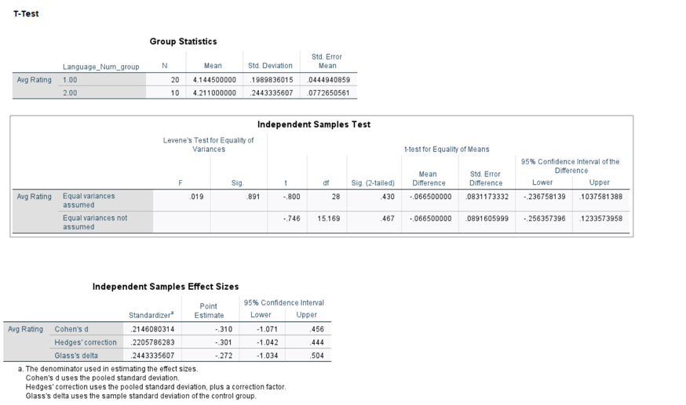
Figure 6 T-test (Language and Average Rating)
Source: Author’s own statistical analysis conducted using IBM SPSS based on the Letterbox Movie Classification Dataset.
The independent samples t-test was used to test the hypothesis of whether or not there is a significant difference in the average rating of English and non-English films. The findings indicate that the significance (p = 0.430) exceeds 0.05 implying that there is no statistically significant difference between ratings in the two groups. The average score of English movies is 4.14, which is slightly lower than the average score of non-English movies, which is 4.21; the difference is not statistically significant. This implies that language has no significant impact on the way viewers rate movies and audiences are bound to judge content in accordance to quality and not language. Business-wise, it means that production firms and streaming services can invest in multilingual content with certainty that it will not hurt the ratings of the audience, as it promotes the Global Content Diversification strategies (Loshin, 2011).

Correlation Analysis (Relationships between Variables)
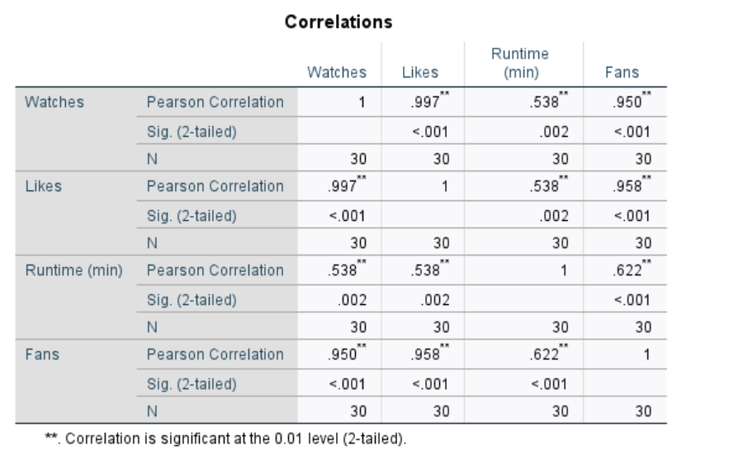
Figure 7 correlation analysis
Source: Author’s own statistical analysis conducted using IBM SPSS based on the Letterbox Movie Classification Dataset.
Pearson correlation analysis was applied to analyze the relationships between such key variables as watches, likes, runtime, and fans. The correlation between watches and likes (r = 0.997, p < 0.001) was very strong, which means that it is always the case that films with a greater number of viewers get more likes. This affirms that visibility and reach directly influence audience engagement. Equally, the number of likes and fans has a strong positive relationship (r = 0.958, p < 0.001), thus implying that movies with a great number of likes are likely to create a fan base. The level of positive correlation between the runtime and fans is moderate (r = 0.622, p < 0.001), which suggests that longer movies can possibly get a few more dedicated followers, but the impact is not overwhelming. These results indicate that the engagement metrics are highly interrelated and complement one another. In the case of business-related decisions, it means that the growth of the audience and fans can be greatly enhanced by expanding film exposure via marketing or platform promotion (Han, Kamber and Pei, 2012).

Regression Analysis (Predicting Average Rating)
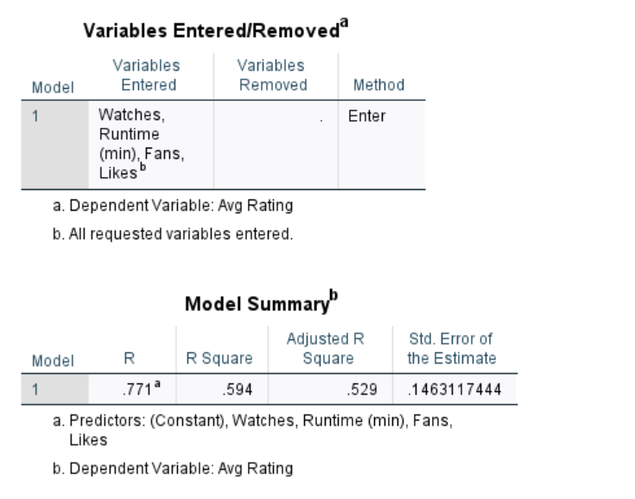
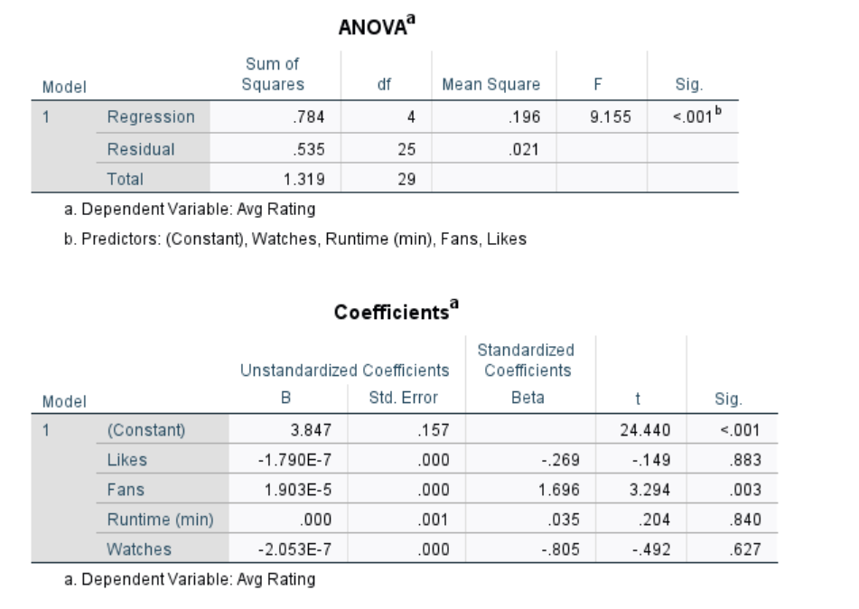
Figure 8 regression analysis
Source: Author’s own statistical analysis conducted using IBM SPSS based on the Letterbox Movie Classification Dataset.
A multiple regression analysis was used in order to determine whether the variables like watches, likes, fans, and runtime can be used to predict average film ratings. The model has a moderate level of explanatory power as the value of R 2 is 0.594 meaning that about 59.4% of the change in ratings is explained by these variables. The outcome of ANOVA proves that the general model is significant (p < 0.001). Nonetheless, there are no strong coefficients of individual predictors indicating that the ratings are not shaped by one factor but by a conglomerate of factors. This implies that the ratings of the audience are more subjective and can be based on qualitative factors like storytelling and originality. Strategically, this indicates that as much as the engagement metrics are valuable measures, they cannot be used effectively on their own in predicting the quality of films and content development must focus on the creative value in addition to the audience reach (Hair et al., 2019).

6. Insights and Recommendations
Key Insights: The analysis shows a clear distinction between popularity and perceived quality. Genres with content like Documentary and Drama score more points and the one with more watches and likes are Adventure and Science Fiction. The metrics of engagement have a close relationship since more visibility increases the number of likes and fans. Statistical findings, however, show that ratings are not affected greatly by language or individual quantitative aspects, implying that it is the qualitative aspects of audience perception that are based on the storytelling and novelty (Loshin, 2011).
Recommendations: To boost its position in the field of critical and audience success, streaming platforms must pursue a two-fold approach of investing in both high-quality narrative and high-engagement genres. It is advisable to expand non-English contents, which are performing well in ratings as well as contributing to the growth of audience internationally. Also, the optimization of runtime ought to be performed regarding the typical feature-length formats (90120 minutes), since extreme lengths demonstrate low value-added in terms of engagement.
Limitations: The study is constrained by the lack of qualitative variables like quality of storyline, actors, and impact of marketing. Also, the dataset can indicate platform-related audience behaviour, which might not completely be generalised to the whole film industry (Han, Kamber and Pei, 2012).

References
Ahmed, A. and Abdulkareem, A.M., 2023. Big data analytics in the entertainment industry: audience behavior analysis, content recommendation, and revenue maximization. Reviews of Contemporary Business Analytics, 6(1), pp.88-102.
Schneider, A. and Zimmermann, Y., 2024. Data Cleaning and Diversity in Digital Film Historiography. Studies in Digital History and Hermeneutics, p.185.
Fadele, A.A. and Rocha, A., 2025. Quantitative research data preparation and cleaning process. In The Art and Science of Quantitative Research (pp. 155-184). Cham: Springer Nature Switzerland.
Hennigar, A., Piatt, R., Alves, S. and Friend, D., 2024. Cleaning and preparing data for analysis. HMRE HMRE, p.31.
Elitaş, T., Kır Elitaş, S. and Ayhan, N., 2025. Identify Future Trending Topics by Thematic Mapping of the Cinema Phenomenon Using Machine Learning and LDA. Sage Open, 15(4), p.21582440251390678.
Ni, Y. and Li, S., 2023. Decomposition-integration-based prediction study on the development trend of film industry. Heliyon, 9(11).
Jonson, M. and Tomlinson, G.D., 2025. Demographic Trends and Box Office Performance: A Data-Driven Analysis of Four-Quadrant Films.
Shreyas, T.S., VS, S., Chari, S., Katte, S.S., Rajapurohit, P. and KS, S., 2024, September. Tri-Data Approach to Movie Success: Historical Trends, Current Dynamics, and Sentiment Insights. In Proceedings of the 2024 The 6th World Symposium on Software Engineering (WSSE) (pp. 259-265).
Provost, F. and Fawcett, T., 2013. Data Science for Business: What You Need to Know About Data Mining and Data-Analytic Thinking. Sebastopol: O’Reilly Media.
Loshin, D., 2011. Master Data Management. Burlington: Morgan Kaufmann.
Han, J., Kamber, M. and Pei, J., 2012. Data Mining: Concepts and Techniques. 3rd ed. Burlington: Morgan Kaufmann.
Hair, J.F., Black, W.C., Babin, B.J. and Anderson, R.E., 2019. Multivariate Data Analysis. 8th ed. Andover: Cengage Learning.
Shao, Y., 2024, June. Research on prediction model of audience viewing behavior of new media driven by big data. In 2024 IEEE 2nd international conference on image processing and computer applications (ICIPCA) (pp. 1882-1886). IEEE.

Appendix

Trend Analysis
TREND ANALYSIS — DATA TABLES & VISUALISATION
All chart data sourced from these tables | 6 charts generated in Charts sheet
TABLE 1: Avg Rating by Genre |  |  |  | TABLE 2: Avg Watches by Genre |  |  |  | TABLE 3: Language Comparison
Genre | Avg Rating | Film Count |  | Genre | Avg Watches | Avg Likes |  | Language | Avg Rating | Avg Watches | Avg Likes
Documentary | 3.63 | 338 |  | Adventure | 296,178 | 65,122 |  | English | 3.21 | 196,530 | 49,385
Drama | 3.47 | 2,232 |  | Fantasy | 278,867 | 64,671 |  | Italian | 3.31 | 17,409 | 5,163
Crime | 3.37 | 529 |  | Science Fiction | 253,656 | 64,722 |  | Japanese | 3.60 | 115,829 | 43,362
Romance | 3.36 | 504 |  | Mystery | 204,921 | 57,879 |  | French | 3.60 | 70,807 | 21,841
Mystery | 3.29 | 261 |  | Action | 190,666 | 43,507 |  | Korean | 3.42 | 96,235 | 36,848
Comedy | 3.19 | 1,423 |  | Crime | 183,128 | 54,060 |  | Spanish | 3.44 | 66,810 | 18,007
Fantasy | 3.16 | 333 |  | Romance | 173,395 | 44,021 |  | German | 3.50 | 55,347 | 15,193
Thriller | 3.15 | 802 |  | Comedy | 172,485 | 43,584 |  | No spoken language | 3.64 | 45,261 | 12,223
Adventure | 3.11 | 420 |  | Thriller | 151,941 | 35,610
Action | 3.07 | 734 |  | Drama | 140,876 | 41,160
Science Fiction | 3.02 | 443 |  | Horror | 108,149 | 28,065
Horror | 2.99 | 867 |  | Documentary | 20,260 | 4,975

