Contextual Practices

‘Investigate the digital graphic design revolution of the mid-80s, discuss the work of 3 designers who embraced this new technology to challenge the past and define the future.’

Luke Jones
2203663
BA Graphic Design
Word Count: 2491
Phil Thomas

When Henry Ford revolutionised the production of cars, especially that of readily available wagons, he also defined how society worked for many years. In turn, this created a faster, safer, and more reliable way to transport, this also forced urbanisation among cities all over America, with ‘the 1920s saw tremendous growth in automobile ownership, with the number of registered drivers almost tripling to 23 million by the end of the decade.’ (USH, n/a). The societal impacts surrounding this newfound phenomenon were integral in the 20th century. Capitalism, consumerism and cultural transformation were all on the rise in society, an interesting effect of these collective shifts in life took place in the world of applied arts. Namely, the many different periods of graphic design throughout history, Arts and Crafts, Modern, Swiss and Post-modern to name a few.
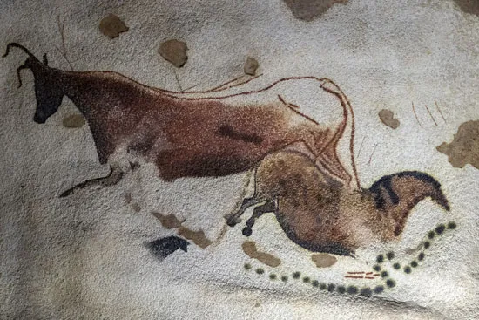
From the very beginning, your average graphic designer would sport the finest unibrow and a hairstyle that could only be described as ‘bedhead’ and grunting at a bonfire while eating the most impeccable steak, cooked to raw perfection. These Neanderthals ‘64,000’ (Little, 2010) to ’40,000 years ago’ (Clottes, 2023) found caves to be the perfect canvas for paintings, such as this prehistoric cave painting found in France in the 1940s, illustrating a horse and a bull facing away from each other, early signs of creativity on display in the vast amount of these early cave paintings. Advancements and millenniums later mankind began to pour meaning into their artworks, culminating in creations that stand the test of time; these include Michelangelo’s ‘Hand of David (16th century), Da Vinci’s ‘The Last Supper’ (15th Century) and ‘The Great Wave off Kanagawa’ (19th Century) by Japanese artist Hokusai. As a whole, Humanity’s collection of artworks is rich in diversity, influence and thought-provoking denotations. Three graphic designers who embodied profoundly thought-provoking pieces of work will be discussed in this essay on the Post-modern revolution of the 1980s, this triad of creators relished in the opportunity to propel the space of graphic design, all while reassessing the rules set before them.
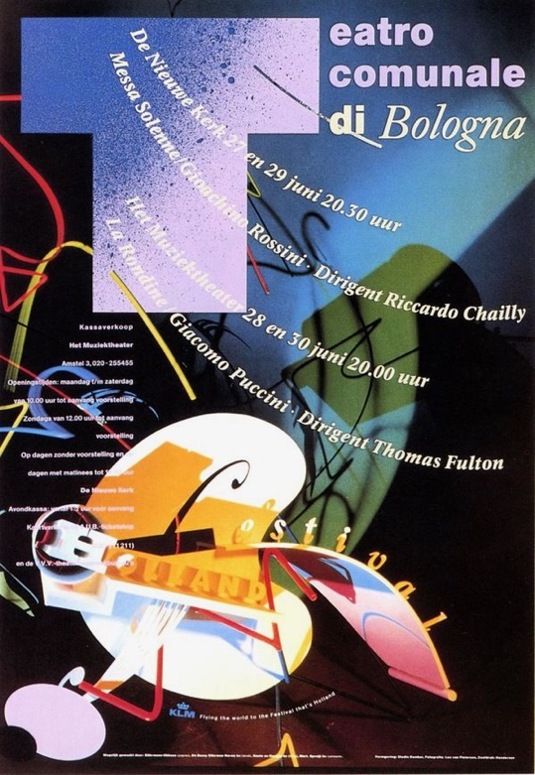
Considerably and consistently raising the standard of the applied arts comes at no easy feat for anyone, achieving it in one of the most design-rigid countries in the West is an accomplishment few can claim. Dutch postmodernist designer Gert Dumbar can declare his victory in evolving the space through his holistic typography approach, breaking the mould of Ernst Keller’s ‘International style’. ‘A country renowned for both its three-dimensional and graphic design traditions’ (Aynsley, J. 2001) The Netherlands is a polarising country when it comes to the visual communication landscape, a progressive state that early on saw that design could play an integral role in establishing a redeveloped national identity where societal prosperity and culture directly correlated to democracy and not the economy. Theorised that improvements and overall life could be enhanced by thought-out signage systems would greatly increase the need for applied artists in the Netherlands. The duality of experimental and traditional mindsets within the Dutch space caused direct competition between two radically different methods, that would coexist until the 1990s, where in Craig Berry’s article he states ‘Modernism in the Netherlands was beginning to be seen as a negative thing, due to its supposedly one-dimensional look. Supporting this statement, Dumbar vocalises in his 1986 Journal titled Kunstschrift ‘My Colleagues sometimes scold me for being an artist among designers’ (Aynsley, J. 2001). Labelling himself as an ‘artist among designers’ is fascinating because the phrase can be seen as degrading to modernist designers because utilising a noun to describe himself before he describes his peers places hierarchy in the sentence where Dumbar is seen as more superior to his colleagues as they are all grouped together under one term. Dumbar’s work displays postmodernist core values emphatically, the helical type used in Studio Dumbar’s work for the 1987 Holland Festival poster design was eye-catching and simply sublime. Cementing his success with this piece, Dumbar was Awarded two separate Design and Art Direction (D&AD) Silver (Graphite now) pencils for ‘Design Program and Poster Series’ (Dumbar. 2023). Two of the most coveted awards an individual or organisation can win for ‘Outstanding work that achieves true creative excellence’ (D&AD. 2023), apposite praise for Dumbar’s studio, proving that he challenged former conventions and expressed through visual communication that applied artists didn’t need to conform to modernist sentiments. Dumbar’s use of contrasting colours, block shapes and dissident type represents the Dutch Design movement of the 1970s where balloon typography was setting trends, the ‘T’ in this poster reserves over a third of the page taking the trend to new heights, in a modernist view this would be an issue as one character seizing that much of the limelight would disrupt the structure and science, Gerstner intended in his systematic view of graphic design. However, postmodernity welcomes this trend and to overlay information on other aspects of the poster, to broaden the range of meaning a poster can be relayed to the reader. In this case, the curvilinear form of the type and the intelligent hierarchy used amalgamated with the previously spoken about ‘T’ letterform directs the readers eyes to the first line of information, using an arc fashion for the text improves readability, greatly by allowing people’s eyes to smoothly glide across the poster, reaching the ancillary graphic that accompanies the lower third of the piece. Looking ahead in Dumbar’s career, the Indonesian native continued to expand his studio with an ever-growing diverse set of personalities, each having their own speciality, collaborating together to create innovative design, motion graphics, brand identity plus many more available services that are tailored to each client. More than 40 years after its inception, Studio Dumbar is still a ground-breaking force to be reckoned with in the digital era of Graphic Design. Speaking with English Creative Director and judge of D&AD, Graham Stuart, ‘Nobody ever asked about this subject and my answer is that marketing-driven design, in my opinion, kills all the spontaneity of a good creative idea by a talented designer.’ (Stuart, G. 2016). After such an illustrious career as Dumbar has had, this quote further propels the notion that Dumbar was a figure of importance in the graphic design revolution of the mid-1980s, he expresses his disdain for marketing design, seeing it as a soulless route for aspiring designers because of the corporate mentality to appease to the masses, rather than maintaining integrity within the artform, allowing the creator to freely express themselves as he did in the postmodern revolution.
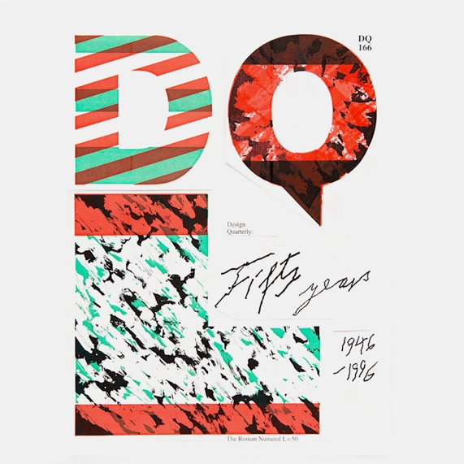
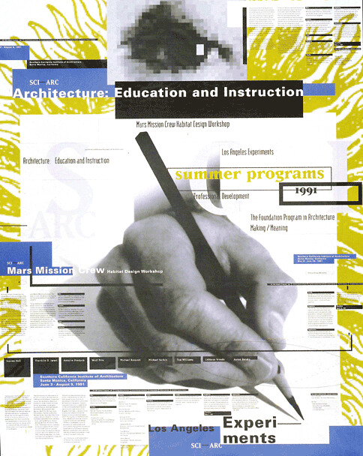
‘How Can One Make Swiss Typography’ (1972) was the title of Wolfgang Weingart’s uber-descriptive academic guide on the Swiss style, as well as his theoretical and practical results from the teachings of his subverted experiments surrounding the evolution of International Typography Style. In this guide, Weingart consciously declines to accept this guide as his ‘teaching activities’ (Weingart, W. 1972) as he was the pioneer of the ‘New Wave’, a heavily debated period in graphic design history, as many do not feel it was a natural progression, instead, it was argued as a pause in Swiss Style. This ‘New Wave’ was nurtured from the foundations of the period pre-dating, by German designer Wolfgang Weingart. On his way to teaching, Weingart found a lot of subjects difficult in his younger years, ‘I was really untogether at school. I found the abstract subjects hard to grasp.’ (Schwemer-Scheddin, Y. 2023). However, as he recalls he experienced ‘an overnight revelation’ (Schwemer-Scheddin, Y. 2023) when he began studying at the Mertz Academy for art and applied graphics, falling in love with the idea of learning a respected profession, throughout a three-year-long apprenticeship Weingart ‘became expert in letterpress printing’ (Weingart, W. and Muller, L. 2000) benefitting from this, Weingart reached out to Armin Hofmann and found himself as an Independent student under Ruder and Hofmann. The latter of the two saw tremendous potential in Weingart at just twenty-two years old, ‘During the interview, with the hope of being accepted into the School, I showed him my work. At twenty-two, I was astonished when he asked me if I wouldn’t consider teaching in his Graphic Design programme.’ (Resnick, E. 1998) and five years later he surpassed his goal of just learning a respectable profession. He was now teaching one. Weingart’s opinions on the ‘Swiss Style’ were very negative, as revealed in ‘My Way To Typography’ he is quoted as saying that Swiss Typography was ‘on the threshold of stagnation; it became sterile and anonymous’ (Weingart, W. and Muller, L. 2000), receiving notoriety for speaking out against modernist values Weingart was determined to dismantle the authoritative shadow set by his mentors by learning with his students. Through this Weingart unintentionally led a rebellion opposed to the ‘Swiss Style’ by refusing to conform to rules such as, forbidding the indentation of paragraphs, testing complex inconsistencies in typeface weight and most notoriously of all, disrupting the grid system. When asked if he ever wanted to create a new style, a surprising answer arose. ‘No. Never. The purpose was to make typography more lively and to integrate it into graphic design…It is only now that people have learned to see it in a totally new light. Designers everywhere are creating very lively and more human typography, as if it had just been invented.’ With his background in hand-crafted processes, Weingart lived and breathed core applied artistic values when it came to the process of design. Sixteen flourishing years later, 1984. The year that fishnets and leg warmers were all the rage, Band-Aid was topping the UK Christmas charts, and a new kid on the block appeared in the form of the Macintosh 128K was released to the public, marking a seismic shift in the world as it began a digital revolution worldwide. At this point, Weingart’s ‘New Wave’ phenomena had created a stir in the space where designers and society alike didn’t feel they were bound to the structural conformity of a canvas. Speed, ease of use and freedom warranted a creative uprising, no more were artists bound by a grid and strict rules. Weingart took this in his stride and embraced the Macintosh, in fact, a ‘gift from Steve Jobs’ (Weingart, W. 2021), the very first Macs in Switzerland. Enabled to create more daring designs with vibrant colours and more control over the type, Weingart invited by DQL to materialise a magazine cover for fifty years of Design Quarterly competition in 1995, further evidence that Weingart seen in the piece displays he kept exploring with the digital realm, combining his physical work in the form of his beloved type workshop, photography darkrooms and lithographic printing with continued use of the Macintosh. An inspiring figure he taught Dan Friedman and April Greiman in the Basel school of design, Greiman specifically can be seen taking influence in her 1991 poster for South California Institute of Architecture . The use of an illustration in the background covered by thoughtful yet cluttered graphics in the style of a computer UI design at the time, denotations from this piece reveal Grieman is displaying her the fact manual processes in the applied arts are being crowded by digital imagery, colour choice is also an important denotation in this poster, the manual process being seen is monotone, there is no colour, no life in design if manual processes aren’t used. Weingart would have drilled this into his students as it was of the upmost importance for the German designer. The last piece of influence in Grieman’s poster design is the word ‘experiments’, seen to have been experimented on by Grieman as there is thought behind spacing the words over two lines. Possibly a homage to her post-graduate mentor who loved to ‘experiment’ with type?
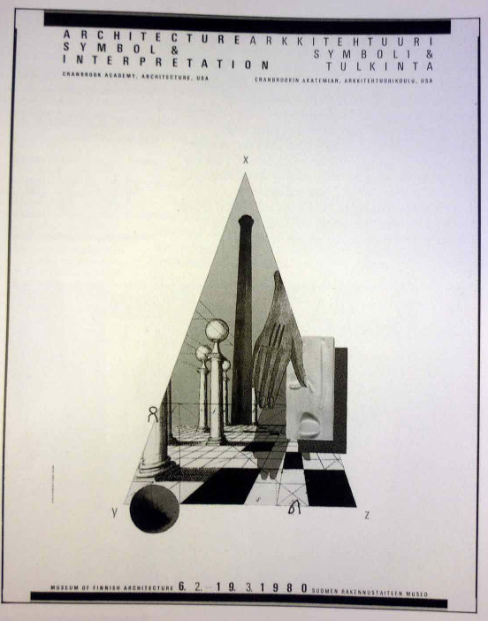
‘Her students ushered in a period of complexity, ambiguity and subjectivity.’ (Armstrong, H. 2012) Katherine and her husband Michael were imperative in the ‘Cranbrook discourse’, a movement that can be regarded as the American version of the ‘New Wave’ movement because the two were essentially complementing each other in their differences yet achieving the shared moral goal through their similarities. Either wanted to challenge the past and believed artists should express themselves fluidly through their visual outcomes. ‘For the McCoy’s, the relationship between designer and audience was no longer a matter of problem-solving or strictly one-way process of communication. Instead, they introduced scepticism about meaning.’ (Aynsley, J. 2001) This quote symbolises McCoy’s values, through her early form of surrealism, scepticism about meaning is a powerful tool, particularly in the case of this poster design named ‘Architecture, Symbol & Interpretation’. The name indicates to the reader exactly what McCoy wants you to interpret, and that can be anything the reader wants it to be. Maybe, they see the ‘Hand of David’ reaching down from the heavens to bless earth, but the brutalist trend of architecture isn’t the natural way god intended, so that hand will stay suspended in the air indefinitely. Or possibly there is a game of chess underway, and all we can see in the scene is that hand ready to play their turn. There are magnitudes of denotations you can pull from her work, it’s a calculated choice, one that McCoy touches upon in her journal titled ‘American Graphic Design Expression’, she speaks about the classic ‘Swiss Style’, ‘The ideal was the objective (dead serious) presentation of information, rather than the subjective expression of an attitude, emotion or humour.’ (McCoy, K. 1990) The three last words in the quote can be used to describe her artistic style, using the choice of words she expresses her desire to include individuality into her designs. In the same journal, she uses the phrase ‘the genius of inspiration’ (McCoy, K. 1990) when comparing her thoughts and feelings with the structure of the traditional ‘Swiss’ design, denoting the phrase she sees inspiration not as a feeling but as a concept of semiotics in its’ own right. McCoy invites the reader to denote anything they’d like through her use of character. Without a shadow of a doubt, her ethos challenged the past.
Through investigating three graphic designers who embraced new technology to challenge the past and define the future, I can conclude this period of design deserves to be known as the Big Bang of how we see graphic design in the 21st century, for its revolutionary approach to not just how graphic design is perceived, but also how society is perceived as well, by highlighting the impact that everyone is individual. Approaching the fortieth anniversary of the Apple Macintosh, it is very likely that we’ll see codes and conventions of the postmodern revolution remain in our wacky, wonderful and wild art form we call graphic design.

Fig. 1, A cave painting in Lascaux, near Montignac, France, depicting a bull and a horse. (Brittanica, Fig1)
Gert Dumbar’s revolutionary poster design for the ‘Holland Festival’.
Design Quarterly’s 50th anniversary magazine cover, created by Weingart in 1995.
April Grieman’s Poster for South California Institute of Architecture, Designed 1991.

