Student Name: Farhan Sajid Rahman Student ID: 1802359
Module: ACCA 6024 - Cloud-Based Web Services
Lecturer: Michael Dacey & Tim Bashford

Cloud-Based web services

Abstract
Throughout the document holds discussion of cloud computing with the comparison of virtualisation and containers with Docker. From the comparison it clearly displayed that containers with the use of Docker provides a more suitable use for deployment of a software application. Furthermore, the process of building a node.js application and processing it into a docker image container was completed with information of the process with illustration.

Table of Contents
Cloud-Based web services 0
Abstract 0
Table of Contents 1
1. Introduction 3
2. Cloud computing 3
2.1 Cloud Service Models 3
2.1.1 Software as a Service (SaaS) 3
2.1.2 Infrastructure as a Service (IaaS) 3
2.1.3 Platform as a Service (PaaS) 3
2.2 Evaluation of Deploying Applications to the Cloud 3
2.2.1 Advantages 4
2.2.2 Disadvantages 4
2.2.3 Conclusion 5
3. Virtualisation and Containerisation 5
3.1 Virtualisation 5
3.1.1 Hypervisor 5
3.2 Containers 7
3.3 Differences between Virtualisation and Containers 7
3.4 Conclusion 7
4. Building Node.js Applications with Docker 8
4.1 Producing Node.js Application 8
4.2 Evaluation of Node.js with Docker 8
4.3 Conclusion 8
5. Appendices 9
5.1 Appendix A – Processing node.js application with Docker 9
5.1.1 Creating node.js file through terminal 9
5.1.2 Saving the express.js library on the package it created: 9
5.1.3 Adding script to run node.js file 10
5.1.4 Working script 10
5.1.5 Processing the node.js app into a Docker image 11
6. References 13

Glossary:
OS – Operating system
AWS – Amazon Web Service
NIST – National Institute of Standards and Technology
SaaS - Software as a Service
IaaS - Infrastructure as a Service
PaaS - Platform as a Service

1. Introduction
Throughout the document, it will hold discussion of cloud computing involving the benefits and drawbacks it brings from using it to deploy applications. The discussion will be covering the cost implications, reliability, and scalability of approaches with explanation to the importance towards cloud computing. Furthermore, virtualisation and the use of containers are also discussed, this is in reference to node.js and docker which is technologies to build web applications deployed into the cloud. Additionally, an evaluation of the development process to produce node.js applications in link with docker to run will be completed with demonstrated examples.

2. Cloud computing
Cloud computing is the introduction of allowing configurable computing resources accessible over a network at any time. Some of the main instances of the use for cloud computing include storage of data, servers, networking, and deployment of applications [1]. This section will behold the benefits and drawbacks which come from deploying applications with cloud computing. Consideration towards the cost implications, reliability and scalability will be included with addition of examples. The top three available cloud-services online are Amazon Web services, also known as AWS, Microsoft Azure and Google Cloud [2].

2.1 Cloud Service Models
Following from the National Institute Standard of Technology, as part of Cloud Computing there are service models which determine the type of environment of a cloud service. They each have strengths of their own and deploy for different uses, the choice depends for the requirements of the customer or goals of a business [3].

2.1.1 Software as a Service (SaaS)
This service model provides an application of the provider running in a cloud infrastructure. It is accessible through a number of client devices, examples being a web browser such as a web-based email or simply a client of a program interface. This service being consumed do not hold ability of handling any of the cloud service underlying infrastructure such as the network, storage, servers and more.

2.1.2 Infrastructure as a Service (IaaS)
The consumer of this model would be the one who will hold capability of providing the computer resources, storage, network and also running software that can involve the operating system and applications deployed. This does not involve management of the cloud infrastructure of the aspects mentioned but can manage deployed applications and configuration settings for the hosting environment.

2.1.3 Platform as a Service (PaaS)
This model is for the consumer to have the ability of deploying created applications to the cloud. The languages, libraries, services, and tools must be supported by the provider of choice. The only control given is of the deployed applications [4].

2.2 Evaluation of Deploying Applications to the Cloud
Evaluation will be mainly on the benefits, drawbacks, costs, reliability, and scalability of cloud computing.

2.2.1 Advantages
The advantages will be discussed and looked at what it brings to cloud computing.

2.2.1.1 Scalability
Cloud computing brings in the opportunity for developers to make use of deploying applications into a network environment where the application can be accessed at any given time with a network connection. An issue an organisation can have is of servers not being used to their fullest extent, along with days of varying demands of usage. This would result in unnecessary additional costs to the organisation such as energy costs. However, an adaptation of a cloud service brings in the advantage of being scalable to move with the time of peak demands and setting the required number of resources needed. Scalability holds an important principle within cloud services, as it allows the ability of expanding a system as well as maintaining the performance to keep it a reliable service. It necessitates with the growing needs of the current moment, and it could be scaled dynamically or proactively [5]. In relation to cost, with the possibility of scalability, this means a cloud service being introduced diminishes the payments for purchasing different infrastructure, maintenance, and energy expenses [6].

2.2.1.1 Efficiency
With the use of introducing a cloud computing service, there is less focus needed on things such as management of hardware and the underlying IT infrastructure. With the use of a given interface, the management of resources, setting and more can be handled there [7]. In result, this allows for more time to be allocated on other aspects.

2.2.1.3 Collaboration
Deploying into the cloud also allows for the advantage of collaboration amongst a team. All software and resources are shared to the consumers of the service and this allows for working at the same time and serving multiple needs as well as multiple people [8].

2.2.2 Disadvantages
The disadvantages will be discussed to show the negative aspects to deal with.

2.2.2.1 Outages/Downtime
The availability of a cloud service would be throughout each hour every day; however, it requires a connection to the internet at all times throughout use. Additionally, if the cloud service is experiencing downtime, it will not be accessible until the moment it is back running [9]. This brings the disadvantage of down time of service as well as being incapable of accessing resources. With the idea of customers, this brings further disadvantages of dissatisfaction and possible reputation loss. Unless there was a planned maintenance scheduled, it would be unpredictable to know if the cloud service or the network decides to crash. If the cloud-based service were to be down and used for production, this can mean there would be money loss each minute that there is downtime. Estimates found online from a comprehensive model to calculate loss from cloud outages per minute, revealed that Amazon made a loss of 141,647 dollars, Google with 113,641 dollars and eBay with 30,536 dollars [10].

2.2.2.2 Security
Furthermore, with cloud computing being over the internet, it brings a disadvantage of security concerns such as hackers. This is because of the worry regarding the chances of data that is stored over the cloud being compromised and accessed without authorization. With poor security, the advantages of cloud computing would be meaningless with the thought sensitive data being at risk, causing the potential issue of cloud computing not being adapted within organisations and businesses [11] . It is said that the main causes of data being breached over the cloud is due to “a malicious or criminal attack, system malfunction or human error” [12]. From reading the reasons, they can only largely be prevented by measures being put in place by the organisation, meaning the chance still poses there. Data breaches can result in a substantial amount being fined under the General Data Protection Act (GDPR). An example being “Home Depot” for 200 million dollars where a large number of customer personal information was breached and stolen [13].
Also, information provided by the National Institute of Standards and Technology mentions that “Increased levels of network-based attacks” [14] is a possible type of threat to security and the types of network attacks can be denial of service, man in the middle, network sniffing and more of which poses a threat to the network [15]. This links with the outcome of outages and downtime, where money can be lost if the network were to be attacked.
To expand on security, disadvantages also hold the possible chance of a malicious insider with harmful intent such as compromising data confidentiality which nothing can be done if the data is already processed outside of the cloud and business or organisation [16].

2.2.2.3 Training Employees
Time must be allocated in the training of employees and new employees who join at a later time to understand how everything functions.

2.2.3 Conclusion
In conclusion, the information found shows that delving into the world of cloud brings the opportunity to lower organisation costs significantly, and increasingly improve the scalability and reliability of the management of resources. The drawbacks found however, primarily about security, is an important risk factor that must be dealt with and thought about prior to moving forward for the use of cloud services. Serious implications can come from the loss of data such as customer private information and having any significant downtime can bring in major loss of revenue.

3. Virtualisation and Containerisation
In reference to technologies which allow for building and deploying web applications to the cloud, such as Node.js and Docker, the use of virtualisation, virtual machines and containers will be discussed. The section goes on to reveal the primary differences as well as why there is a drive for the adoption of Docker. This is a component of cloud computing, not cloud computing itself.

3.1 Virtualisation
Virtualisation is in reference to creating a virtual system such as a server [17]. Rather than having multiple physical systems for a server, virtualisation introduces the separation of the operating system from the hardware, allowing multiple instances of an OS on the same system. This removes the need to install an operating system several times on several separate physical hardware but rather one. In result, money is saved from the need to buy hardware equipment, as well as extra energy costs from the running multiple systems [18].

3.1.1 Hypervisor
Virtualisation provides a layer on the hardware where an instance of an operating system can be installed, this is with a hypervisor. A hypervisor is the software which makes the virtual machine emulate the whole hardware environment, and these allow for the execution of more than one virtual machine [19].

3.1.2 Types of Hypervisor
There are two types of hypervisors:

3.1.2.1 Hypervisor Type 1
A type 1 hypervisor is one that is installed directly on top of the physical server and is also known as bare metal hypervisors as there is “no software and operating system in between.” The type 1 hypervisors are an OS itself, which ran on top of the physical server as a guest OS [20]. The machine it is being ran on is only serving for the purpose of virtualization. This type of hypervisor is hardware virtualization and does not provide many functionalities. A type 1 hypervisor gives the ability to allocate more resources than there is available, an example can be with 8 virtual machines that are each holding 16GB of ram, which totals to 128 GB. This can be increased to 24GB of RAM to instead provide a total of 192GB. Some of the top software type 1 hypervisors on the market are VMware, Xen, KVM [21].

3.1.2.2 Hypervisor Type 2
A type 2 hypervisor is known as a hosted hypervisor, where there is a layer of the host OS that sits between the physical server and the hypervisor [22]. This serves virtualization of the OS, and the popular software available on the market are Oracle VirtualBox and VMware Workstation [23]. A hypervisor can run multiple instances of an operating system and can manage resources which are allocated to these virtual environments from the physical server [24]. The type 2 hypervisor also allows for creating snapshots of the virtual machine, giving the ability to export for portability of importing the same machine again [21].

3.2 Containers
Containers are a cloud implementation which is based on OS virtualization only. On a physical server, containers lay at the top and the operating system would be Windows or Linux. Containerisation holds the ability to have software application packaged up with its dependencies and libraries. This packaged container is executable and can be ran on either the desktop or even cloud, making use of the host resources for the instance. This allows for easy portability in different operating environments, and a benefit to this is for testing, development and deployment of applications [25] [26]. A technology and tool which is used for the containerisation of software is known as Docker, making the process easier to “create, deploy and run applications [27].”

3.3 Differences between Virtualisation and Containers
From both the explanation of virtualisation and containers, one of the differences which can be highlighted is that containers are only OS-level virtualisation, there is no hardware virtualisation like type 1 hypervisor, making it more relatable with hypervisor type 2. Containers package up software and save the application, whereas a hypervisor would save the whole OS and virtual machine. The containers do not require a guest OS and work with the host operating system which makes it simple and faster for containers to process.

3.4 Conclusion
In conclusion, both virtualisation and containers were looked at and had the differences compared. In reference to deployment of applications, the comparison of differences indicates a more beneficial path with the concept of containerisation. Containerisation proved to be more suitable for the use of software delivery, and this can highlight why there is a pushed adoption of using Docker over the method virtualisation.

4. Building Node.js Applications with Docker
A perspective into the building process of Node.js applications ran with Docker will be given with illustration provided in the appendices.

4.1 Producing Node.js Application
To produce a node.js application, a simple app was made in to display “hello world” with express.js rest API. Illustration showing the simple node.js app and the containerising process can be seen throughout appendix A 5.1. Throughout the process, the docker tool was opened within the background.
The process started off created a JS file holding the app code, and then initializing the project as a node.js package through the terminal setting the information shown in appendix A 5.1.1. The next step then required installing the express.js library on the package using the terminal code shown in image appendix A 5.1.2. The highlighted text in appendix A 5.1.3 was added for the capability of running the app with node.js through the terminal which determined the completion of the node.js application after running it. The final steps were to package the application into an image, this was a straightforward process of packaging the main file. This did not take more than 6 lines of simple code as explained in appendix A 5.1.5. After completing the packaging, the image was running with the docker interface highlighting the application running too.

4.2 Evaluation of Node.js with Docker
The clear benefit brought from processing the node.js application into a docker image shown the simple process of packaging an application to a container. The advantage which was mentioned in an earlier section allows for easy portability to have this app ran in a different environment by simply sending the image to another location.

4.3 Conclusion
In conclusion, the building of a simple app and processing it into a docker-image can be completed very easily as shown in the images illustrating it. After the building of the node.js package, it did not require more than 6 lines of code with a simple node terminal command to package the application within a container.

5. Appendices

5.1 Appendix A – Processing node.js application with Docker
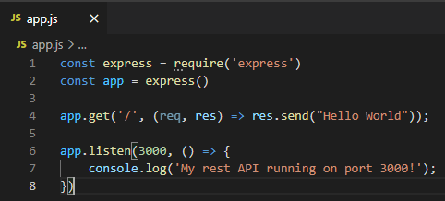

5.1.1 Creating node.js file through terminal
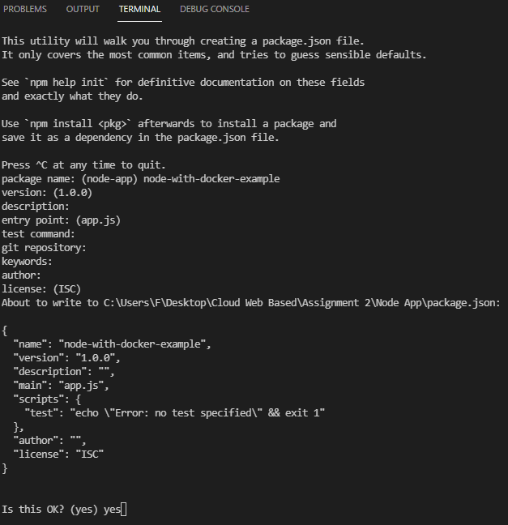

5.1.2 Saving the express.js library on the package it created:
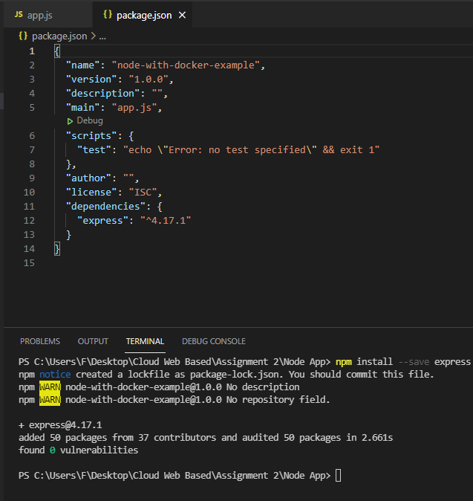

5.1.3 Adding script to run node.js file
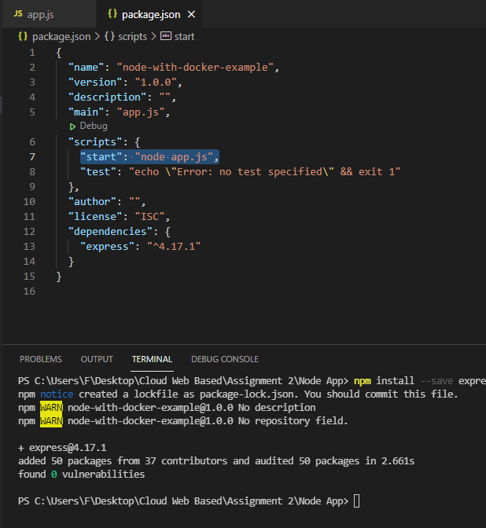

5.1.4 Working script
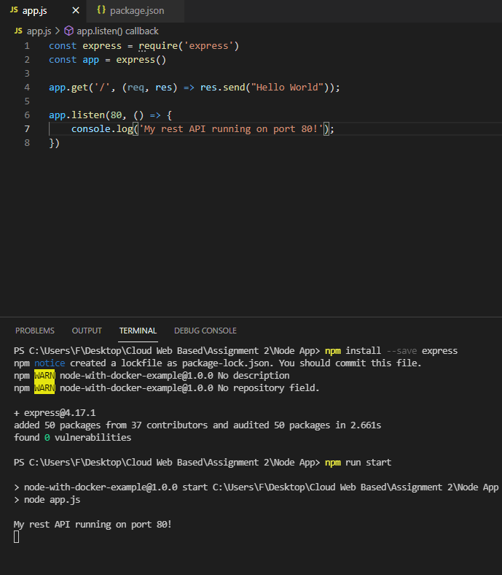

5.1.5 Processing the node.js app into a Docker image
Creating the docker file where the code to package the basic application will be.
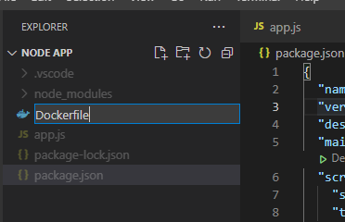
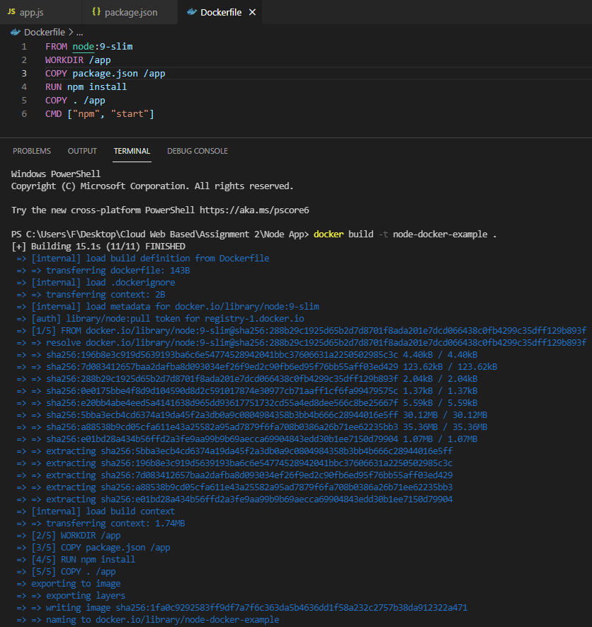
The first line specifies the base image to base the from, then choosing where the code will be packaged up and copying the json package into the app directory created.

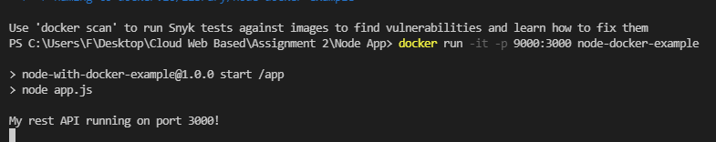
The next step required building the complete docker image by specifying a free port and the port the app runs on.
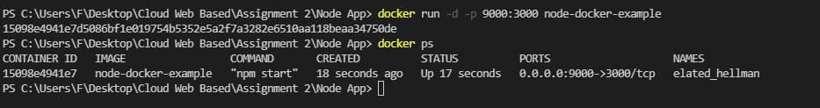
The docker image of the code package up is created and running.
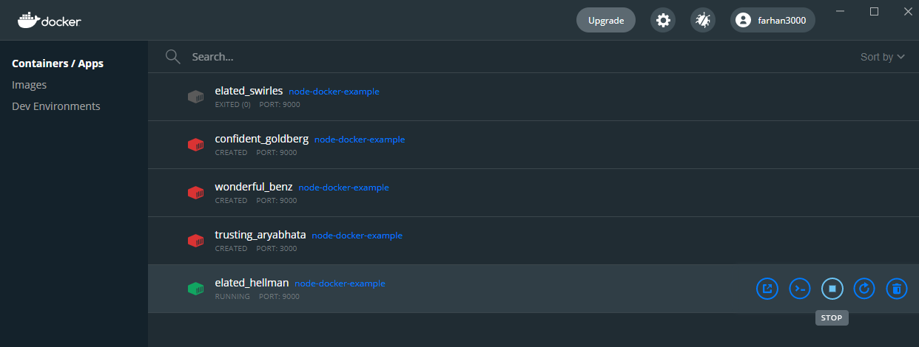
The docker interface updates highlighting that the image is indeed running.

6. References

[1] | S. Rahul and S. , “Cloud Computing: Advantages and Security Challenges,” International Journal of Information and Computation Technology, vol. 3, no. 8, p. 771, 2013.
[2] | “Best cloud computing services of 2021,” Techradar.pro, 17 March 2021. [Online]. Available: https://www.techradar.com/uk/best/best-cloud-computing-services. [Accessed 3 May 2021].
[3] | L. Badger, T. Grance, R. Patt-Comer and J. Voas, “Cloud Computing Synopsis,” Recommendations of the National Institute, p. 9, 2012.
[4] | P. Mell and T. Grance, “The NIST Definition of Cloud Computing,” Information Technology Laboratory, pp. 2-3, 2011.
[5] | U. Kazemi and R. Boostani, “Analysis of Scalability and Risks in Cloud Computing,” International Journal of Academic Research in Computer Engineering, vol. 2, no. 1, pp. 24-26, 2018.
[6] | D. A. Edache, J. Ellman and S. Keogh, “A Cost Modelling System for Cloud Computing,” Faculty of Engineering and Environment, Northumbria University, p. 1, 2014.
[7] | Q. Alajmi, A. S. Sadiq, M. A. Al-Sharafi and A. Kamaludin, “Cloud Computing Delivery and Delivery Models: Opportunity and Challenges,” Faculty of Computer Science & MIS, Oman College of Management & Technology, pp. 4-5, 2018.
[8] | N. R. C. Ganga, S. R. Tirupati and P. Srinivas, “Deploying an Application on the Cloud,” International Journal of Advanced Computer Science and Applications, vol. 2, no. 5, p. 120, 2011.
[9] | A. Abdollahzadehgan, A. C. H. Razak, M. G. Moshfegh and M. Amini, “The Organizational Critical Success Factors for Adopting Cloud,” Faculty of Computer Sciences and Information Systems, University of Technology Malaysia, p. 69, 2013.
[10] | M. Naldi, “Evaluation of Customer’s Losses and Value-at-Risk,” Department of Civil Engineering and Computer Science, p. 1, 2017.
[11] | S. Jagirdar, “CLOUD COMPUTING BASICS,” International Journal of Advanced Research in Computer and Communication Engineering, vol. 1, no. 5, pp. 345-346, 2012.
[12] | D. M. Prasead, M. M. Julkar Nayeen and M. Whaiduzzaman, “Cloud Computing Security Breaches and Threats Analysis,” International Journal of Scientific & Engineering Research, vol. 8, no. 1, pp. 1287-1288, 2017.
[13] | “The biggest data breach fines, penalties, and settlements so far,” CSO, 5 March 2021. [Online]. Available: https://www.csoonline.com/article/3410278/the-biggest-data-breach-fines-penalties-and-settlements-so-far.html. [Accessed 3 May 2021].
[14] | M. Hogan and A. Sokol, “NIST Cloud Computing,” NIST Cloud Computing Standards Roadmap Working Group, p. 45, 2011.
[15] | S. Qaisar and K. Khawaja, “Cloud computing: Network/security threats and countermeasures,” INTERDISCIPLINARY JOURNAL OF CONTEMPORARY RESEARCH IN BUSINESS , vol. 3, no. 9, p. 1325, 2012.
[16] | F. N. Ogigau, “Cloud Computing Security Issues,” The Regional Department of Defense Resources Management Studies, vol. 3, no. 2, p. 146, 2012.
[17] | “Virtualization,” Techopedia, 30 July 2011. [Online]. Available: https://www.techopedia.com/definition/719/virtualization. [Accessed 3 May 2021].
[18] | Hamdani and P. U. A. S. , “Virtualization Approach Theory and Application,” IOSR Journal of Electrical and Electronics Engineering (IOSR-JEEE), vol. 11, no. 5, pp. 187-188, 2016.
[19] | B. Golden, in Virtualization for Dummies, Wiley, 2007, p. 14.
[20] | “Hypervisors,” ScienceDirect, [Online]. Available: https://www.sciencedirect.com/topics/computer-science/hypervisors. [Accessed 3 May 2021].
[21] | “What is a Hypervisor? Types of Hypervisors 1 & 2,” PhoenixNAP, 24 January 2019. [Online]. Available: https://phoenixnap.com/kb/what-is-hypervisor-type-1-2. [Accessed 3 May 2021].
[22] | “What is a hypervisor,” RedHat, [Online]. Available: https://www.redhat.com/en/topics/virtualization/what-is-a-hypervisor. [Accessed 3 May 2021].
[23] | K. K and A. Bendigeri, “The Top Open Source Hypervisor Technologies,” OpenSourceForU, 1 April 2019. [Online]. Available: https://www.opensourceforu.com/2019/04/the-top-open-source-hypervisor-technologies/. [Accessed 3 May 2021].
[24] | B. Singh and G. Singh, “A study on virtualization and Hypervisor in cloud computing,” International Journal of Computer Science and Mobile Applications, vol. 6, no. 1, pp. 18-21, 2018.
[25] | I. C. Education, “Containers,” IBM, 12 August 2019. [Online]. Available: https://www.ibm.com/cloud/learn/containers. [Accessed 3 May 2021].
[26] | R. Bauer, “What’s the Diff: VMs vs Containers,” BackBlaze, 28 June 2018. [Online]. Available: https://www.backblaze.com/blog/vm-vs-containers/. [Accessed 3 May 2021].
[27] | “What is Docker?,” OpenSource, 19 August 2014. [Online]. Available: https://opensource.com/resources/what-docker. [Accessed 3 May 2021].
[28] | Overview of Amazon Web Services (AWS White Paper), Amazon, 2021.

