
Maéva RONCEY
2422915

Network Operating Systems and Services

Coursework 1

Table des matières
TASK 1 1
Introduction 2
Hypervisors 3
Type 1 hypervisors 3
Type 2 hypervisors 4
IP Addresses 5
Structure and Format of IP Addresses 5
Subnetting 6
Practical applications of IP addressing 6
Routing protocols 7
Analyse of routing protocols 7
Use cases and implementation 8
Network services 9
VPNs (Virtual Private Networks) 9
DHCP (Dynamic Host Configuration Protocol) 9
Active Directory Domain Services (AD DS) 9
Certificate Authorities (CA) 9
References 10
IP Address 10
Hypervisors: 10
Routing: 10
Network services: 11
TASK 2 12
1. The choice of the hypervisor 13
2. Download and Setup 13
3. Configuration of the IP addresses 18
3.1. Windows 18
3.2. Linux-based 23
3.3. Problem and resolution 24
TASK 3 28
3.1. Technical reflection 29
3.2. Personal reflection 29

TASK 1

Introduction

The objective of this project is to design and deploy a network infrastructure for the multinational company NOSS2025, which operates in two locations: Swansea and Cardiff. This will involve analysing the virtualisation requirements, selecting a suitable hypervisor and setting up a network topology including Windows and Linux servers. The study will also cover the configuration of essential services, IP address management, DNS resolution and network security. This initial phase is important to ensure the stability and efficiency of the system before full implementation.

Hypervisors
A hypervisor, also called a Virtual Machine Monitor (VMM), is software or firmware that lets you run more than one operating system at a time on a single computer. It does this by hiding the details of the hardware and allocating resources to virtual machines (VMs) as needed.
There are two primary categories of hypervisors are distinguished: Type 1, also referred to as 'Bare-Metal', and Type 2, which is designated as 'Hosted’.
Type 1 hypervisors
They can run directly on the host system's hardware, so you don't need an underlying operating system. This design has clear benefits in terms of performance and stability, as it allows direct access to hardware resources.
There are several features and advantages of a hypervisor of Type 1. For example, it is very powerful, because it can access the hardware directly. It is also very secure, because it doesn't have an underlying OS that can be exploited. It is also efficient, and it is suitable for enterprise-level virtualisation.
However, it should be noted that this hypervisor imposes specific hardware prerequisites, namely a compatible processor with virtualisation support, an adequate quantity of random-access memory (RAM) and storage, and BIOS/UEFI settings that have been enabled for virtualisation purposes.
Most people think that Type 1 hypervisors are better at handling large amounts of data and are more secure, which makes them good for use in big companies.
They have been shown to work better on systems that meet their specific hardware needs. Some good Type 1 hypervisors on the market include VMware ESXi, Microsoft Hyper-V and Xen.

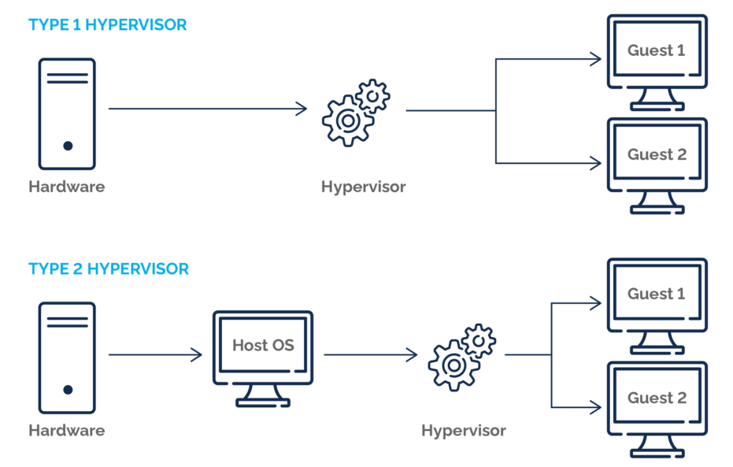
1 - Hypervisor types

Type 2 hypervisors
In that case, it has been established that their functionality is based on an existing operating system, thus engendering a more flexible and user-friendly environment.
A distinguishing feature of Type 2 hypervisors is their simplified installation and management processes, along with notable compatibility with a broad variety of hardware configurations.
They are particularly well-suited to testing, development, and personal use, a fact further facilitated by the existence of open-source and free versions.
Despite their limited scalability, they can still provide adequate security for smaller-scale operations.
Type 2 hypervisors have been observed to exhibit a greater degree of compatibility with a variety of hardware configurations, a phenomenon that can be attributed to their reliance on the host operating system (OS). There are many Type 2 solutions on the market available, including VMware Workstation, Oracle VirtualBox and Parallels Desktop (for Mac only).

IP Addresses

IP (Internet Protocol) addressing is essential for device identification and communication in networks (Tanenbaum & Wetherall, 2011).
To help to understand, let's compare IP Addresses to sending a letter. If we want to send a letter to someone, we need their address so that it arrives at the right place. The same is true for computers: they need the same thing and use unique IP addresses to communicate with each other. These IP addresses contain information about the sender and the recipient of the data. All this information is divided into small packets of data, which are put back together once they arrive at their destination. Thanks to their uniqueness, ID Addresses help to identify devices and so help the routers to find the better itinerary possible for the data through the networks. They are also used by switches that work like routers but in local networks.

Structure and Format of IP Addresses
We can identify two very common types of ID Address: IPv4 and IPv6 (there are other but simply not used).

IPv4 Addressing
IPv4 addresses are 32-bit numerical labels in dotted decimal format, e.g., 192.168.1.1 (Forouzan, 2017). They are divided into five classes (A-E), with classes A-C commonly used. Each decimal number represent 8 bits, so they can go from 0 to 255 because $2^{8}$ = 256.
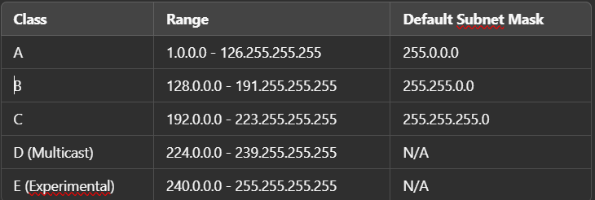

IPv6 Addressing
IPv6 addresses are 128-bits numerical labels in dotted hexadecimal format, e.g., 0db8:85a3::8a2e:0370:7334 (typical in 2001). IPv6 include unicast, multicast and anycast addresses:
- Unicast: identify only one device in the network, ensuring a direct communication between two hosts.
- Multicast: allow to send data to a specific group of devices, rather than sending it individually to each device.
- Anycast: is assigned to multiple devices, and the router routes the data to the closest node or the most efficient one.
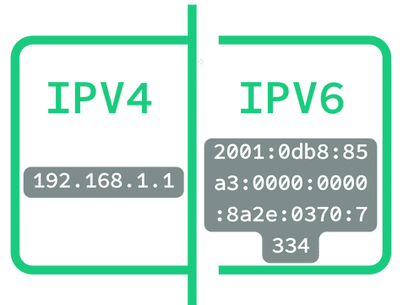
2- IP structure's comparison

Subnetting
Divide a network in under-networks, called the subnet, improving it efficiency and the security and can communicate directly with each other. (Cordeiro et al., 2016)
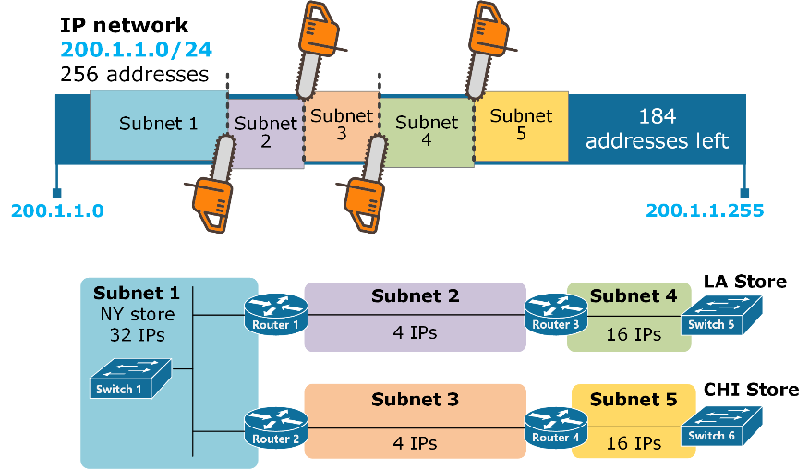
3 - Illustration of how subnetting works
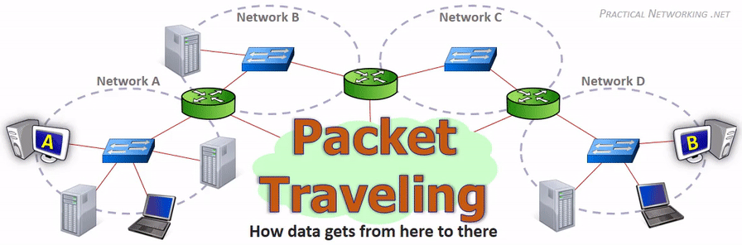
4 - How packet routing across networks

Practical applications of IP addressing
- Network Address Translation (NAT): This technique allows multiple devices on a local network to share a single public IP address, conserving IPv4 addresses.
- Virtual Local Area Networks (VLANs): use IP addressing to create logical separations within a physical network, improving security and performance.
- Classless Inter-Domain Routing (CIDR): allows more flexible allocation of IP addresses, improving routing efficiency.

Routing protocols

These protocols play a key role in the routing of data across the network. They define the rules that allow the router to determine the best path to the destination, considering several factors such as latency, network load and distance (Tanenbaum & Wetherall, 2021). It ensures communication between routers by sharing information about the network topology. There are two categories:
- Static routing: The network administrator configs manually the paths.
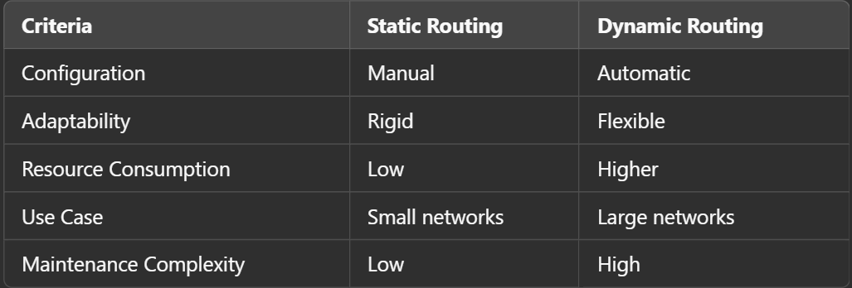
- Dynamic routing: The paths are updated automatically thanks to the OSPF or BGP adaptative protocols. (Kurose & Ross, 2021).

The static routing is efficient for simple and stable networks, while the dynamic routing is more suitable for complex environments and in constant evolution (Forouzan, 2017).

Analyse of routing protocols
Interior Gateway Protocols (IGP)
- Routing Information Protocol (RIP): It is based on the vectorial distance algorithm, which it is simple but not effective for large networks (Perlman, 2016). It is simple to configure and requires minimal computing resources, but it is unsuitable for large networks due to slow convergence and limited scalability.
- Open Shortest Path First (OSPF): Suitable for large enterprise networks, it uses the Dijkstra algorithm to determine the shortest paths. It provides efficient routing for large enterprise networks, supports hierarchical design, and provides faster convergence. But it is more complex to configure and maintain, add to that it requires more processing power and memory.
- Enhanced Interior Gateway Routing Protocol (EIGRP): A hybrid protocol that combines the benefits of RIP and OSPF to optimise speed and efficiency (Comer, 2018). It Reduces unnecessary network traffic, faster than RIP, supports both distance vector and link-state principles. Unfortunately, Cross-vendor compatibility is limited because it is Cisco proprietary.
Exterior Gateway Protocols (EGP)
- Border Gateway Protocol (BGP): On the Internet, it is used for routing between different Internet Service Providers (ISPs). It is essential for global interconnectivity, offers excellent scalability, and allows policy-based routing. But it requires skilled network administrators to optimise performance and security. Complex to configure and manage (Stewart, 2019).

Use cases and implementation
- Enterprise Networks: Due to its rapid convergence and adaptability, OSPF is widely used in the enterprise.
- Internet: To ensure global connectivity between different ISPs, BGP plays a critical role.
- Home networks: For home use, where the network topology does not change frequently, static routing is usually sufficient.
The size and complexity of the network determines the choice of routing protocol. While static protocols are suitable for small networks, dynamic protocols are better suited to infrastructures that are scalable and interconnected (Tanenbaum & Wetherall, 2021). A well-informed choice will improve the efficiency and resilience of the network.

Network services

Network services are essential to ensure the connectivity, management and security of an IT infrastructure. VPNs, DHCP, Active Directory Domain Services (AD DS) and Certificate Authorities (CA) are some of the most common services.

VPNs (Virtual Private Networks)
A VPN establishes an encrypted tunnel over a public network in order to ensure the confidentiality and integrity of the data (Çelik et al., 2020). There are several types of VPNs. These include:
- Remote Access VPN: Provides secure connectivity for remote users.
- Site-to-Site VPN: Create seamless connections between multiple remote networks. It allows better use of the network, enabling strong authentication and control of use via secure protocols (IPSec, OpenVPN).

DHCP (Dynamic Host Configuration Protocol)
DHCP automates the assignment of IP addresses, simplifying network management (Droms, 2017).
- Key features: Automatic IP assignment, central management and reduced address conflicts. Configure DHCP leases, reserve critical device addresses and monitor DHCP logs.

Active Directory Domain Services (AD DS)
ADDS is a Microsoft service which allows network identity and assets to be managed centrally.
- Key features: Authenticate users, manage permissions and organize domains. Implement a secure Group Policy strategy, restrict access where it is not needed and take advantage of domain controller redundancy.

Certificate Authorities (CA)
A CA issues and validates digital certificates to ensure authentication and encrypted communication.
- Key features: Generate SSL/TLS certificates, digital signatures and manage certificate lifecycle. Establish a reliable CA hierarchy, use strong keys, and monitor expired certificates.
Network services play a central part in the management of modern infrastructures. By following deployment and security best practices, organisations can improve the performance, reliability and protection of their systems.

References:

IP Address
- Cordeiro, E., Carnier, R., & Zucchi, W. L. (2016). Comparison Between IPv4 to IPv6 Transition Techniques. [Online]. Available: https://arxiv.org/abs/1612.00309

- Beverly, R., Durairajan, R., Plonka, D., & Rohrer, J. P. (2018). In the IP of the Beholder: Strategies for Active IPv6 Topology Discovery. [Online]. Available: https://arxiv.org/abs/1805.11308

- Tanenbaum, A. S., & Wetherall, D. J. (2011). Computer Networks. Pearson. [Online]. Available : https://www.pearson.com/us/higher-education/program/Tanenbaum-Computer-Networks-5th-Edition/PGM791920.html

Hypervisors:
- “What is hypervisor type 1 and 2” Pheonixnap. Accessed: 30/01/2025. [Online]. Available: https://phoenixnap.com/kb/what-is-hypervisor-type-1-2

- “What is a hypervisor?” Sentinelone. Accessed: 30/01/2025. [Online]. Available: https://www.sentinelone.com/cybersecurity-101/cybersecurity/what-is-a-hypervisor/

- "Hypervisor" GeeksforGeeks. Accessed: 30/01/2025. [Online]. Available: https://www.geeksforgeeks.org/hypervisor/

Routing:
- Tanenbaum, A. S., & Wetherall, D. J. (2021). Computer Networks. Pearson. Available:
https://csc-knu.github.io/sys-prog/books/Andrew%20S.%20Tanenbaum%20-%20Computer%20Networks.pdf

- Kurose, J. F., & Ross, K. W. (2021). Computer Networking: A Top-Down Approach. Pearson. Available : https://www.ucg.ac.me/skladiste/blog_44233/objava_64433/fajlovi/Computer%20Networking%20_%20A%20Top%20Down%20Approach,%207th,%20converted.pdf

- Forouzan, B. A. (2017). Data Communications and Networking. McGraw-Hill. Available:
https://dpvipracollege.in/wp-content/uploads/2023/01/Data-Communications-and-Networking-By-Behrouz-A.Forouzan.pdf

- Perlman, R. (2016). Interconnections: Bridges, Routers, Switches, and Internetworking Protocols. Addison-Wesley. Available:
https://biblio.cerist.dz/hrbdonf5214/ouvrages/IST2654-Sommaire.pdf

- Comer, D. E. (2018). Computer Networks and Internets. Pearson. Available:
https://api.pageplace.de/preview/DT0400.9781292061825_A26647113/preview9781292061825_A26647113.pdf

- Stewart, J. (2019). BGP4: Inter-Domain Routing in the Internet. Addison-Wesley. Available:
https://prep.missouri.edu/Download_PDFS/browse/4030133/Bgp4_Inter_Domain_Routing_In_The_Internet.pdf

Network services:
- Çelik, Z. B., et al. (2020). Security and Privacy of VPNs. IEEE Communications. Available:
https://ieeexplore.ieee.org/ielaam/9739/9621320/9520645-aam.pdf

- Droms, R. (2017). Dynamic Host Configuration Protocol. Addison-Wesley.
Available : https://www.academia.edu/52697995/Dynamic_host_configuration_protocol

TASK 2

The choice of the hypervisor
We chose a type 2 hypervisor (Virtualbox) because of its high compatibility with both Windows and Linux environments, allowing both to be smoothly installed and run on a host operating system without the need for direct hardware control. This makes it easy to install, manage and prevents it from affecting the host OS. Its permits easy scaling by adding more virtual machines (VMs) if additional servers or clients are needed. Its affordable because it doesn’t require dedicated hardware. It provides isolation between VM and security feature such as snapshots to recover quickly from failure or restart of the host.

Download and Setup
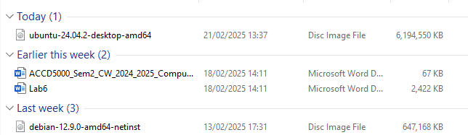
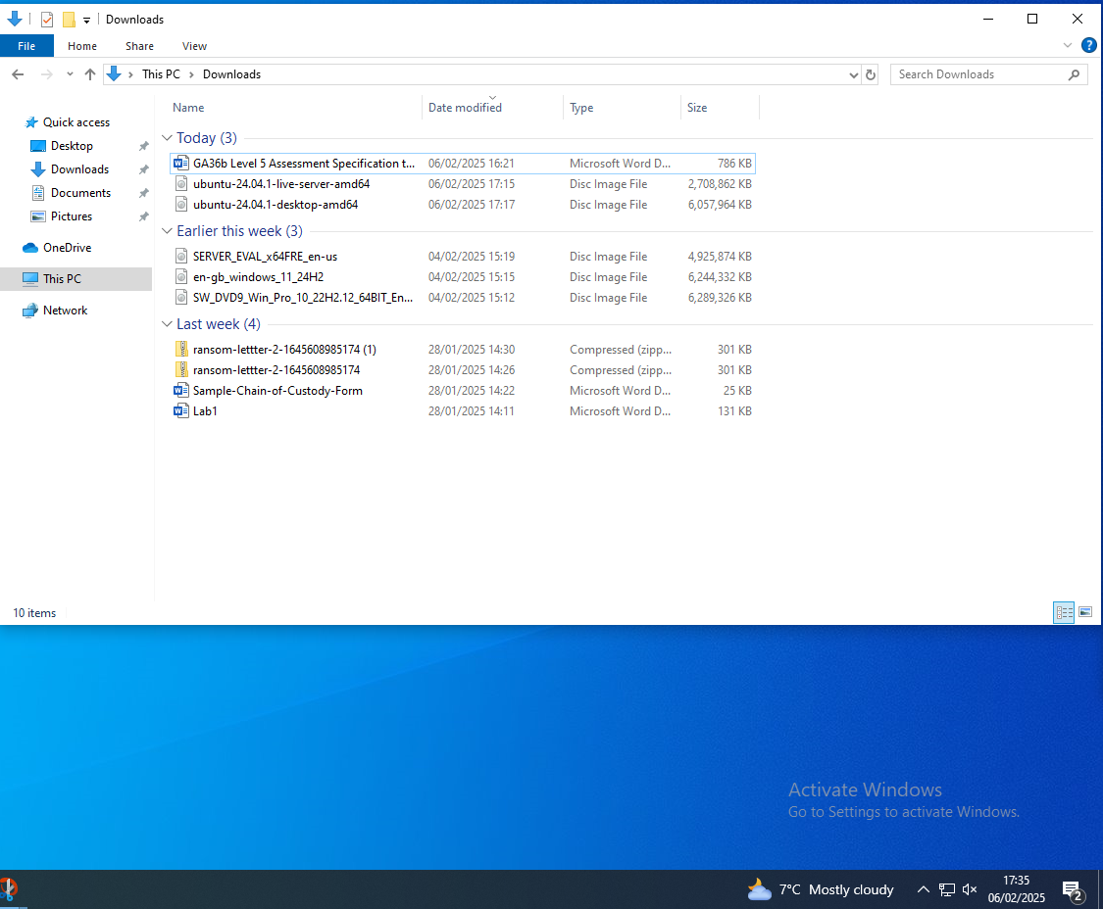
We downloaded the ISO for Windows Server, 10 and Ubuntu Server / Desktop but ended up changing the Ubuntu server by a Debian 12 CLI later.

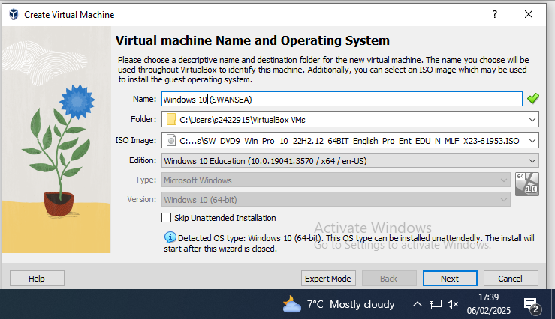
We created each Virtual machines and provided them their respective OS by giving it the ISO that we downloaded before. We named the machines respectively to their location on the topology.

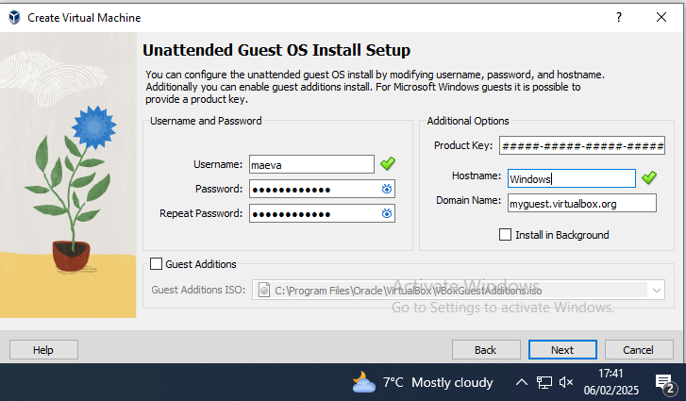
Then we set the username, password and hostname.

We assigned the allocated memory and the number of cores to the VM and then gave it the disk size following the Virtualbox instructions. 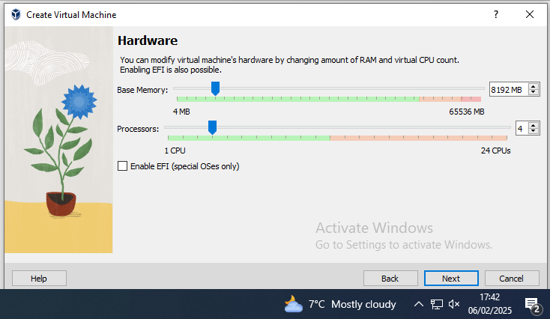 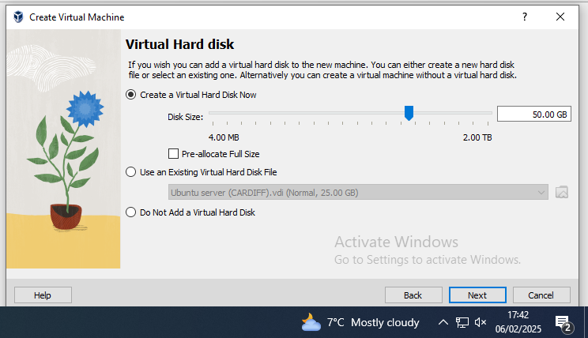

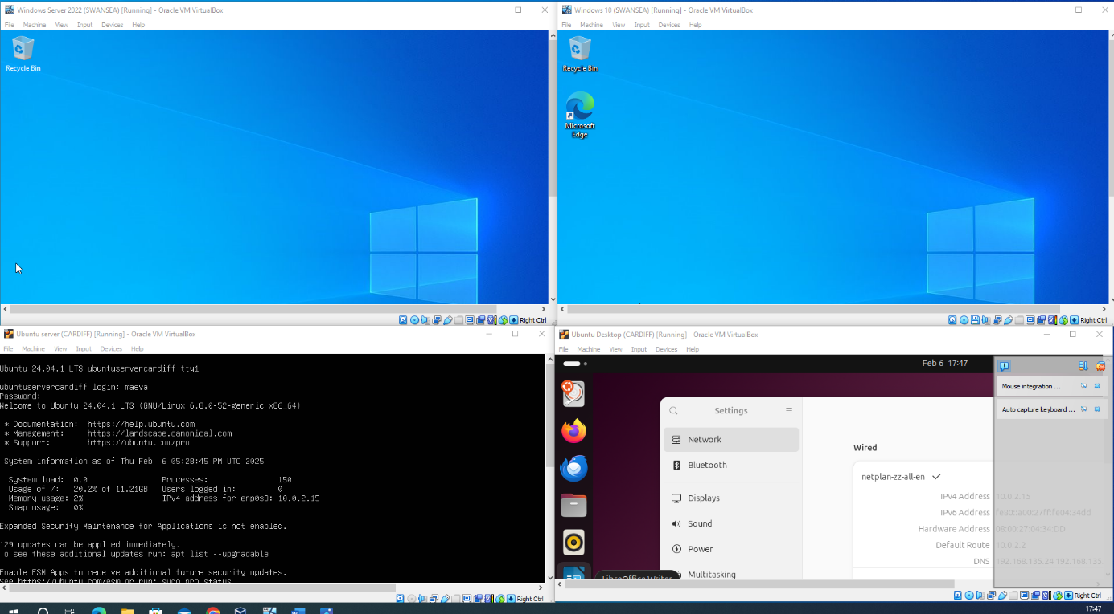
We started all the virtual machines and set all the parameters like the language (UK), the keyboard, the time, and for the Linux-based the usernames and passwords. We also matched the passwords and username for every VMS for conveniency.

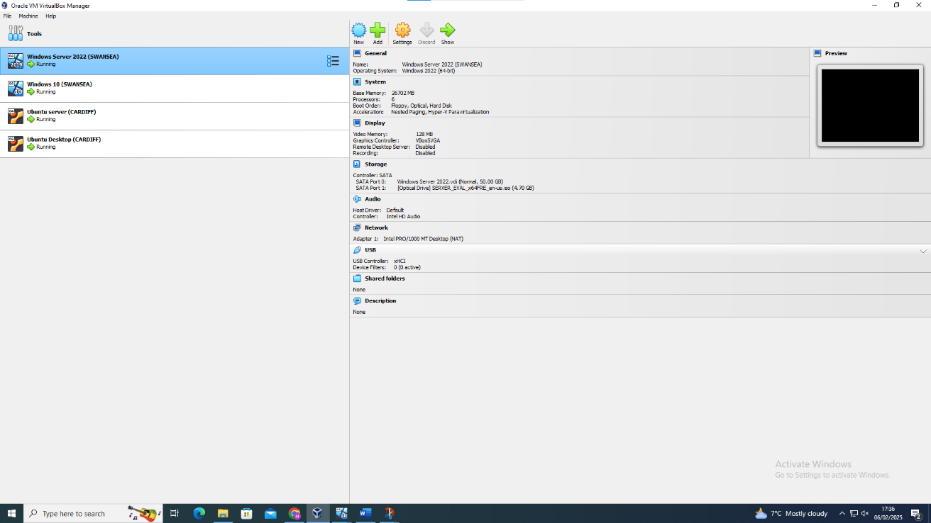
This is a screenshot to show that all the virtual machines are installed and ready to be configured for the network.

On VirtualBox, we created the LANs and the WANs for Swansea and Cardiff and also added a NAT interface to give internet to the servers, by going on the settings of each virtual machine, in the network’s section. The Windows and Linux servers have in total three interfaces, and the clients have one interface each.
Now that we had all our virtual machines, we had to create this topology:
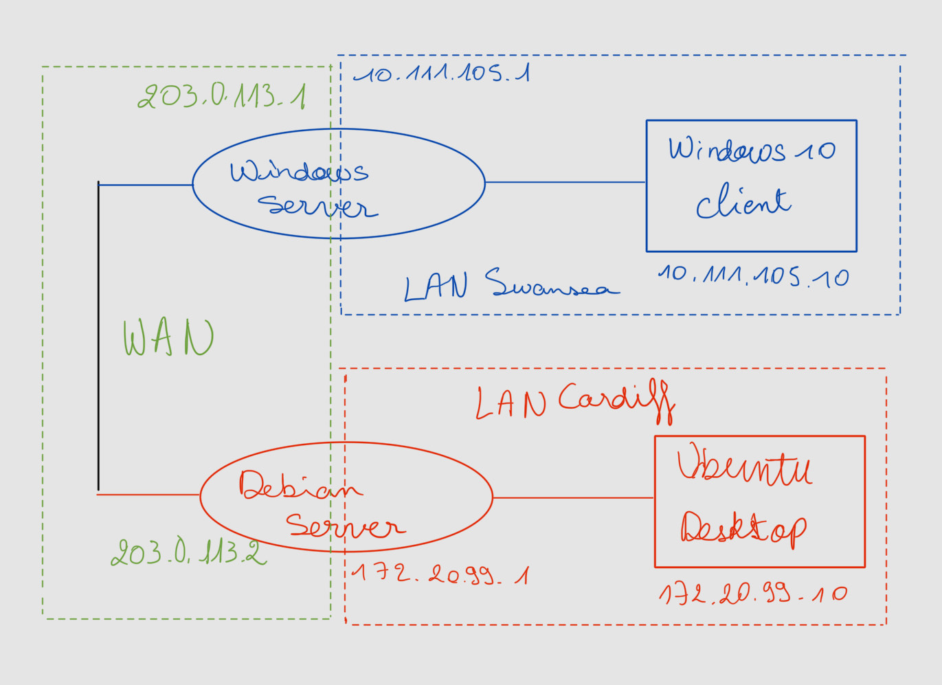

- Windows Server must communicate with its Windows 10 client and the Debian server but not with Ubuntu client.
- Debian Server also must communicate with Ubuntu but not Windows 10 client.
- The two clients mustn’t communicate with each other.
- The network must have access to Internet.

Configuration of the IP addresses

3.1. Windows
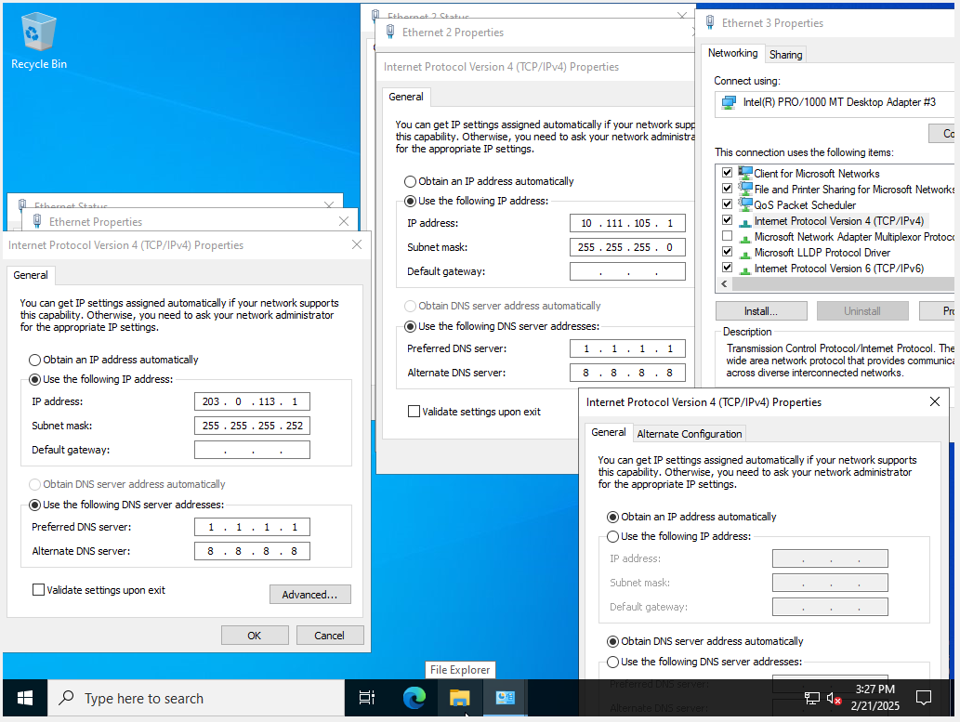

For the topology we had now chose our IP addresses to use. For the Swansea’s LAN, we chose 10.111.105.0/24 which is a reserved scope for a private network according to the Wikipedia page. For Cardiff’s LAN, we chose 172.20.99.0/24 and for the WAN 203.0.113.0/30.

We downloaded a DHCP server and configured it thanks to the server manager included on Windows Server by following the instructions. This method was done so that it was easier to configure each LANs network. Clients would just have to connect to the LAN to be assigned an IP address.

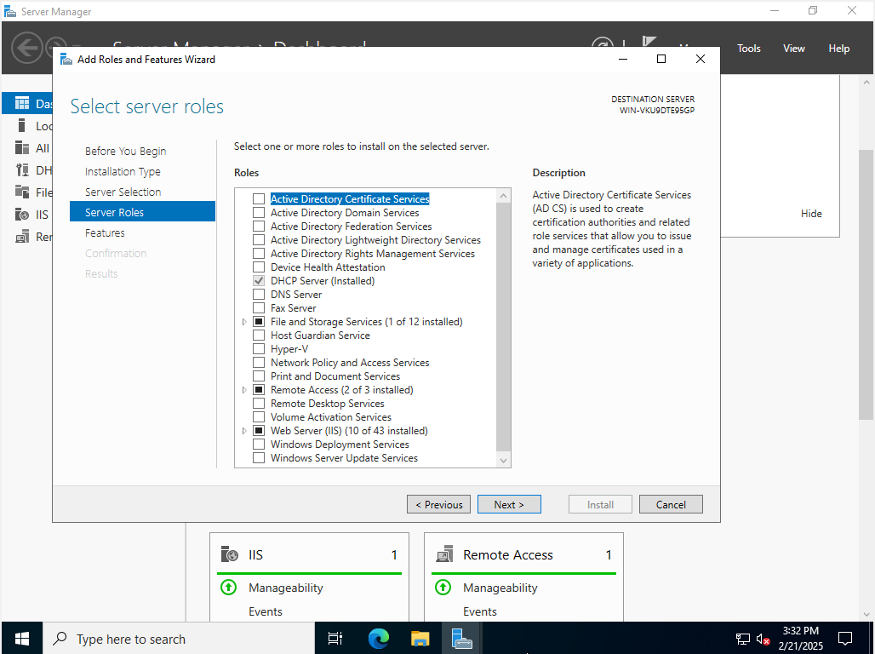

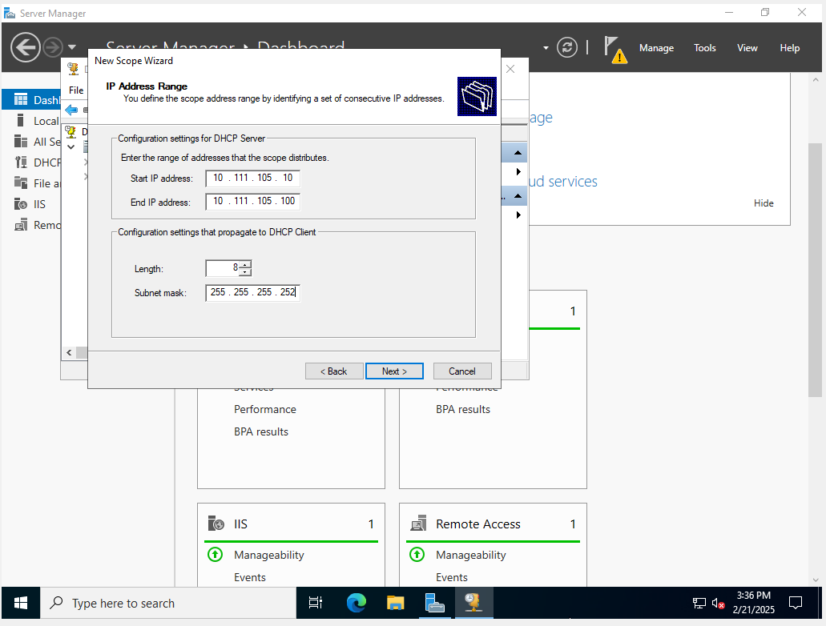
We created a new scope of 90 for the DHCP, so we defined the address range by identifying a set of consecutive IP addresses. And we set the gateway as the Windows Server IP address. Clients will then have internet given by WS22.
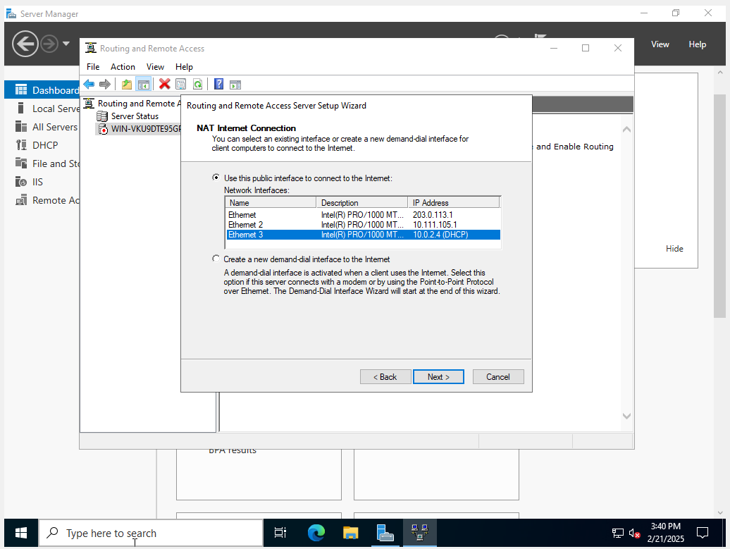
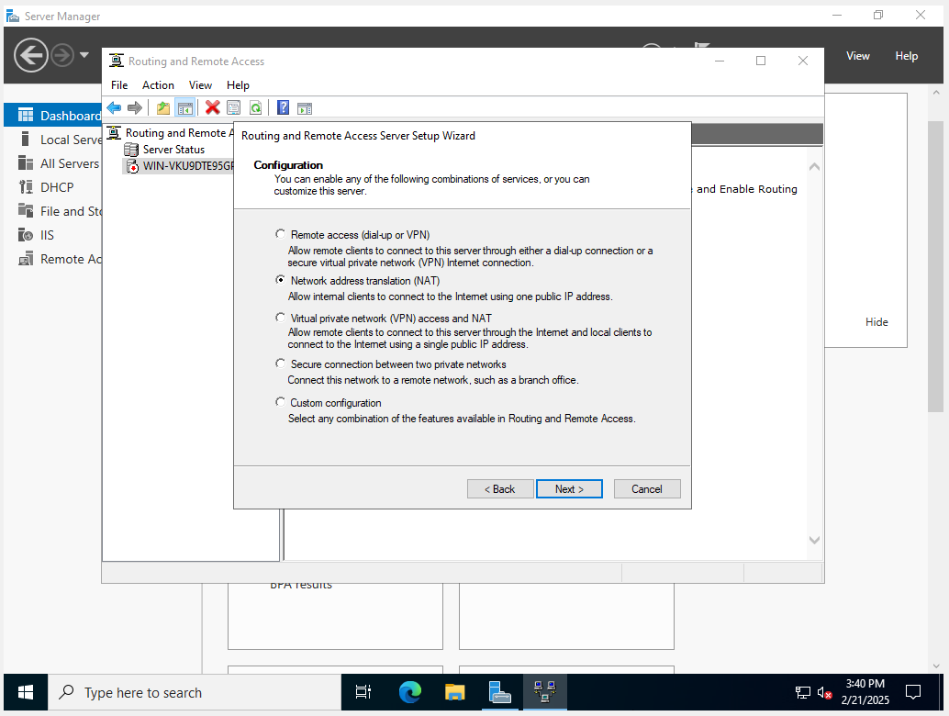
We downloaded the routing and remote access role and configured a NAT. We selected the interface connected to the Internet (the third one) and choose on which network to give Internet access (so the LAN)
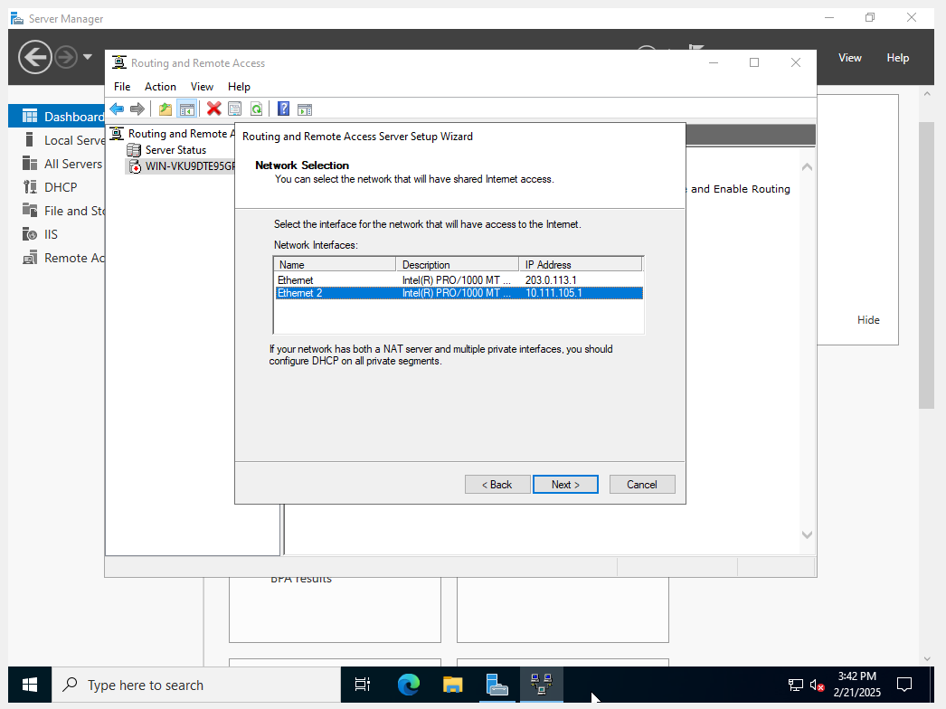
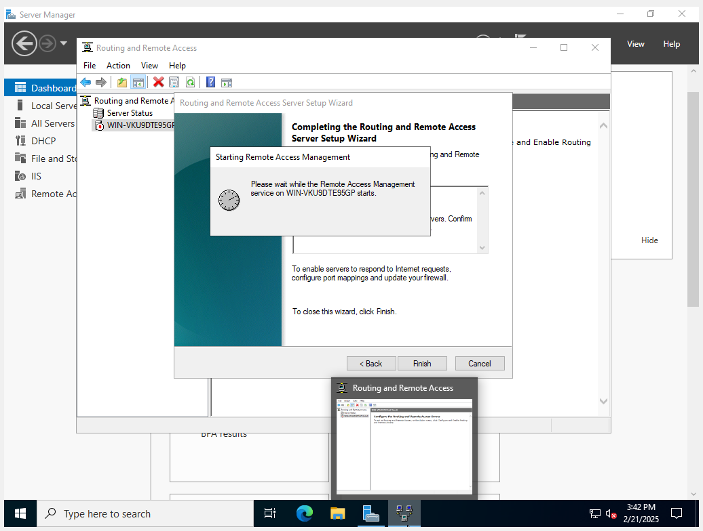

3.2. Linux-based
We configured the IP addresses in the interface file on the command prompt. We did it for the three interfaces.
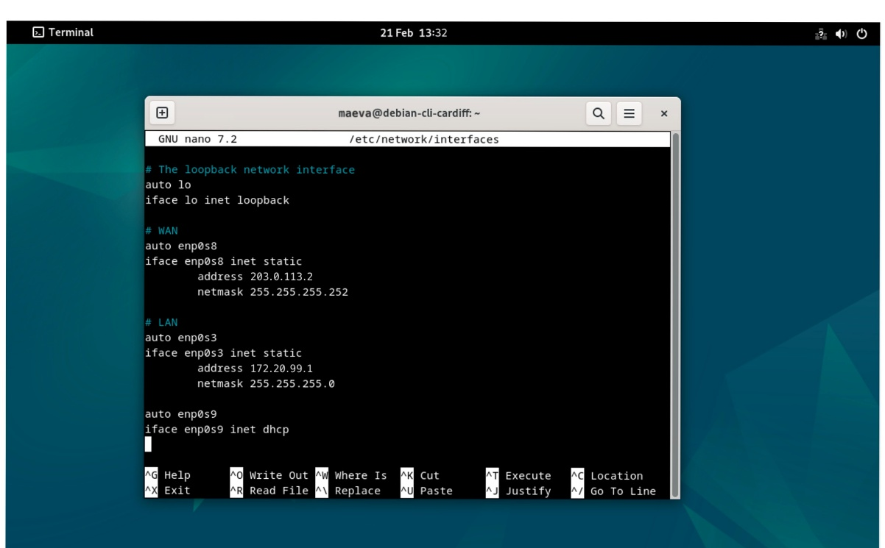
Afterwards, we downloaded isc-dhcp-server using the command prompt. We configured the DHCP server following the same config as Windows Server and restarted the DHCP server.
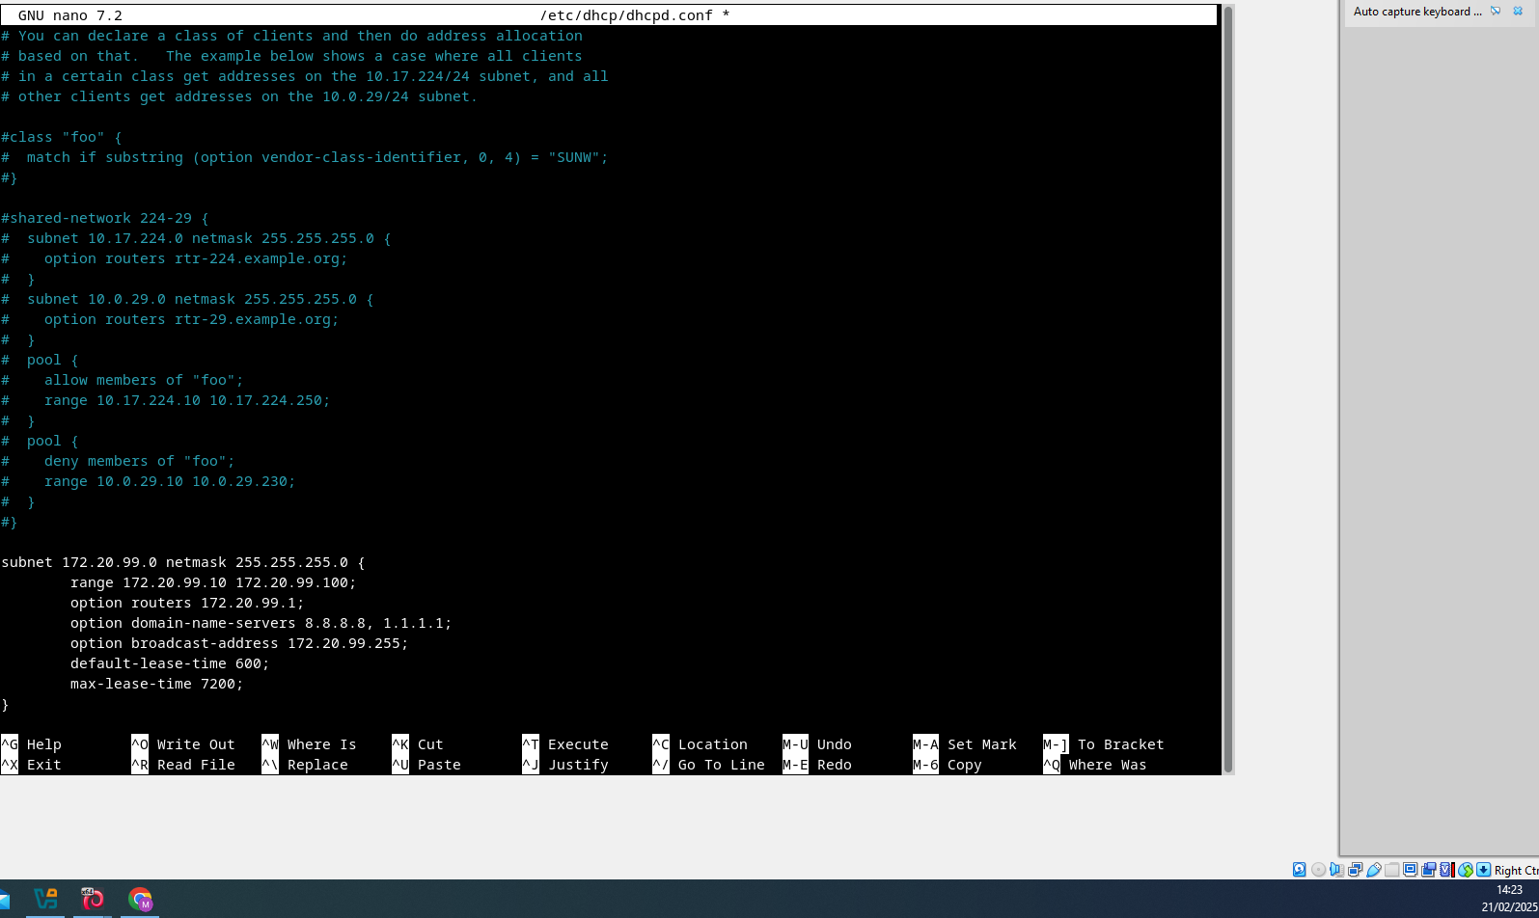
Then, we configured the NAT by activating the forwarding IP. We used the command iptables for a part of the configuration.

3.3. Problem and resolution
But we encountered an issue: the two client’s machine were able to ping the IP address of its respective server on the WAN’s due to the NAT configuration. We understood that there was a base rule which allowed the client to ping all the interfaces. So, to resolve this, we had to create two firewall rules that specifically authorise the pings echo request for the ping between the LANs and another between the WANs. After, restarting the Windows client, we tested with good results our solution. We found that
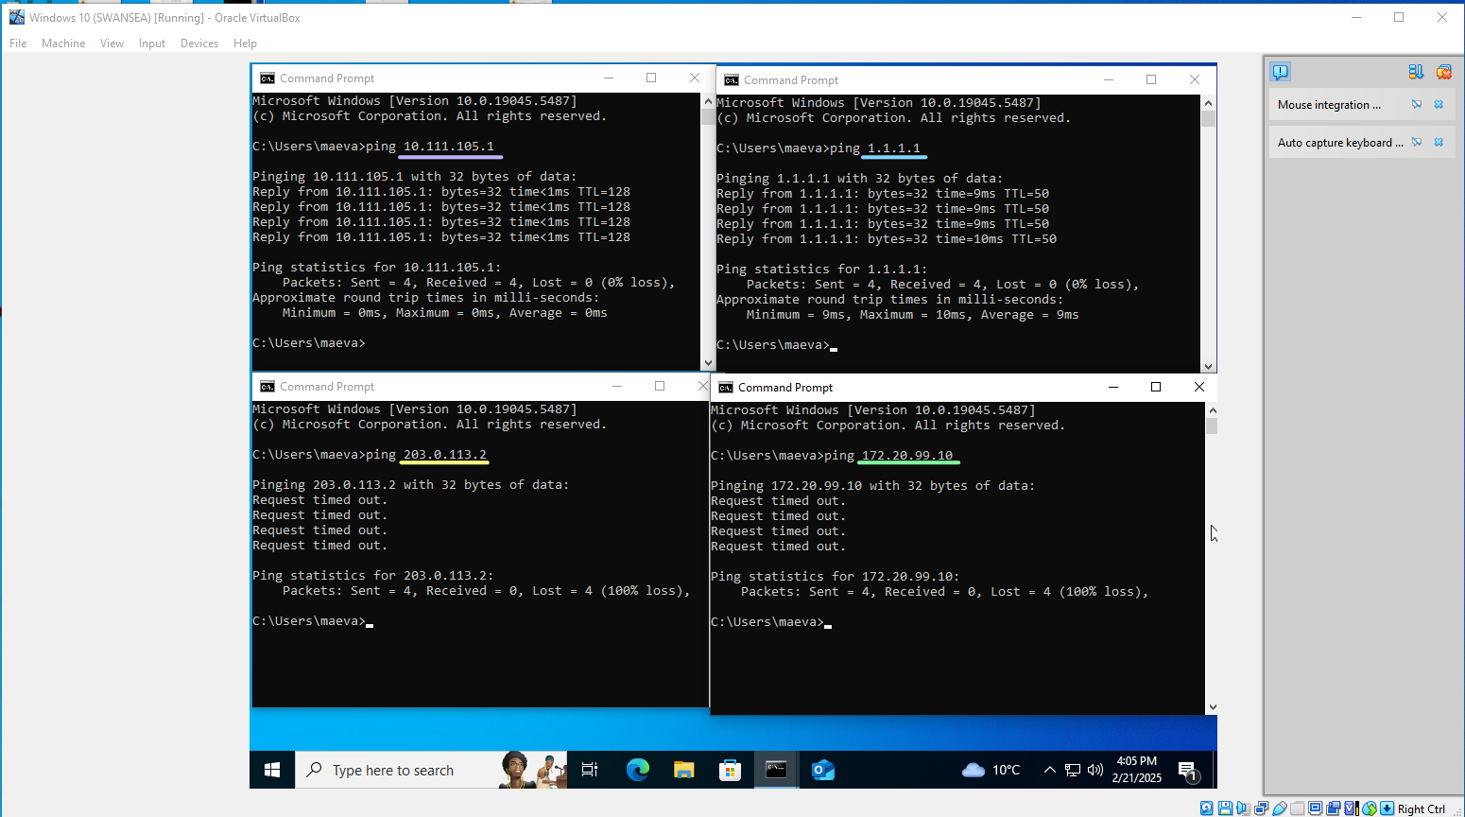
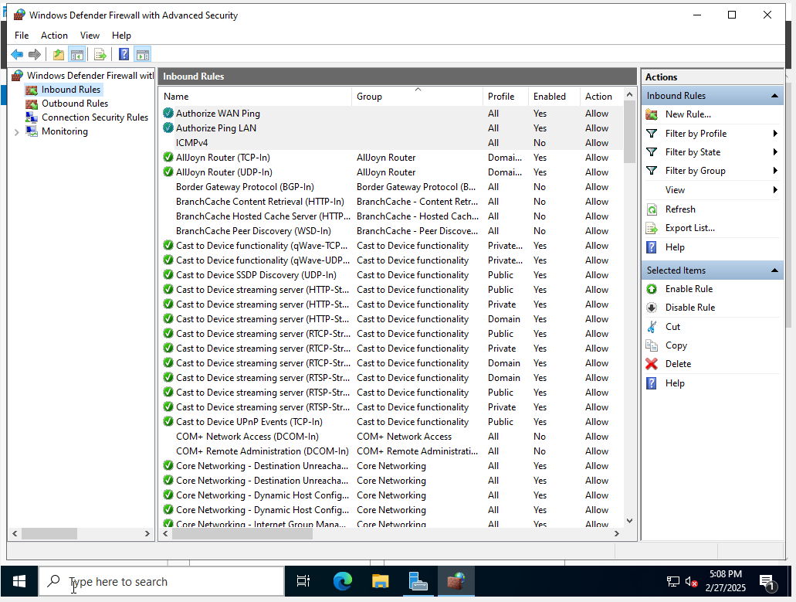

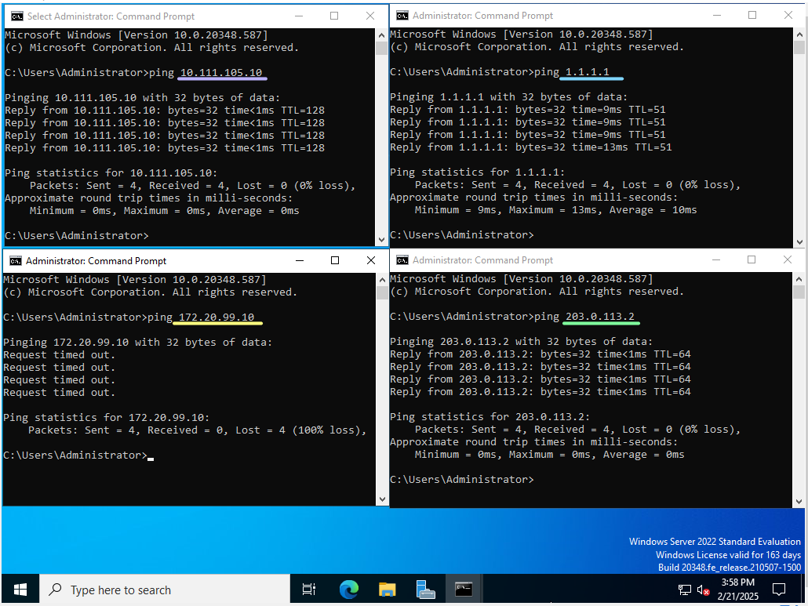
We tested all the pings on Windows client and on Windows server:

It shows us that both has access to internet, ping each other well and can’t ping Ubuntu desktop but, only Windows server can ping Debian server.
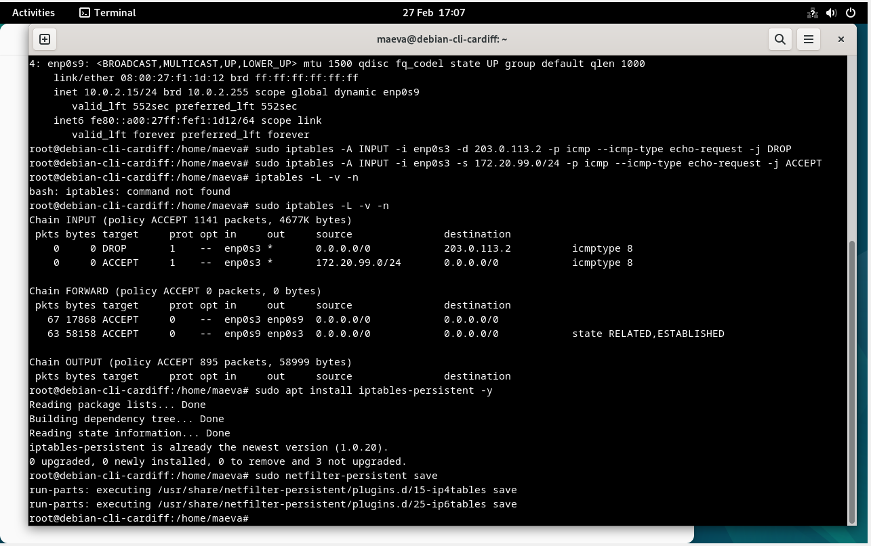

We blocked the ping’s demands from the Cardiff LAN (enp0s3) going to the WAN server’s IP address (203.0.113.2), with iptables. After that, we made the NAT persistent, to save it.
To verify that everything was functioning correctly, we pinged internet on Ubuntu and the other machines. It pinged the Debian server but not the Windows one nor the Windows client, so we succeed to archived what we wanted to do.

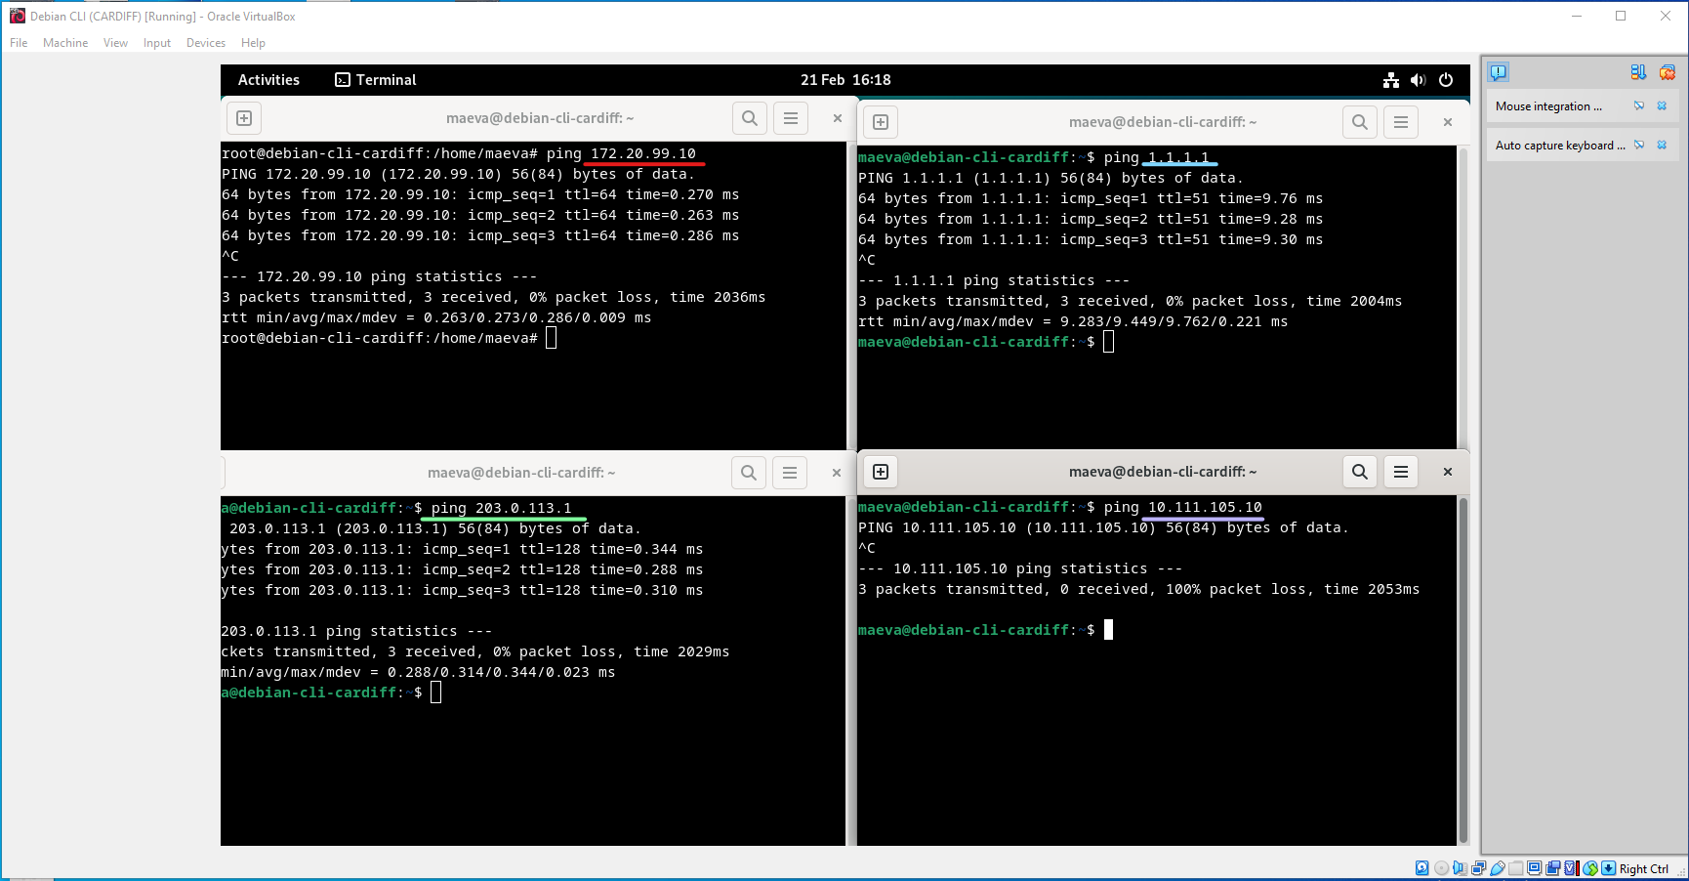
Windows client:
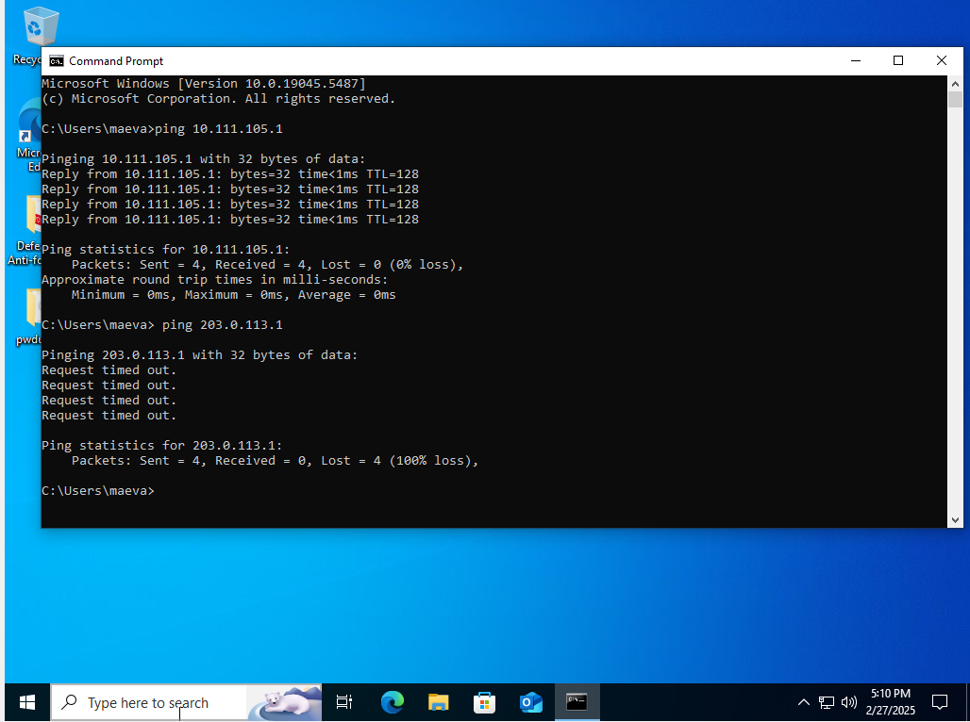
Ubuntu desktop:
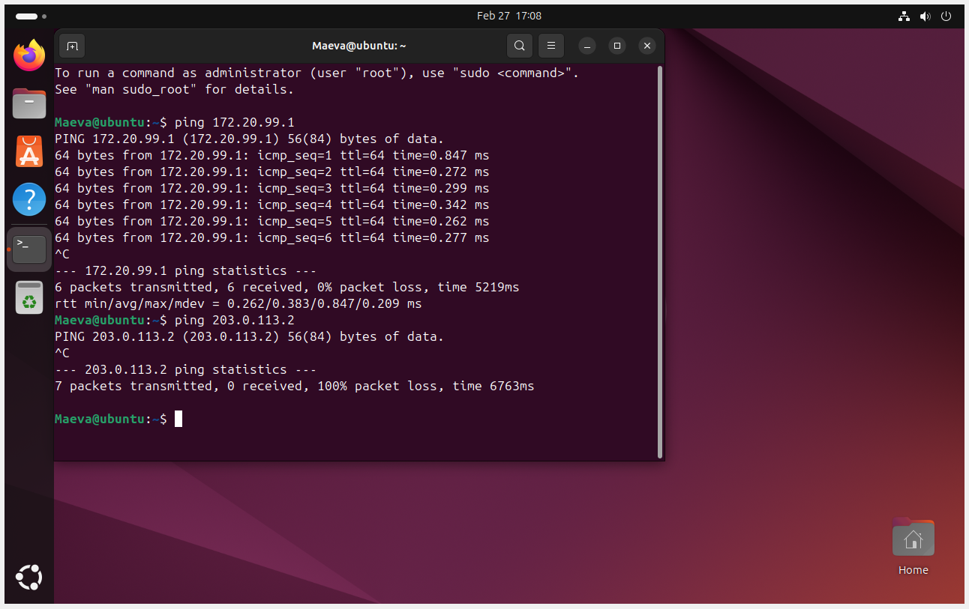

TASK 3

3.1. Technical reflection
We had to change some parameters because the firewall blocked a required command. Another issue was that clients of each server could ping the other’s server. To fix this, we blocked all pings and then allowed only the necessary ones.

3.2. Personal reflection
I had never done this type of project before, so I’m proud of the results. Thanks to prior research, I understood everything I was doing. As a beginner, starting was difficult, but in the end, I’m happy to have completed it successfully, even if there was a lot of research to do to find a solution for the problems encountered.

